Fig. S1, related to Fig 1

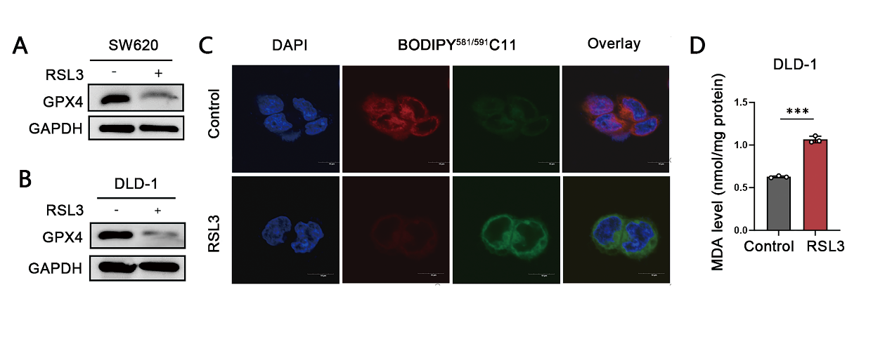
Fig. S1. ILF3 is decreased in RSL3-mediated ferroptosis. A, B The protein level of GPX4 in RSL3-induced (10μM,24h) SW620 and DLD-1 cells was detected by western blot assay. C Lipid peroxidation levels in DLD-1 cells treated with RSL3 (10 μM, 24 h) were detected using a BODIPY (581/591) C11 probe. Scale bar = 10 μm. Red represents reductive status, green represents oxidative status, and blue represents DAPI staining. D MDA levels in DLD-1 cells treated with RSL3 (10 μM, 24 h) compared to the control group.

Fig S2, related to Fig 2

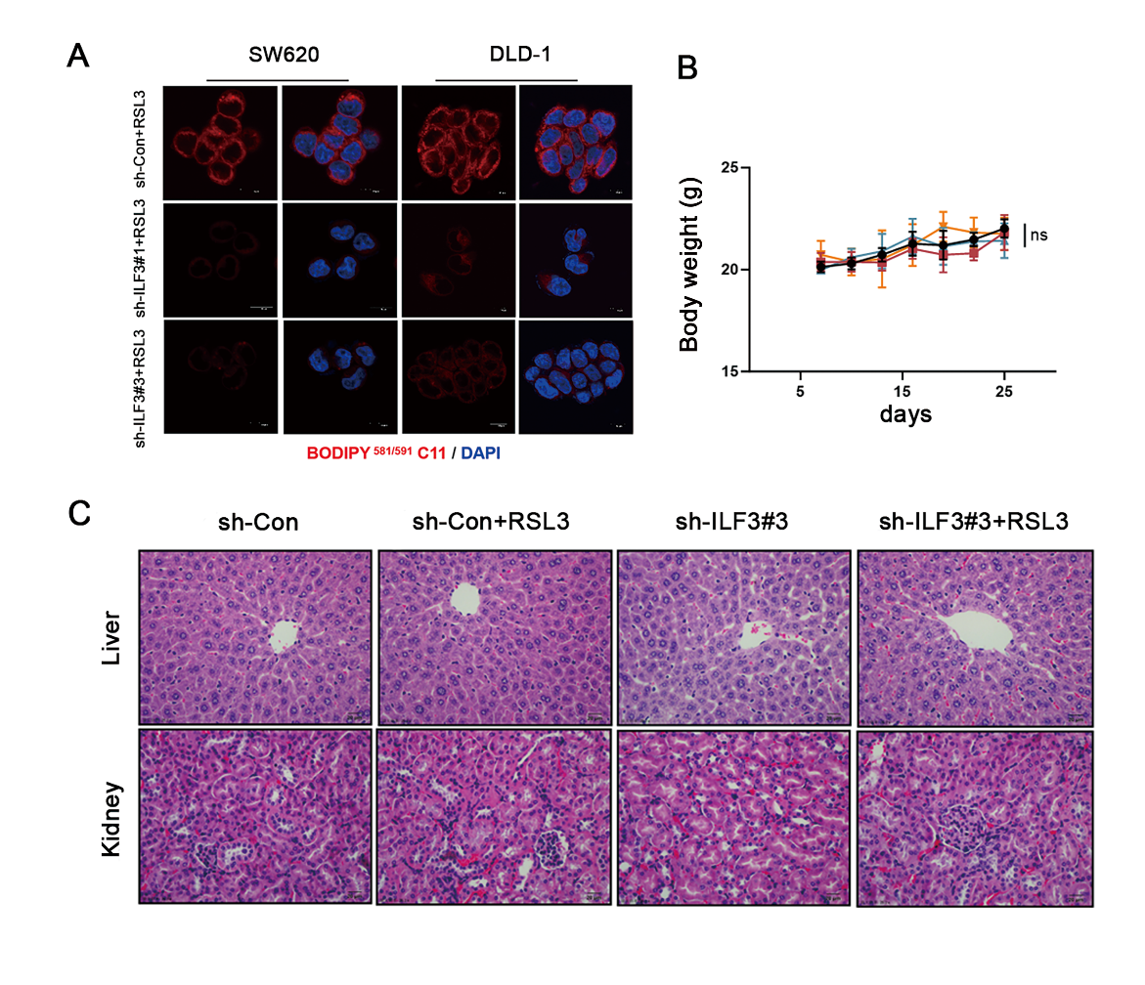
Fig S2. Knockdown of ILF3 promotes ferroptosis sensitivity in CRC cells. A Lipid peroxidation levels in sh-Con and sh-ILF3 groups treated with RSL3 (10 μM, 24 h) were detected using a BODIPY (581/591) C11 probe. Scale bar = 10 μm. Red represents reductive status and blue represents DAPI staining. B Mouse weight of Xenograft model. C HE staining for Liver and kidney of xenograft mouse model.

Fig S3, related to Fig 4
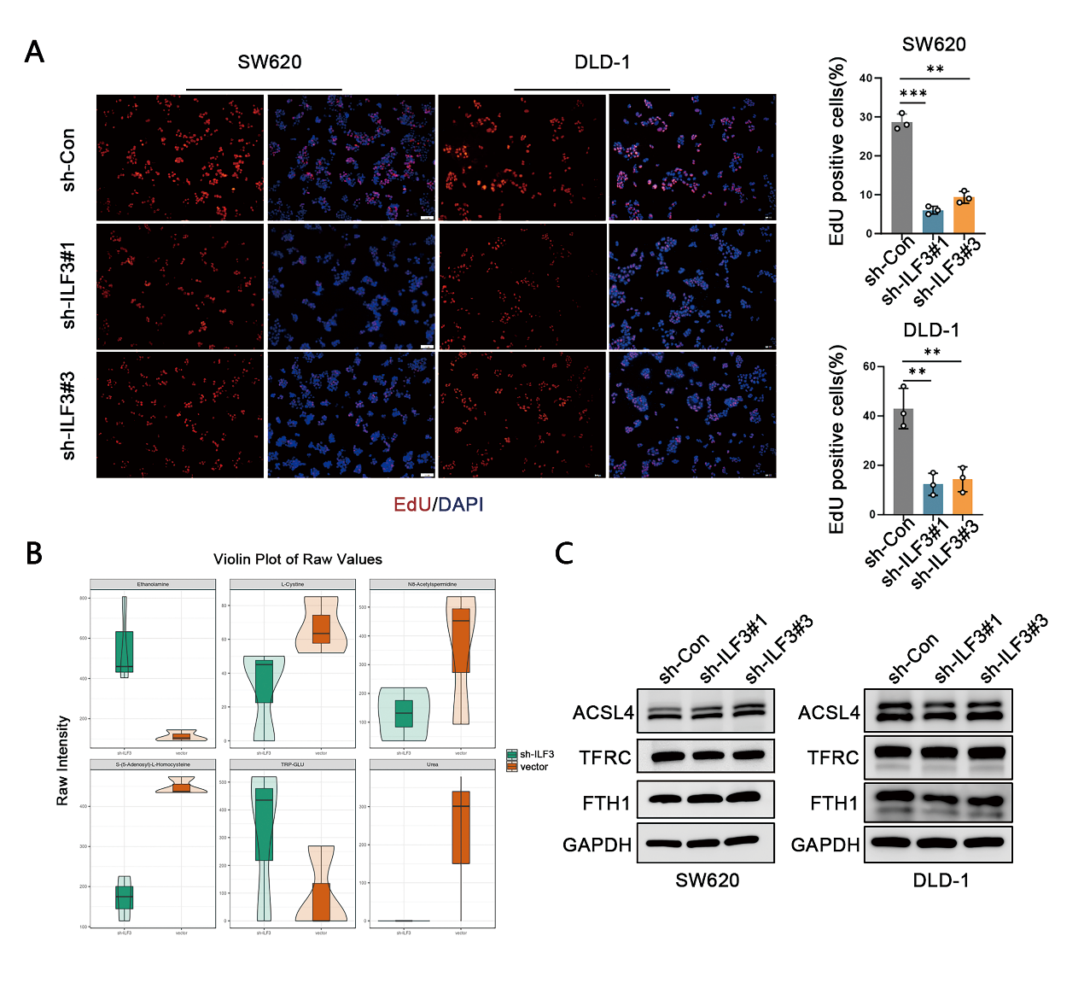

Fig. S3. ILF3 loss inhibits GSH synthesis by suppressing xCT-mediated cystine uptake. A EdU staining for ILF3 knockdown CRC cells. Red represents EdU staining and blue represents DAPI staining. B The differentially expressed metabolites of amino-acid in ILF3 knockdown cells determined by targeted amino-acid metabolomics. C The protein expression of ACSL4, TFRC, and FTH1 in ILF3-knockdown SW620 and DLD-1 cells was detected by western blot assay.

Fig S4, related to Fig 5

Fig. S4. ILF3 modulates SLC3A2 mRNA stability by directly binding to the 3’ UTR. A The protein expression of SLC3A2 in SW620 and DLD-1 cells was detected by western blot assay. B Colony formation assay for ILF3 knockdown cells with or without SLC3A2 overexpression. C Representative fluorescence images of BODIPY 581/591 C11-labeled lipid peroxidation in ILF3 knockdown cells with or without SLC3A2 overexpression in the presence of RSL3 (10 μM, 24 h). Red represents reductive status and blue represents DAPI staining.

Fig S5, related to Fig 6

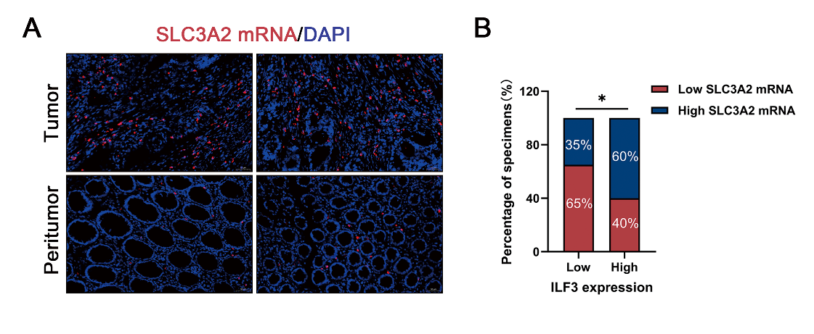
Fig. S5. ILF3 and SLC3A2 are co-expressed in CRC tissues. A Representative FISH images of TMA showing SLC3A2 expression in colorectal cancer (CRC) and adjacent normal tissues. Scale bar = 20 μm. B Correlation between SLC3A2 mRNA expression and ILF3 protein levels in CRC specimens. *P<0.05

Fig S6, related to Fig 7

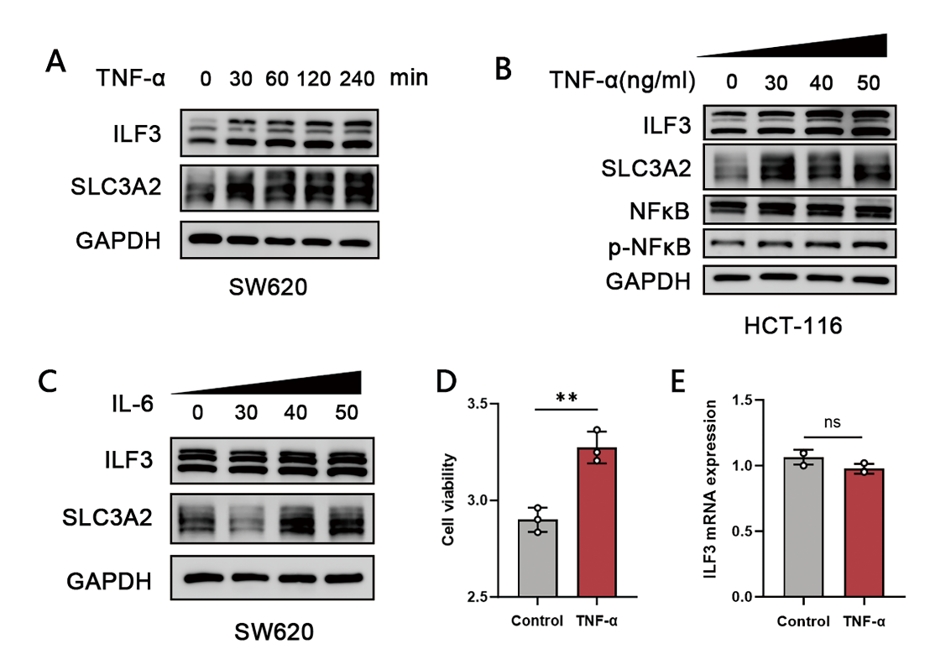
Fig. S6. TNF-α accelerates cystine uptake and GSH synthesis by upregulating ILF3 expression. A The protein levels of ILF3 and SLC3A2 in TNF-α-induced (40ng/ml) SW620 cells at different times were detected by western blot assay. B HCT-116 cells were treated with different concentrations of TNF-α for 24 h, and protein expression levels of ILF3, SLC3A2, NF-κB p65, and p-NF-κB p65 were analyzed by western blot. C The protein levels of ILF3 and SLC3A2 induced by IL-6 at different concentrations in SW620 cells were detected by western blot assay. D Cell viability was detected using CCK-8 assay after TNF-α treatment. E ILF3 mRNA expression was detected using RT-qPCR after TNF-α treatment.

