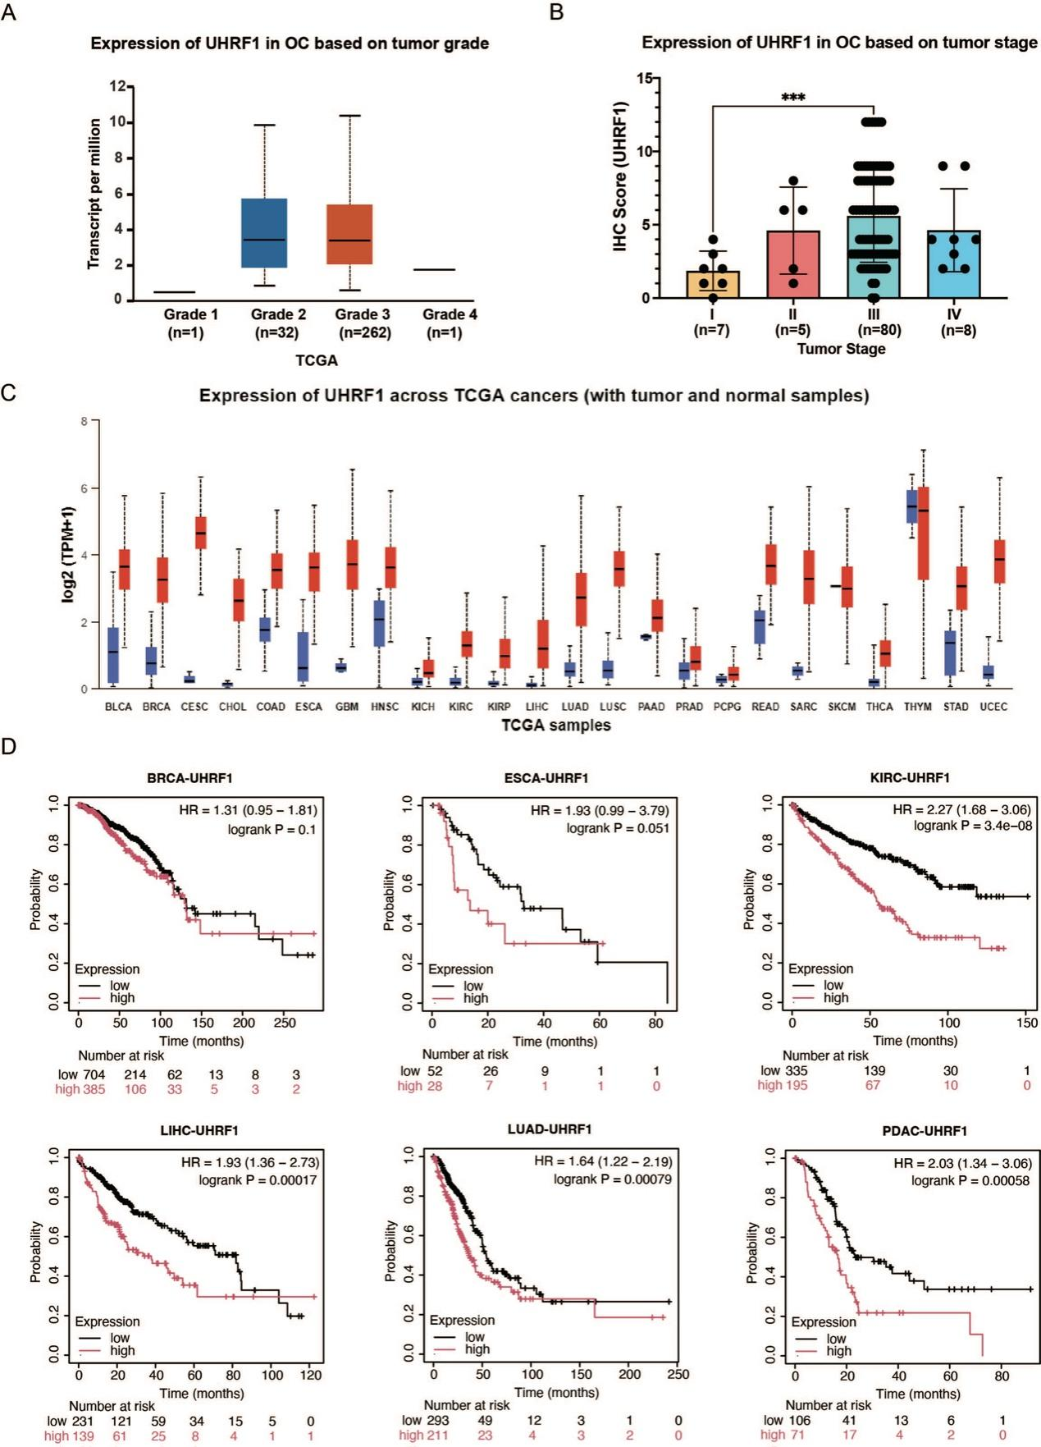
Fig.S1: UHRF1 is overexpressed in various tumors and is associated with poor prognosis. (A) Correlation between UHRF1 transcriptional levels and tumor grades in OC using the UALCAN (https://ualcan.path.uab.edu/) database; (B) The correlation between UHRF1 expression levels and tumor grade based on IHC score analysis in OC patients ;(C)Expression analysis of UHRF1 across pan-cancer using the UALCAN（https://ualcan.path.uab.edu/）database; (D) Prognostic analysis of UHRF1 in multiple tumors（Breast Cancer (BRCA), Esophageal Cancer (ESCA), Kidney Renal Clear Cell Carcinoma (KIRC), Liver Hepatocellular Carcinoma (LIHC), Lung Adenocarcinoma (LUAD), Pancreatic Ductal Adenocarcinoma (PDAC)）.
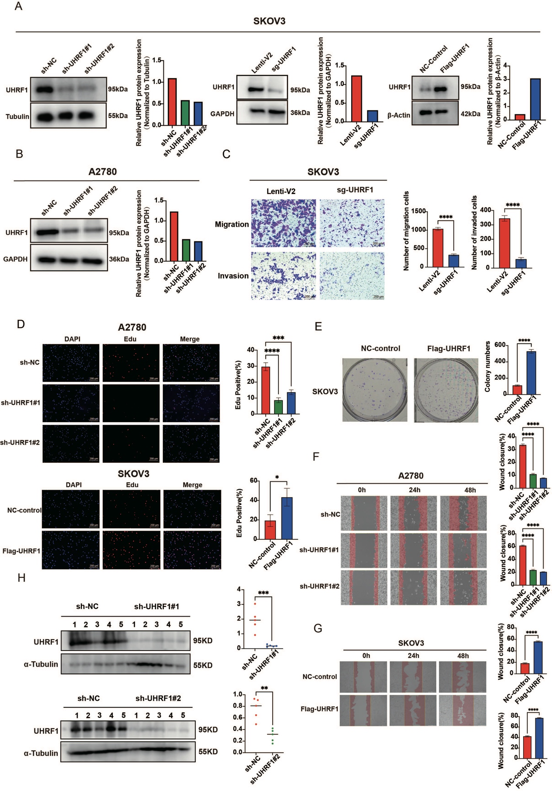
Fig. S2: Knockdown of UHRF1 inhibits proliferation, migration, and invasion of OC cells. (A, B) UHRF1-knockdown/knockout and UHRF1-overexpressed in OC cells, cells were collected to WB analysis and grayscale analysis; (C) Transwell migration and invasion assays showing the effect of UHRF1-knockout SKOV3 cells on migration and invasion abilities; (D) EDU cell proliferation assay showing the effect of UHRF1-knockdown and UHRF1-overexpressed SKOV3 cells on proliferation; (E) Colony formation assay showing the effect of UHRF1-overexpressed SKOV3 cells on colony-forming ability; (F, G) Wound healing assay showing the effect of UHRF1-knockdown A2780 cells and UHRF1-overexpressed SKOV3 cells on migration; (H) WB analysis of tumor tissues from xenograft mice. *p < 0.05; **p < 0.01; ***p < 0.001; ****p < 0.0001.
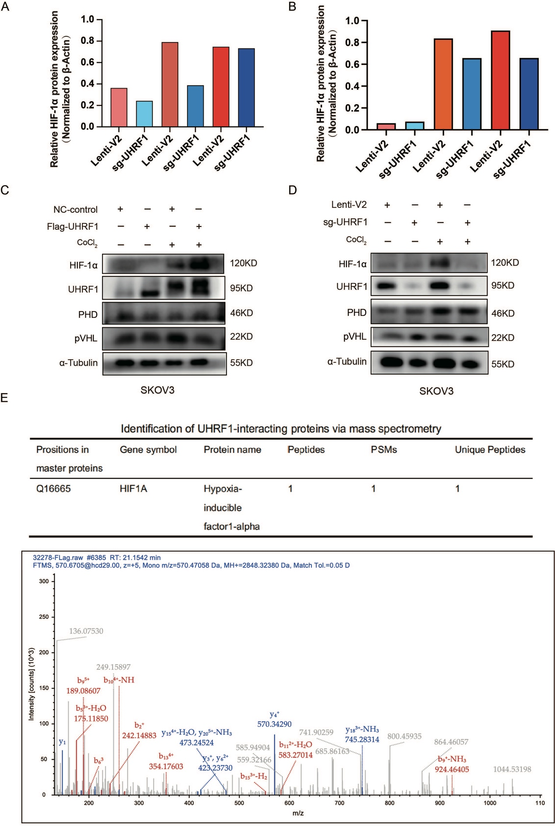
Fig. S3: UHRF1 does not affect the expression of PHD and pVHL. (A) Cells were treated with 20 µM MG132 for 12 h, and collected for grayscale analysis; (B) Cells were treated with 20 µM MG132 for 12 h, and collected for grayscale analysis; (C, D) UHRF1-overexpressed SKOV3 or UHRF1-knockout SKOV3 cells were treated with CoCl₂ for 24 h, and cells were collected for WB analysis; (E) Mass spectrometry assay identified proteins potentially interacting with UHRF1. Analysis results identified the interaction between UHRF1 and HIF-1α in SKOV3 cells.
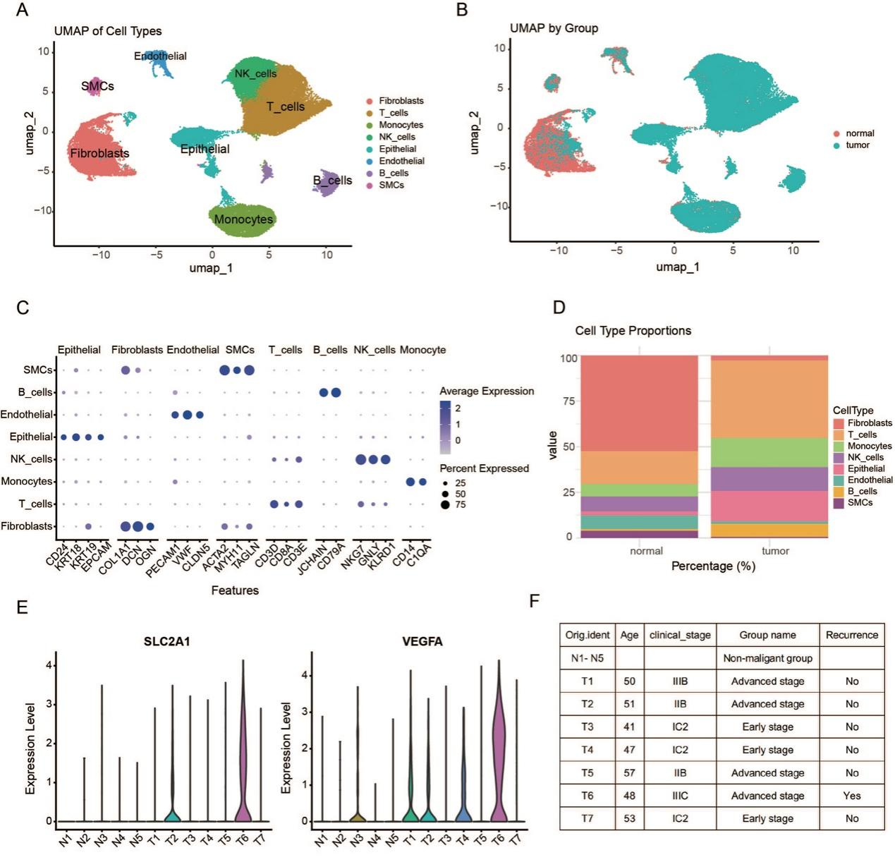
Fig. S4: Diverse cell types in OC and nonmalignant ovarian tissues delineated by single-cell transcriptomic analysis. (A) The UMAP plot demonstrates the main cell types in OC and control ovarian tissues; (B) The UMAP plot demarcated by colors showing the two groups of OC tumors and nonmalignant ovarian tissues; (C) Dot plots showing the expression levels of specific marker genes in each cell type. The size of dots indicates the proportion of cells expressing the particular marker gene. The spectrum of color represents the mean expression levels of the marker genes; (D) The proportion of each cell type relative to the total cell count in OC tumor and normal tissues; (E) The expression of SLC21A and VEGFA in each patient; (F) Clinical information of each patient.
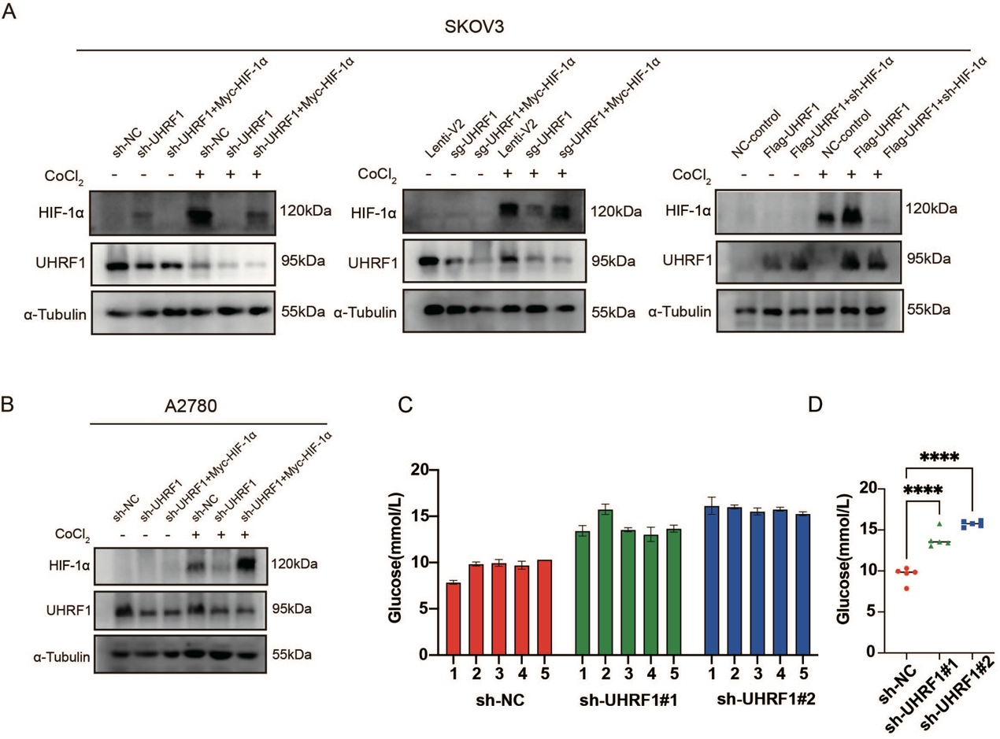
Fig. S5: Construction of a bistable transgenic cell line. (A-B) Generation of stable transfected cell lines, and WB analysis and grayscale analysis of the expression levels of relevant proteins; (C-D) Plasma glucose levels were measured from tumor-bearing mice and analyzed statistically.
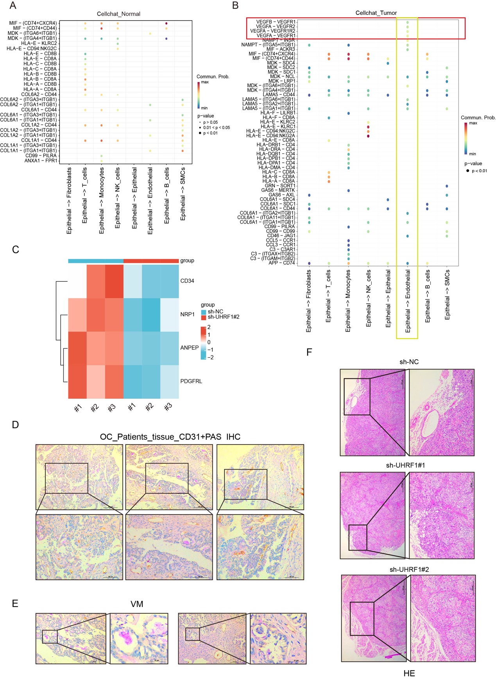
Fig. S6: UHRF1 is involved in the regulation of tumor angiogenesis. (A, B) Analysis of cell-cell communication between tumor and normal tissues; (C) Heatmap from transcriptomic analysis shows that knockdown of UHRF1 leads to a decrease in the expression of some angiogenesis-related genes; (D-E) CD31 and PAS co-staining of tumor tissues from OC patients indicates the presence of a large number of blood vessels and VM within the tumors; (F) HE staining of mouse tumor tissues.
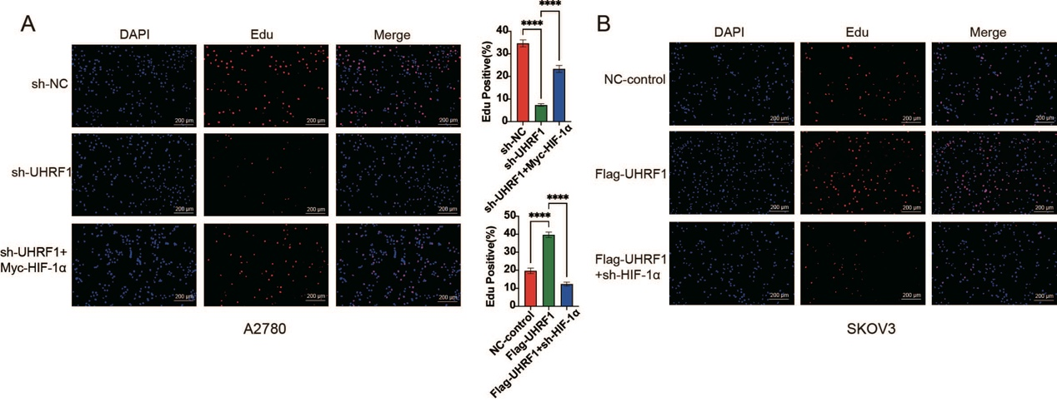
Fig. S7:Knockdown of HIF-1α partially attenuates the promotion of malignant phenotypes in OC by UHRF1. (A, B) EDU cell proliferation assay to evaluate the proliferation capacity of double stable transfected cells.
Supplementary Table1：Association of UHRF1 expression with clinicopathological features in OC patients
Characteristics |  | UHRF1 expression |  | χ² | P-value
Characteristics | （N） | Low（-、+）  （N=53） | High（++、+++）  （N=47） | χ² | P-value
Age, n (%) |  |  |  | 0.542 | 0.462
< 50 | 40 | 23（57.5%） | 17（42.5%）
≥ 50 | 60 | 30（50.0%） | 30（50.0%）
Stage, n (%) |  |  |  | 8.989 | 0.029*
I | 7 | 7（100%） | 0（0.00%）
II | 6 | 3（50.0%） | 3（50.0%）
III | 79 | 37（46.8%） | 42（53.2%）
IV | 8 | 6（75.0%） | 2（25.0%）
Lymph node metastasis, n (%) |  |  |  | 0.915 | 0.339
- | 54 | 31（57.4%） | 23（42.6%）
+ | 46 | 22（47.8%） | 24（52.2%）
Omentum metastasis, n (%) |  |  |  | 7.032 | 0.008*
- | 37 | 26（70.3%） | 11（29.7%）
+ | 63 | 27（42.9%） | 36（57.1%）
Tumors with low UHRF1 expression (-/+) showed IHC scores of 0-4, while those with high expression (++/+++) had scores of 6-12.

Supplementary Table2:
Truncated Primer
UHRF1-UBL F | GAATTCGCCACCATGTCCGACACCGACT
UHRF1-UBL R | CATGGTGGCGAATTCGCTAGCTCTAG
UHRF1-TTD F | AGCCGATGAGGACATGGGGAGCCCATGGTT
UHRF1-TTD R | CATGTCCTCATCGGCTGGCCCTGCTGT
UHRF1-PHD F | ACTGCAAGGACGACGTGGCCAGCGAGGT
UHRF1-PHD R | CACGTCGTCCTTGCAGTGCTTGCAGGAC
UHRF1-SRA F | ATGTGGCGGTTCCGAGTCCCTGGCCCTT
UHRF1-SRA R | GACTCGGAACCGCCACATGGTGCCCA
UHRF1-RING F | GAGGAGACGTTCCAGGGCTACGGCAAT
UHRF1-RING R | CTGGAACGTCTCCTCCACTTTACTCAGG
HIF-bHLH F | AAGATAAGTTCTGAAAAACTTCTGGATGCTGGTG
HIF-bHLH R | TTCAGAACTTATCTTTTTCTTGTCGTTCGCGCCG
HIF-PAS F | GGATATTGAAGATGACATGAAAGAACAAAACAC
HIF-PAS R | CATGTCATCTTCAATATCCAAATCACCAGCATCC
HIF-ODDD F | CTGATGCTTTAACTTTGCTGCAGACTCAAATAC
HIF-ODDD R | CAGCAAAGTTAAAGCATCAGGTTCCTTCT
HIF-NTAD F | GGATAGTGATATGGTCAATGAATCCTTCGATCAG
HIF-NTAD R | TTCATTGACCATATCACTATCCACATAAAAAC
HIF-CTAD F | TGTAGACTGCTGGGGCAAAACGAACAAAAA
HIF-CTAD R | TTGCCCCAGCAGTCTACATGCTAAATCAG
qPCR Primer
GAPDH F | CAAGGCTGTGGGCAAGGTCATC
GSPDA R | GTGTCGCTGTTGAAGTCAGAGGAG
ACTIN F | CTTCGCGGGCGACGAT
ACTIN R | CCACATAGGAATCCTTCT
UHRF1 F | CACAACGTGTGCAAGGACTG
UHRF1 R | TTTCAGCAAAACGCCTGTCG
HIF1A F | GATCACCCTCTTCGTCGCTT
HIF1A R | CCTCCATGGTGAATCGGTCC
GLUT1 F | GGTTGTGCCATACTCATGACC
GLUT1 R | GAGATAGGACATCCAGGGTAGC
HK2 F | CCCGGGAAAGCAACTGTTTG
HK2 R | ACCGGTGTTGAGAAGCTCTG
LDHA F | CGTCAGCAAGAGGGAGAAAG
LDHA R | GCCACGTAGGTCAAGATATCC
VEGF F | GGGAAAGGGGCAAAAACGAA
VEGF R | GGAGGCTCCAGGGCATTAGA
Truncated Primer was used for plasmid design; qPCR Primer was used for quantitative analysis.

Supplementary Table3:
Antibolidies
Name | Vendor |  | Cat# | WB | IHC | Validation
UHRF1 | Proteintech |  | #21402-1-AP | 1:1000 | 1:200 | - WB validation using human and murine tissues  - WB validation at the cellular level  - IHC staining of human and murine tissues
HIF-1α | Proteintech |  | #20960-1-AP | 1:1000 | 1:200
GAPDH | Proteintech |  | #60004-1-Ig | 1:5000 | - | Loading control protein
β-actin | Proteintech |  | #66009-1-Ig | 1:5000 | - | Loading control protein
α-tubulin | Proteintech |  | #66009-1-Ig | 1:5000 | - | Loading control protein
GLUT1 | ZEN-BIOSCIENCE |  | #R380464 | 1:1000 | - | Pathway proteins validated by WB
HK2 | Proteintech |  | #22029-1-AP | 1:1000 | - | Pathway proteins validated by WB
LDHA | Cell Signaling Technology |  | #3582T | 1:1000 | - | Pathway proteins validated by WB
VEGF | Proteintech |  | #19003-1-AP | 1:1000 | - | Pathway proteins validated by WB
Hydroxy-HIF-1α | Cell Signaling Technology |  | #3434 | 1:1000 | - | Pathway proteins validated by WB
PHD | Proteintech |  | # 19886-1-AP | 1:1000 | - | Pathway proteins validated by WB
pVHL | Proteintech |  | #24756-1-AP | 1:1000 | - | Pathway proteins validated by WB
DYKDDDDK-tag | Proteintech |  | #20543-1-AP; #66008-4-Ig | 1:1000 | - | - Tag protein  - Used for enrichment in IP assays and detection by WB
MYC-tag | Proteintech |  | #16286-1-AP; #60003-2-Ig | 1:1000
HA-tag | Abmart |  | #M20003 | 1:1000
Ki67 | Abmart |  | #TW0001 | - | 1:100 | IHC staining of mouse tissues
CD31 | Abmart |  | #TA6191 | - | 1:100 | IHC staining of human and mouse tissues
Reagents
CoCl2 |  | #102533，Merck KGaA
MG132 |  | #S2619，Selleck，China
CHX |  | #S7418，Selleck，China
PX-478 |  | #S7612，Selleck，China
Detailed information on antibody suppliers, catalog numbers, and applications.

Supplementary Table4:
Enriched pathway
GO:0016651 | oxidoreductase activity, acting on NAD(P)H
GO:0004032 | alditol:NADP+ 1-oxidoreductase activity
GO:0005125 | cytokine activity
GO:0048018 | receptor ligand activity
GO:0001664 | G protein-coupled receptor binding
GO:0031406 | carboxylic acid binding
GO:0016616 | oxidoreductase activity, acting on the CH-OH group of donors, NAD or NADP as acceptor
GO:0016614 | oxidoreductase activity, acting on CH-OH group of donors
GO:0004857 | enzyme inhibitor activity
GO:0016684 | oxidoreductase activity, acting on peroxide as acceptor
Specific pathway information obtained from GO enrichment analysis of the transcriptome sequencing data.

Supplementary Table5:
Abbreviations List
Abbreviations | Full Spelling
ECM | Extracellular Matrix
FBS | Fetal Bovine Serum
PEI | Polyethylenimine
SDS | Sodium Dodecyl Sulfate
BSA | Bovine Serum Albumin
Information on abbreviations.

