Table S1. Information of differential metabolites
Metabolites | Formula | Structure | m/z
13S-HODE | C₁₈H₃₂O₃ | 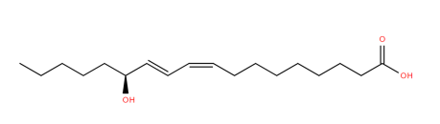 | 296.2346
24,25-dihydrolanosterol | C₃₀H₅₂O | 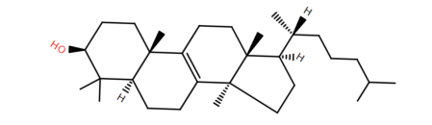 | 428.4013
4-Hydroxyphenyllactic acid | C₉H₁₀O | 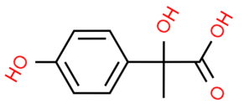 | 182.0579
AICAR | C₉H₁₅N₄O₈P | 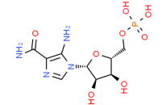 | 338.0627
Aminoisobutyric acid | C₄H₉NO₂ | 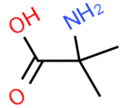 | 103.0633
CAR 10:0 | C₁₇H₃₃NO₄ | 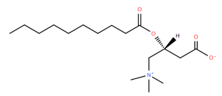 | 315.2404
CAR 12:0 | C₁₉H₃₇NO₄ | 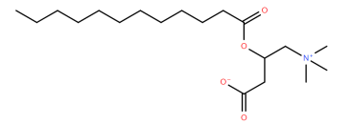 | 343.2717
CAR 12:1 | C₁₉H₃₅NO₄ | 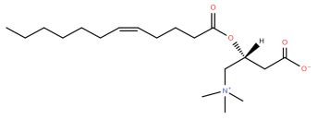 | 341.2561
CAR 14:0 | C₂₁H₄₁NO₄ | 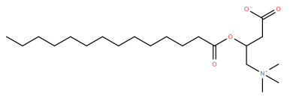 | 371.3030
CAR 14:0_1 | C₂₁H₄₁NO₄ | 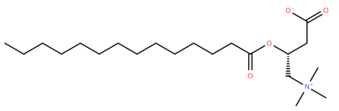 | 371.3030
CAR 14:1 | C₂₁H₃₉NO₄ | 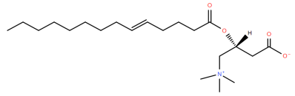 | 369.2874
CAR 16:0 | C₂₃H₄₅NO₄ | 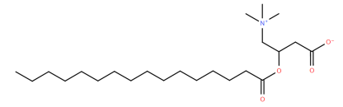 | 399.3343
CAR 16:0;O | C₂₃H₄₅NO₅ | 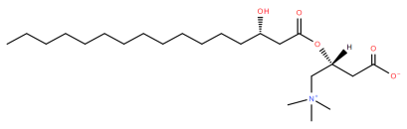 | 415.3292
CAR 16:1 | C₂₃H₄₃NO₄ | 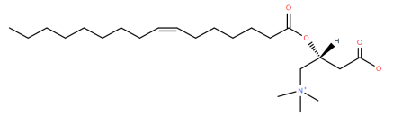 | 397.3187
CAR 18:0 | C₂₅H₄₉NO₄ | 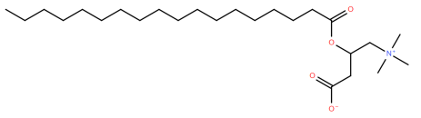 | 427.3656
CAR 18:1 | C₂₅H₄₇NO₄ | 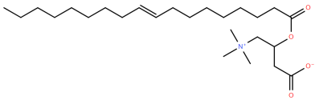 | 425.3500
CAR 18:1;O2 | C₂₅H₄₇NO₆ | 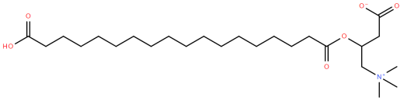 | 457.3398
CAR 18:2 | C₂₅H₄₅NO₄ | 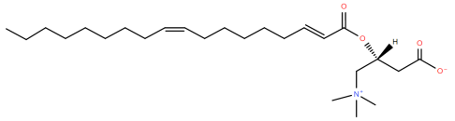 | 423.3343
CAR 8:0 | C₁₅H₂₉NO₄ | 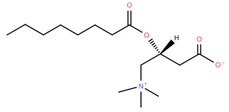 | 287.2091
Carbamoylphosphate | CH₂NO₅P | 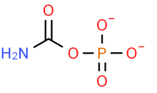 | 138.9682
Cystine | C₆H₁₂N₂O₄S₂ | 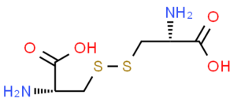 | 240.0238
Cytidine | C₉H₁₃N₃O₅ | 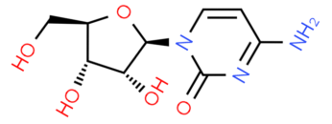 | 243.0855
Dextroamphetamine | C₉H₁₃N | 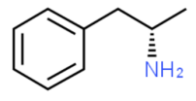 | 135.1048
Docosahexaenoic acid | C₂₂H₃₂O₂ | 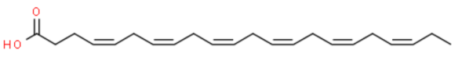 | 328.2402
Dopamine | C₈H₁₁NO₂ | 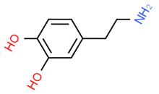 | 153.0790
Gamma-Aminobutyric acid | C₄H₉NO₂ | 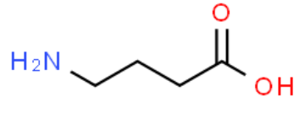 | 103.0633
Glycine | C₂H₅NO₂ | 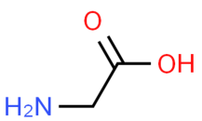 | 75.0320
GlcCer(d18:1/20:0) | C₄₄H₈₅NO₈ | 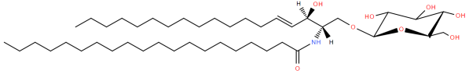 | 755.6270
GlcCer(d18:1/24:1(15Z)) | C₄₈H₉₁NO₈ | 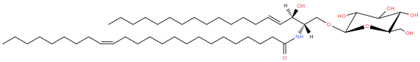 | 809.6739
Hypoxanthine | C₅H₂N₄O | 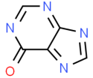 | 134.0229
L-2-Hydroxyglutaric acid | C₅H₈O₅ | 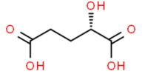 | 148.0372
PC 36:4 | C₄₄H₈₀NO₈P | 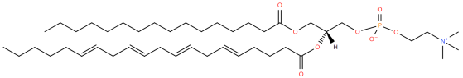 | 781.5616
PC O-36:5 | C₄₄H₈₀NO₇P | 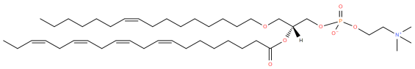 | 765.5667
PC O-36:6 | C₄₄H₇₈NO₇P | 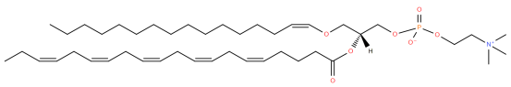 | 763.5510
Serine | C₃H₇NO₃ | 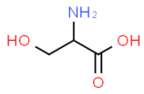 | 105.0426
SM(d18:1/25:0) | C₄₈H₉₇N₂O₆P | 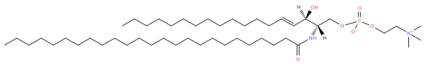 | 828.7079
sn-Glycero-3-phosphocholine | C₈H₂₀NO₆P | 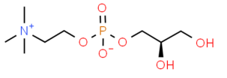 | 257.1028

Table S2. Antibody information in IHC
Antibody | Product No. | Dilution Ratio | Manufacturer
Rabbit polyclonal to HIF-1 alpha | ab114977 | 1:100 | Abcam
Anti-L-Lactyl-Histone H3 (Lys18) Rabbit mAb | PTM-1406RM | 1:200 | PTM BIO
Rabbit polyclonal to Ki67(IHC) | ab15580 | 1:100 | Abcam

Table S3. Antibody information in Western Blot
Antibody | Product No. | Dilution Ratio | Manufacturer
Anti-L-Lactyl Lysine Rabbit mAb | PTM-1401RM | 1:1000 | PTM BIO
Anti-L-Lactyl-Histone H3 (Lys18) Rabbit mAb | PTM-1406RM | 1:1000 | PTM BIO
Rabbit monoclonal to Histone H3 | ab176842 | 1:1000 | Abcam
Rabbit monoclonal to HIF-1 alpha | ab179483 | 1:1000 | Abcam
Rabbit monoclonal to beta Actin | ab213262 | 1:1000 | Abcam
Goat Anti-Rabbit IgG | ab6721 | 1:2000 | Abcam

Table S4. Primer sequence
Gene | Primer Sequence (5’-3’)
HIF1A(mouse) | Forward: CTTGACAAGCTAGCCGGAGG
HIF1A(mouse) | Reverse: AAGAGACAAGTCCAGAGGCG
HIF1A(ChIP) | Forword: GCATCCATGTGTGGAGACCA
HIF1A(ChIP) | Reverse: CTGCAAACTCCAAGGCAACC
β-actin(mouse) | Forword: CACTGTCGAGTCGCGTCC
β-actin(mouse) | Reverse: CGCAGCGATATCGTCATCCA

Table S5. shRNA sequence
shRNA | Sequence (5’-3’)
sh-NC | GCCAATATACAGATTCAAGAT
sh-HIF1A-1 | GCCACTTTGAATCAAAGAAAT
sh-HIF1A-2 | GCCGCTCAATTTATGAATATT

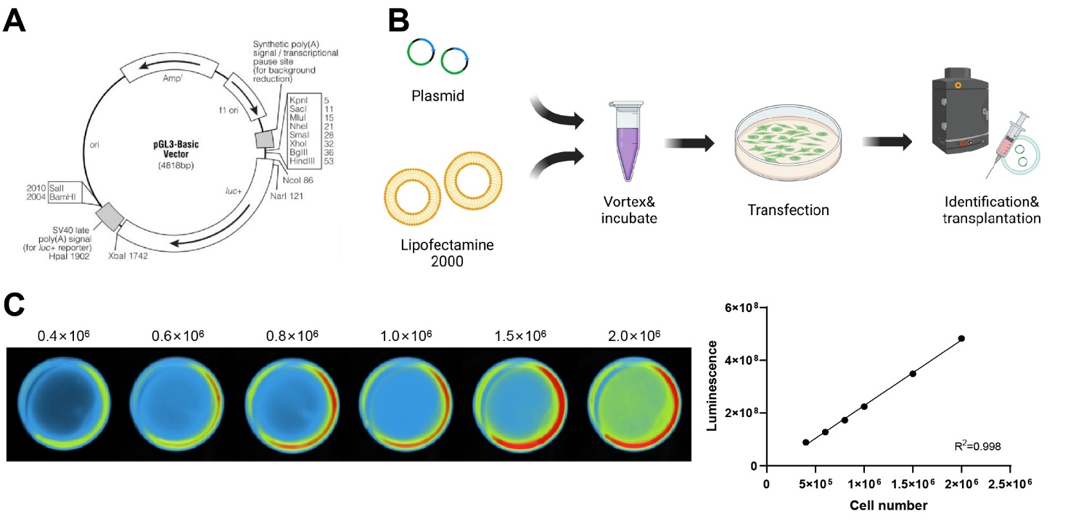
Figure S1. Preparation and identification of fluorescently labeled RCC cells in mice.
Note: (A) Schematic diagram of the pGL3-Basic plasmid structure (Created with BioRender.com); (B) Transfection procedure of the luciferase reporter plasmid (Created with BioRender.com); (C) In vitro cell imaging of transfected cells with different cell numbers and correlation analysis between fluorescence intensity and cell number.

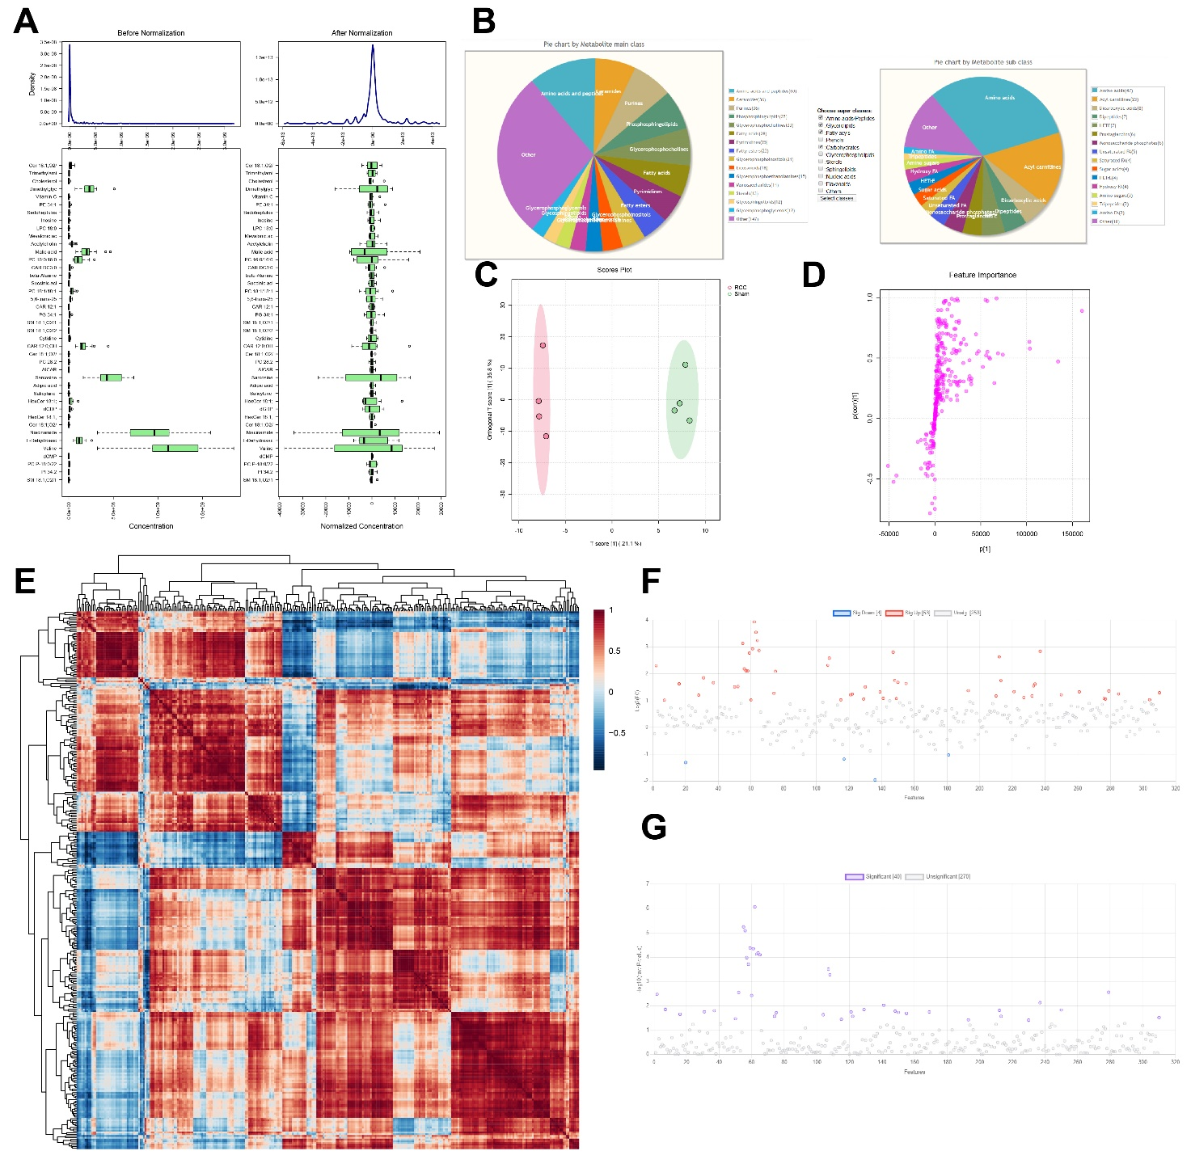
Figure S2. Metabolomic data quality control and multivariate statistical analysis.
Note: (A) Comparison of raw and normalized metabolomic data.; (B) Pie chart illustrating the composition of energy metabolism–related metabolites classified by “Main class” and “Sub class”; (C) OPLS-DA score plot displaying group separation along principal and orthogonal components; (D) S-plot of OPLS-DA analysis showing the importance of metabolites closer to the two angles of the plot; (E) Heatmap of correlation analysis of all metabolites; (F) Score plot of Fold Change analysis; (G) T-test analysis highlighting significantly different metabolites (red dots; P < 0.05). Each group included N=4 samples.

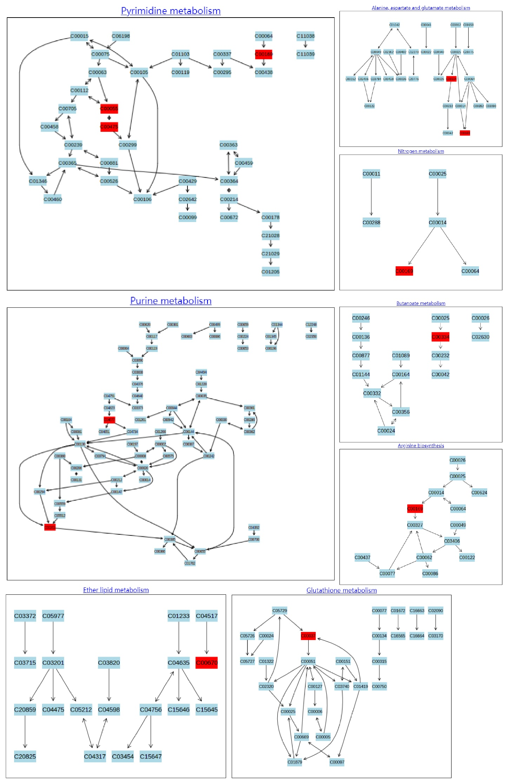
Figure S3. Enrichment analysis results of differential metabolite pathways.
Bar plot showing the top eight enriched pathways and associated metabolite categories based on functional analysis of differential metabolites (Created with BioRender.com).

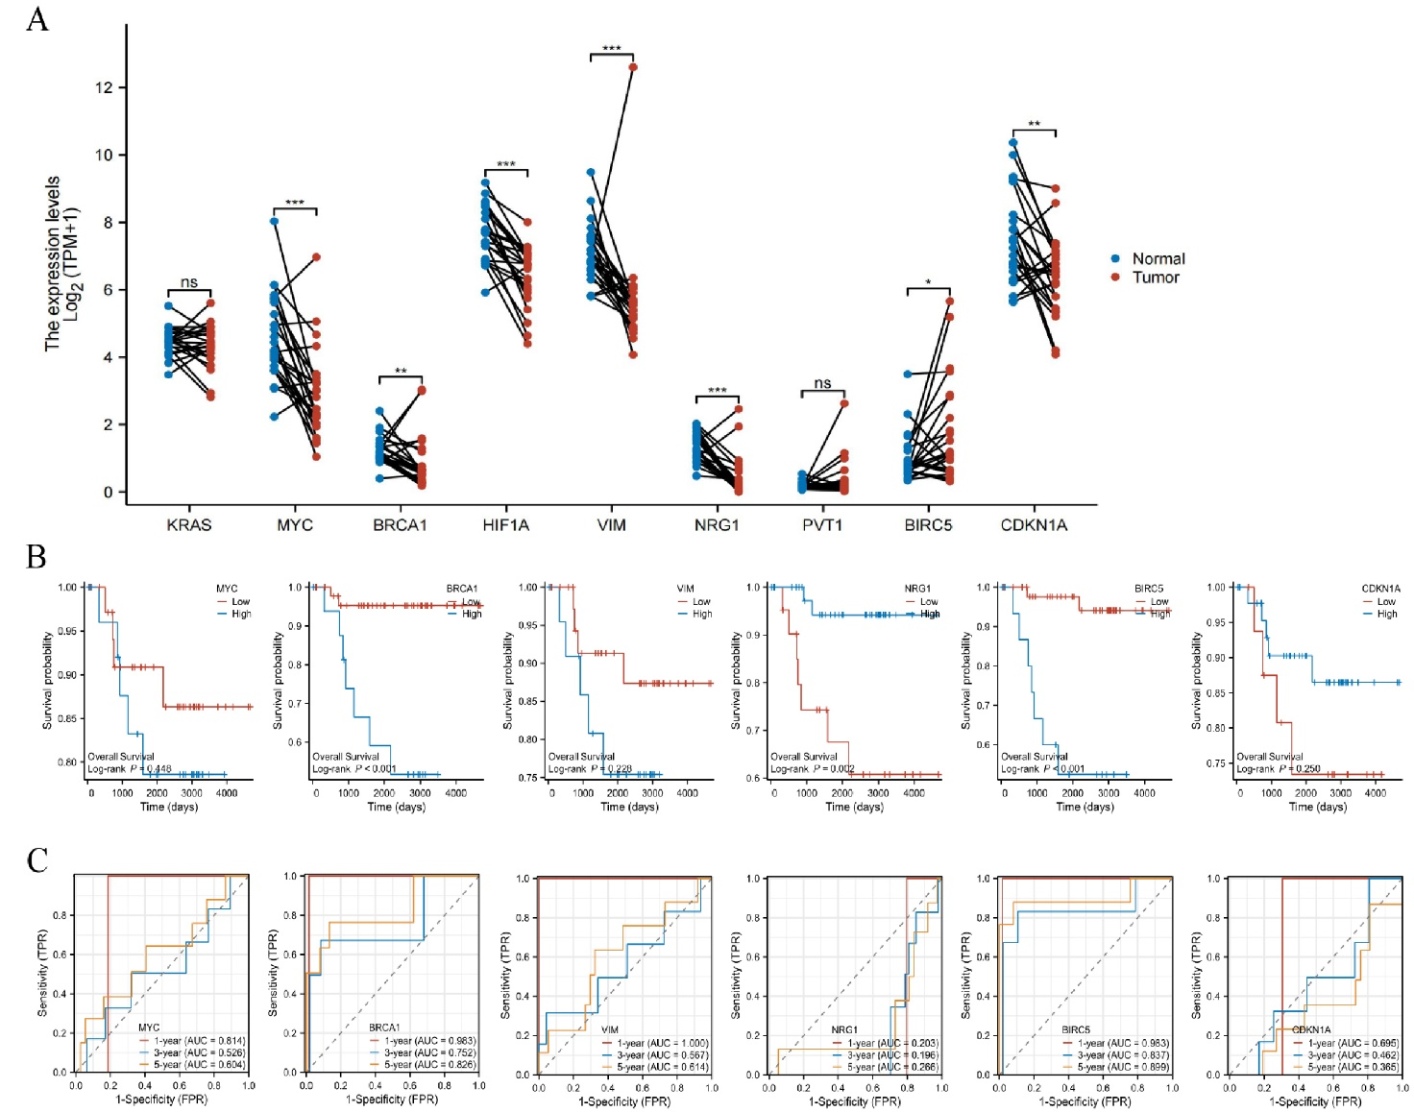
Figure S4. Selection of prognosis-related factors from the TCGA database.
Note: (A) Paired differential expression analysis of nine candidate genes, including KRAS and MYC, based on TCGA RCC data (N = 25 normal, N = 90 tumor samples). ns, *, and ** indicate no statistical difference, P < 0.05, and P < 0.01, respectively; (B) Survival analysis of seven differential genes such as BRCA1 and NRG1 using TCGA RCC cohort (N = 45 per group); (C) ROC curves for 1-, 3-, and 5-year survival prediction based on expression levels of these seven genes, with AUC values reflecting predictive accuracy.

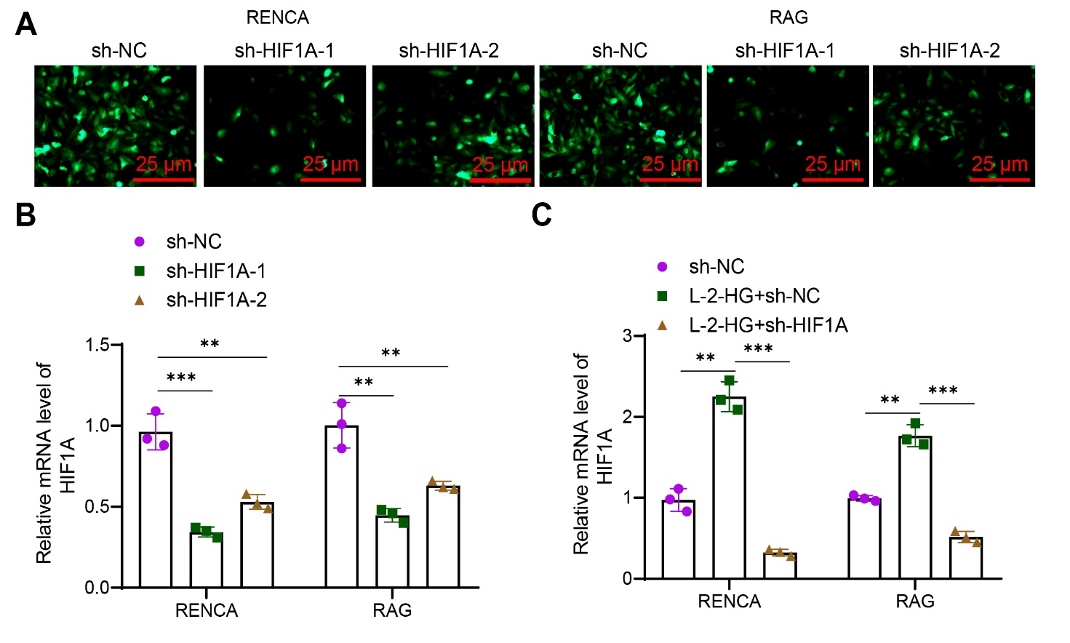
Figure S5. Evaluation of cell transfection efficiency.
Note: (A) Observation of cell transfection efficiency using fluorescence microscopy; (B) Detection of HIF1A expression levels in different transfection groups using RT-qPCR; (C) Detection of the impact of different treatments on HIF1A expression in cells using RT-qPCR. * and ** indicate P < 0.01 and P < 0.001, respectively, for the comparison between the two groups. The cell experiments were repeated three times.

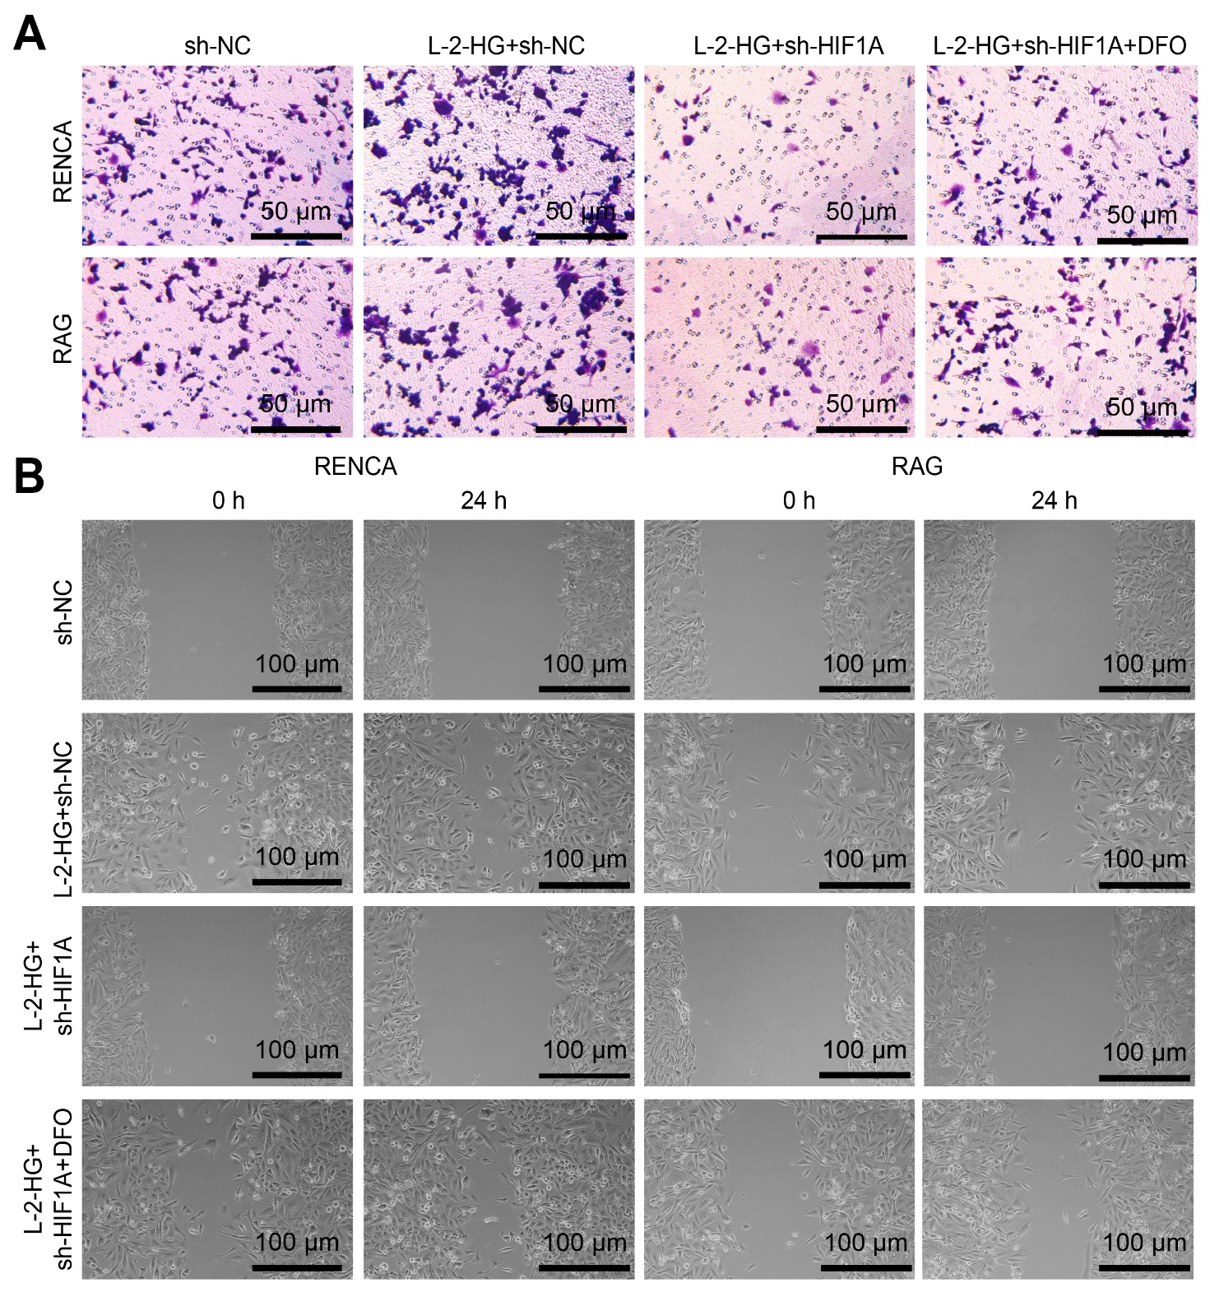
Figure S6. Detection of malignant phenotypes in RCC cells.
Note: (A) Transwell assay was conducted to detect the invasive ability of cells in each group; (B) Scratch assay was performed to detect the migration ability of cells in each group. The cell experiments were repeated three times.

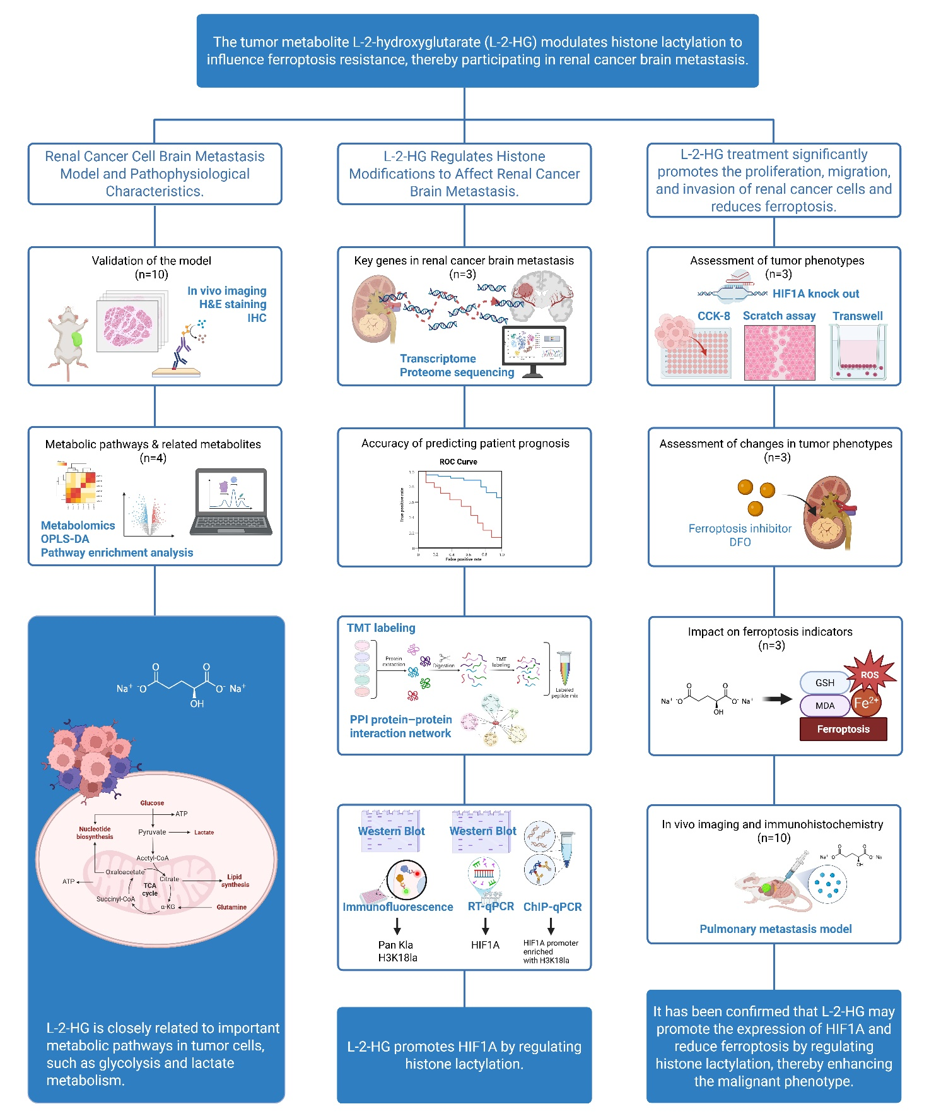
Figure S7. Overview of experimental design, methods, and replicates.
Schematic illustration summarizing the major experimental workflows, including both in vitro and in vivo assays. Key abbreviations and the number of biological and technical replicates are presented for each method to aid in manuscript interpretation (Created with BioRender.com).

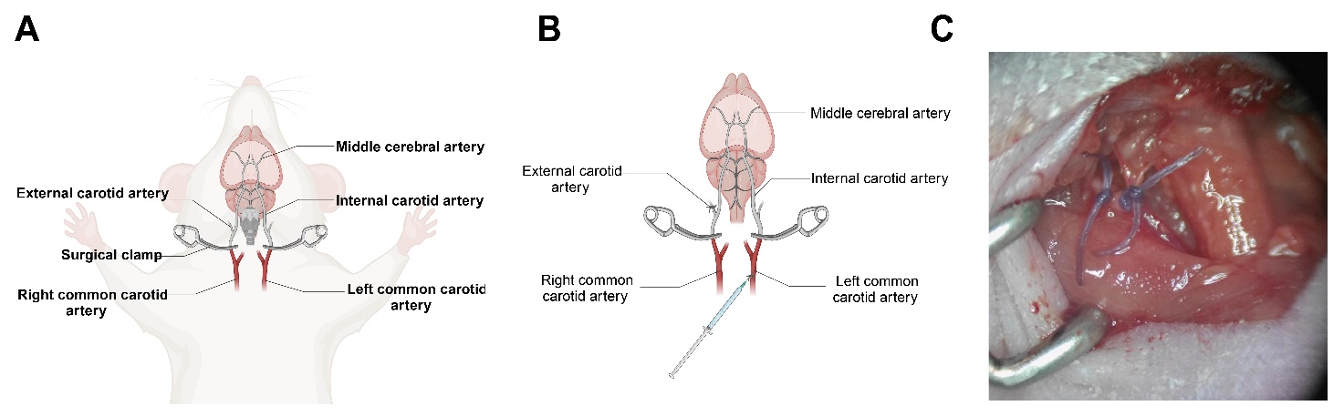
Figure S8. Construction of mouse RCC brain metastasis model.
Note: (A) Schematic diagram of mouse cranial anatomy (Created with BioRender.com); (B) Schematic diagram of tumor cell injection site and blood vessels (Created with BioRender.com); (C) Display of the carotid artery ligation experiment.

