Full and uncropped western blots of Figure 5A-1
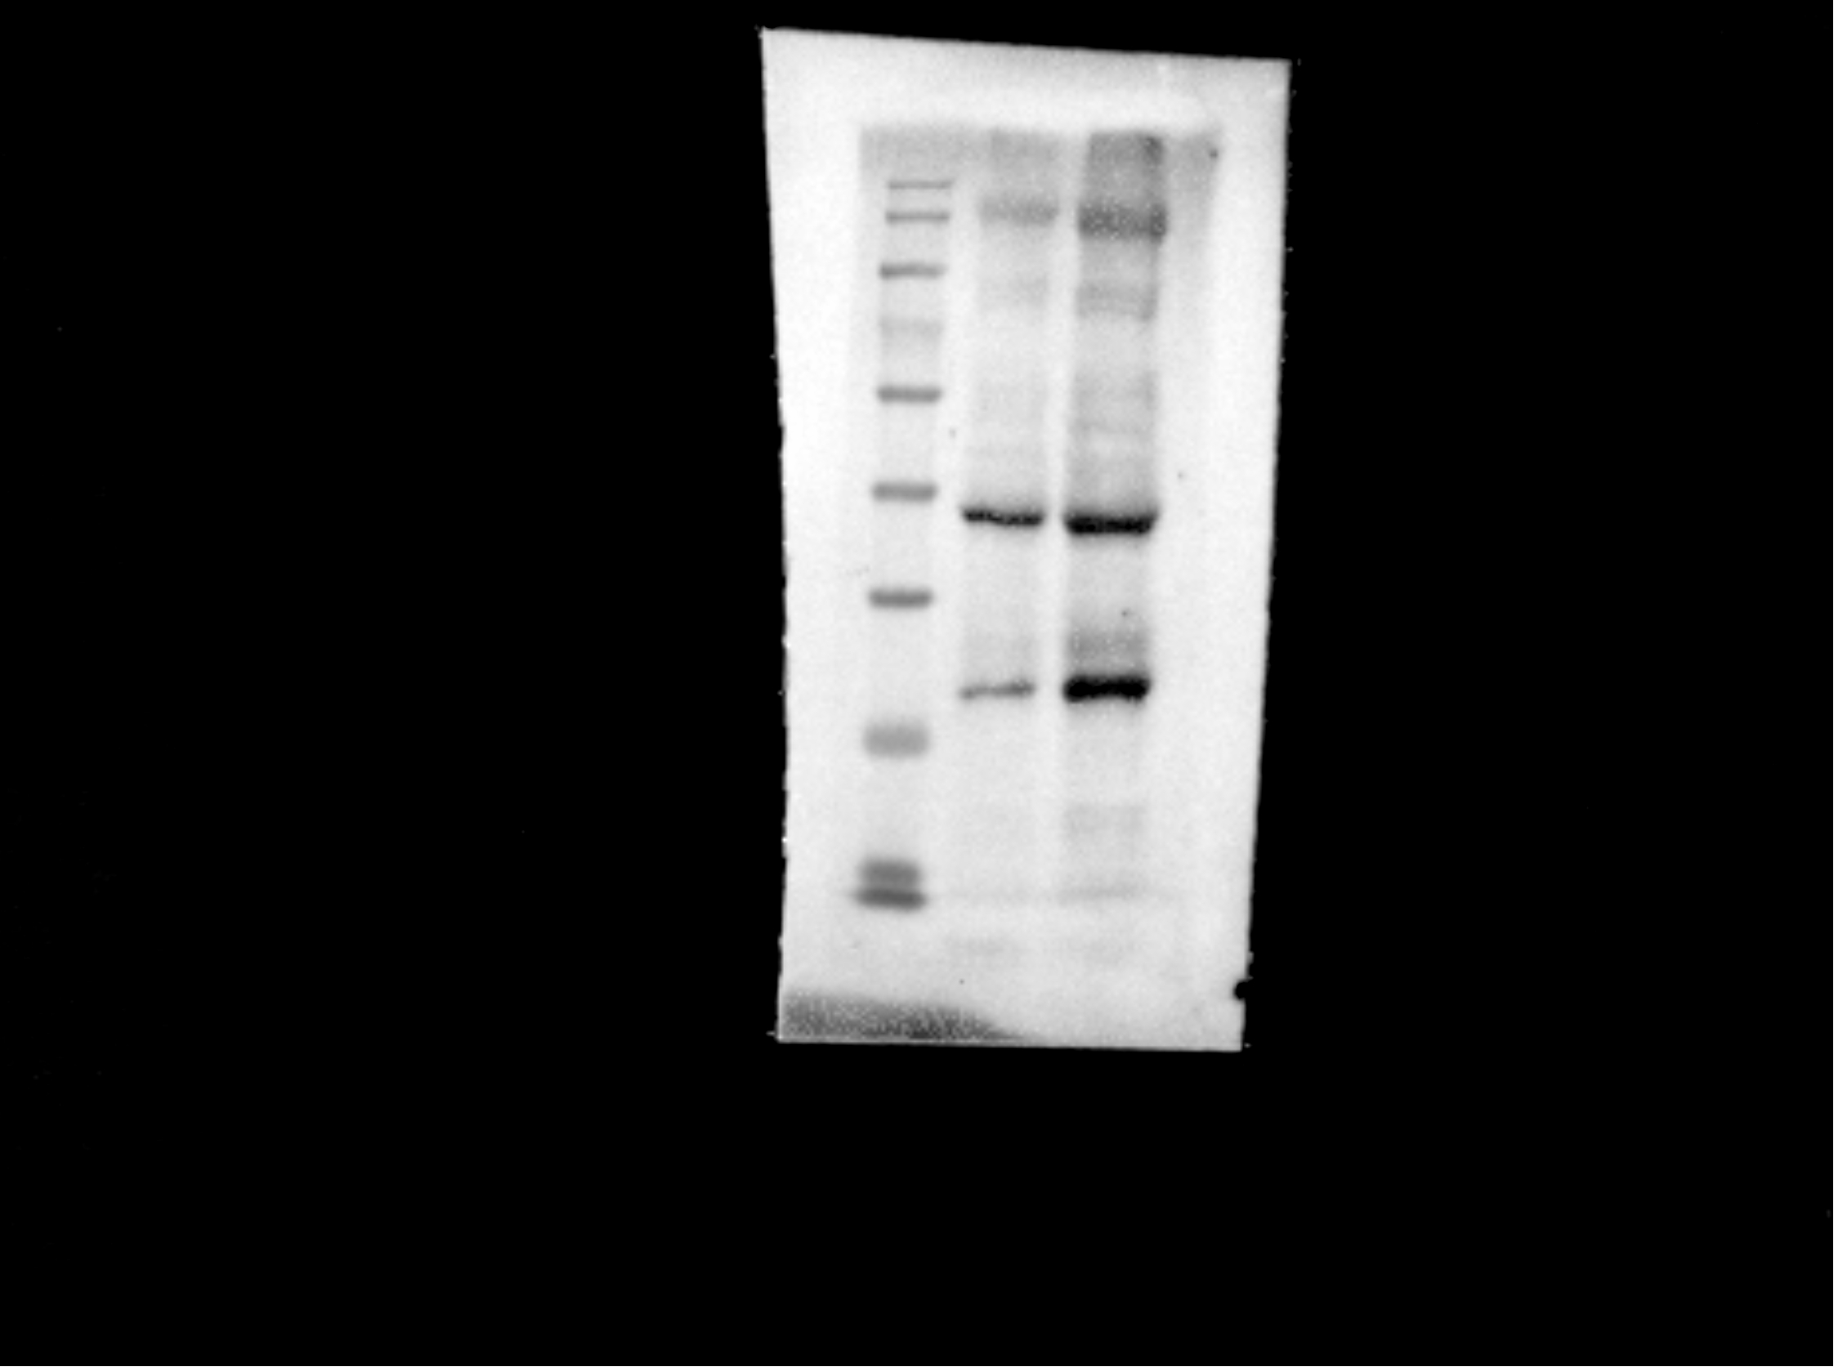
Full and uncropped western blots of Figure 5A-2
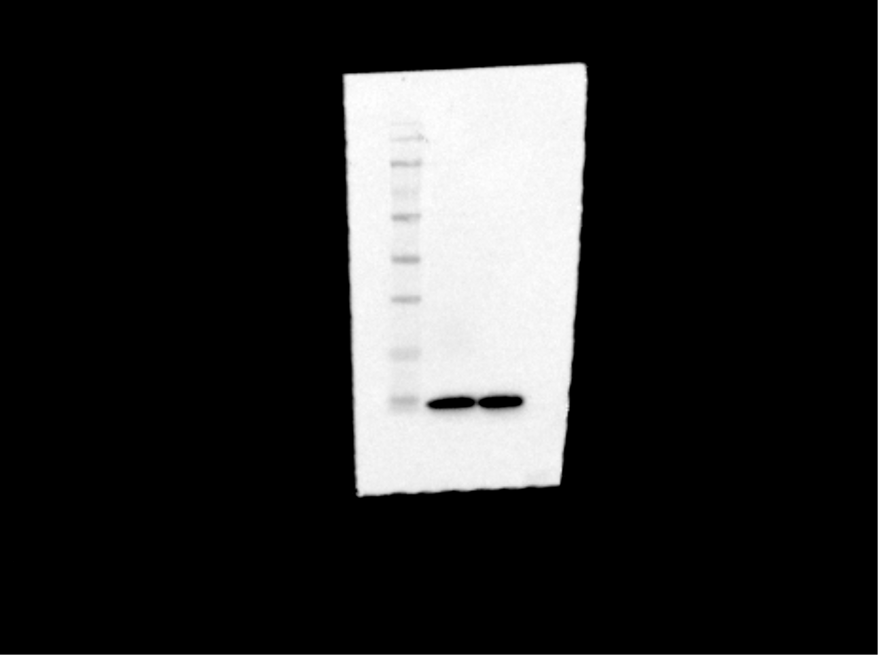
Full and uncropped western blots of Figure 5B-1
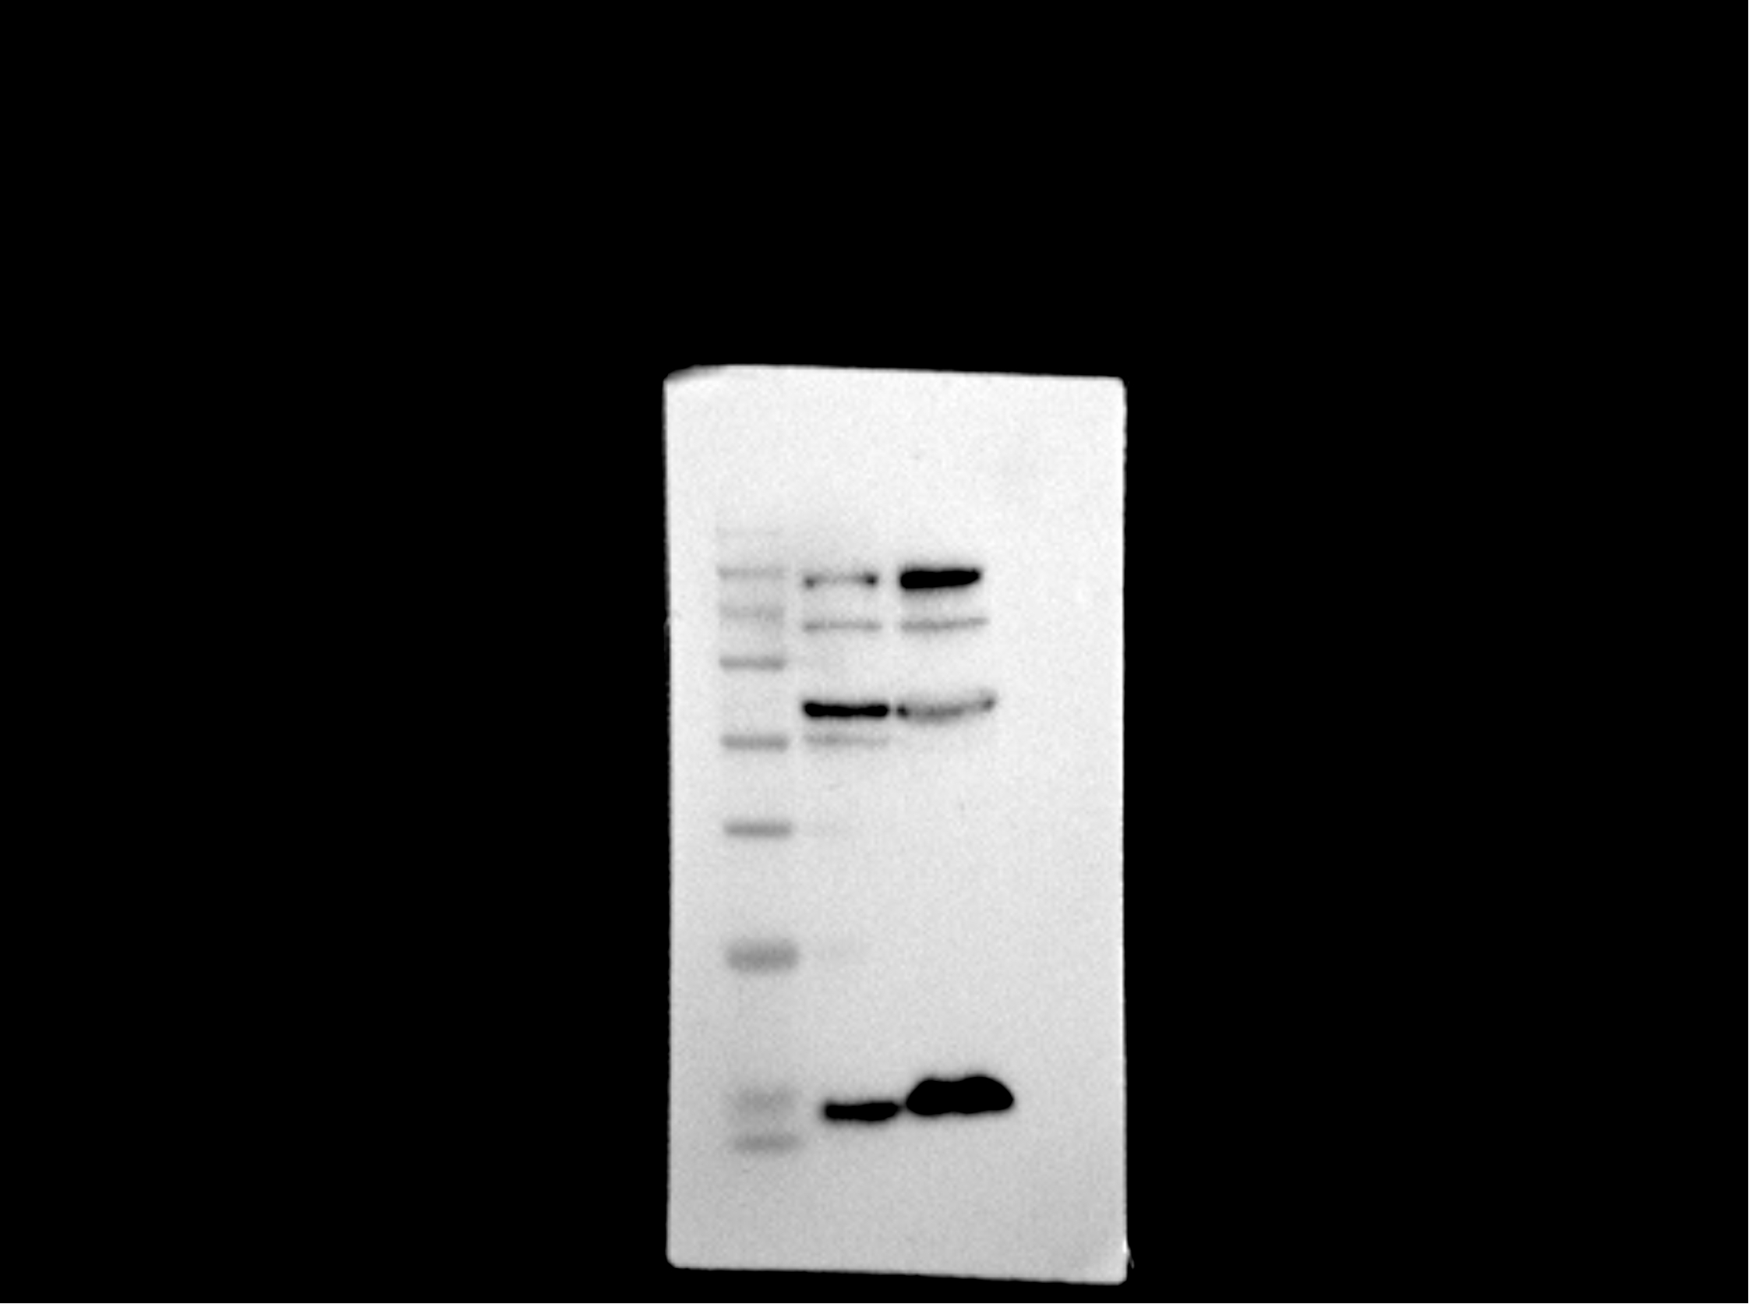
Full and uncropped western blots of Figure 5B-2
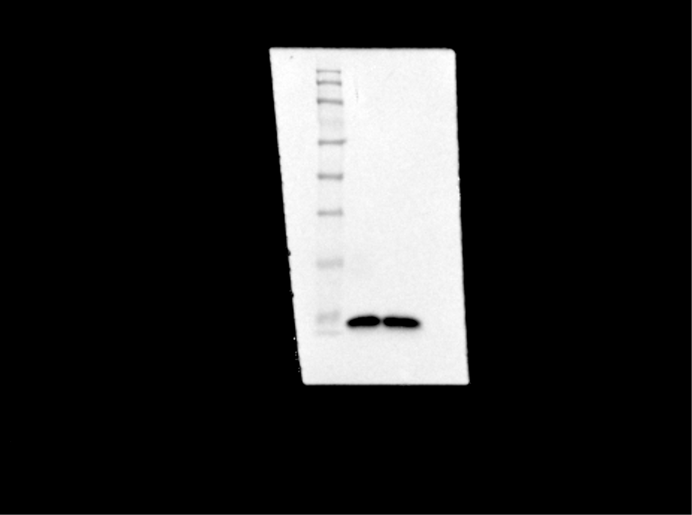
Full and uncropped western blots of Figure 5C-1
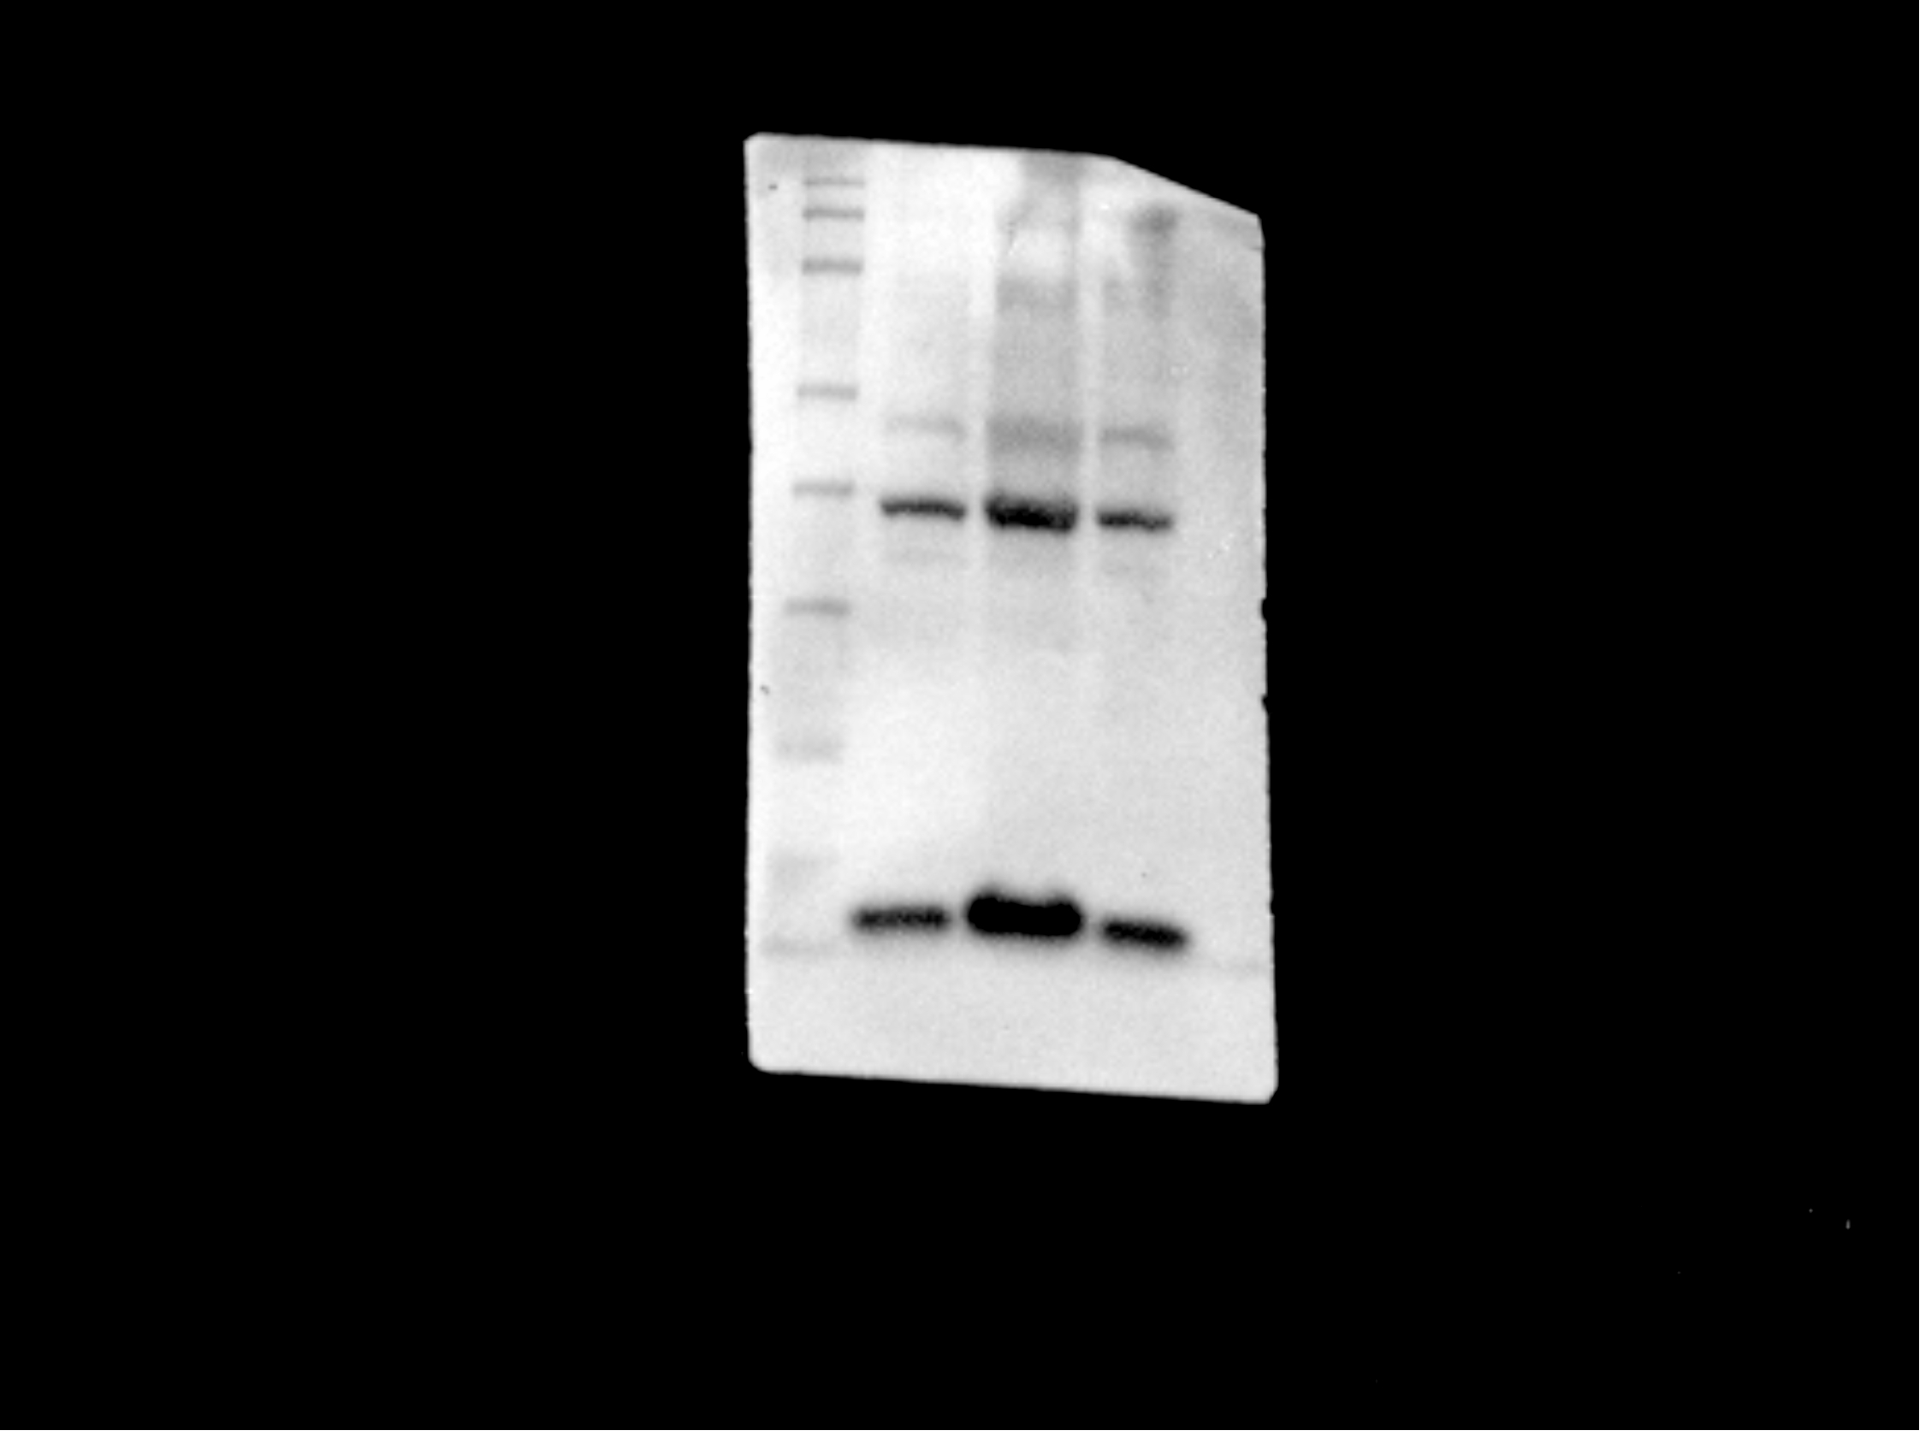
Full and uncropped western blots of Figure 5C-2
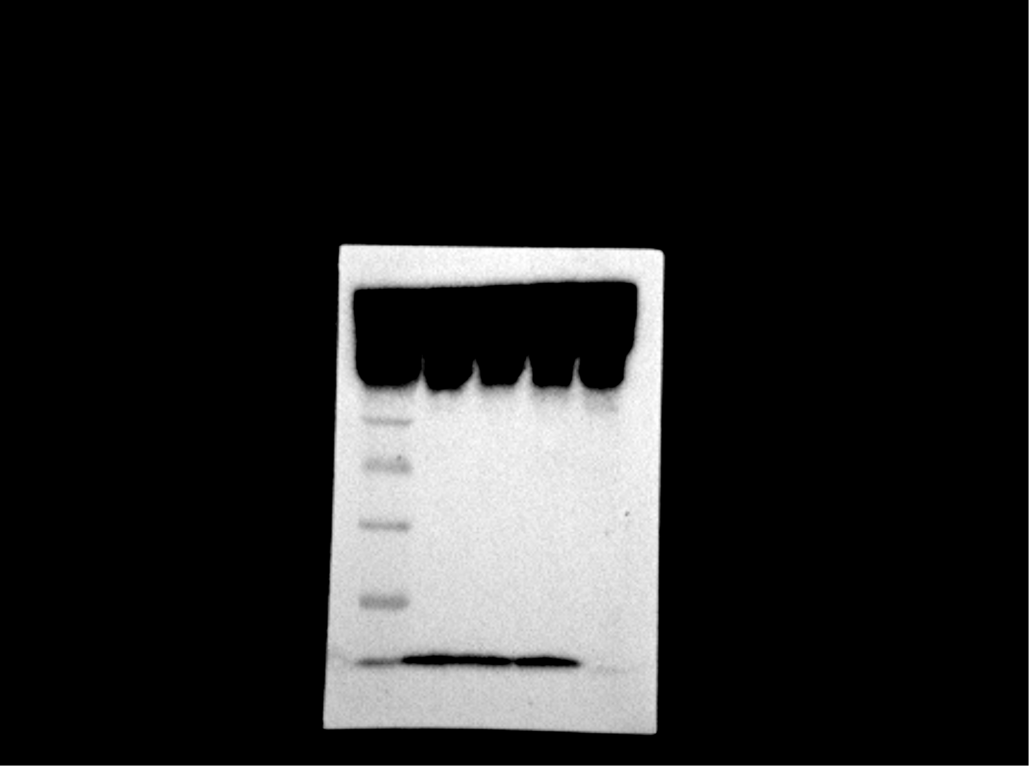
Full and uncropped western blots of Figure 5C-3
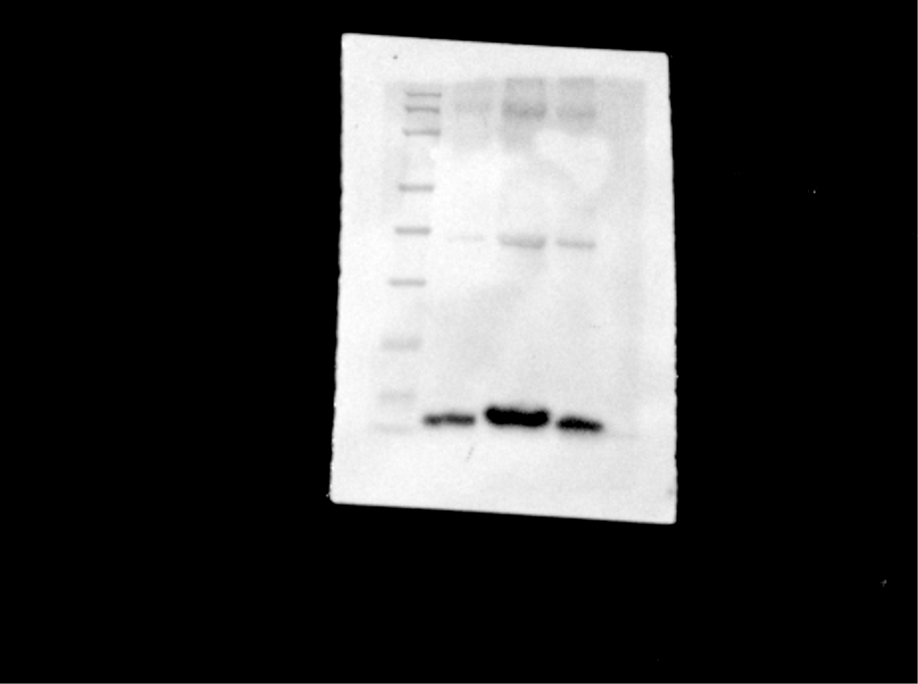
Full and uncropped western blots of Figure 5C-4
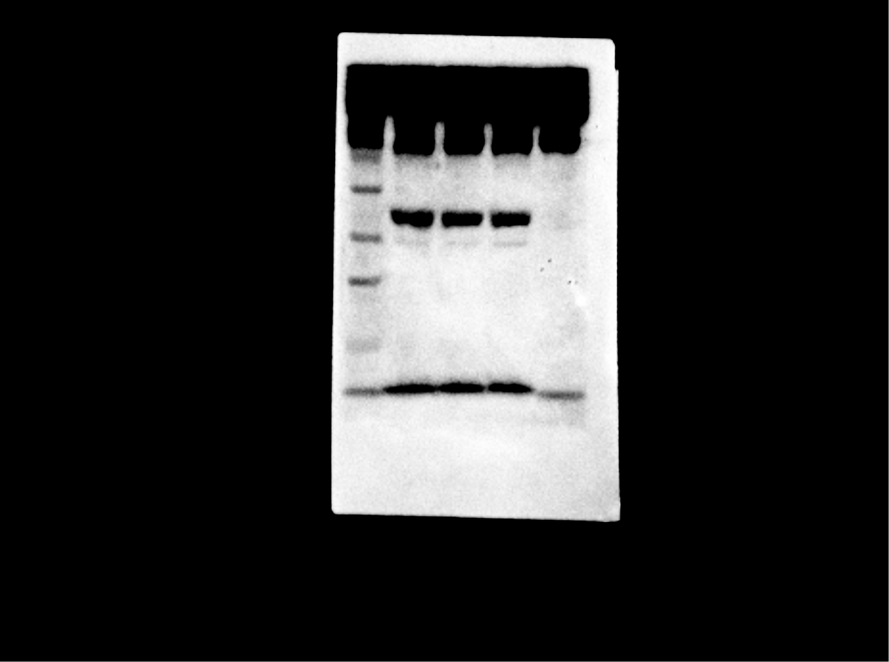
Full and uncropped western blots of Figure 5E-1
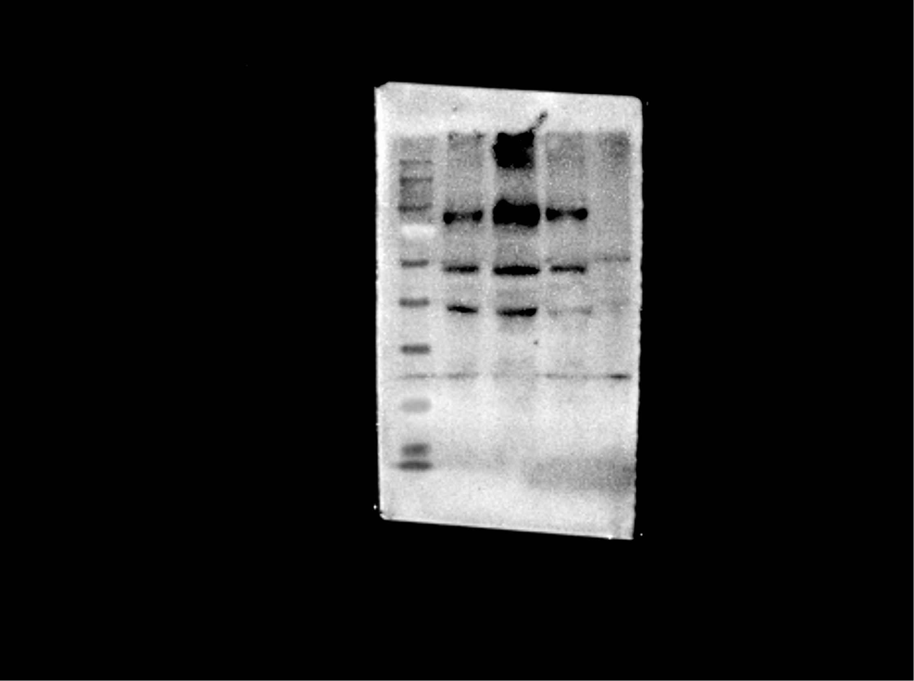
Full and uncropped western blots of Figure 5E-2
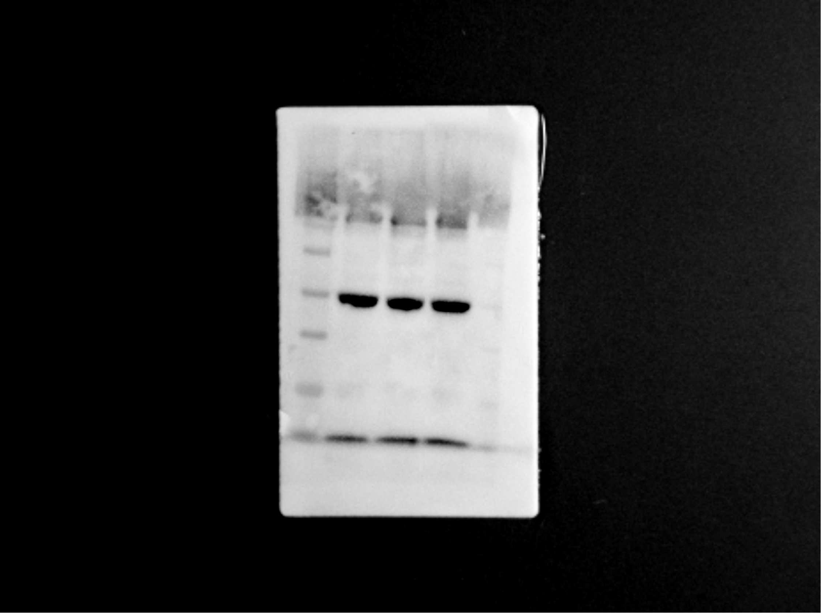
Full and uncropped western blots of Figure 5E-3
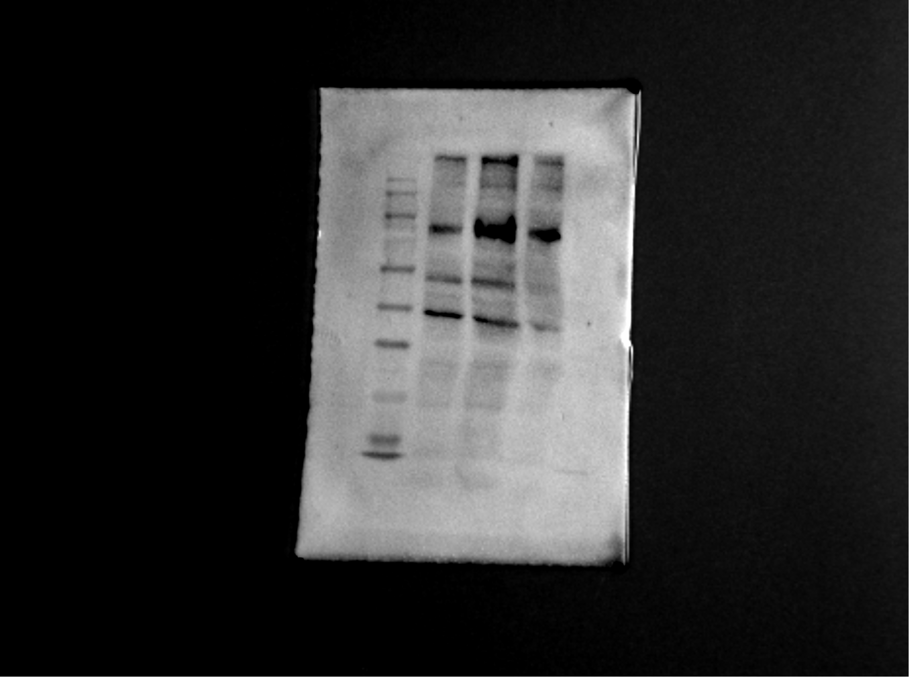
Full and uncropped western blots of Figure 5E-4
