MLKL in liver parenchymal cells promotes liver cancer in murine metabolic dysfunction-associated steatotic liver disease

Ghiles Imerzoukene, Ghania Hounana Kara-Ali, Céline Heitz-Marchaland, Thibaut Larcher, Mélanie Simoes Eugénio, Annaïg Hamon, Aurore Bidon, Gevorg Ghukasyan, Laurence Dubreil, Nicolas Loiseau, Sarah Dion, Céline Raguenes-Nicol, Claire Piquet-Pellorce, Michel Samson, Marie-Thérèse Dimanche-Boitrel and Jacques Le Seyec

Table of contents:

Fig. S1: Pathological hyperglycemia in STZ-treated mice.
Fig. S2: Metabolic stress in mice subjected to the MASH-HCC protocol.
Table S1: Sequences of primers used for real-time quantitative PCR.
Table S2: List of used antibodies.

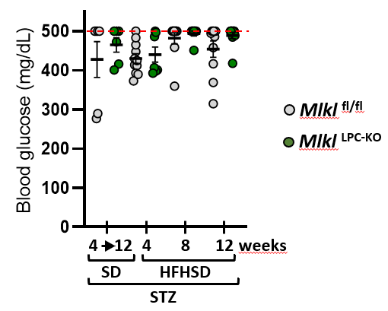
Fig. S1. Pathological hyperglycemia in STZ-treated mice. Mlkl^{fl/fl} and Mlkl^{LPC-KO} mice with streptozotocin (STZ)-induced diabetes were fed either a standard diet (SD) for a period of 4 to 12 weeks or a high-fat high-sugar diet (HFHSD) for 4, 8, or 12 weeks. Fed-state blood glucose was measure at euthanasia. Each grey and green dots represent Mlkl^{fl/fl} and Mlkl^{LPC-KO} individuals, respectively. Errors bars: means ± SEM. The glucometer used for blood glucose measurements had an upper detection limit of 500 mg/dL, indicated in the graph by a red dotted line.

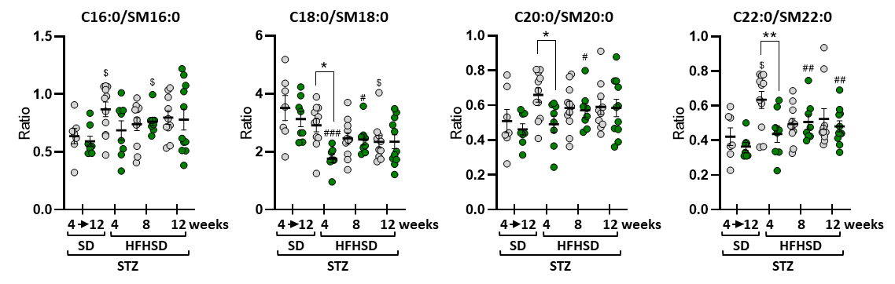
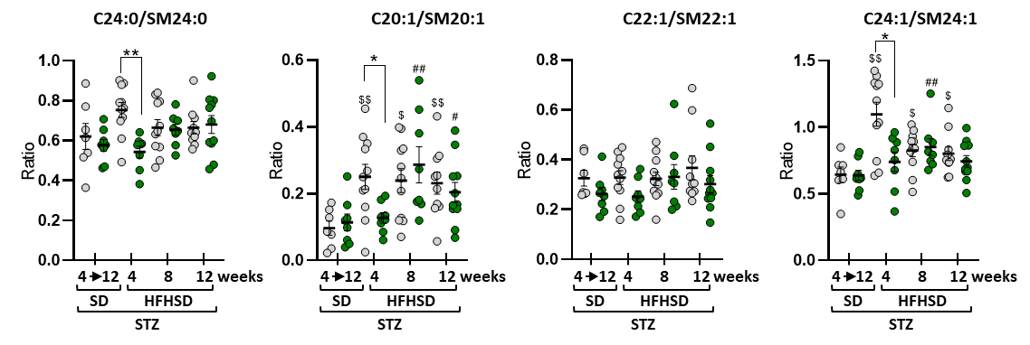
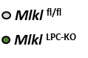
Fig. S2. Metabolic stress in mice subjected to the MASH-HCC protocol. Mlkl^{fl/fl} and Mlkl^{LPC-KO} mice with streptozotocin (STZ)-induced diabetes were fed either a standard diet (SD) for a period of 4 to 12 weeks or a high-fat high-sugar diet (HFHSD) for 4, 8, or 12 weeks. Hepatic ceramide-to-sphingomyelin ratios for individual lipid species. Each grey and green dots represent Mlkl^{fl/fl} and Mlkl^{LPC-KO} individuals, respectively. Errors bars: means ± SEM (*p < 0.05 and **p < 0.01 compared Mlkl^{LPC-KO} to Mlkl^{fl/fl} mice under similar experimental conditions; $p < 0.05 and $$p < 0.01 compared Mlkl^{fl/fl} diabetic mice on HFHSD vs on SD; #p < 0.05, ##p < 0.01 and ###p < 0.001 compared Mlkl^{LPC-KO} diabetic mice on HFHSD vs on SD).

Table. S1. Sequences of primers used for real-time quantitative PCR.
Gene | Forward primer | Reverse primer
18S | GTAACCCGTTGAACCCCATT | CCATCCAATCGGTAGTAGCG
Mlkl | ATGCCAGCGTCTAGGAAACC | TGTCATCGGGCAGGTTCTTC
Tgfb1 | CACCATCCATGACATGAACC | CAGAAGTTGGCATGGTAGCC
ColA1A | GAAGCACGTCTGGTTTGGA | ACTCGAACGGGAATCCATC
Acta2 | GTCCCAGACATCAGGGAGTAA | TCGGATACTTCAGCGTCAGGA
Tnf-a | TAGCTCCCAGAAAAGCAAGC | TTTTCTGGAGGGAGATGTGG
Il-1b | GATCCACACTCTCCAGCTGCA | CAACCAACAAGTGATATTCTCCA
Il-6 | CCGGAGAGGAGACTTCACAG | TCCACGATTTCCCAGAGAAC
Ccl2 | TCTGGACCCATTCCTTCTTG | AGGTCCCTGTCATGCTTCTG
Cd133 | TGGAGCTACCTGCGGTTTAGA | GGACCTGTGATTGCGATAATGA
Nrf2 | TAGATGACCATGAGTCGCTTGC | GCCAAACTTGCTCCATGTCC
Keap-1 | CATCCACCCTAAGGTCATGGA | GACAGGTTGAAGAACTCCTCC
p62 | CAGGCACCCCGAAACATG | ACTTATAGCGAGTTCCCACCA
Hmox1 | AGGTACACATCCAAGCCGAGA | CATCACCAGCTTAAAGCCTTCT
Gpx4 | CCGGCTACAACGTCAAGTTT | TCCATTTCCACAGTGGGTGG
Gclc | GTGCTCAAGTGGGGTGACGA | GGGTCGGATGGTTGGGGTTT
Ogg1 | TGAGCTGCGTCTGGACTTGGTT | CTCCGTCTGAGTCAGTGTCCA

Table. S2. List of used antibodies.
Antibody | Reference | Tissue | IHC  (dilution) | IF  (dilution)
Glutamine synthetase | Abcam, ab73599 | Liver | 1/100
CD68 | Abcam, ab125212 | Liver |  | 1/200
B220 | BioLegend, # 553084 | Spleen |  | 1/2000
CD3 | Dako, A0452 | Liver |  | 1/1000
CD3 | Dako, A0452 | Spleen |  | 1/1000
CD8 | Abcam, ab209775 | Liver |  | 1/500
CD8 | Abcam, ab209775 | Spleen |  | 1/500
CD4 | Interchim, #50134-R001 | Liver |  | 1/200
CD4 | Interchim, #50134-R001 | Spleen |  | 1/200
FOXP3 | Fisher Scientific, #15247457 | Liver |  | 1/50
FOXP3 | Fisher Scientific, #15247457 | Spleen |  | 1/50
PD-L1 | Cell Signaling, #13684 | Liver |  | 1/50
PD-1 | NovusBio, #NBP1-77276 | Liver |  | 1/1000
Collagen I a1 (Col1a1) | Abcam, ab34710 | Liver |  | 1/100
8-OHdG | Abcam, ab48508 | Liver |  | 1/100
Ki67 | Novusbio, NB600-1252 | Liver |  | 1/100

IHC: Immunohistochemistry; IF: Immunofluorescence

