Supplementary Information

Lactic acid drives NLRP3 inflammasome activation and caspase-1–like cytokine cleavage via intracellular acidification
Hsin-An Lin, Hsin-Chung Lin, Ming-Hang Tsai, Yu-Jen Chen, Bo-Ying Bao, Kuen-Jou Tsai, Chieh-Tien Shih, Jau-Song Yu, Kun-Yi Chien, Kuo-Yang Huang, David M. Ojcius, and Lih-Chyang Chen

Supplementary Contents
Supplementary Figures and Figure Legends
Supplementary Fig. S1. Pharmacological modulation of GPR81 does not alter extracellular lactic acid–enhanced NLRP3 inflammasome activation.
Supplementary Fig. S2. Inhibition of lactate dehydrogenase suppresses AIM2 inflammasome activation.
Supplementary Fig. S3. Extracellular lactic acid–induced intracellular acidification does not alter potassium efflux during NLRP3 inflammasome activation.

Supplementary Fig. S1

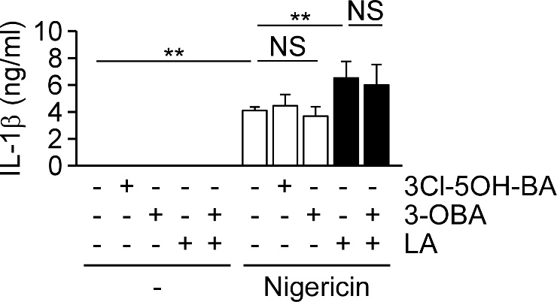

Supplementary Fig. S1. Pharmacological modulation of GPR81 does not alter extracellular lactic acid–enhanced NLRP3 inflammasome activation. THP-1-derived macrophages were stimulated with nigericin in the presence or absence of extracellular lactic acid (10 mM), the GPR81 antagonist 3-OBA (15 mM), or the GPR81 agonist 3Cl-5OH-BA (1 mM). IL-1β levels in culture supernatants were quantified by ELISA (n = 3). Data are presented as mean ± SD. Statistical significance was determined by one-way ANOVA with Tukey’s HSD post hoc test; NS, not significant; **P < 0.01.
Supplementary Fig. S2

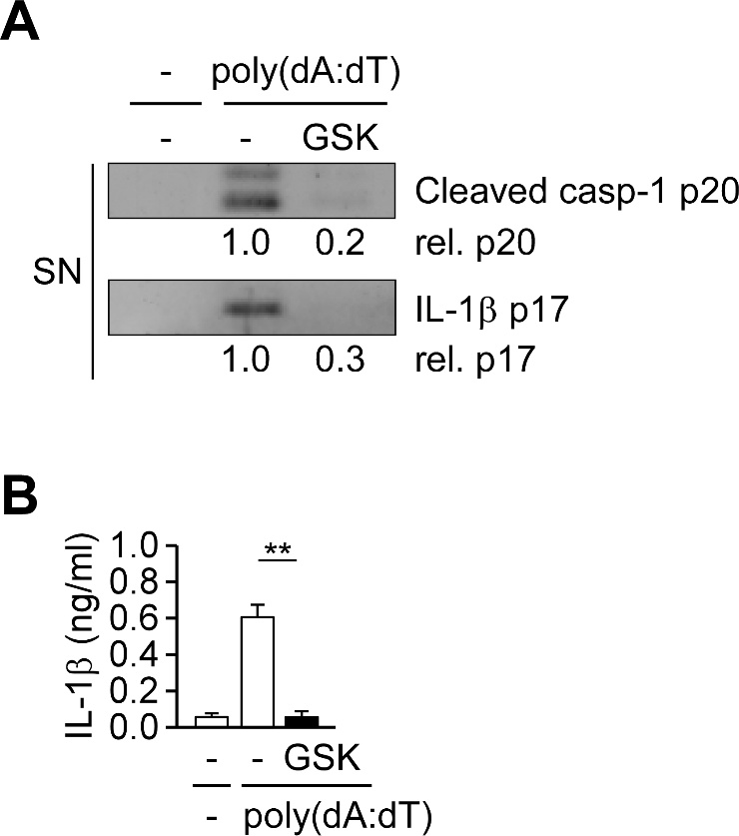

Supplementary Fig. S2. Inhibition of lactate dehydrogenase suppresses AIM2 inflammasome activation. (A) Immunoblot analysis of caspase-1 p20 and IL-1β p17 in culture supernatants of THP-1-derived macrophages stimulated with poly(dA:dT) in the presence or absence of the lactate dehydrogenase inhibitor GSK2837808A (10 μM). The western blot is a representative of three independent experiments. (B) ELISA quantification of IL-1β secretion from THP-1-derived macrophages treated as in (A) (n = 4). Data are presented as mean ± SD. Statistical significance was assessed by one-way ANOVA with Tukey’s HSD post hoc test; **P < 0.01.
Supplementary Fig. S3

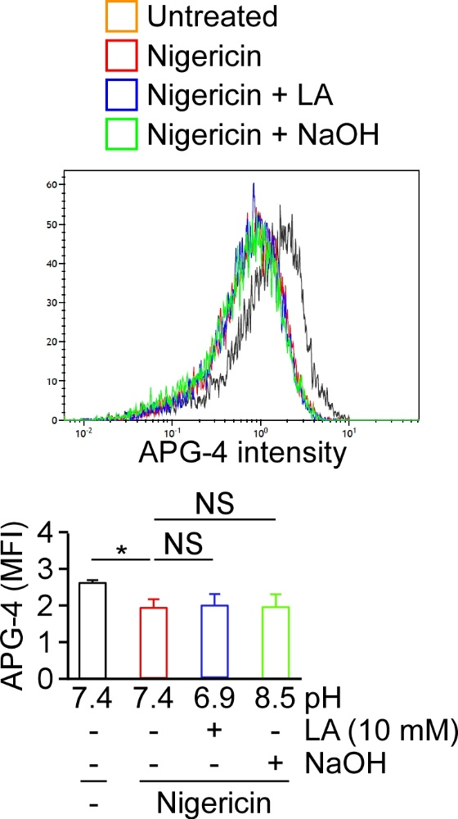

Supplementary Fig. S3. Extracellular lactic acid–induced intracellular acidification does not alter potassium efflux during NLRP3 inflammasome activation. THP-1-derived macrophages were stimulated with nigericin in the presence or absence of extracellular lactic acid (LA, 10 mM; pH 6.9) or extracellular alkalinization (NaOH; pH 8.5) for 8 min. Intracellular potassium levels were quantified by APG-4 fluorescence using flow cytometry (n = 3). Data are presented as mean ± SD and were analyzed by one-way ANOVA with Tukey’s HSD post hoc test; *P < 0.05; NS, not significant.

