Figure 2B
MND1β-actin
Figure 2C
MND1(left) 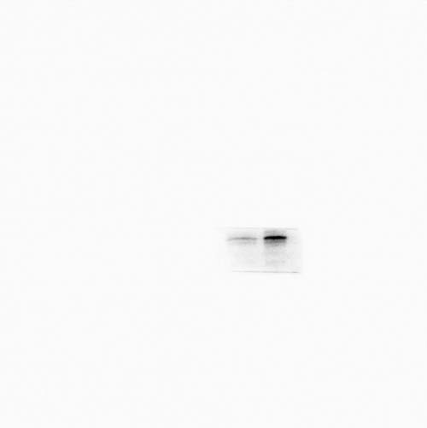 MND1(right)
β-actin(left) β-actin(right)
Figure 2K
E-cadherin (left) E-cadherin (right)
N-cadherin (left) N-cadherin (right)
ABCG2 (left) ABCG2 (right)
β-actin (left) β-actin (right)
Figure 3H
p-ATM (left) p-ATM (right)
γ-H2AX (left) γ-H2AX (right)
RAD51 (left) RAD51 (right)
E2F1 (left) E2F1 (right)
β-actin (left) β-actin (right)
Figure 4D
RAD51 (up) MND1 (up) 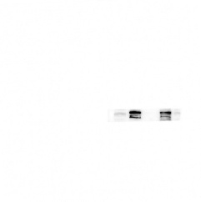
MND1 (down) RAD51 (down)
Figure 4F
Myc (left) Myc (right)
Flag (left) Flag (right)
Figure 4G
RAD51 β-actin
Figure 4I
RAD51 (up) β-actin (up)
RAD51 (down) β-actin (down)
Figure 4K
RAD51 (left) RAD51 (right)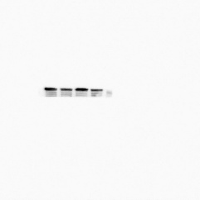
MND1 (left) MND1 (right)
β-actin (left) β-actin (right)
Figure 5A
HA (up) HA (down)
RAD51 β-actin
Figure 5D
MND1 (up) USP5 (up) 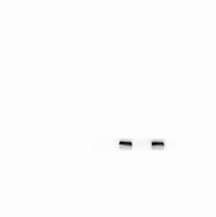
USP5 (down) MND1 (down) 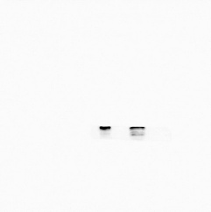
Figure 5E
USP5 (up) USP5 (down)
GST (up) GST (down)
Figure 5F
HA (left) HA (left)
Myc (left) (up) Myc (left) (down)
Myc (right) (up) 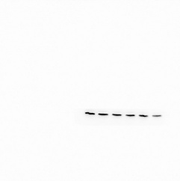 Myc (right) (down)
His (left) His (right) 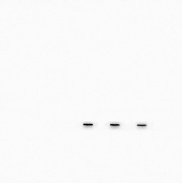
Figure 5G
HA His
Myc (up) Myc (down)
Figure 5H
HA His 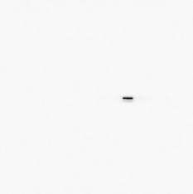
Myc (up) 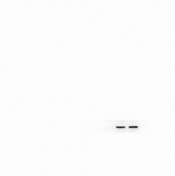 Myc (down) 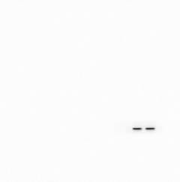
Figure 5I
USP5 Myc 
RAD51 His
Figure 5J
RAD51 β-actin
Figure 5K
RAD51 β-actin
Figure 6F
MND1 (left) 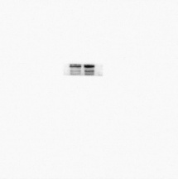 MND1 (right)
β-actin (up) (left) β-actin (up) (right) 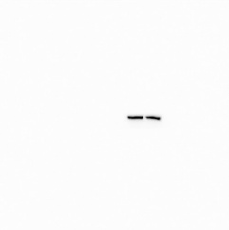

E2F1 (left) 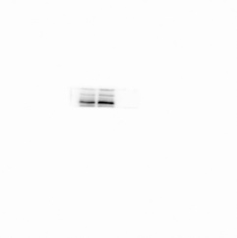 E2F1 (right) 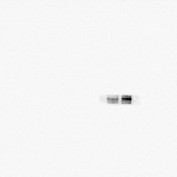
β-actin (down) (left) 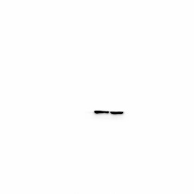β-actin (down) (right) 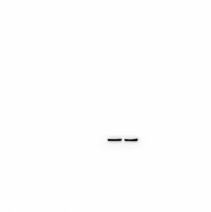
Figure S1A
MND1 β-actin
Figure S2E
XPA MLH1 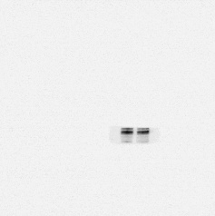
XPC 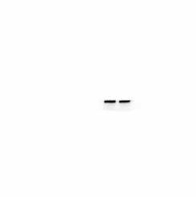 MSH2 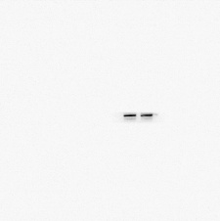
ERCC1 MSH6
β-actin (left) 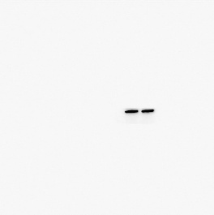β-actin (right) 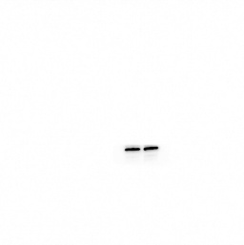
Figure S2F
p-ATM (Ser1981) (left) p-ATM (Ser1981) (right)
γ-H2AX (Ser139) (left) 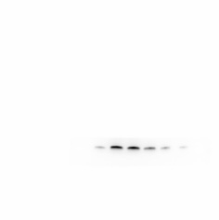γ-H2AX (Ser139) (right) 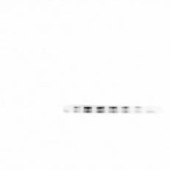
RAD51 (left) 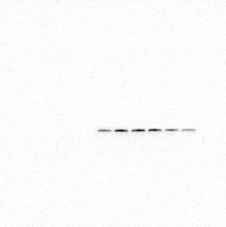 RAD51 (right) 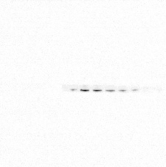
E2F1 (left) 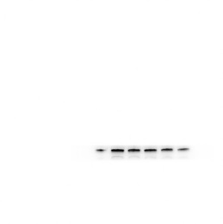 E2F1 (right) 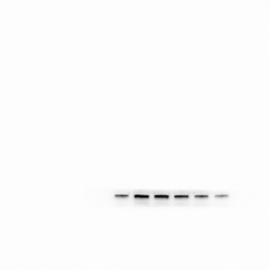
β-actin (left) 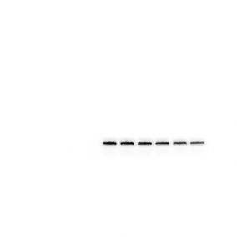β-actin (right) 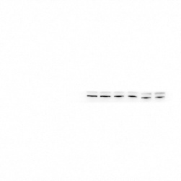
Figure S3A
RAD51 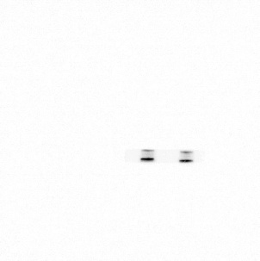 Flag 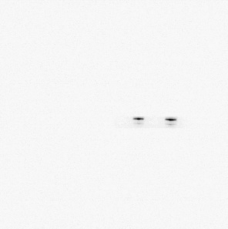
MND1 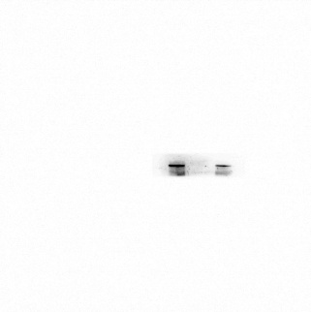 Myc 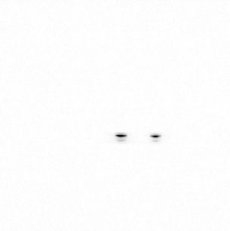
Figure S3B
MND1 RAD51
Figure S3C
RAD51 β-actin
Figure S3F
MND1 E2F1 β-actin
Figure S3G
E2F1 TET1
TET2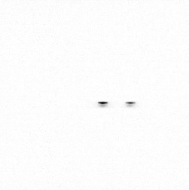 DNMT3B
Figure S4A
p-ATM 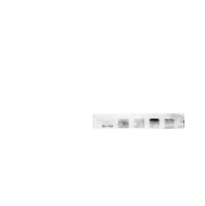 E2F1 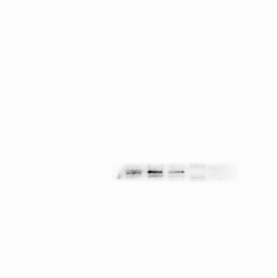
MND1 RAD51 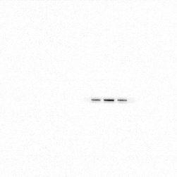β-actin

