Supplementary Figures
Supplementary Figure 1| Quality control of single-cell RNA-seq data from HGSOC specimens. (A-C) Histograms showing the distributions of UMI counts (A), mitochondrial gene percentage (B), and detected gene numbers (C) before quality control. (D-F) Histograms showing the distributions of UMI counts (D), mitochondrial gene percentage (E), and detected gene numbers (F) after quality control.

Supplementary Figure 2 | The sources and proportions of samples in the single-cell data. (A) UMAP plots showing the sources of samples from all samples of scRNA-seq cohort. (B) Cell proportions of major cell types in different lesions.
Supplementary Figure 3 | ERO1A drives SKOV3 cells migration and peritoneal metastasis in vitro and in vivo. (A) Transwell migration and invasion assays. n = 3. OE versus NC analyzed by t-test. Knockdown groups analyzed by one-way ANOVA with Tukey’s post hoc test. Scale bars, 200 μm. (B) Scratch-wound assays at 0 h and 24 h showing wound-healing ratios. n = 3. OE versus NC by two-sided t-test; knockdown by one-way ANOVA with Tukey’s post hoc test. Scale bars, 200 μm. (C-D) Representative in vivo bioluminescence back (C) and abdominal (D) images at 7 d (C) and 14 d (D) after implantation and corresponding photon-flux quantification. (E) Gross tumors from orthotopic SKOV3 shNC and shERO1A groups with tumor volume quantification (mm³). Scale bar, 1 cm. Two-sided t-tests. shNC n = 4; shERO1A n = 4. *P < 0.05, **P < 0.01, ***P < 0.001; ns, not significant.
Supplementary Figure 4 | ERO1A promotes endothelial angiogenesis through VEGFA in SKOV3. (A) CellChat analysis reveals the roles of various cell clusters in the VEGF signaling pathway. (B) Ranked ligand-receptor pairs contributing to E04-endothelium communication. (C–D) HUVEC tube-formation with indirect conditioned medium from control (NC) or ERO1A-overexpressing (OE-ERO1A) SKOV3, ± VEGFA-neutralizing antibody (α-VEGFA) (C) or supplementation with recombinant VEGFA (r-VEGFA) (D). n = 3, one-way ANOVA with Sidak’s multiple-comparisons test.
Supplementary Figure 5 | Targeting ERO1A enhances platinum sensitivity of SKOV3 cells in vitro and in vivo. (A) UMAP plots of malignant epithelial cells colored by treatment status(left) and PFI groups (right). (B) Cisplatin dose-response of SKOV3 with ERO1A overexpression (OE-ERO1A) or control (NC). IC₅₀ was estimated by nonlinear regression; IC₅₀ comparisons by two-sided t-test, n = 3. (C) Representative laparotomy images (red arrows, peritoneal deposits) and quantification of the number of intraperitoneal metastatic lesions in SKOV3. (D) Excised primary ovarian tumors and quantified volumes (mm³) from SKOV3. Scale bars, 1 cm. n = 3/4. For C-D, dots represent individual mice. one-way ANOVA followed by Tukey’s multiple-comparison test across the four groups. (E) Western blots images of stable VEGFA knockdown in OVCAR3. n = 3. Two-sided t-test. *P < 0.05, **P < 0.01, ***P < 0.001.
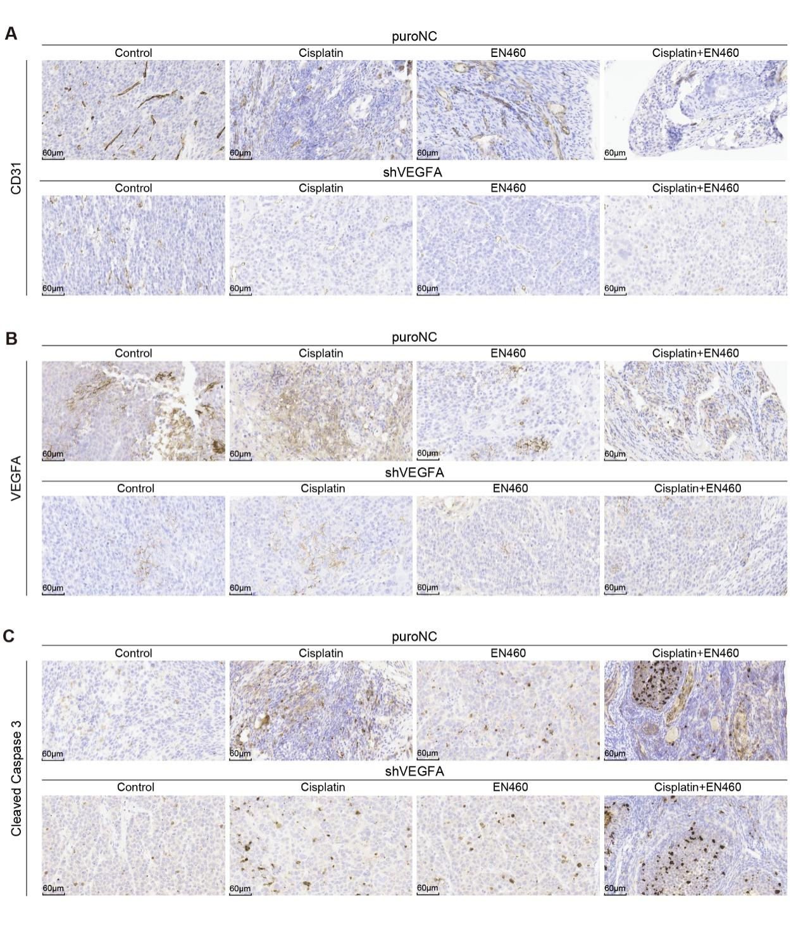
Supplementary Figure 6 | Representative immunohistochemical images of orthotopic primary ovarian lesions from the VEGFA-knockdown rescue experiment. (A) Representative CD31 immunohistochemical staining of orthotopic primary ovarian tumors from the puroNC and shVEGFA groups treated with vehicle control, cisplatin, EN460, or cisplatin plus EN460. (B) Representative VEGFA immunohistochemical staining of orthotopic primary ovarian tumors from the puroNC and shVEGFA groups treated as indicated. (C) Representative cleaved Caspase 3 immunohistochemical staining of orthotopic primary ovarian tumors from the puroNC and shVEGFA groups treated as indicated. All representative IHC images were obtained from orthotopic primary ovarian tumor lesions. Scale bars, 60 μm.

