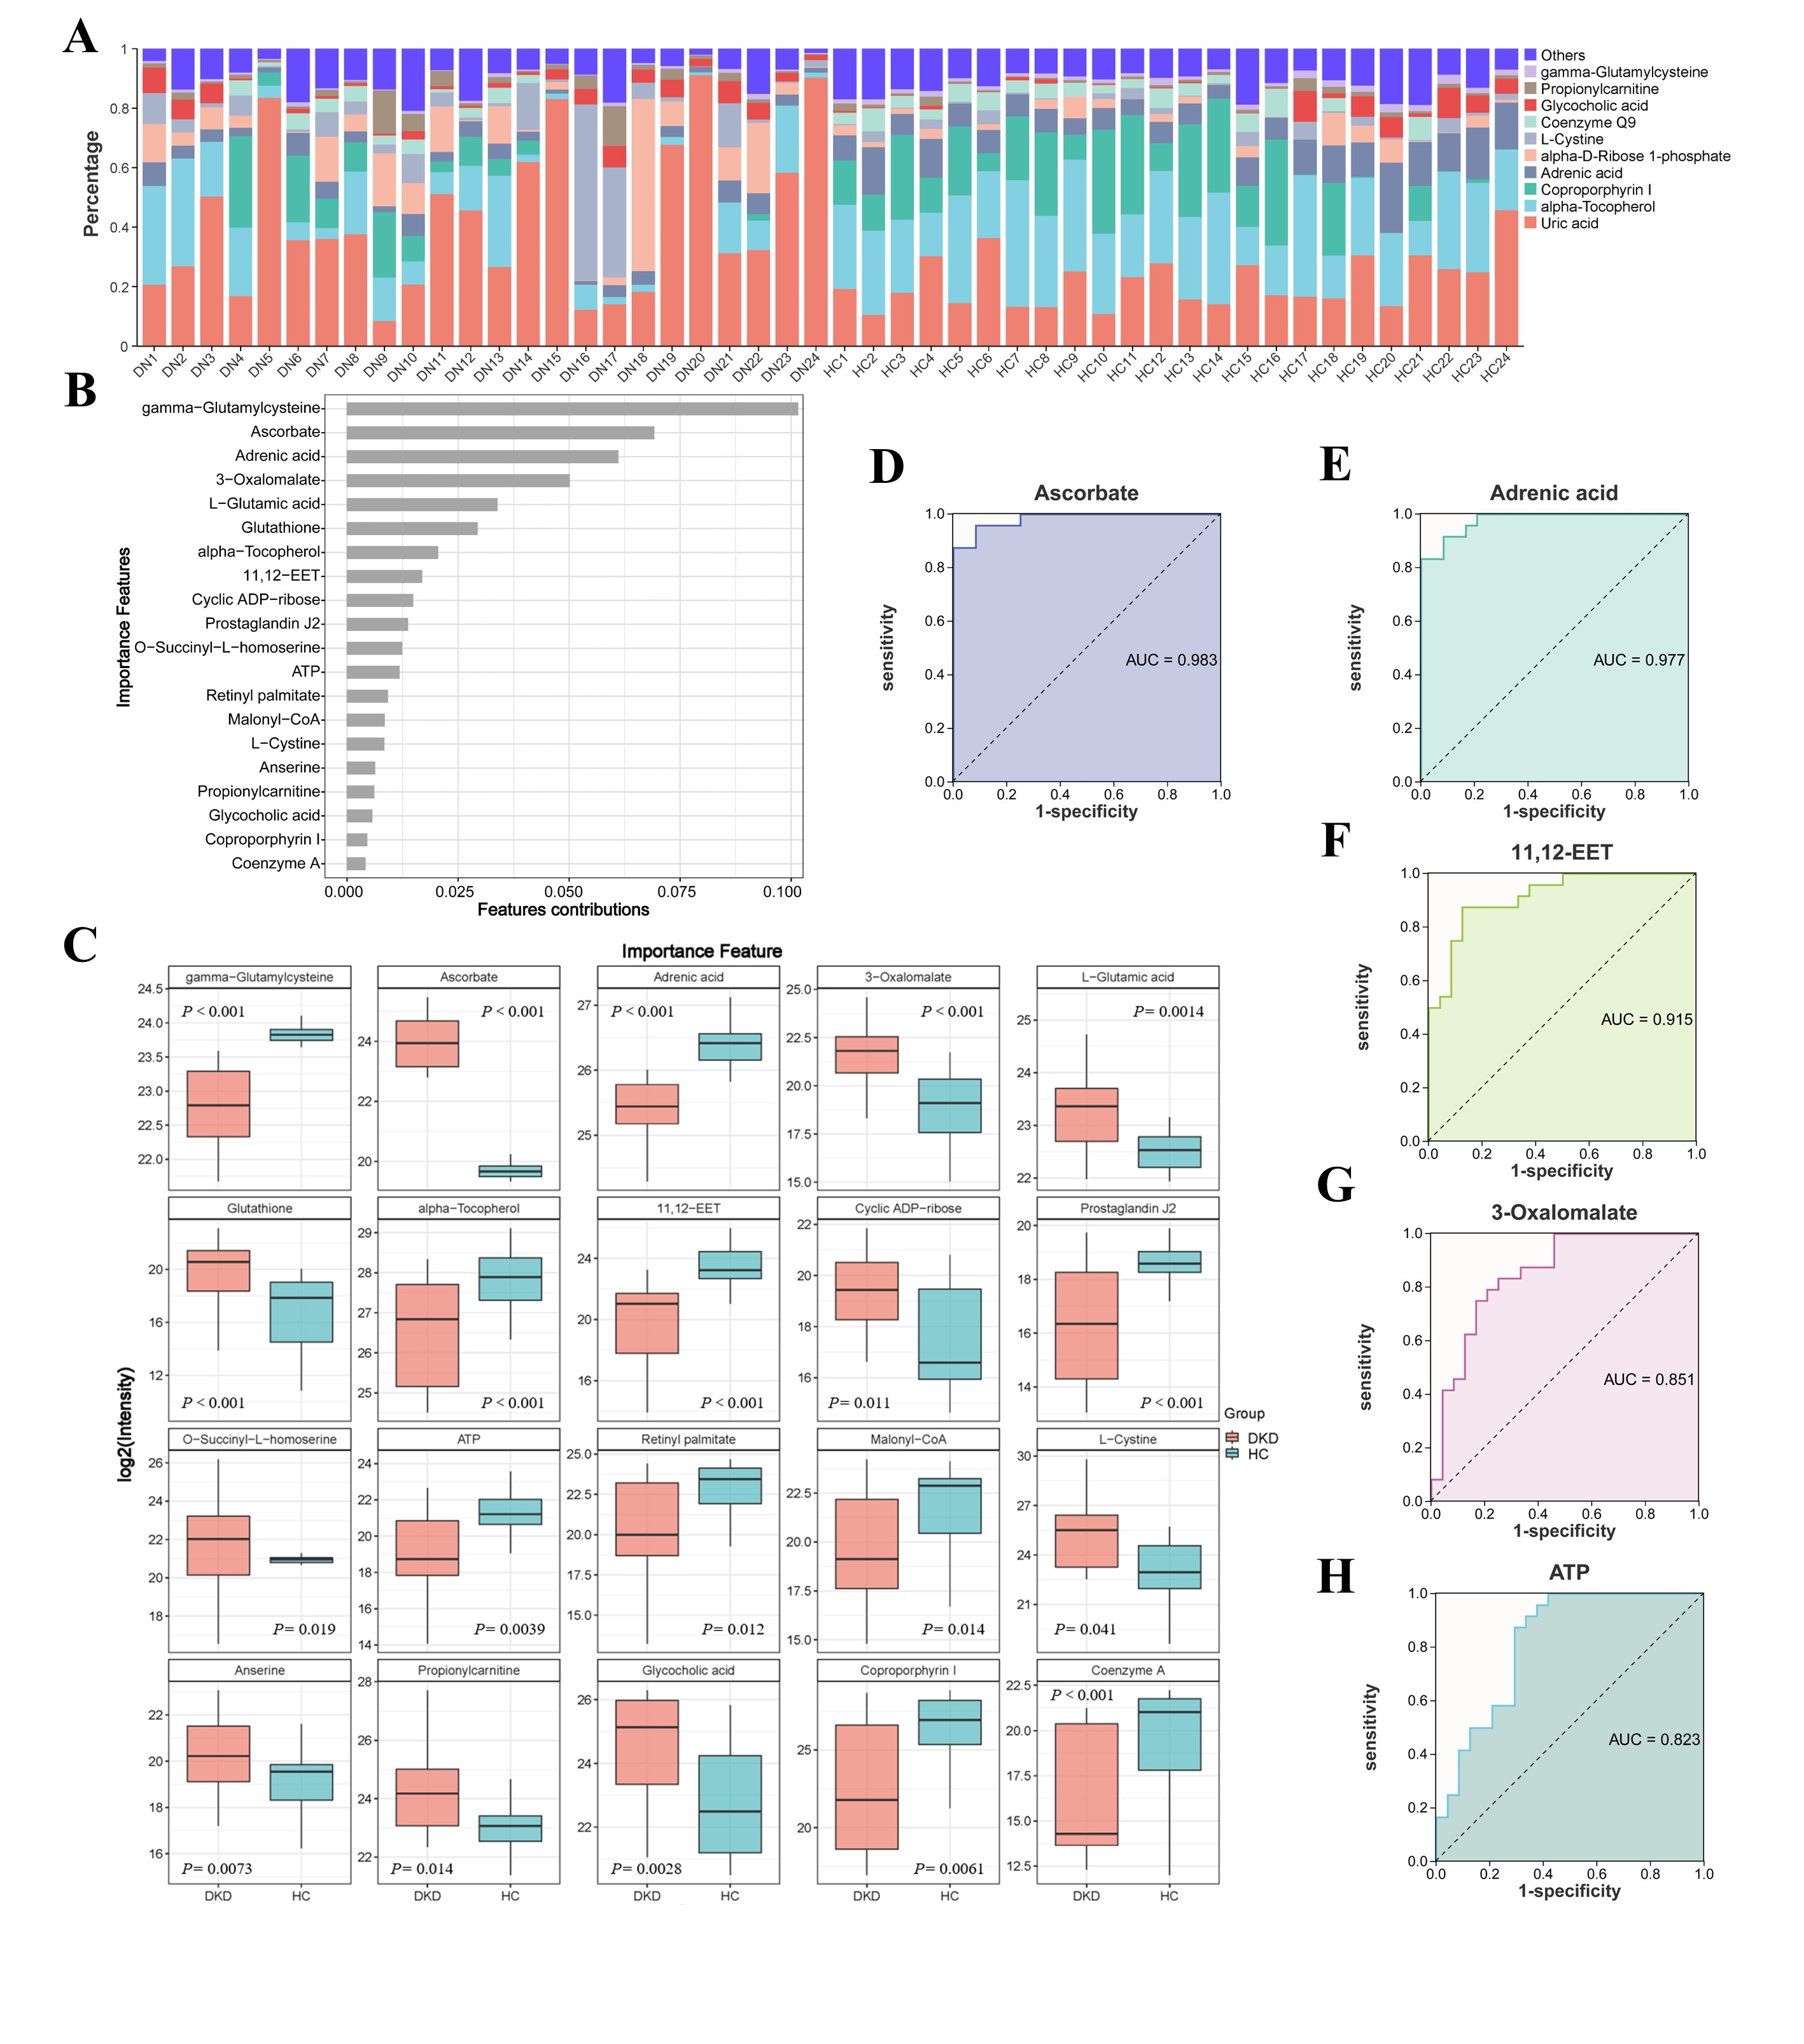
Figure S1. Metabolomic profiling reveals key metabolites and diagnostic biomarkers for diabetic kidney disease (DKD).
(A) Stacked bar chart showing the relative abundance of the top 10 most abundant metabolites across all samples. Each colored segment represents the proportional contribution of a single metabolite to the total ion abundance within each sample, providing an overview of the dominant metabolic patterns in the cohort. (B) SHAP summary plot for the top 20 most influential metabolites in the random forest classification model. The x-axis (SHAP value) indicates the impact on the model output for predicting DKD, with γ-GC identified as the feature with the highest mean absolute SHAP value, highlighting its primary importance in distinguishing DKD from HC. (C) Box plots illustrating the relative abundances (log₂-transformed) of the top 20 key important metabolites (as ranked by SHAP analysis) in the HC and DKD groups. The center line represents the median, the box limits indicate the upper and lower quartiles, and the whiskers extend to 1.5 times the interquartile range. Statistical significance was determined by a two-sided t-test. (D-H) Receiver operating characteristic (ROC) curves evaluating the diagnostic potential of individual metabolites with an area under the curve (AUC) > 0.8: (D) Ascorbate (AUC = 0.983), (E) Adrenic acid (AUC = 0.977), (F) 11,12-Epoxyeicosatrienoic acid (11,12-EET, AUC = 0.915), (G) 3-Oxalomalate (AUC = 0.851), and (H) Adenosine triphosphate (ATP, AUC = 0.823). The dashed gray line in each ROC plot represents the line of random guess (AUC = 0.5). Data in (A, C) are presented as mean ± SD. The cohort consisted of 24 DKD patients and 24 HCs.

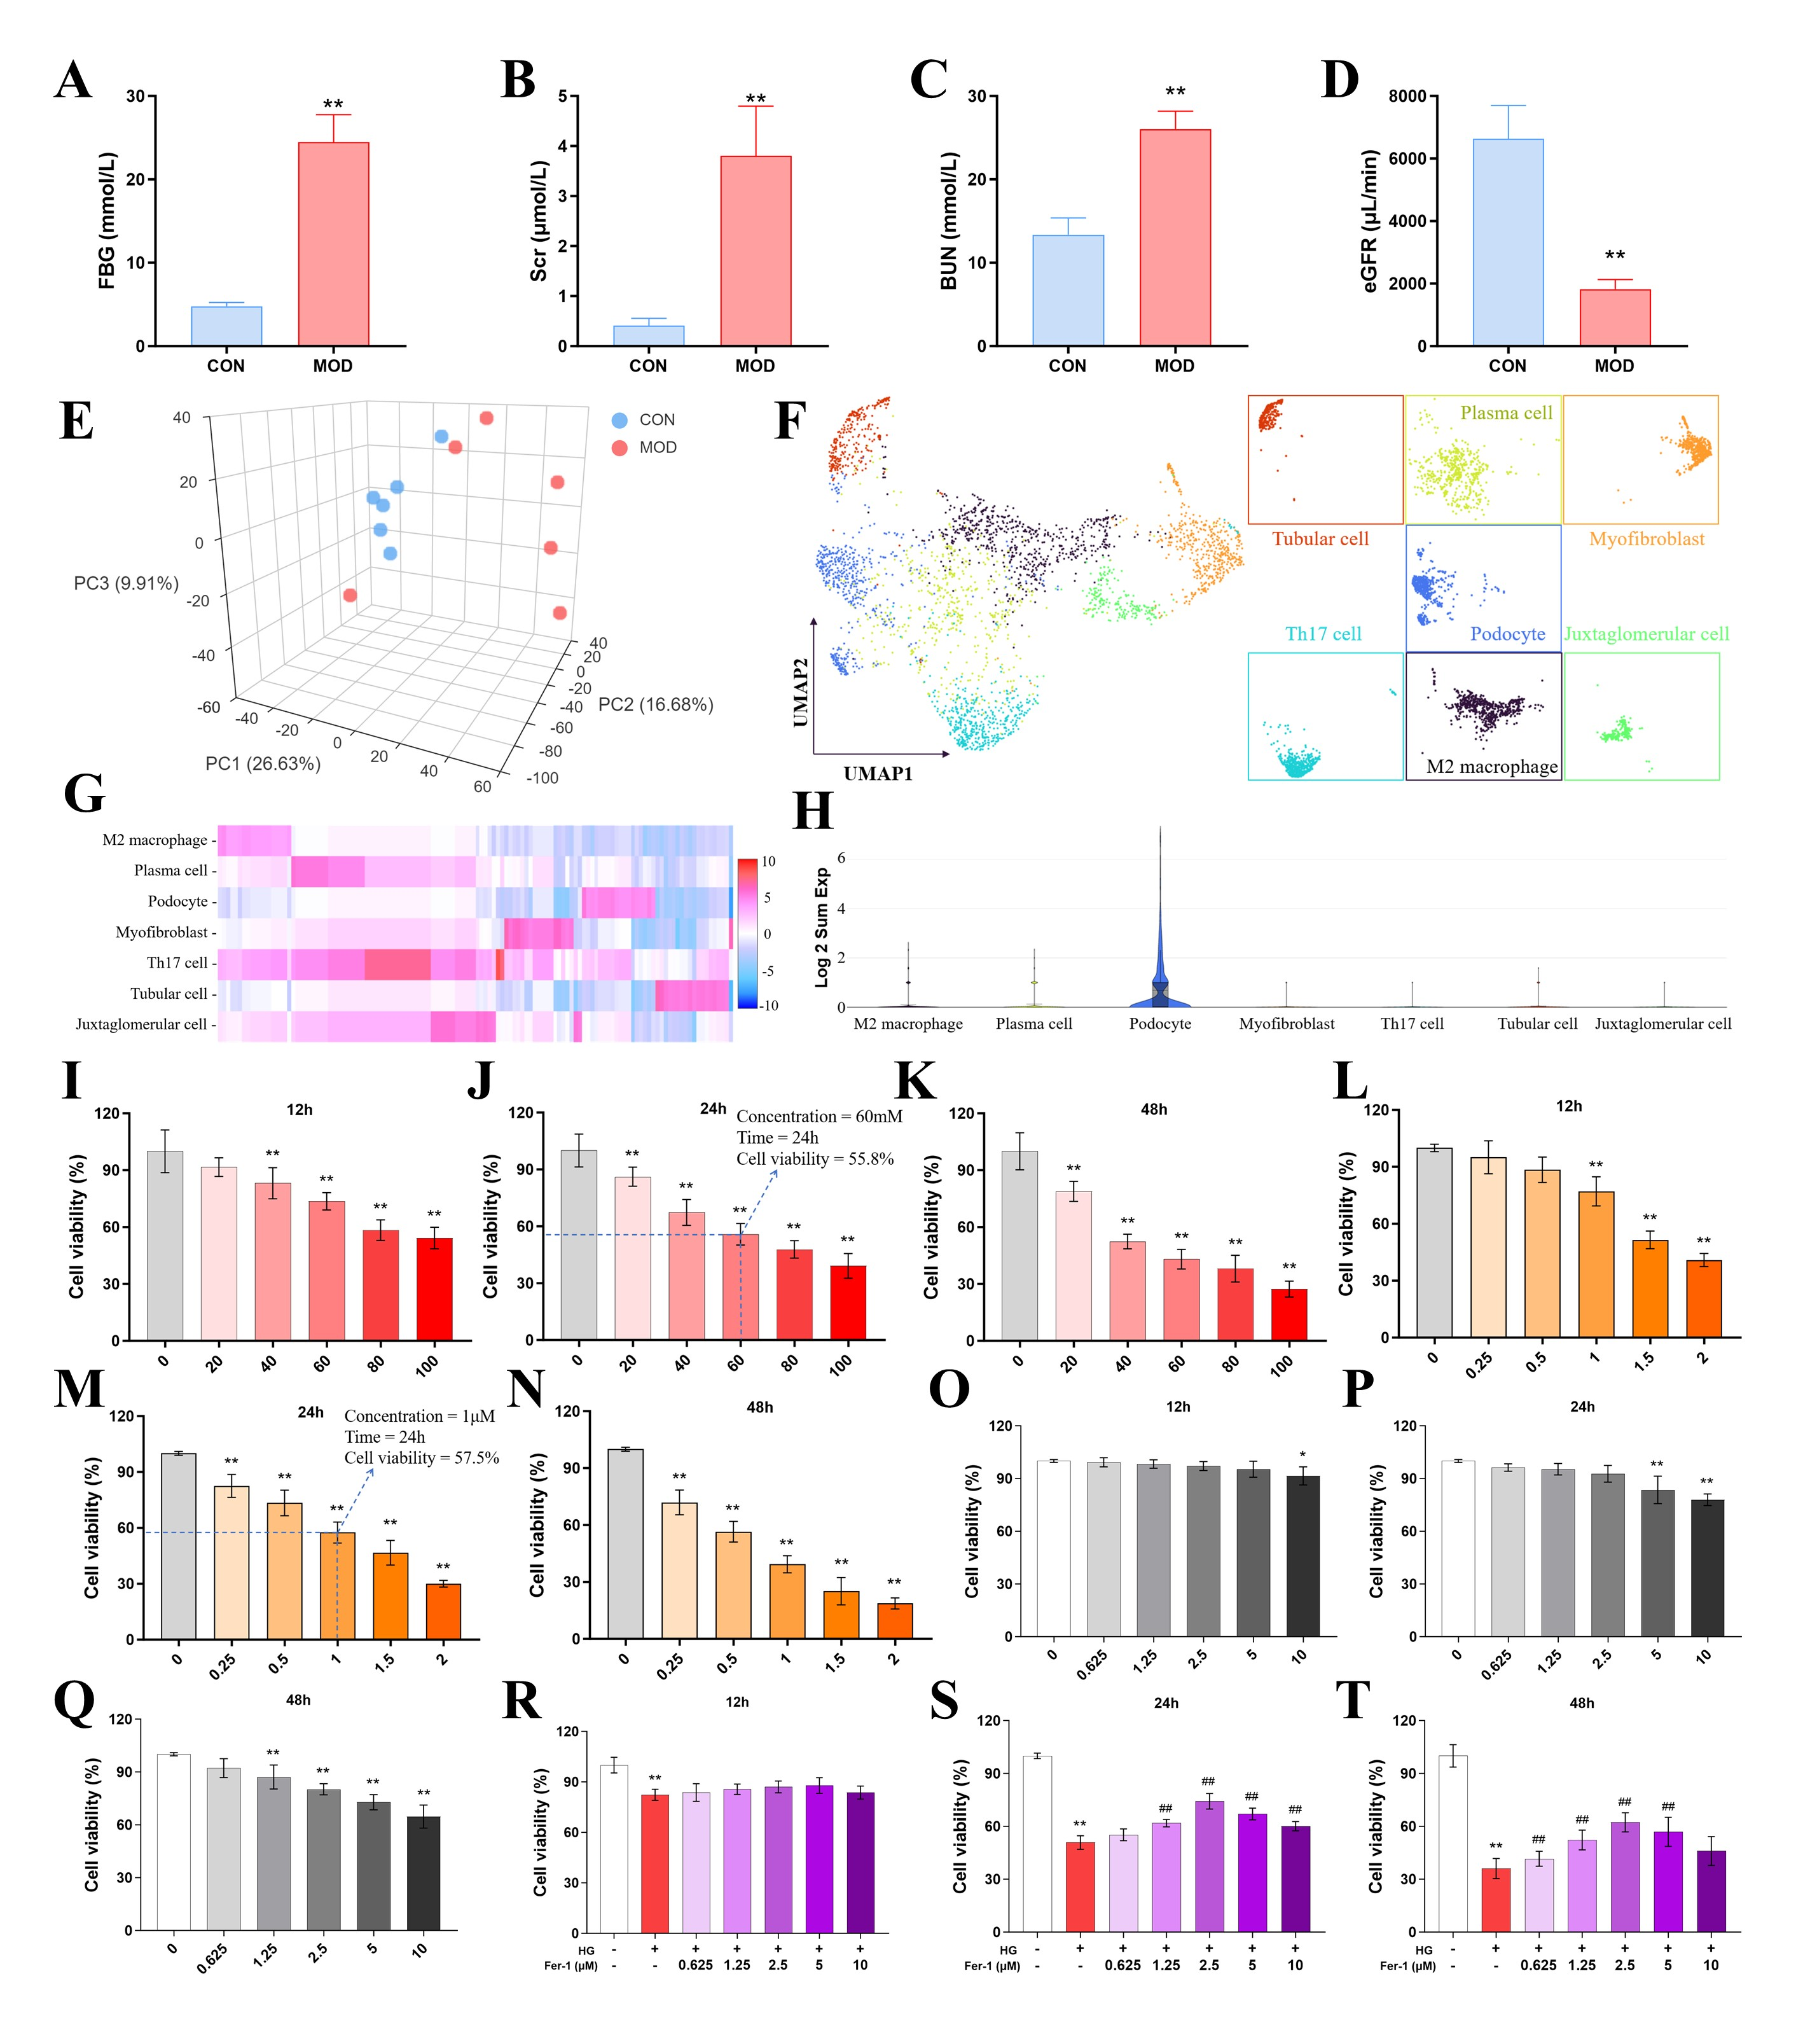
Figure S2. Metabolic and functional characterization of the DKD mouse model and optimization of in vitro experimental conditions.
(A-D) Comparison of physiological and biochemical parameters between db/db (DKD model, MOD) and db/m (control, CON) mice: The MOD group exhibited significantly elevated (A) fasting blood glucose (FBG), (B) serum creatinine (Scr), and (C) blood urea nitrogen (BUN), alongside a significantly reduced (D) estimated glomerular filtration rate (eGFR) (P < 0.01), confirming the successful establishment of the DKD model. Data are presented as mean ± SD; n = 6 mice per group. (E) Three-dimensional principal component analysis (PCA) score plot of serum metabolomes from mice, visually demonstrating the separation trend between MOD and CON groups. (F) UMAP plot of human renal biopsy-derived spatial transcriptomics data, colored by annotated cell clusters. (G) Heatmap of cluster-specific differentially expressed genes across renal cell populations from human tissues. Rows represent genes, columns represent spatial spots/cells grouped by cluster. (H) Violin plots showing the total number of detected genes per cell clusters, with podocytes exhibiting the highest transcriptional activity. (I-K) Optimization of high glucose (HG) stimulation conditions in MPC-5 podocytes. Cell viability assays across dose-time gradients identified 60 mM HG for 24 h as the optimal condition to induce injury. (L-N) Optimization of ferroptosis induction conditions using RSL3: 1 μM RSL3 for 24 h was identified as the optimal condition to induce ferroptosis. (O-Q) Cytotoxicity assessment of the ferroptosis inhibitor Ferrostatin-1 (Fer-1) in MPC-5 cells: Fer-1 concentrations up to 10 μM for 48 h displayed no significant cytotoxicity, confirming a safe working range. (R-T) Protective effect of Fer-1 against HG-induced podocyte injury: 2.5 μM Fer-1 for 24 h significantly reversed the HG-induced decrease in cell viability (from 50.8% to 74.2%). Data in cell-based assays are presented as mean ± SD from at least three independent experiments. Statistical significance was analyzed using one-way ANOVA followed by Tukey’s post-hoc test: *p < 0.05, **p < 0.01 vs. Control group. CON, control; HG, high glucose.

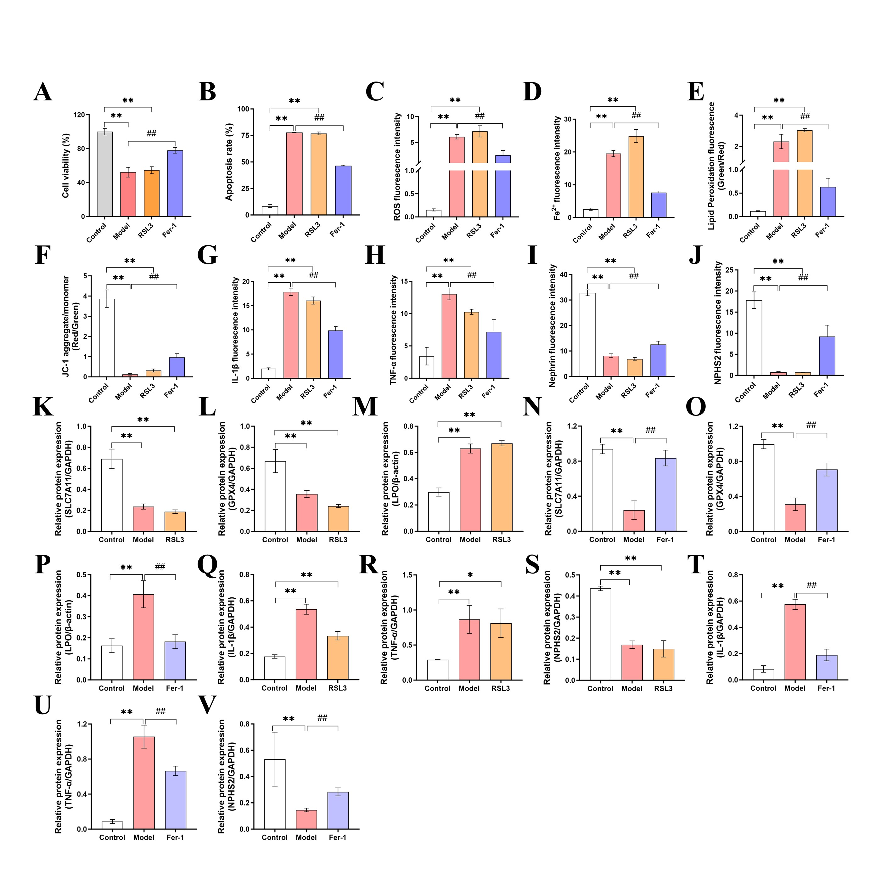
Figure S3. Ferroptosis is a central mechanism underlying high glucose (HG)-induced podocyte injury.
(A) Cell viability assessed by the CCK-8 assay. HG (60 mM) treatment significantly reduced MPC-5 cell viability, an effect recapitulated by the ferroptosis inducer RSL3 (1 μM). Conversely, the ferroptosis inhibitor Ferrostatin-1 (Fer-1, 2.5 μM) significantly rescued the HG-induced loss of viability. (B) Quantitative analysis of apoptosis rates across treatment groups, as determined by flow cytometry. (C-V) Quantitative analyses corresponding to indicators shown in Figure 4D-O: (C) Relative ROS fluorescence intensity (DCFH-DA), (D) Relative Fe²⁺ fluorescence intensity, (E) Lipid peroxidation levels (oxidized/non-oxidized BDP 581/591 C11 ratio), and (F) Mitochondrial membrane potential (JC-1 red/green fluorescence ratio). (G, H) Mean fluorescence intensity of pro-inflammatory cytokines: (G) IL-1β and (H) TNF-α. (I, J) Mean fluorescence intensity of podocyte slit diaphragm proteins: (I) Nephrin and (J) NPHS2. (K-V) Relative protein expression levels quantified by densitometric analysis of western blot bands: (K-P) Ferroptosis-related proteins (K, N) SLC7A11, (L, O) GPX4, and (M, P) LPO; (Q-V) Inflammatory proteins (Q, T) IL-1β and (R, U) TNF-α; (S, V) Podocyte integrity protein NPHS2. All protein expression levels were normalized to β-actin or GAPDH. Data are presented as mean ± SD from at least three independent experiments. Statistical significance was determined by one-way ANOVA followed by Tukey’s post-hoc test: *p < 0.05, **p < 0.01 vs. Control group; #p < 0.05, ##p < 0.01 vs. Model (HG) group.

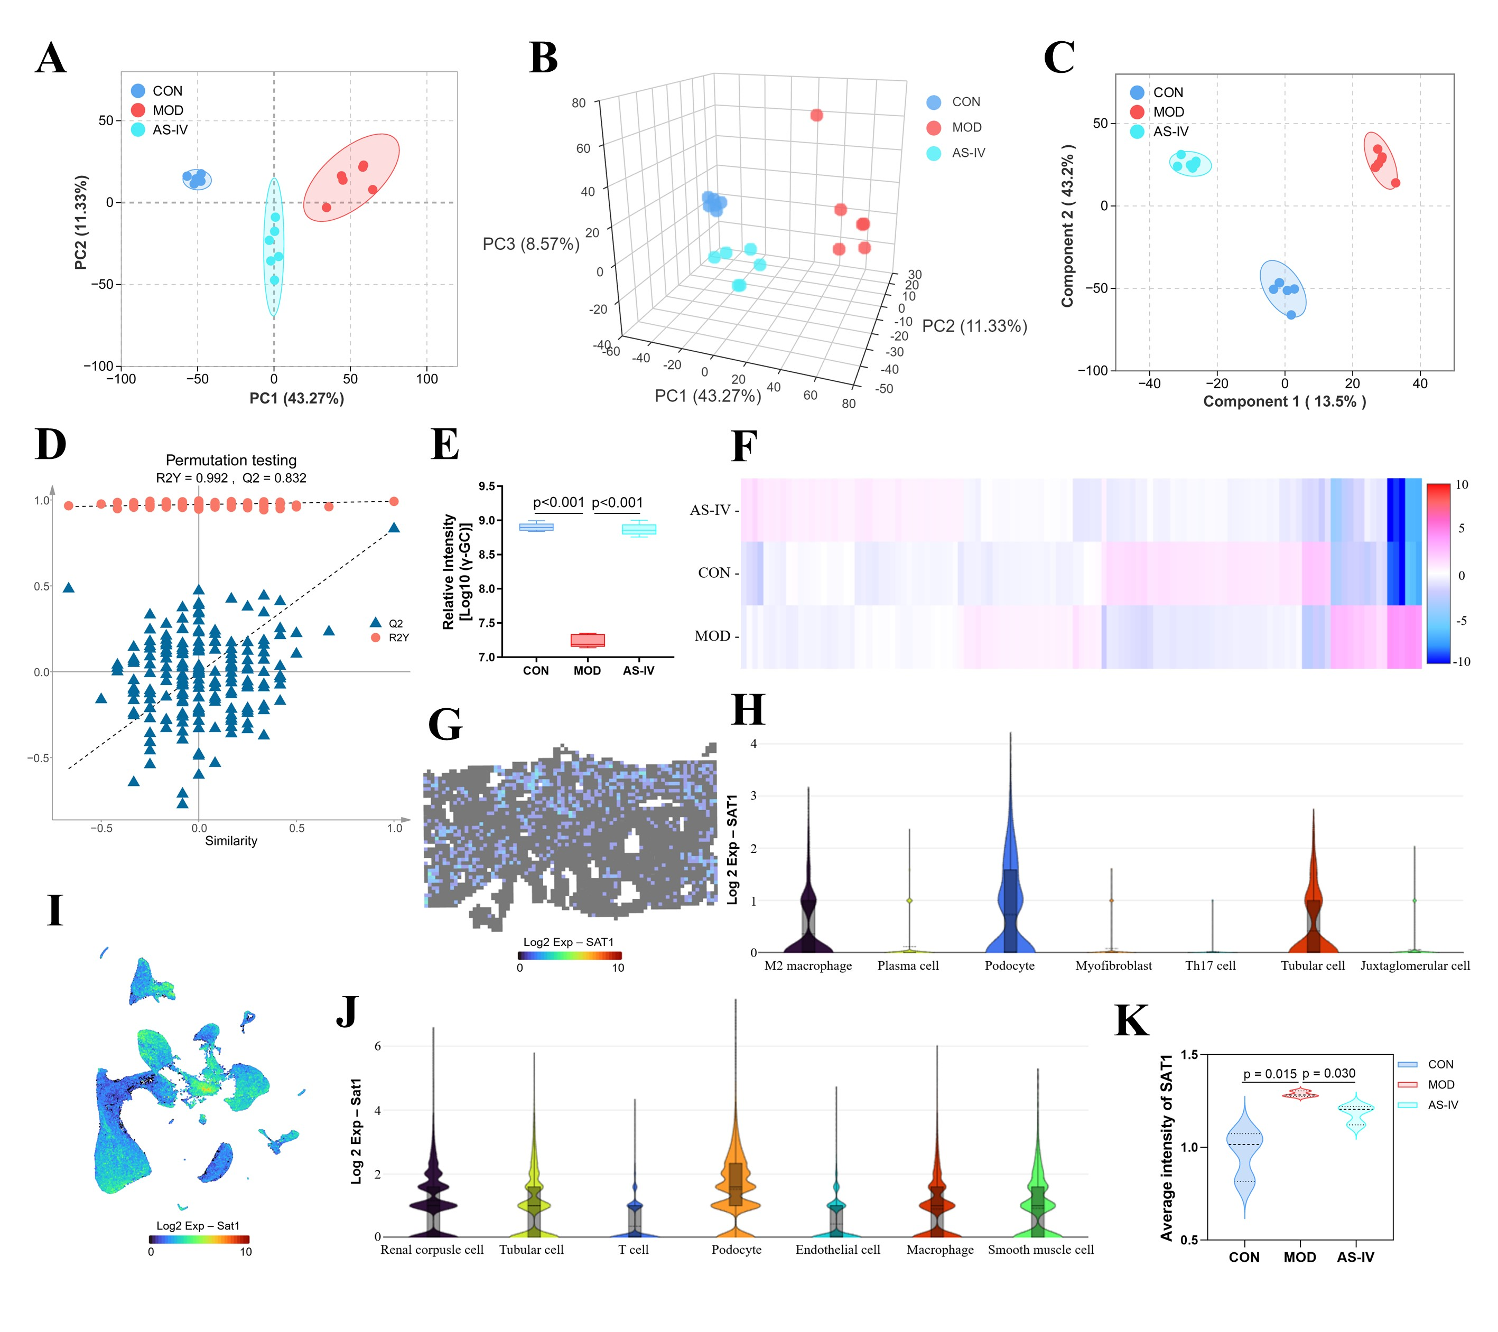
Figure S4 | Multi-omics profiling reveals AS-IV effects and identifies SAT1 as a key target.
(A, B) Principal component analysis (PCA) of serum metabolomic profiles in the murine cohort: (A) two-dimensional and (B) three-dimensional score plots demonstrate clear metabolic separation among the CON, MOD, and AS-IV treatment groups. (C) Orthogonal partial least squares-discriminant analysis (OPLS-DA) score plot further highlights the distinct metabolic signature of AS-IV treatment. (D) Permutation testing (n=200) of the OPLS-DA model validates its robustness and high predictive capability (R²Y = 0.992, Q² = 0.832). The Q² regression line intersecting the vertical axis below zero confirms the model is not overfitted. (E) Relative γ-GC levels in mouse serum across groups, where AS-IV significantly restored γ-GC depletion observed in the MOD group. (F) Heatmap illustrating proportional abundance of renal cell clusters by single-cell RNA sequencing (scRNA-seq) across the three groups. (G) Spatial expression distribution of SAT1 mRNA in human DKD renal tissue from spatial transcriptomics. (H) Violin plots showing SAT1 expression across renal cell types in human DKD, revealing cell-type-specific expression enrichment. (I) Spatial distribution of Sat1 mRNA in mouse kidney tissue from the CON, MOD, and AS-IV groups via scRNA-seq. (J) Violin plot depicting Sat1 expression across mouse renal cell types, derived from scRNA-seq data. (K) Mean Sat1 expression across all kidney cells based on scRNA-seq data, confirming that AS-IV attenuates the disease-associated elevation of Sat1 in DKD. Data in (E, K) are presented as mean ± SD. Statistical significance was determined using one-way ANOVA followed by Tukey’s post-hoc test: *p < 0.05, **p < 0.01 vs. CON group; #p < 0.05, ##p < 0.01 vs. MOD group. The murine cohort consisted of 6 mice per group. Metabolomics analyses were conducted using 6 biological replicates. scRNA-seq datasets were generated from 3 mice per group.

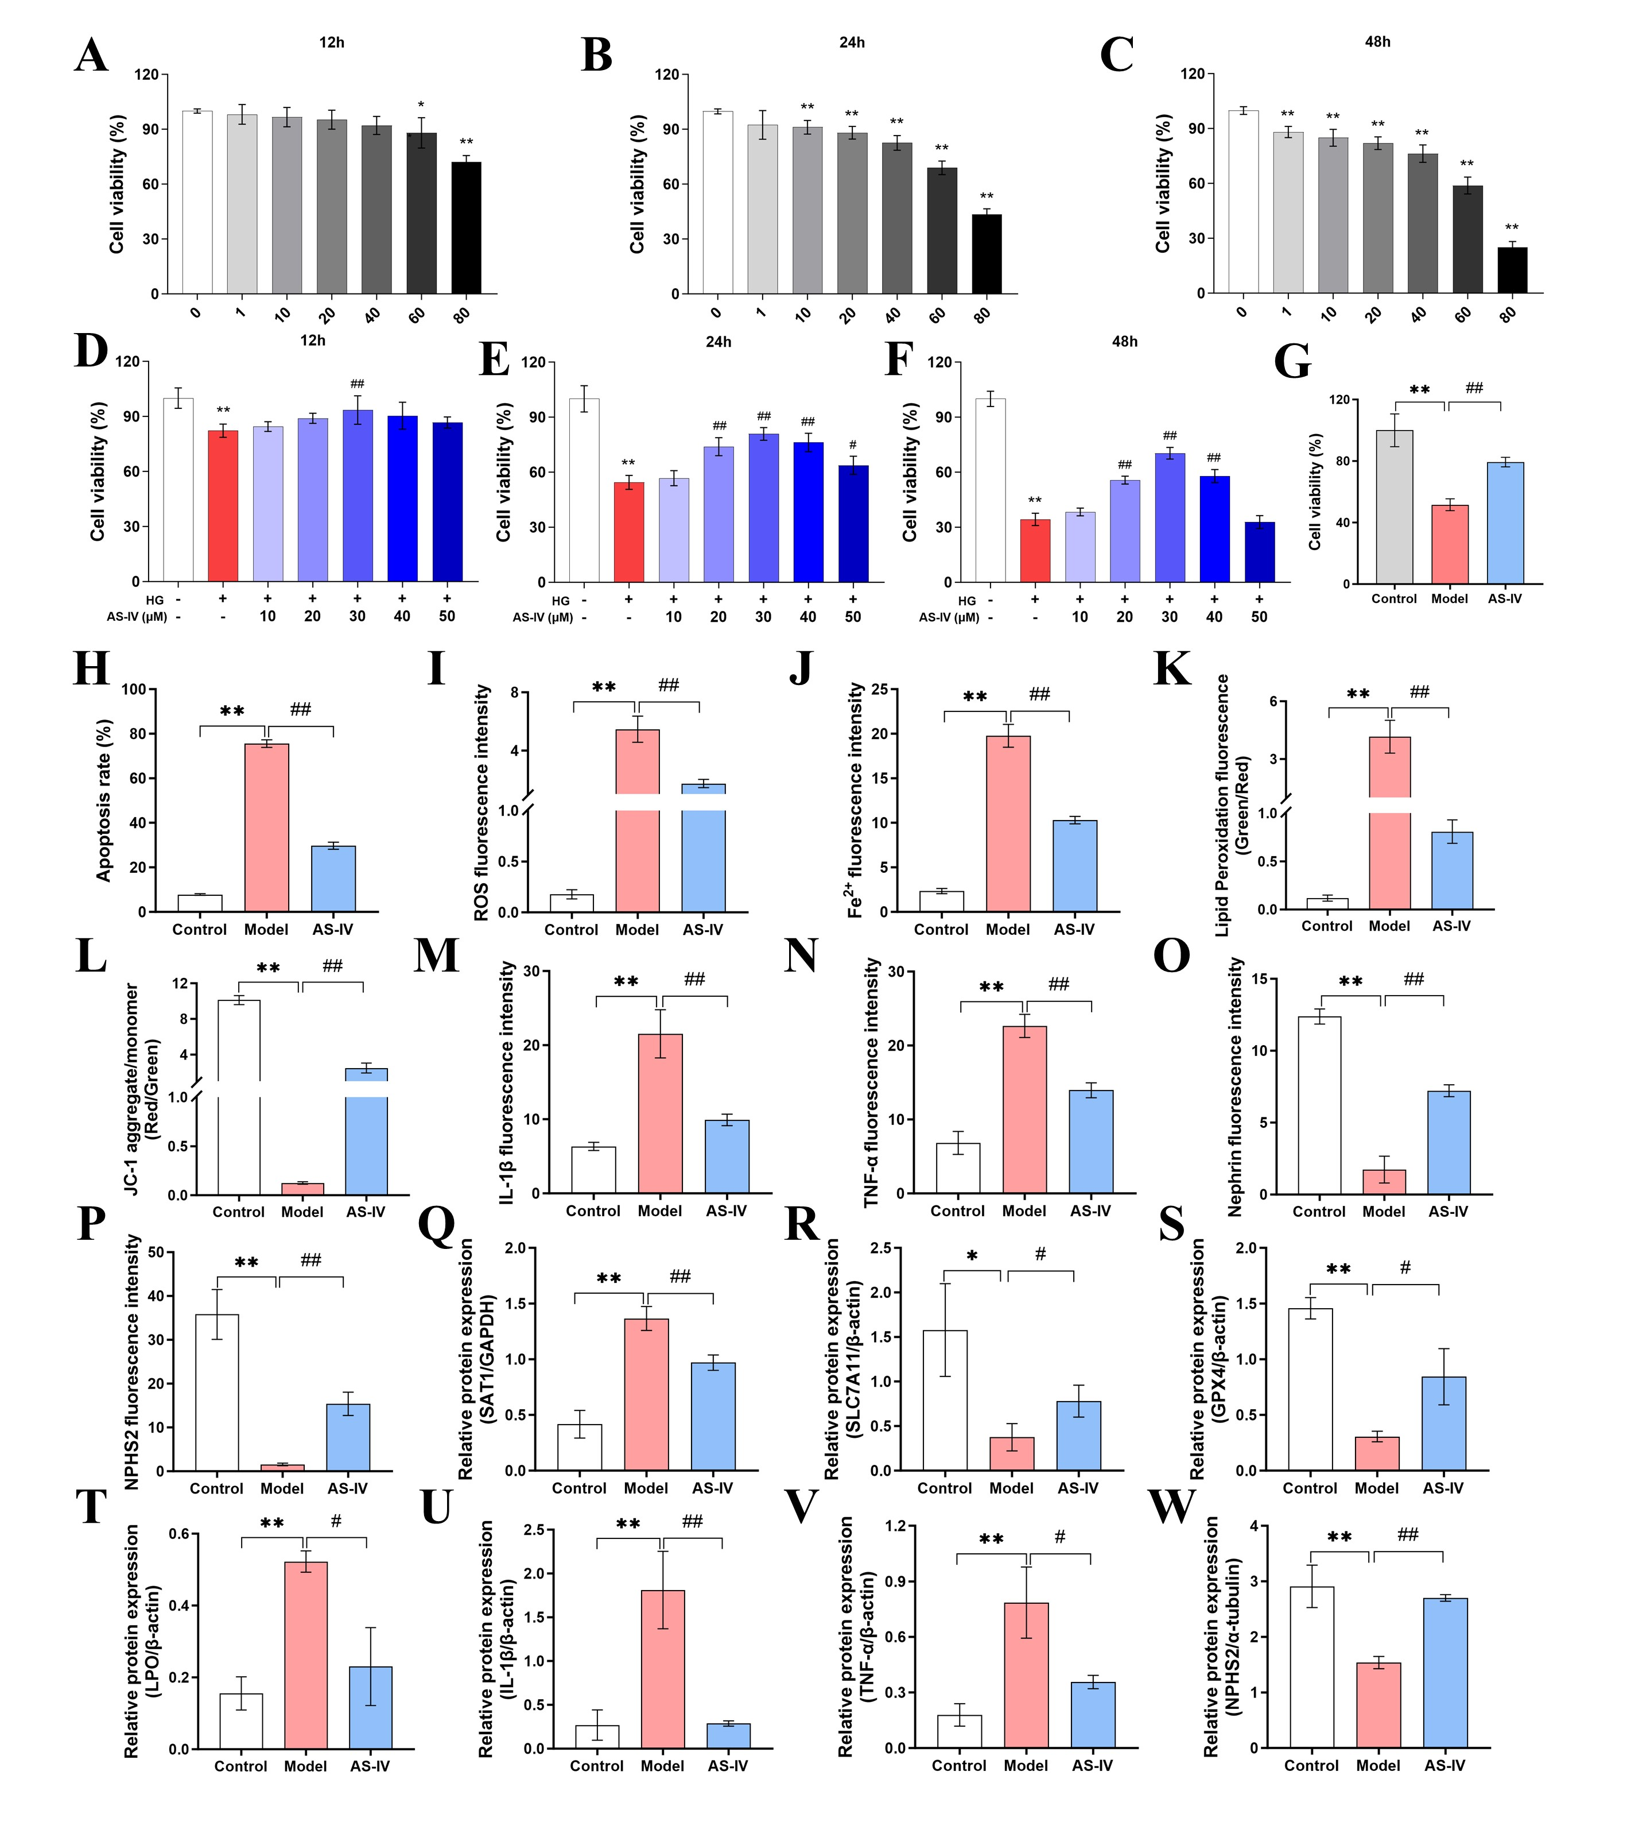
Figure S5. AS-IV attenuates high glucose–induced podocyte injury by inhibiting ferroptosis.
(A-C) Cytotoxicity evaluation of AS-IV in MPC-5 podocytes: Cell viability was assessed across different concentrations and treatment durations. AS-IV exhibited no significant cytotoxicity (cell viability ≥ 60%) at concentrations up to 60 μM for 48 h, establishing a safe treatment range. (D-F) Condition optimization for the protective effect of AS-IV against high glucose (HG, 60 mM)-induced injury: Dose and time-response assays identified 30 μM AS-IV for 24 h as the optimal protective condition. (G) CCK-8 assay confirming that 30 μM AS-IV for 24 h significantly restored cell viability under HG, from 51.6% in the Model group to 79.4%. (H) Quantitative analysis of apoptosis rates by flow cytometry across treatment groups. (I-L) Quantification of ferroptosis-related fluorescence indicators: (I) ROS (DCFH-DA), (J) Fe²⁺ (FerroOrange), (K) Lipid peroxidation (BDP 581/591 C11), and (L) Mitochondrial membrane potential (JC-1 red/green ratio). (M-P) Quantitative analysis of immunofluorescence mean intensity for (M) IL-1β, (N) TNF-α, (O) Nephrin, and (P) NPHS2. (Q-T) Densitometric quantification of western blot bands for ferroptosis-related proteins: (Q) SAT1, (R) SLC7A11, (S) GPX4, and (T) LPO. AS-IV decreased SAT1 and LPO levels while increasing SLC7A11 and GPX4 expression. (U-W) Densitometric quantification of western blot bands for inflammatory and podocyte integrity proteins: (U) IL-1β, (V) TNF-α, and (W) NPHS2. AS-IV reduced HG-induced expression of IL-1β and TNF-α and restored NPHS2 expression. All data are presented as mean ± SD from at least three independent experiments. Statistical significance was determined by one-way ANOVA followed by Tukey’s post-hoc test: *p < 0.05, **p < 0.01 vs. Control group; #p < 0.05, ##p < 0.01 vs. Model (HG) group.

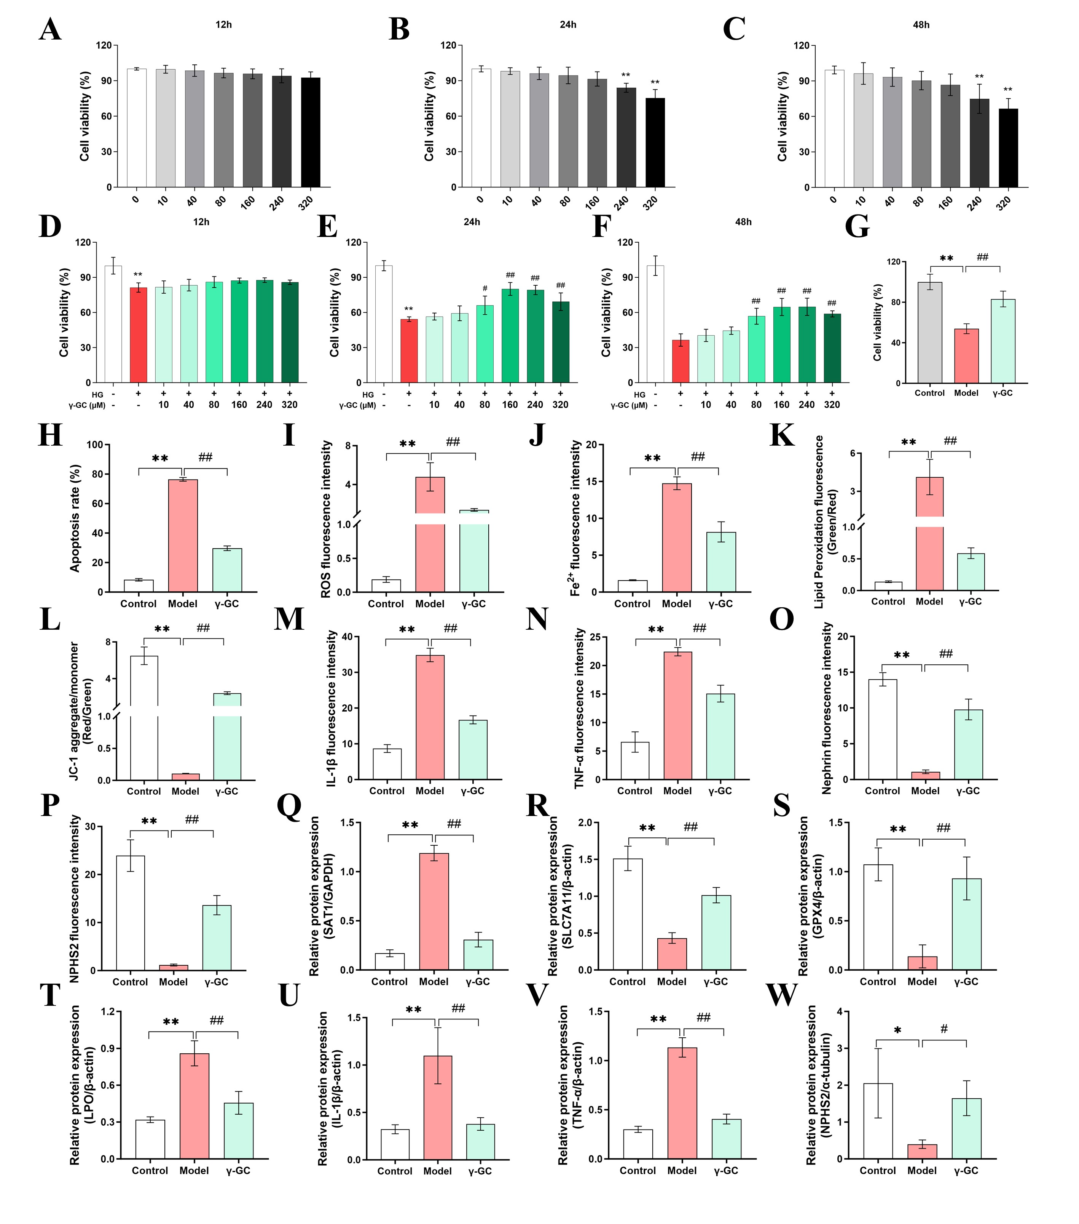
Figure S6. γ-GC ameliorates high glucose–induced podocyte injury by inhibiting ferroptosis.
(A-C) Cytotoxicity assessment of γ-GC on MPC-5 podocytes: Cell viability was evaluated across a concentrations range (0-320 μM) and various treatment durations (12-48 h). γ-GC exhibited an acceptable cytotoxicity profile (cell viability ≥ 60%) at concentrations up to 240 μM for 48 h, maintaining viable cell levels within the safe range. (D-F) Optimization of protective conditions against high glucose (HG, 60 mM)-induced injury identified 160 μM γ-GC for 24 h as the optimal treatment. (G) CCK-8 analysis confirmed that γ-GC significantly restored cell viability under HG conditions (from 53.8% in the Model group to 83.2%). (H) Quantitative analysis of apoptosis rates by flow cytometry across treatment groups. (I-L) Quantification of fluorescence intensity for ferroptosis-associated indicators: (I) ROS (DCFH-DA), (J) Fe²⁺(FerroOrange), (K) lipid peroxidation (BDP 581/591 C11), and (L) mitochondrial membrane potential (J-aggregate/J-monomer ratio of JC-1). (M-P) Quantitative analysis of immunofluorescence mean intensity for (M) IL-1β, (N) TNF-α, (O) Nephrin, and (P) NPHS2. (Q-T) Densitometric quantification of western blot bands for ferroptosis-related proteins: (Q) SAT1, (R) SLC7A11, (S) GPX4, and (T) LPO. γ-GC treatment downregulated HG-induced SAT1 and LPO expression while upregulating SLC7A11 and GPX4. (U-W) Densitometric quantification of western blot bands for inflammatory and podocyte integrity proteins: (U) IL-1β, (V) TNF-α, and (W) NPHS2. γ-GC alleviated inflammation and restored podocyte integrity. All data are presented as mean ± SD from at least three independent experiments. Statistical significance was assessed using one-way ANOVA followed by Tukey’s post-hoc test: *p < 0.05, **p < 0.01 vs. Control group; #p < 0.05, ##p < 0.01 vs. Model (HG) group.

Table S1 Clinical characteristics of patients with diabetic kidney disease (DKD) and healthy controls (HC).
 | DKD (n=24) |  | HC(n=24) |  | P value
Sex (male/female) |  | 17/7 |  | 16/8 |  | ＜0.01
Age (y) |  | 57.9±10.1 |  | 59.8±8.6 |  | 0.49
Height (cm) |  | 163.4±6.2 |  | 165.9±7.5 |  | 0.21
Weight (kg) |  | 64.8±9.8 |  | 69.87±13.3 |  | 0.14
BMI (kg/m2) |  | 24.24±3.32 |  | 25.40±5.21 |  | 0.36
Scr (μmol/l) |  | 493.27±259.68 |  | 72.66±15.15 |  | ＜0.01
BUN (mmol/l) |  | 20.96±9.35 |  | 4.743±1.56 |  | ＜0.01
eGFR (ml/min/1.73m²) |  | 17.13±20.37 |  | 97.50±14.078 |  | ＜0.01
SUA (μmol/l) |  | 412.00±134.09 |  | 381.38±74.02 |  | 0.33
TC (mmol/l) |  | 5.12±1.94 |  | 5.67±1.28 |  | 0.26
TG (mmol/l) |  | 1.86±1.18 |  | 1.72±0.73 |  | 0.61
HDL-C (mmol/l) |  | 1.04±0.38 |  | 1.18±0.24 |  | 0.12
LDL-C (mmol/l) |  | 2.69±1.41 |  | 3.19±0.89 |  | 0.15
FBG (mmol/l) |  | 8.81±1.75 |  | 5.10±0.48 |  | ＜0.01
Note: BMI, Body Mass Index; BUN, Blood Urea Nitrogen; DKD, diabetic kidney disease; eGFR, Estimated Glomerular Filtration Rate; FBG, Fasting Blood Glucose; HC, healthy control; HDL-C: High-Density Lipoprotein Cholesterol; LDL-C: Low-Density Lipoprotein Cholesterol; Scr, Serum Creatinine; SUA, Serum Uric Acid; TC, Total Cholesterol; TG, Triglycerides.

Table S2 Significantly altered serum metabolites in diabetic kidney disease (DKD) and healthy controls (HC).
Metabolites | FC | P value | Trends  DKD vs. HC | Metabolites | FC | P value | Trends  DKD vs. HC
gamma-Glutamylcysteine | 0.497 | 0.000 | ↓*** | Uric acid | 3.637 | 0.009 | ↑**
Adrenic acid | 0.496 | 0.000 | ↓*** | Taurocholic acid | 0.495 | 0.010 | ↓**
Ascorbate | 17.111 | 0.000 | ↑*** | Cyclic ADP-ribose | 2.323 | 0.011 | ↑*
11,12-EET | 0.149 | 0.000 | ↓*** | Retinyl palmitate | 0.487 | 0.012 | ↓*
alpha-Tocopherol | 0.490 | 0.000 | ↓*** | Propionylcarnitine | 3.467 | 0.014 | ↑*
Glutathione | 5.585 | 0.000 | ↑*** | Malonyl-CoA | 0.454 | 0.014 | ↓*
Coenzyme A | 0.346 | 0.001 | ↓*** | O-Succinyl-L-homoserine | 5.559 | 0.019 | ↑*
3-Oxalomalate | 5.298 | 0.001 | ↑*** | 4-hydroxybenzoyl-CoA | 0.455 | 0.021 | ↓*
Prostaglandin J2 | 0.472 | 0.001 | ↓*** | alpha-D-Ribose 1-phosphate | 3.941 | 0.023 | ↑*
L-Glutamic acid | 2.017 | 0.001 | ↑** | Phenylglyoxylyl-CoA | 0.439 | 0.023 | ↓*
Glycocholic acid | 2.382 | 0.003 | ↑** | Oxoadipic acid | 2.289 | 0.025 | ↑*
ATP | 0.295 | 0.004 | ↓** | 5a-Pregnane-3,20-dione | 0.425 | 0.027 | ↓*
Coproporphyrin I | 0.371 | 0.006 | ↓** | Oxidized glutathione | 2.125 | 0.038 | ↑*
Anserine | 2.964 | 0.007 | ↑** | L-Cystine | 6.055 | 0.041 | ↑*
Taurochenodesoxycholic acid | 0.444 | 0.007 | ↓** | beta-D-Fructose 6-phosphate | 3.240 | 0.050 | ↑*
Coenzyme Q9 | 0.470 | 0.008 | ↓**
Note: DKD, diabetic kidney disease; FC, fold change; HC, healthy control. ↑upregulation, ↓downregulation, *P ＜ 0.05, **P ＜ 0.01, ***P ＜ 0.001.

Table S3 Altered serum metabolomic profile in diabetic kidney disease murine models.
Metabolites | FC | P value | Trends  MOD vs. CON | Metabolites | FC | P value | Trends  MOD vs. CON
gamma-Glutamylcysteine | 0.021 | 0.000 | ↓*** | Allopregnanolone | 0.652 | 0.004 | ↓**
O-Succinyl-L-homoserine | 4.452 | 0.000 | ↑*** | L-Glutamic acid | 0.600 | 0.004 | ↓**
Purine | 0.650 | 0.000 | ↓*** | Oxidized glutathione | 2.212 | 0.004 | ↑**
N-Acetylleucine | 0.519 | 0.000 | ↓*** | 13-L-Hydroperoxylinoleic acid | 2.151 | 0.004 | ↑**
Uracil | 0.643 | 0.000 | ↓*** | 5-Hydroxy-L-tryptophan | 0.570 | 0.005 | ↓**
5a-Pregnane-3,20-dione | 0.132 | 0.000 | ↓*** | 11-Dehydro-thromboxane B2 | 2.523 | 0.005 | ↑**
Fructose-1P | 0.460 | 0.000 | ↓*** | L-Cystine | 1.745 | 0.005 | ↑**
Glycerol 3-phosphate | 0.489 | 0.000 | ↓*** | 3-Methoxytyramine | 1.795 | 0.005 | ↑**
(3S,5S)-3,5-Diaminohexanoate | 0.517 | 0.000 | ↓*** | Gamma-Tocotrienol | 0.540 | 0.005 | ↓**
Adrenic acid | 3.055 | 0.001 | ↑*** | D-Ribulose 5-phosphate | 0.436 | 0.006 | ↓**
Acetylcholine | 0.443 | 0.001 | ↓*** | 3-Dehydroshikimate | 0.516 | 0.006 | ↓**
Xanthine | 0.495 | 0.001 | ↓*** | 3,4-Dihydroxyphenylpropanoate | 2.764 | 0.007 | ↑**
Ascorbate | 3.686 | 0.001 | ↑** | alpha-Tocopherol | 0.342 | 0.007 | ↓**
Heme | 0.490 | 0.001 | ↓** | N-Acetyl-D-galactosamine | 0.591 | 0.007 | ↓**
Normetanephrine | 0.558 | 0.001 | ↓** | Decanoyl-CoA (n-C10_0CoA) | 0.609 | 0.007 | ↓**
L-Ribulose | 0.585 | 0.001 | ↓** | Nonadecanoic acid | 0.613 | 0.008 | ↓**
L-Octanoylcarnitine | 1.929 | 0.002 | ↑** | 2,3-Bisphosphoglycerate | 2.101 | 0.008 | ↑**
3-Methylindolepyruvate | 1.522 | 0.003 | ↑** | Arachidonic acid | 1.731 | 0.009 | ↑**
Glutathione | 2.115 | 0.003 | ↑** | Phenylglyoxylyl-CoA | 19.268 | 0.010 | ↑**
2-Ketohexanoic acid | 1.854 | 0.003 | ↑**
Note: CON, control; FC, fold change; MOD, model. ↑upregulation, ↓downregulation, *P ＜ 0.05, **P ＜ 0.01, ***P ＜ 0.001.

Table S4 Astragaloside IV restores dysregulated serum metabolites in db/db mice.
Metabolites | FC | P value | Trends  AS-IV vs. MOD | Metabolites | FC | P value | Trends  AS-IV vs. MOD
gamma-Glutamylcysteine | 43.603 | 0.000 | ↑*** | Heme | 2.627 | 0.070 | ↑
L-Glutamic acid | 1.891 | 0.000 | ↑*** | Xanthine | 2.034 | 0.071 | ↑
D-Ribulose 5-phosphate | 3.642 | 0.000 | ↑*** | Normetanephrine | 1.505 | 0.077 | ↑
3-Dehydroshikimate | 3.366 | 0.001 | ↑*** | Purine | 1.258 | 0.089 | ↑
Oxidized glutathione | 0.247 | 0.001 | ↓** | Phenylglyoxylyl-CoA | 0.579 | 0.234 | ↓
3-Methoxytyramine | 0.485 | 0.001 | ↓** | Acetylcholine | 1.212 | 0.240 | ↑
3-Methylindolepyruvate | 0.632 | 0.003 | ↓** | Nonadecanoic acid | 1.307 | 0.266 | ↑
Allopregnanolone | 1.454 | 0.005 | ↑** | Arachidonic acid | 0.823 | 0.348 | ↓
Decanoyl-CoA (n-C10_0CoA) | 1.398 | 0.005 | ↑** | L-Cystine | 0.911 | 0.506 | ↓
Uracil | 1.460 | 0.017 | ↑* | L-Ribulose | 1.105 | 0.539 | ↑
11-Dehydro-thromboxane B2 | 0.545 | 0.024 | ↓* | Adrenic acid | 0.865 | 0.584 | ↓
Fructose-1P | 2.263 | 0.025 | ↑* | (3S,5S)-3,5-Diaminohexanoate | 1.030 | 0.689 | ↑
5a-Pregnane-3,20-dione | 4.479 | 0.031 | ↑* | 13-L-Hydroperoxylinoleic acid | 0.915 | 0.728 | ↓
alpha-Tocopherol | 1.527 | 0.048 | ↑* | Gamma-Tocotrienol | 1.102 | 0.782 | ↑
Glycerol 3-phosphate | 1.997 | 0.052 | ↑ | Ascorbate | 0.990 | 0.966 | ↓
Note: AS-IV, Astragaloside IV; FC, fold change; MOD, model. ↑upregulation, ↓downregulation, *P ＜ 0.05, **P ＜ 0.01, ***P ＜ 0.001.

