Supplementary figures and figure legends
Supplementary Figure 1. TCF3 keeps muscle stem cells in quiescent state
(A) Bubble plot showing KEGG/GO pathway enrichment analysis of differentially expressed genes comparing quiescent versus activated MuSCs across multiple published datasets, Circle size indicates the enrichment ratio, while color intensity represents the adjusted P value.
(B) RT-qPCR analysis of TCF3 in isolated from PFA perfused MuSCs (quiescent) and freshly isolated MuSCs (activated).
(C) RT-qPCR analysis of mRNA expression level of TCF3 overexpression in vitro cultured MuSCs.
(D) Western blotting analysis of protein expression level of TCF3 overexpression in MuSCs and the integrated density of Western blotting bands were quantified to determine the ratio of TCF3.
(E) Immunofluorescence staining of MF20 was performed and quantified as the percentage of myotube area in Control and TCF3 OE groups. Scale bars=100 μm. n=3 independent assays.
(F) Expression heatmap of downregulated genes related to cell cycle.
(G) GO analysis of 1417 downregulated genes in TCF3 OE, top 20 categories are shown.
(H) Differentiation was visualized by MF20 staining and quantified as the percentage of myotube area in Control and TCF3 iKO groups. Scale bars=100 μm. n=3 independent assays per condition.
Data are expressed as the mean ± SEM. *P < 0.05, **P < 0.01, ***P < 0.001.

Supplementary Figure 2. TCF3 keeps muscle stem cells in quiescent state
(A) Schematic illustration of generation of TCF3 iKO mice. Diagrams of mouse TCF3 genomic locus (top), the TCF3loxp/loxp allele (line2), and the TCF3 disruption allele (TCF3 iKO, bottom).
(B) Schematic illustration of generation of Pax7^{CreERT2/+}; TCF3^{f/f} allele.
(C) Western blotting analysis of the protein expression levels of TCF3 in Control and TCF3 iKO cell.
(D) Schematic illustration of generation of Pax7^{CreERT2/+}; Rosa26^{Tomato/+};TCF3^{f/f}; allele.

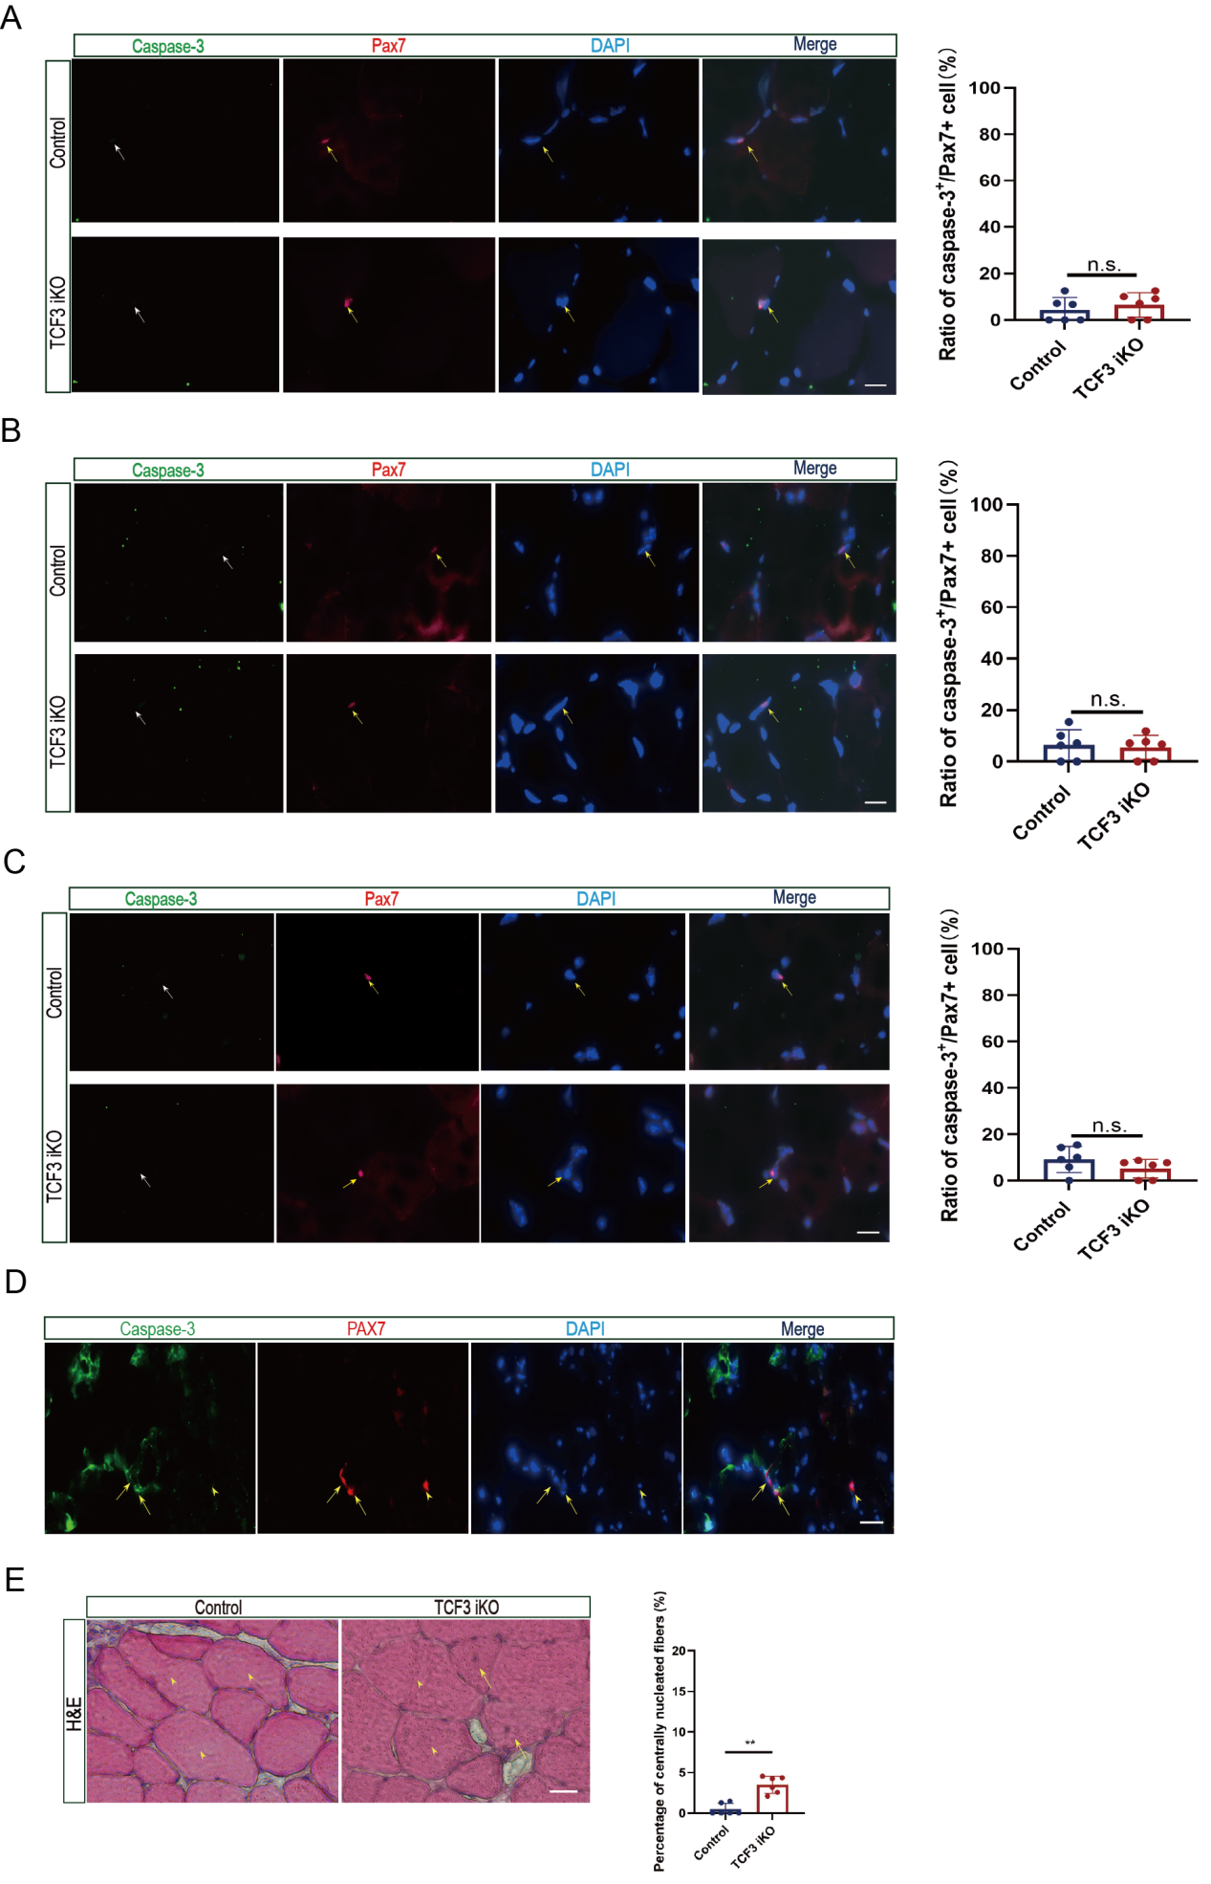
Supplementary Figure 3. TCF3 is required for the maintenance of muscle stem cell pool
Representative immunofluorescence images of cleaved caspase3 staining in MuSCs at 0 d (A), 30 d (B), and 180 d (C) after TCF3 deletion are shown. Quantification of the proportion of cleaved Caspase3⁺/PAX7⁺ cells is presented on the right. Scale bars=12.5 μm.
(D) Positive control for cleaved caspase-3 staining. TA muscles were locally injected with staurosporine (STS) to induce apoptosis. Immunofluorescence staining for cleaved caspase-3 and PAX7 revealed abundant apoptotic cells, including PAX7-positive MuSCs. Arrows represent cleaved caspase-3⁺/PAX7⁺ cells, arrowheads represents cleaved caspase-3⁻/PAX7⁺ cells. Scale bars = 25 μm.
(E) H&E staining of TCF3 iKO and control muscle at 180 d. Arrows represent centrally located nuclei in TCF3 iKO muscle; arrowheads represent no centrally located nuclei in control muscle. Scale bars = 12.5 μm.
Data are expressed as mean ± SEM. Statistical significance was determined using two-tailed unpaired Student’s t-test. n = 3 mice per group. n.s., not significant. **P < 0.01.

Supplementary Figure 4. TCF3 target lysosome pathways genes in quiescent MuSCs
(A) The fragment analysis of TCF3 Chip-seq libiaries with MuSCs.
(B) TF motif enrichment identified from TCF3-chip peaks.
(C) GO analysis of TCF3 binding genes related with cell stemness.
(D) Venn diagram of the TCF3 target genes and downregulated of RNA-seq in TCF3 OE group. Overlapping genes included TCF3 binding signals at TSSs regions (blue) and genes significantly downregulated in TCF3 OE cells (green).
(E) GO analysis of the 1014 overlapping genes in (D) was performed.
(F) Heatmaps showing the expression of TFEB target genes in TCF3 overexpression MuSCs (Ctrl vs. TCF3 OE) and in published datasets of quiescent and activated MuSCs (Luo et al., 2022) (middle) and neural stem cells (Codega et al., 2014) (right). Columns represent sample groups, while the color bars above the heatmaps indicate biological state annotations (quiescent or activated) for each sample. Heatmaps are organized by sample groups corresponding to experimental conditions or published cell states, not by an internal state-based comparison within one dataset.

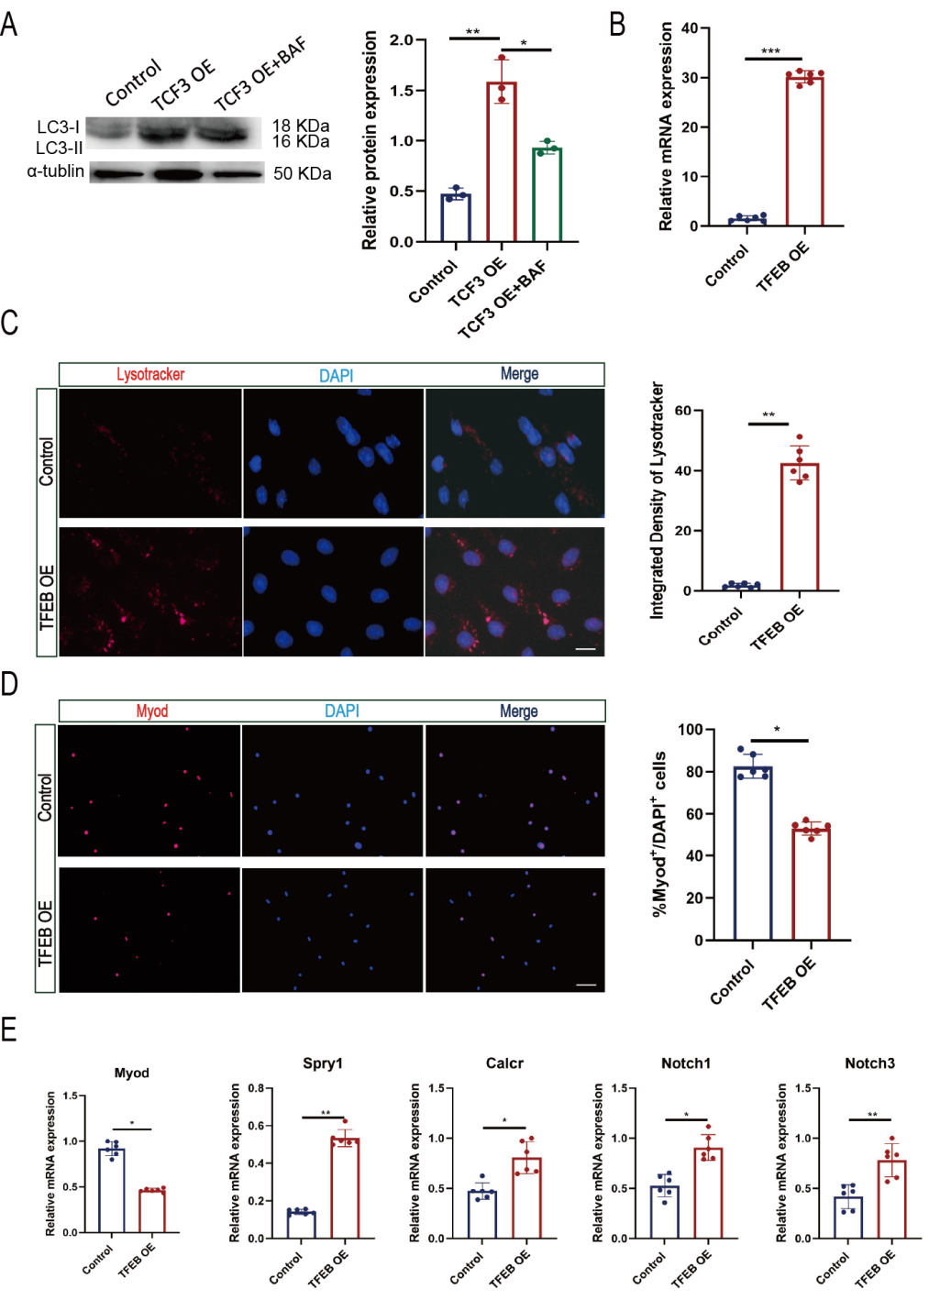
Supplementary Figure 5. TCF3 promotes lysosomal activity to restrain muscle stem cell activation
(A) Western blotting analysis of protein expression level of LC3II in MuSCs in control, TCF3 OE and TCF3 OE+BAF groups, the integrated density of Western blotting bands were quantified below.
(B) RT-qPCR analysis of mRNA expression level of TFEB overexpression in vitro cultured MuSCs.
(C) Immunofluorescence of Lysotracker in Control, TFEB OE groups was performed (left). Integrated Lysotracker fluorescence intensity per cell was shown on the right. Scale bars=12.5 μm. n=3 independent assays.
(D) Immunofluorescence of Myod in Control and TFEB OE groups was performed (left). Quantification of Myod-positive MuSCs was shown on the right. Scale bars=50 μm. n=3 independent assays.
(E) RT-qPCR analysis of quiescence-related genes (Spry1, Calcr, Notch1 and Notch3) and activation-related gene (Myod) in TFEB OE MuSCs. n = 3 independent assays.
Data are expressed as mean ± SEM. Statistical significance was determined using unpaired two-tailed Student’s t-test for two-group comparisons and one-way ANOVA followed by Tukey’s multiple comparison test for multiple-group comparisons.**p < 0.01, *P < 0.05.

Supplementary Figure 6. TCF3-induced lysosomal activity is essential for maintaining MuSC quiescence
(A) Immunofluorescence of Lysotracker in Control, TCF3 OE, and TCF3 OE+CQ groups was performed (left). Integrated Lysotracker fluorescence intensity per cell was shown on the right. Scale bars=12.5 μm. n=3 independent assays.
(B) Representative fluorescence images of DQ-BSA in MuSCs from the control group, TCF3 overexpression (TCF3 OE) group, and TCF3 OE plus BAF treatment group are shown. Quantification of DQ-BSA fluorescence intensity, reflecting lysosomal proteolytic activity, is presented on the right. Scale bars=12.5 μm. n=3 independent assays.
(C) EdU assays in Control, TCF3 OE, and TCF3 OE+CQ groups were performed. Quantification of percentage of EdU⁺ MuSCs was shown on the right. Scale bars=50 μm. n=3 independent biological replicates per condition.
Data are expressed as the mean ± SEM. Statistical significance among multiple groups was determined using one-way ANOVA followed by Tukey’s multiple comparison test. *P < 0.05, **P < 0.01.

Supfigure 1C
Supfigure 2C
Supfigure 4G
Supplementary Figure 7. Uncropped original blots in main figures

