Supplementary Figure 1

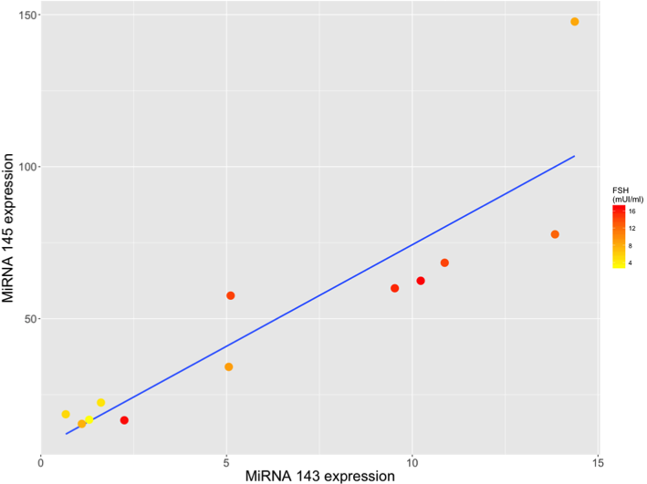

Supplementary Figure 1. Association between MIR143 and MIR145 expression and serum FSH levels. Scatterplot of relative expression show the correlation between MIR143 and MIR145 and FSH serum levels.

Supplementary Figure 2

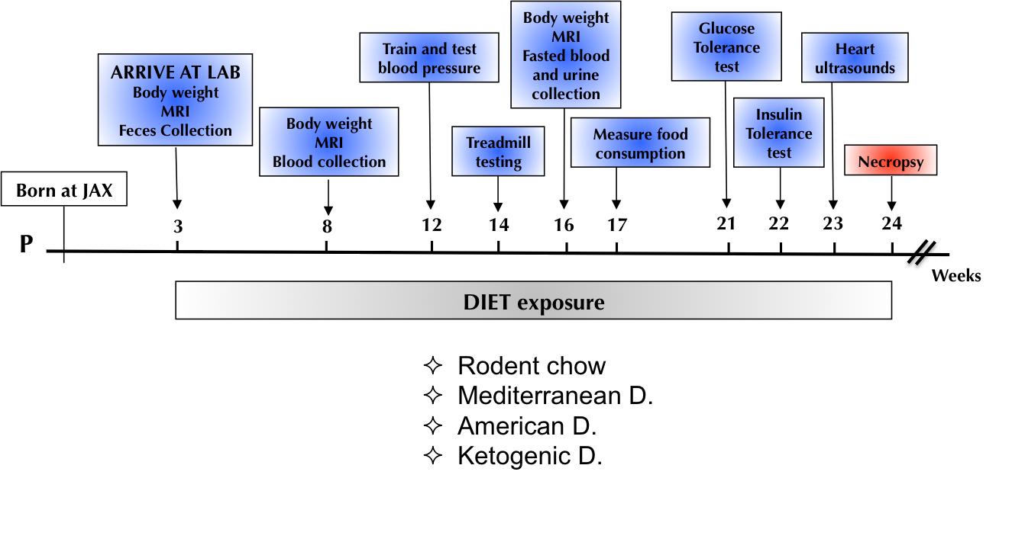

Supplementary Figure 2. Diet experimental design. C57BL/6J and FVB/NJ female mice were fed for 8 months starting at 6 weeks of age (n=5).

Supplementary Figure 3

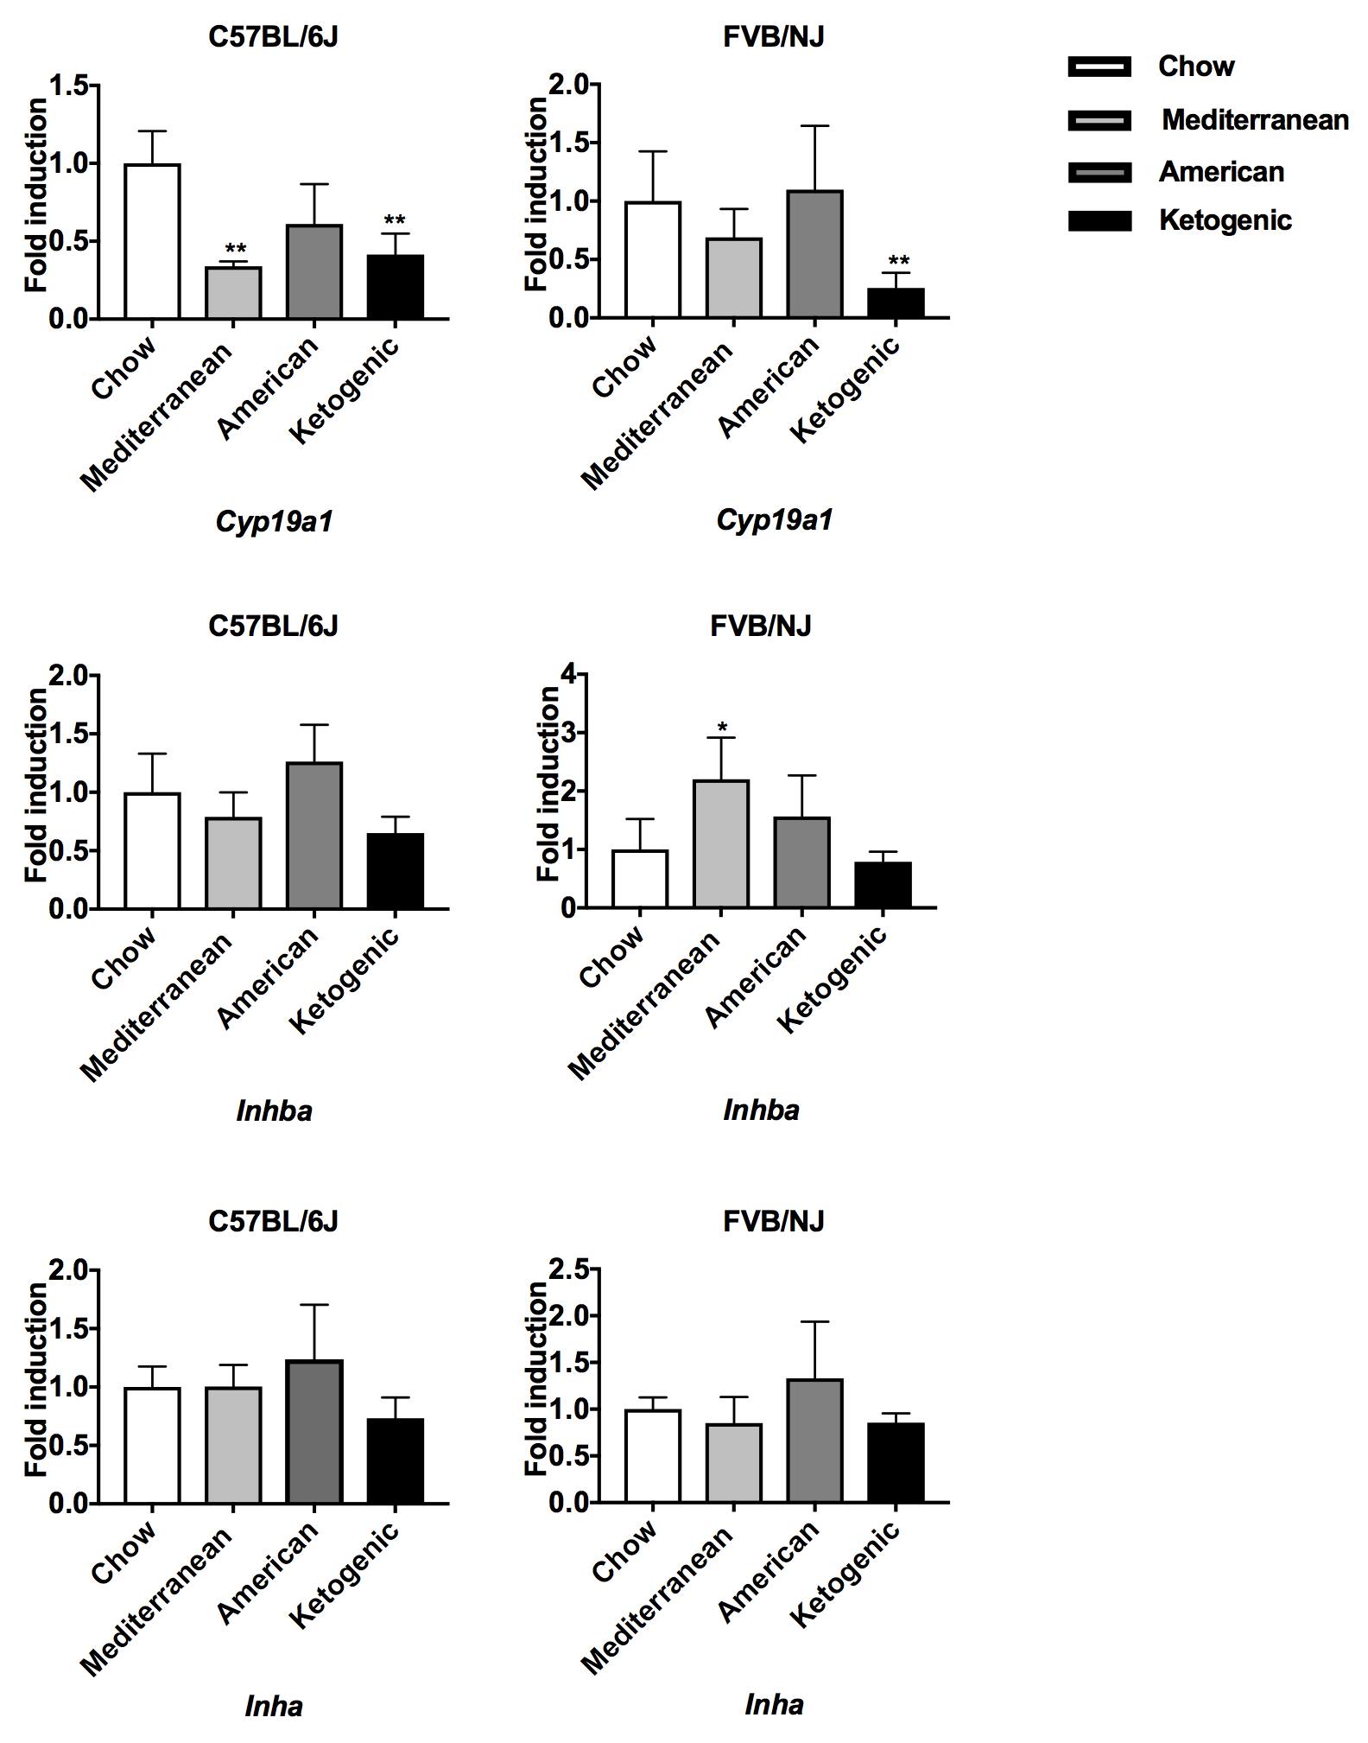
Supplementary Figure 3. Markers of ovarian aging in C57BL/6J and FVB/NJ mice fed different diets. Dietary effects on ovarian aging were determined by qRT-PCR of well-characterized ovarian aging markers in both strains.

Supplementary Figure 4

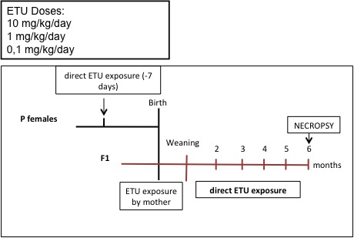

Supplementary Figure 4. ETU experimental design. Developmental and long-life exposure to environmentally relevant doses of ETU.

Markers* | Late reproductive period or post-menopause
Cytochrome P450, family 19, subfamily a, polypeptide 1 (Cyp19a1) | ( )
Inhibin beta-A (Inhba) | ( )
Inhibin alpha (Inha) | ( )
anti-Müllerian hormone (Amh)** | ( )
Growth differentiation factor9 (Gdf9) | ( )
Bone morphogenetic protein 15 (Bmp15)** | ( )

Supplementary Table 2. Markers used to assess ovarian reserve.

*Normal values are considered those found in healthy women of reproductive age
** Deregulated in microarray

Supplementary Table 3. Differentially expressed genes in middle- aged ovaries included in OAGS

TranscriptID | GeneSymbol^{A} | GeneDescription | Pathway | log2FC^{B}
10468828 | Eif3a | Eukaryotic translation initiation factor 3, subunit A | EIF2, Regulation of eIF4 and p70S6K, mTOR (protein synthesis) | -0.84**
10485635 | Eif3m | Eukaryotic translation initiation factor 3, subunit M | EIF2, Regulation of eIF4 and p70S6K, mTOR (protein synthesis) | -3.49***
10566966 | Eif4g2 | Eukaryotic translation initiation factor 4, subunit gamma | EIF2, Regulation of eIF4 and p70S6K, mTOR (protein synthesis) | -3.54***
10565802 | Rps3 | Ribosomal protein S3 | EIF2, Regulation of eIF4 and p70S6K, mTOR (protein synthesis) | -0.90**
10435980 | Rps24 | Ribosomal protein S24 | EIF2, Regulation of eIF4 and p70S6K, mTOR (protein synthesis) | -2.24***
10351039 | Gas5 | Growth arrest specific 5 |  | -2.83***
10547073 | Snora7a | Small nucleolar RNA, H/ACA box 7A |  | -0.01
10586168 | Snord16a | Small nucleolar RNA, C/D box 16A |  | -2.10**
10432176 | Snora34 | Small nucleolar RNA, H/ACA box 34 |  | -0.72**
10420668 | Mir15a | microRNA 15a | Cell Death and Survival, Protein Synthesis, Cancer, Organismal Injury and Abnormalities, Reproductive System Disease, Cell Cycle | -0.83

10442081 | Mir99b | microRNA 99b |  | 0.37
10459227 | Mir143 | microRNA 143 | Cell Death and Survival, Organ Morphology, Organismal Development and Function, Cancer, Organismal Injury and Abnormalities, Protein Synthesis | 1.60***
10459225 | Mir145 | microRNA 145 |  | 2.18***
10400760 | Mir681 | microRNA 681 |  | 1.30**
10447617 | Mir692-1 | microRNA 692-1 |  | 1.53**

^{A}Transcripts included in OAGS are reported in bold
^{B}Data are reported as Log₂ Fold change vs. Y group
*P<0.05; **P<0.01; ***P<0.001

Supplementary Table 4 - Clinico-pathological features of patients.

ID pz | Diagnosis | MII Oocytes | Immature  Oocytes
4 | Male infertility | 7 | 3
5 | Male infertility | 10 | 2
6 | Male infertility | 0 | 6
9 | Male infertility | 8 | 7
15 | Male infertility | 4 | 1
7 | DOR | 3 | 0
8 | DOR | 9 | 1
11 | DOR | 1 | 1
12 | DOR | 9 | 2
13 | DOR | 3 | 1
14 | DOR | 0 | 1
16 | DOR | 3 | 1

