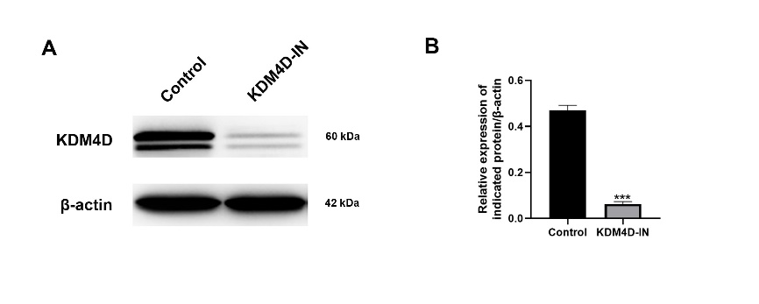
Supplementary Figure 1 A Western blot images of 786-O cells treated with or without KDM4D inhibitor B The protein expression of KDM4D was significantly decreased in KDM4D-IN group. ***p < 0.001.

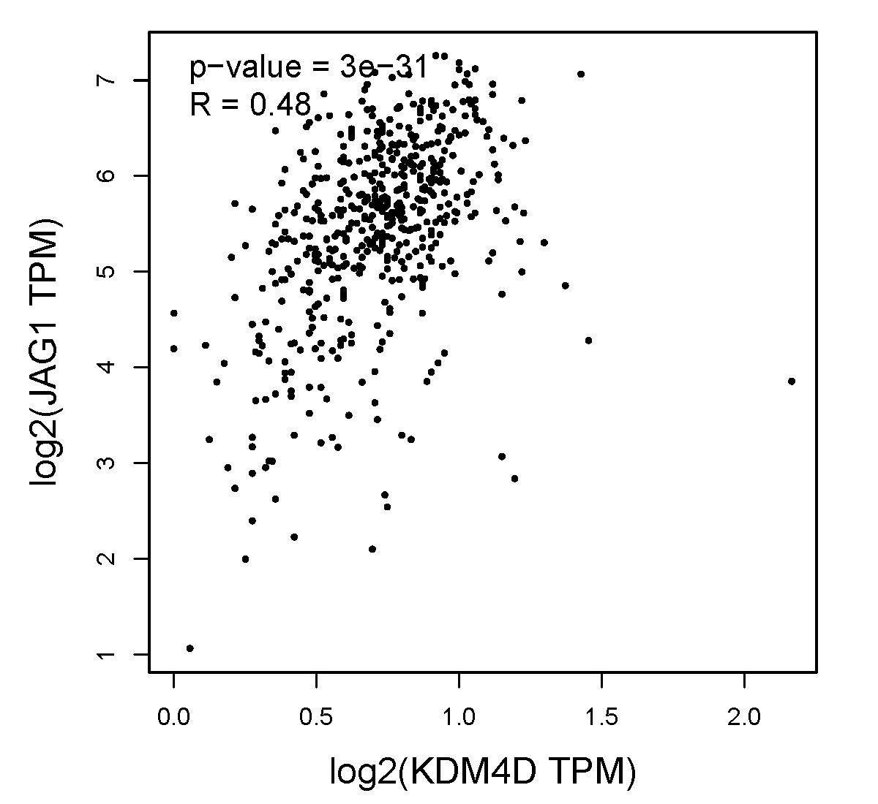
Supplementary Figure 2 Correlation analysis demonstrated that JAG1 is positively associated with KDM4D.

Supplementary Figure 3 Representative images 786-O cells transfected with pcDNA-3.1(+)-JAG1, successfully transfected cells have eGFP green fluorescence.

Supplementary Table 1 Primer sequences of quantitative real-time PCR

Gene | Sense primer (5'-3') | Anti-sense primer (5'-3')
KDM4D | GGGCAGGGGTGTTTACTCAAT | TGTTTGCCAAATGGCGATACT
JAG1 | GTATCTGTCCACCTGGCTATGC | GTCACTGGCACGGTTGTAGC
STAT1 | ACTTTCCCTGACATCATTCGC | TCTACAGAGCCCACTATCCGAG
VEGFR3 | CAGCATCCTGACCATCCACA | ATGGGTCCTTTGAGCCACTC
AKT3 | TGGCACTCCAGAATATCTGGC | CTCCACCAAGGCGTTTATTTG
PLXND1 | CCATCAAGCAGCAAATCAACA | CCACTGGGAGTAGGGCACAT
TGFβ1 | CAGCAACAATTCCTGGCGATA | GCTAAGGCGAAAGCCCTCAAT
GADPH | CATCATCCCTGCCTCTACTGG | GTGGGTGTCGCTGTTGAAGTC

