miR548ai antagonism attenuates exosome-induced endothelial cell dysfunction

Xiujie Xie, PhD¹; Lian-Wang Guo^{1,2,3,*}, PhD; K. Craig Kent^{1,*}, MD

¹Department of Surgery, School of Medicine, University of Virginia, Charlottesville, VA 22908, USA
²Department of Molecular Physiology and Biological Physics, University of Virginia, Charlottesville, Virginia 22908, United States.
³Robert M. Berne Cardiovascular Research Center, University of Virginia, Charlottesville, VA 22908, USA

Running title: miR548ai as a new target

* Corresponding authors:

Lian-Wang Guo, Ph.D.
Department of Surgery, School of Medicine, University of Virginia, 409 Lane Road, Charlottesville, VA 22908, USA
Tel: +1 614 292 5276. Email: lg8zr@virginia.edu

K. Craig Kent, M.D.
1415 Jefferson Park Avenue #4027, Charlottesville, VA 22908, USA. Tel: 434-924-1082.
CK8AQ@hscmail.mcc.virginia.edu.

Supplemental Figures

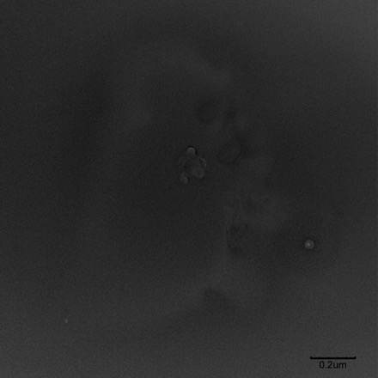

Figure S1. Negative control of TEM imaging of exosomes

Exosomes purified from human primary aortic smooth muscle cells (AoSMCs) were resuspended in PBS and subjected to TEM (see Figure 1A). The PBS buffer was used for negative control. Scale bar: 200 nm.

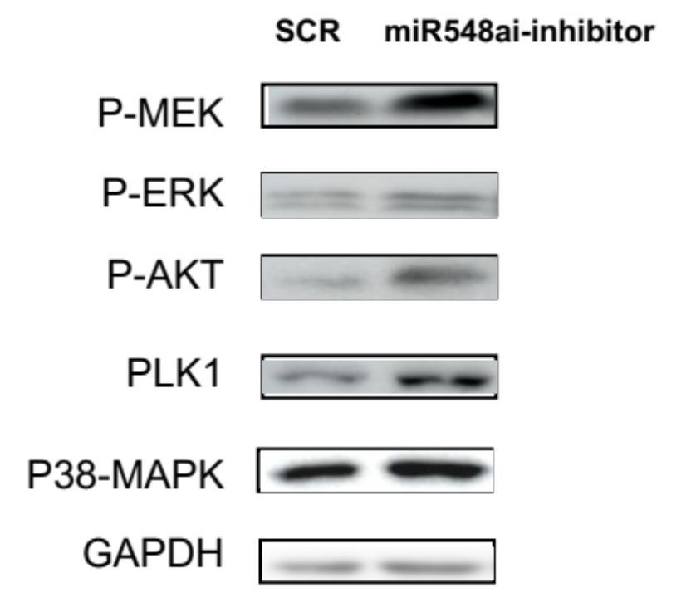

Figure S2. Possible miR548ai’s target gene products in ECs

ECs (HUVEC) cultured in full medium were transfected with miR548ai inhibitor or scrambled control (SCR), the cells were then used for Western blot analysis of proteins.

