Supplementary Information
Supplementary Table 1. List of antibodies used in this study.
Name | Species | Dilution | Vendor | Catalog #
APP-CTF | mouse | 1:500 | biolegend | 802803
APP | Rabbit | 1:500 | Cell signaling | #2452
Parkin | mouse | 1:1000 | Merck Milipore | MAB5512
PINK1 | Rabbit | 1:1000 | Novus | BC100-494
HSP60 | Rabbit | 1:1000 | Cell signaling | #12165
NESTIN | mouse | 1:1000 | Millipore | MAB5326
SOX2 | Rabbit | 1:1000 | Merck | ab5603
Ki67 | Rabbit | 1:500 | abcam | ab15580
TUJ1 | mouse | 1:500 | Biolegend | 801202
LC3 | Rabbit | 1:500 | Novus | NB100
P62 | mouse | 1:500 | BD bioscience | 610832
Ubiquitin | Rabbit | 1:200 | abcam | ab7780
LAMP1 | Mouse | 1:500 | Santa Cruz | SC-20011
Neurofilament | Mouse | 1:500 | Cell signaling | #2836
MAP2 | Mouse | 1:500 | Merck | MAB3418
β-actin | mouse | 1:1000 | Cell signaling | #4967
PSEN1 | Rabbit | 1:1000 | Cell signaling | #5643
PSEN2 | Rabbit | 1:1000 | Cell signaling | #9979
OXPHOS | mouse | 1:1000 | abcam | ab110411

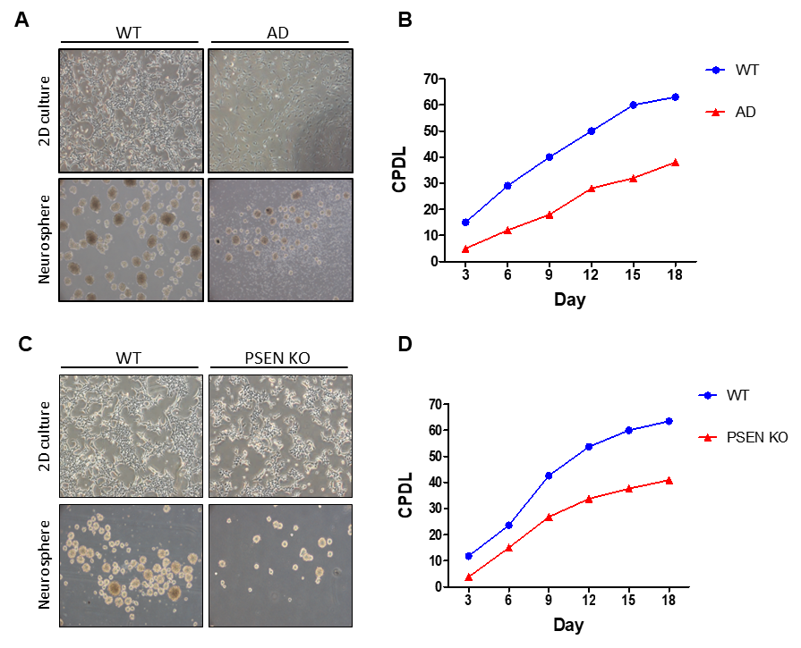
Supplementary figure S1. Proliferation rate of AD-iNSCs and PSEN KO-iNSCs.
(A) Morphology of WT- and AD-iNSCs in 2D culture and neurosphere formation. (B) Cumulative population doubling level (CPDL) of WT- and AD-iNSCs through continuous passaging from day 3 to day 18. (C) Morphology of WT- and PSEN KO-iNSCs in 2D culture and neurosphere formation. (D) Cumulative population doubling level (CPDL) of WT- and PSEN KO-iNSCs through continuous passaging from day 3 to day 18.
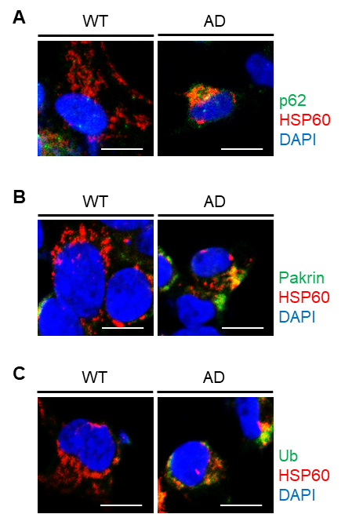
Supplementary figure S2. (A) Representative images of WT- and AD-iNSCs stained with anti-p62 (green) and anti-HSP60 (red). (B) Representative images of WT- and AD-iNSCs stained with anti-Parkin (green) and anti-HSP60 (red). (C) Representative images of WT- and AD-iNSCs stained with anti-Ub (green) and anti-HSP60 (red). Scale bars, 10 µm.

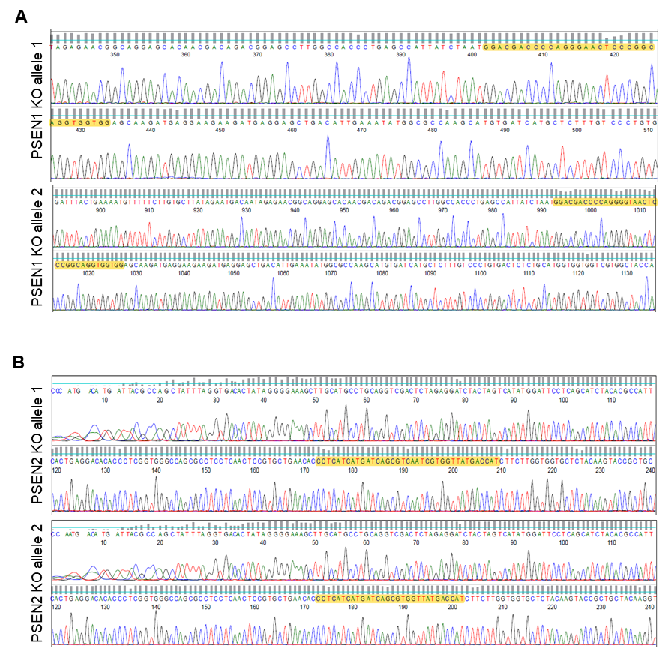
Supplementary figure S3. The genomic DNA sequence of PSEN1 and PSEN2 knockout iNSC.
(A) The genomic DNA sequence of PSEN1 knockout iNSCs. Targeting guide RNAs are shown in the yellow part of this panel. Sanger sequencing of PSEN1 knockout iNSC clones identified two deletions in exon 4 of PSEN1. Allele 1 is a 1-bp exonic deletion, and allele 2 is a 1-bp insertion.
(B) The genomic DNA sequence of PSEN2 knockout iNSCs. Targeting guide RNAs are shown in the yellow part of this panel. Sanger sequencing of PSEN2 knockout iNSC clones identified two deletions in exon 6 of PSEN2. Allele 1 is a 1-bp exonic insertion, and allele 2 is a 7-bp deletion.

