Figure 3C
METTL3 and GAPDH
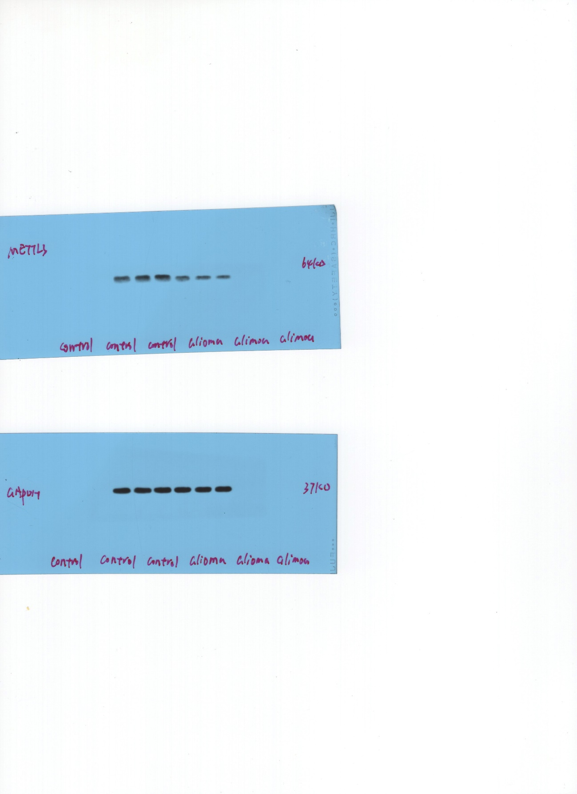

Figure 3D
METTL3 and GAPDH
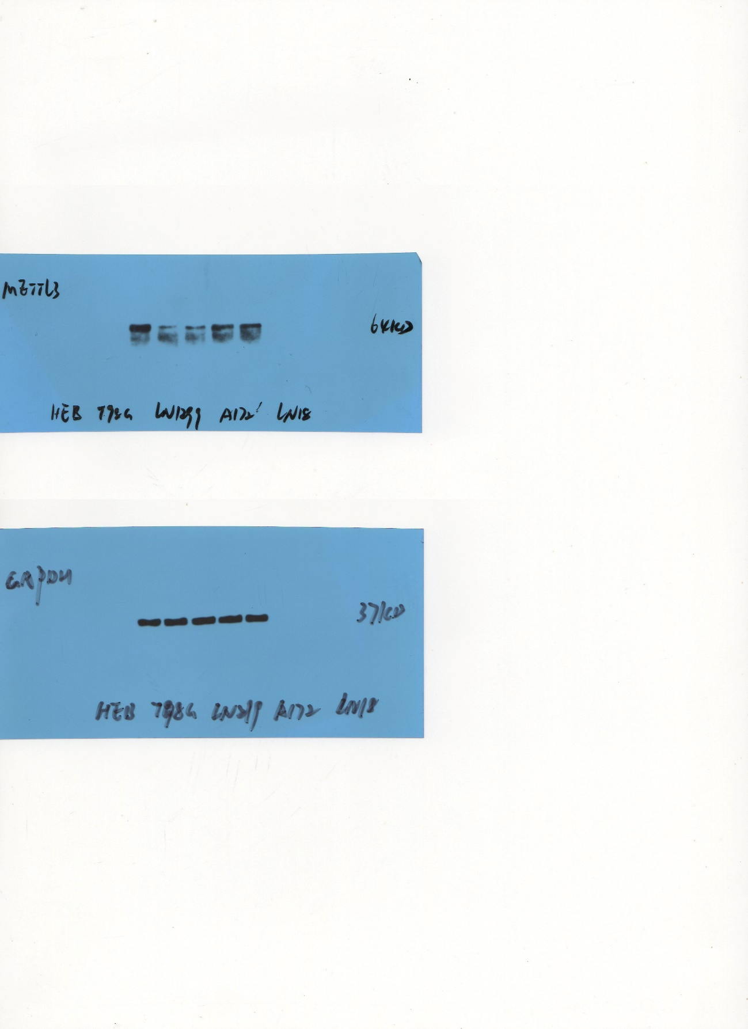

Figure 3K
LN229: METTL3 and GAPDH
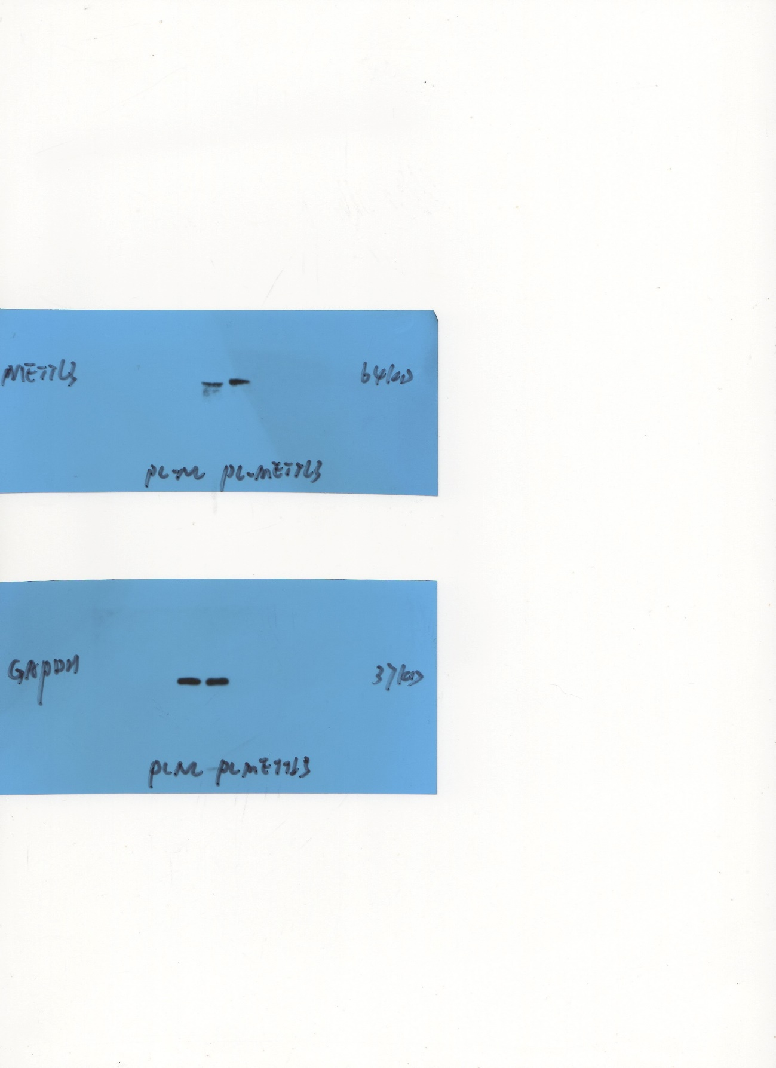

Figure 3K
A172: METTL3 and GAPDH
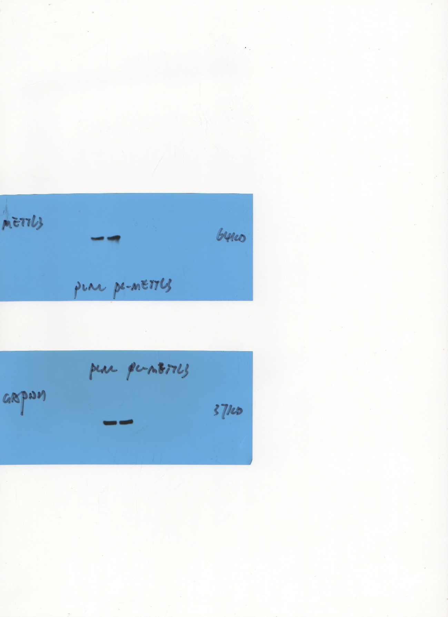

Figure 4B
METTL3 and GAPDH
