Mitochondrial Damage and Activation of the Cytosolic DNA Sensor cGAS–STING Pathway Lead to Cardiac Pyroptosis and Hypertrophy in Diabetic Cardiomyopathy Mice
Meiling Yan^{1†}, Yun Li^{1†}, Qingmao Luo^{1†}, Wenru Zeng¹, Xiaoqi Shao¹, Lun Li¹, Qing Wang¹, Dongwei Wang¹, Yue Zhang¹, Hongtao Diao¹, Xianglu Rong²⁻⁵, Yunlong Bai⁶⁻⁷ and Jiao Guo^{2-5*}
Full WB bands of cGAS, STING, pTBK1, TBK1, pIRF3 and IRF3 shown in Fig1e.

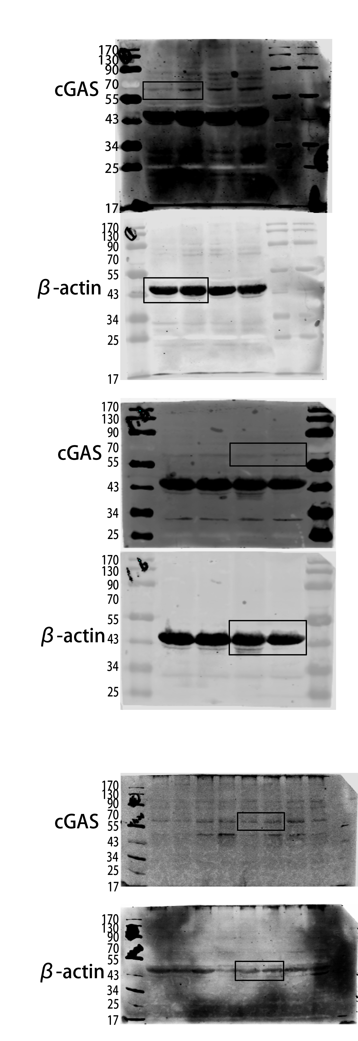
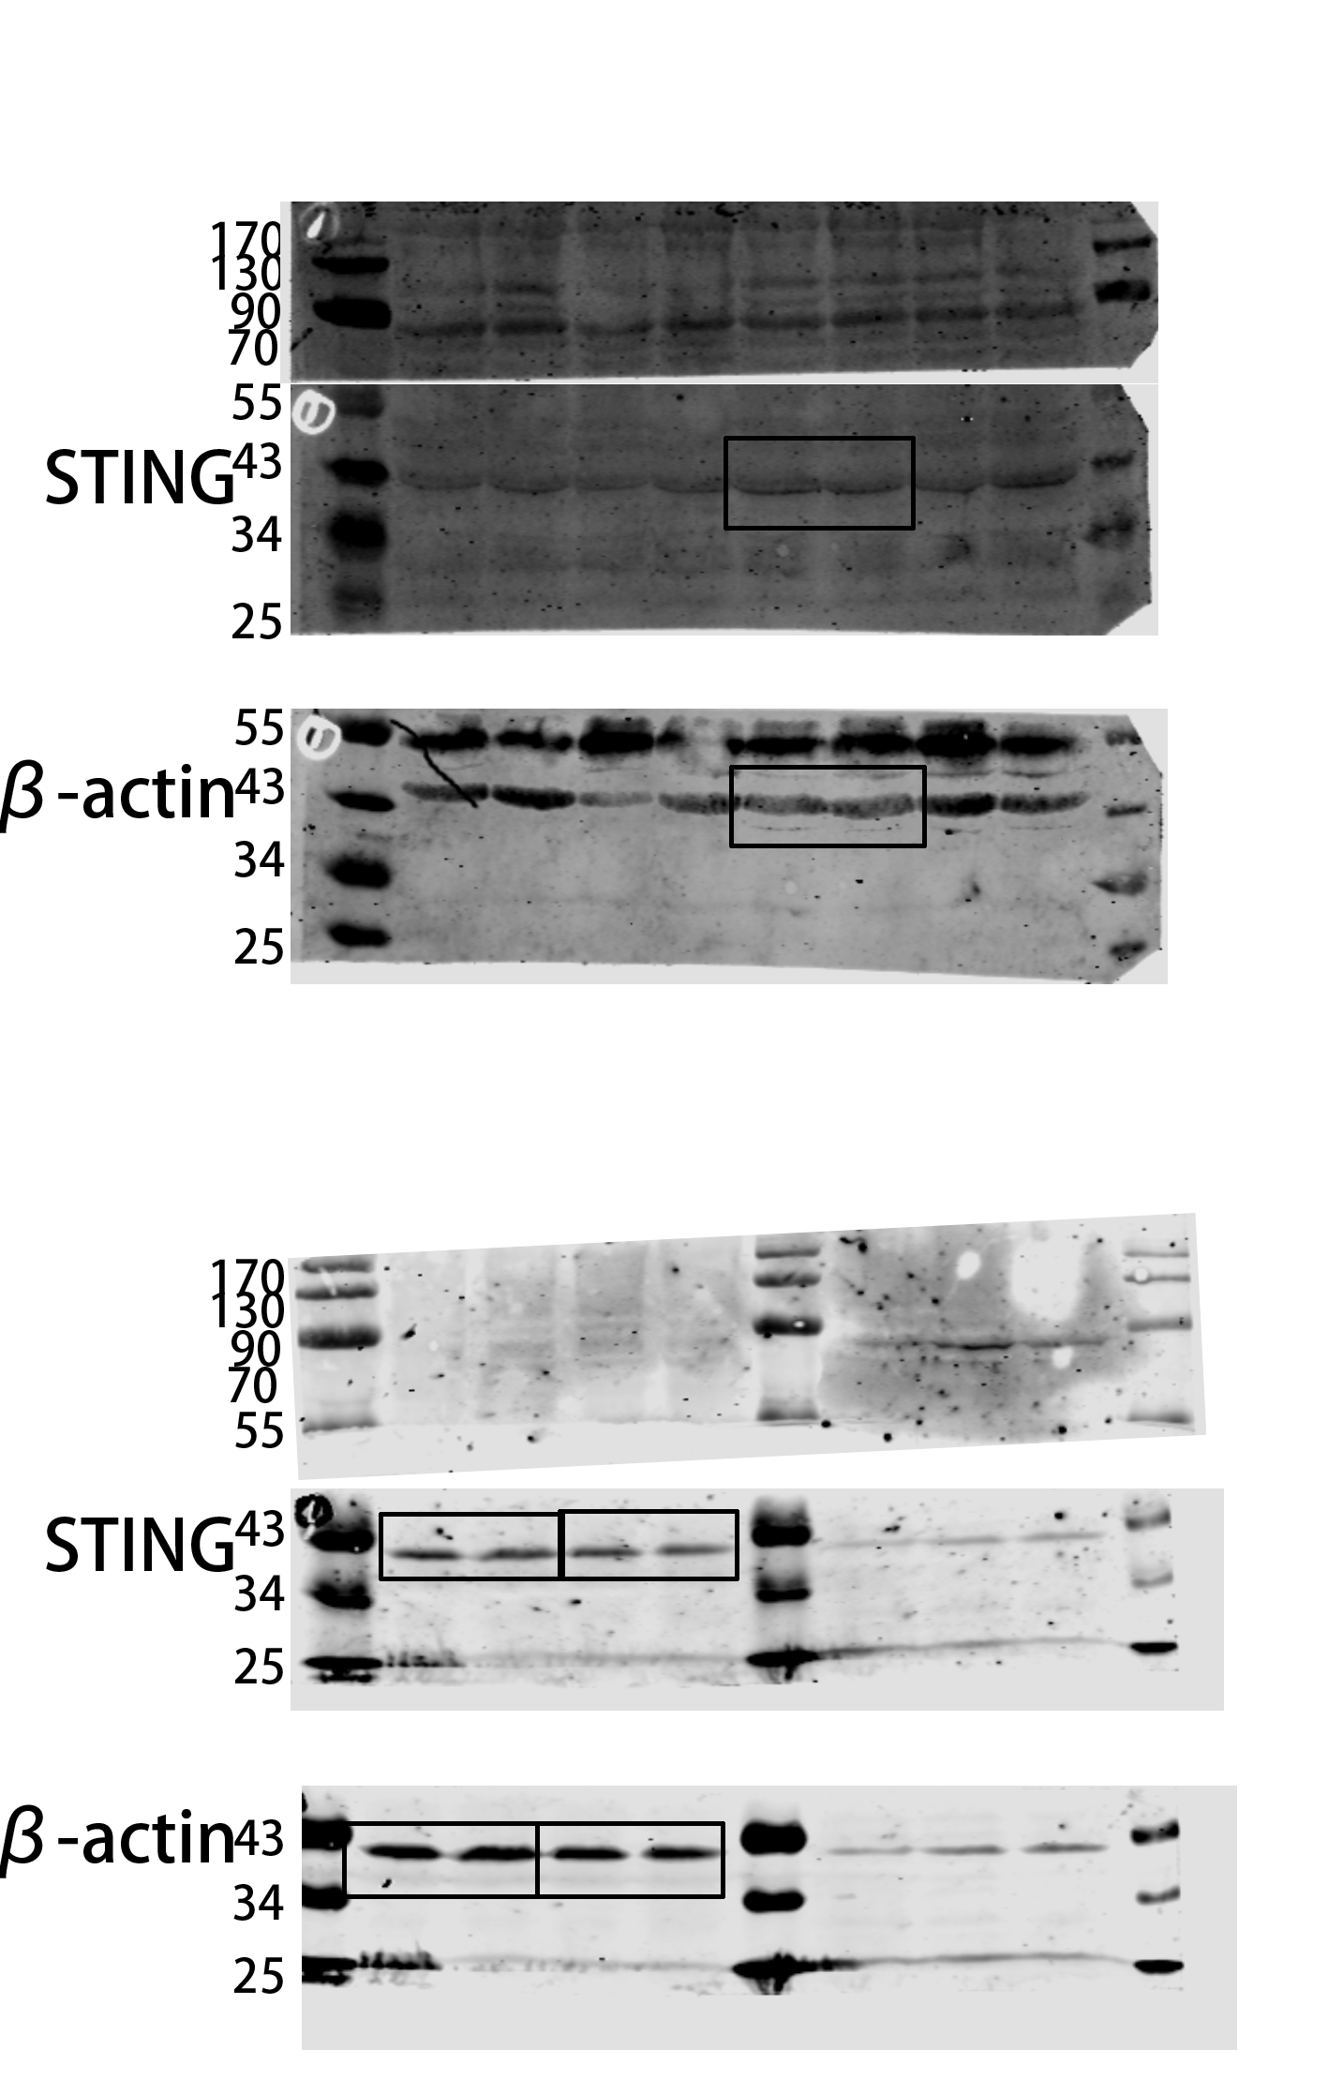
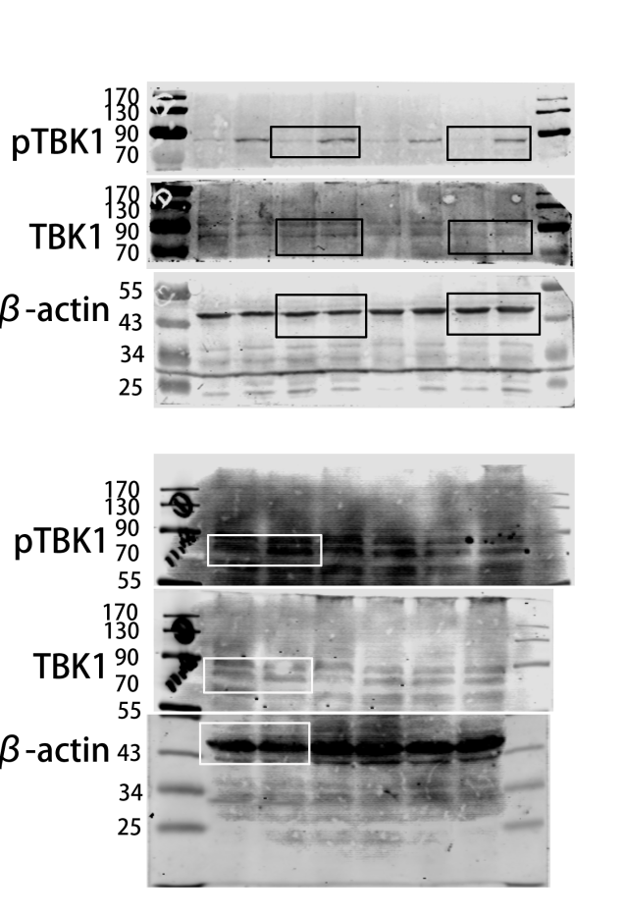
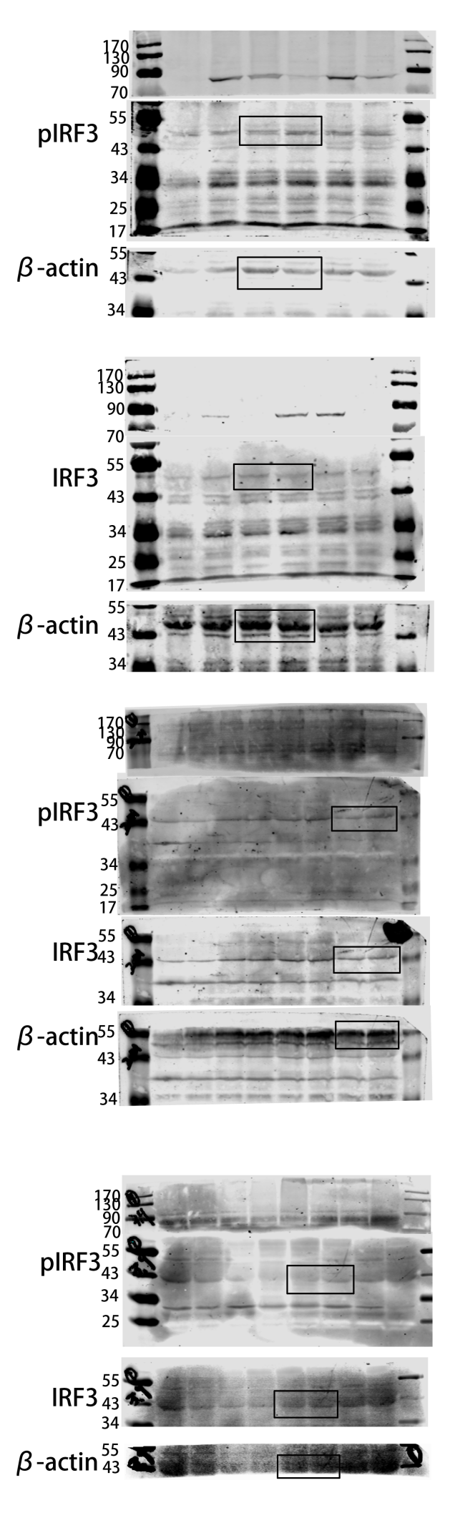
Full WB bands of STING shown in Fig2a.
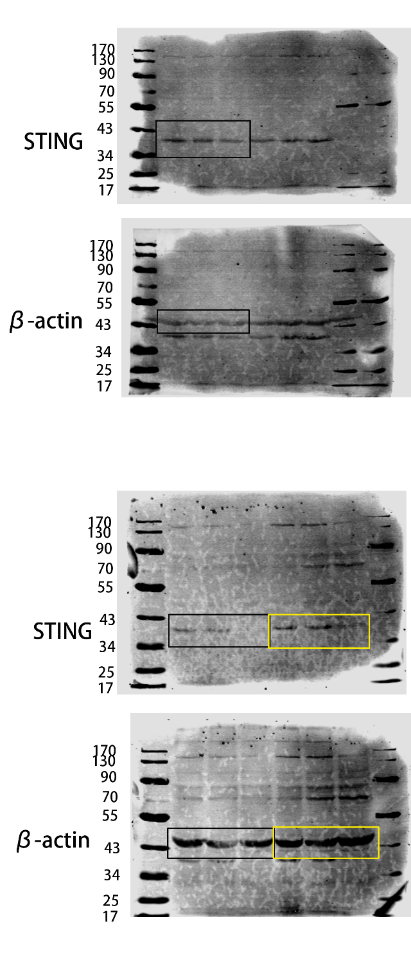

Full WB bands of NLRP3, GSDMD, GSDMD-N shown in Fig3a.

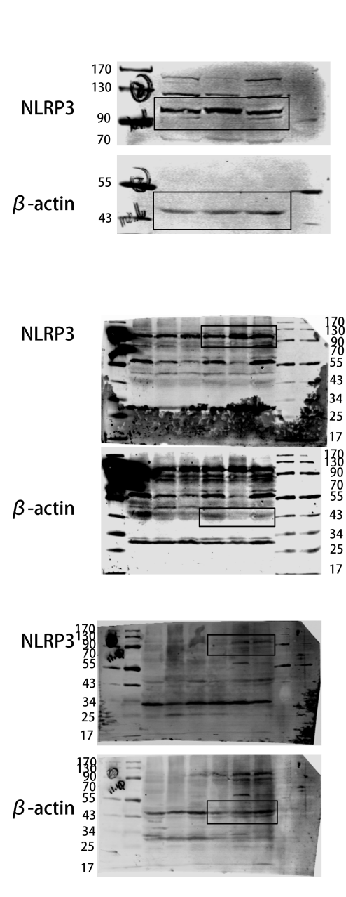
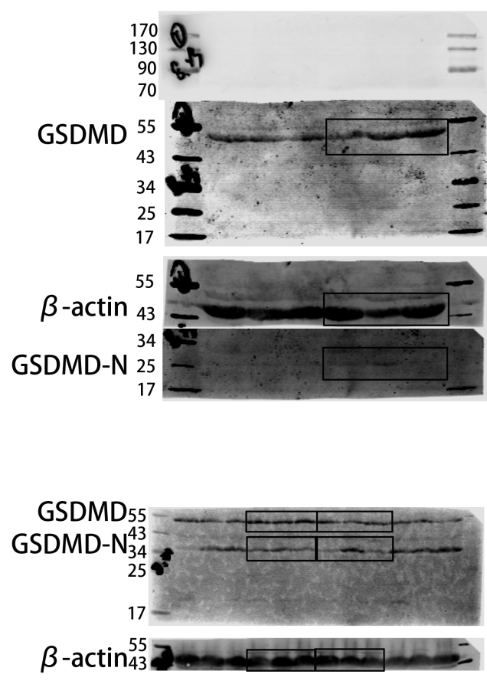

Full WB bands of cGAS, STING, pTBK1, TBK1, pIRF3 and IRF3 shown in Fig4f.
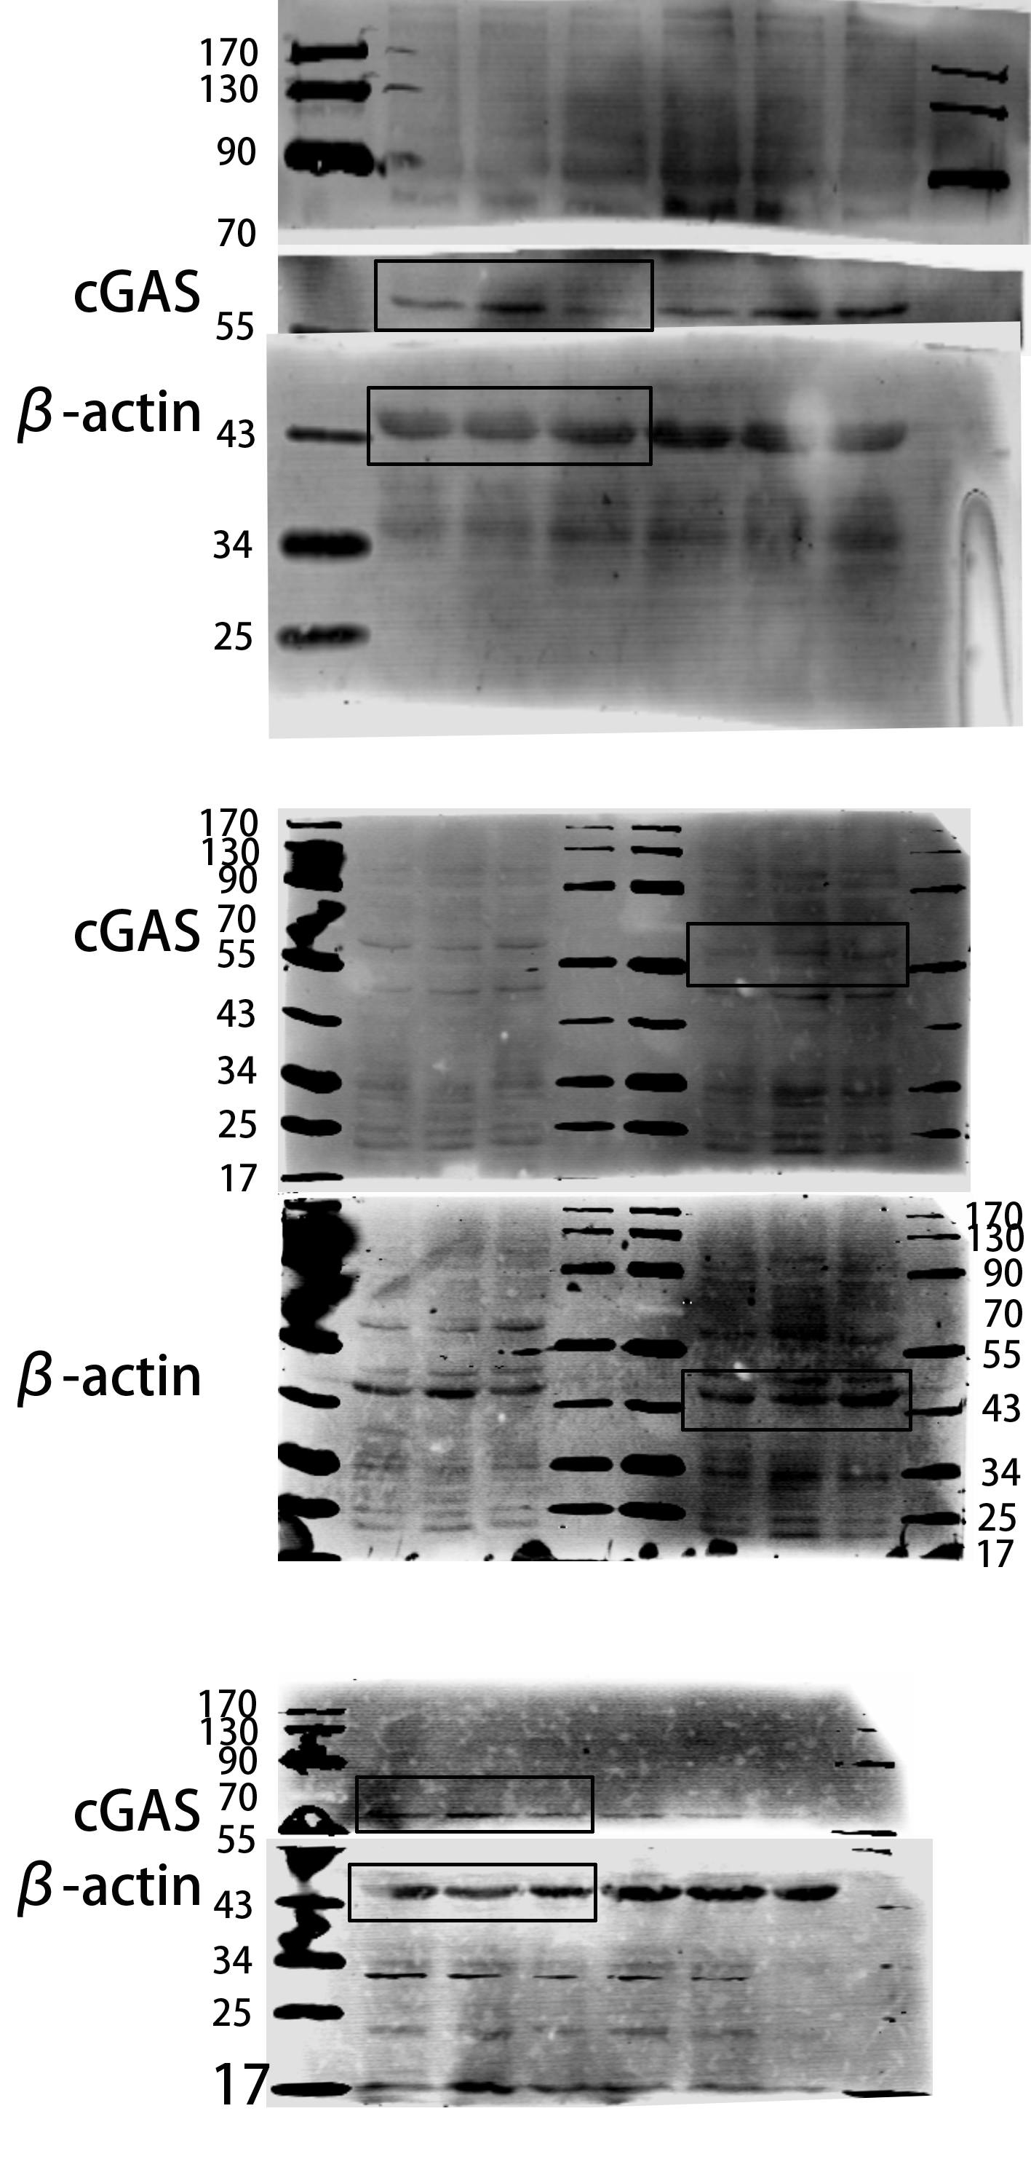
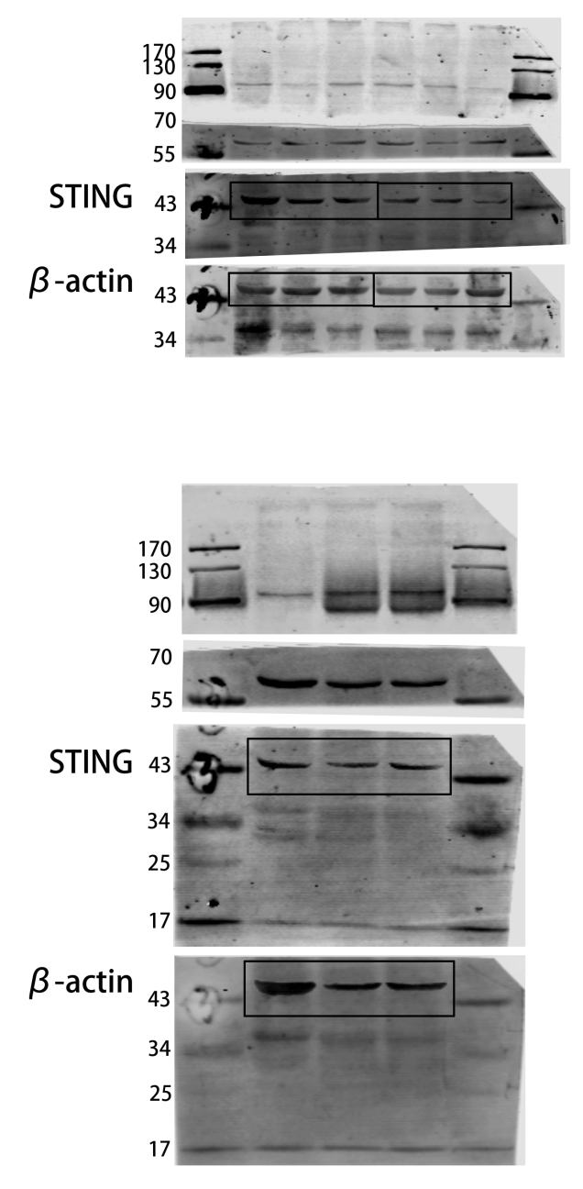
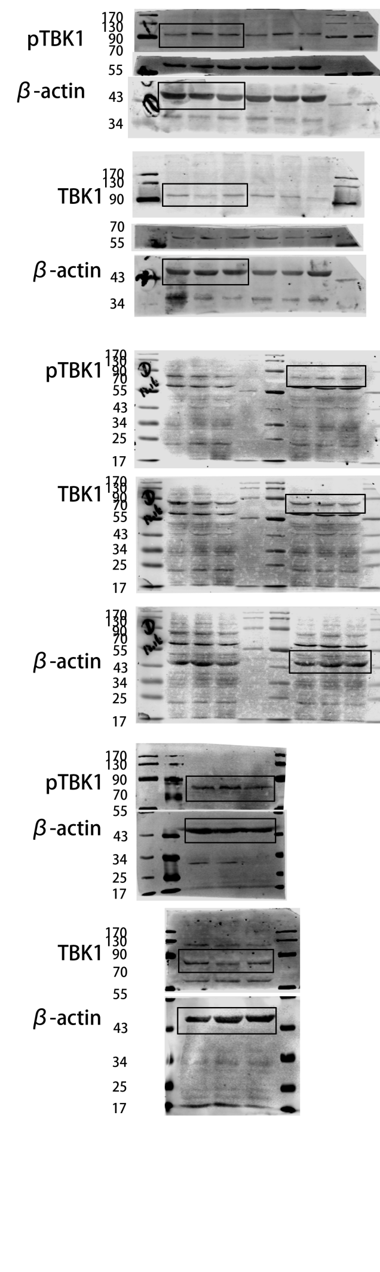
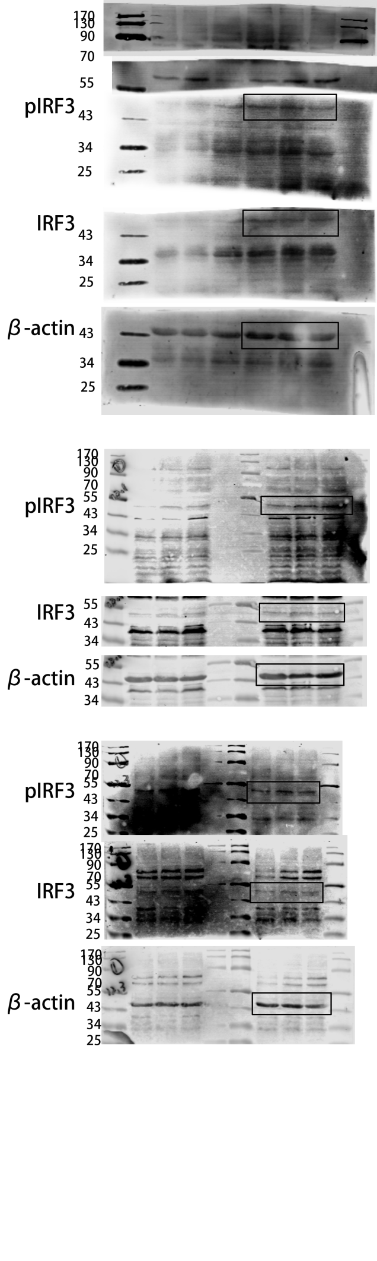
Full WB bands of NLRP3, GSDMD-N and GSDMD shown in Fig5a.
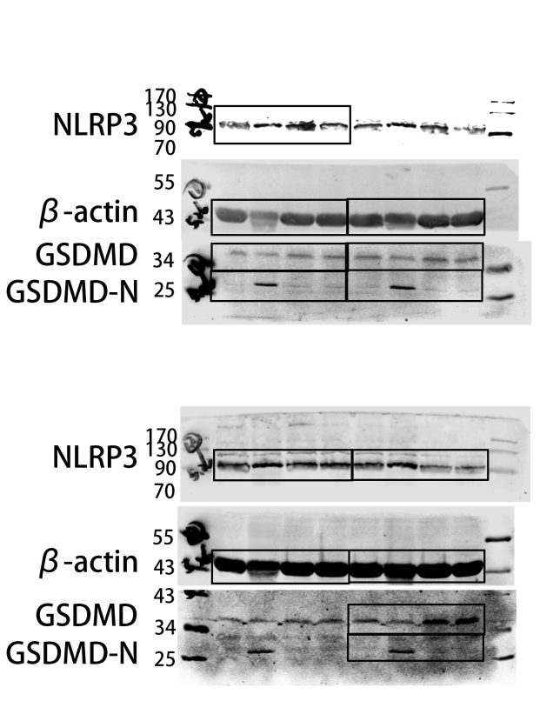

Full WB bands of cGAS shown in Fig S1a.

