Supplemantary Figures & Supplemantary Figure Legends
Supplementary Figure S1. The flow chart of multi-omics analysis of tissues before and after trastuzumab resistance. DNA and RNA extracted from 176P and 176R tissues were used for high-throughput sequencing, single cell suspensions were prepared for single-cell RNA sequencing and protein expression was detected by protein profiling and protein chip.

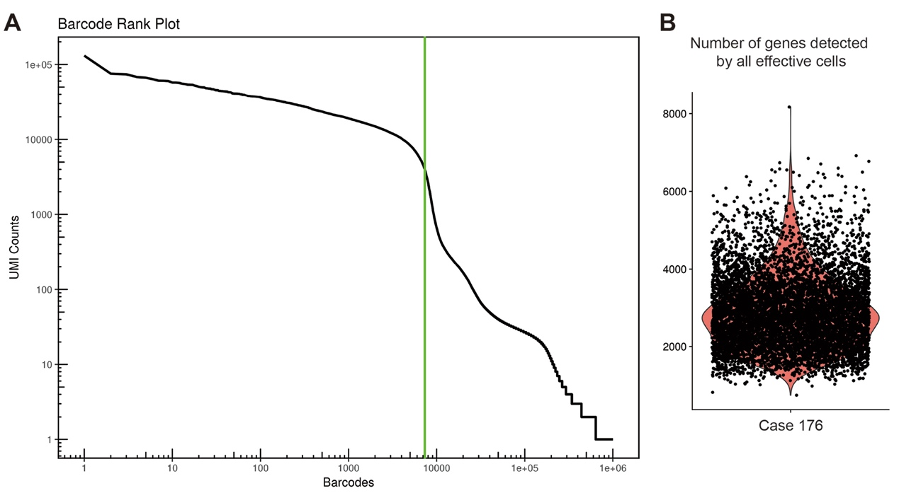
Supplementary Figure S2. Evaluation of effective cells for single-cell transcriptome sequencing. A. Barcodes were ranked according to the UMI (Unique Molecular Identifier) counts in descending order. The X-axis was Barcodes, and the left of the green line was the effective cells. B. Distribution of gene number detected by all the effective cells.

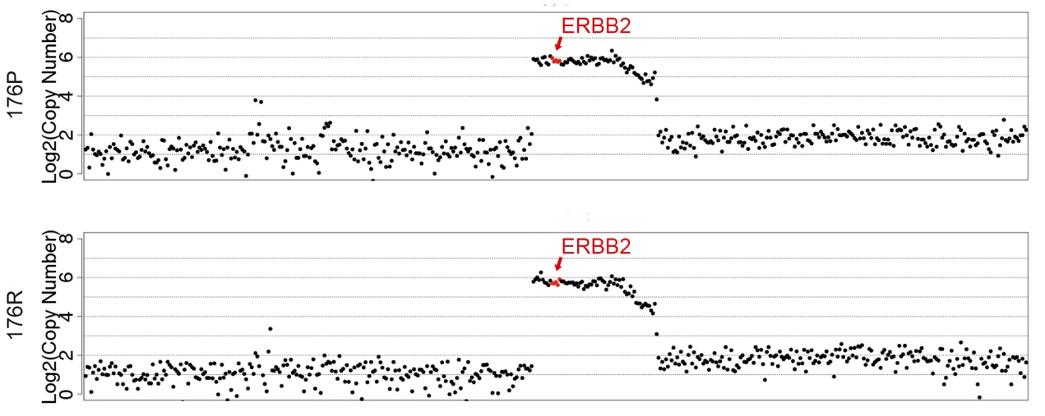
Supplementary Figure S3. WGS showed ERBB2 amplification status of 176P and 176R. Copy number was 43.69 of 176P and 48.14 of 176R.

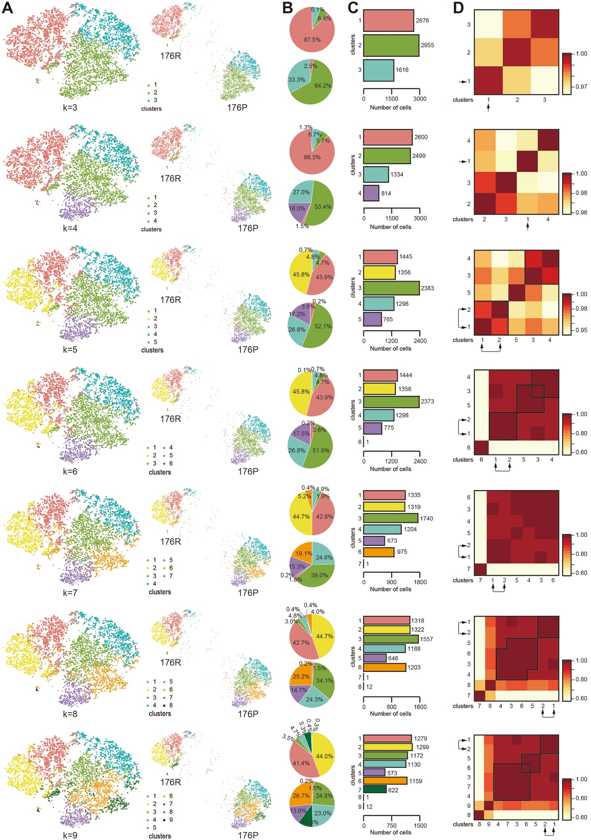
Supplementary Figure S4. Cell subpopulation distributions of all cells when k=3-9 from top to the bottom. A. 176P and 176R tissues had different dominant subgroups and few overlaps were existed. B. The proportion of each cluster in the two samples by pie charts showing fewer dominant subgroups in 176R than 176P tissues. C. Number of cells in each cluster of all cells when k=3-9 by bar graphs. D. Subpopulation correlations were represented by heat maps. The arrows indicated the dominant subgroups in 176R tissue.

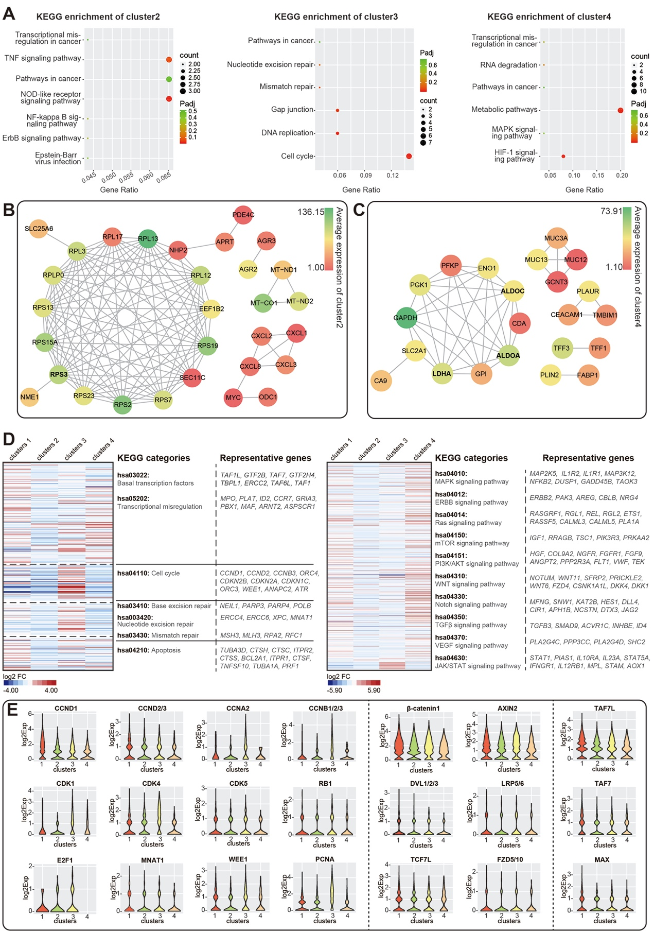
Supplementary Figure S5. Different phenotypes in four clusters by scRNA-seq when k=4. A. KEGG enrichment of top 50 upregulated genes in cluster 2, 3, and 4. B, C. Network diagrams of top 50 upregulated genes of cluster 2 (confidence score=0.700) and cluster 4 (confidence score=0.700) according to STRING database. The color bar represented the average expression of genes in each cluster. D. The heatmaps of genes related to multiple pathways according to KEGG categories with the hsa codes showed beside. E. Violin plots showed the expression profiles of some critical molecules that were involved in cell cycle, transcription factors, and WNT signaling pathways in four clusters.

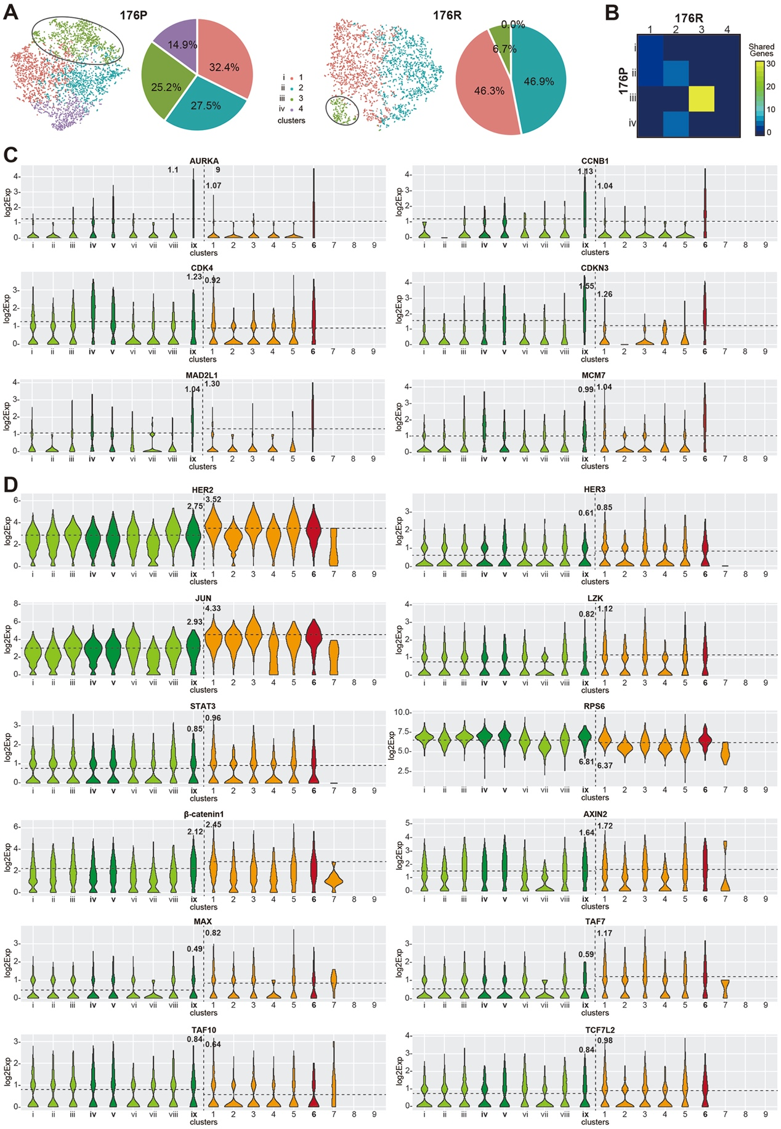
Supplementary Figure S6. Homology analysis revealed the evolved process from parental tissue to trastuzumab resistant tissue. A. 4311 cells of 176P and 2936 cells of 176R were divided into 4 clusters by k means algorithm, respectively. B. Shared genes between clusters of 176P and 176R tissues. C. Violin plots showed the expressions of partial top 50 genes. Cluster 6 and cluster ix, v, iv were highlighted. Dashed lines represented log2 average expression of cells in both samples. D. Violin plots showed the expressions of some enriched genes in previous results. Cluster 6 and cluster ix, v, iv were highlighted. Dashed lines represented log2 average expression of cells in both samples.

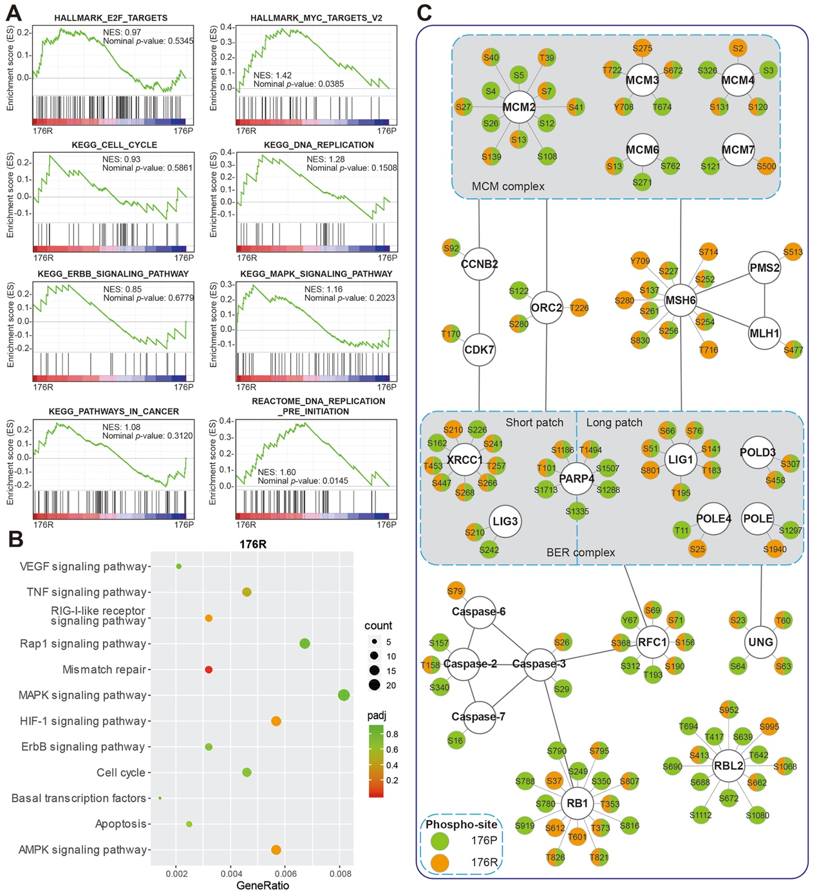
Supplementary Figure S7. Protein expression profile and phosphorylation profile in tissues before and after trastuzumab resistance. A. Co-expressed proteins of 176P and 176R tissues were enriched according to GO, KEGG, REACTOME, and HALLMARK datasets, by GSEA. NES: Normalized Enrichment Score. B. KEGG pathway enrichment of molecules that upregulated after trastuzumab resistance by protein profiling. C. Phosphorylation profiles of some key molecules that were involved in cell cycle, DNA replication, mismatch repair cascades.

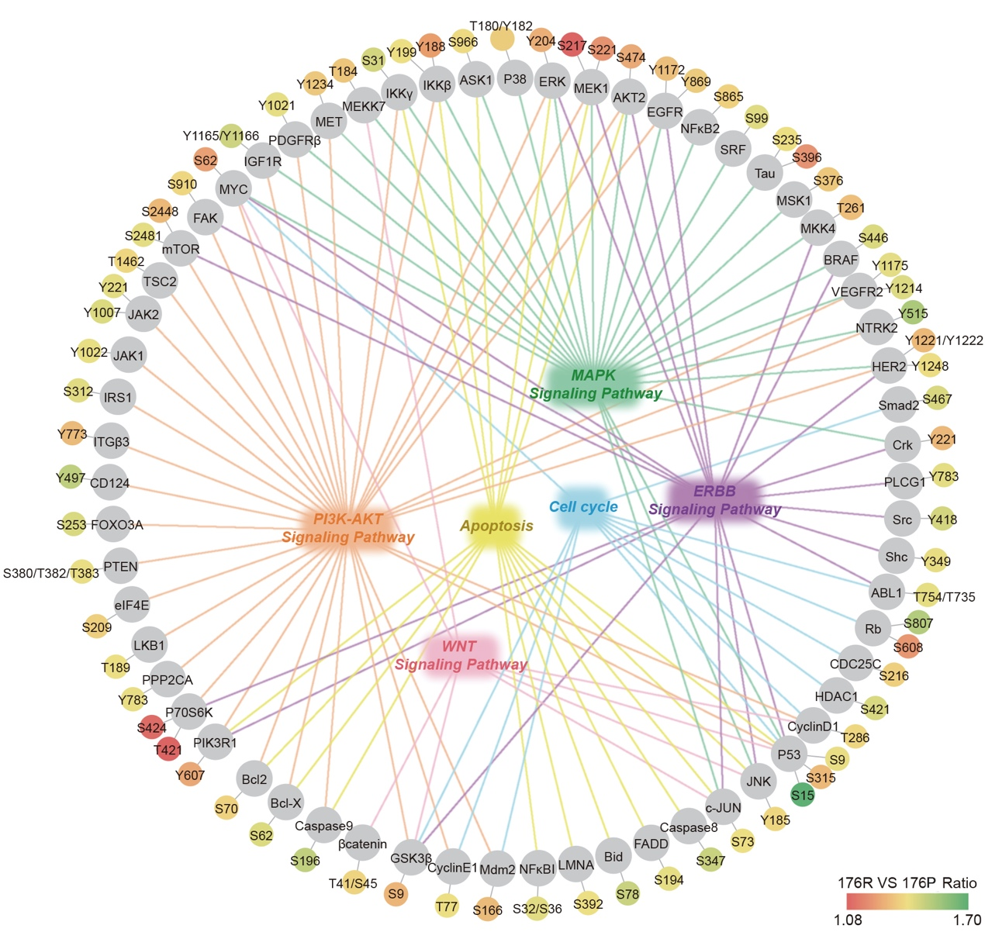
Supplementary Figure S8. The upregulated proteins of phosphorylated forms found by protein chip. Several critical pathways (including MAPK, PI3K/AKT, WNT pathways, cell cycle) were involved.

Supplementary Figure S9. Validations of several molecules before and after trastuzumab resistance. A. The expressions of several markers related with stemness, DNA repair, and EMT were detected by western blot. β-actin as endogenous control. B. HE staining (x40) of tissues in different groups, suggesting the different degrees of tumor inhibition. C. Quantification of WB-identified intensity of molecules related with stemness, DNA repair, and EMT.

Supplementary Figure S10. Quantification of WB-identified molecules and signaling pathways involved in Trastuzumab resistance.
Supplementary Figure S11. Quantification of WB-identified molecules and signaling pathways after combining inhibitors with Trastuzumab in 176R model.

Supplemantary Tables & Supplemantary Table Legends
Supplementary Table S1. DNA targeted capture sequencing panel of 483 genes
DNA targeted capture sequencing panel of 483 genes
ABCB1 | CIC | FUBP1 | MSH6 | SF3B1
ABCC1 | CSNK1A1 | FYN | MTDH | SGK1
ABCC2 | COMT | FZD7 | MTHFR | SHH
ABCC4 | CREBBP | GALNT14 | MTOR | SIK1
ABCC6 | CRKL | GATA1 | MTRR | SKP2
ABCG2 | CRLF2 | GATA2 | MUTYH | SLC10A2
ABL1 | CSF1R | GATA3 | MYC | SLC15A2
ACK1/TNK2 | CSK | GCK | MYCL1 | SLC22A1
ACVR1B | CTCF | GID4 | MYCN | SLC22A16
AKT1 | CTLA4 | GINS2 | MYD88 | SLC22A2
AKT2 | CTNNA1 | GNA11 | NAT1 | SLC22A6
AKT3 | CTNNB1 | GNA13 | NAT2 | SLCO1B1
ALK | CYBA | GNAQ | NCAM1 | SLCO1B3
AMER1 | CYLD | GNAS | NCF4 | SMAD2
APC | CYP19A1 | GPC3 | NCOA3 | SMAD4
AR | CYP1A1 | GPR124 | NCOR1 | SMARCA4
ARAF | CYP1A2 | GRIN2A | NEK11 | SMARCB1
ARFRP1 | CYP1B1 | GSK3B | NF1 | SMO
ARID1A | CYP2A6 | GSTM1 | NF2 | SOCS1
ARID1B | CYP2B6 | GSTM3 | NFE2L2 | SOD2
ARID2 | CYP2C19 | GSTP1 | NFKBIA | SOX10
ASXL1 | CYP2C8 | GSTT1 | NKX2-1 | SOX2
ATIC | CYP2C9 | H3F3A | NOS3 | SOX9
ATM | CYP2D6 | HCK | NOTCH1 | SPEN
ATP7A | CYP2E1 | HGF | NOTCH2 | SPG7
ATR | CYP3A4 | HIF-1/HIF1A | NPM1 | SPOP
ATRX | CYP3A5 | HIST1H3B | NQO1 | SRC
AURKA | CYP4B1 | HNF1A | NRAS | SRD5A2
AURKB | DAXX | HRAS | NTRK1 | SRMS
AXIN1 | DDR1 | HSP90AA1 | NTRK2 | STAG2
AXL | DDR2 | IDH1 | NTRK3 | STAT1
B2M | DNMT1 | IDH2 | NUP93 | STAT2
BAIAP3 | DNMT3A | IGF1 | PAK1 | STAT3
BAP1 | DOT1L | IGF1R/IGFR | PAK3 | STAT4
BARD1 | DPYD | IGF2 | PALB2 | STAT5A
BCL2 | DSCAM | IGF2R | PARP1 | STAT5B
BAL2L2 | E2F1 | IKBKB | PARP2 | STAT6
BCL6 | EGF | IKBKE | PAX5 | STEAP1
BCOR | EGFL7 | IKZF1 | PBRM1 | STK11
BCORL1 | EGFR | IL7R | PDCD1 | STK3
BCR | EGR1 | INHBA | PDGFRA | STK4
BIRC5 | EMC8 | INSR/IR | PDGFRB | SUFU
BLK | EML4 | IRF4 | PDK1 | SULT1A1
BLM | ENOSF1 | IRS2 | PHF6 | SULT1A2
BRAF | EP300 | ITK | PHKA2 | SULT1C4
BRCA1 | EPH/EPHA1 | JAK1 | PIGF | SYK
BRCA2 | EPHA2 | JAK2 | PIK3CA | TCF7L1
BRIP1 | EPHA3 | JAK3 | PIK3CB | TCF7L2
BRK/PTK6 | EPHA4 | JUN | PIK3CG | TEK
BSG/CD147 | EPHA5 | KAT6A | PIK3R1 | TET2
BTK | EPHA7 | KDM5A | PIK3R2 | TGFBR1
C11orf30 | EPHA8 | KDM5C | PKC/PRRT2 | TGFBR2
C18orf56 | EPHB1 | KDM6A | PKCγ/PRKCG | TK1
C8orf34 | EPHB2 | KDR/VEGFR | PKCε/PRKCE | TMPRSS2
CAMK2G | EPHB3 | KEAP1 | PLK1 | TNF
CAMKK2 | EPHX1 | KIT | PPARD | TNFAIP3
CARD11 | ERBB2/HER2 | KLC3 | PPP1R13L | TNFRSF14
CASP8 | ERBB3 | KLHL6 | PPP2R1A | TNFRSF8
CBFB | ERBB4 | KMT2A/MLL | PRDM1 | TNFSF11
CBL | ERCC1 | KMT2B/MLL4 | PRDX4 | TNFSF13B
CBR1 | ERCC2 | KMT2C/MLL3 | PRKAA1 | TOP1
CBR3 | ERG | KMT2D/MLL2 | PRKAR1A | TP53
CCND1 | ESR1/ER | KRAS | PRKCA | TPMT
CCND2 | ETV1 | LCK | PRKCB | TPX2
CCND3 | ETV4 | LIMK1 | PRKDC | TRAIL-R1/TNFRSF10A
CCNE1 | ETV5 | LMO1 | PTCH1 | TRAIL-R2/TNFRSF10B
CCR4 | ETV6 | LRP1B | PTEN | TSC1
CD19 | EWSR1 | LRP2 | PTK2 | TSC2
CD22 | EZH2 | LYN | PTPN11 | TSHR
CD274 | FAM46C | MAP2K1 | PTPRD | TYMS/TS
CD33 | FANCA | MAP2K2 | RAC2 | TYRO3
CD38 | FANCC | MAP2K4 | RAD50 | U2AF1
CD3EAP | FANCD2 | MAP3K1 | RAD51 | UBE2I
CD52 | FANCE | MAP4K4 | RAF1 | UGT1A1
CD74 | FANCF | MAP4K5 | RARA | UGT1A9
CD19A | FANCG | MAPK1 | RB1 | UGT2B15
CD79B | FANCL | MAPK10 | RET | UGT2B17
CDA | FBXW7 | MAPK14 | RICTOR | UGT2B7
CDC73 | FCGR3A | MAPK8 | RMDN2 | UMPS
CDH1 | FGF10 | MAPK9 | RNF43 | VEGFA
CDK1 | FGF14 | MAPKAPK2 | ROCK1 | VEGFB
CDK12 | FGF19 | MARK1 | RON/MST1R | VHL
CDK2 | FGF23 | MCL1 | ROS1 | WEE1
CDK4 | FGF3 | MDM2 | RPL13 | WISP3
CDK5 | FGF4 | MDM4 | PRS6KA1 | WNK3
CDK6 | FGF6 | MED12 | RPS6KB1 | WT1
CDK7 | FGFR1 | MEF2B | RPTOR | XPC
CDK8 | FGFR2 | MEN1 | RRM1 | XPO1
CDK9 | FGFR3 | MERTK | RUNX1 | XRCC1
CDKN1B | FGFR4 | MET | SCF/KITLG | XRCC4
CDKN2A | FGR | MITF | SDHA | YES1
CDKN2B | FKBP1A | MKNK2 | SDHAF1 | ZAP70
CDKN2C | FLT1 | MLH1 | SDHAF2 | ZC3HAV1
CEBPA | FLT3 | MPL | SDHB | ZNF217
CHEK1 | FLT4 | MRE11A | SDHC | ZNF703
CHEK2 | FOXL2 | MS4A1 | SDHD
CHST3 | FRK | MSH2 | SETD2

Supplementary Table S2. Antibodies involved in western blot and immunohistochemistry
Antibodies | Catalog Number | Manufacturer | Western Blot (Dilution) | Immunohistochemistry (Dilution)
HER2 | #2165 | Cell Signaling Technology | 1:1000 | 1:400
pHER2 (Tyr1221/1222) | #2243 | Cell Signaling Technology | 1:1000
AKT | #4691 | Cell Signaling Technology | 1:1000
pAKT (Ser473) | #4060 | Cell Signaling Technology | 1:2000
S6 | #2217 | Cell Signaling Technology | 1:1000
pS6 (Ser235/236) | #4858 | Cell Signaling Technology | 1:2000
EGFR | #4267 | Cell Signaling Technology | 1:1000
pEGFR (Tyr1068) | #3777 | Cell Signaling Technology | 1:1000
HER3 | #12708 | Cell Signaling Technology | 1:1000
pHER3 (Tyr1289) | #2842 | Cell Signaling Technology | 1:1000
mTOR | #2983 | Cell Signaling Technology | 1:1000
pmTOR (Ser2448) | #5536 | Cell Signaling Technology | 1:1000
pPI3K p85 (Tyr458) / p55 (Tyr199) | #17366 | Cell Signaling Technology | 1:1000
EphA2 | #6997 | Cell Signaling Technology | 1:1000
pEphA2 (Tyr588) | #6347 | Cell Signaling Technology | 1:1000
MEK1/2 | #9126 | Cell Signaling Technology | 1:1000
pMEK1/2 (Ser217/221) | #9154 | Cell Signaling Technology | 1:1000
ERK1/2 | #4695 | Cell Signaling Technology | 1:1000
pERK1/2 (Thr202/Tyr204) | #4370 | Cell Signaling Technology | 1:2000
JNK2 | #9258 | Cell Signaling Technology | 1:1000
pJNK2 (Thr183/Tyr185) | ab4821 | Abcam | 1:1000
c-Myc | ab32072 | Abcam | 1:1000 | 1:100
TCF1/TCF7 | #2203 | Cell Signaling Technology | 1:1000 | 1:400
STAT3 | #9139 | Cell Signaling Technology | 1:1000
pSTAT3 (Tyr705) | #9145 | Cell Signaling Technology | 1:2000
E2F1 | ab179445 | Abcam | 1:1000
CyclinD1 | #2978 | Cell Signaling Technology | 1:1000
CDK4 | #12790 | Cell Signaling Technology | 1:1000
CDK6 | #13331 | Cell Signaling Technology | 1:1000
Rb | #9309 | Cell Signaling Technology | 1:2000
pRb (Ser807/811) | #8516 | Cell Signaling Technology | 1:1000
β-catenin | #8480 | Cell Signaling Technology | 1:1000
A-β-catenin | #19807 | Cell Signaling Technology | 1:1000
p-β-catenin (Ser33/37/Thr41) | #9561 | Cell Signaling Technology | 1:1000
GSK3β | #12456 | Cell Signaling Technology | 1:1000
pGSK3β (Ser9) | #5558 | Cell Signaling Technology | 1:1000
β-actin | #014M4759 | Sigma | 1:10000
Anti-Rabbit IgG, HRP-linked antibody | #7074 | Cell Signaling Technology | 1:1000
Anti-Mouse IgG, HRP-linked antibody | #7076 | Cell Signaling Technology | 1:1000
Enzyme-labeled goat anti-mouse/rabbit IgG polymer | #PV-6000 | ZSGB-BIO |  | /
Ki67 | #ZM-0167 | ZSGB-BIO |  | 1:50

Supplementary Table S3. The weight change of mice under different treatments
Experiment 1
Treatment | Day0 |  | Day3 |  | Day6 |  | Day9 |  | Day12 |  | Day15 |  | Day18 |  | Day21
Treatment | mean (%) | SD (%) | mean (%) | SD (%) | mean (%) | SD (%) | mean (%) | SD (%) | mean (%) | SD (%) | mean (%) | SD (%) | mean (%) | SD (%) | mean (%) | SD (%)
vehicle | 100 | 0 | 103 | 0.23 | 101.5 | 0.99 | 102.5 | 6.53 | 100.8 | 1.99 | 99.76 | 1.37 | 97.53 | 1.73 | 96.41 | 1.36
trastuzumab | 100 | 0 | 103.5 | 2.94 | 102 | 0.94 | 100.1 | 1.06 | 97.4 | 1.81 | 95.91 | 1.53 | 96.42 | 1.94 | 95.42 | 2.13
CAN017 | 100 | 0 | 103.8 | 2.83 | 104 | 3.09 | 101.9 | 1.41 | 100.9 | 2.06 | 98.48 | 3 | 95.2 | 2.68 | 95.34 | 0.91
tras+CAN | 100 | 0 | 102.9 | 1.36 | 104 | 1.43 | 96.61 | 3.94 | 96.61 | 4.26 | 91.56 | 4.18 | 96.34 | 1.34 | 97.39 | 1.33
trametinib | 100 | 0 | 97.21 | 1.05 | 94.5 | 0.86 | 93.14 | 1.91 | 91.73 | 0.14 | 86.3 | 1.9 | 84.96 | 2.08 | 85.86 | 2.59
tras+tram | 100 | 0 | 96.18 | 0.42 | 89.76 | 1.06 | 89.04 | 1.23 | 89.47 | 1.35 | 88.78 | 1 | 85.83 | 0.87 | 85.65 | 1.45
JQ1 | 100 | 0 | 95.44 | 1.52 | 86.56 | 0.78 | 83.82 | 1.82 | 80.86 | 2.73 | 83.54 | 2.95 | 81.08 | 1.88 | 83.43 | 2.09
tras+JQ1 | 100 | 0 | 94.69 | 1.82 | 88.84 | 3.97 | 91.02 | 2.39 | 90.3 | 1.75 | 85.5 | 3.11 | 82.29 | 4.24 | 82.03 | 3.46
BEZ235 | 100 | 0 | 93.36 | 0.52 | 87.86 | 1.29 | 82.26 | 3.34 | 85.8 | 3.24 | 84.08 | 2.44 | 82.47 | 4.84 | 76.88 | 0.96
tras+BEZ | 100 | 0 | 92.57 | 1.85 | 88.52 | 1.76 | 83.86 | 2.12 | 83.44 | 2.67 | 81.97 | 1.64 | 86.02 | 0.44 | 79 | 2.28

Experiment 2
Treatment | Day0 |  | Day3 |  | Day6 |  | Day9 |  | Day12 |  | Day15 |  | Day18 |  | Day21
Treatment | mean (%) | SD (%) | mean (%) | SD (%) | mean (%) | SD (%) | mean (%) | SD (%) | mean (%) | SD (%) | mean (%) | SD (%) | mean (%) | SD (%) | mean (%) | SD (%)
vehicle | 100 | 0 | 101.8 | 1.3 | 100.8 | 1.22 | 99.56 | 1.86 | 101.7 | 1.81 | 100.2 | 1.25 | 101.3 | 1.41 | 102 | 2.07
trastuzumab | 100 | 0 | 102.1 | 1.68 | 103.8 | 1.41 | 102.4 | 1.16 | 101.3 | 1.26 | 99.55 | 1.24 | 100.8 | 1.66 | 103.5 | 2.4
SHR6390 | 100 | 0 | 90.2 | 3.77 | 92.69 | 2.35 | 86.39 | 2.01 | 87.02 | 0.82 | 86.55 | 0.59 | 87.61 | 1.52 | 88.8 | 2.96
tras+SHR | 100 | 0 | 97.73 | 3.87 | 100.5 | 2.95 | 94.51 | 1.31 | 95.02 | 1.21 | 93.61 | 2.99 | 91.8 | 3.08 | 89.43 | 3.41

