SUPPLEMENTARY INFORMATION

Khan et al. Co-targeting BCL-X_{L} and MCL-1 with DT2216 and AZD8055 synergistically inhibit small-cell lung cancer growth without causing on-target toxicities in mice.

SUPPLEMENTARY METHODS
Immunoblotting
Cell pellets were lysed using RIPA lysis buffer (Cat. No. BP-115DG, Boston Bio Products, Ashland, MA) supplemented with protease and phosphatase inhibitor cocktail (Cat. No. PPC1010, Sigma-Aldrich, St. Louis, MO) as described previously¹. Briefly, an equal amount of protein samples (20-40 µg/lane) were loaded to precast gels and transferred onto PVDF membranes. The membranes were blocked with 5% (w/v) non-fat dry milk in TBST buffer, and subsequently probed with primary antibodies overnight at 4 °C. After washing with TBST, the membranes were incubated with horseradish peroxidase (HRP)-linked secondary antibody for 1-2 h at room temperature. Finally, the membranes were incubated with chemiluminescent HRP substrate (Cat. No. WBKLS0500, MilliporeSigma, Billerica, MA), and were recorded using the ChemiDoc MP Imaging System (Bio-Rad, Hercules, CA). The immunoblots were quantified using Image J software. The primary antibody details are provided in Supplementary Table 1.
Clonogenic assay
A total of 2,000 cells per well were seeded in 6-well plates. After overnight incubation, the cells were treated with AZD8055, DT2216, or a combination of the two for 10-14 days. Fresh treatment-containing medium was added to the plates every four days. At the end, the cells were fixed with methanol and stained with 0.1% crystal violet solution.
Annexin-V/PI apoptosis assay using flow cytometry
Cells were seeded in 12-well plates at a density of 1×10⁵ cells per well and were treated with AZD8055, DT2216, or the combination of the two for 72 h. After incubation, the cells were collected by trypsinization and were stained with Annexin V-Alexa Fluor 647 (1:50, Cat. No. 640912, BioLegend, San Diego, CA) and propidium iodide (PI, 1 μg/mL, Cat. No. 421301, BioLegend) for 30 min at room temperature. The samples were analyzed using flow cytometer (Aurora, Cytek Biosciences, Fremont, CA) and the SpectraFlo software (Repligen, Waltham, MA). A minimum of 10,000 events were recorded for each sample. The percentage of apoptotic cells are presented as the sum of Annexin V-positive/ PI-negative and Annexin V-positive/ PI-positive cells.
Histopathology
Mouse lungs were fixed in 4% paraformaldehyde overnight and were then transferred to 70% ethanol. Paraffin embedding, sectioning, and H & E stating were performed by the Molecular Pathology Core (University of Florida). The images were taken using snapshots from Leica Aperio Scanscope CS whole slide scanner (Leica Biosystems, Inc., Buffalo Grove, IL). The tumor area in each lung was calculated using QuPath Quantitative Pathology and Bioimage Analysis software (version 0.2.3) with Image J extension (https://qupath.github.io/).

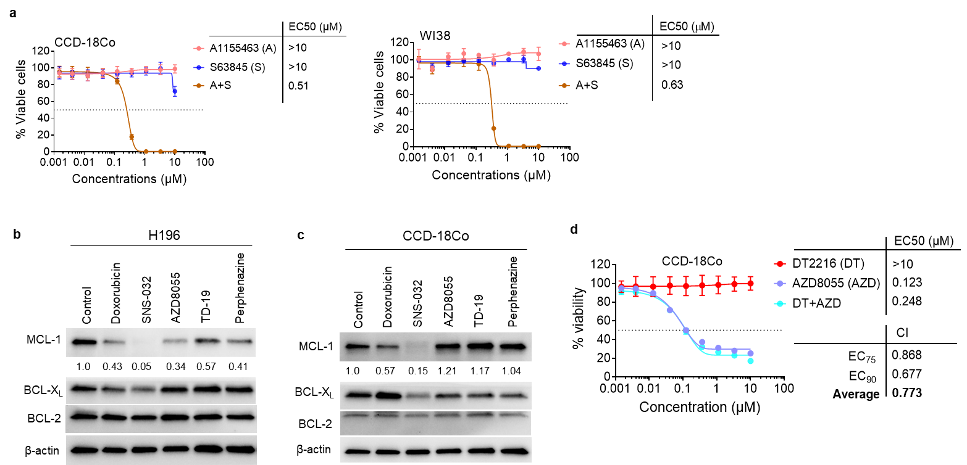
SUPPLEMENTARY FIGURES

Supplementary Fig. 1. AZD8055 selectively suppresses MCL-1 expression in tumor cells and its combination with DT2216 has no additive or synergistic activity in normal cells. a, Viability of normal colon CCD-18Co and lung fibroblasts WI-38 cells after they were treated with increasing concentrations of DT2216 (DT) or S63845 (S) or their combination (1:1 ratio) for 72 h. The data are presented as mean ± SD from a single experiment (n = 6 replicate cell cultures). b, c, Immunoblot analyses of MCL-1, BCL-X_{L,} and BCL-2 in H196 SCLC (b) and CCD-18Co cells (c) after they were treated with indicated agents (1 µM each) for 24 h. The normalized densitometric values for MCL-1 are shown underneath. d, Viability of normal colon CCD-18Co cells after they were treated with increasing concentrations of DT2216 (DT) or AZD8055 (AZD) or their combination (1:1 ratio) for 72 h. The data are presented as mean ± SD from a representative experiment (n = 3 replicate cell cultures). Similar results were obtained in two additional independent experiments.

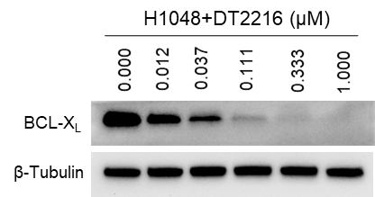

Supplementary Fig. 2. DT2216 causes dose-dependent degradation of BCL-X_{L} in SCLC cells. Immunoblot analysis of BCL-X_{L} in H1048 cells after they were treated with increasing concentrations of DT2216 for 16 h. β-tubulin was used as an equal loading control.

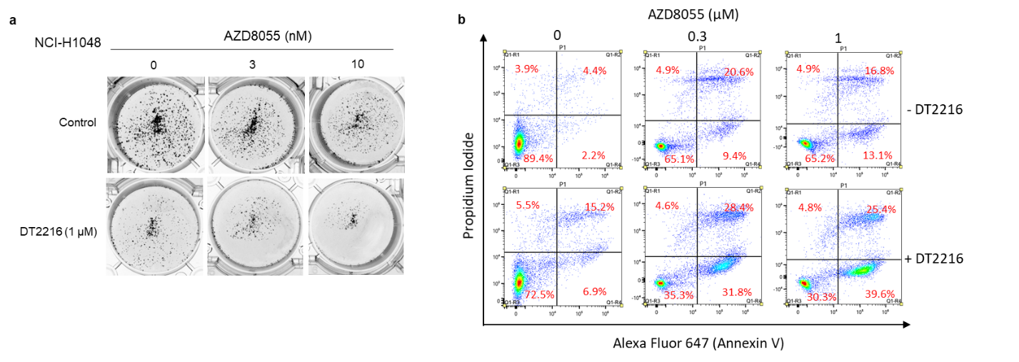
Supplementary Fig. 3. AZD8055+DT2216 combination synergistically kills H1048 SCLC cells. a, Images of colonies in H1048 cells after they were treated with indicated concentrations of DT2216 or AZD8055 or their combinations. b, Apoptosis analysis in H1048 cells after they were treated with indicated concentrations of AZD8055 alone or with DT2216 (1 µM) for 72 h. The percentage proportions of cells are mentioned in each quadrant. Cells in Q1-R2 and Q1-R4 are late and early apoptotic cells, respectively.

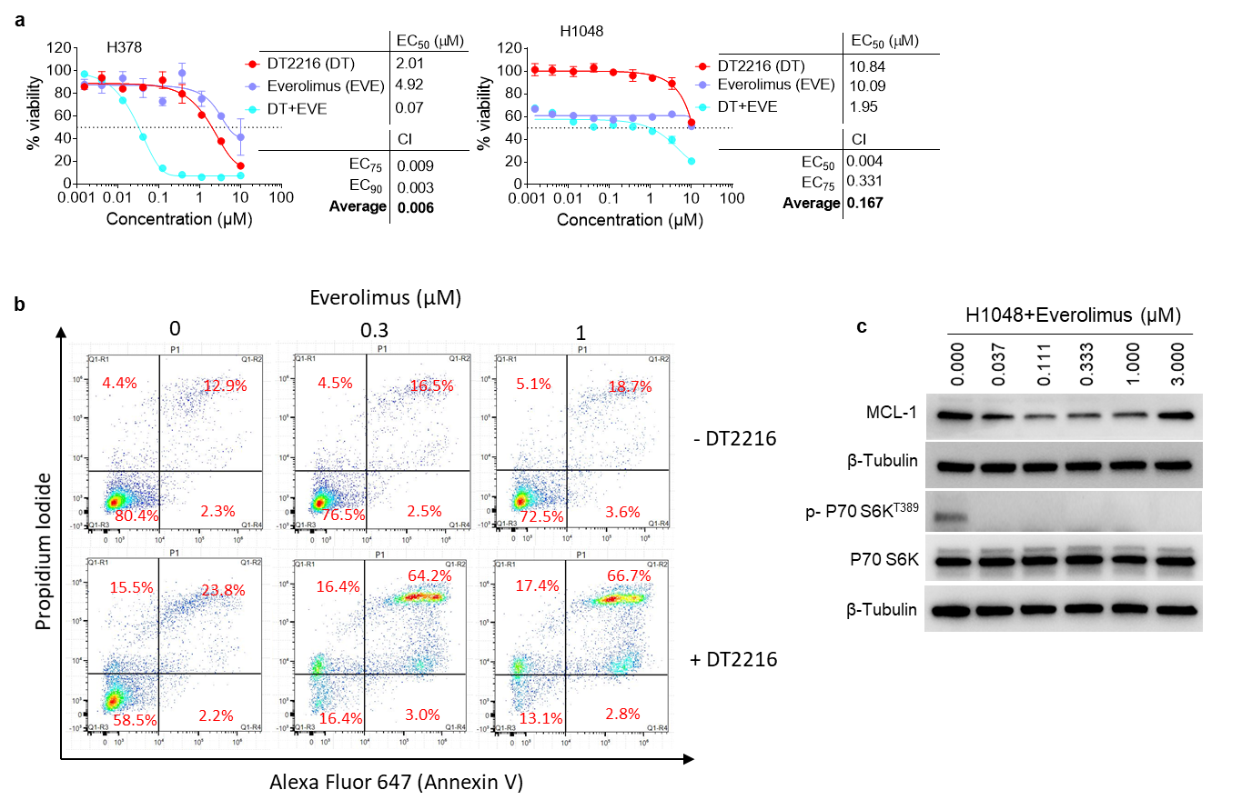
Supplementary Fig. 4. Everolimus shows synergistic activity similar to AZD8055 when combined with DT2216 against SCLC cells. a, Viability of H378 and H1048 SCLC after they were treated with increasing concentrations of DT2216 (DT) or everolimus (EVE) or their combination (1:1 ratio) for 6 days. EC₅₀ and CI values are shown. The data presented are mean ± SD from a single experiment (n = 3 replicate cell cultures). b, Apoptosis analysis in H1048 cells after they were treated with indicated concentrations of DT2216 or everolimus or combinations for 72 h. The percentage proportions of cells are mentioned in each quadrant. Cells in Q1-R2 and Q1-R4 are late and early apoptotic cells, respectively. c, Immunoblot analysis of MCL-1 and mTOR1 substrate P70 S6K after 24 h treatment with indicated concentrations of everolimus in H1048 SCLC cells.
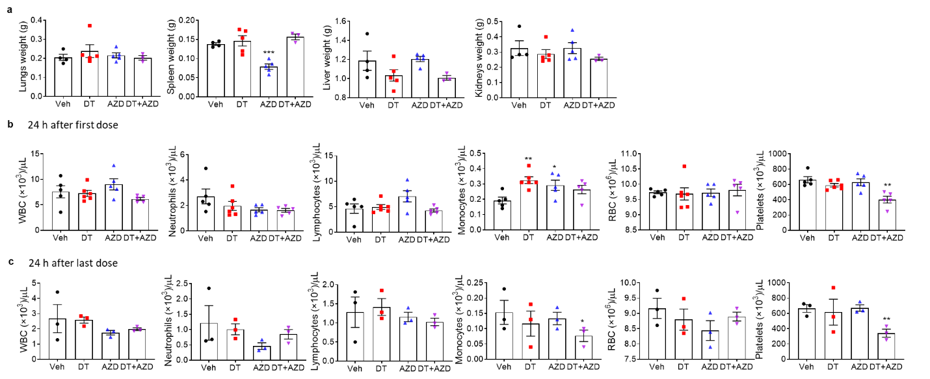
Supplementary Fig. 5. The combination of DT2216 and AZD8055 causes no appreciable normal tissue and hematological toxicities in mice. a, Weights of different organs harvested 24 h treatment with DT2216 (DT), AZD8055 (AZD) or their combination in Rb1/p53/p130 mice as in Fig. 6 e. Data are presented as mean ± SEM (n = 4, 5, 5, and 3 mice in veh, DT, AZD, and DT+AZD groups, respectively). b, c, Counts of different blood cells 24 h after the first dose (b) and 24 h after the last dose (c) as in Fig. 6 e. Data are presented as mean ± SEM (n = 6 mice in DT and 5 mice in each of all other groups in b; n = 3 mice in c).

Supplementary Table 1. Antibodies used in immunoblotting
Antibody | Clone | Antibody isotype | Catalog # | Concentration
BCL-X_{L} | _ | Rabbit IgG polyclonal | 2762 | 1:1000
BCL-2 | 50E3 | Rabbit IgG monoclonal | 2870 | 1:500
MCL-1 | D35A5 | Rabbit IgG monoclonal | 5453 | 1:1000
BIM | C34C5 | Rabbit IgG monoclonal | 2933 | 1:1000
p-4EBP1 T37/46 | 236B4 | Rabbit IgG monoclonal | 2855 | 1:1000
4EBP1 | 53H11 | Rabbit IgG monoclonal | 9644 | 1:1000
p-S6 S240/244 | _ | Rabbit IgG polyclonal | 2215 | 1:1000
S6 | 5G10 | Rabbit IgG monoclonal | 2217 | 1:1000
P-p70 S6K T389 | 108D2 | Rabbit IgG monoclonal | 9234 | 1:1000
p70 S6K | _ | Rabbit IgG polyclonal | 9202 | 1:1000
Full-length PARP | 46D11 | Rabbit IgG monoclonal | 9532 | 1:1000
Cleaved PARP | D64E10 | Rabbit IgG monoclonal | 5625 | 1:1000
full-length caspase-3 | _ | Rabbit IgG polyclonal | 9662 | 1:1000
cleaved caspase-3 | _ | Rabbit IgG polyclonal | 9661 | 1:1000
β-tubulin | _ | Rabbit IgG polyclonal | 2146 | 1:3000
β-actin | D6A8 | Rabbit IgG monoclonal | 8457 | 1:5000
Secondary antibody |  | Anti-rabbit IgG, HRP | 7074 | 1:3000
Footnotes: All the antibodies were purchased from Cell Signaling Technology, Danvers, MA.

SUPPLEMENTARY REFERENCES

- Khan S, Zhang X, Lv D, Zhang Q, He Y, Zhang P, et al. A selective BCL-XL PROTAC degrader achieves safe and potent antitumor activity. Nat Med. 2019;25(12):1938-47.

