Quantified results and statistical analysis of WB
Table of contents
Figure 1E
Figure 2E
Figure 2F
Figure 2G
Figure 3F
Figure 4D
Figure 5L
Figure 5M
Figure 6A
Figure 6H
Figure 7F

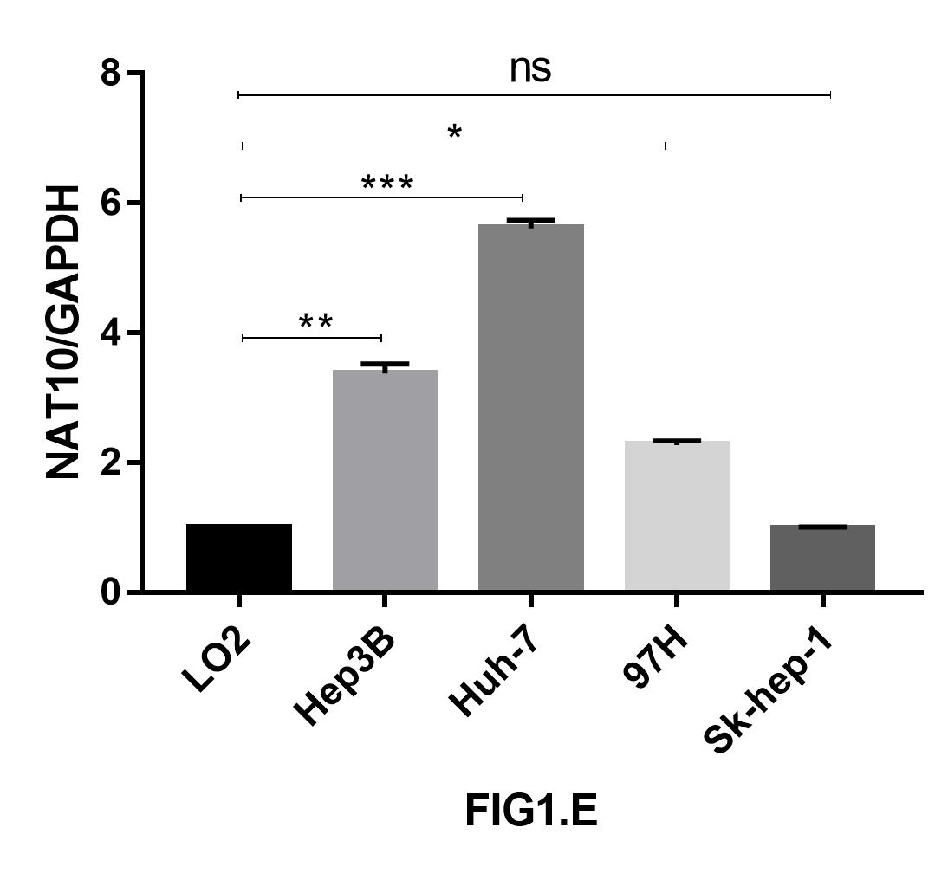
Fig 1E. Hepatocellular carcinoma cell-NAT10

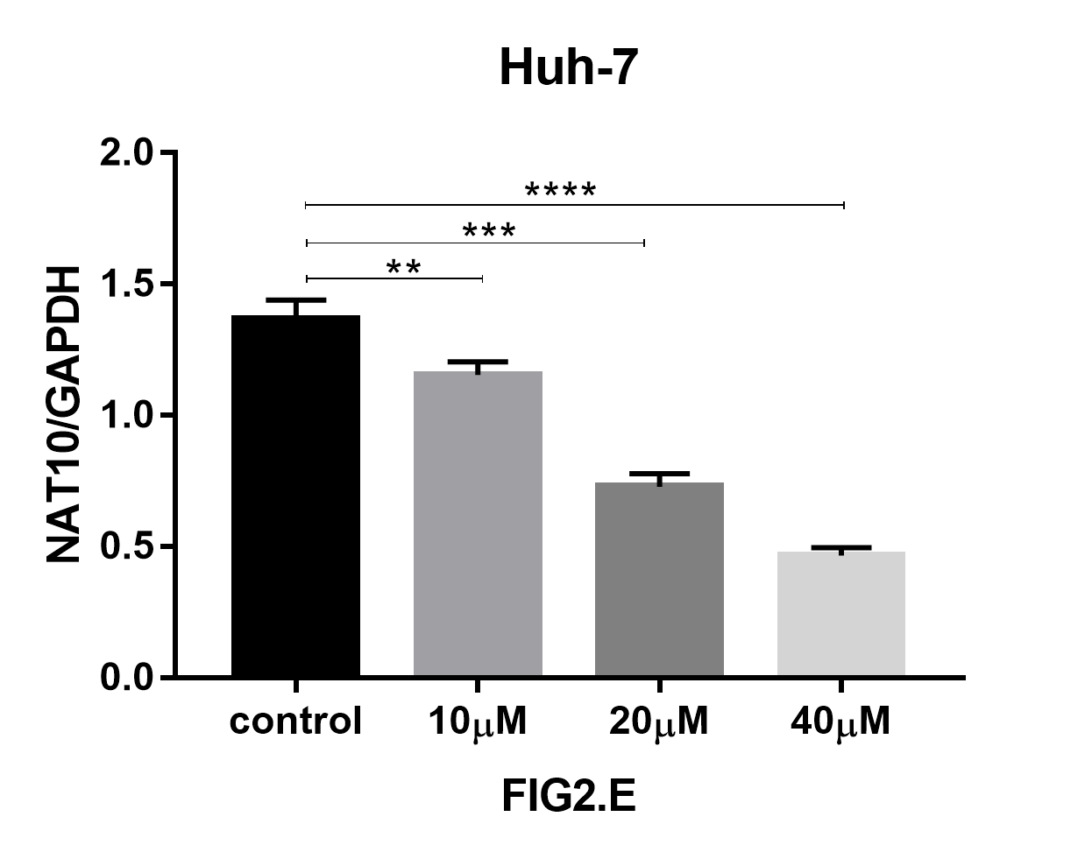
Fig 2E. huh-7-NAT10

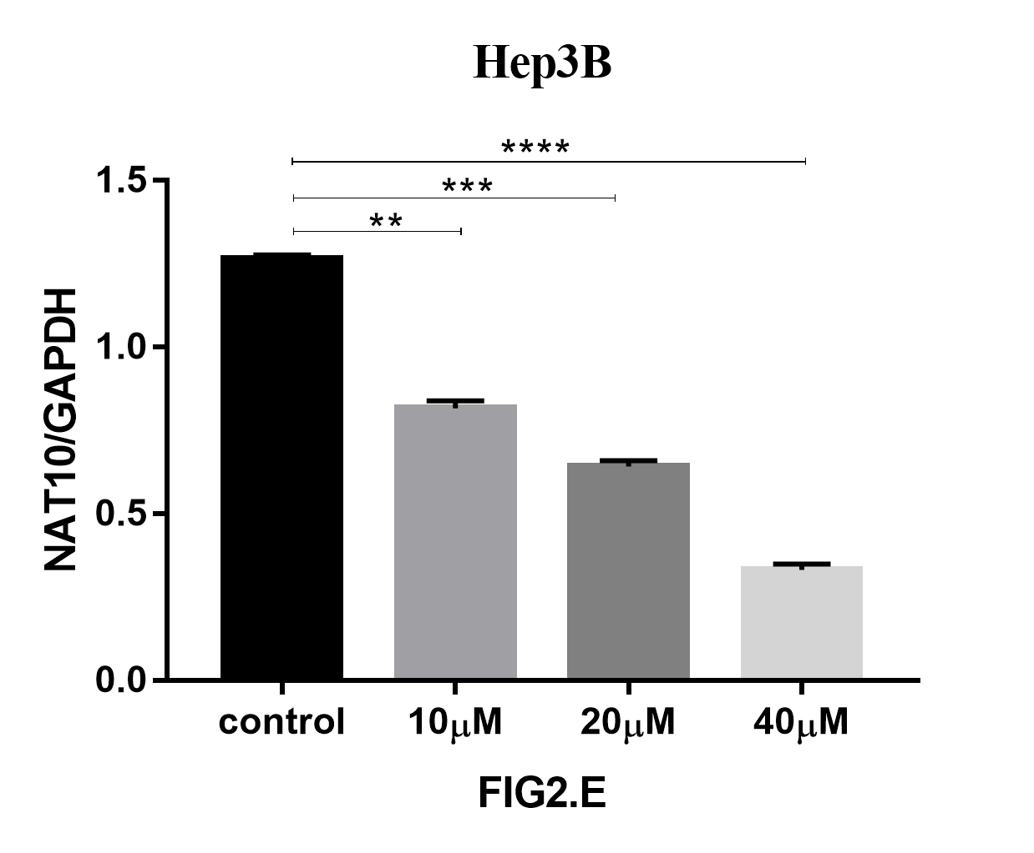
Fig 2E. hep3B-NAT10

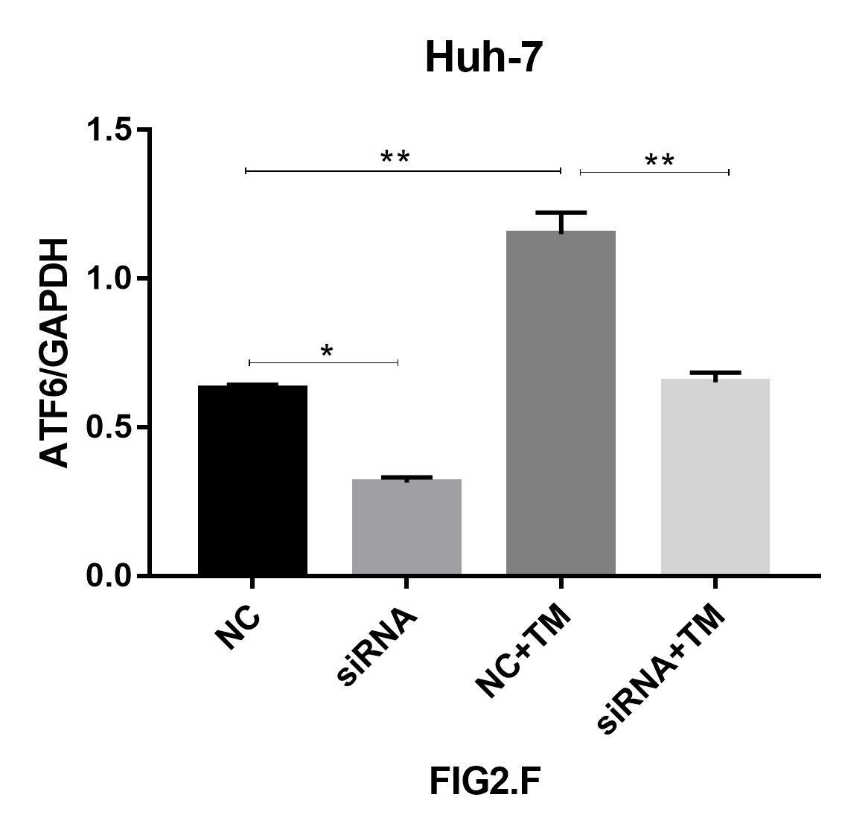
Fig 2F. huh-7-ATF6

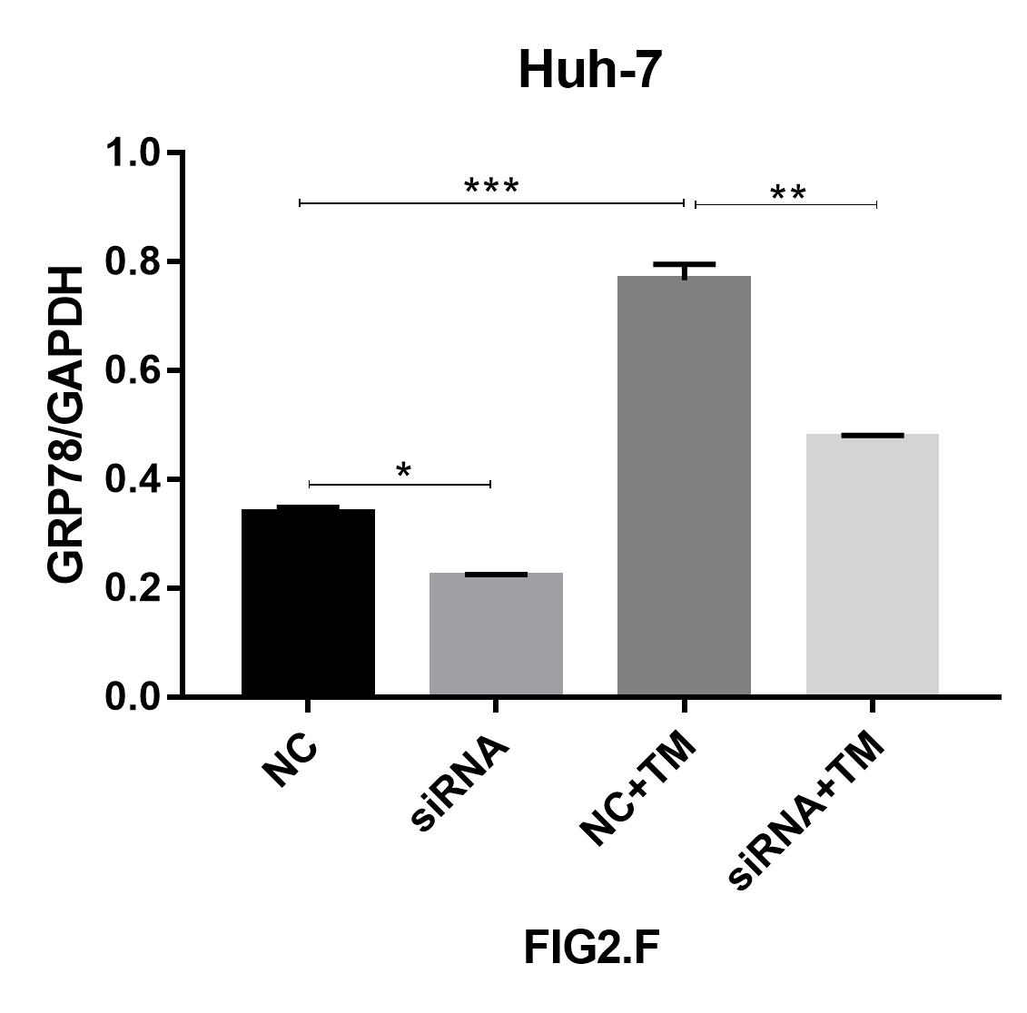
Fig 2F. huh-7-GRP78

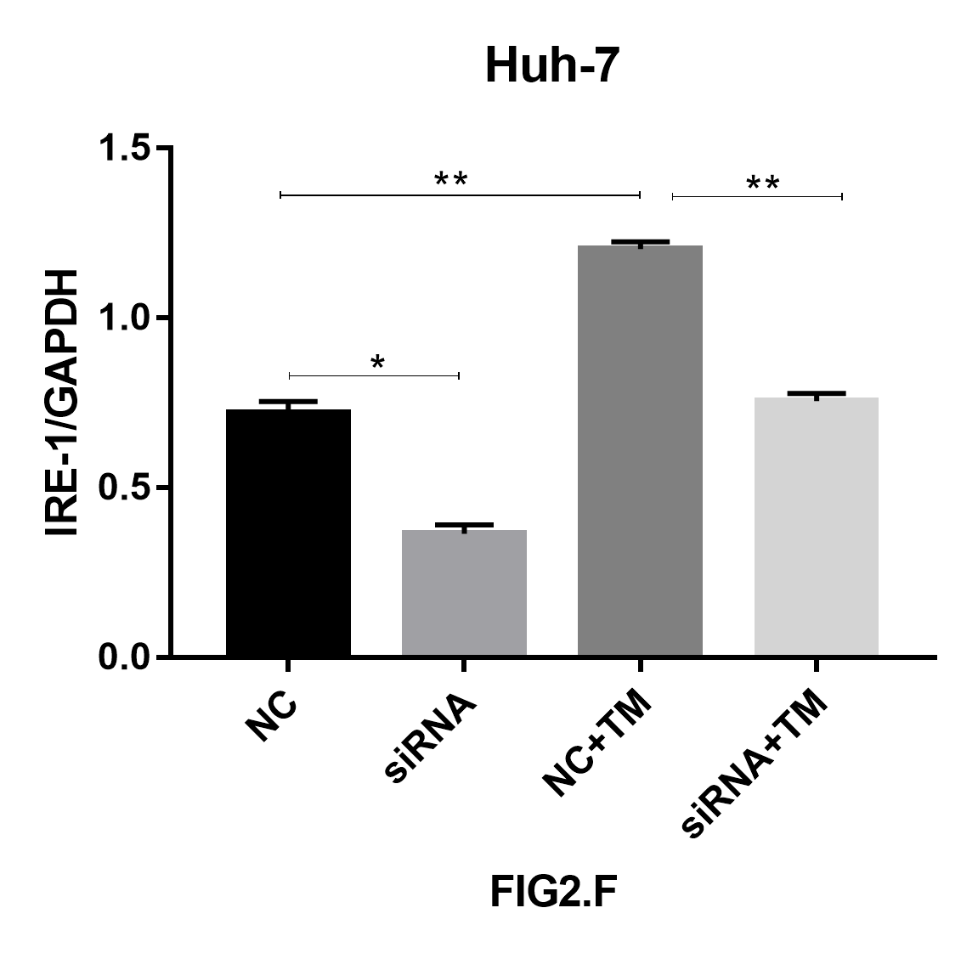
Fig 2F. huh-7-IRE-1

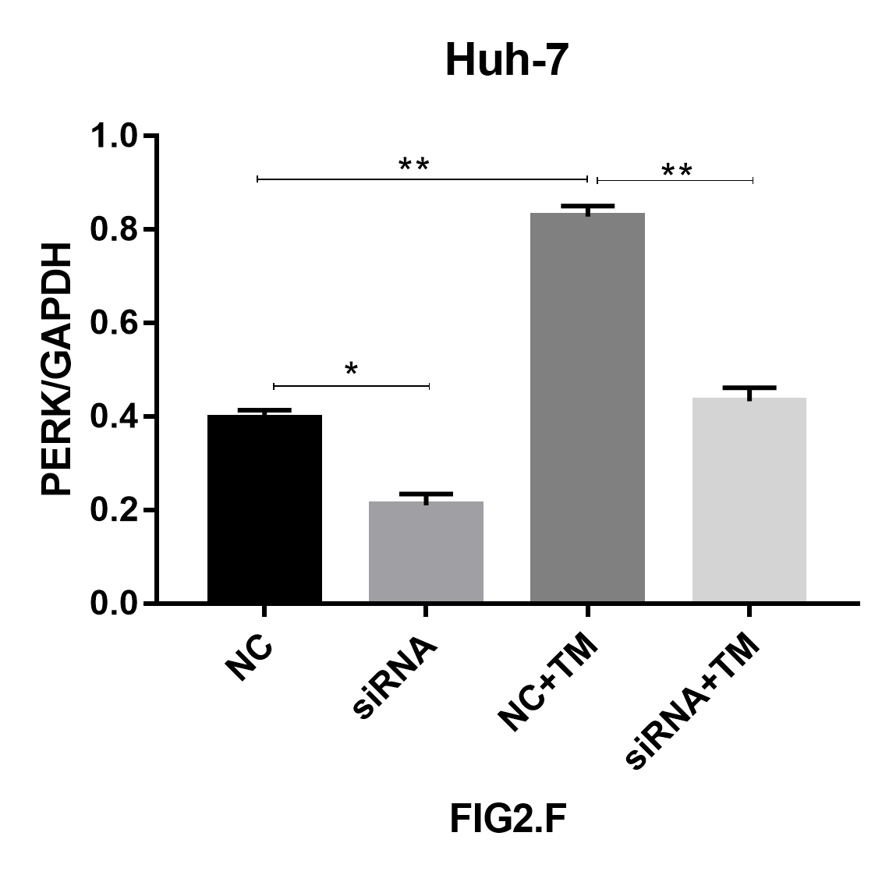
Fig 2F. huh-7-PERK

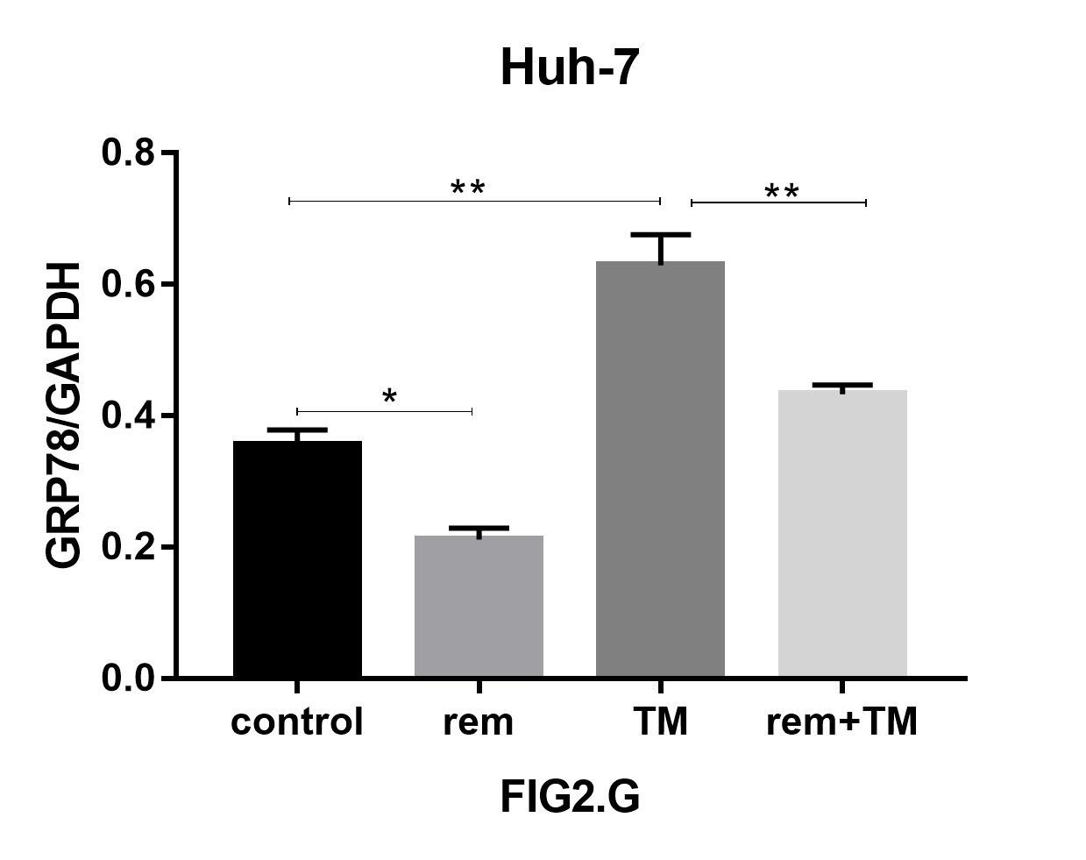
Fig 2G. huh-7-GRP78

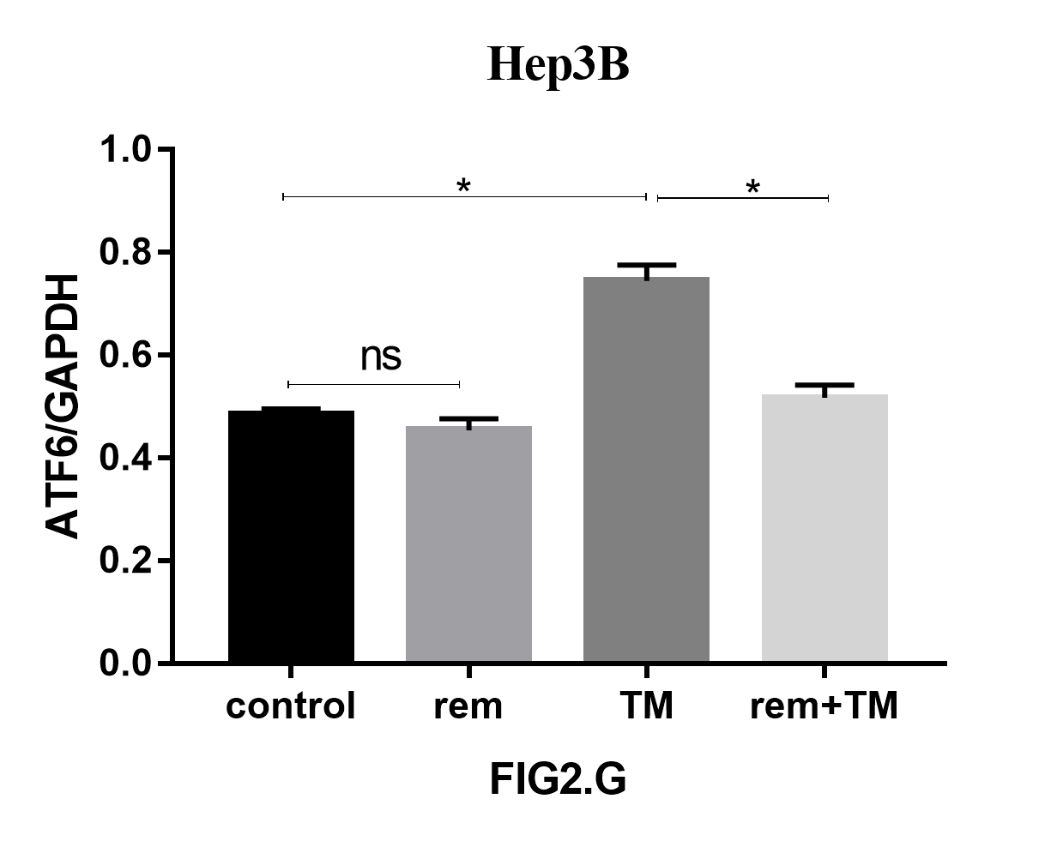
Fig 2G. hep3b-ATF6

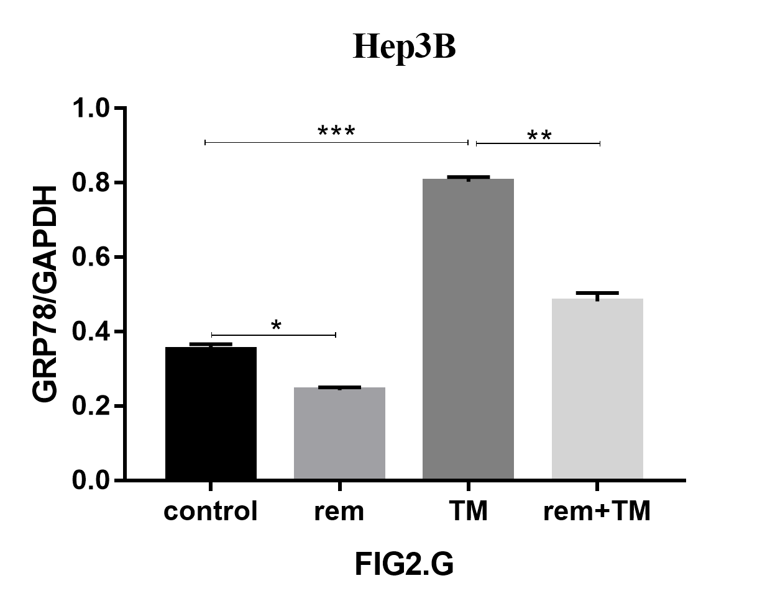
Fig 2G. hep3b-GRP78

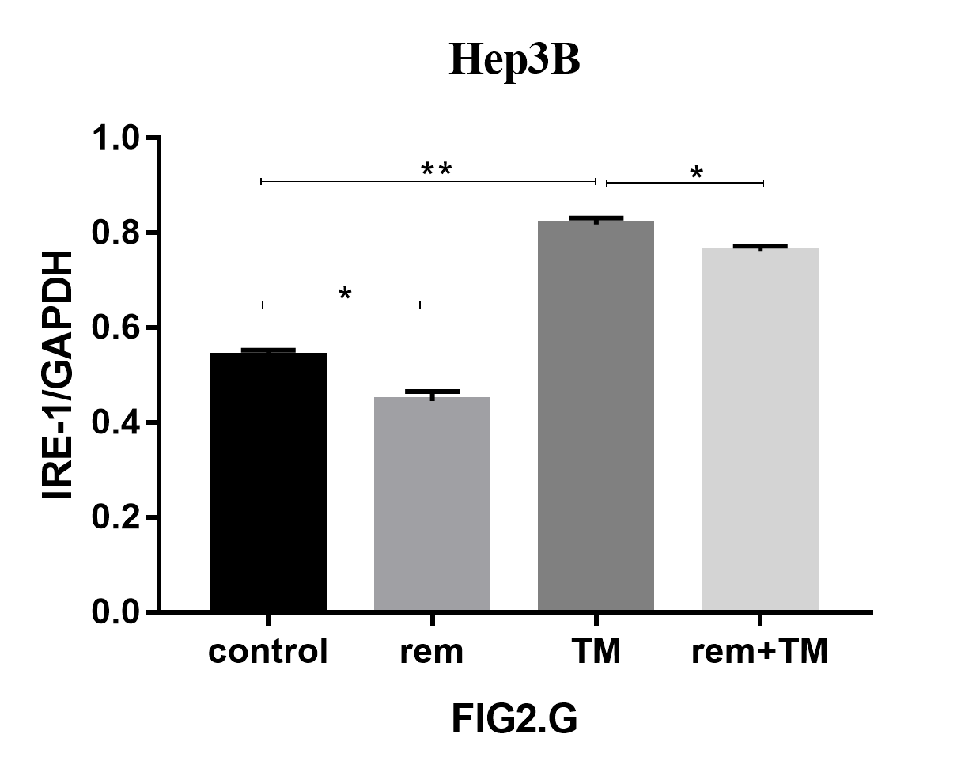
Fig 2G. hep3b-IRE-1

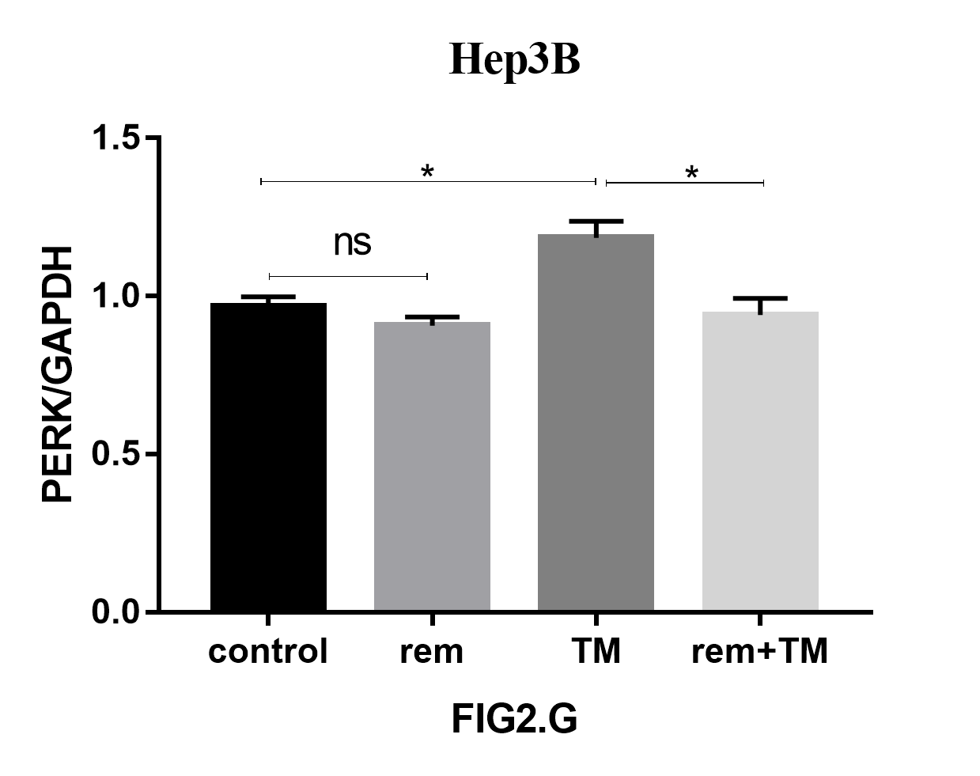
Fig 2G. hep3b-PERK

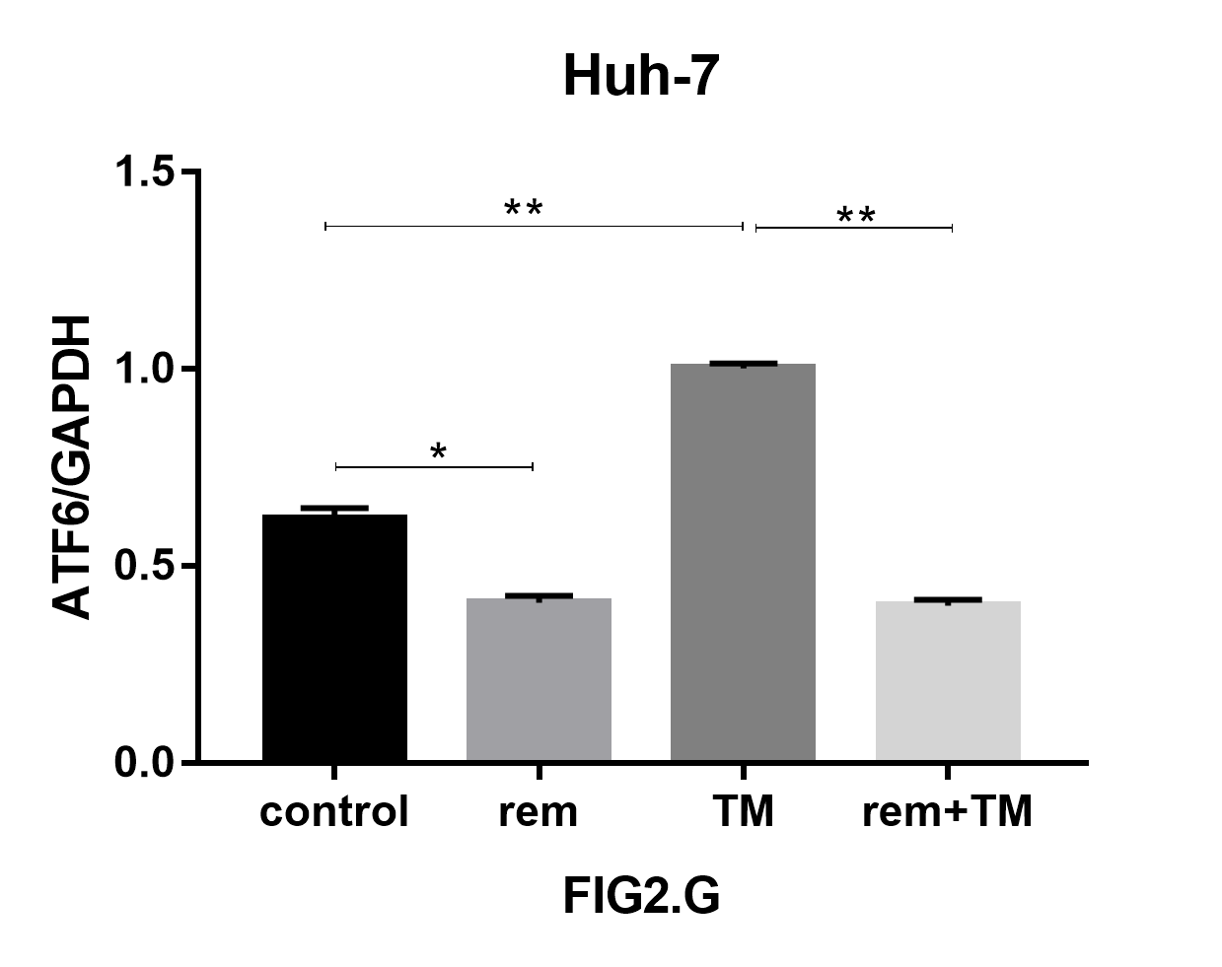
Fig 2G. huh-7-ATF6

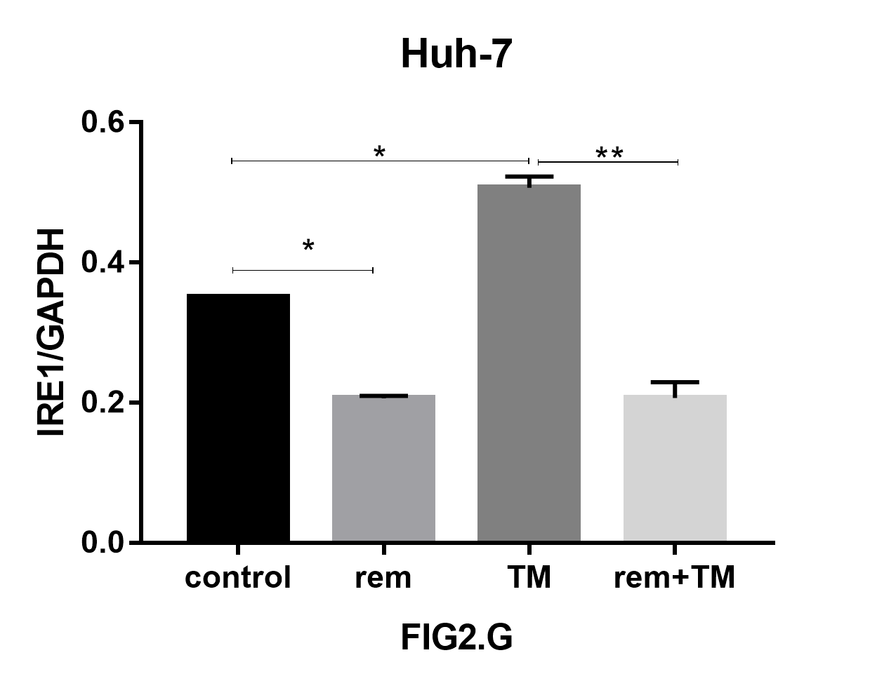
Fig 2G. huh-7-IRE-1

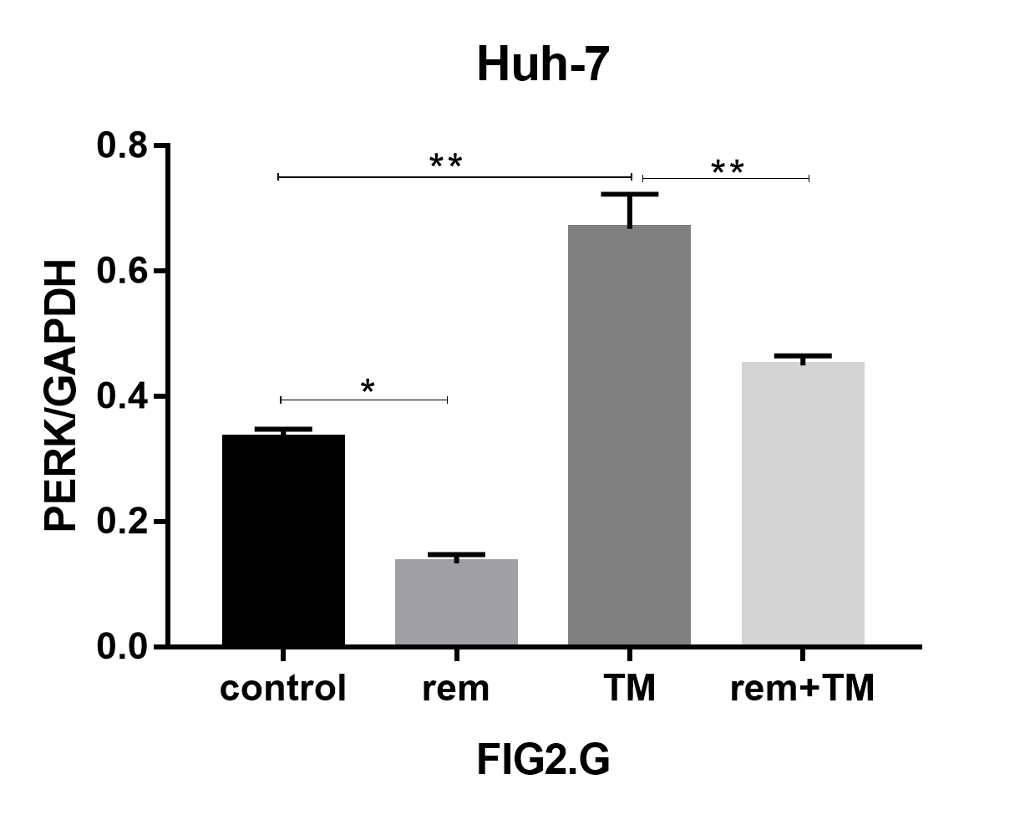
Fig 2G. huh-7-PERK

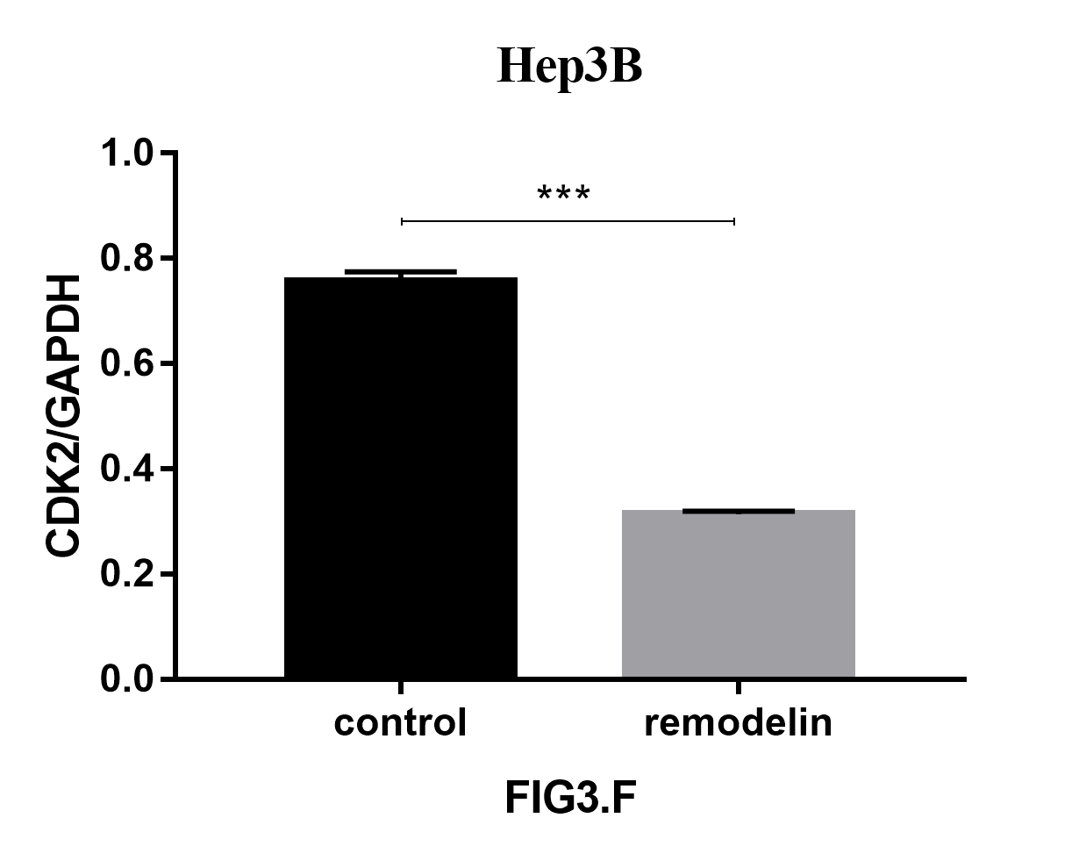
Fig 3F. hep3b-CDK2

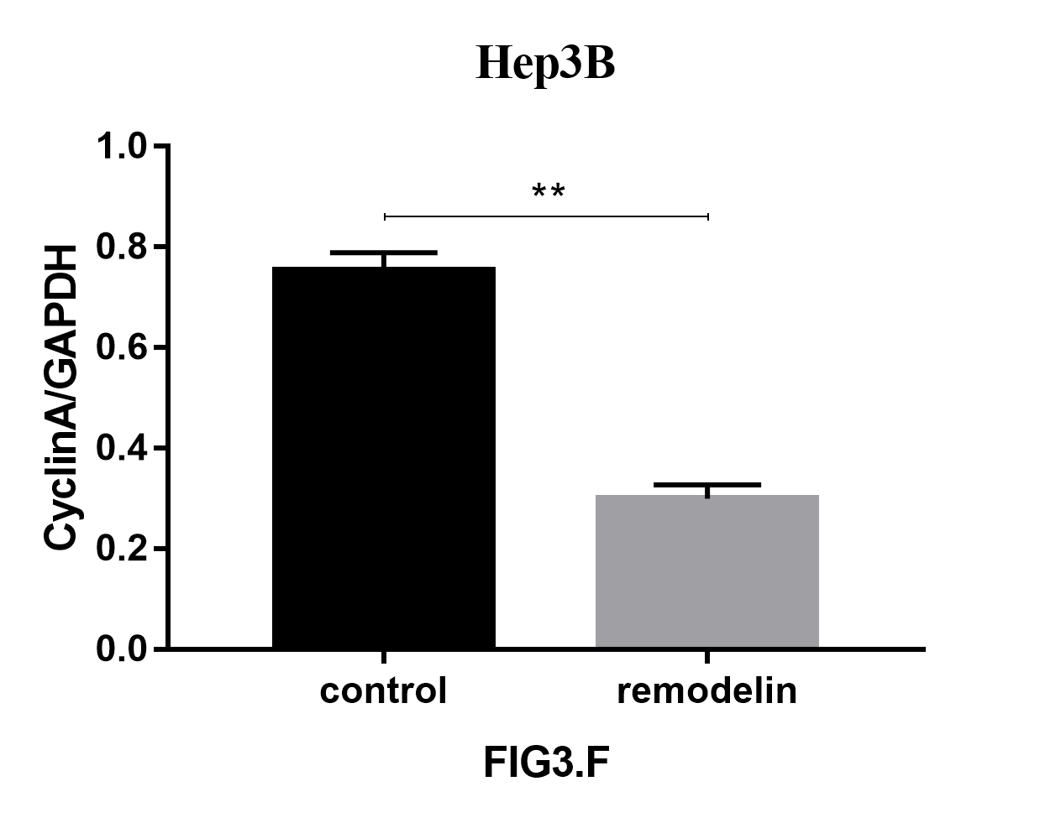
Fig 3F. hep3b-CyclinA

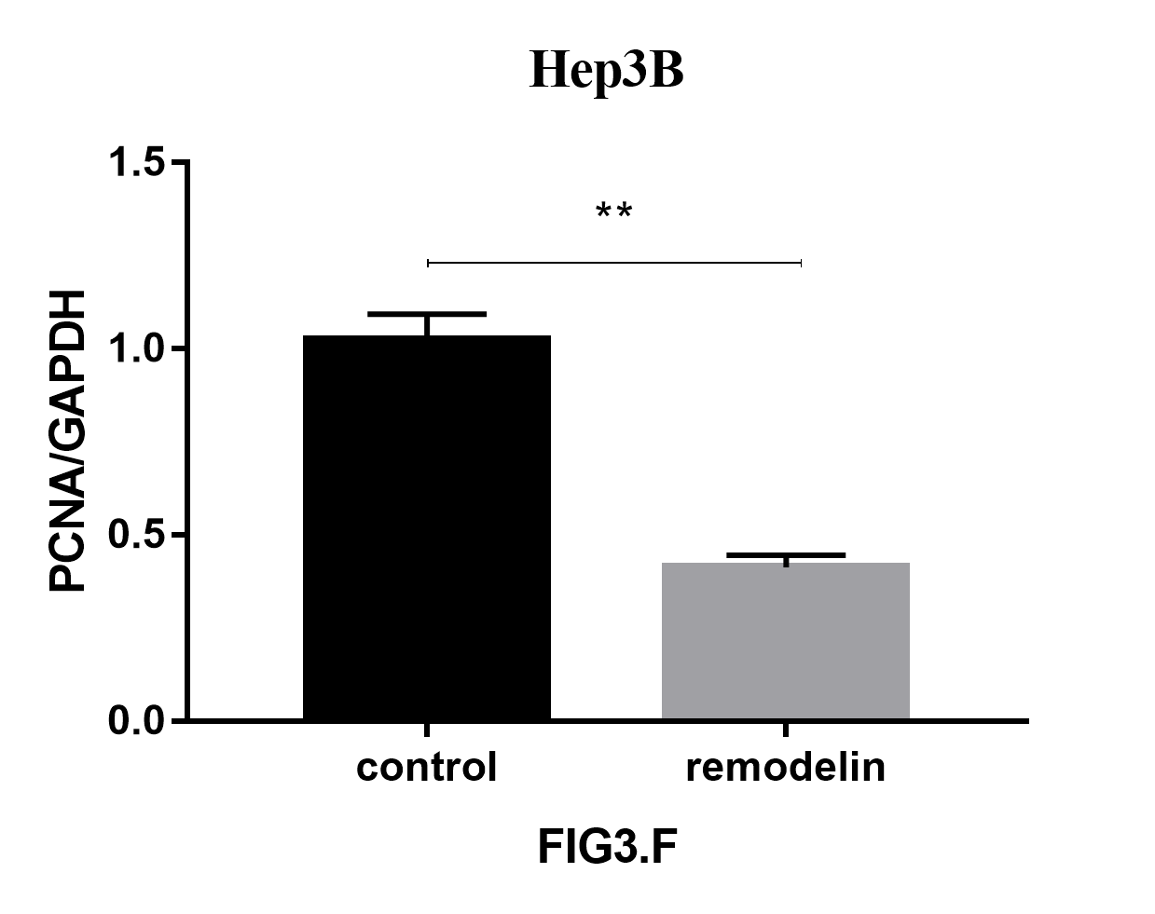
Fig 3F. hep3b-PCNA

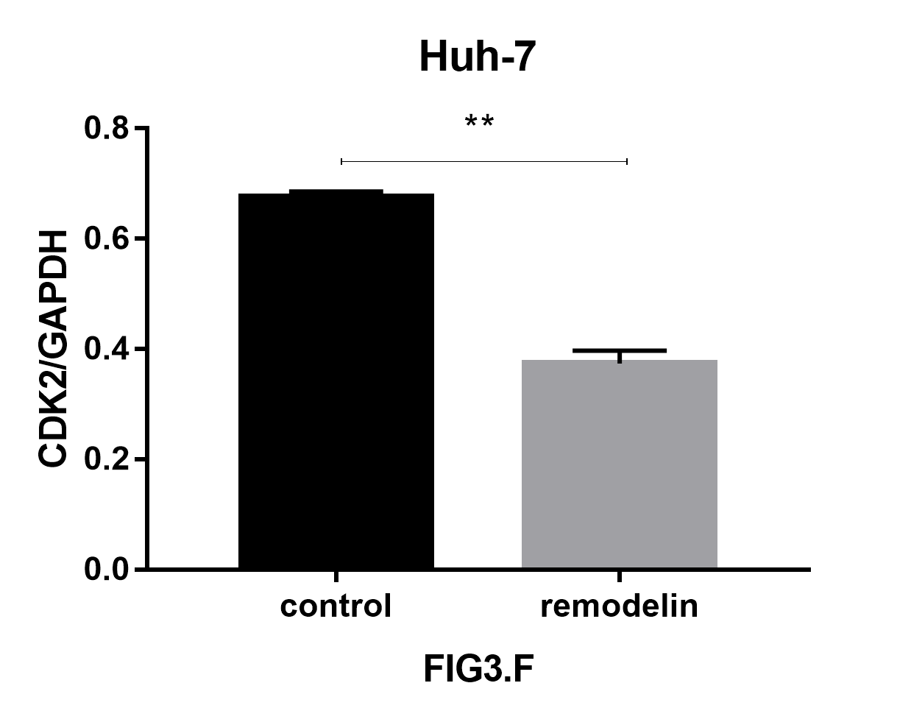
Fig 3F. huh-7-CDK2 (rem)

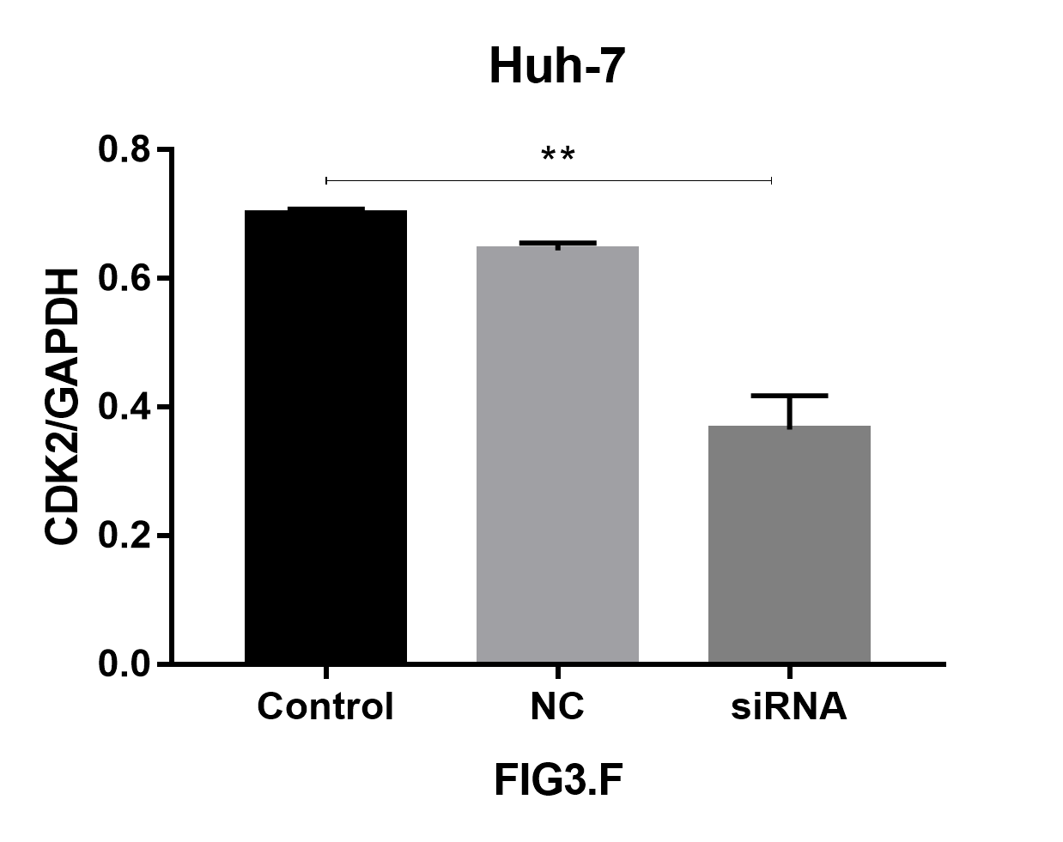
Fig 3F huh-7-CDK2

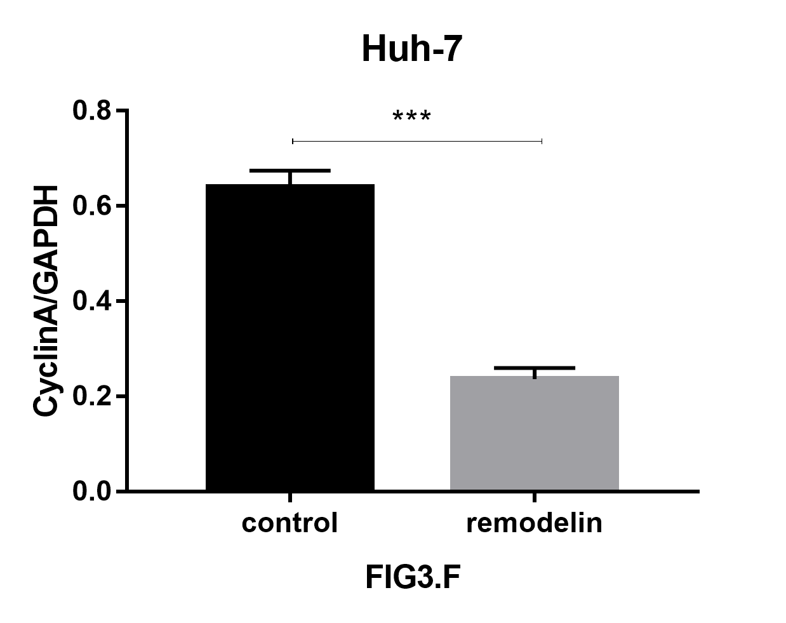
Fig 3F huh-7-CyclinA (rem)

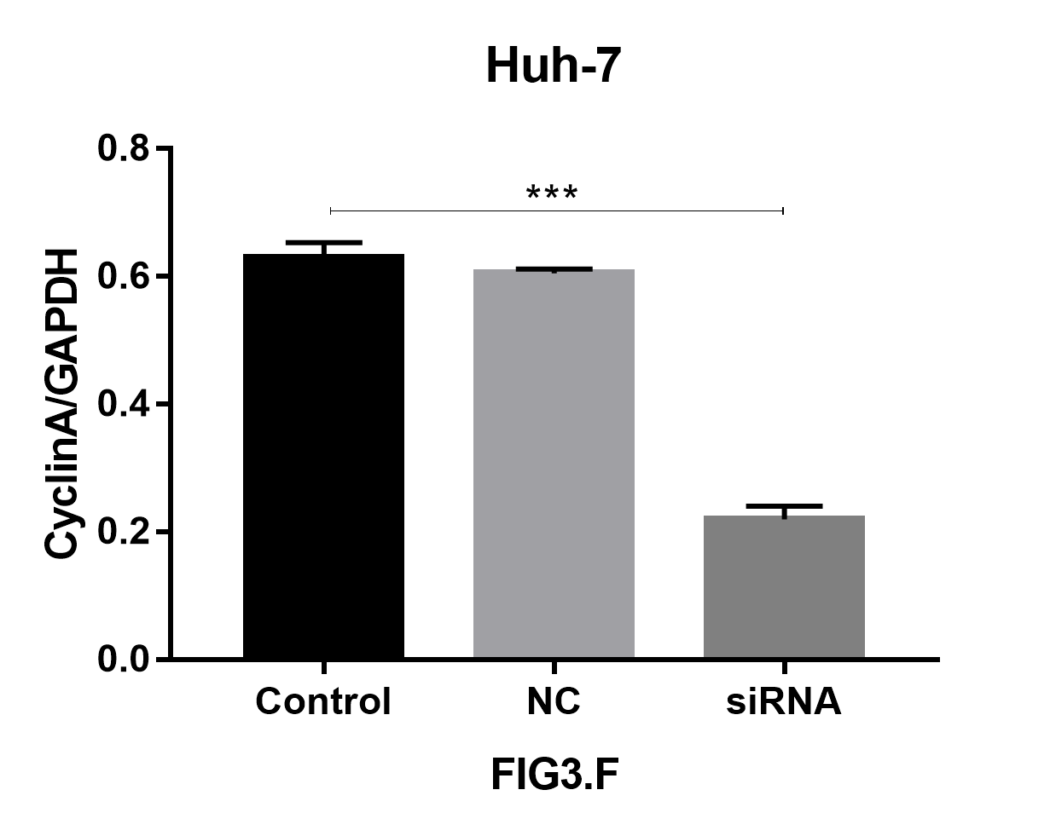
Fig 3F. huh-7-CyclinA

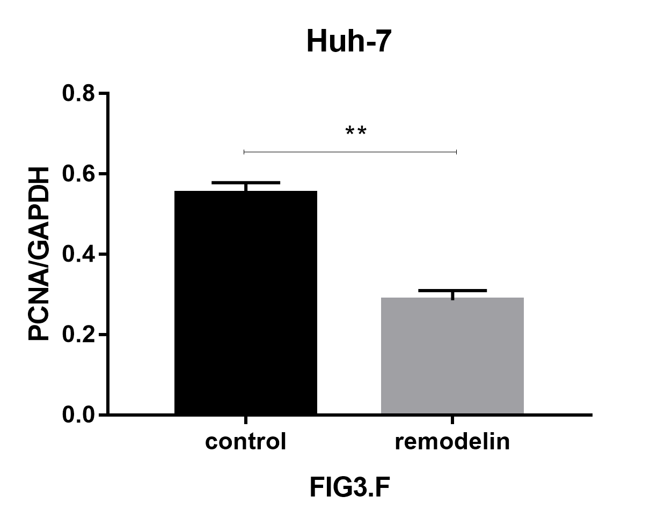
Fig 3F. huh-7-PCNA (rem)

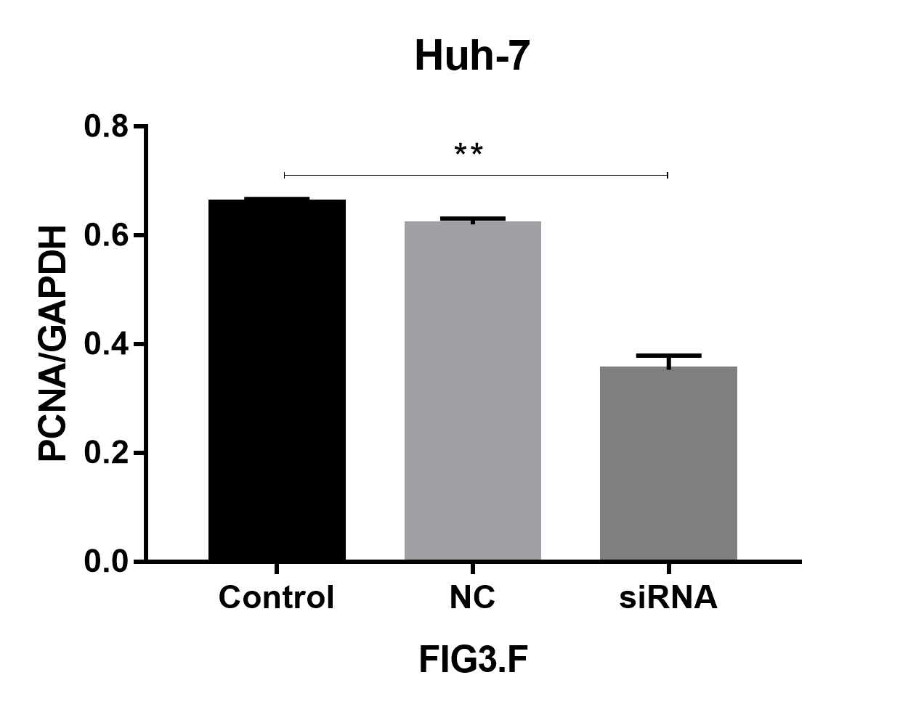
Fig 3F. huh-7-PCNA

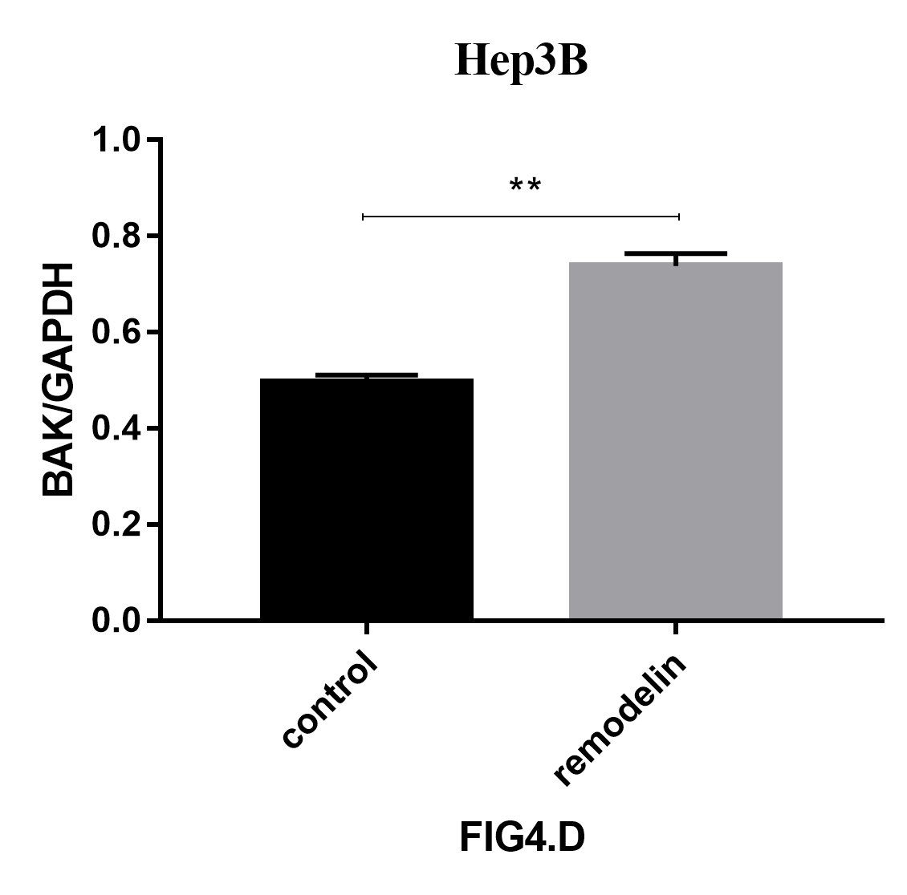
Fig 4D. hep3b-BAK

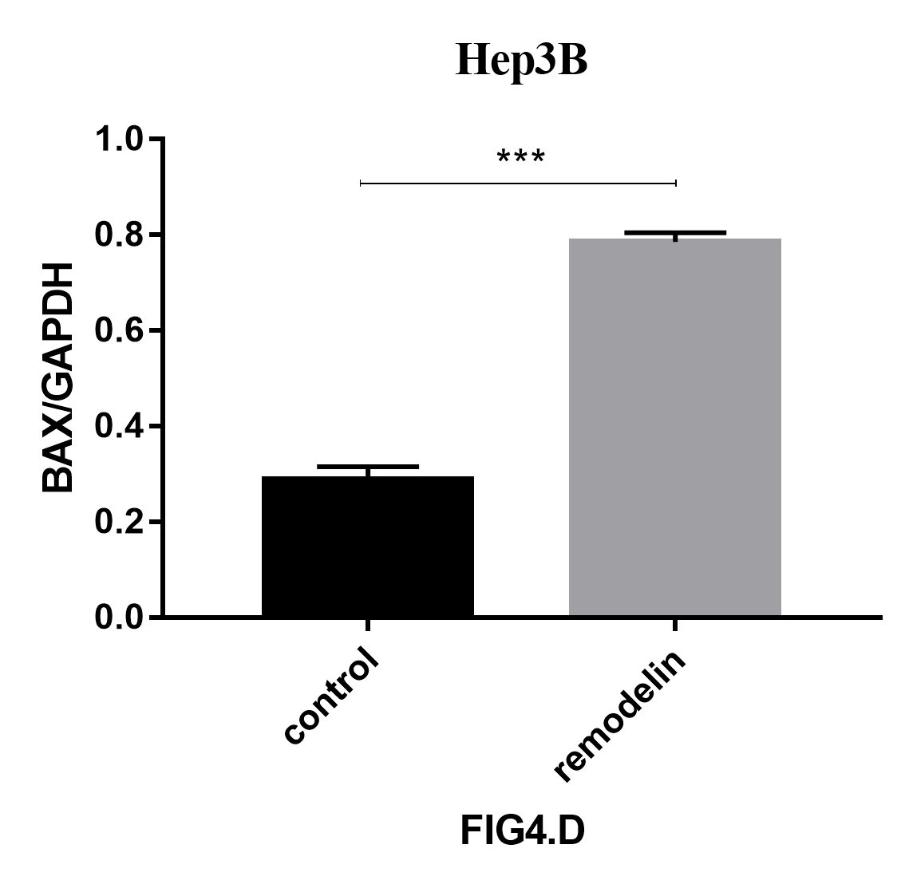
Fig 4D. hep3b-BAX

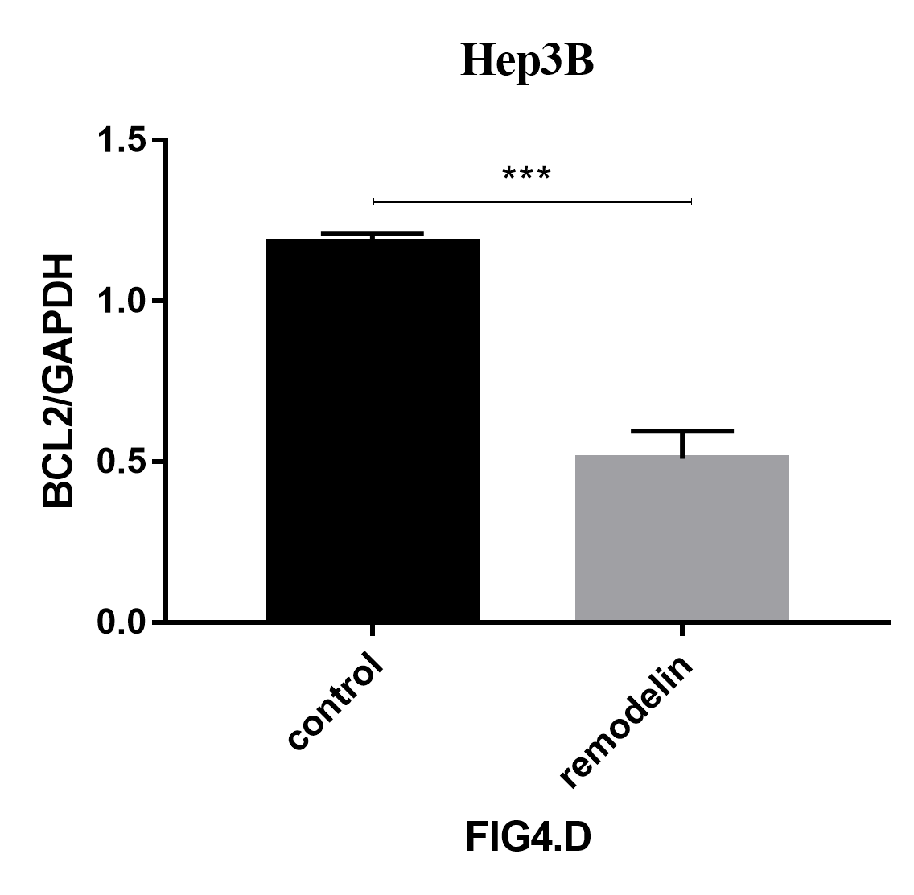
Fig 4D. hep3b-BCL2

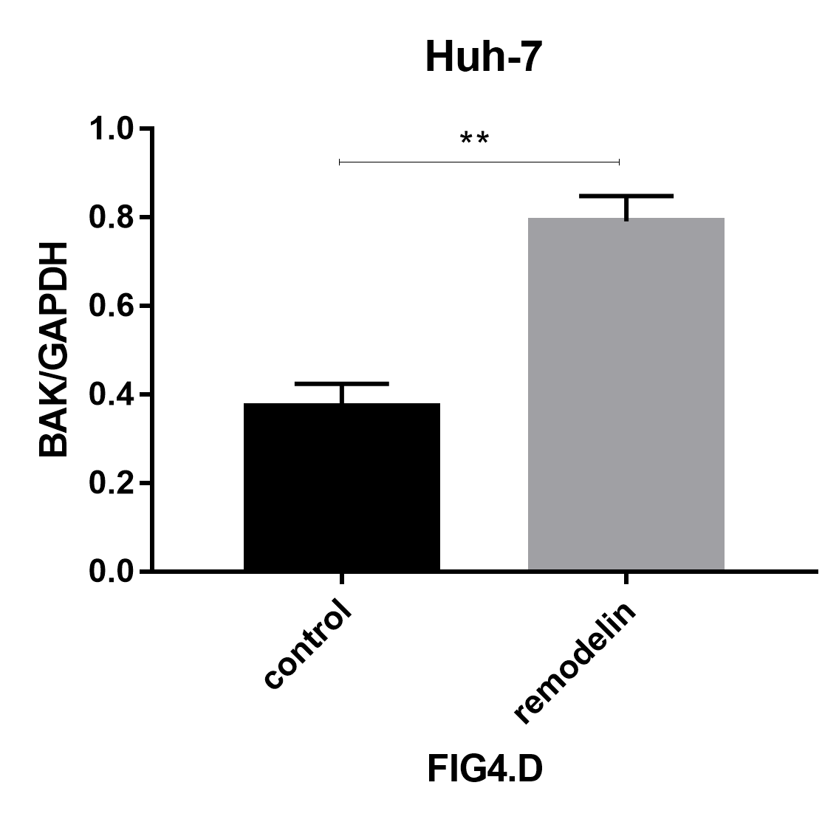
Fig 4D. huh-7-BAK (rem）

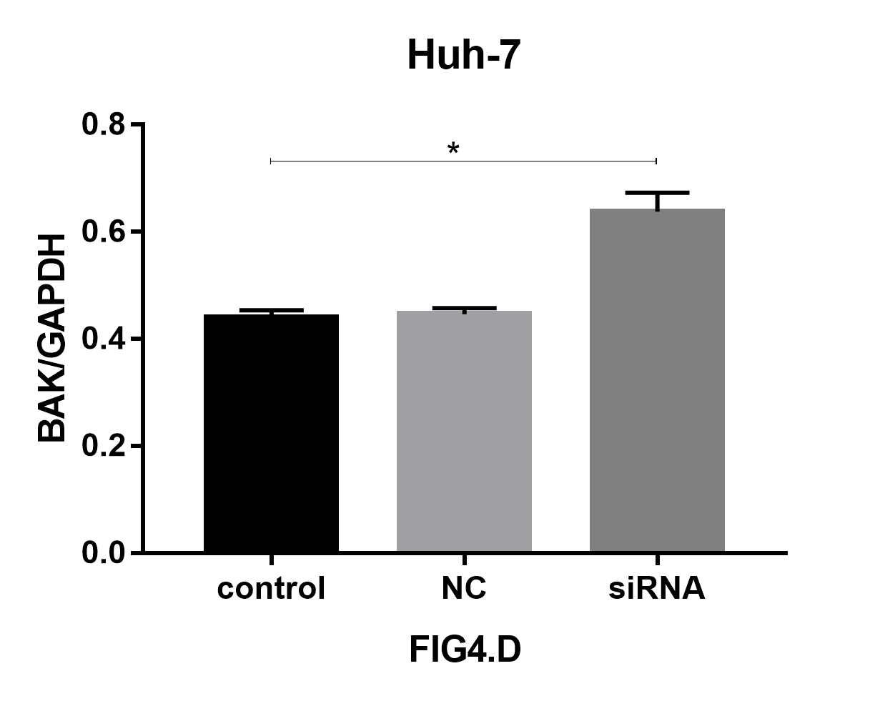
Fig 4D. huh-7-BAK

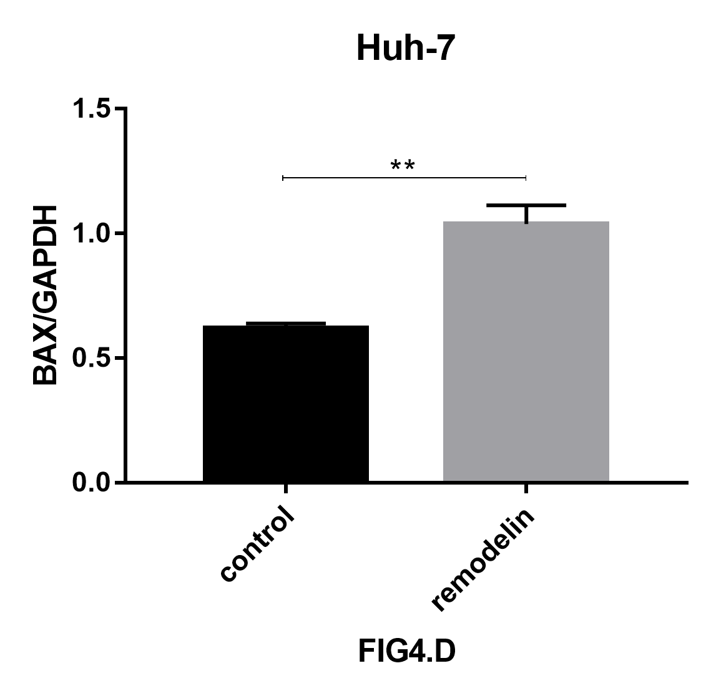
Fig 4D. huh-7-BAX (rem)

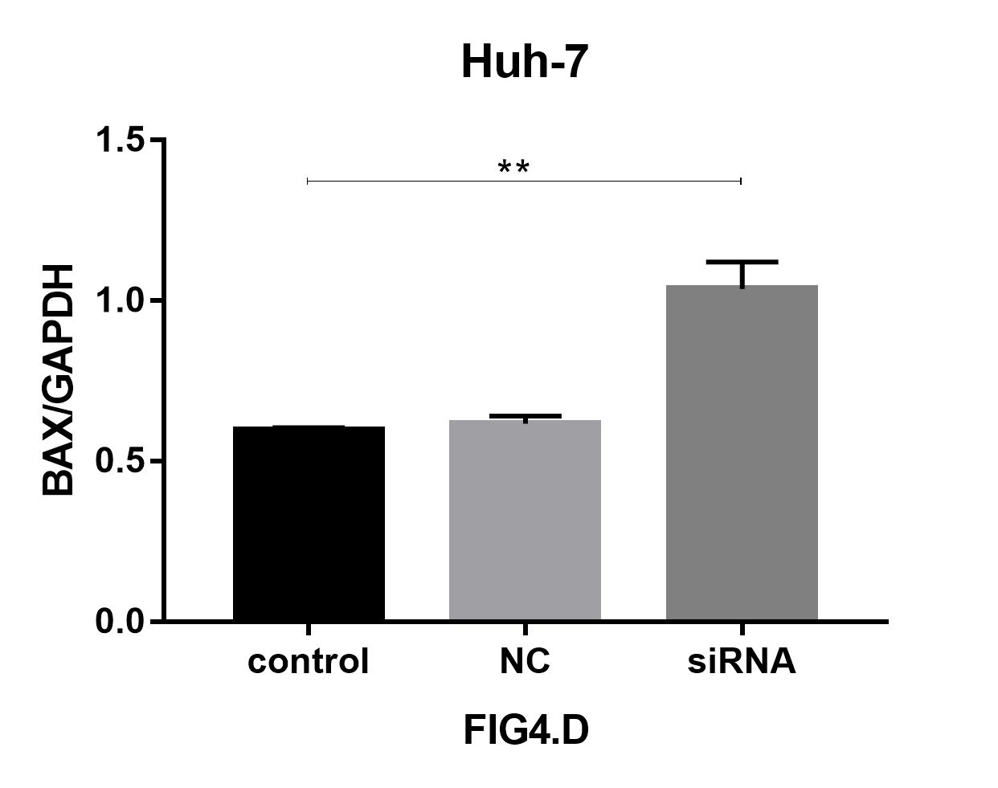
Fig 4D. huh-7-BAX

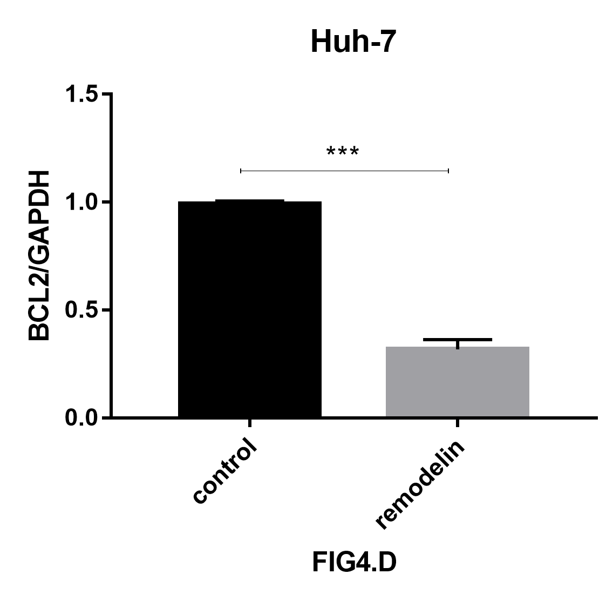
Fig 4D. huh-7-BCL2 (rem)

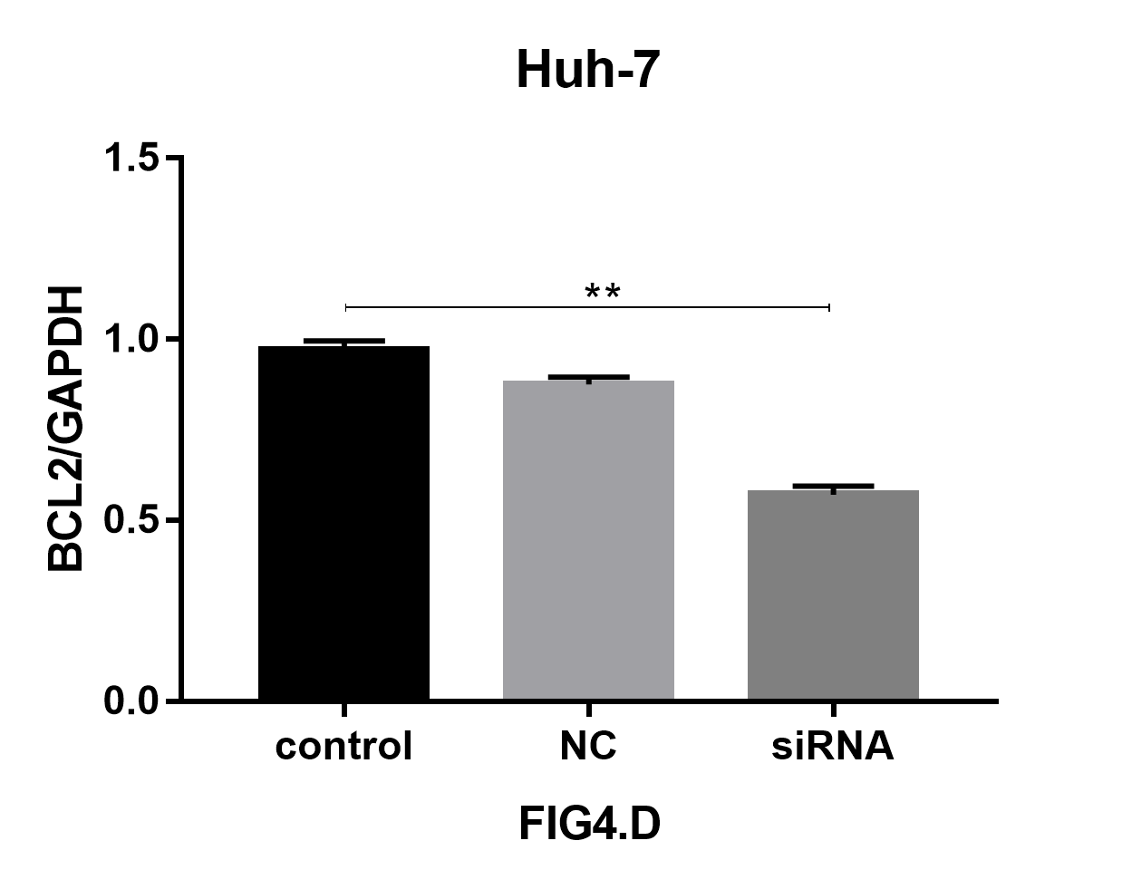
Fig 4D. huh-7-BCL2

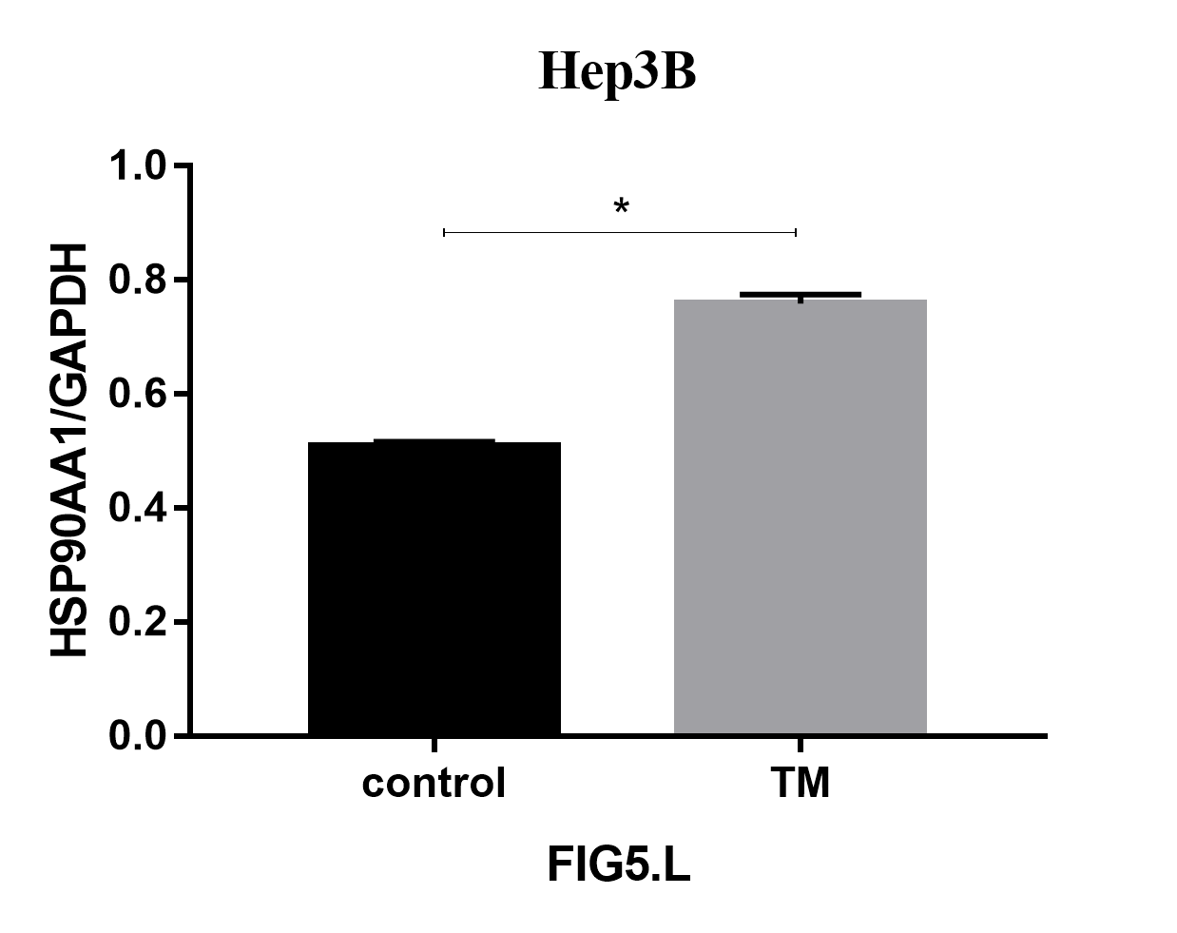
Fig 5L. hep3b-HSP90AA1

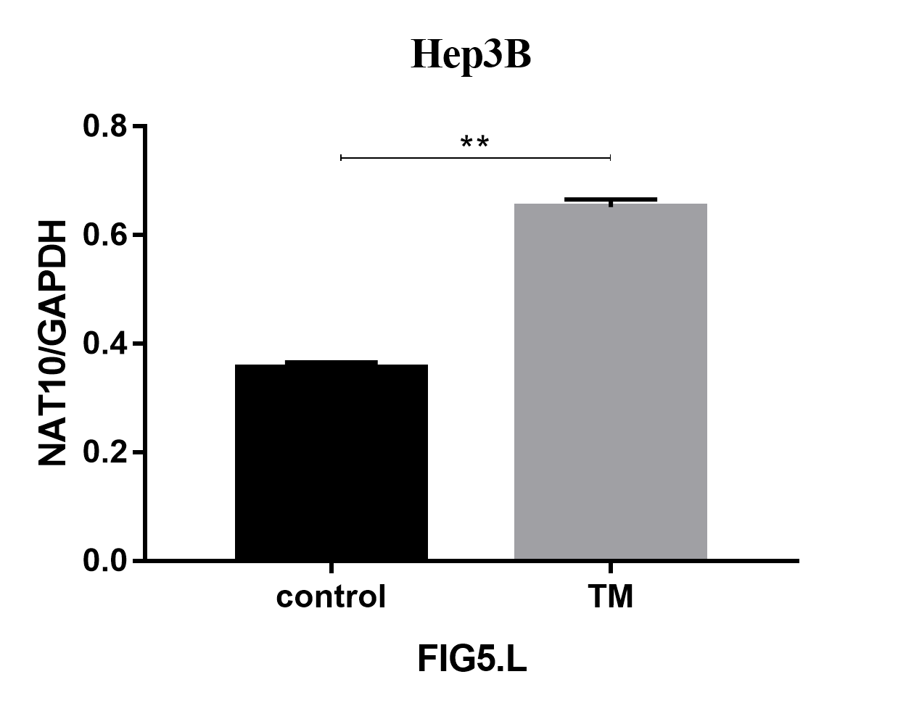
Fig 5L. hep3b-NAT10

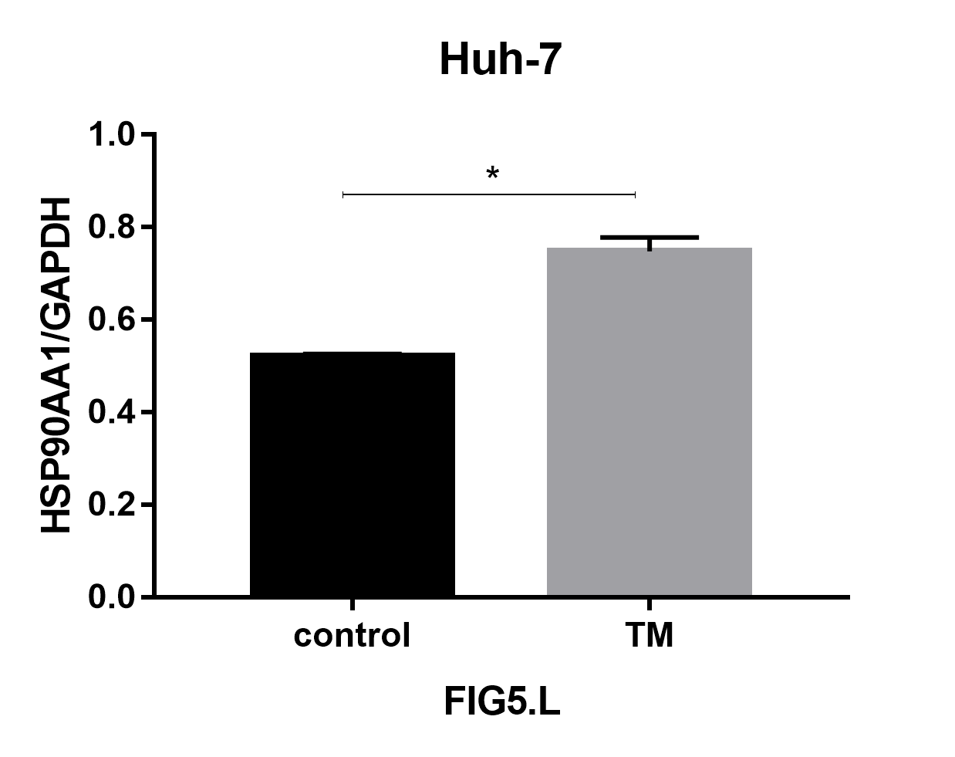
Fig 5L. huh-7-HSP90AA1

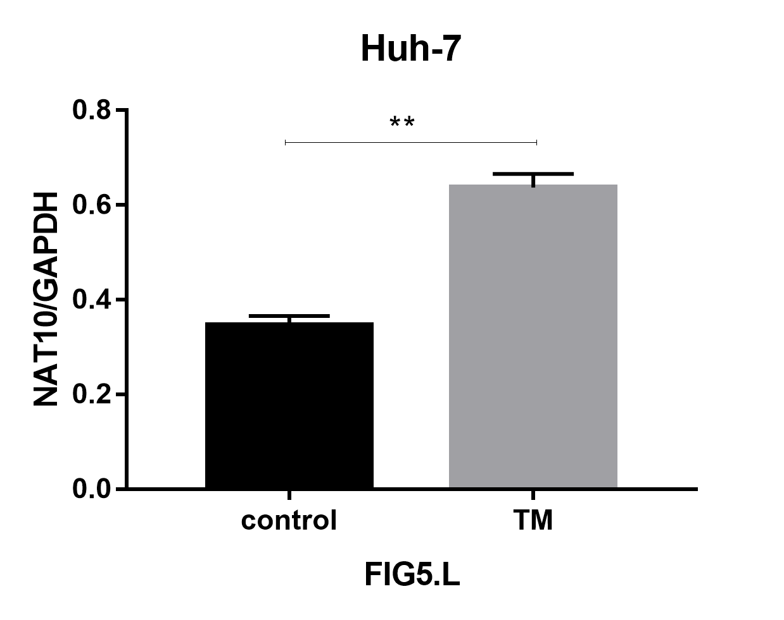
Fig 5L. huh-7-NAT10

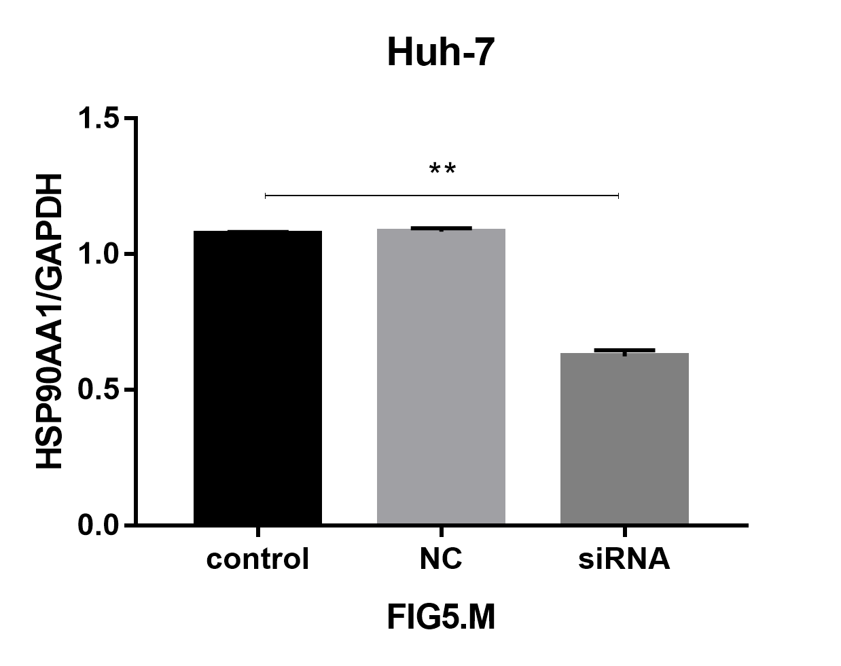
Fig 5M. huh-7-HSP90AA1

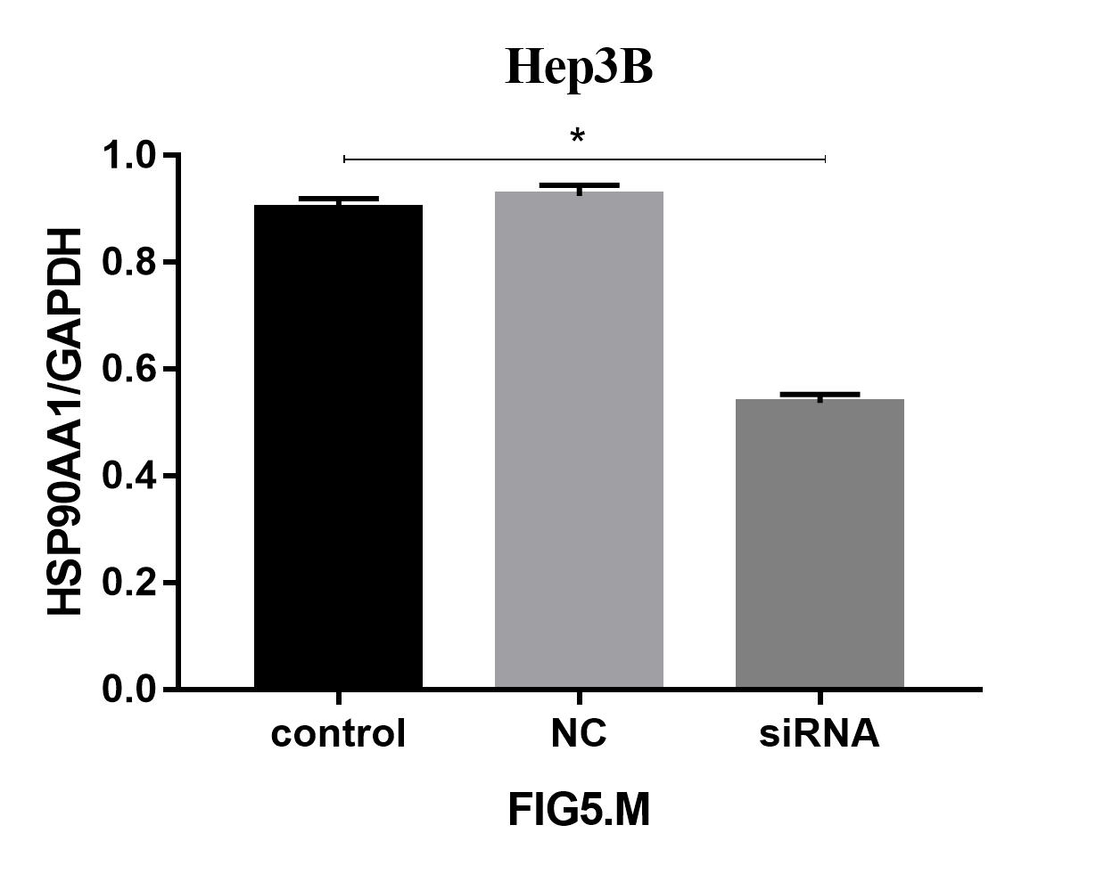
Fig 5M. hep3b-HSP90AA1

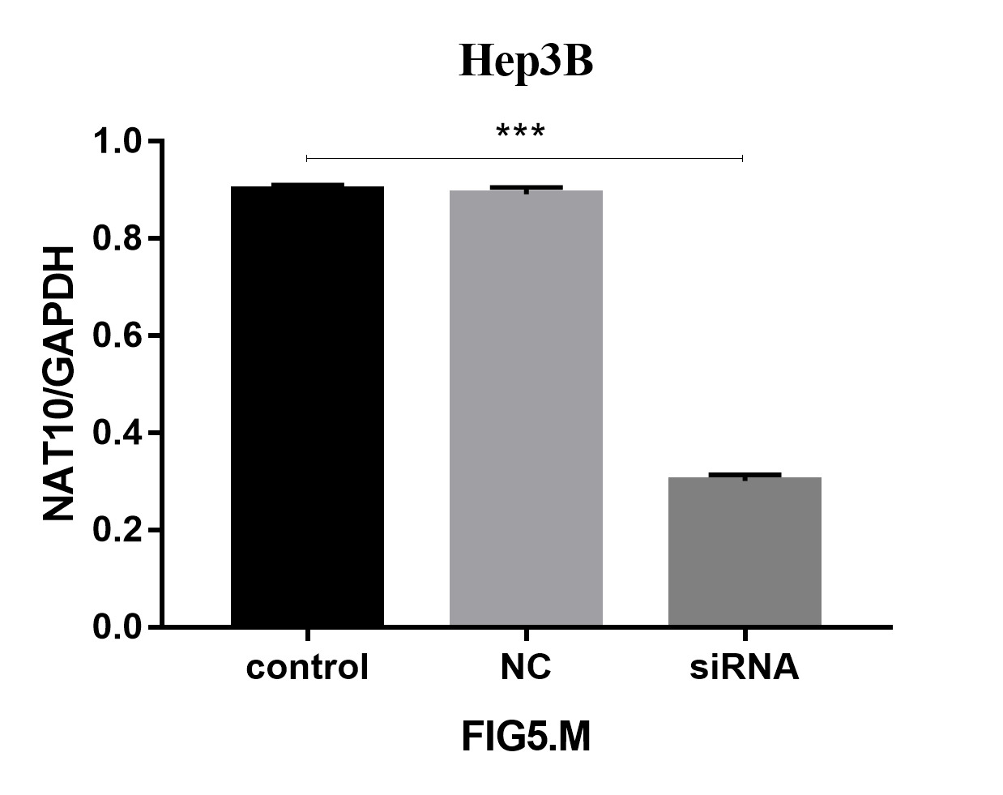
Fig 5M. hep3b-NAT10

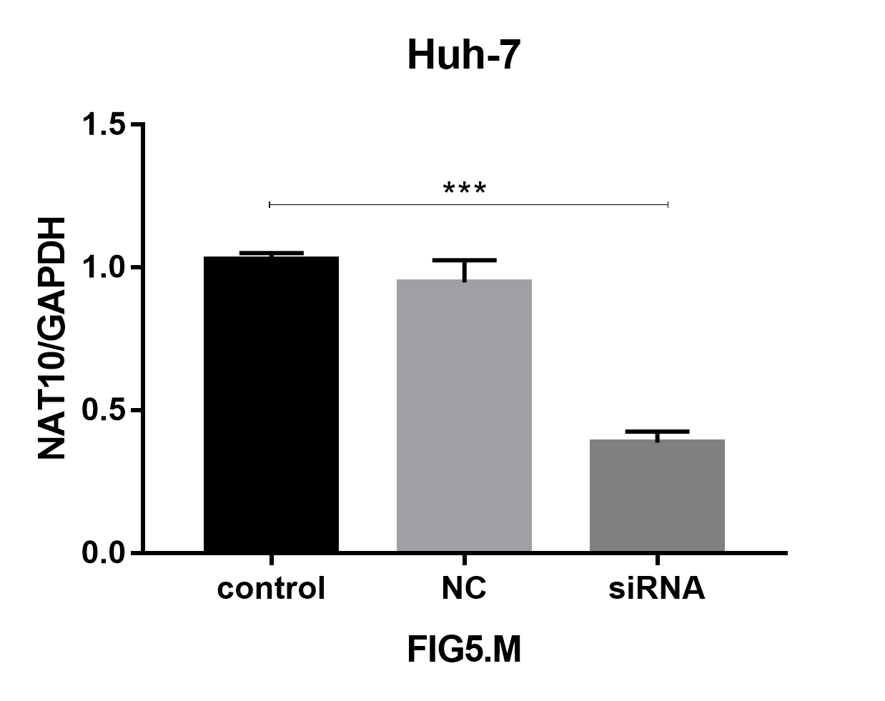
Fig 5M. huh-7-NAT10

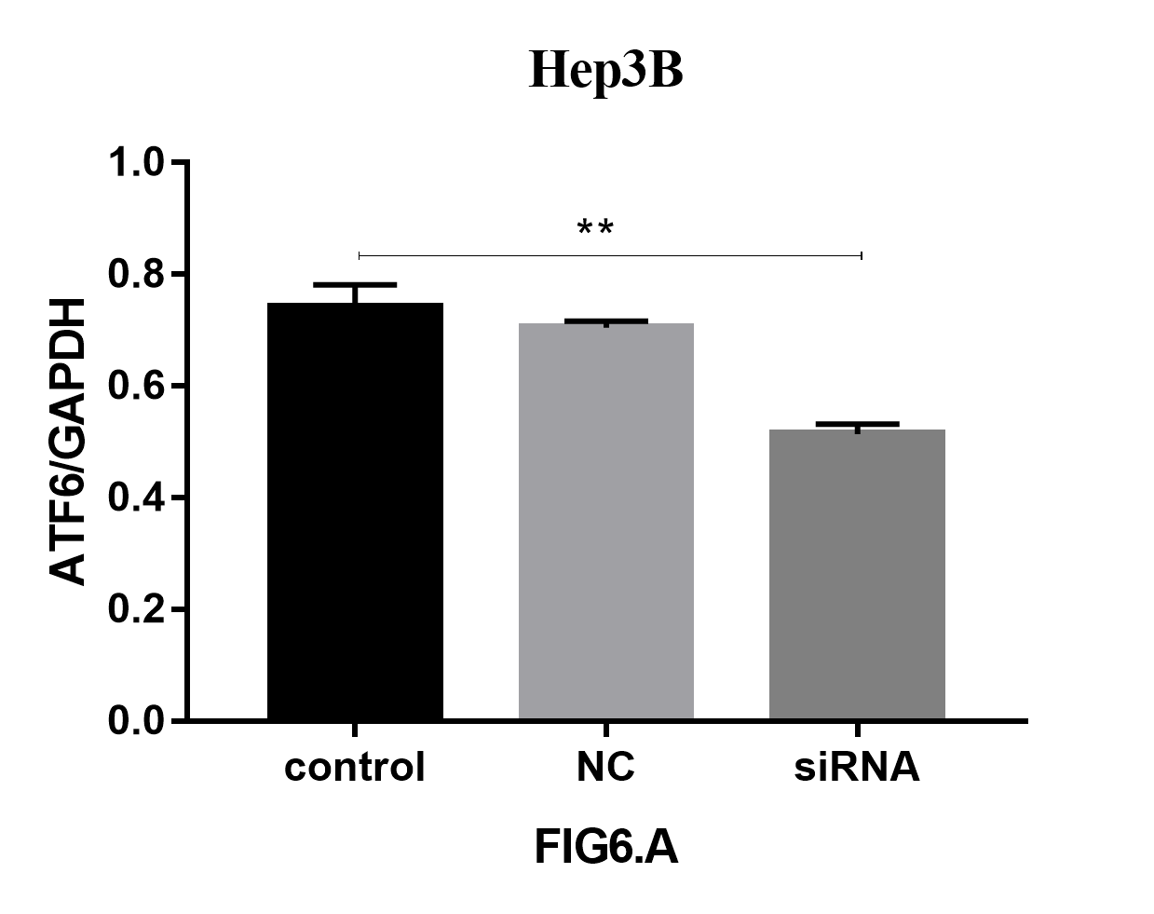
Fig 6A. hep3b-ATF6

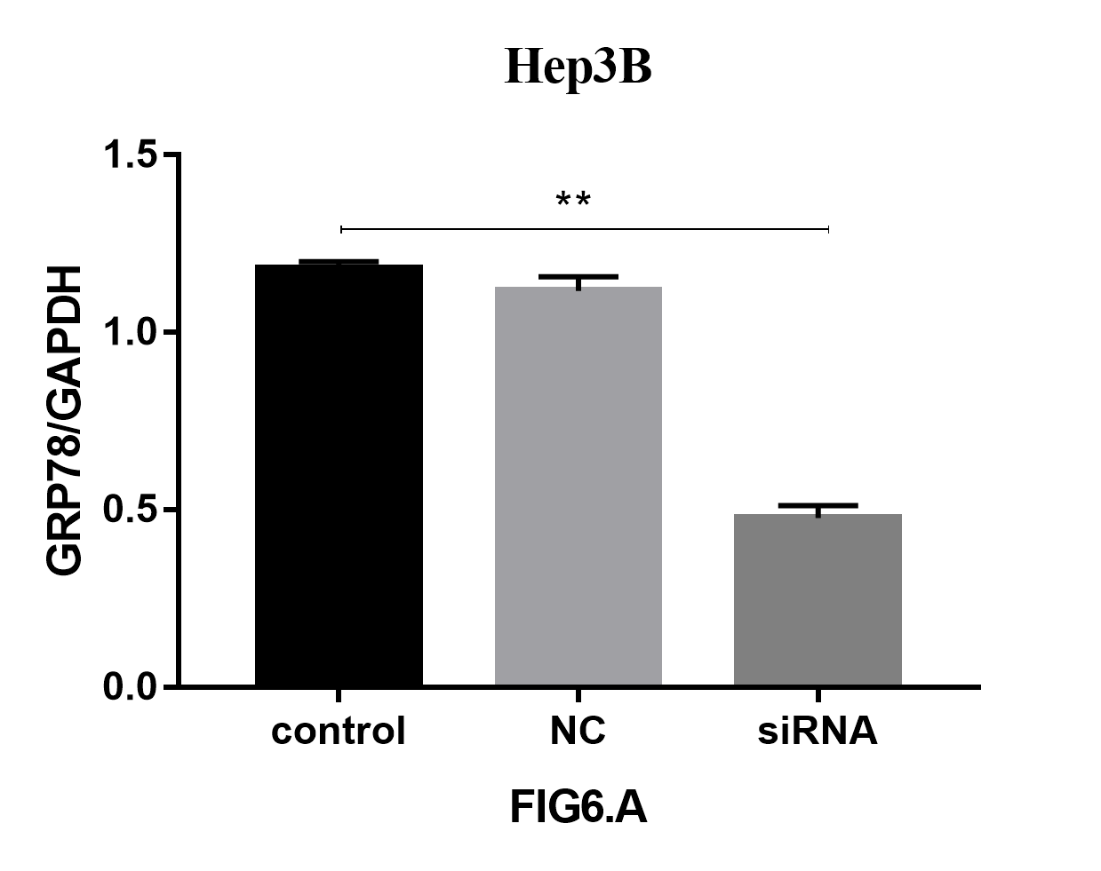
Fig 6A. hep3b-GRP78

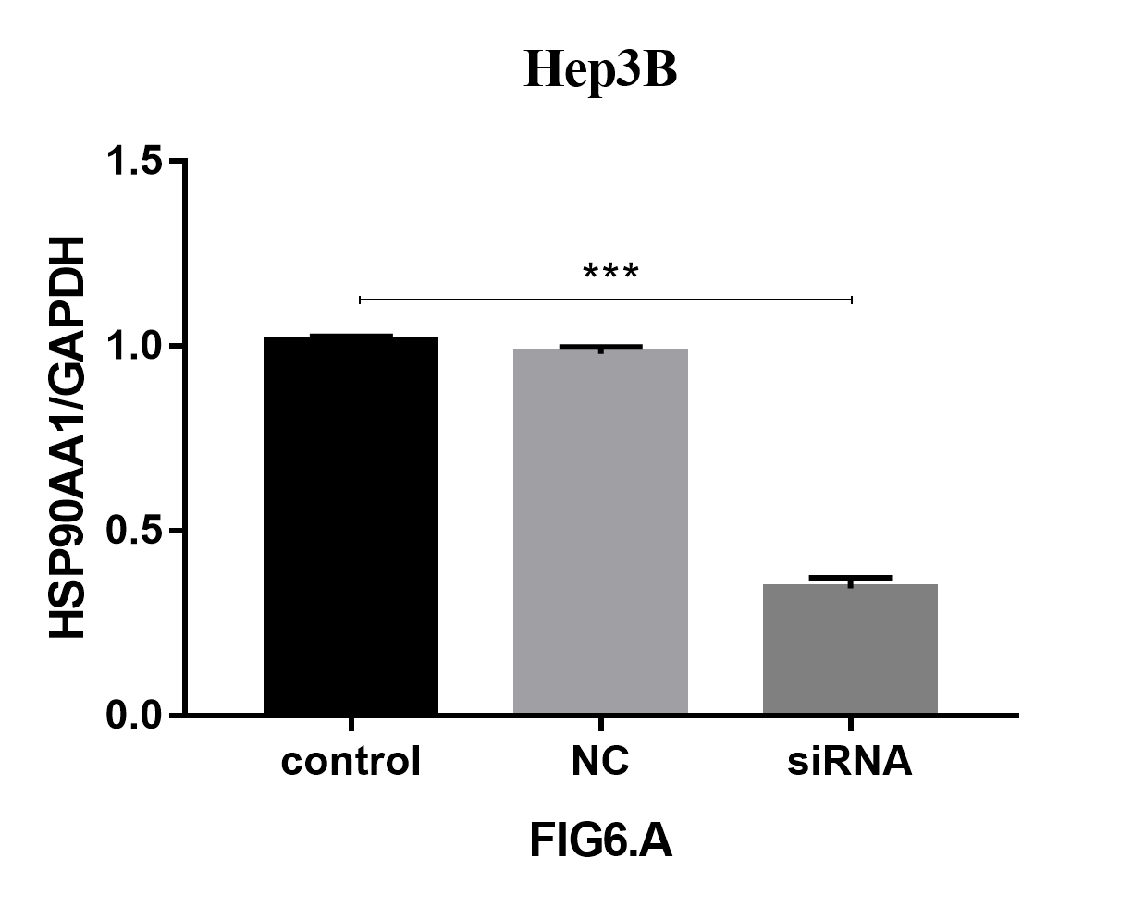
Fig 6A. hep3b-HSP90AA1

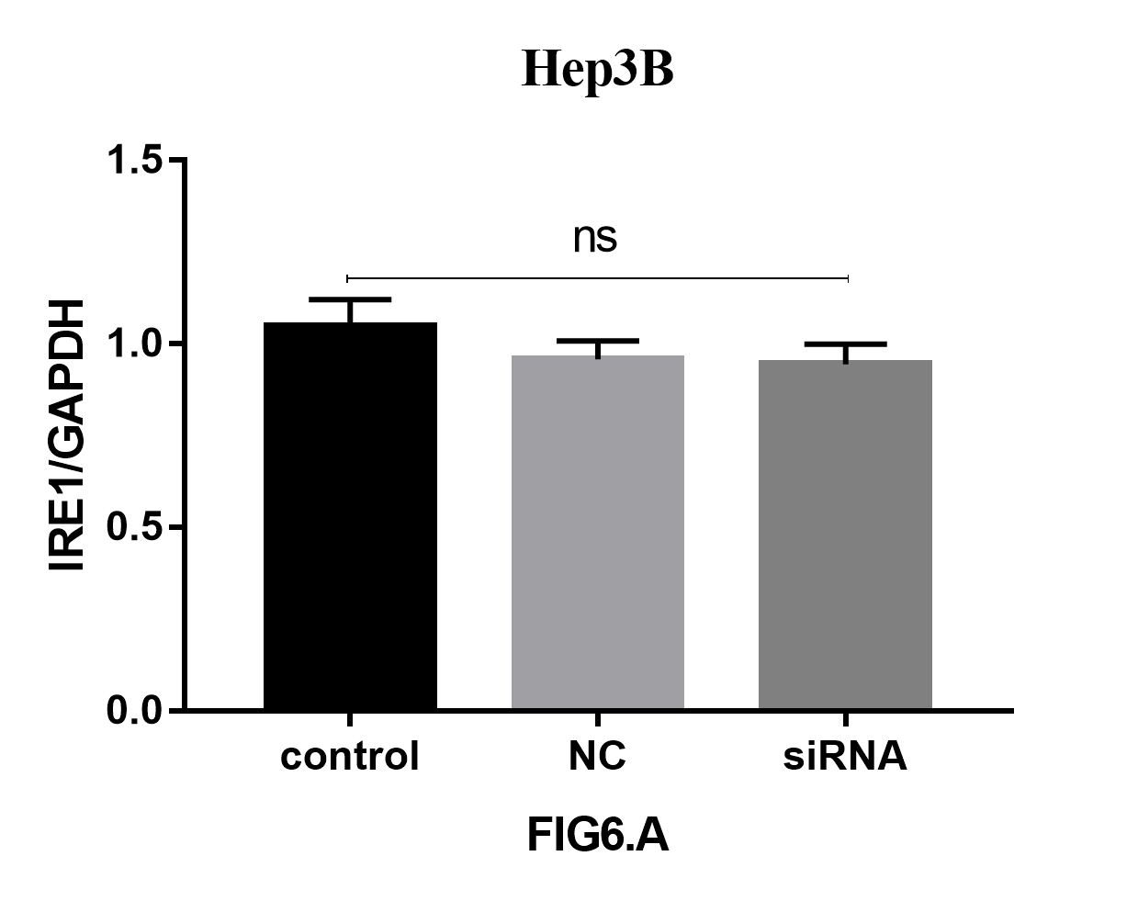
Fig 6A. hep3b-IRE-1

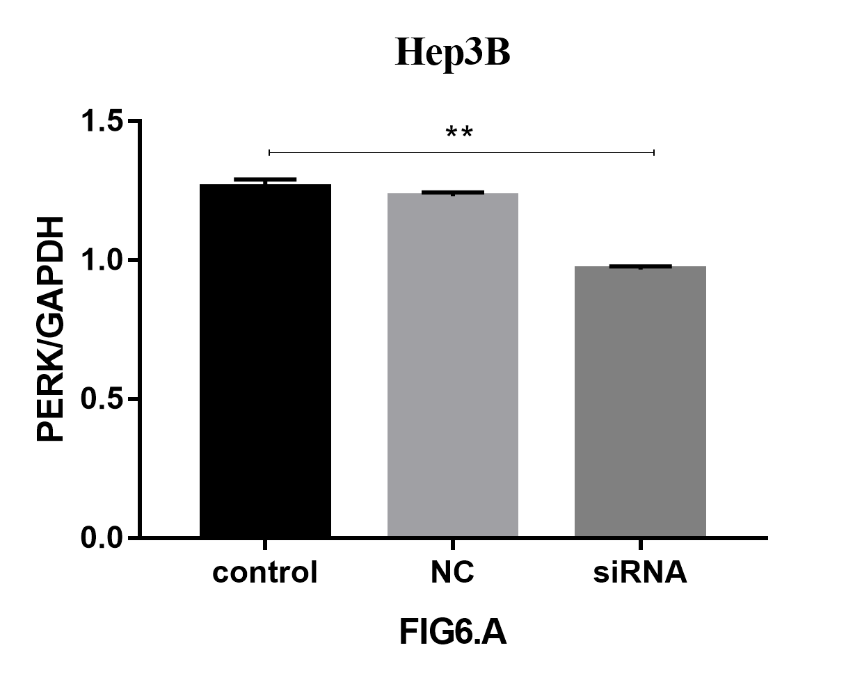
Fig 6A. hep3b-PERK

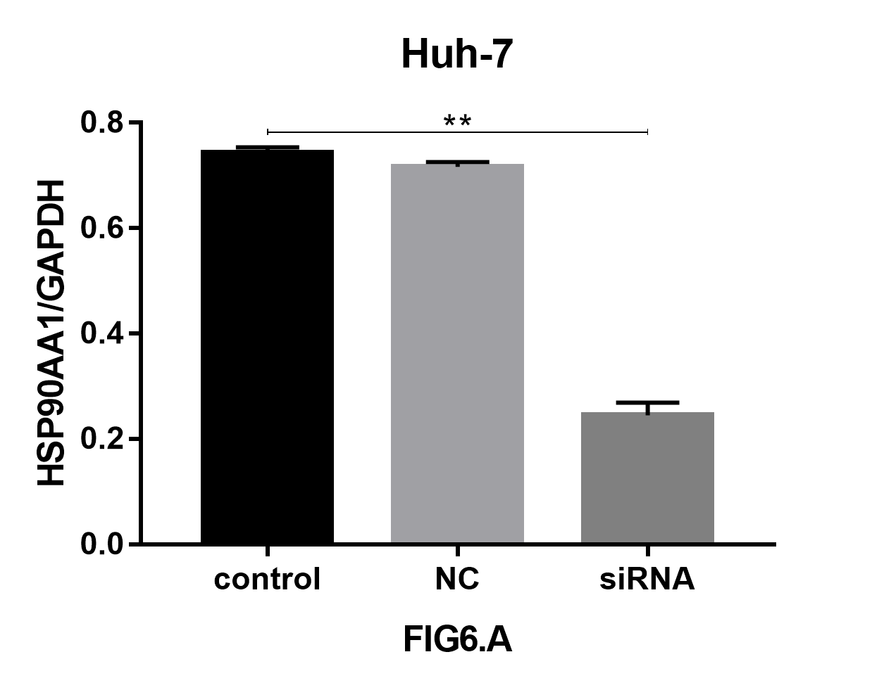
Fig 6A. huh-7-HSP90AA1

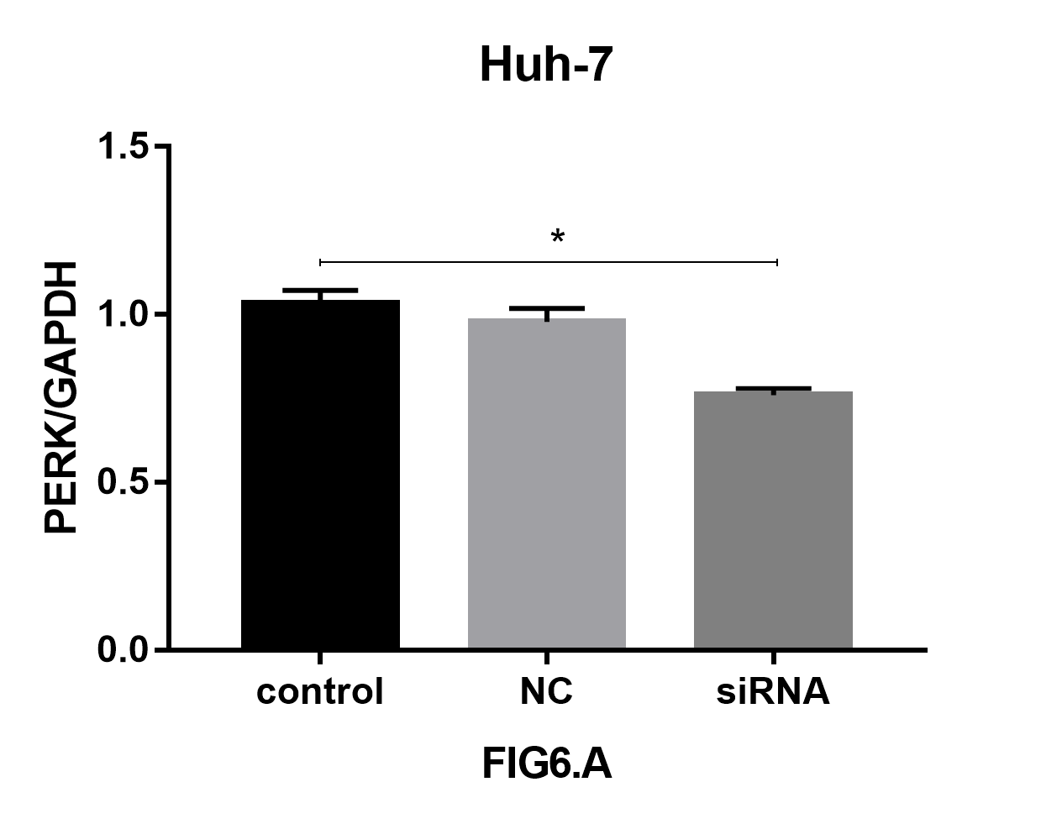
Fig 6A. huh-7-PERK

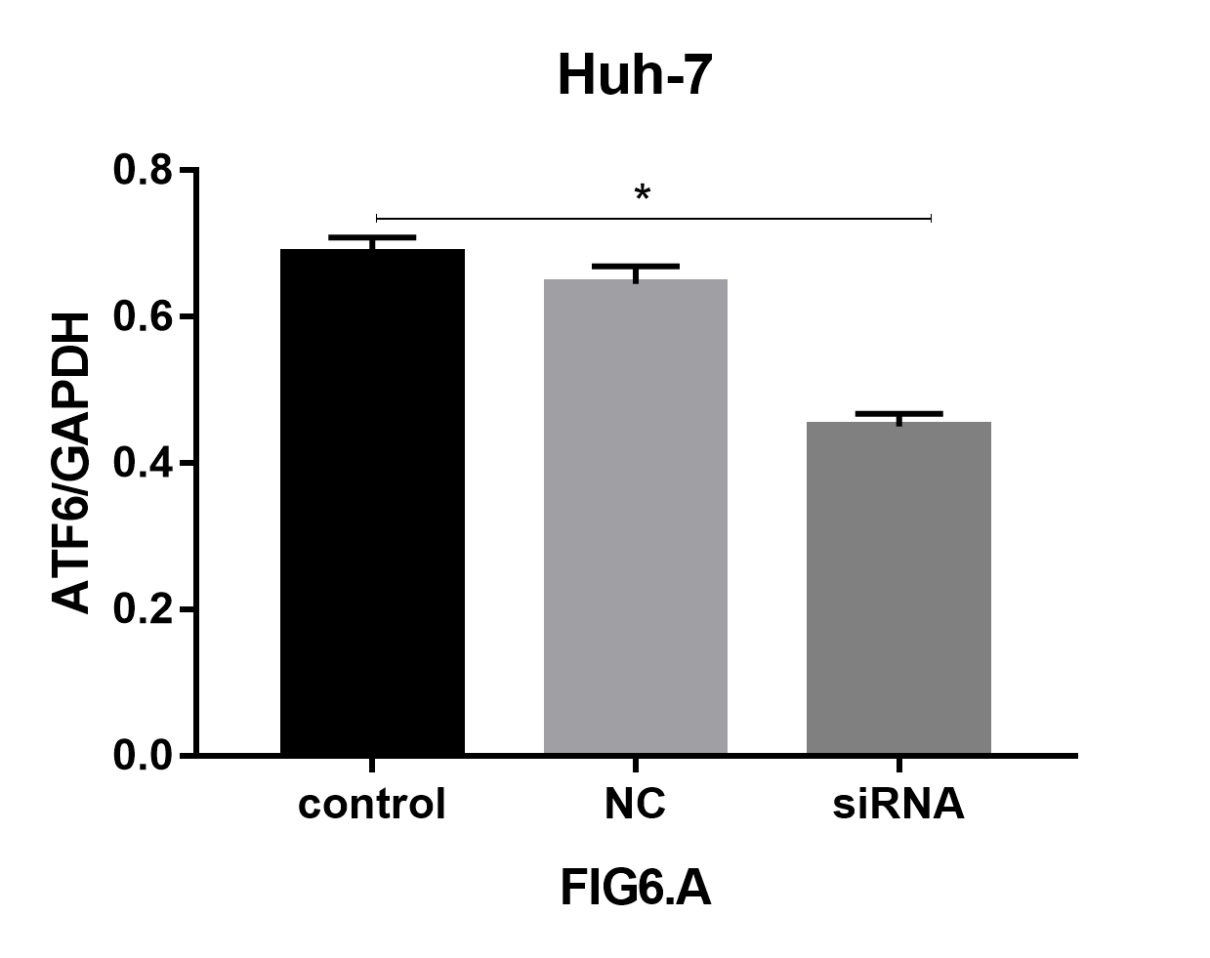
Fig 6A. huh-7-ATF6

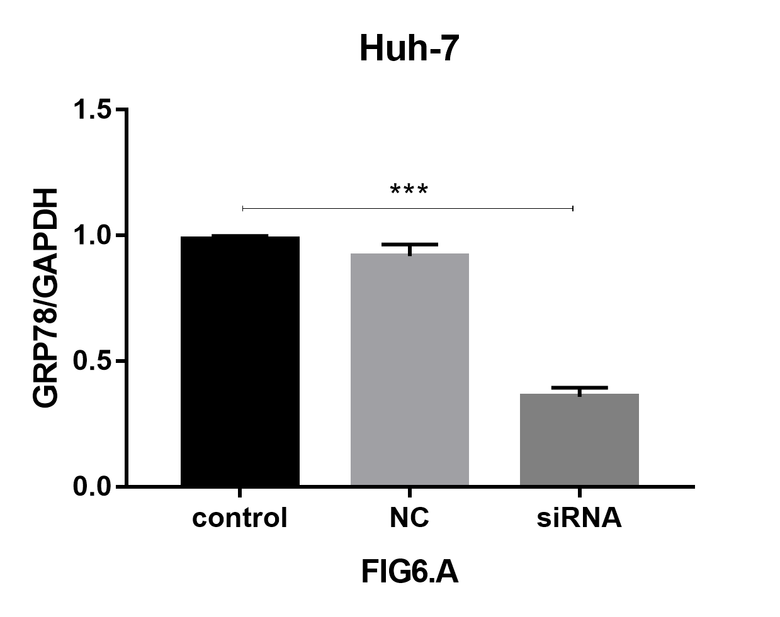
Fig 6A. huh-7-GRP78

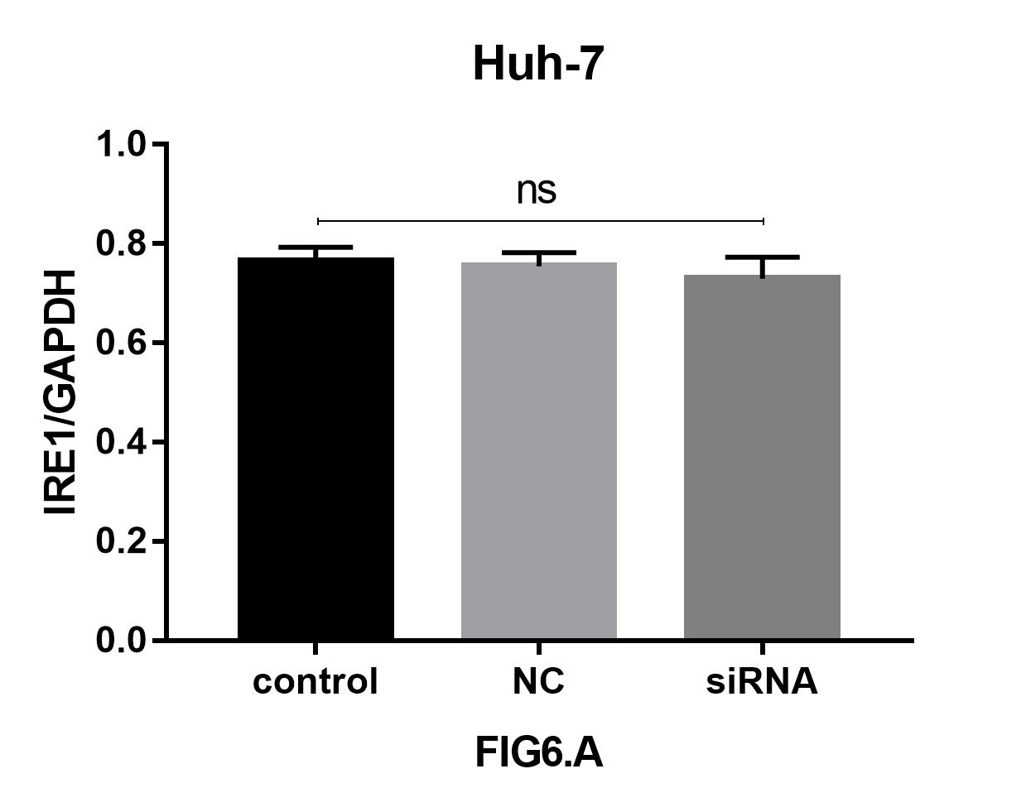
Fig 6A. huh-7-IRE-1

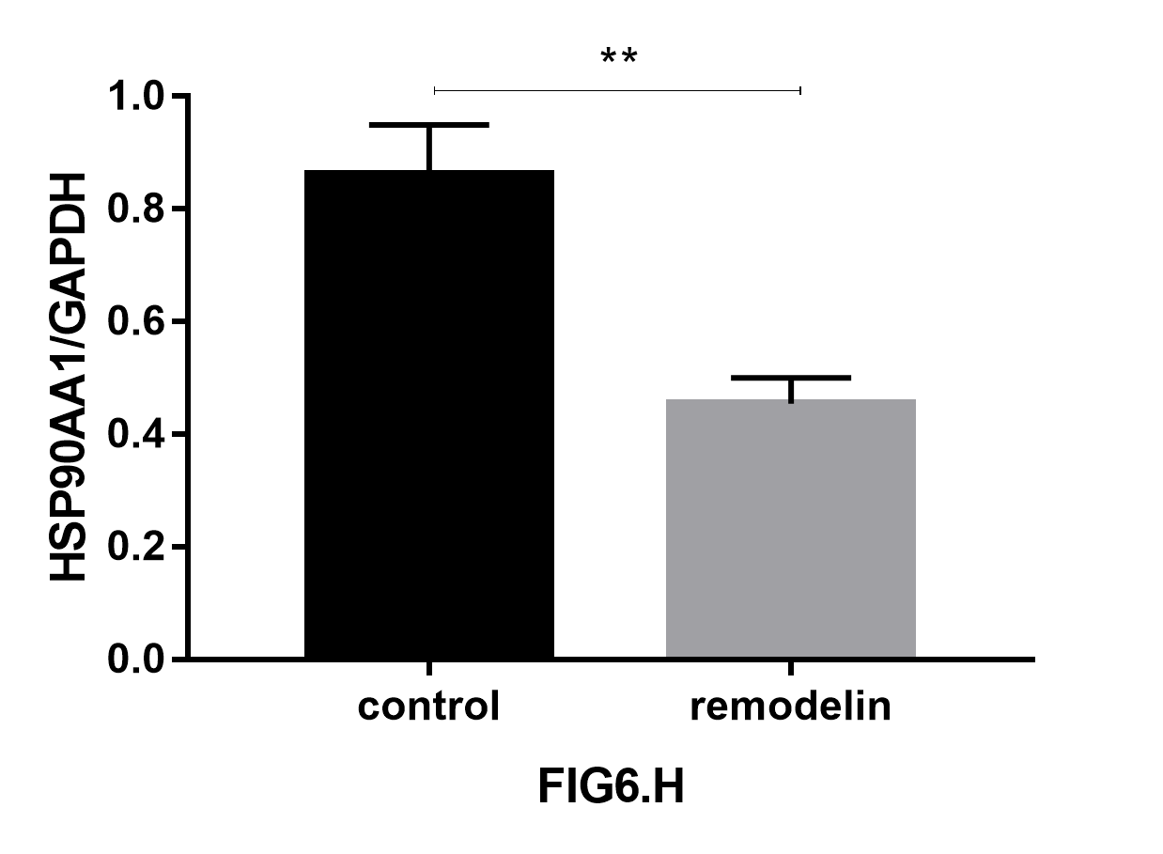
Fig 6H. Mouse tumor tissue-HSP90AA1

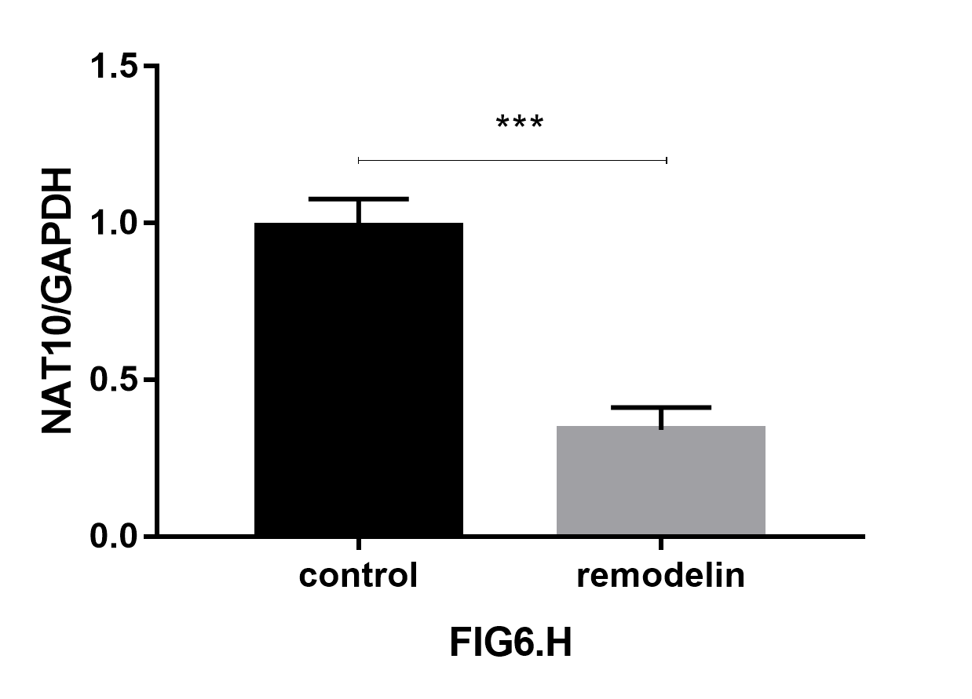
Fig 6H. Mouse tumor tissue-NAT10

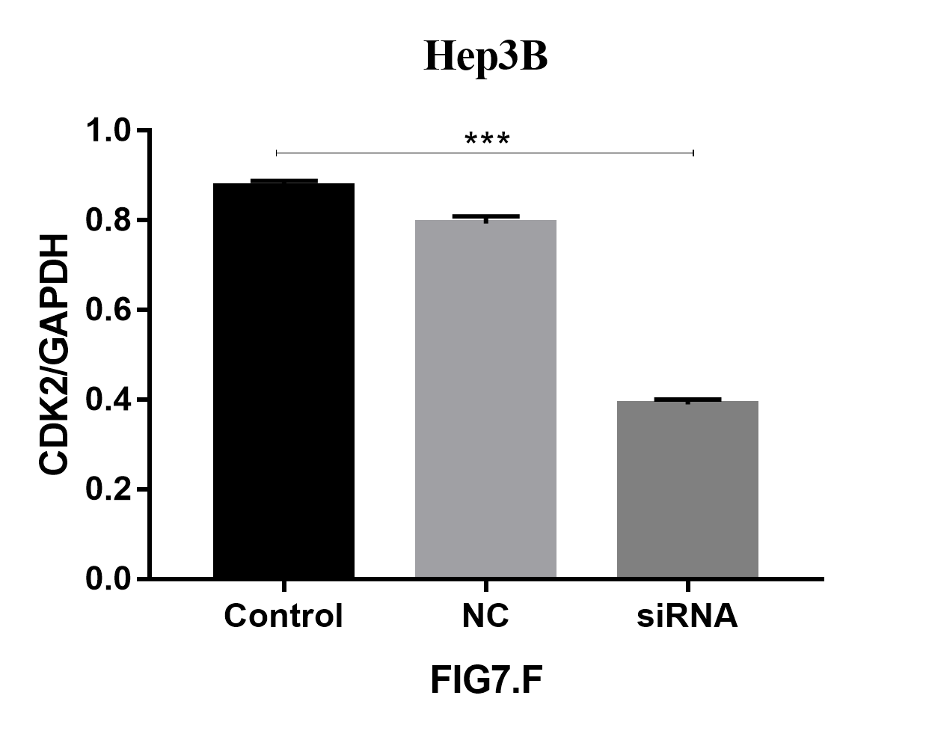
Fig 7F. hep3b-CDK2

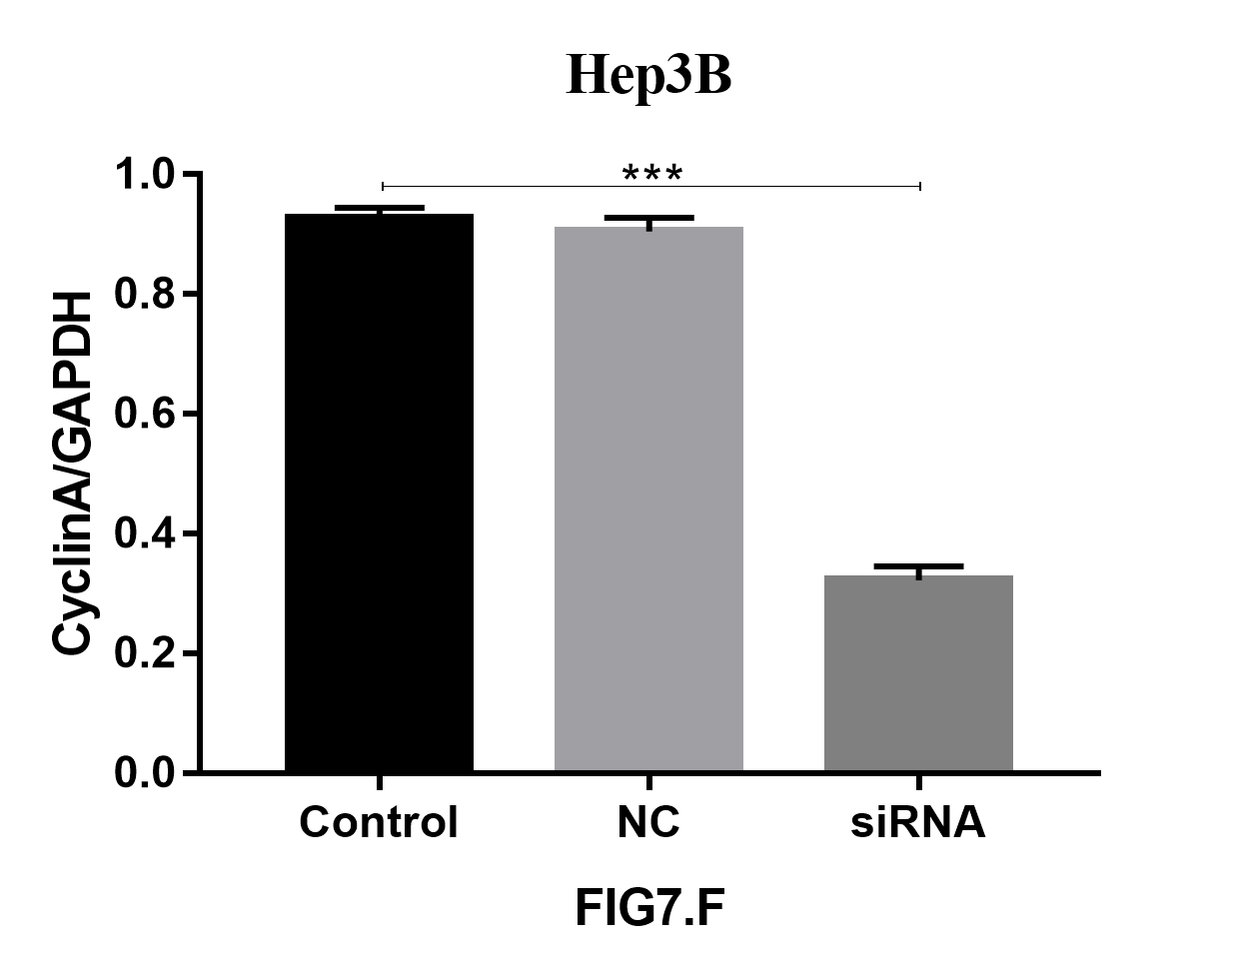
Fig 7F. hep3b-CyclinA

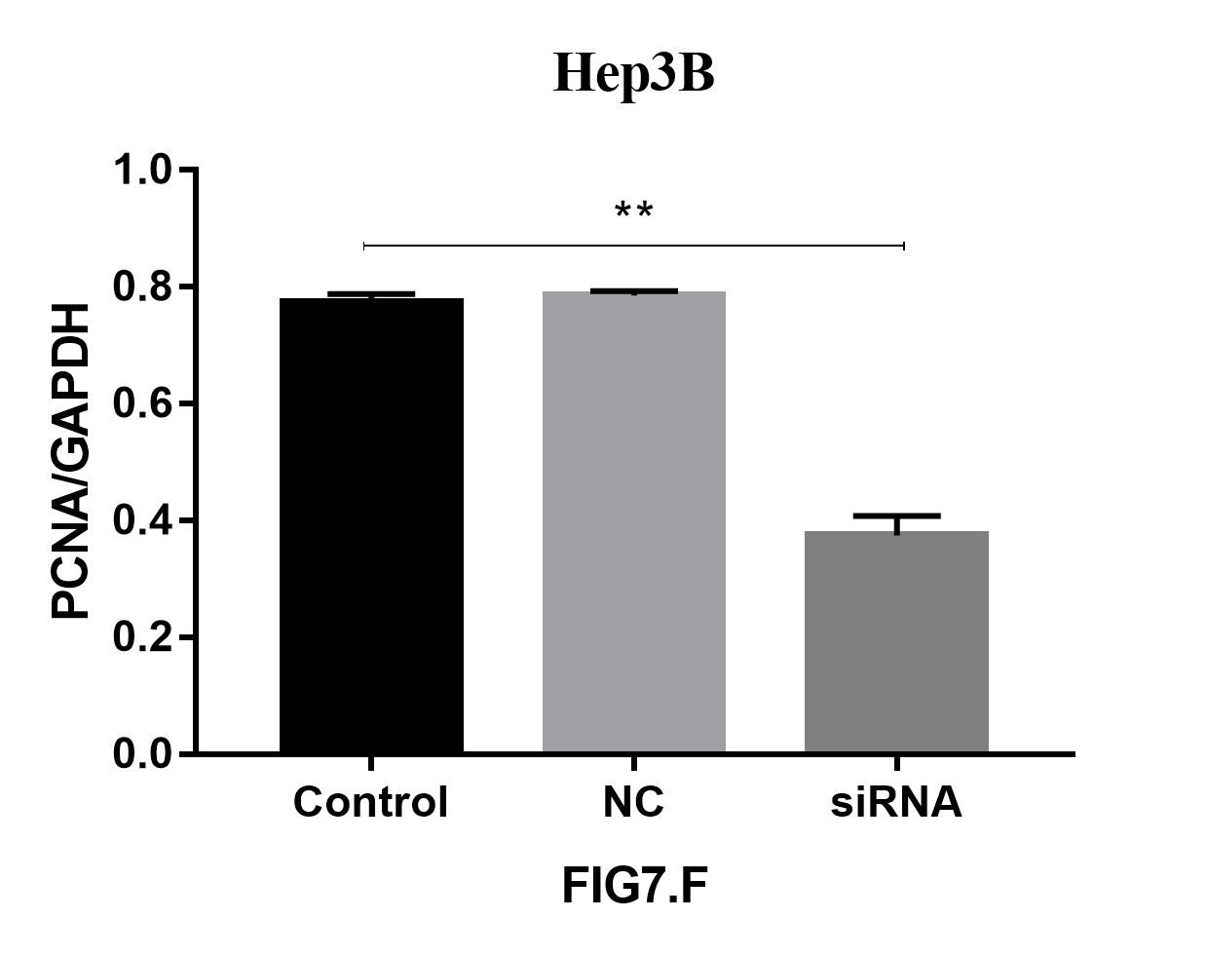
Fig 7F. hep3b-PCNA

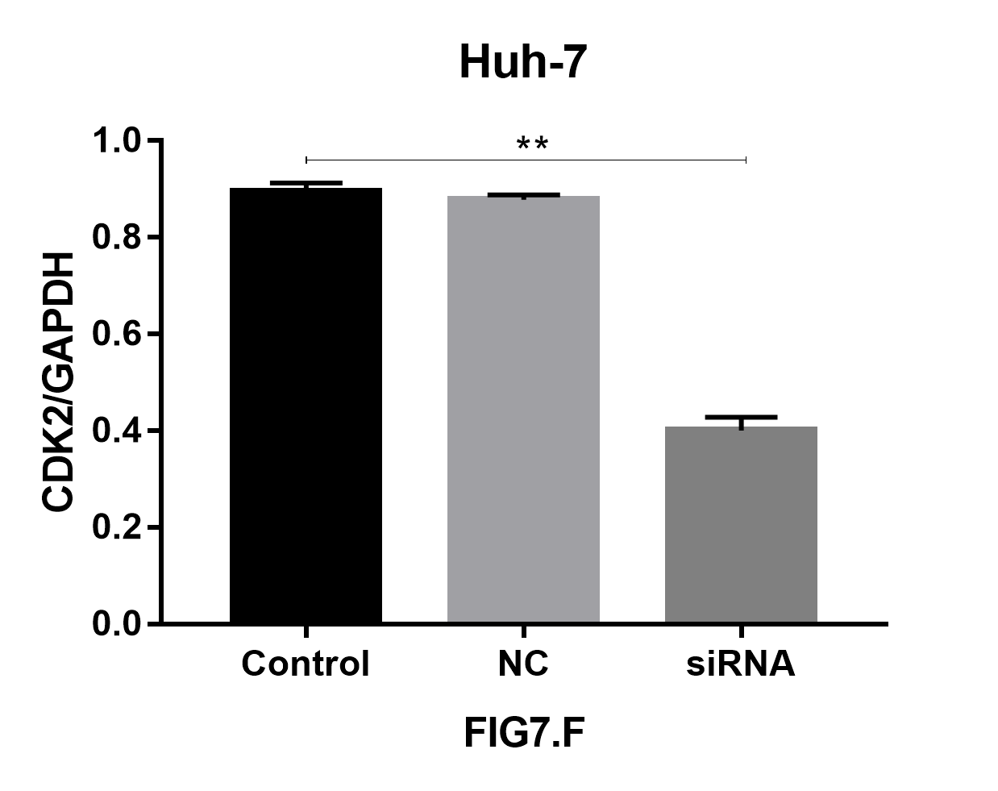
Fig 7F. hep3b-PCNA

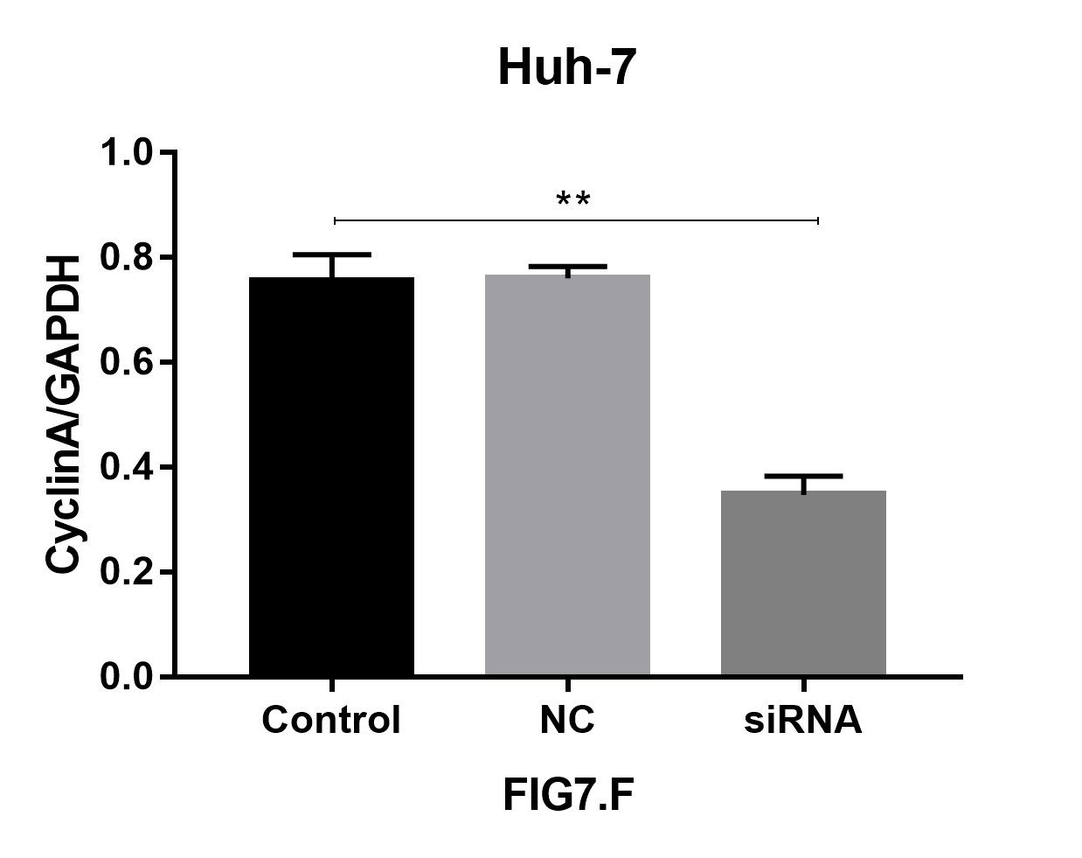
Fig 7F. huh-7-CyclinA

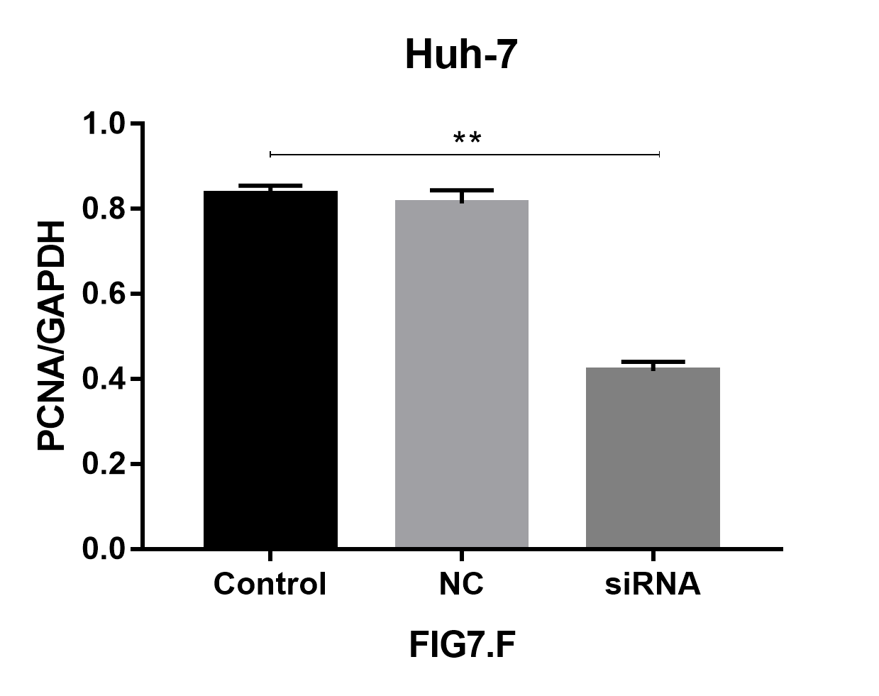
Fig 7F. huh-7-PCNA

