Quantified results and statistical analysis of immunohistochemical assay
Table of contents
Figure of the results of ATF6 immunohistochemical assay
Figure of the results of GRP78 immunohistochemical assay
Figure of the results of IRE-1 immunohistochemical assay
Figure of the results of NAT10 immunohistochemical assay
Figure of the results of PERK immunohistochemical assay

Figure of the results of ATF6 immunohistochemical assay

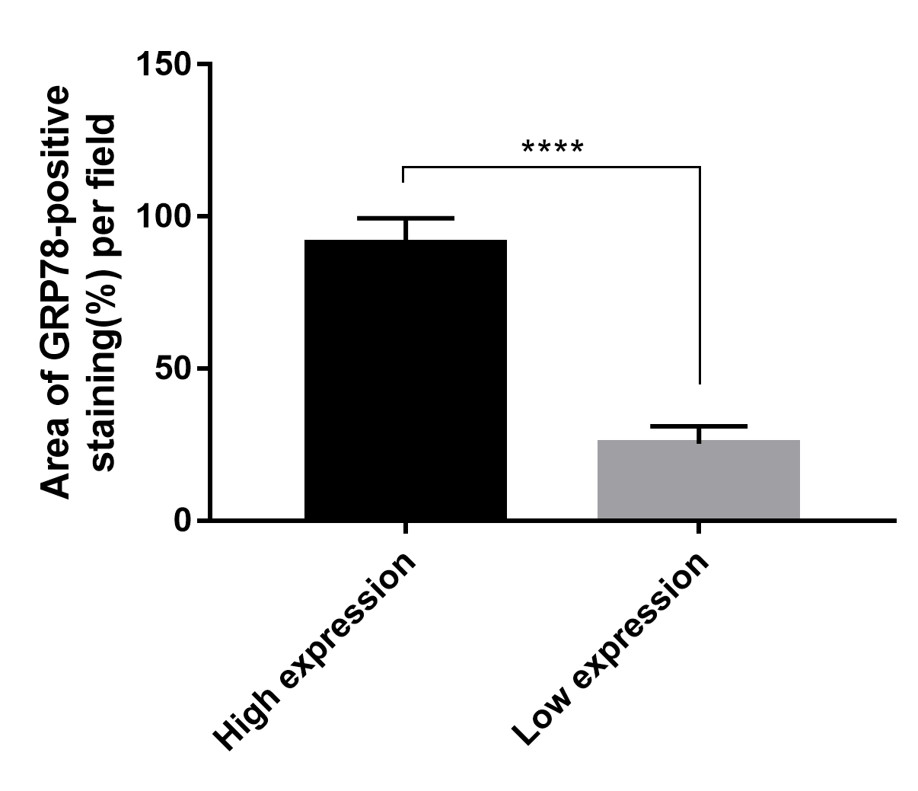
Figure of the results of GRP78 immunohistochemical assay

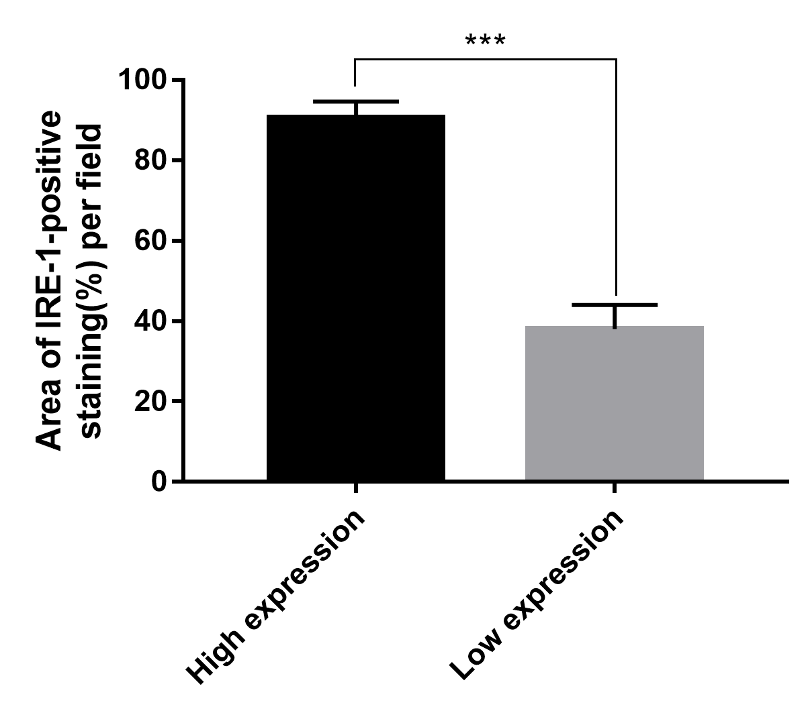
Figure of the results of IRE-1 immunohistochemical assay

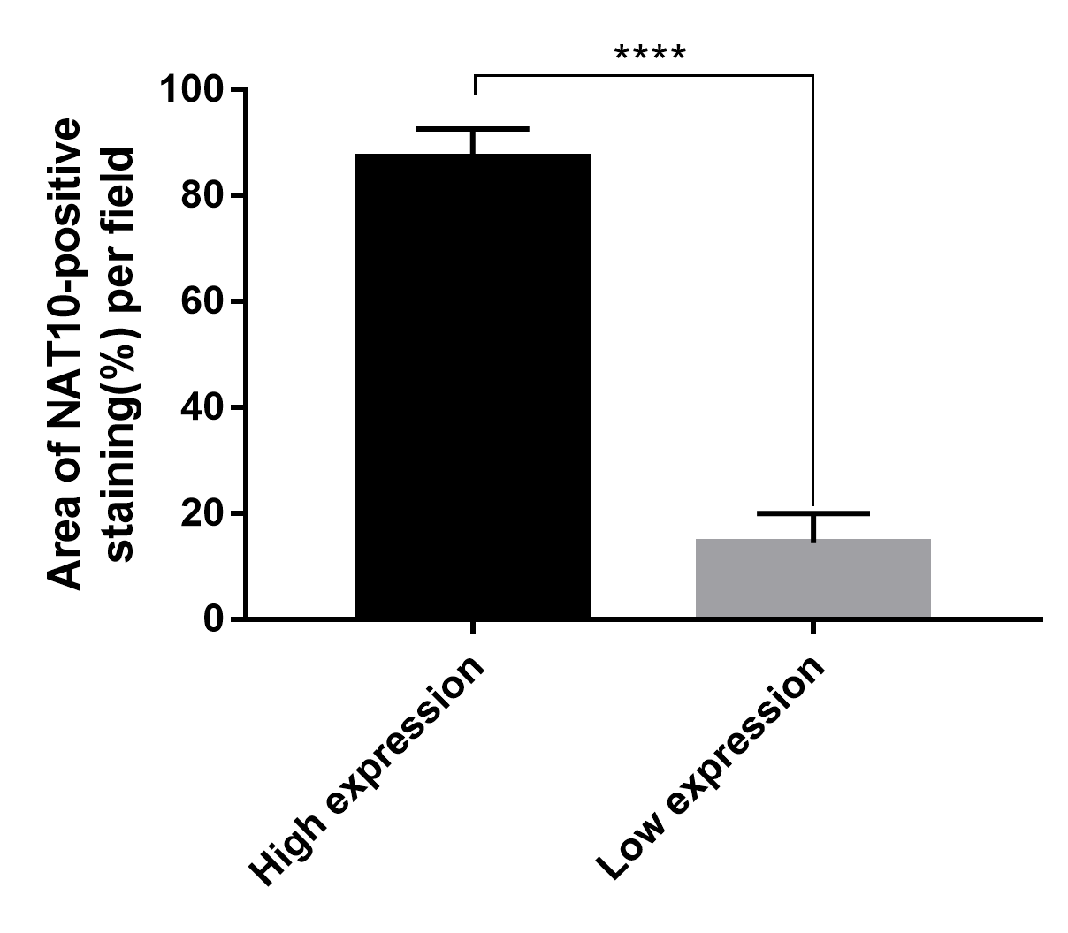
Figure of the results of NAT10 immunohistochemical assay

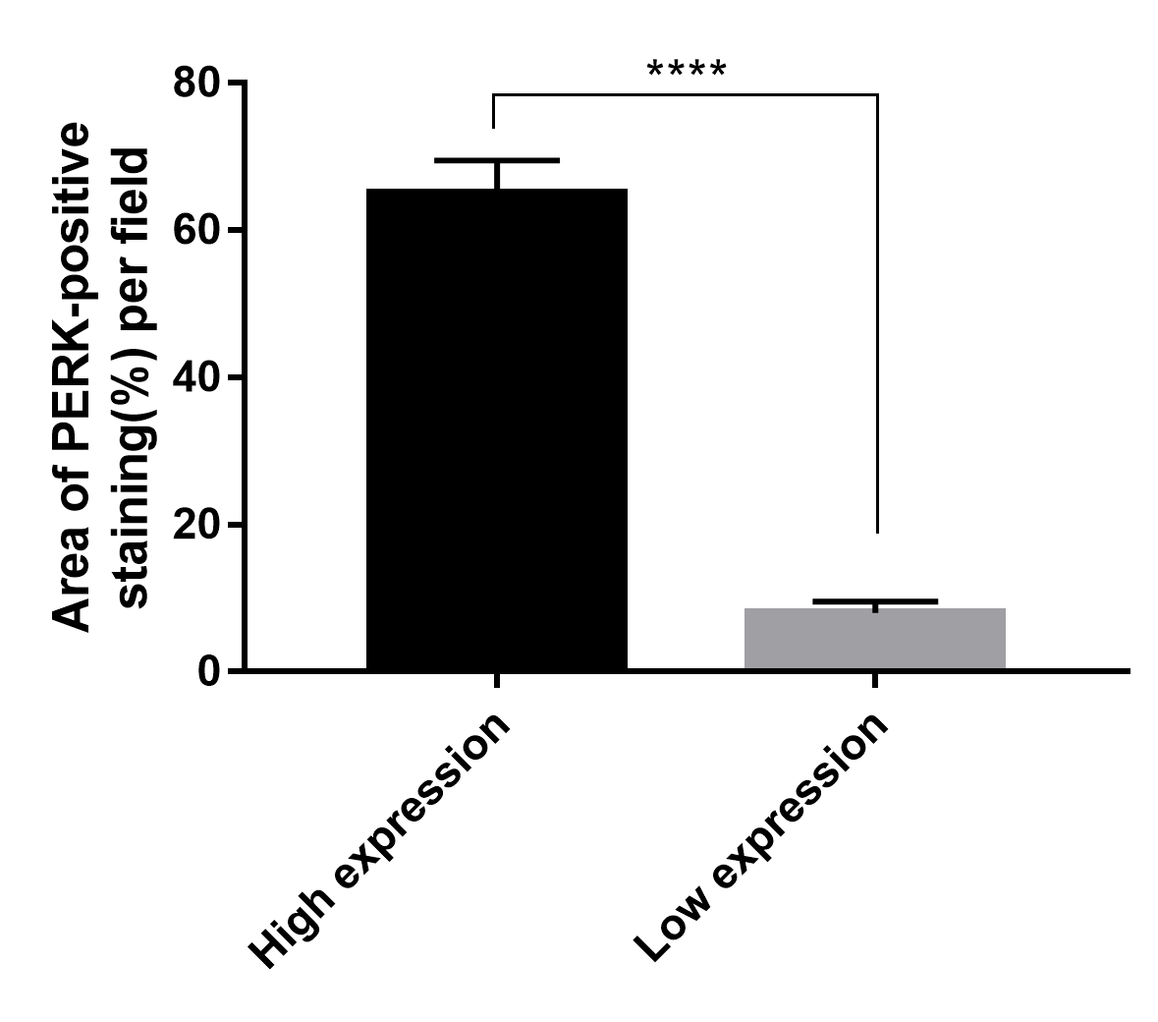
Figure of the results of PERK immunohistochemical assay

