Original figures of WB
Table of contents
Figure 1E
Figure 2E
Figure 2F
Figure 2G
Figure 3F
Figure 4D
Figure 5L
Figure 5M
Figure 6A
Figure 6H
Figure 7F

Figure1E
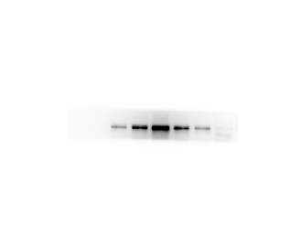
FIG1E-NAT10
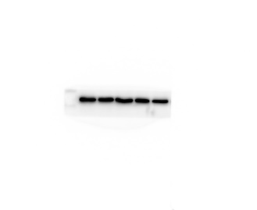
FIG1E-GAPDH

Figure2E
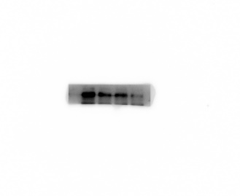
FIG2E-HUH7-NAT10
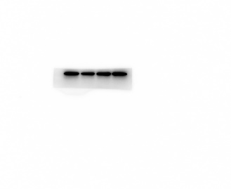
FIG2E-HUH7-GAPDH
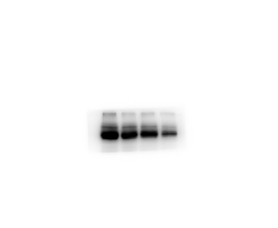
FIG2E-HEP3B-NAT10
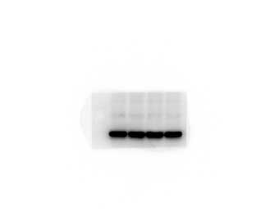
FIG2E-HEP3B-GAPDH

Figure2F
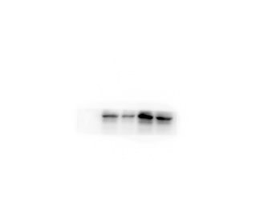
FIG2F-HUH7-GRP78
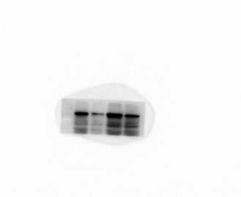
FIG2F-HUH7-ATF6
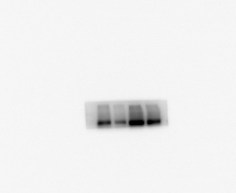
FIG2F-HUH7-IRE-1
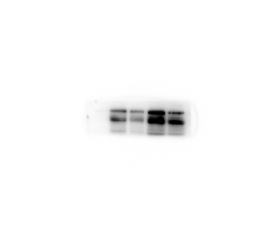
FIG2F-HUH7-PERK
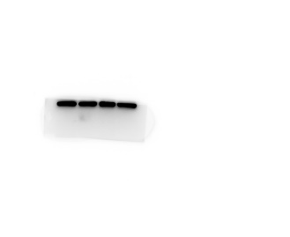
FIG2F-HUH7-GAPDH

Figure2G
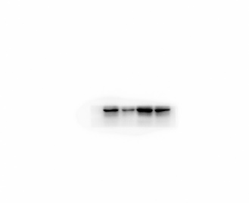
FIG2G-HUH7-GRP78
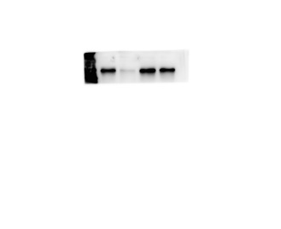
FIG2G-HUH7-ATF6
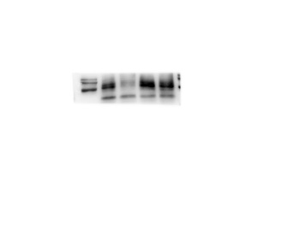
FIG2G-HUH7-IRE-1
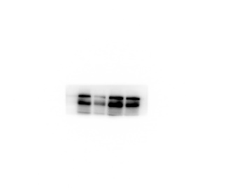
FIG2G-HUH7-PERK
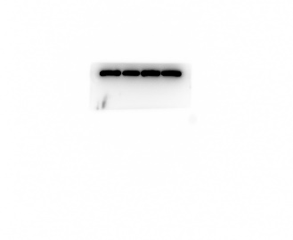
FIG2G-HUH7-GAPDH
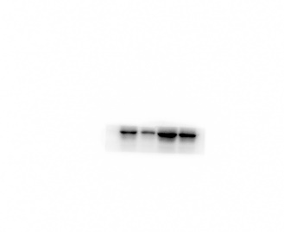
FIG2G-HEP3B-GRP78
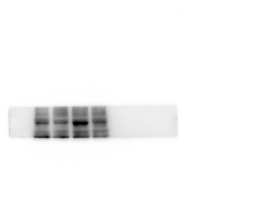
FIG2G-HEP3B-ATF6
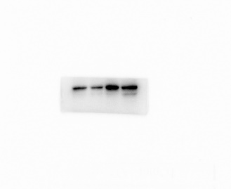
FIG2G-HEP3B-IRE-1
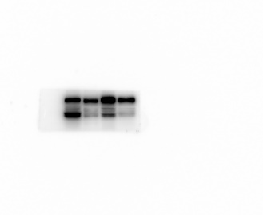
FIG2G-HEP3B-PERK
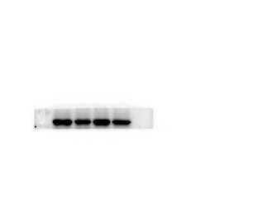
FIG2G-HEP3B-GAPDH

Figure3F
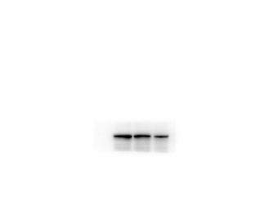
FIG3F-HUH7- CDK2
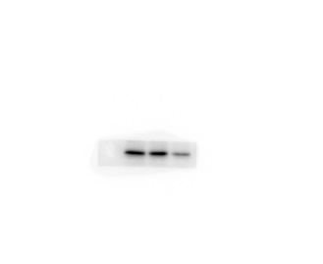
FIG3F-HUH7- CyclinA
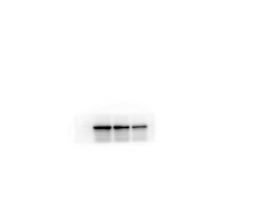
FIG3F-HUH7- PCNA
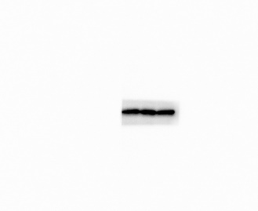
FIG3F-HUH7- GAPDH
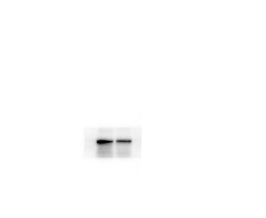
FIG3F-HUH7- CDK2
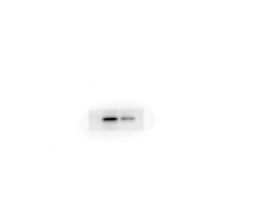
FIG3F-HUH7- CyclinA
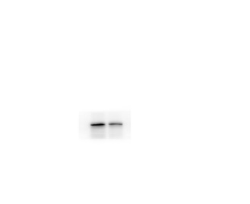
FIG3F-HUH7- PCNA
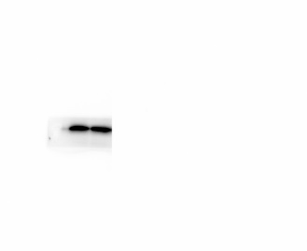
FIG3F-HUH7- GAPDH
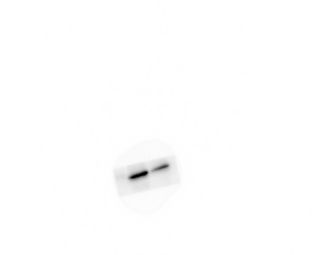
FIG3F-HEP3B- CDK2
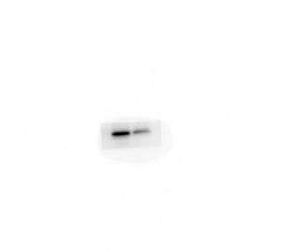
FIG3F-HEP3B- CyclinA
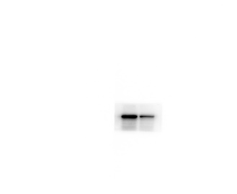
FIG3F-HEP3B- PCNA
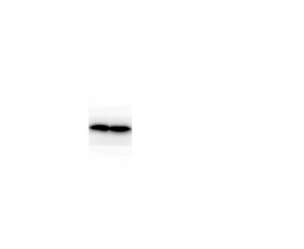
FIG3F-HEP3B- GAPDH

Figure4D
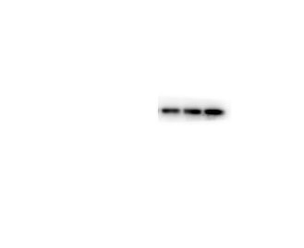
FIG4D-HUH7- Bax
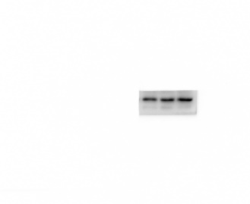
FIG4D-HUH7-Bak
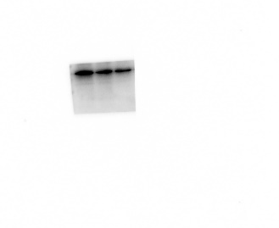
FIG4D-HUH7- Bcl-2
FIG4D-HUH7- GAPDH

Figure4D
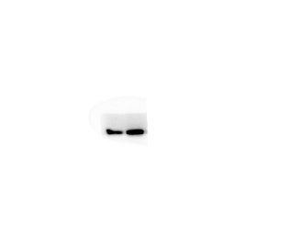
FIG4D-HUH7-Bax
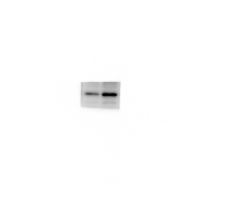
FIG4D-HUH7-Bak
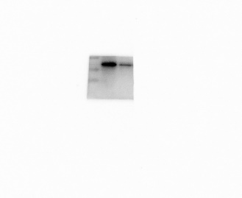
FIG4D-HUH7- Bcl-2
FIG4D-HUH7- GAPDH
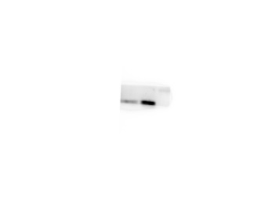
FIG4D-HEP3B-Bax
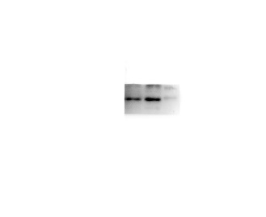
FIG4D-HEP3B-Bak
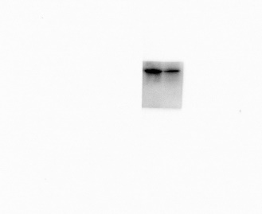
FIG4D-HEP3B- Bcl-2
FIG4D-HEP3B- GAPDH

Figure5L
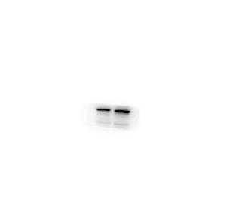
FIG5L-HUH7-HSP90AA1
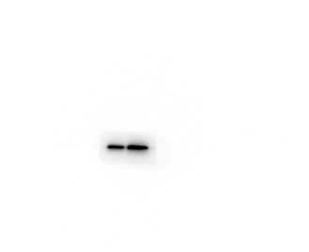
FIG5L-HUH7- NAT10
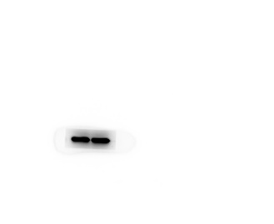
FIG5L-HUH7- GAPDH
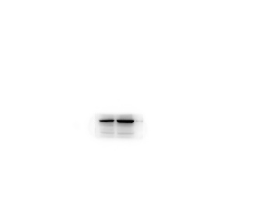
FIG5L-HEP3B-HSP90AA1
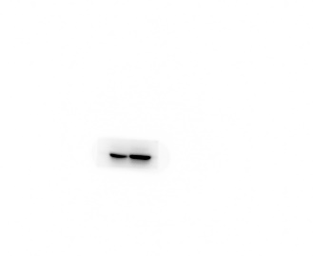
FIG5L-HEP3B- NAT10
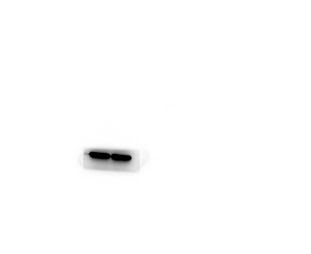
FIG5L-HEP3B-GAPDH

Figure5M
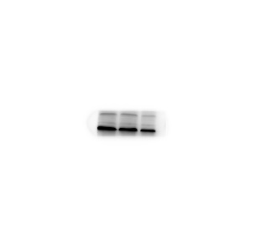
FIG5M-HUH7- HSP90AA1
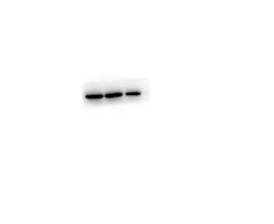
FIG5M-HUH7- NAT10
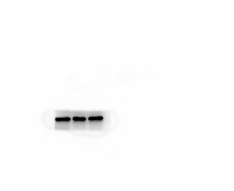
FIG5M-HUH7- GAPDH
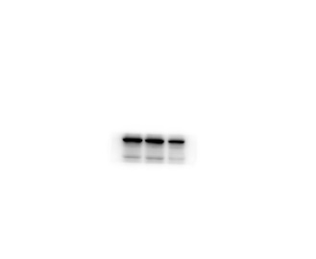
FIG5M-HEP3B-HSP90AA1
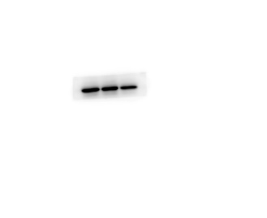
FIG5M-HEP3B- NAT10
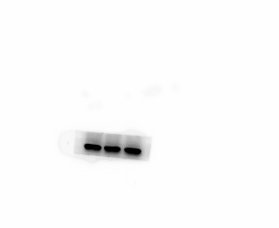
FIG5M-HEP3B- GAPDH

Figure6A
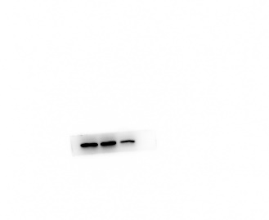
FIG6A-HUH7- HSP90AA1
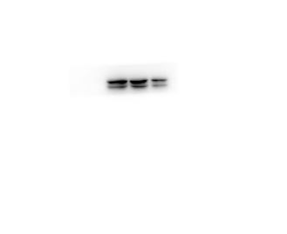
FIG6A-HUH7- GRP78
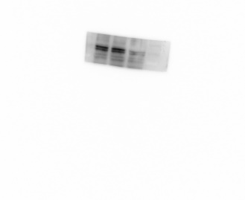
FIG6A-HUH7- ATF6
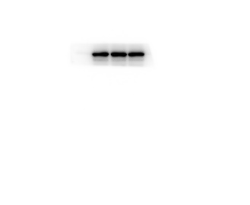
FIG6A-HUH7- IRE-1
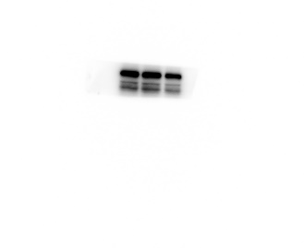
FIG6A-HUH7- PERK
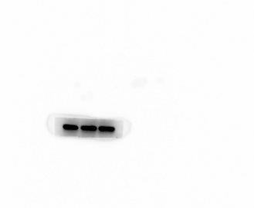
FIG6A-HUH7- GAPDH

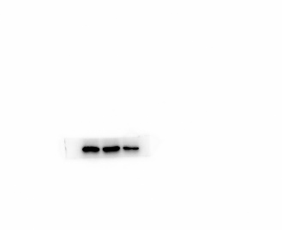
FIG6A-HEP3B- HSP90AA1
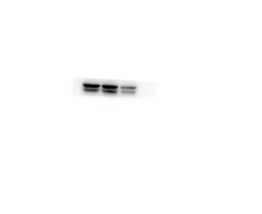
FIG6A-HEP3B- GRP78
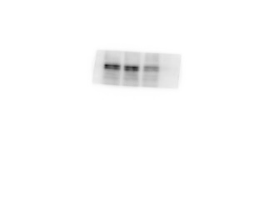
FIG6A-HEP3B- ATF6
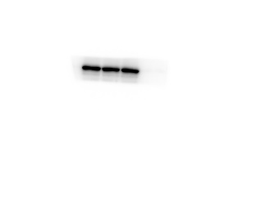
FIG6A-HEP3B- IRE-1
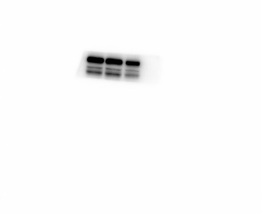
FIG6A-HEP3B- PERK
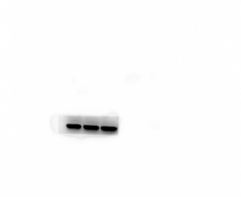
FIG6A-HEP3B- GAPDH

Figure6H
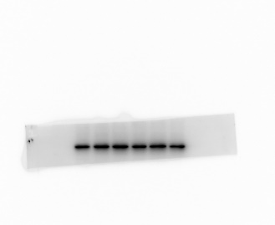
FIG6H-control-NAT10
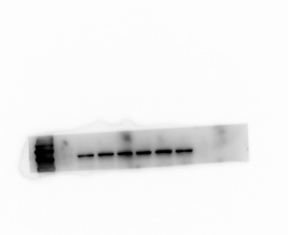
FIG6H-control-HSP90AA1
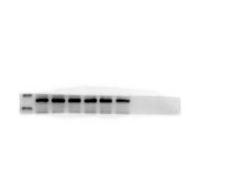
FIG6H-control-GAPDH
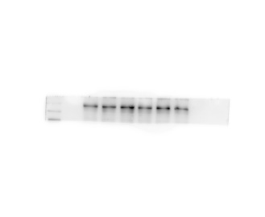
FIG6H-rem-NAT10
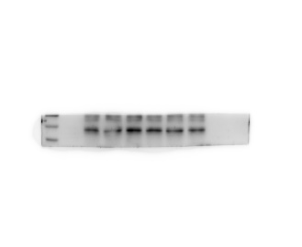
FIG6H-rem-HSP90AA1
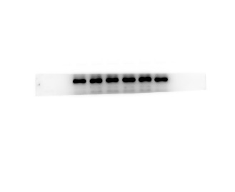
FIG6H-rem-GAPDH

Figure7F
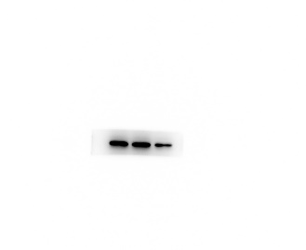
FIG7F-HUH7- CDK2
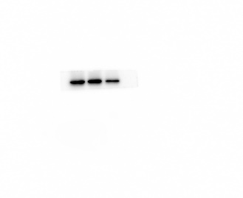
FIG7F-HUH7- CyclinA
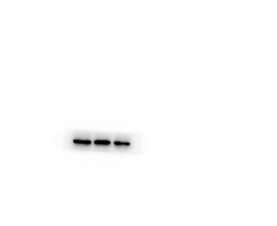
FIG7F-HUH7- PCNA
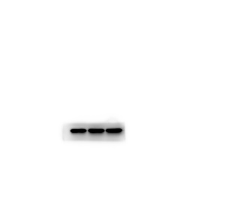
FIG7F-HUH7- GAPDH
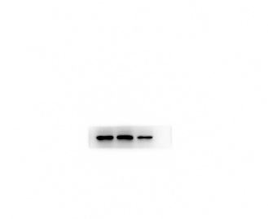
FIG7F-HEP3B- CDK2
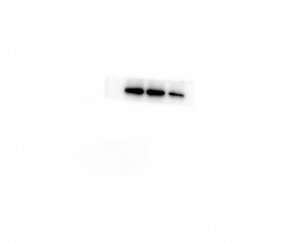
FIG7F-HEP3B- CyclinA
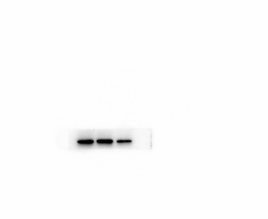
FIG7F-HEP3B- PCNA
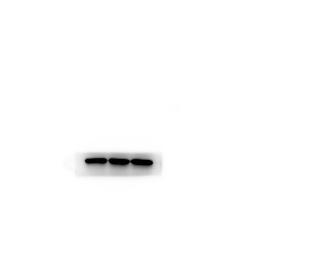
FIG7F-HEP3B- GAPDH

