Supplementary information for
The ELK3-DRP1 axis determines the chemosensitivity of triple negative breast cancer cells to CDDP by regulating mitochondrial dynamics
Joo Dong Park¹, Hye Jung Jang¹, Seung Hee Choi¹, Gae Hoon Jo¹, Jin-Ho Choi¹,
Sohyun Hwang¹, Wooram Park², Kyung-Soon Park¹*
1 Department of Biomedical Science, CHA University, Seongnam, Republic of Korea
2 Department of Integrative Biotechnology, Sungkyunkwan University, Suwon, Republic of Korea
* Correspondence to: Kyung-Soon Park, kspark@cha.ac.kr

Supplementary Table 1. Plasmids and small interfering (si)RNAs used in the study
No | Name | Additional information
1 | pLenti-cMyc-DDK | Origene, PS1000064
2 | pLenti-ELK3-cMyc-DDK | NM_005230.3
3 | pRL-TK | Promega, E2231
4 | pGL3-Basic | Promega, E1751
5 | pGL3-hDNM1L promoter (−1.70 to 0.04 kb) | -
6 | Nonspecific siRNA control | Bioneer, SN-1003
7 | hDNM1L siRNA | Bioneer, 10059

Supplementary Table 2. Antibodies used in the study
Antibody | Manufacturer/supplier | Catalog No. | Application
ELK3 | Novus Biologicals | NBP2-01264 | Immunoblot
p-DRP1(S616) | Cell Signaling | 3455S | Immunoblot
DRP1 | Cell Signaling | 5391T | Immunoblot
GAPDH | Santa Cruz Biotechnology | sc-166574 | Immunoblot
Flag | MBL International Corporation | M185-3L | ChIP
γ-H2AX | Abcam | ab22551 | Flow cytometry
Abbreviations: ChIP, chromatin immunoprecipitation.

Supplementary Table 3. Primers used in the study
Genes | Forward Primer (5' to 3') | Reverse Primer (5' to 3') | Application
ELK3 | ACC CAA AGG CTT GGA AAT CT | TGT ATG CTG GAG AGC AGT GG | qRT-PCR
DNM1L | CCA AGG TGC CTG TAG GTG AT | CAG CAG TGA CAG CGA GGA TA | qRT-PCR
GAPDH | GGG TGT GAA CCA TGA GAA | GTC TTC TGG GTG GCA GTG AT | qRT-PCR
DNM1L Promoter  (−149 to −13 bp) | CAG GCC TTG CTC CTC TCC A | GGC CCA CAG TTC GCC TCC | ChIP-qPCR
DNM1L Promoter  (−1.70 to 0.04 kb) | ATG CTA GCC CTC TCC TCA CCT GCT TTA ATT | ATC TCG AGT CTG AAA ACA CGG GGC C | Luciferase assay
Abbreviations: ChIP, chromatin immunoprecipitation; qPCR, quantitative polymerase chain reaction.
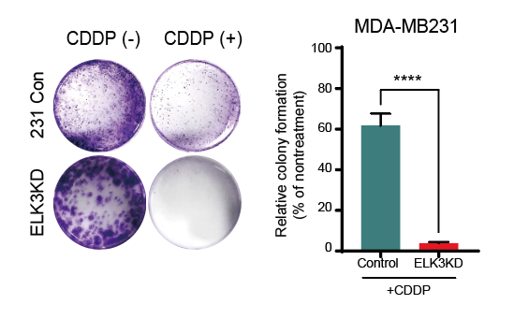
Supplementary Figure 1. The effect of ELK3 expression level on the capacity of MDA-MB231 cells to form colonies under conditions of prolonged CDDP treatment (Left) Representative image and (Right) a quantified bar graph displaying the colony formation rate of MDA-MB231 control cells (231 Con) and ELK3KD-231 cells (ELK3KD) following treatment with 5 µM of CDDP for a week. P-values were calculated using a two-tailed Student’s t-test. Data represent the mean ± SD. ****P < 0.0001

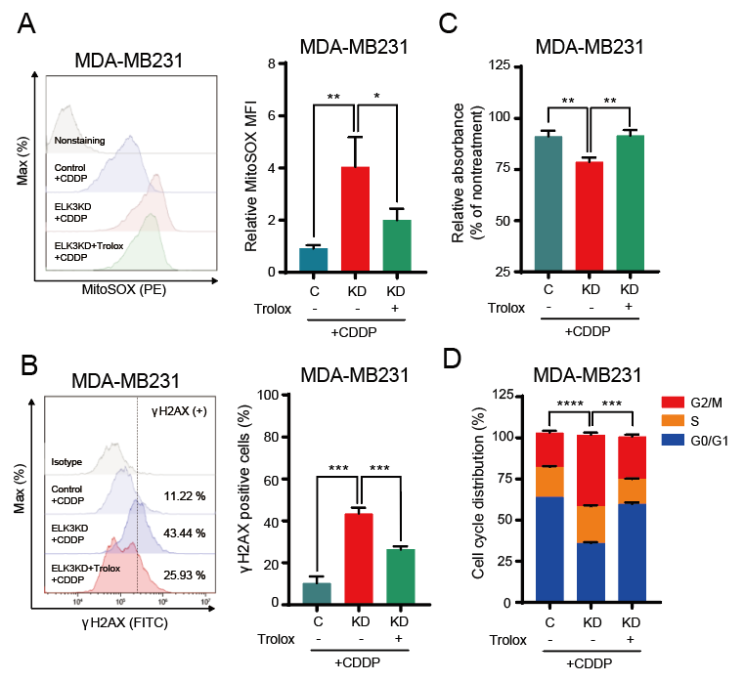
Supplementary Figure 2. Effect of Trolox on CDDP sensitivity of ELK3-depleted MDA-MB231 cells. (A) (left) Flow cytometry histogram and (right) corresponding bar graph of MitoSOX staining in MDA-MB231 control and ELK3KD-231 cells after treatment with 5 µM CDDP for 48 h, in the presence or absence of 50 µM Trolox, a ROS scavenger. (B) (left) Flow cytometric histogram and (right) the quantified data of γ-H2AX-positive cells in MDA-MB231 control and ELK3KD-231 cells after treatment with CDDP, in the presence or absence of Trolox. (C) Relative proportions of MDA-MB231 and ELK3KD-231 cells treated with CDDP, in the presence or absence of Trolox. (D) Cell cycle analysis of MDA-MB231 control and ELK3KD-231 cells after CDDP treatment, in the presence or absence of Trolox. Statistical analysis was performed by comparing the percent of cells in the G2/M phase. P-values were calculated using a two-tailed Student’s t-test (A–D). Data represent the mean ± SD. *P < 0.05, **P < 0.01, ***P <0.001, ****P < 0.0001.

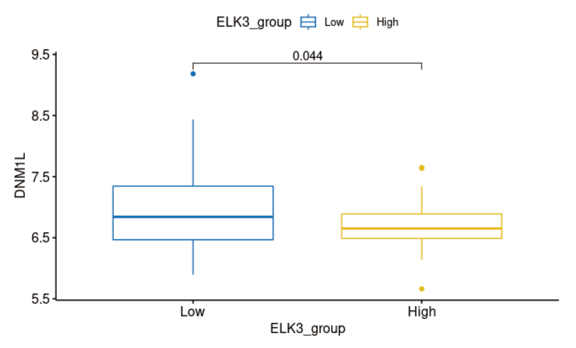
Supplementary Figure 3. DNM1L expression level according to ELK3 expression level in METABRIC TNBC patients. TNBC patients with ELK3 expression in the bottom 15 % were labeled as “ELK3^{low}” (n=36). Conversely, TNBC patients with ELK3 expression in the top 15% were labeled as “ELK3^{high}” (n=36). P-values were calculated using a Student’s t-test. Data represent the mean ± SD.

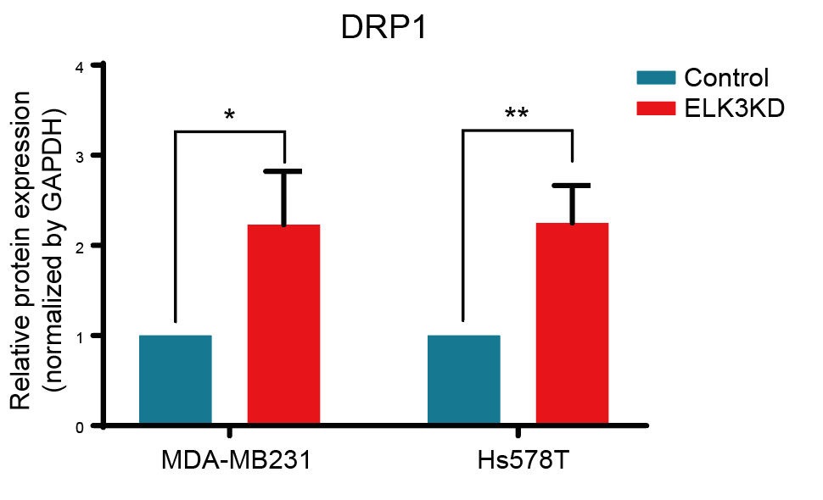
Supplementary Figure 4. DRP1 protein expression level in ELK3KD-TNBC cells. Immublot results of DRP1 expression level in Figure 3A were quantified by ImageJ software. P-values were calculated using a two-tailed Student’s t-test. Data represent the mean ± SD. *P < 0.05, **P < 0.01.

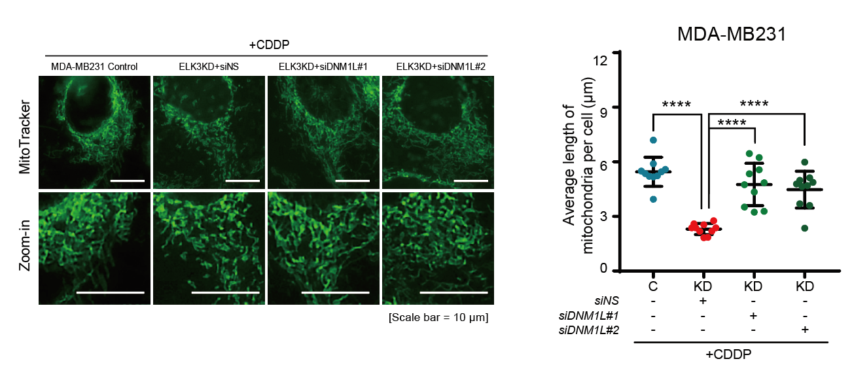
Supplementary Figure 5 The effect of siRNA-mediated DNM1L suppression on the mitochondrial length of ELK3KD-231 cells in the presence of CDDP. (left) Representative imaging results are presented on the left side, showing MitoTracker staining of mitochondria in MDA-MB231 control, ELK3KD-231, and ELK3KD-231 cells transfected with two siRNAs targeting DNM1L. Scale bar, 10 µm. The quantified data is displayed as a bar graph on the right side, indicating the average length of mitochondria per cell. The measurements were performed on 10 cells using ImageJ software. P-values were determined using a two-tailed Student’s t-test to assess statistical significance. Data represent the mean ± SD. ****P < 0.0001.

