Administration of AG490 decreases the senescence of Umbilical cord-Mesenchymal Stem Cells and promotes the cytotherapeutic effect in Liver fibrosis
Chenhao Jiang¹, Huaxin Chen², Yinqian Kang³, Xinyi He⁴, Jianyang Huang⁴, Tongyu Lu¹, Xin Sui⁵, Haitian Chen¹, Jiaqi Xiao¹, Jiebin Zhang¹, Hanwen Zhang⁶, Jun Zheng¹, Yang Yang¹, Jia Yao^{1*}, Jianye Cai^{1*}, Yingcai Zhang^{1*}
This file contains original WB blot bands in this research.

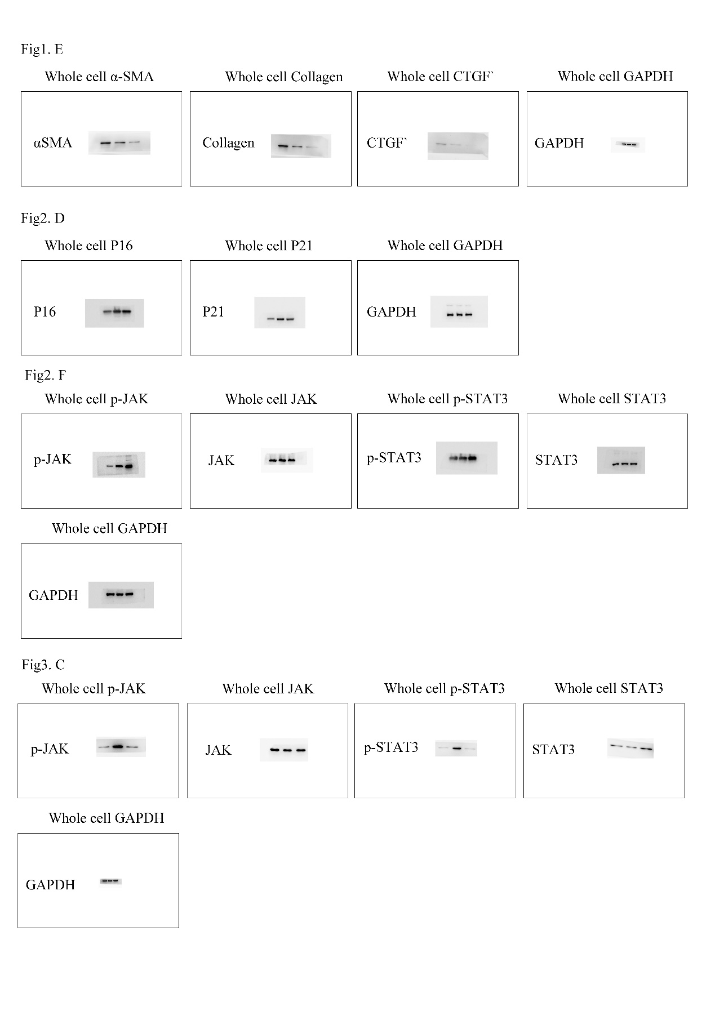
Original WB blot 1. Related to Figure 1E, Figure 2D and Figure 3C.
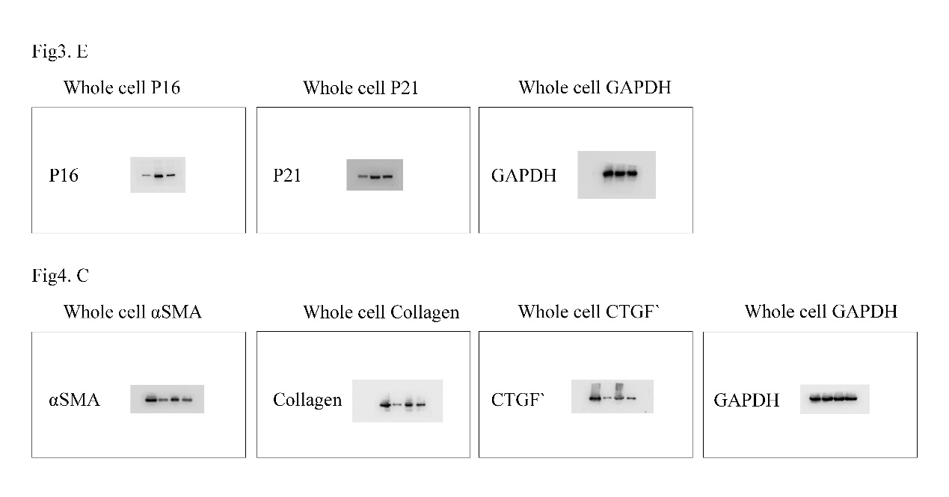
Original WB blot 2. Related to Figure 3E and Figure 4C.

