Supplementary figure
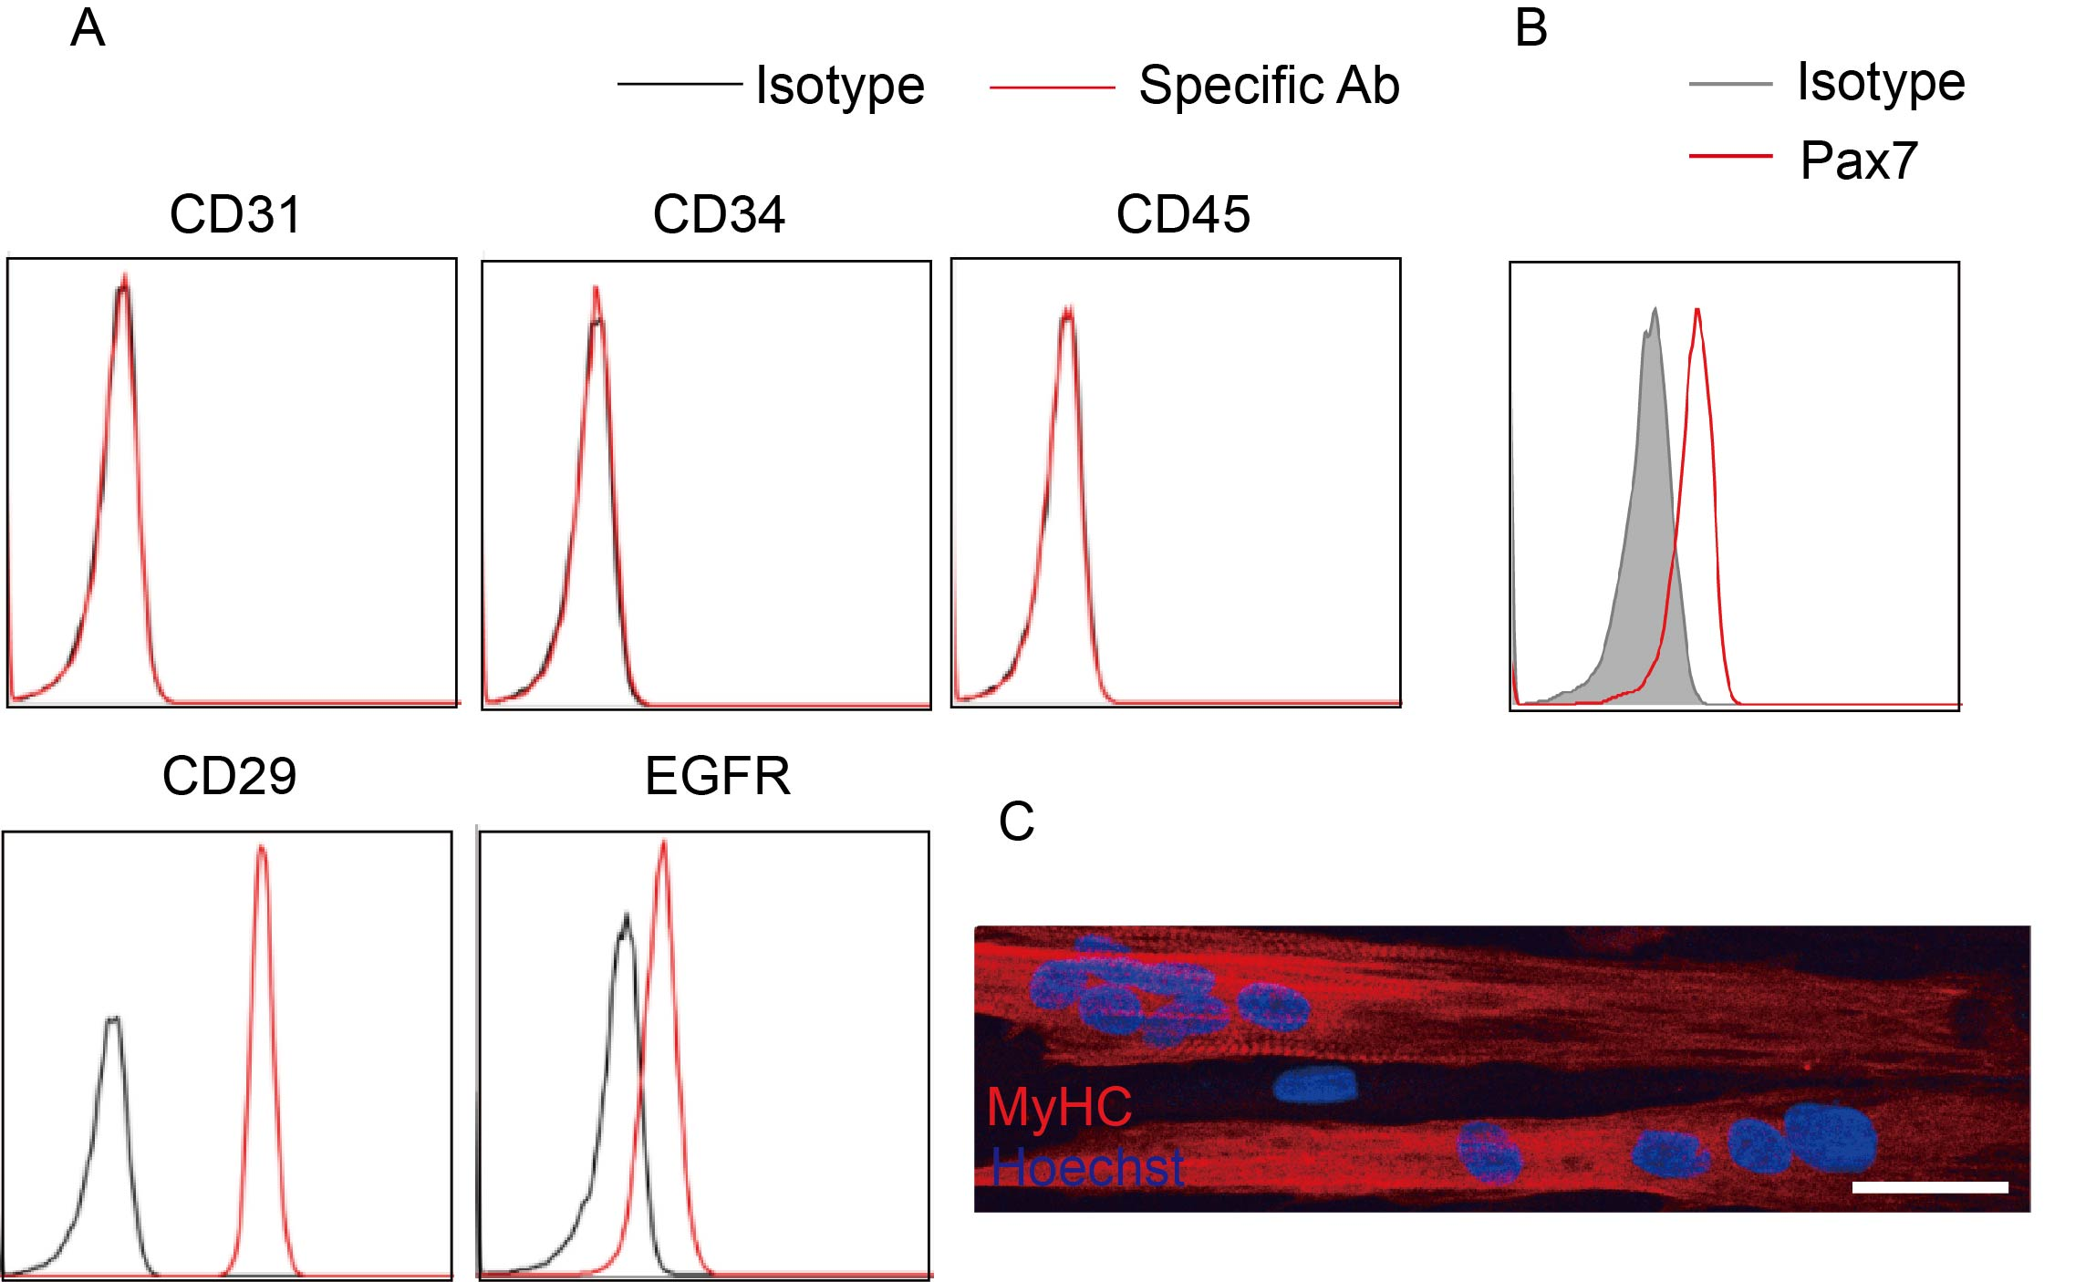
Fig. S1 Phenotypic characterization of MuSCs and their differentiation in vitro. A Characterization of cultured human MuSC surface markers by flow cytometric analysis. B Characterization of nuclear factor PAX7 in cultured human MuSCs by flow cytometric analysis. C Representative images of the differentiation potentials of cultured human MuSCs. Scale bar, 50 μm.

Fig. S2 The gating strategy for determination of the different cell populations in the BAL liquid, blood and lungs. A Debris and doublets were first excluded from the single cells, thereby yielding the living cell population as shown in the SSC vs. 7AAD plot. The total immune cell population was gated based on their high CD45 expression. Neutrophils were further gated based on their high Ly6G expression.

Supplementary table
Table S1 The primers for qRT-PCR
Gene | Classification of primers | Sequence (5’-3’)
IL4I1 | Forward primer | 5’-GCCAAGACCCCTTCGAGAAAT-3’
IL4I1 | Reverse primer | 5’-CCGATCCTGTTATCTGCCTCC-3’
TSG-6 | Forward primer | 5’-TTTCTCTTGCTATGGGAAGACAC-3’
TSG-6 | Reverse primer | 5’-GAGCTTGTATTTGCCAGACCG-3’
CYP1B1 | Forward primer | 5’-GCAAGGGCATGGGAATTGAC-3’
CYP1B1 | Reverse primer | 5’-GAGTCTCTTGGCGTCGTCAG-3’
β-ACTIN | Forward primer | 5’-TTGCCGACAGGATGCAGAAGGA-3’
β-ACTIN | Reverse primer | 5’-AGGTGGACAGCGAGGCCAGGAT-3’
Cxcl1 | Forward primer | 5’-CCCTCTCCTTCCTCATTCTTACA-3’
Cxcl1 | Reverse primer | 5’-AGTCTTGAAAGCCCATGTGAAA-3’
β-actin | Forward primer | 5’-GTGACGTTGACATCCGTAAAGA-3’
β-actin | Reverse primer | 5’-GCCGGACTCATCGTACTCC-3’
Ccl5 | Forward primer | 5’-GCTGCTTTGCCTACCTCTCC-3’
Ccl5 | Reverse primer | 5’-TCGAGTGACAAACACGACTGC-3’
Mcp1 | Forward primer | 5’-CTCCAAGCCAAAGTCCTTAGAG-3’
Mcp1 | Reverse primer | 5’-TCTCTCTTCCTCCACCACCATG-3’
Mcp1 | Reverse primer | 5’-GCGTTAACTGCATCTGGCTGA-3’
Nrf2 | Forward primer | 5’-GAAGCACGCTGAAGGCACAAT-3’
Nrf2 | Reverse primer | 5’-AGGGCCGTTCTGTTTGACAC-3’
Ho1 | Forward primer | 5’-AGGTACACATCCAAGCCGAGA-3’
Ho1 | Reverse primer | 5’-CATCACCAGCTTAAAGCCTTCT-3’

