Supplementary Figures and Tables
Supplementary Figures
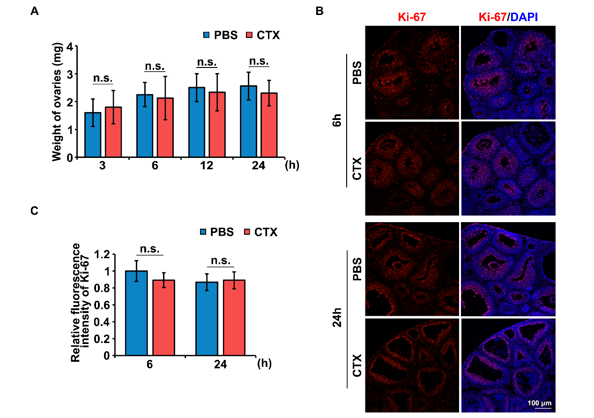
Fig. S1 The effect of CTX on weight of ovary and Ki-67. A Weight of the ovaries isolated from mice treated with or without CTX 24 h prior. Ovaries were collected at different time points after i.p. injection of PBS or CTX. N = 8 mice per time point for each group. B Immunofluorescence staining of ovarian sections 6 and 24 h after i.p. injection of PBS or CTX. Rabbit monoclonal antibody Ki-67 was detected using anti-rabbit IgG (red). Cell nuclei were labeled with DAPI (blue); scale bar, 100 μm; N = 6 ovaries from different mice per time point for each group. C Quantitative plots for fluorescence intensity of Ki-67. Statistical analyses were carried out using a two-tailed Student’s t-test; n.s.: non-significant; * P < 0.05; ** P < 0.01; and *** P < 0.001.

Supplementary Tables
Supplementary Table 1: Antibody information.
Protein name | Manufacture (catalogue number) | Applications (working dilution)
H3K27me3 | Cell Signaling (9733) | IF (1:200), WB (1:1000)
H2AK119ub1 | Cell Signaling (8240) | WB (1:1000)
H3K9me3 | Cell Signaling (5237) | IF (1:200), WB (1:1000)
H3K4me3 | Abcam (ab213224) | WB (1:1000)
Phospho-Histone H2A.X (Ser139) | Cell Signaling (9718) | WB (1:1000)
PARP | Cell Signaling (9532) | WB (1:1000)
Cleaved PARP | Cell Signaling (5625) | WB (1:1000)
BCL-2 | Cell Signaling (15071) | WB (1:1000)
Cleaved Caspase-3 (Asp175) | Cell Signaling (9661) | IF (1:200)
Ki-67 | Abcam (ab15580) | IF (1:200)
EZH2 | Cell Signaling (5246) | WB (1:1000)
SUZ12 | Cell Signaling (3737) | WB (1:1000)
H3 | Cell Signaling (9715) | WB (1:2000)
β-Actin | Sigma (F3165) | WB (1:5000);
α-Tubulin | Abcam (ab7291) | IF (1:1000)
β-tubulin | Cell Signaling (2125S) | WB (1:5000)
GAPDH | Proteintech (60004-1-Ig) | WB (1:5000)

Supplementary Table 2: Primer sequences for RT-qPCR.
Primer name | Target Gene | Sequences (5′-3′)
Ezh2-F | Ezh2 | 5’- CGAATAACAGTAGCAGACCCAG -3’
Ezh2-R | Ezh2 | 5’- TGTTTGACACCGAGAATTTGCTT -3’
Cdkn1a-F | Cdkn1a | 5’- CCTGGTGATGTCCGACCTG -3’
Cdkn1a-R | Cdkn1a | 5’- CCATGAGCGCATCGCAATC -3’
Eda2r-F | Eda2r | 5’- ATGAGGCTGAAAAGACAGTGG -3’
Eda2r-R | Eda2r | 5’- TCCAGGATGGAGTTAAGTGGTT -3’
Fas-F | Fas | 5’- TATCAAGGAGGCCCATTTTGC -3’
Fas-R | Fas | 5’- TGTTTCCACTTCTAAACCATGCT -3’
Ccng1-F | Ccng1 | 5’- ACAACTGACTCTCAGAAACTGC -3’
Ccng1-R | Ccng1 | 5’- CATTATCATGGGCCGACTCAAT -3’
Gadd45g-F | Gadd45g | 5’- GGGAAAGCACTGCACGAACT -3’
Gadd45g-R | Gadd45g | 5’- AGCACGCAAAAGGTCACATTG -3’
Alox5-F | Alox5 | 5’- ACTACATCTACCTCAGCCTCATT -3’
Alox5-R | Alox5 | 5’- GGTGACATCGTAGGAGTCCAC -3’
Egr4-F | Egr4 | 5’- TATCCTGGAGGCGACTTCTTG -3’
Egr4-R | Egr4 | 5’- AGATGCCAGACATGAGGTTGA -3’
Klf4-F | Klf4 | 5’- GTGCCCCGACTAACCGTTG -3’
Klf4-R | Klf4 | 5’- GTCGTTGAACTCCTCGGTCT -3’
Btg2-F | Btg2 | 5’- ATGAGCCACGGGAAGAGAAC -3’
Btg2-R | Btg2 | 5’- GCCCTACTGAAAACCTTGAGTC -3’
Actb-F | Actb | 5′- GCTCTTTTCCAGCCTTCCTT -3′
Actb-R | Actb | 5′- GTACTTGCGCTCAGGAGGAG -3′

