SUPPLEMENTARY FILES
TITLE
Differential Activation of Programmed Cell Death in Patients with Severe SARS-CoV-2 Infection
AUTHORS
Ashleigh N Riegler¹, Paul Benson², Kenneth Long³, Sixto M Leal Jr^{1*}

SUPPLEMENTARY TABLES AND LEGENDS
Supplementary Table S1: Antibodies and Dilutions
Antibody Target | Target Pathway | Manufacturer | Clone | Dilution | Conjugate
Phosphorylated MLKL (p Thr357) | Necroptosis | Novus (#954724) | 954724 | 1:200 | *see goat anti-mouse
CD71/Transferrin Receptor 1 | Ferroptosis | Sigma (MABC1765) | 3F3 FMA | 1:1,000 | *see goat anti-mouse
Cleaved Caspase 3 (Asp 175) | Apoptosis | Cell Signaling (9664T) | 5A1E | 1:500 | *see goat anti-rabbit
Cleaved Gasdermin D (Asp275) | Pyroptosis | Cell Signaling (NC1630035) | E7H9G | 1:500 | *see goat anti-rabbit
Nucleocapsid protein | SARS-CoV-2 | Abcam (ab281301) | HL5410 | 1:500 | *see goat anti-rabbit
Goat anti-mouse IgG2a, human adsorbed | N/A | Southern Biotech (OB108007) | *poly | 1:3,000 | Texas Red
Goat anti-Rabbit IgG(H+L), human adsorbed | N/A | Southern Biotech (OB405030) | *poly | 1:3,000 | AlexaFluor 488

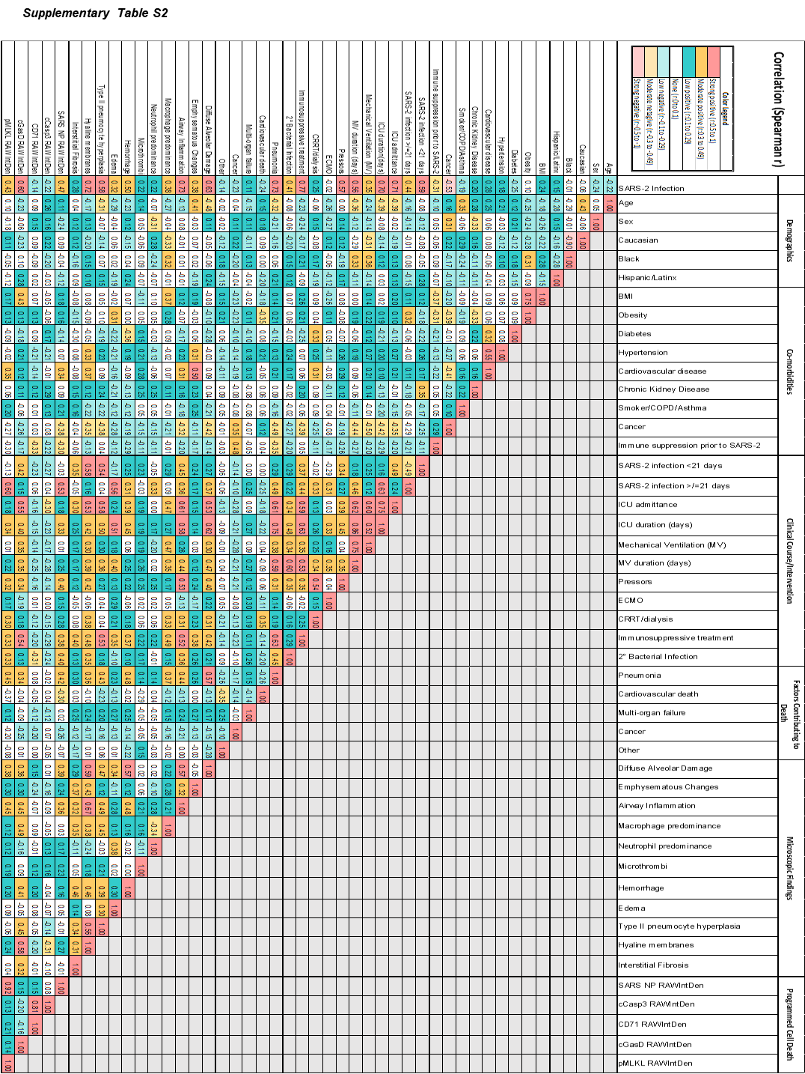
Supplementary Table S2: Correlation between patient characteristics and PCD. Spearman’s r resulting from correlation between listed characteristics and results. Color shading legend to indicate strength and directionality of correlation
Supplementary Table S3: Characteristics of patients that died from severe SARS-CoV-2 infection with high versus low viral burden
 | Low SARS-CoV-2 burden (n=19) |  | High SARS-CoV-2 burden (n=9) |  | p-value
Demographics
Age (years) | 51.9 | - | 61.2 | - |  | 0.21
Male | 11 | 58% | 6 | 67% |  | 0.65
Female | 8 | 42% | 3 | 33% |  | 0.65
Caucasian | 5 | 26% | 4 | 44% |  | 0.34
Black | 12 | 63% | 5 | 56% |  | 0.70
Hispanic/Latinx | 2 | 11% | 0 | 0% |  | 0.31
Co-morbidities
BMI | 35.7 | - | 37.7 | - |  | 0.80
Obesity | 14 | 74% | 6 | 67% |  | 0.70
Diabetes | 2 | 11% | 4 | 44% | * | 0.04
Hypertension | 10 | 53% | 4 | 44% |  | 0.69
Cardiovascular disease | 10 | 53% | 9 | 100% | * | 0.01
Chronic Kidney Disease | 3 | 16% | 4 | 44% |  | 0.10
Smoker/COPD/Asthma | 0 | 0% | 2 | 22% | * | 0.03
Cancer | 1 | 5% | 0 | 0% |  | 0.48
Immune suppression prior to SARS-CoV-2 | 1 | 5% | 0 | 0% |  | 0.48
Clinical Course/ Intervention
SARS-CoV-2 infection < 21 days | 13 | 68% | 3 | 33% | ~ | 0.08
SARS-CoV-2 infection >/= 21 days | 6 | 32% | 6 | 67% | ~ | 0.08
ICU admittance | 19 | 100% | 8 | 89% |  | 0.14
ICU duration (days) | 23.0 | - | 19 | - |  | 0.59
Mechanical Ventilation (MV) | 17 | 89% | 7 | 78% |  | 0.41
MV duration (days) | 20.0 | - | 16.9 | - |  | 0.68
Pressors | 14 | 74% | 9 | 100% |  | 0.09
ECMO | 4 | 21% | 2 | 22% |  | 0.94
CRRT/ dialysis | 8 | 42% | 6 | 67% |  | 0.22
Immune suppressants | 17 | 89% | 9 | 100% |  | 0.31
2° bacterial lung infection’ | 6 | 32% | 5 | 56% |  | 0.23
Factors Contributing to Death
Pneumonia | 14 | 74% | 8 | 89% |  | 0.36
Cardiovascular death | 8 | 42% | 2 | 22% |  | 0.31
Multi-organ failure | 1 | 5% | 0 | 0% |  | 0.48
Cancer | 0 | 0% | 0 | 0% |  | -
Other` | 5 | 26% | 2 | 22% |  | 0.82
Vaccination Status
Unvaccinated^ | 16 | 84% | 9 | 100% |  | 0.96
Unknown Status | 3 | 16% | 0 | 0% |  | 0.96
-ECMO- extracorporeal membrane oxygenation; CRRT- continuous renal replacement therapy
#ANOVA with Fisher's Least Significant Difference (LSD) test was used for continuous variables;Chi Square test was used for qualitative variables
’ 2° bacterial lung infection include 45.5% Gram negative bacteria (P.aeruginosa, S. maltophilia, K. pneumoniae, K. aerugenes, P. agglomerans, Achromobacter, Acinetobacter, and Enterobacter, ), 27.3% Gram positive pathogens (methicillin-sensitive or methicillin-resistant S. aureus), and 27.3% mixed infection with both Gram negative and Gram positive bacteria (MRSA with K. pneumoniae, MRSA with P. agglomerans, and S. aureus with E. cloaceae).
` Other factors contributing to death include: blunt force trauma, renal failure, cirrhosis, and sepsis
^Individuals that died prior to the availability of SARS-CoV-2 vaccines were considered unvaccinated

Supplementary Table S4: Microscopic findings in the lungs of patients that died from severe SARS-CoV-2 infection with high versus low viral burden
 | Low SARS-CoV-2 burden (n=19) |  |  | High SARS-CoV-2 burden (n=9) |  |  | p-value (Scores) |  | p-value  (# cases)
 | Cases | % | Score^ | Cases | % | Score^
Diffuse alveolar damage | 13 | 68% | - | 6 | 67% | - | - |  |  | 0.9260
Emphysematous Changes | 9 | 47% | 1.18 | 6 | 67% | 2.06 |  | 0.29 |  | 0.34
Airway inflammation | 19 | 100% | 2.87 | 9 | 100% | 3.00 |  | 0.88 | -
Macrophage-predominant^ | 12 | 63% | - | 6 | 67% | - | - |  |  | 0.18
Neutrophil-predominant^ | 2 | 11% | - | 2 | 22% | - | - |  |  | 0.41
Both^ | 5 | 26% | - | 1 | 11% | - | - |  |  | 0.36
Microthrombi | 1 | 5% | - | 3 | 33% | - | - |  | * | 0.047
Hemorrhage | 14 | 74% | 2.29 | 4 | 44% | 1.39 |  | 0.28 |  | 0.1315
Edema | 11 | 58% | 1.89 | 4 | 44% | 1.06 |  | 0.31 |  | 0.51
Type II pneumocyte hyperplasia | 18 | 95% | 3.13 | 4 | 44% | 3.44 |  | 0.71 | ** | 0.0025
Hyaline membranes | 17 | 89% | 2.61 | 7 | 78% | 2.06 |  | 0.51 |  | 0.41
Interstitial fibrosis | 10 | 53% | 1.50 | 4 | 44% | 1.33 |  | 0.84 |  | 0.40
^Severity was scored from H&E stained tissue sections on a scale from 0 (trace) to 4 (most severe).

SUPPLEMENTARY FIGURE AND LEGEND
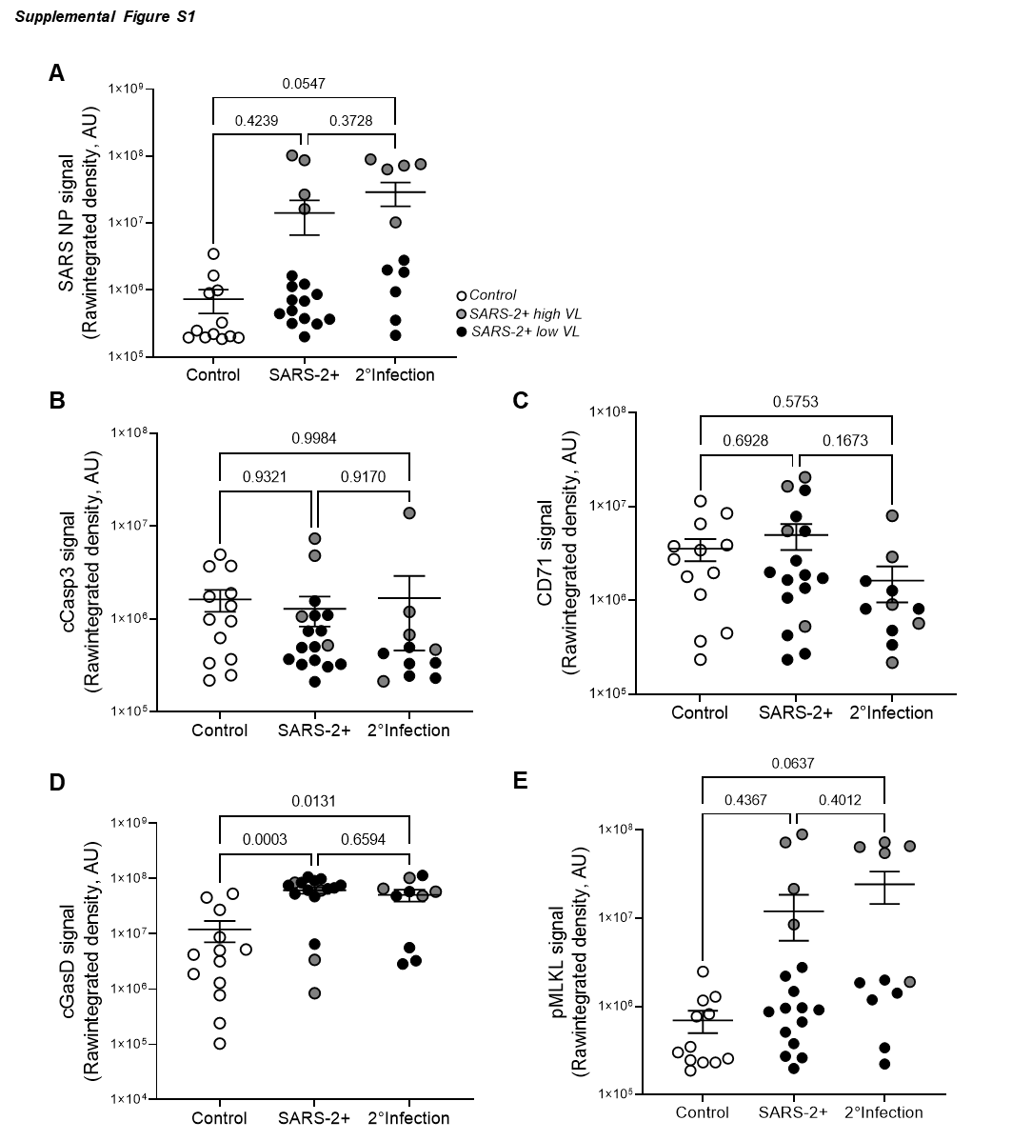
Supplementary Figure S1. Patients with SARS-CoV-2 infection and 2° bacterial pneumonia exhibit no change in the lung programmed cell death profile relative to SARS-CoV-2 only infection. Immunofluorescence staining was performed on FFPE lung tissues from patients that died from severe SARS-CoV-2 infection with (n= 11) or without (n=17) evidence of 2° bacterial respiratory tract infection. Quantification of raw integrated intensity shows no statistically significant difference in the following parameters: A. SARS-CoV-2 nucleoprotein (N protein), B. cleaved caspase-3 (cCasp3), C. transferrin receptor (CD71), D. cleaved gasdermin D (cGasD), and E. phosphorylated MLKL (pMLKL).

