Supplementary Figures
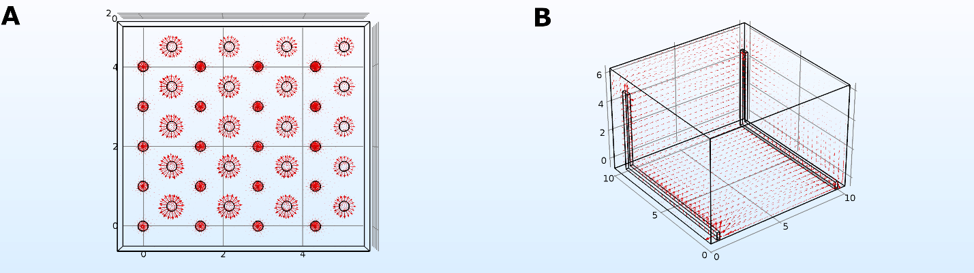
Supplementary Figure 1: Current density COMSOL Simulations. A: 8W10E+. B: Direct coupling setup example. Current is shown as red arrows proportional to the value. Arrows have been scaled for better visualization. Materials used are gold for the electrodes and DMEM (60ε, 0.5 S/m) for the environment.

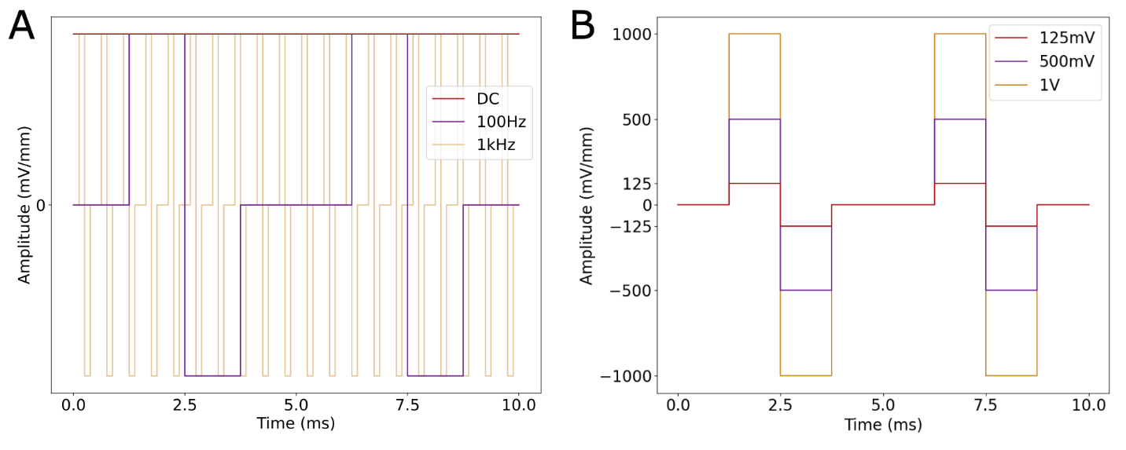
Supplementary Figure 2: A: Example of the electrical stimulation signals outputted by the ES system and applied to the culture. A: Three different frequencies: DC, 100Hz and 1kHz. B: Three different amplitudes: 125mV/mm, 500mV/mm and 1V/mm at 100Hz.

Primer Sequences
Primers used had the following specific primer pairs: from 5´to 3´:
Neurod1 forward: TCAGCATCAATGGCAACTTC and reverse: AAGATTGATCCGTGGCTTTG.
mMEIS1 forward: CTTTCCCAAAGTAGCCACCA and reverse TGTGCCAACTGCTTTTTCTG.
mRplp0 forward: CCAGGCTTTGGGCATCAC and reverse CTCGCTGGCTCCCACCTT.

