Supplementary Information: Original Western Blots
- β-Actin control blots were sometimes used for different figures since the same blots were used for detecting different specific factors. This is indicated in the respective blots.
- Lanes outside the frames were not used in this manuscript. These lanes represent different conditions and controls not used in this manuscript.
Figure 2D:
Lanes as described in Fig. 2D: Control | Pyr 0.35 | Pyr 0.5 | Thaps 50 | Thaps 50 + Pyr 0.35 | Thaps 50 + Pyr 0.5
 | p38 |  | phospho-p38
 | Original molecular weight ladder | Original chemiluminescent blot | Original molecular weight ladder | Original chemiluminecent blot
J 01.08.2023 | 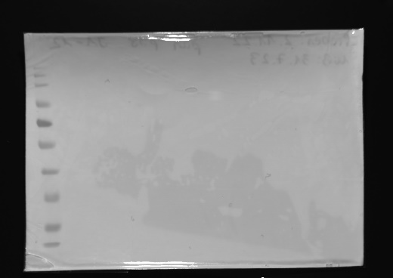 |  | 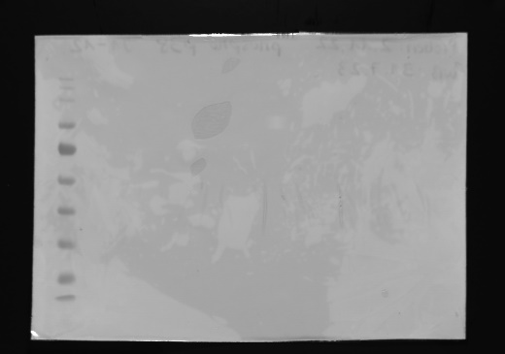
A 01.08.2023 | 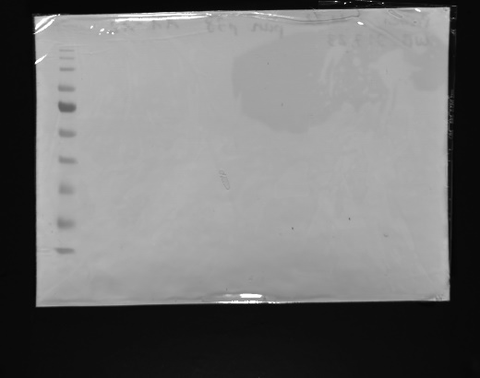 |  | 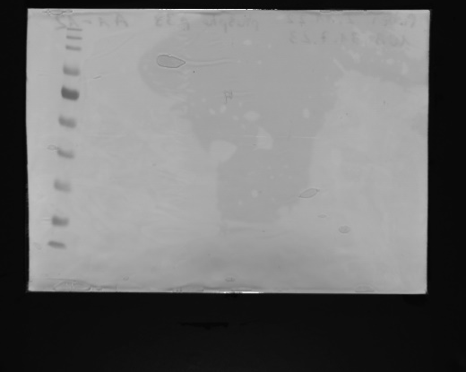
J 24.08.2023 | 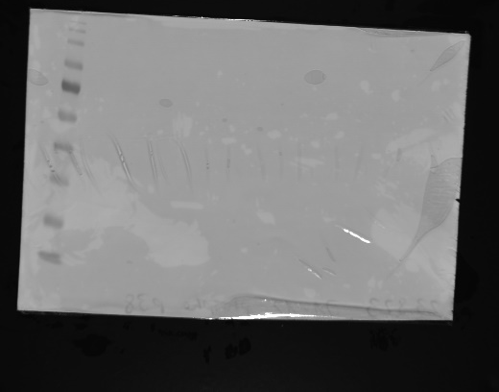 |  | 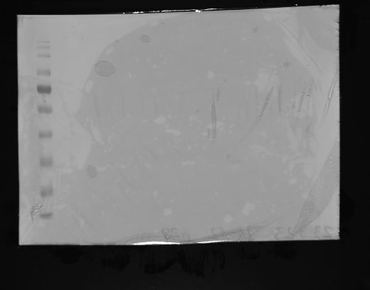
T 24.08.2024 | 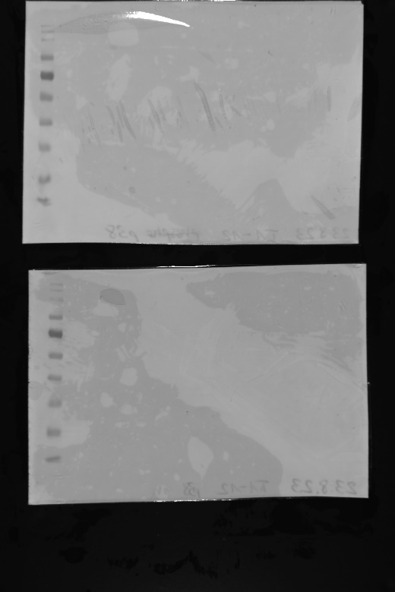
A 24.08.2024 | 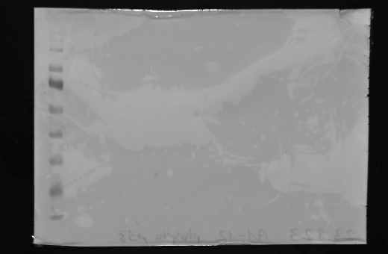 |  | 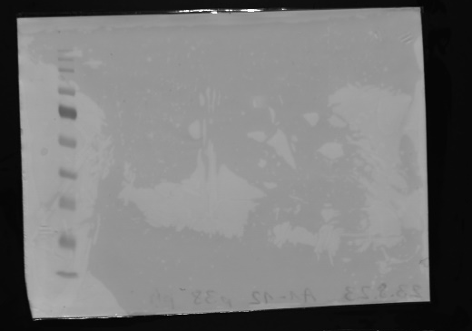

Figure 3D:
Lanes as described in Fig. 3D: Control | Pyr 0.35 | Pyr 0.5 | Thaps 50 | Thaps 50 + Pyr 0.35 | Thaps 50 + Pyr 0.5
 | β−Actin |  |  | T-bet
 | Original molecular weight ladder | Original chemiluminescent blot |  | Original molecular weight ladder | Original chemiluminecent blot
M 08.10.2021 | 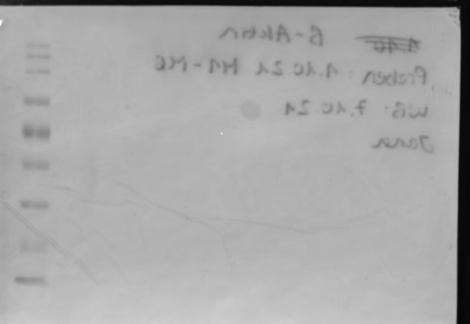 |  |  | 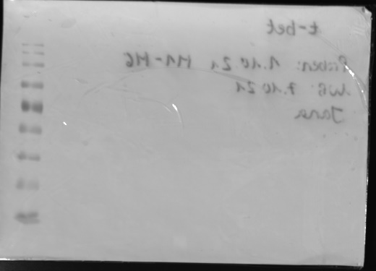
A 08.10.2021 | 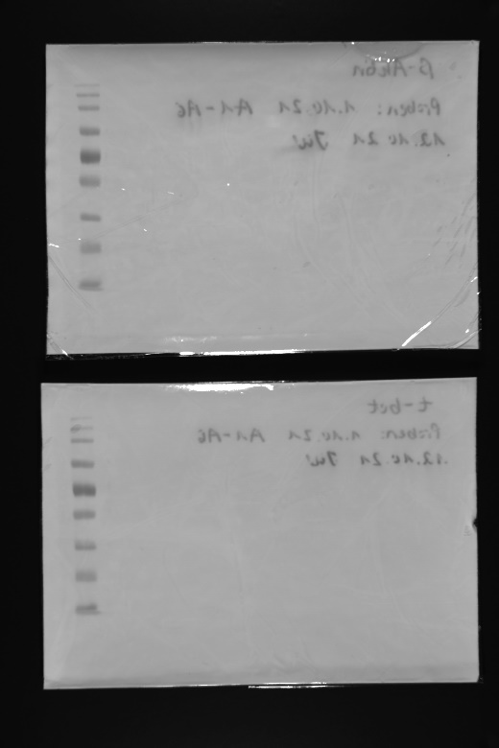
K 22.10.2021 | 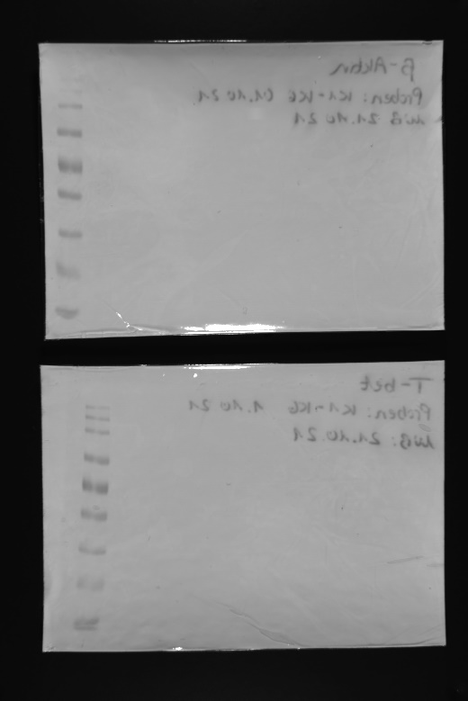
B 19.11.2021 | 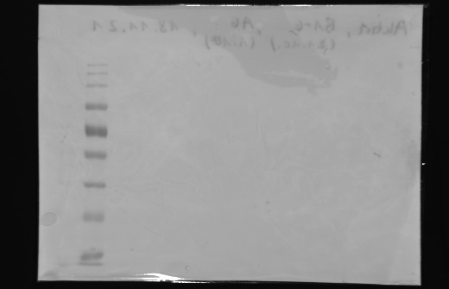 |  |  | 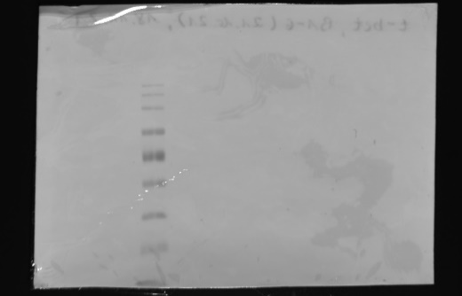
A 21.12.2021 | 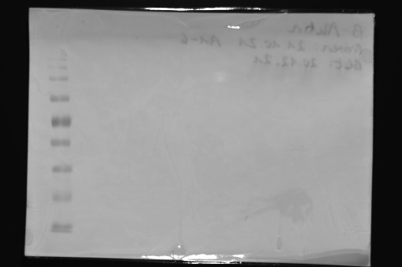 |  |  | 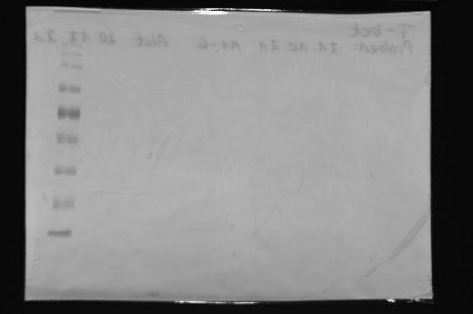
J 27.01.2022
S 27.01.2022 |  |  |  | 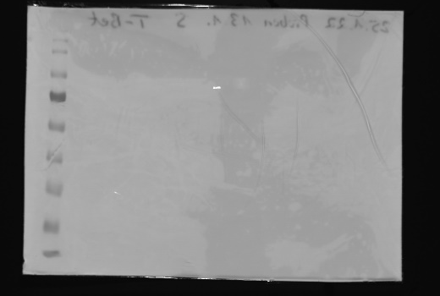
T 27.01.2022
E 25.02.2022 | Same blot as J 25.02.2022 | Same blot as J 25.02.2022 |  | Same blot as J 25.02.2022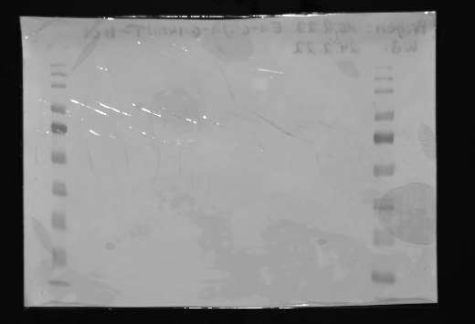 | Same blot as J 25.02.2022
J 25.02.2022 | Same blot as E 25.02.2022 | Same blot as E 25.02.2022 |  | Same blot as E 25.02.2022 | Same blot as E 25.02.2022
T 25.02.2022
A 10.01.2023 | 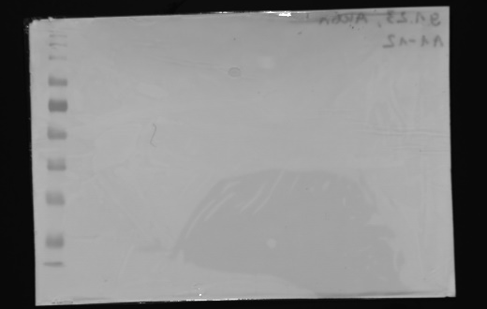 |  |  | 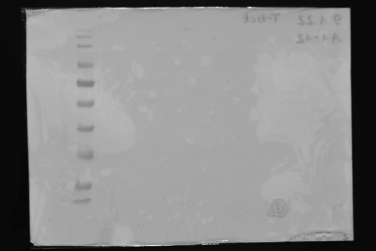
H 15.02.2023 | 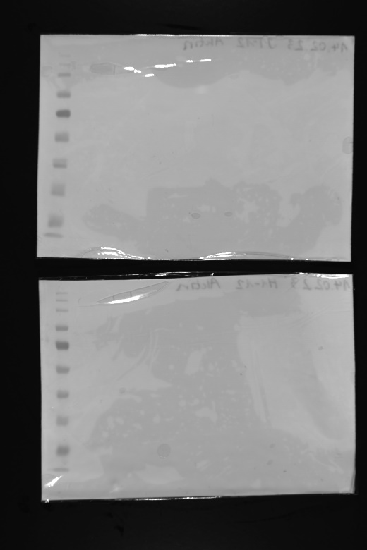 |  |  | 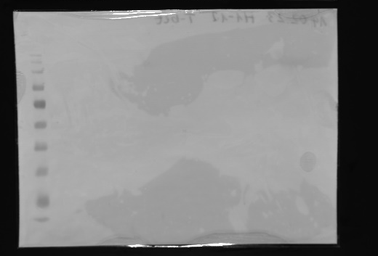
J 15.02.2023 |  |  |  | 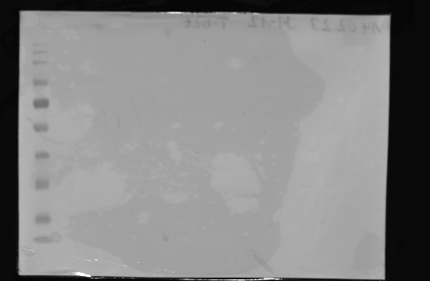

Fig 4 A:
Lanes as described in Fig. 4A:
Control (same blots and lanes as is Fig. 3D) | p38 inhibitor
Control | P0.35 | P0.5 | T50 | T50+P0.35 | T50 + P0.5 | Control | P0.35 | P0.5 | T50 | T50+P0.35 | T50 + P0.5

 | β−Actin |  |  | T-bet
 | Original molecular weight ladder | Original chemiluminescent blot |  | Original molecular weight ladder | Original chemiluminecent blot
J 27.01.2022
S 27.01.2022
T 27.01.2022
A 10.01.2023
H 15.02.2023
J 15.02.2023

Fig. 6 C and D:
Lanes as described in Fig. 6C and D: Control | Pyr 0.35 | Pyr 0.5 | Thaps 50 | Thaps 50 + Pyr 0.35 | Thaps 50 + Pyr 0.5
GATA-3 and RORC2 are normalized to β−Actin. The according β−Actin is shown in Fig. 3D!
 | GATA-3 (Fig. 6C) |  |  | RORC2 (Fig. 6D)
 | Original molecular weight ladder | Original chemiluminescent blot |  | Original molecular weight ladder | Original chemiluminecent blot
M 08.10.2021 |  |  |  | 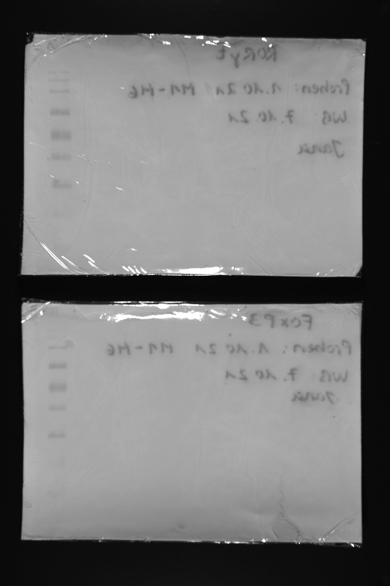
A 08.10.2021 |  |  |  | 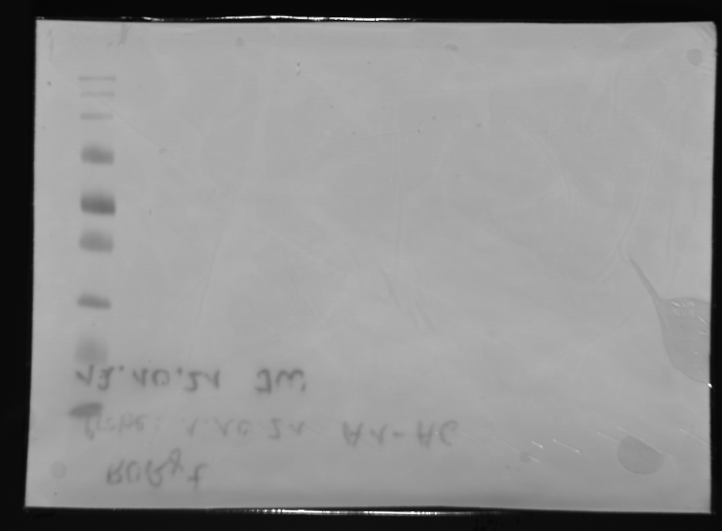
K 22.10.2021 | 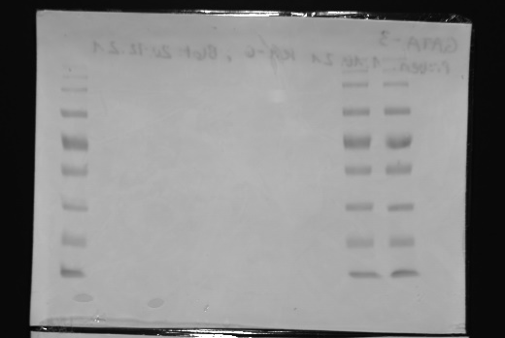 |  |  | 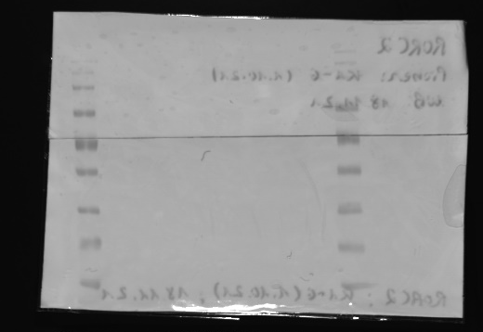
B 19.11.2021 | 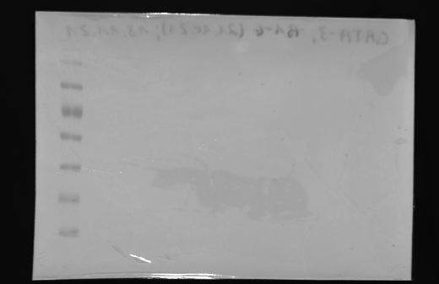 |  |  | 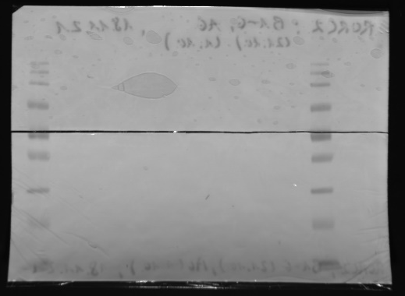
A 21.12.2021 | 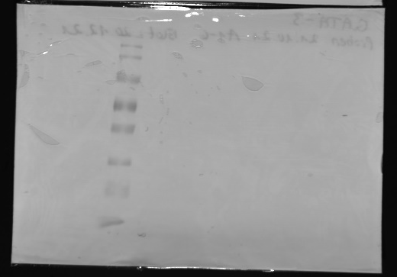

Fig. 7 A:
Lanes as described in Fig. 7 A: Control | Pyr 0.35 | Pyr 0.5 | Thaps 50 | Thaps 50 + Pyr 0.35 | Thaps 50 + Pyr 0.5
 | β−Actin |  |  | FoxP3
 | Original molecular weight ladder | Original chemiluminescent blot |  | Original molecular weight ladder | Original chemiluminecent blot
M 08.10.2021 | Same blot + lanes as in Fig. 3D | Same blot + lanes as in Fig. 3D
A 08.10.2021 | Same blot + lanes as in Fig. 3D | Same blot + lanes as in Fig. 3D |  | 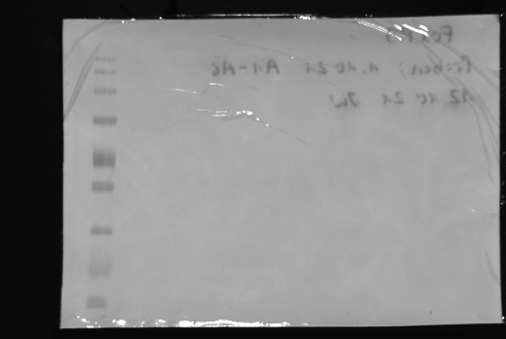
K 22.10.2021 | Same blot + lanes as in Fig. 3D | Same blot + lanes as in Fig. 3D |  | 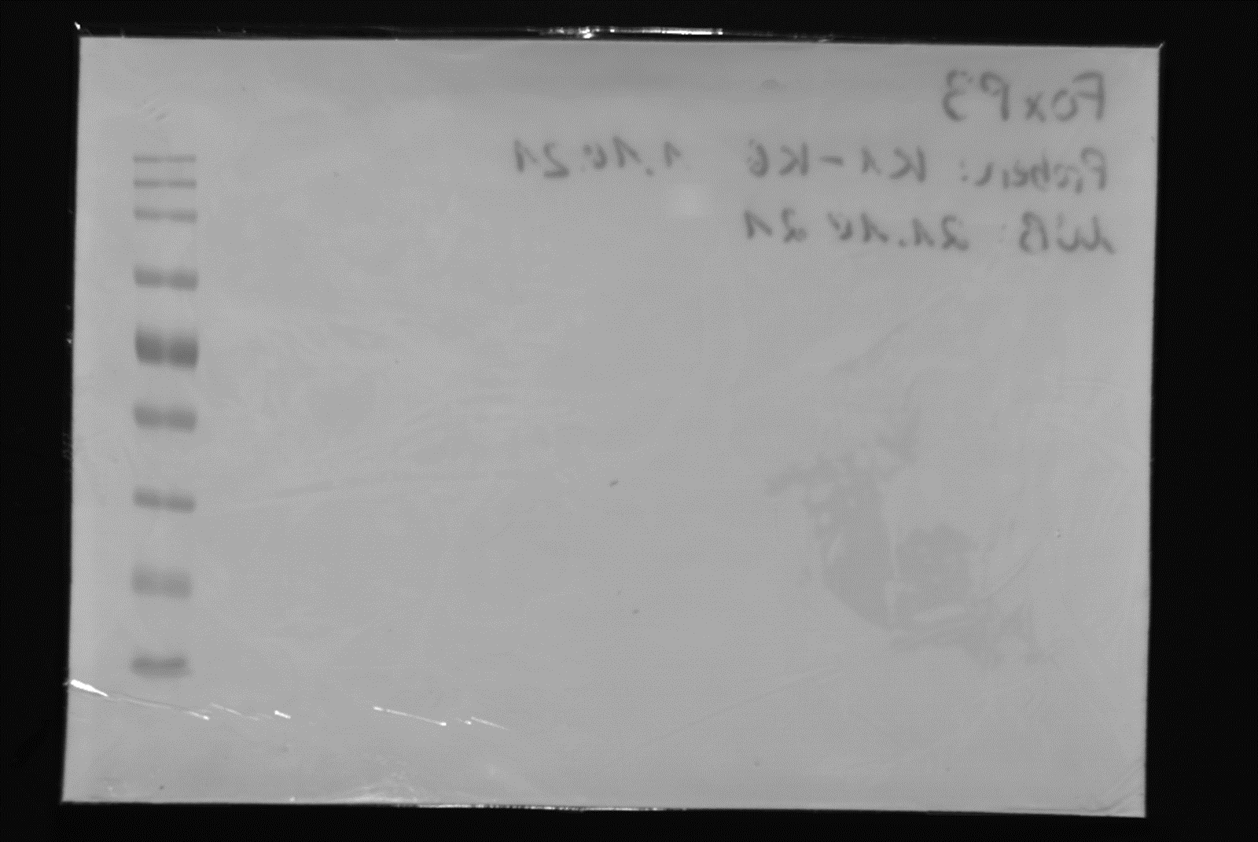 | 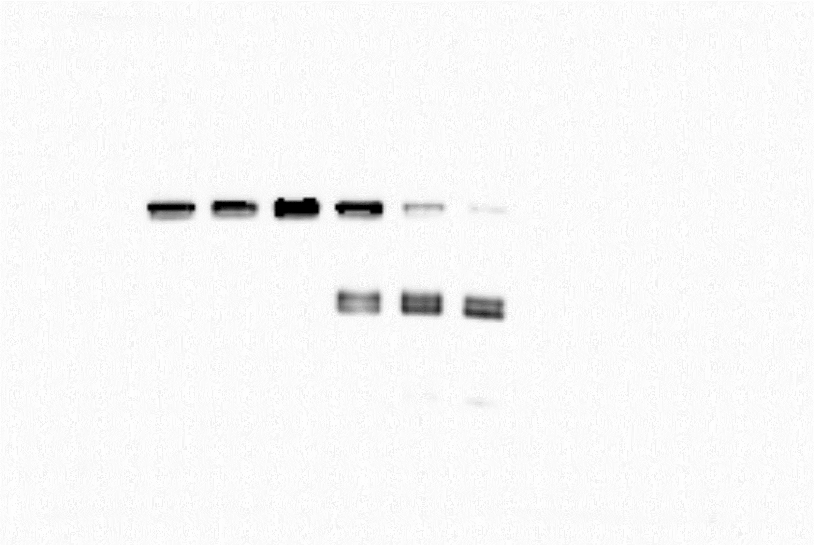
B 19.11.2021 | Same blot + lanes as in Fig. 3D | Same blot + lanes as in Fig. 3D
A 21.12.2021 | Same blot + lanes as in Fig. 3D | Same blot + lanes as in Fig. 3D
A 10.01.2023 | Same blot + lanes as in Fig. 3D | Same blot + lanes as in Fig. 3D |  | Same blot as W 10.01.2023 but  different lanes | Same blot as W 10.01.2023 but  different lanes
W 10.01.2023 | 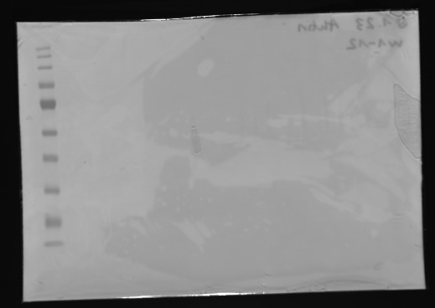 |  |  | Same blot as A 10.01.2023 but  different lanes | Same blot as A 10.01.2023 but  different lanes
H 15.02.2023 | Same blot + lanes as in Fig. 3D | Same blot + lanes as in Fig. 3D |  | Same blot as J 15.02.2023
J 15.02.2023 | Same blot + lanes as in Fig. 3D | Same blot + lanes as in Fig. 3D |  | Same blot as H 15.02.2023

Fig. 7 B:
Lanes as described in Fig. 7 B: Control | Chelex |Thaps 50 | Chelex + Thaps 50 |
 | β−Actin |  |  | FoxP3
 | Original molecular weight ladder | Original chemiluminescent blot |  | Original molecular weight ladder | Original chemiluminecent blot
A 15.07.2022 | Same blot as J 15.07.2022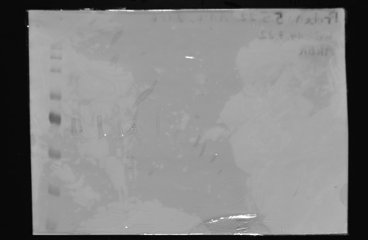 | Same blot as J 15.07.2022 |  | Same blot as J 15.07.2022 | Same blot as J 15.07.2022
J 15.07.2022 | Same blot as A 15.07.2022 | Same blot as A 15.07.2022 |  | Same blot as A 15.07.2022 | Same blot as A 15.07.2022
H 01.03.2023 | Same blot as J 01.03.2023 | Same blot as J 01.03.2023 |  | Same blot as J 01.03.2023 | Same blot as J 01.03.2023
J 01.03.2023 | Same blot as H 01.03.2023 | Same blot as H 01.03.2023 |  | Same blot as H 01.03.2023 | Same blot as H 01.03.2023
L 30.03.2023 | Same blot as F 30.03.2023 | Same blot as F 30.03.2023 |  | Same blot as F 30.03.2023 | Same blot as F 30.03.2023
F 30.03.2023 | Same blot as H 30.03.2023 | Same blot as H 30.03.2023 |  | Same blot as H 30.03.2023 | Same blot as H 30.03.2023

