Supplementary Figure
Enhancing Antitumor Efficacy of CLDN18.2-directed antibody-drug conjugates through Autophagy Inhibition in Gastric Cancer
Wenjing Xue^{1#}, Caili Xu^{1#}, Kaiqi Zhang^{2#}, Lu Cui², Xiting Huang¹, Yanyang Nan¹, Dianwen Ju¹*, Xusheng Chang²*, Xuyao Zhang¹*
¹Department of Biological Medicines & Shanghai Engineering Research Center of Immunotherapeutics, School of Pharmacy, Fudan University, Shanghai, 201203, China
²Department of Gastrointestinal Surgery, Changhai Hospital, Naval Medical University, Shanghai 200433, China
#These authors contributed equally to this work.
Running title: αCLDN18.2-MMAE and autophagy in gastric cancer
*Corresponding Author:
Dianwen Ju, dianwenju@fudan.edu.cn
Xusheng Chang, cxs20051014@163.com
Xuyao Zhang, xuyaozhang@fudan.edu.cn

Supplementary Figure 1.
Figure S1. Cytotoxicity of αCLDN18.2-MMAE on GES-1 cells. A. Flow cytometry analysis of CLDN18.2 expression in GES-1 cells. B. Cell viability of GES-1 was evaluated using the CCK-8 assay following exposure to increasing concentrations of αCLDN18.2-MMAE for 48h. Data were shown as mean ± S.D. (n = 3) and analyzed by two-tailed unpaired t-test (ns not significant).

Supplementary Figure 2.

Figure S2. related to Figure 3. MKN45-CLDN18.2 cells were treated with αCLDN18.2-MMAE or Rapamycin for 48h. Cyto-ID and Hoechst 33342 were utilized to stain autophagosomes (green fluorescence) and cell nucleus (blue fluorescence), respectively.

Supplementary Figure 3.
Figure S3. After treating MKN45-CLDN18.2 and SNU-601 cells with αCLDN18.2-MMAE (4 μg/mL) and either chloroquine (5 μM), 3-MA (0.125 mM), or hydroxychloroquine (0.5 μM for MKN45-CLDN18.2, 2.5 μM for SNU-601) for 48h, cell viability was evaluated using CCK-8 assay. Results were shown as mean ± S.D. (n = 3) and analyzed by two-tailed unpaired t-test (** P < 0.01).

Supplementary Figure 4.
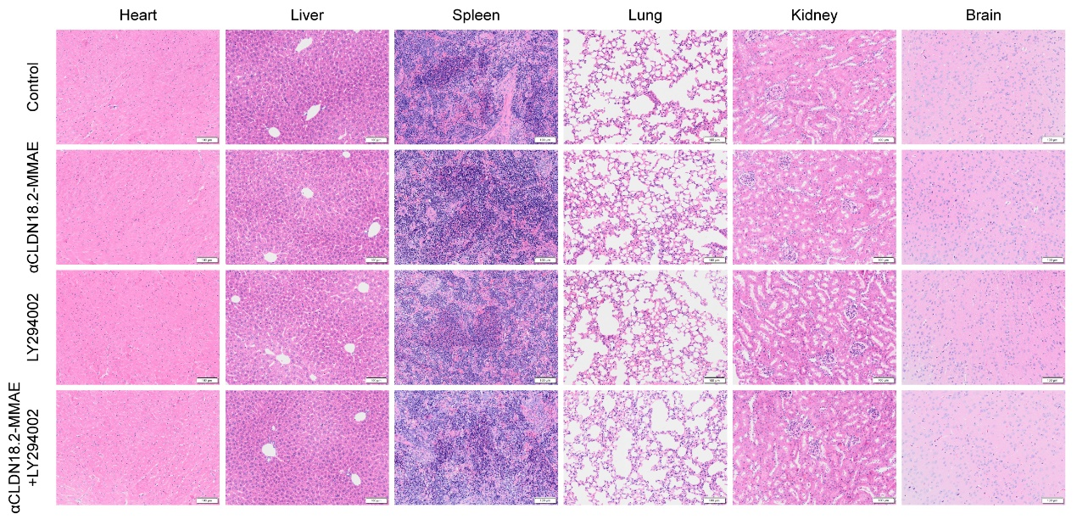
Figure S4. Representative H&E staining images of heart, liver, spleen, lung, kidney, and brain tissues from mice which were treated with PBS, αCLDN18.2-MMAE (2 mg/kg), LY294002 (50 mg/kg), or their combination twice a week for three weeks. Scale bar = 100 μm.

