Supplementary Information
Characterization of Regulated Cancer Cell Death Pathways Induced by the Different Modalities of Non-Thermal Plasma Treatment
Eline Biscop^{1,2*}, Jana Baroen^{1,2}, Joey De Backer³, Wim Vanden Berghe³, Evelien Smits², Annemie Bogaerts¹, Abraham Lin^{1,2}
¹PLASMANT, Department of Chemistry, University of Antwerp, Antwerp, Belgium
²Center for Oncological Research – Integrated Personalized & Precision Oncology Network (IPPON), University of Antwerp, Antwerp, Belgium
³Protein Chemistry, Proteomics, and Epigenetic Signaling, University of Antwerp, Antwerp, Belgium

*corresponding author email: eline.biscop@uantwerpen.be
*corresponding author email: abraham.lin@uantwerpen.be

1. Optimizing the PTL ratio for SK-MEL-28
During the cell death kinetics experiments, we noted that SK-MEL-28 exhibited greater resistance to NTP treatment, thus requiring a higher NTP dose for cytotoxicity induction compared to A375. We examined varying volumes of PTL in combination with 150 µL of cell culture medium, resulting in PTL:Medium ratios of 1:6, 2:7, 3:8, 4:9, and 1:2 (Figure S1). Among these, the 2:7 ratio displayed the most favorable dose-response pattern (Figure S1b), prompting us to select this condition, with the corresponding treatment times, for subsequent experiments.
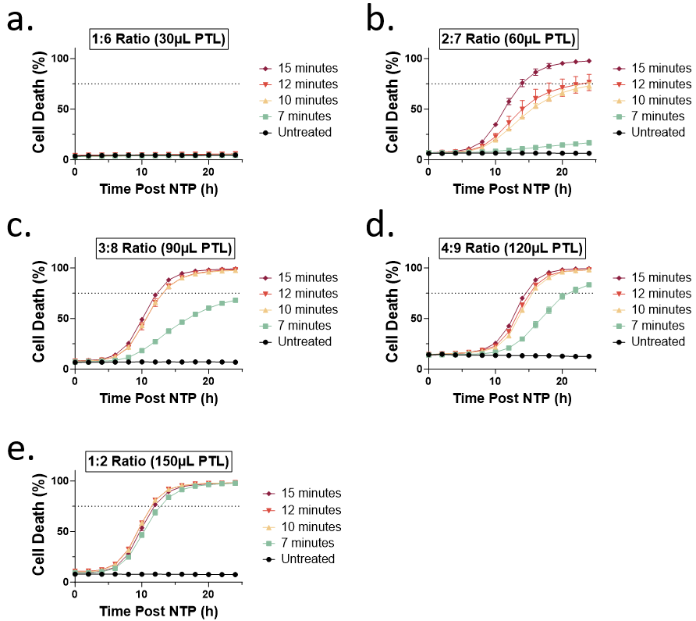
Figure S1 Percentage of cell death over time post NTP treatment of SK-MEL-28 for optimization of the PTL ratio for cell death kinetics experiments. PTL was added to the cells in a ratio of a 1:6, b 2:7, c 3:8, d 4:9, and e 1:2. The durations for which PBS was exposed to NTP are shown in the legend in minutes. The vehicle (untreated PBS) was defined as ‘Untreated’ in the legend.
2. Baseline MLKL expression in A375 and SK-MEL-28
Different response in MLKL phosphorylation was found in the 2 melanoma cell lines. To investigate these different responses, we evaluated the baseline expression of MLKL for both cell lines using western blotting. We observed that the A375 cells had a higher basal expression of MLKL compared to SK-MEL-28 cells (Figure S2a), which could contribute to the augmented MLKL phosphorylation expression following NTP treatment (Figure 5b). Therefore cell susceptibility to necroptosis could also be dependent on basal MLKL expression. The uncropped Western blots are also shown (Figure S2b-d).
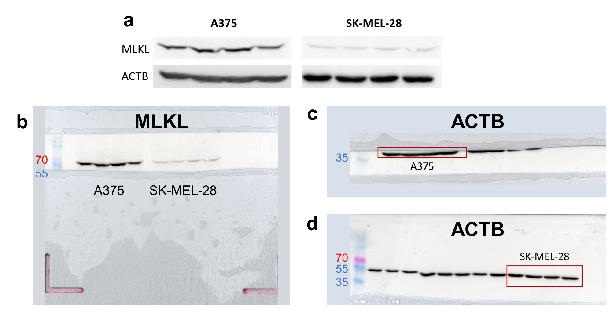
Figure S2 Western blots showing a difference in the basal expression of a MLKL for A375 and SK-MEL-28. The MLKL bands were normalized to the signal of their corresponding Actin B (ACTB) band. b-d Representative, uncropped Western blots are also shown. The size of protein marker bands are in kilodalton (kDa).

3. Uncropped Western blots for GPX4 and Actin B
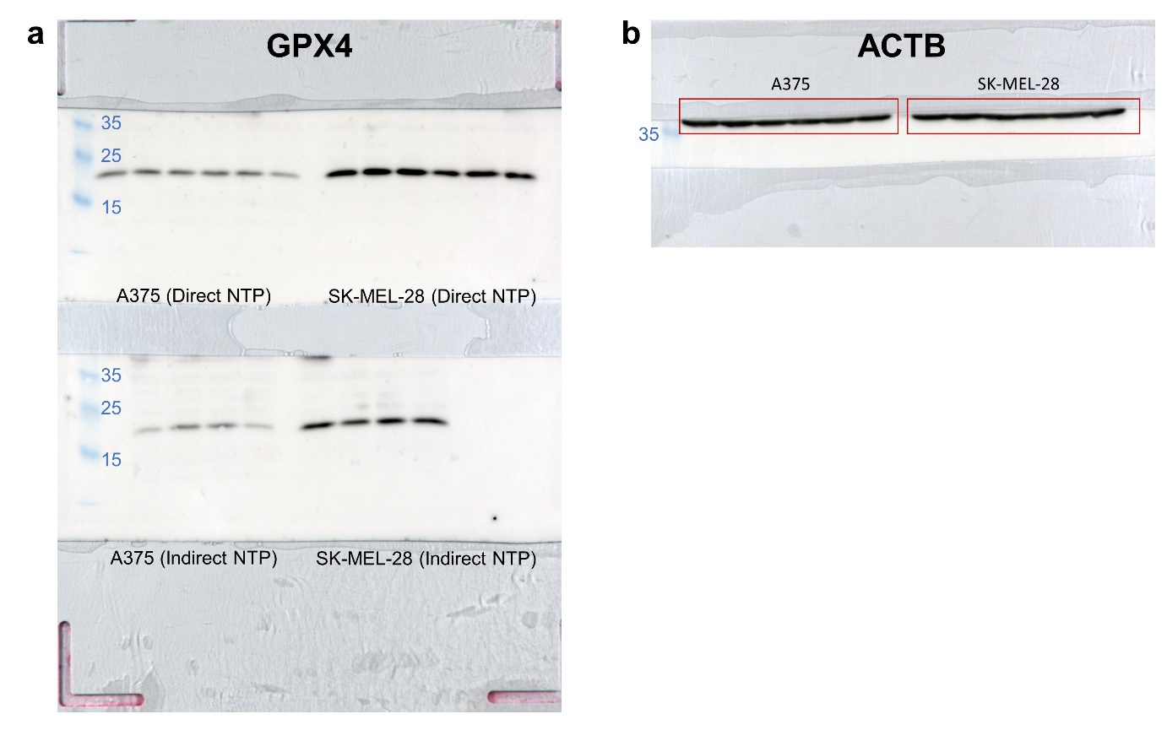
Figure S3 GPX4 was evaluated with Western blot analysis and a the original, uncropped blot of GPX4 used in Figure 6a and b is shown. b Representative Actin b blot shows equivalent loading. The size of protein marker bands are in kDa.
4. Caspase 3/7 positivity 48h after indirect NTP treatment
To follow up a possible delayed effect for the indirect NTP treatment regarding apoptosis induction, we examined the caspase 3/7 expression at 24 hours and 48 hours post NTP treatment. We observed that 48 hours post NTP treatment, caspase 3/7 positivity was indeed, increased in comparison to the expression at 24 hours after treatment (Figure S4).
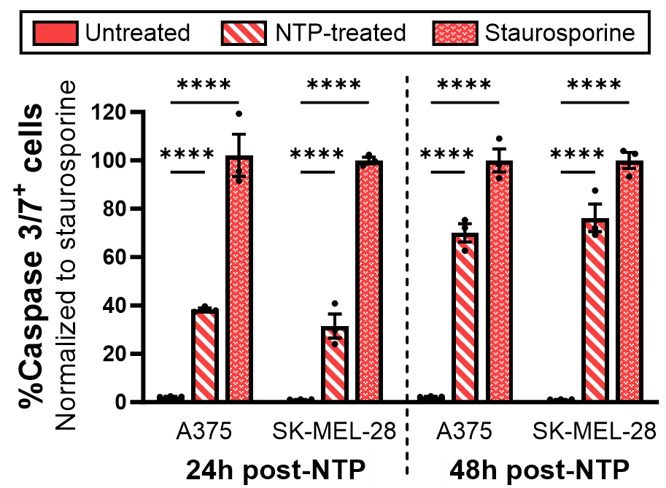
Figure S4 Percentage of caspase 3/7 positive cells following indirect NTP treatment. The experiment was performed in triplicate and the data is presented as mean ± SEM. Statistical significance was calculated using the generalized linear mixed model. **** p ≤ 0.0001.

