Figure 2
Deptor
GAPDH
Figure 3
C
Bax
Bcl-2
Caspase9
Cleved-caspase9
GAPDH
F.
Bax
Bcl-2
Caspase9
Cleved-caspase9
GAPDH
Figure 4
C
Bax
Bcl-2
Caspase9
Cleved-caspase9
GAPDH
F.

Bax
Bcl-2
Caspase9
Cleved-caspase9
GAPDH

Figure 5
A
p-4EBP1
4EBP1
p-mTOR
mTOR
GAPDH
C
P62
LC3
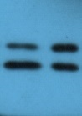
GAPDH
D
p-mTOR
mTOR
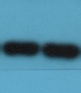
P62
LC3
GAPDH
F
p-mTOR
mTOR
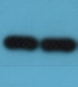
P62
LC3
GAPDH
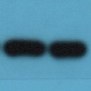

Figure 6
D
p-4EBP1
4EBP1
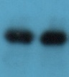
p-mTOR
mTOR
GAPDH
F.
P62
LC3
GAPDH
Figure 7
C
P62
LC3
GAPDH
G
P62
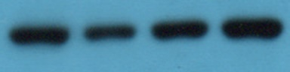
LC3
GAPDH

