TITLE: Molecular insight in advantages of anti-tumor tri-specific tribodies with respect to combinations of clinically validated immunomodulatory mAbs with conventional T-cell engagers

AUTHORS: Margherita Passariello^{1,2}, Lorenzo Manna^{1,2}, Rosa Rapuano Lembo^{2,3}, Asami Yoshioka⁴, Toshikazu Inoue⁴, Kentaro Kajiwara⁴, Shu‑ichi Hashimoto⁴, Koji Nakamura⁴ and Claudia De Lorenzo^{1,2}.

AFFILIATIONS:
¹ Department of Molecular Medicine and Medical Biotechnologies, University of Naples “Federico II”, 80131 Naples, Italy.
² Ceinge - Biotecnologie Avanzate S.C. a.R.L, via Gaetano Salvatore 486, 80145 Naples, Italy.
³ European School of Molecular Medicine, University of Milan, 20122 Milan, Italy
⁴ Chiome Bioscience Inc, 3‑12‑1 Honmachi Shibuya‑Ku, Tokyo 151‑0071, Japan. European School of Molecular Medicine, University of Milan, 20122 Milan, Italy

CORRESPONDING AUTHOR: Claudia De Lorenzo, email: cladelor@unina.it, tel.: +39-081-3737868.

Supplementary Figures and Legends
Supplementary Fig. 1 Fold increase of PD-L1 and 5T4 expression after IFNγ stimulation on tumor cells. Lung A-549, breast MDA-MB-231 and liver Li-7 cancer cells were stimulated with IFNγ used at the concentration of 10 ng/mL for 48 h and incubated at 37°C. Cell ELISA assays were performed to check the expression level of PD-L1 and 5T4 by using a commercial anti-PD-L1 or anti-5T4 antibody. Error bars depicted means ± SD.
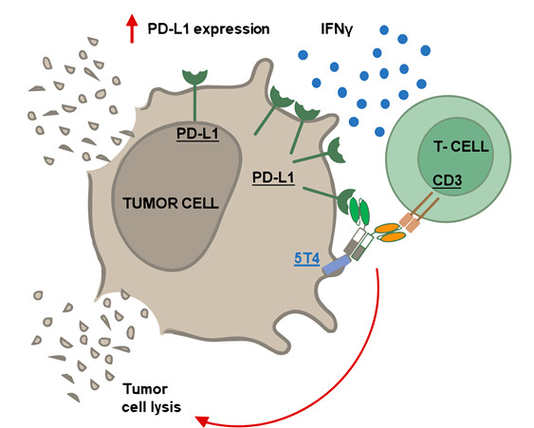

Supplementary Fig. 2 Model for the mechanism of action of anti-PD-L1 53L10 tri-specific tribody in tumor microenvironment. Release of IFNγ induced by T cell activation promotes an increase of PD-L1 expression which leads to stronger binding and inhibition of PD-L1/PD-1 interaction by 53L10.

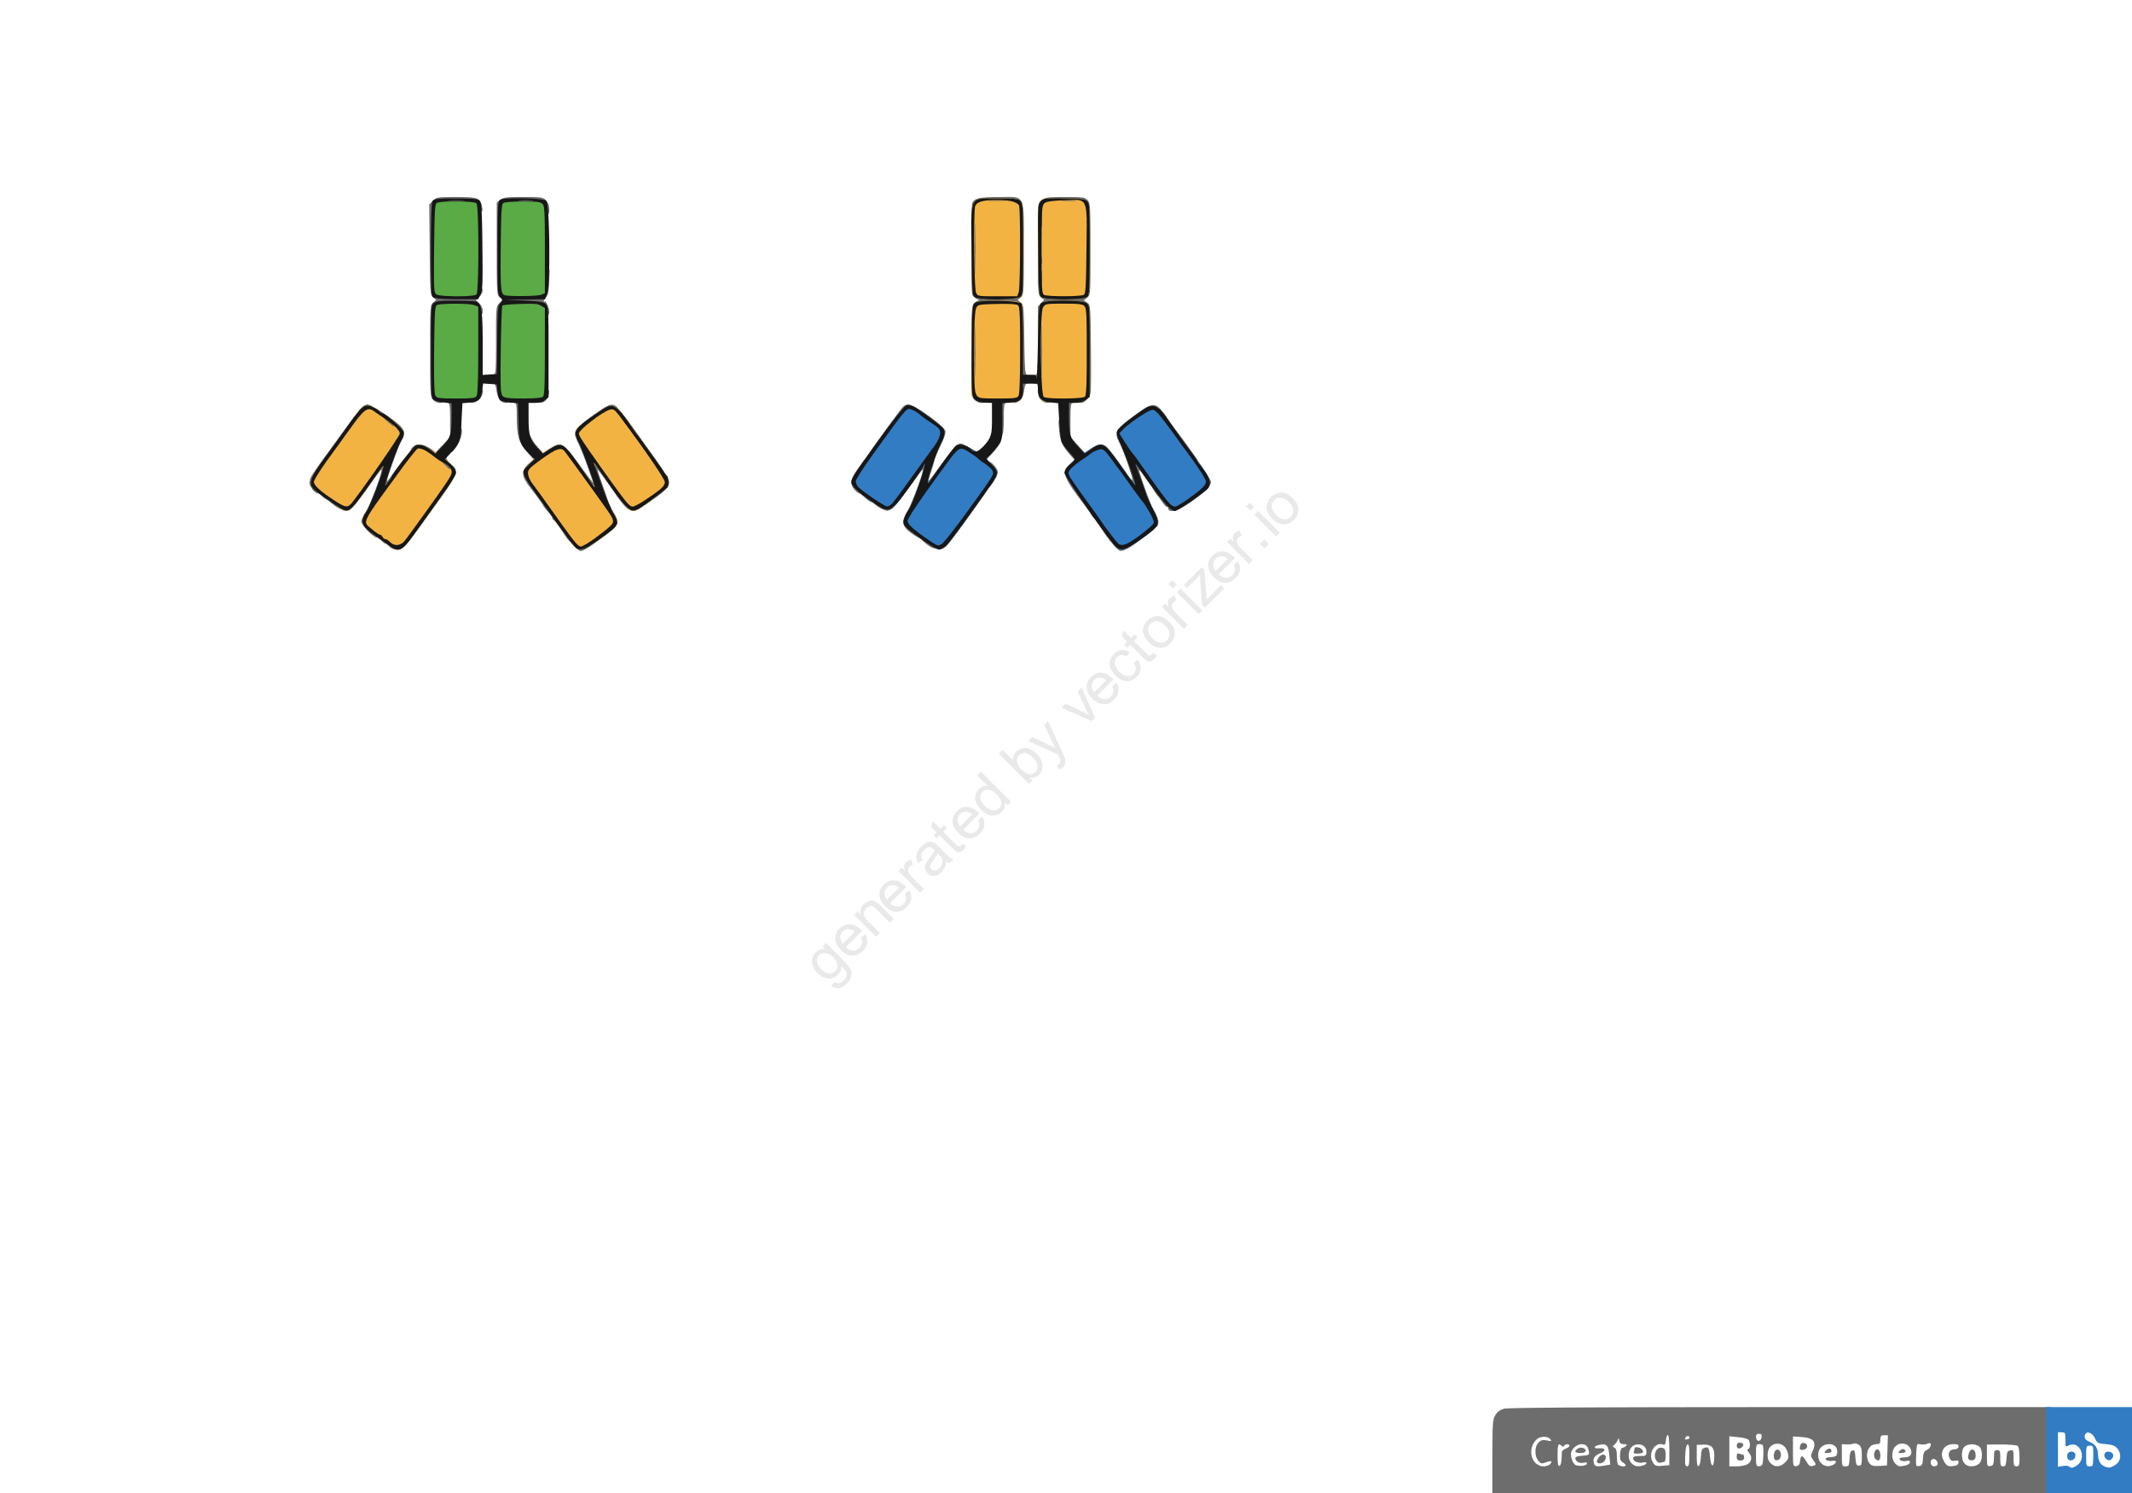
α-PD-L1 Fab
α-LAG-3 scFv
α-LAG-3 scFv
TR0304
α-PD-1 scFv
α-PD-1 scFv
α-LAG-3 Fab
TR0506

Supplementary Fig. 3 Graphical representation of the bi-specific tribodies 0304 and 0506.
The bi-specific TR0304 (left) and TR0506 (right) contain two scFvs, targeting LAG-3 or PD-1 respectively, genetically fused with a Fab specific for PD-L1 or LAG-3.

