Supplementary File

Western blot files for Figure 5B – full length uncropped western blot files
The membrane was scanned using an Odyssey CLx Imager (LI-COR Biosciences, Lincoln, NE) and normalized to the density of α-tubulin in the corresponding samples. Chameleon Duo Pre-stained Protein Ladder (LI-COR) was used as the ladder. Red is alpha-tubulin (DyLight 680). Green is anti-rabbit.

Antibody, species | Company | Catalog
Bax, rabbit | Cell Signaling Technology, Danvers, MA | 2772
Bak, rabbit | Cell Signaling Technology | 12105
Alpha-tubulin, mouse | Abcam, Cambridge, UK | ab7291
anti-rabbit IgG, goat; DyLight 800 | Invitrogen/Thermo | SA5-10036
anti-mouse IgG, goat; DyLight 680 | Invitrogen/Thermo | 35518

Columns (from left to right): ladder, SCR KO (scramble), BAX KO, BAK KO, BAX/BAK KO, ladder
Red bands only with exposure to see DyLight680 (excitation/emission max 676/705nm)
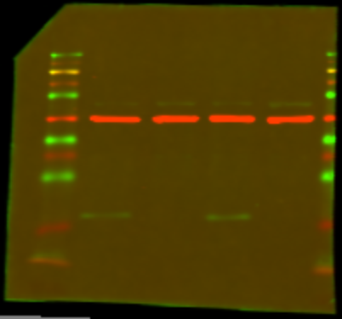
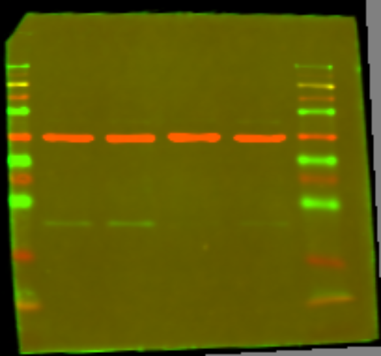
Green bands only with exposure to see DyLight800 (excitation/emission max 789/794nm)
BAX blot
BAK blot

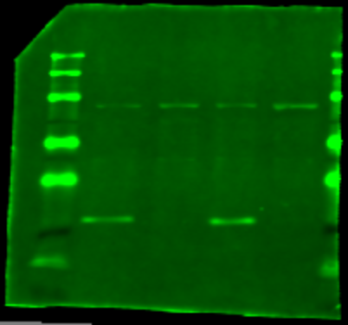
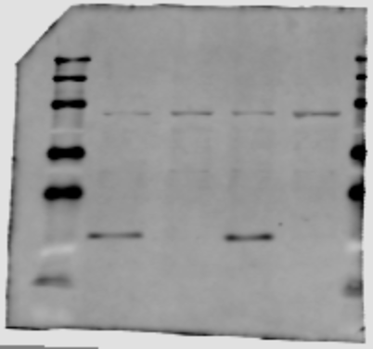
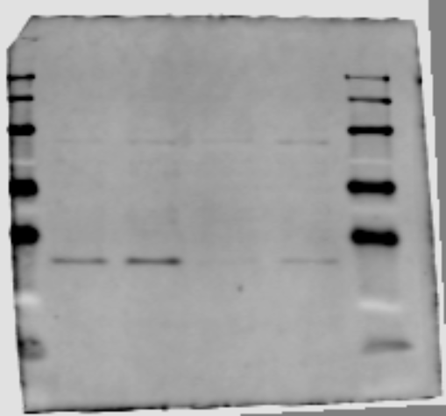
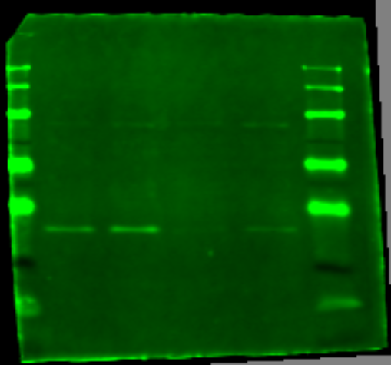
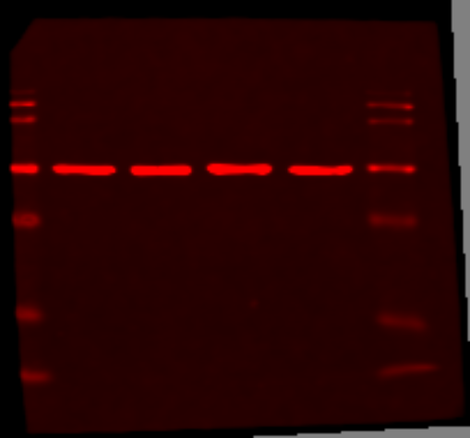
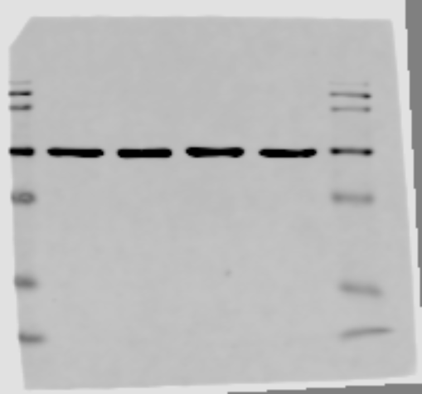
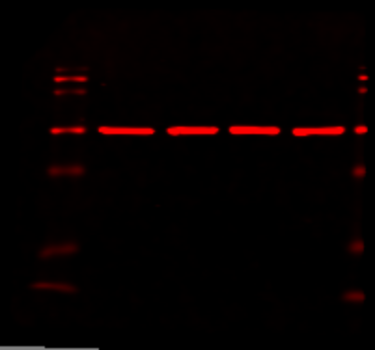
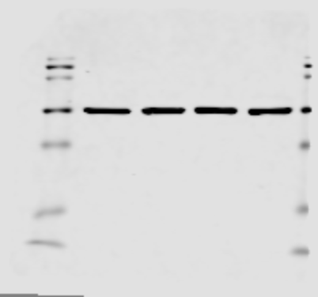
Green bands only
Green bands only
Red bands only
Red bands only
Western blot files for Supplementary Figure 4E – full length uncropped western blot files
The membrane was scanned using an Odyssey CLx Imager (LI-COR Biosciences, Lincoln, NE) and normalized to the density of α-tubulin in the corresponding samples. Chameleon Duo Pre-stained Protein Ladder (LI-COR) was used as the ladder. Red is alpha-tubulin (DyLight 680). Green is anti-rabbit.

Antibody, species | Company | Catalog
Bid, rabbit | Cell Signaling Technology | 2002
Alpha-tubulin, mouse | Abcam, Cambridge, UK | ab7291
anti-rabbit IgG, goat; DyLight 800 | Invitrogen/Thermo | SA5-10036
anti-mouse IgG, goat; DyLight 680 | Invitrogen/Thermo | 35518

Columns (from left to right): ladder, SCR KO OCI-AML2 (scramble), additional/noncontributory cell lysate, BID KO OCI-AML2, ladder
Red bands only with exposure to see DyLight680 (excitation/emission max 676/705nm)
Green bands only with exposure to see DyLight800 (excitation/emission max 789/794nm)

BID blot
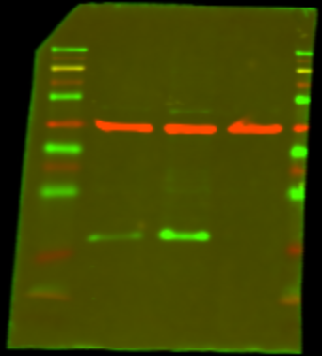

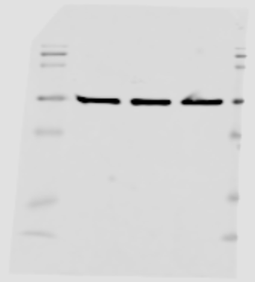
Red bands only
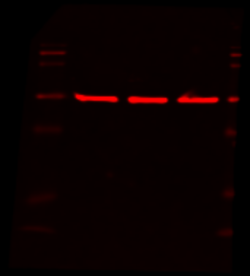

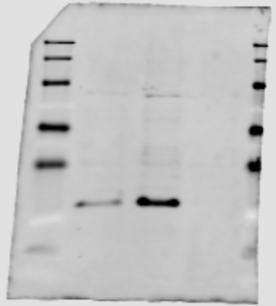
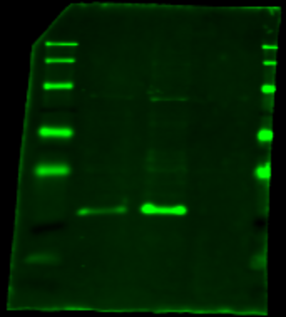
Green bands only

