Figure. S1 GO analysis of the RNA sequencing data between sh-NC and sh-MGP groups. n= 3 per group.
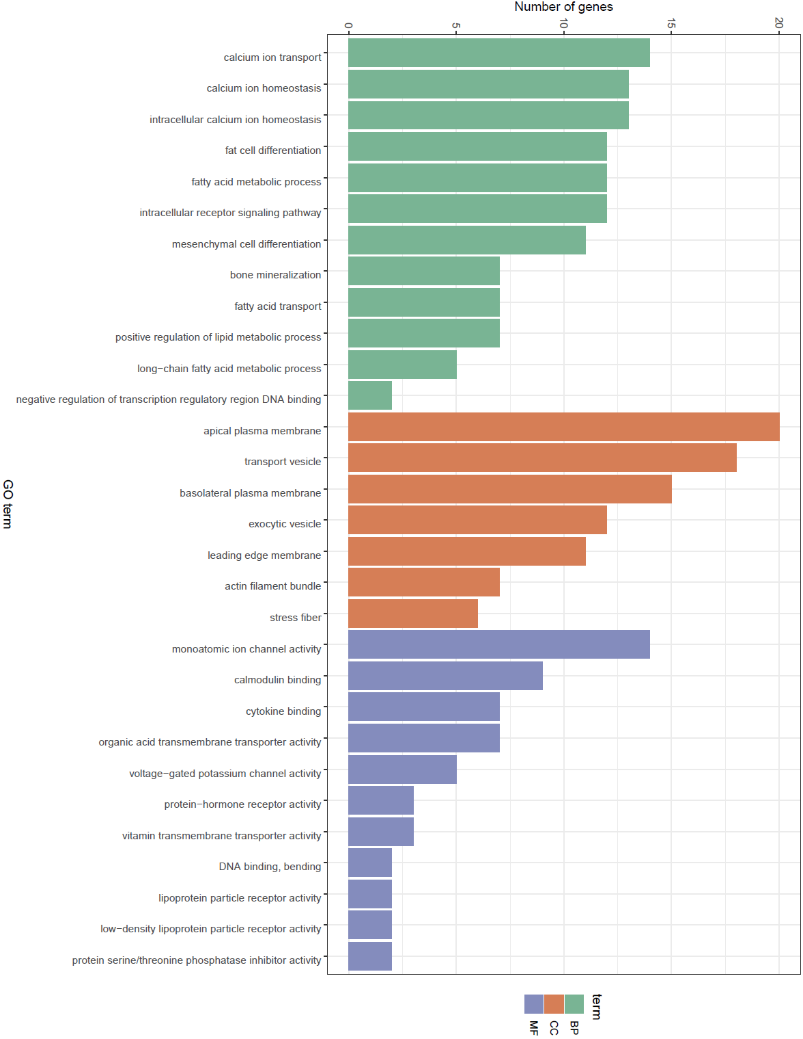

Figure. S2 KEGG pathway analysis between sh-NC and sh-MGP groups. n= 3 per group.

Figure. S3 The relative RNA expression of RIP140 levels was determined via qRT–
PCR are shown along with the concentration gradient of KN93. All the data are presented as the means ± SDs; n= 6 per group. ANOVA was used to determine significant differences. ns, not statistically significant.
Figure. S4 Serum OCN and PINP bone formation marker levels measured by ELISA. The data are presented as the means ± SDs; n= 6 per group. ANOVA was used to determine significant differences. ns, not statistically significant; *P < 0.05; **P < 0.01.

