TIPE3 promotes drug resistance in colorectal cancer by enhancing autophagy via the USP19/Beclin1 pathway
Chun Chen^{1,2*}, Longyang Jin^{2*}, Hong Wan⁴, Hu Liu⁴, Shuping Zhang⁵, Gang Shen^{6&}, Jiao Gong^{6&}, Yong Zhu^{3,4&}

Supplementary results

Supplementary Figure S1. Kaplan Meir curve for patients with colorectal cancer.

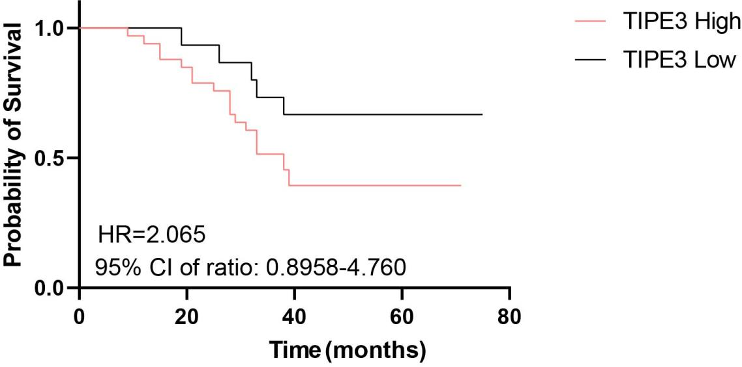

Supplementary Figure S2. TIPE3 promotes cell proliferation and inhibits apoptosis of CRC cells. (A) Western blot analysis of TIPE3 protein expression in SW480 and LoVo cells.

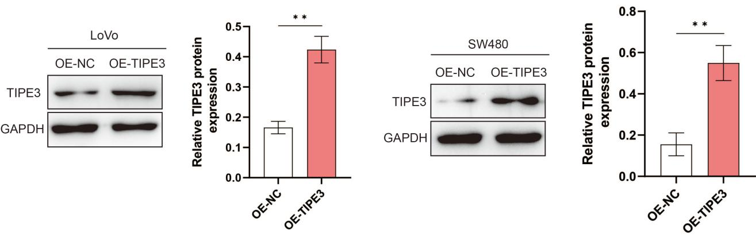

Supplementary Table 1. Primer sequence of qPCR.

Primer | Primer sequence |  | Length of product/bp
Primer | Forward sequence (5’-3’) | Reverse sequence (5’-3’) | Length of product/bp
TIPE3 | CCGCAGCATGGATTCGGATT | GTTGGCCACAGTTTTGCTGG | 145
CD206 | GCAAAAAGGGCAACACCACT | TTCCTTCCTGCAGGTGGTCA | 164
Arg1 | GAGTCATCTGGGTGGATGCT | CAGGGAGTCACCCAGGAGAA | 148
β-actin | CAGGGAGTCACCCAGGAGAA | CAGGGAGTCACCCAGGAGAA | 136

Supplementary Table 2 Association between TIPE3 expression in CRC tissues and clinical features of patients
Clinicopathological | case | TIPE3 expression
 |  | High | Low
Ages
60 or Less | 22 | 14 | 8
>60 | 26 | 19 | 7
Gender
Males | 30 | 20 | 10
Females | 18 | 13 | 5
Differentiation
Moderate | 37 | 24 | 13
Poor | 11 | 9 | 2
metastasis
No | 31 | 22 | 9
N1 or more | 17 | 11 | 6

