Supplementary Tables and Supplementary Figures for

Salmonella typhimurium co-expressing cytolysin A and hyaluronidase
suppresses tumor growth and metastasis

Khuynh Van Nguyen et al.

*Corresponding author:

Jung-Joon Min (jjmin@jnu.ac.kr)
Yeongjin Hong (yjhong@chonnam.ac.kr)

Supplementary tables
Table S1. Antibodies used for the study
Antibody name | Company | Catalog No. | Application
Anti-DnaK | Enzo Life Sciences | ADI-SPA-880D | WB
Alexa Fluor™ 555 anti-rabbit | Invitrogen | A-31572 | IF
Anti-CD44 | Abcam | Ab157107 | WB
Anti-CD44 antibody PE | BioLegend | 103024 | Flow
Anti-E-cadherin | Cell Signaling | 3195S | WB
Anti-E-cadherin Alexa Fluor® 488 | Cell Signaling | 3199S | Flow
Anti-Flag tag | Abcam | Ab1162 | WB
Anti-HAS2 | Santa Cruz | Sc-514737 | WB
Anti-HMGB1 | Abcam | Ab18256 | WB
Anti-LC3B | Novus Biologicals | NB600-1384 | WB
Anti-Myc tag | Abcam | Ab9132 | WB
Anti-RSK1 | Cell Signaling | 9333S | WB
Anti-RSK2 | Cell Signaling | 5528S | WB
Anti-Salmonella | Abcam | Ab35156 | IF
Anti-vimentin (V9) | Santa Cruz | Sc-6260 | WB
Anti-vimentin (V9) Alexa Fluor® 647 | Santa Cruz | Sc-6260 AF647 | Flow
FAM-FLICA® Caspase-1 (YVAD) Assay Kit | Immunochemistry | 97 | Flow
FAM-FLICA® Caspase-3/7 Assay Kit | Immunochemistry | 93 | Flow
FITC Annexin V Apoptosis Detection Kit I | BD Biosciences | 556547 | Flow
Goat anti-Rabbit IgG (H+L) secondary antibody, HRP | Invitrogen | 31460 | WB
Human/Mouse Phospho-RSK1 (S221)/RSK2 (S227) Antibody | R&D Systems | MAB892-SP | WB
Hyaluronic Acid Binding Protein−Biotin bovine (bHABP) | Sigma-Aldrich | H9910 | IF, IHC
Streptavidin-PE | Vectorlabs | SA-5207-1 | IF
LIVE/DEAD™ Fixable Aqua Dead Cell Stain Kit | Invitrogen | L34957 | Flow
Pacific Blue CD45 Ab | Biolegend | 103126 | Flow
APC/Cy7 anti-mouse CD11b Ab | Biolegend | 101226 | Flow
PerCP/Cy5.5 anti-mouse MHC-II Ab | Biolegend | 107626 | Flow
PE/Cy7 anti-mouse CD11c Ab | Biolegend | 117318 | Flow
FITC anti-CD3 monoclonal Ab | eBioscience™ | 11-0038-42 | Flow
PE anti-mouse CD4 Ab | Biolegend | 100511 | Flow
BV605 anti-mouse CD8a Ab | Biolegend | 100744 | Flow
BV650 anti-mouse CD44 Ab | Biolegend | 103049 | Flow
APC/Cy7 anti-mouse IFN-γ Ab | Biolegend | 505850 | Flow
Alexa Fluor 700 anti-mouse CD62L Ab | Biolegend | 104426 | Flow

Supplementary figures
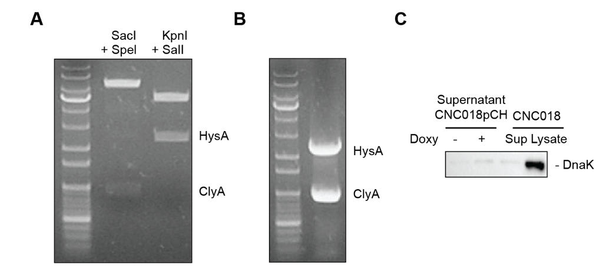
Figure S1. Functional characterization of CNC018pCH bacteria.
(A) Restriction mapping of pCH. The plasmid was digested with SacI and SpeI to target the clyA gene under the PtetA promoter (lane 1), or with SalI and KpnI to target the hysA gene under the PtetR promoter (lane 2). (B) PCR analysis of pCH. Gene fragments were amplified using primer mixtures containing clyA forward and clyA-Myc reverse primers specific for clyA, and hysA forward and hysA-Flag reverse primers specific for hysA, using pCH as the template. (C) Western blot analysis of DnaK in CNC018pCH culture supernatant. Bacteria were treated with (+) or without (-) 300 ng/mL Doxy. After 5 h of culture, supernatants were analyzed by western blot with an anti-DnaK antibody. Sup: bacterial supernatant; Lysate: bacterial lysate.
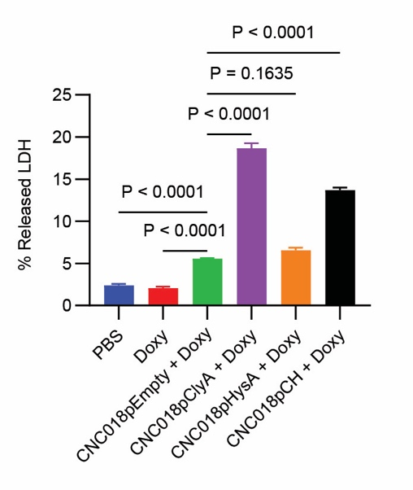
Figure S2. Release of LDH from tumor cells treated with ClyA-secreting bacteria.
CT26 tumor cells (3 × 10⁵) were treated with bacteria (1 MOI) plus 300 ng/mL Doxy. After 16 h, LDH levels in the culture supernatant were measured using a cytotoxicity assay kit.
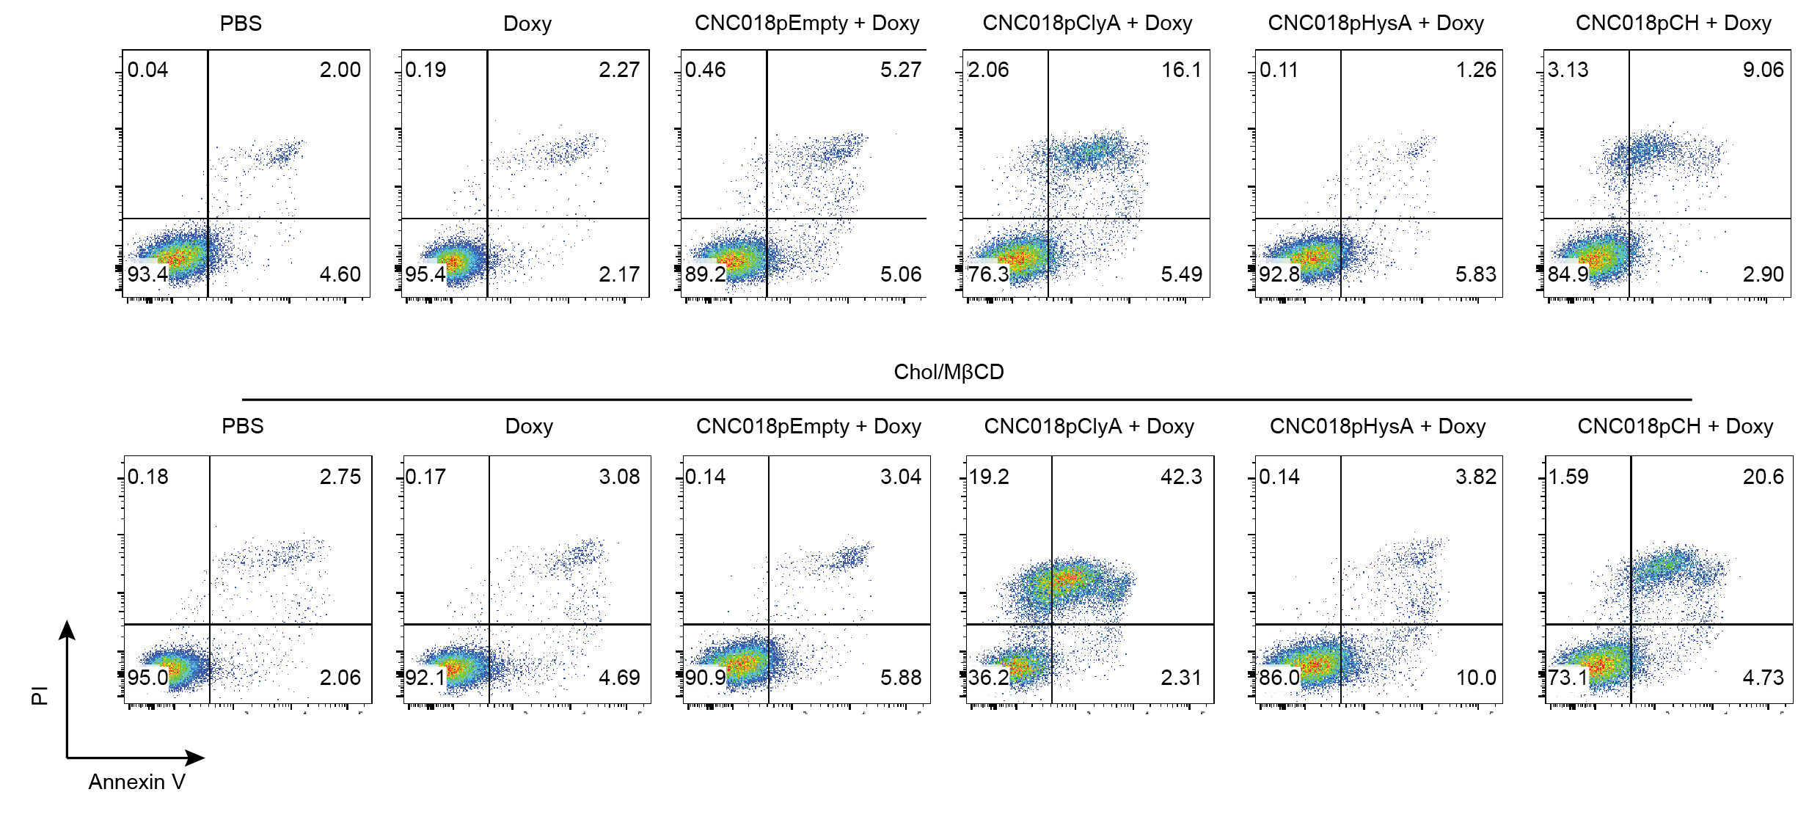
Figure S3. Cytotoxicity of CNC018pCH against 4T1 tumor cells supplemented with cholesterol.
Cholesterol-supplemented 4T1 tumor cells were incubated with bacteria (MOI 1) plus 300 ng/mL Doxy for 16 h. Cells were then stained with Annexin V-PI and analyzed by flow cytometry.
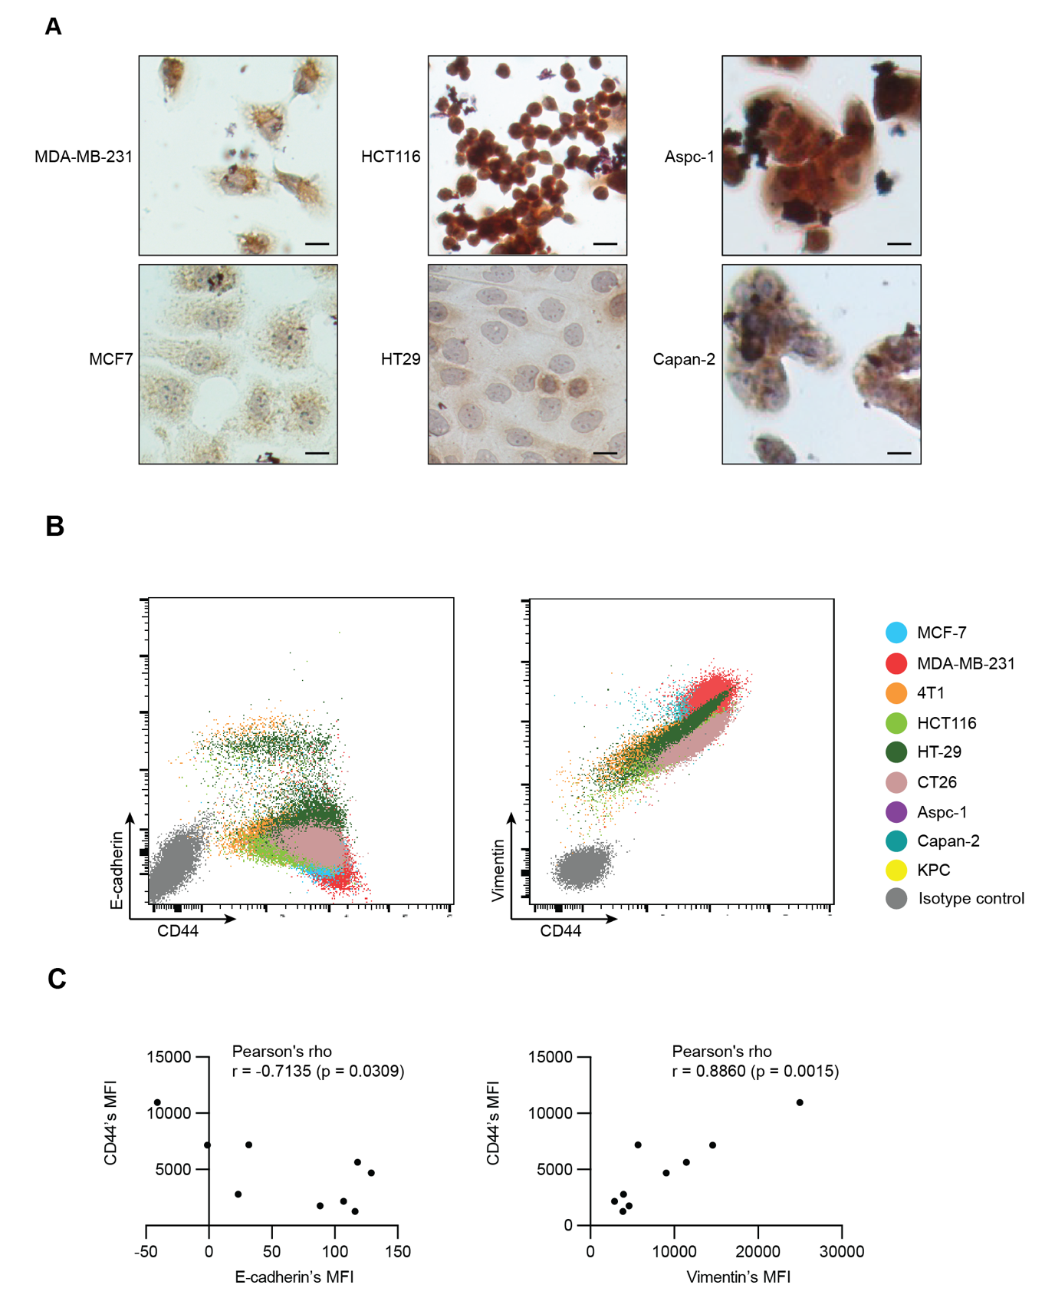
Figure S4. HA levels, and correlation between CD44 and E-Cadherin/vimentin expression, in tumor cells.
(A) Immunocytochemistry was performed using bHABP to detect HA in human tumor cells (brown staining). Images were captured at 400× magnification. Scale bar: 10 µm. (B) Correlation between CD44 and vimentin or E-cadherin in tumor cells. The cells were stained with antibodies specific to vimentin or E-cadherin and CD44, and fluorescence levels were measured using flow cytometry. (C) Mean fluorescence intensities (MFIs) of CD44 staining in (B) were plotted against those of vimentin or E-cadherin staining. Correlation was assessed using Pearson’s rho test.
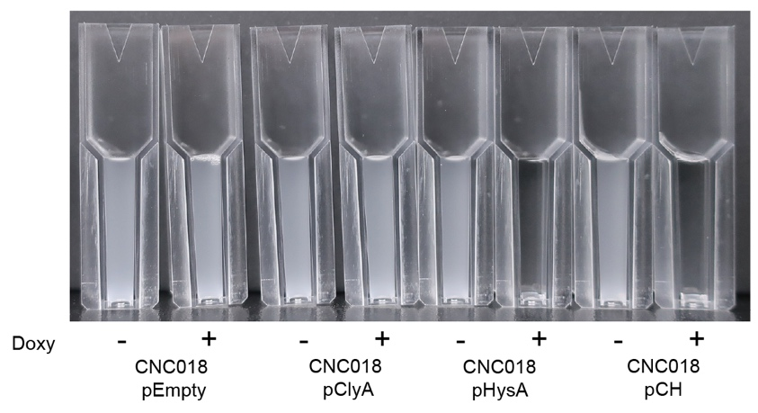
Figure S5. HysA activity in bacterial supernatant.
Bacteria were treated with (+) or without (-) 300 ng/mL Doxy. After 5 h of culture, the bacterial supernatants were analyzed following the HA degradation reaction.
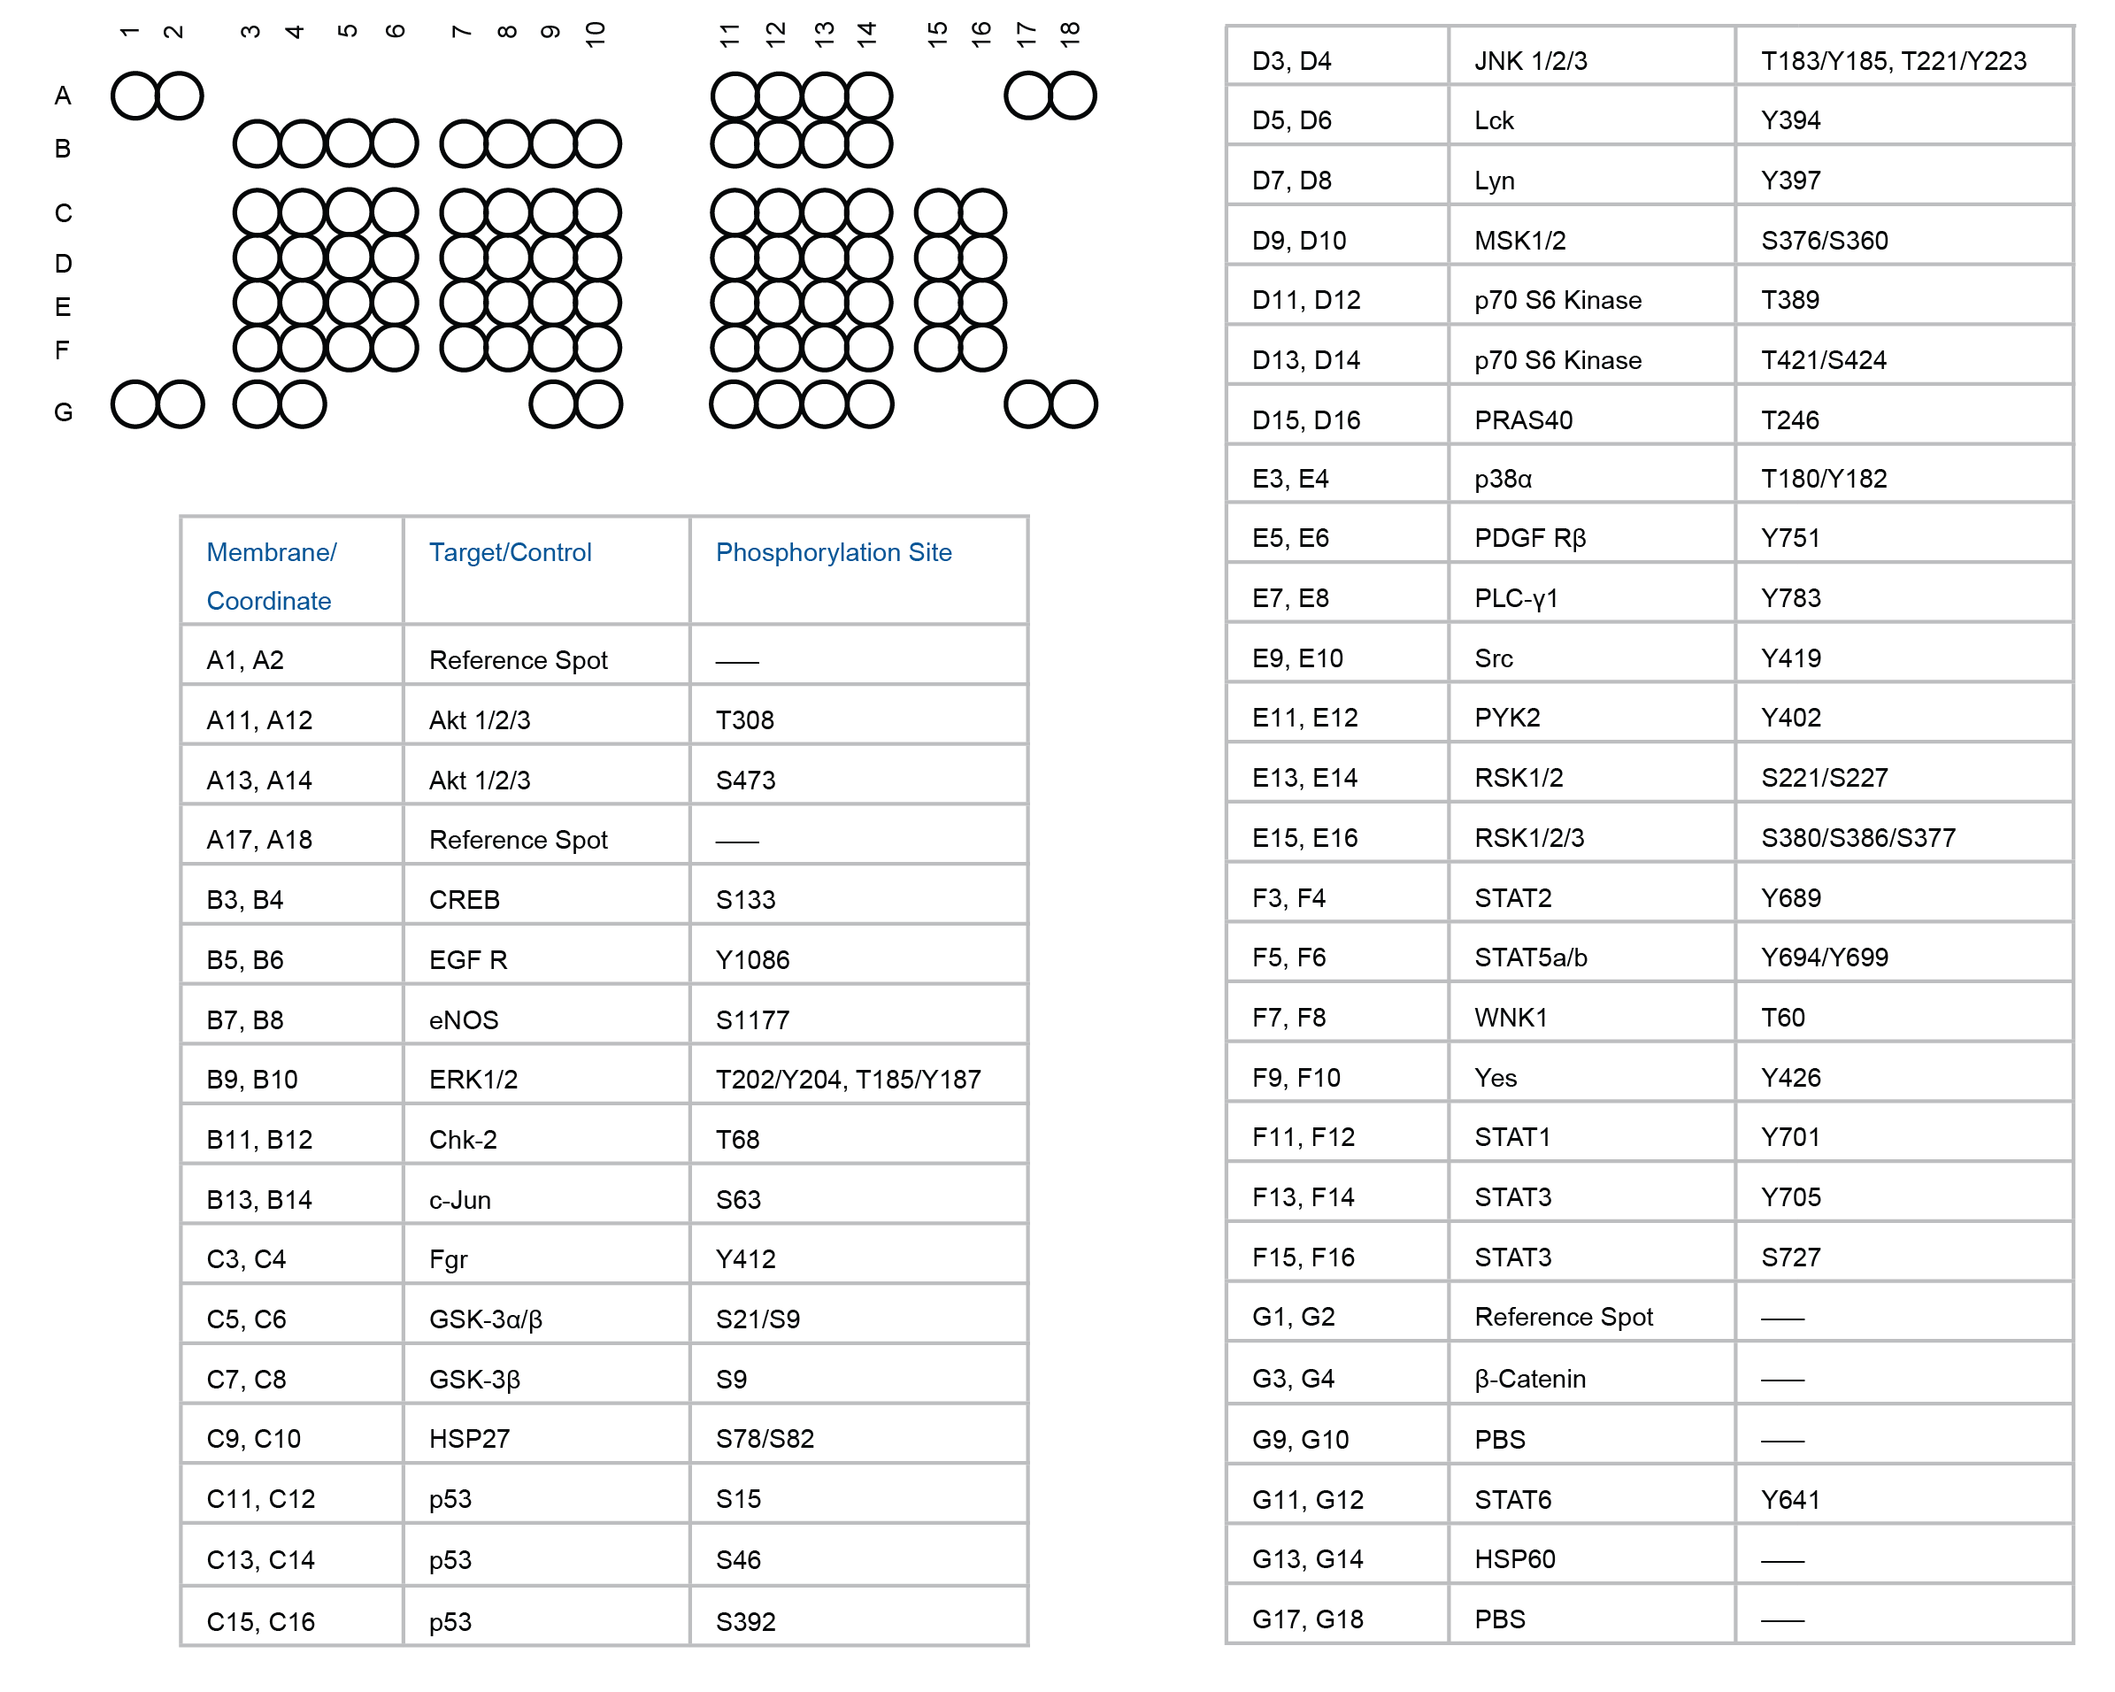
Figure S6. Phospho-kinase array.
Human phospho-kinase array coordinate map.
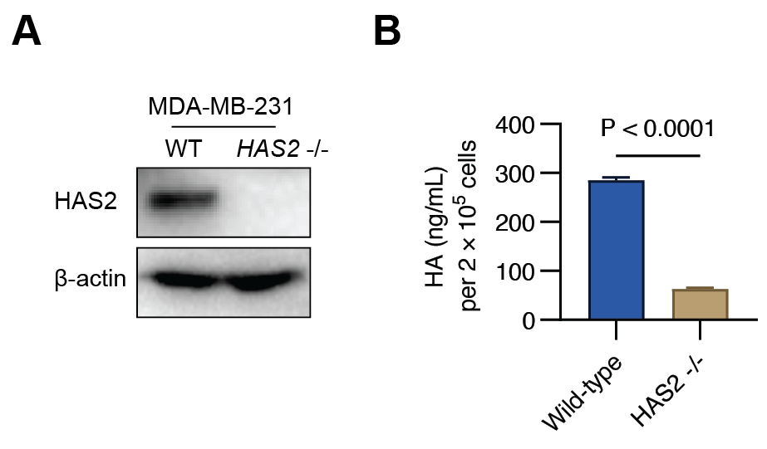
Figure S7. Knockout of the HAS2 gene in MDA-MB-231 cells.
The HAS2 gene in MDA-MB-231 cells was deleted using the CRISPR/Cas9 system. (A) Western blot analysis with an anti-HAS2 antibody was performed to confirm deletion of the HAS2 protein. (B) HA levels in the cell culture supernatant were measured using an ELISA assay to assess the impact of HAS2 knockout on HA secretion.

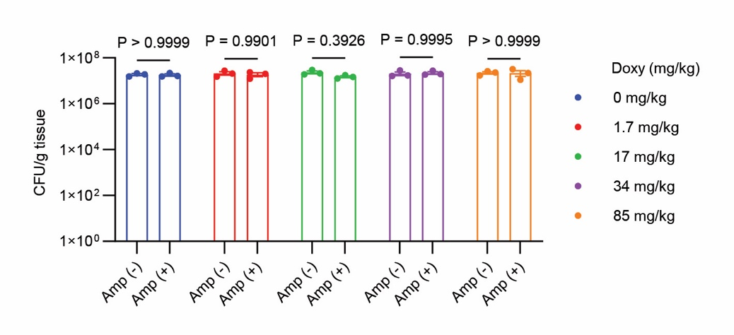
Figure S8. Assessment of plasmid stability following Doxy induction.
CT26 cells (5 × 10⁵) were injected subcutaneously into the right flank of mice (three per group). When tumors reached a volume of 100–120 mm³, mice were injected with bacteria (10⁷ CFU) and orally administered the indicated doses of Doxy on Day 3. On day 4, the number of CNC018pCH bacteria within tumors was quantified on LB agar plates with [amp (+)] or without [amp (–)] ampicillin.
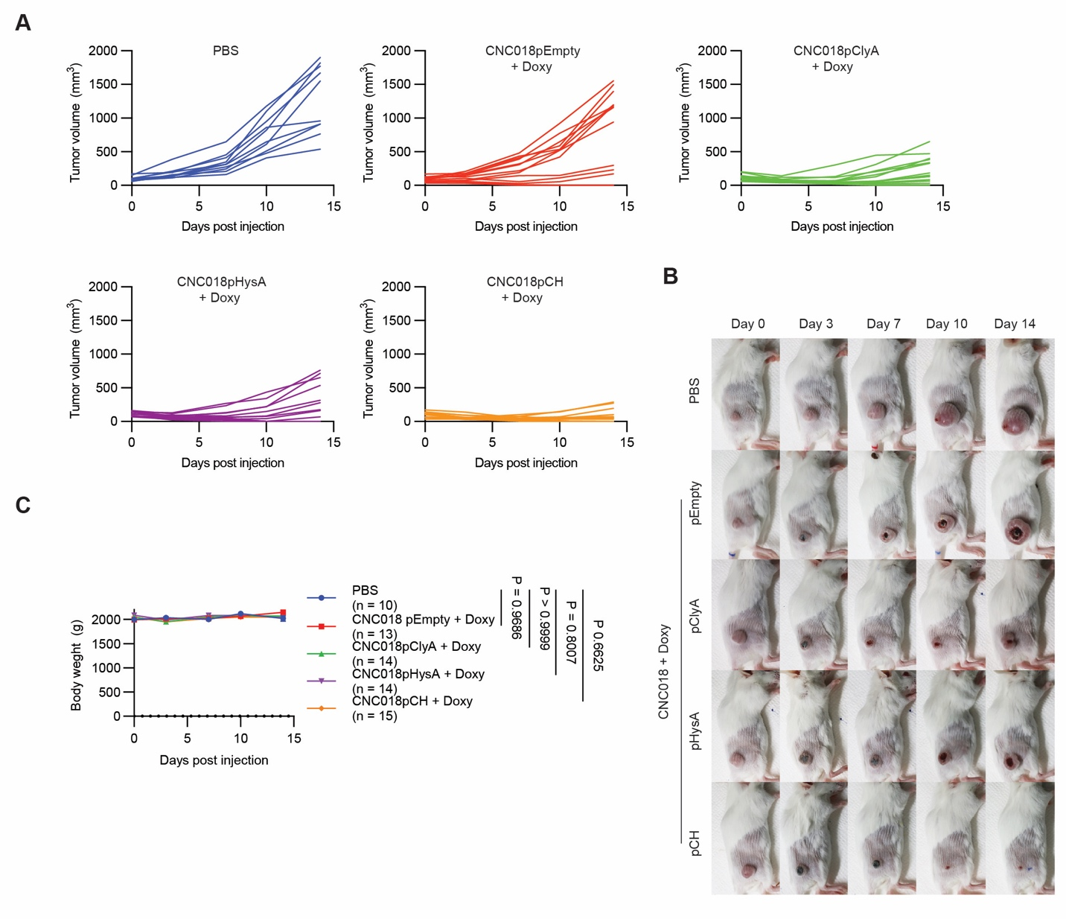
Figure S9. Tumor growth curves for individual mice carrying CT26 tumors.
(A) The CT26 model. Data are representative of two independent experimental replicates. (B) Representative images of CT26 tumor-bearing mice post-treatment. (C) Body weight after treatment.
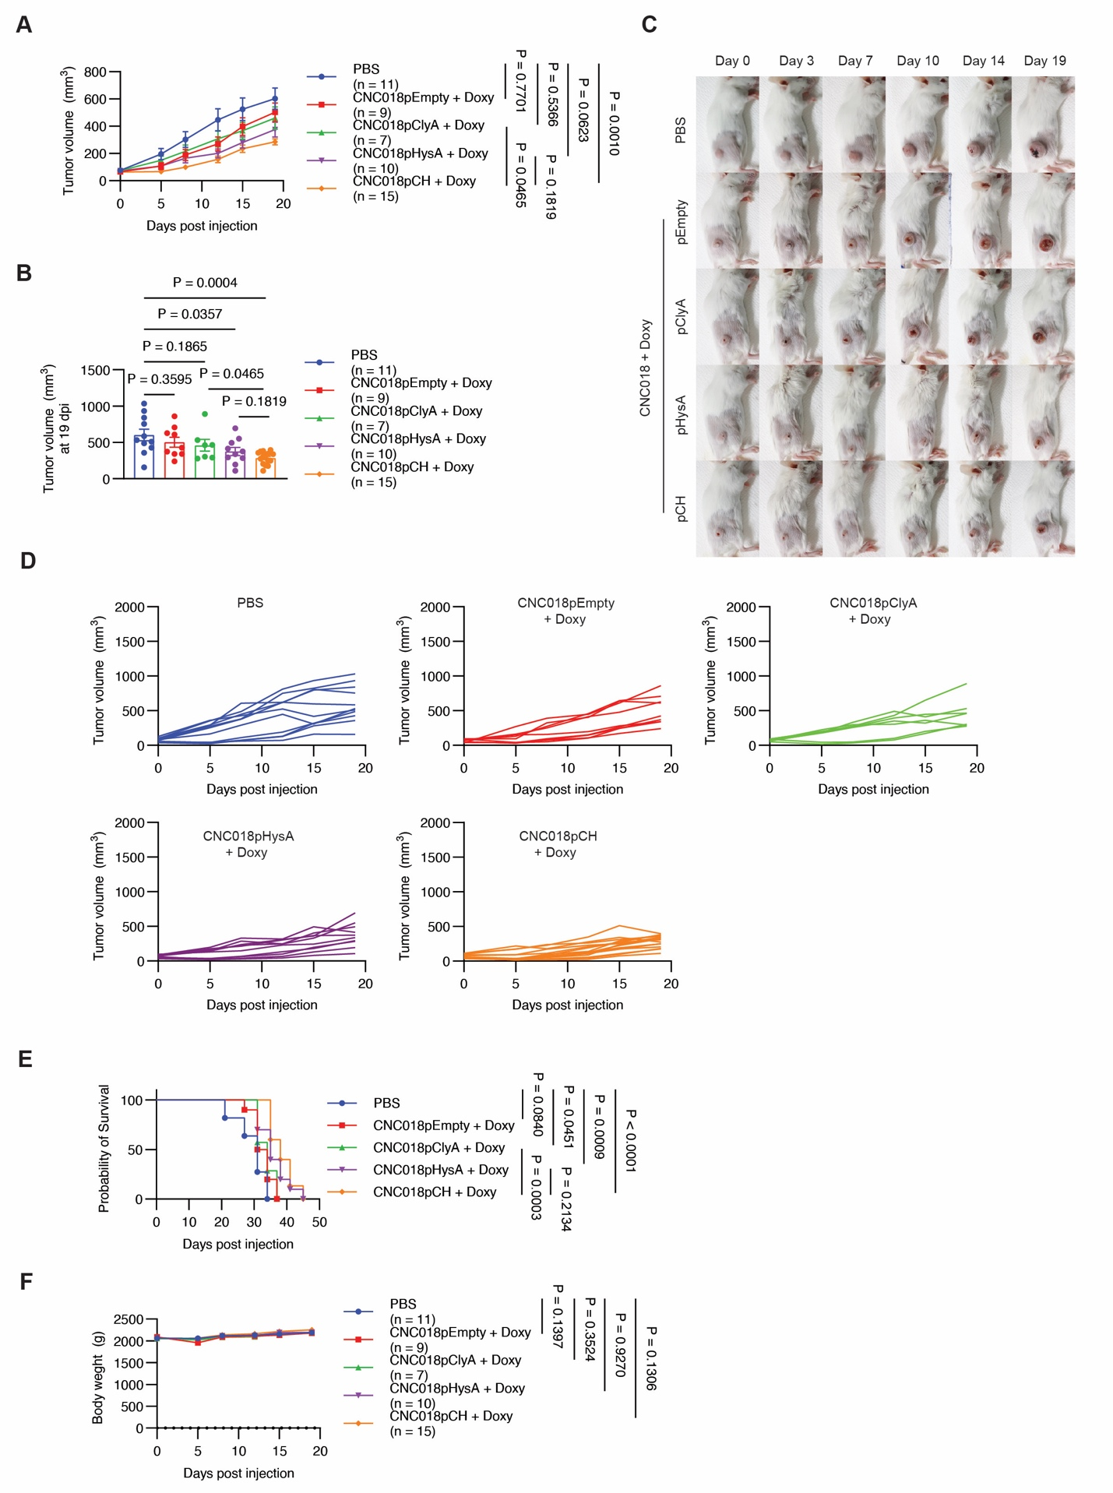
Figure S10. Tumor growth curves for individual mice bearing 4T1 tumors.
(A) Tumor growth curves for 4T1 tumor-bearing mice. Mice bearing subcutaneous 4T1 tumors were treated as described in Figure 6A. Data are representative of two independent experimental replicates. (B) Tumor volume at Day 19 post-treatment. (C) Representative images of 4T1 tumor-bearing mice after treatment. (D) Tumor growth curves for individual mice. (E) Kaplan–Meier survival curves of 4T1 tumor-bearing mice (log-rank (Mantel–Cox test)). (F) Body weight after treatment.

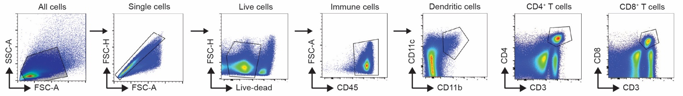
Figure S11. Flow cytometry gating strategies.
Tumors and TdLNs were collected from CT26 tumor-bearing mice following bacterial injection and Doxy treatment, and immune cells were analyzed by flow cytometry. Gating strategy using the fluorescence minus one (FMO) control to set gates.

