Supplementary Figures

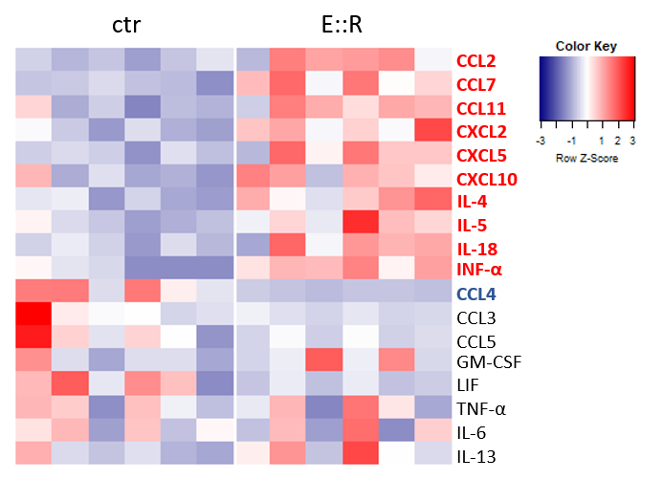

Supplementary Figure S1. Heatmap showing all cytokines/chemokines detected in a multiplex assay performed using conditioned media collected from E::R and control cells. Data are represented as Z-Score of normalized concentrations. Cytokines/Chemokines that are significantly differentially secreted (FDR<0.05) are highlighted in bold. Red and blue indicate up-regulated and down-regulated factors, respectively.

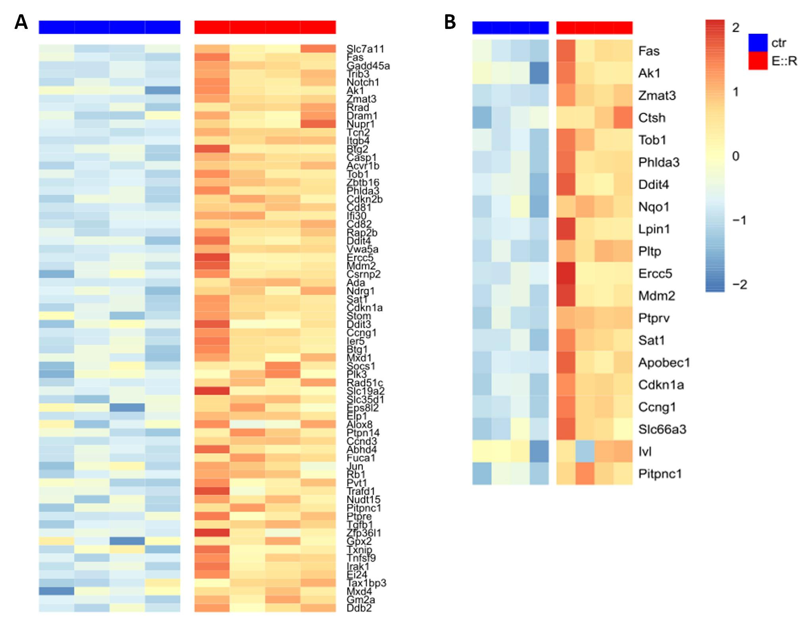
Supplementary Figure S2. Heat maps of the gene set HALLMARK_P53_PATHWAY (A) ONGUSAHA_TP53_TARGETS (B) containing all genes found significantly up-regulated in E::R+ BaF3 cells vs control cells.

Supplementary Figure S3. GEP analysis of LMNA gene in E::R+ and control cells. Boxplot of LMNA gene expression level in E::R+ and control cells. Error bar represents SD. (FDR: < 0.05).

