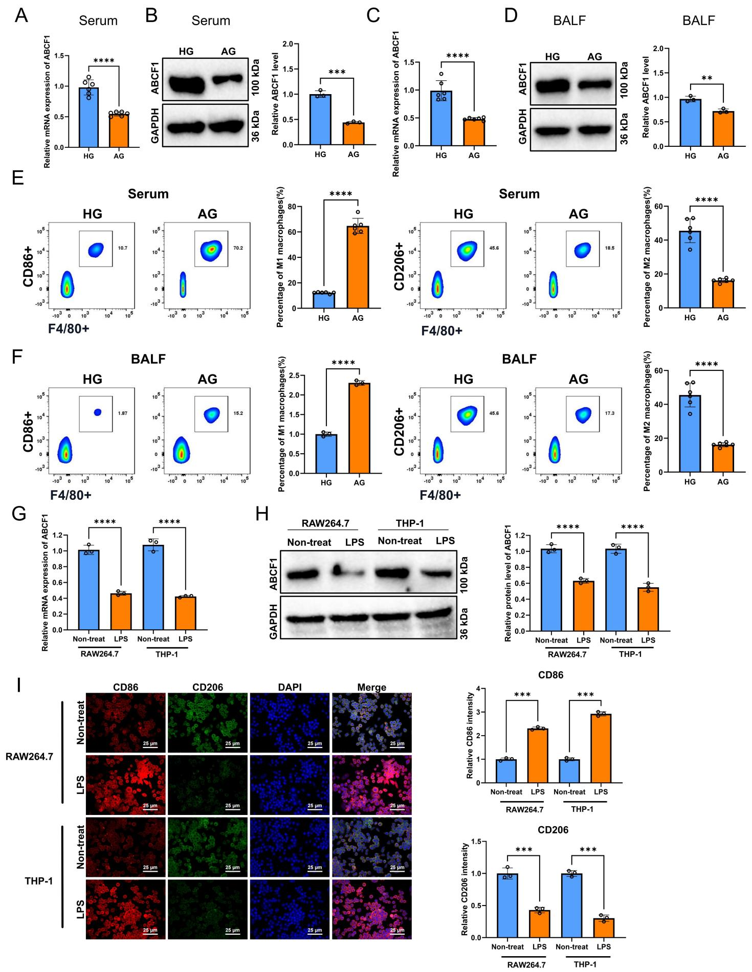
Figure S1. Downregulation of ABCF1 Expression Promotes M1 Polarization in Blood and BALF of Sepsis-Induced ALI Mice, and in LPS-Stimulated Macrophages.
Note: (A-B) RT-qPCR (A) and Western blot (B) analyses of ABCF1 mRNA and protein expression levels, respectively, in blood samples from the Healthy group (HG) and the ALI group (AG). GAPDH served as the loading control for Western blot. (C-D) RT-qPCR (C) and Western blot (D) analyses of ABCF1 mRNA and protein expression levels in BALF samples from the HG and AG mice. (E-F) Representative flow cytometry plots and quantitative percentages of M1 (F4/80⁺CD86⁺) and M2 (F4/80⁺CD206⁺) macrophage populations in blood (E) and BALF (F) samples from the HG and AG mice. (G-H) RT-qPCR (G) and Western blot (H) analyses of ABCF1 mRNA and protein expression levels in in vitro cultured RAW264.7 and THP-1 macrophages stimulated with LPS (100 ng/mL) to induce M1 polarization, compared to the untreated control (Non-treat). (I) Representative immunofluorescence images and quantitative intensity analysis of CD86 (M1 marker, red) and CD206 (M2 marker, green) in Non-treat and LPS-stimulated RAW264.7 and THP-1 macrophages. Nuclei were counterstained with DAPI (blue). Scale bar: 25 μm. All data are presented as mean ± SEM. Animal experiments involved n = 6 mice per group. In vitro cell experiments were performed in triplicate, with data derived from three independent experiments (n = 3 per experiment). Statistical significance: *p < 0.05; **p < 0.01; ***p < 0.001; ****p < 0.0001 (analyzed by unpaired Student’s t-test).
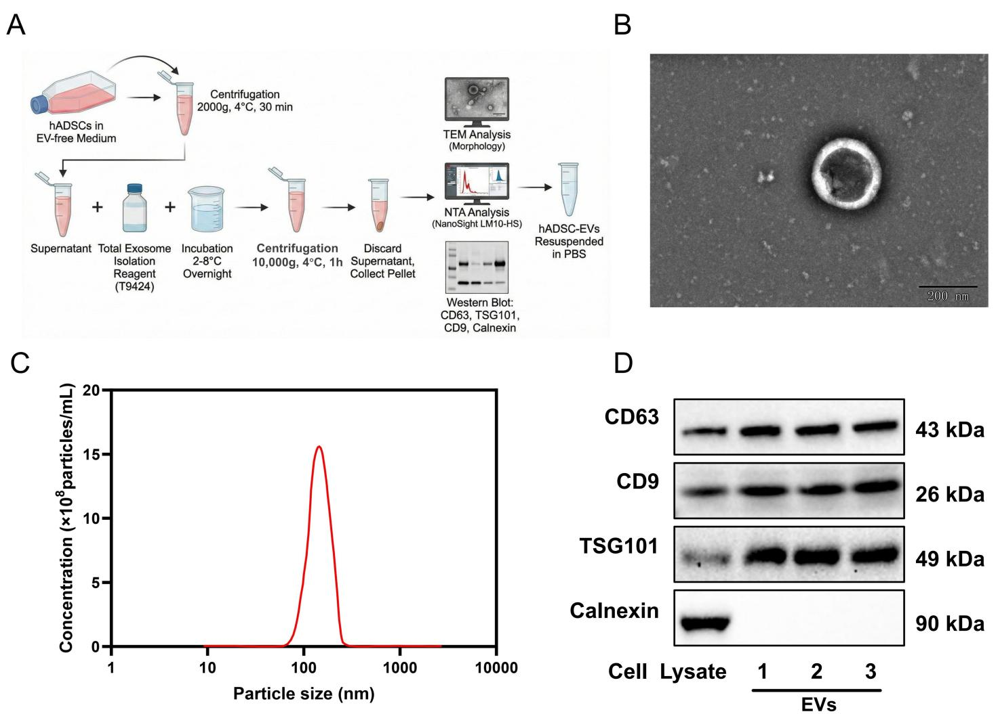Figure S2. Characterization of hADSC-EVs.
Note: (A) Schematic diagram illustrating the isolation and purification workflow of hADSC-EVs using a polymer-based precipitation method. (B) Representative Transmission Electron Microscopy (TEM) image showing the typical cup-shaped morphology of the isolated hADSC-EVs (scale bar: 200 nm). (C) Nanoparticle Tracking Analysis (NTA) depicting the particle size distribution and concentration of the hADSC-EVs, with the major peak at approximately 140 nm. (D) Western blot analysis confirming the presence of EV-specific positive surface markers (CD63, CD9, and TSG101) and the absence of the endoplasmic reticulum negative marker (Calnexin) in hADSC-EVs, verifying the high purity of the isolation. Lanes 1, 2, and 3 represent three independent batches of hADSC-EV preparations.
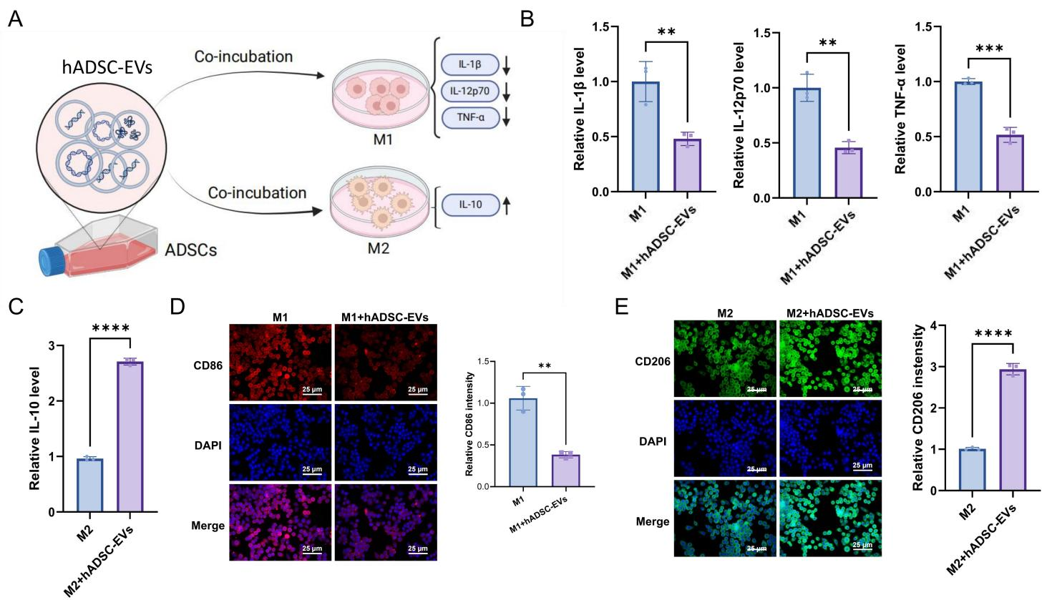
Figure S3. hADSC-EVs Promote M2 Macrophage Polarization and Suppress M1 Polarization In Vitro.
Note: (A) Schematic overview of the experimental procedure. RAW264.7 macrophages were cultured under M1 or M2 polarizing conditions and subsequently co-incubated with hADSC-EVs for phenotypic and functional analysis. (B) ELISA quantification of the pro-inflammatory cytokines IL-1β, IL-12p70, and TNF-α secreted into the culture supernatants of M1-polarized macrophages with or without hADSC-EV treatment. (C) ELISA analysis of the anti-inflammatory cytokine IL-10 secreted into the culture supernatants of M2-polarized macrophages with or without hADSC-EV treatment. For (B) and (C), relative cytokine secretion levels were normalized to the respective control group (M1 or M2 alone), which was set to 1. (D–E) Representative immunofluorescence images and quantitative analysis of (D) CD86⁺ (M1 marker, red) and (E) CD206⁺ (M2 marker, green) RAW264.7 macrophages in the designated groups. Nuclei were counterstained with DAPI (blue) (scale bar: 25 μm). All cell-based experiments were performed in triplicate, with data obtained from three independent experiments (n = 3 per group). Data are presented as mean ± SEM. *p < 0.05; **p < 0.01; ***p < 0.001; ****p < 0.0001 (analyzed by unpaired Student’s t-test).
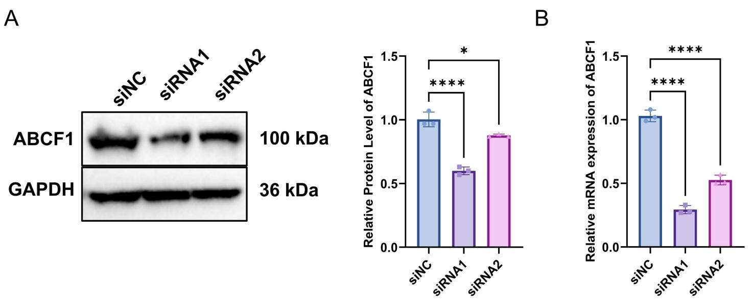
Figure S4. Validation of ABCF1 Knockdown by siRNA In Vitro.
Note: (A) Representative Western blot images and densitometric quantification of ABCF1 protein levels in RAW264.7 macrophages. Cells were transfected with either a negative control siRNA (siNC) or two different ABCF1-targeting siRNAs (siRNA1 and siRNA2). GAPDH was used as the loading control. (B) RT-qPCR analysis of ABCF1 mRNA expression in RAW264.7 macrophages across the corresponding groups. Data were normalized to Gapdh as the internal reference gene. For both (A) and (B), relative expression levels were calculated by setting the siNC group to 1. Based on these validation results, siRNA1 exhibited the most robust knockdown efficiency and was subsequently utilized for all downstream loss-of-function experiments. All cell-based experiments were performed in triplicate, with data obtained from three independent experiments (n = 3 per group). Data are presented as mean ± SEM. *p < 0.05; ****p < 0.0001 (analyzed by one-way ANOVA followed by Tukey’s post hoc test).
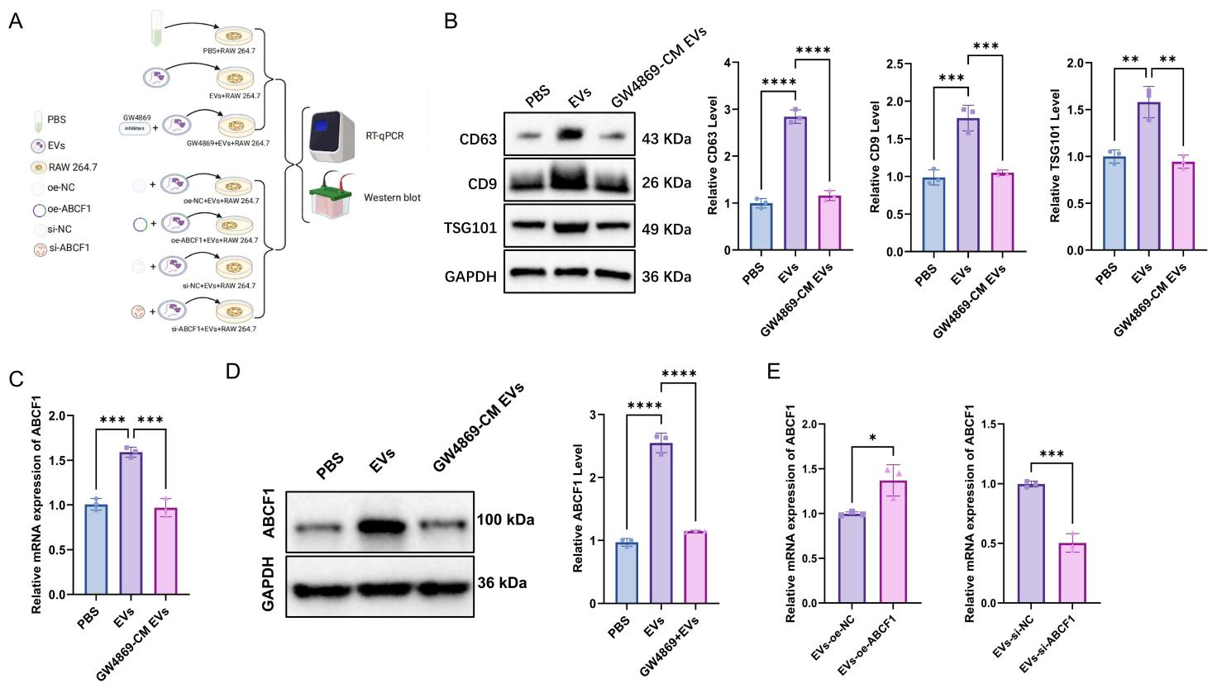
Figure S5. Experimental Validation of ABCF1 Delivery to RAW264.7 Macrophages via hADSC-EVs.
Note: (A) Schematic illustration of the experimental design. To confirm EV-mediated delivery, RAW264.7 macrophages were treated with PBS, normal hADSC-EVs (EVs), or the equivalent fraction isolated from hADSCs pre-treated with the exosome secretion inhibitor GW4869 (labeled as "GW4869-CM EVs"). Additionally, modified EVs were prepared for cargo validation. (B) Representative Western blot images and quantification of EV marker proteins (CD63, CD9, and TSG101) internalized within recipient RAW264.7 macrophages following the respective treatments. GAPDH served as the cellular internal control. (C-D) RT-qPCR analysis (C) and Western blot detection (D) of ABCF1 expression levels within the recipient RAW264.7 macrophages. Data demonstrates that inhibiting EV secretion from donor cells (GW4869+EVs group) abrogates the increase of ABCF1 in recipient cells. mRNA data were normalized to Gapdh, and protein data to GAPDH. Relative levels were normalized to the PBS group (set to 1). (E) RT-qPCR detection of ABCF1 mRNA enrichment directly extracted from isolated, modified hADSC-EVs. The left panel confirms enrichment in EVs-oe-ABCF1 compared to EVs-oe-NC, while the right panel confirms depletion in EVs-si-ABCF1 compared to EVs-si-NC. Data were normalized to Gapdh (as an EV internal reference) and expressed relative to the respective negative control (NC) group (set to 1). All experiments were performed in triplicate, with data obtained from three independent experiments (n = 3 per group). Data are presented as mean ± SEM. *p < 0.05; **p < 0.01; ***p < 0.001; ns, not significant (analyzed by one-way ANOVA followed by Tukey’s post hoc test for multi-group comparisons, or unpaired Student’s t-test for two-group comparisons).
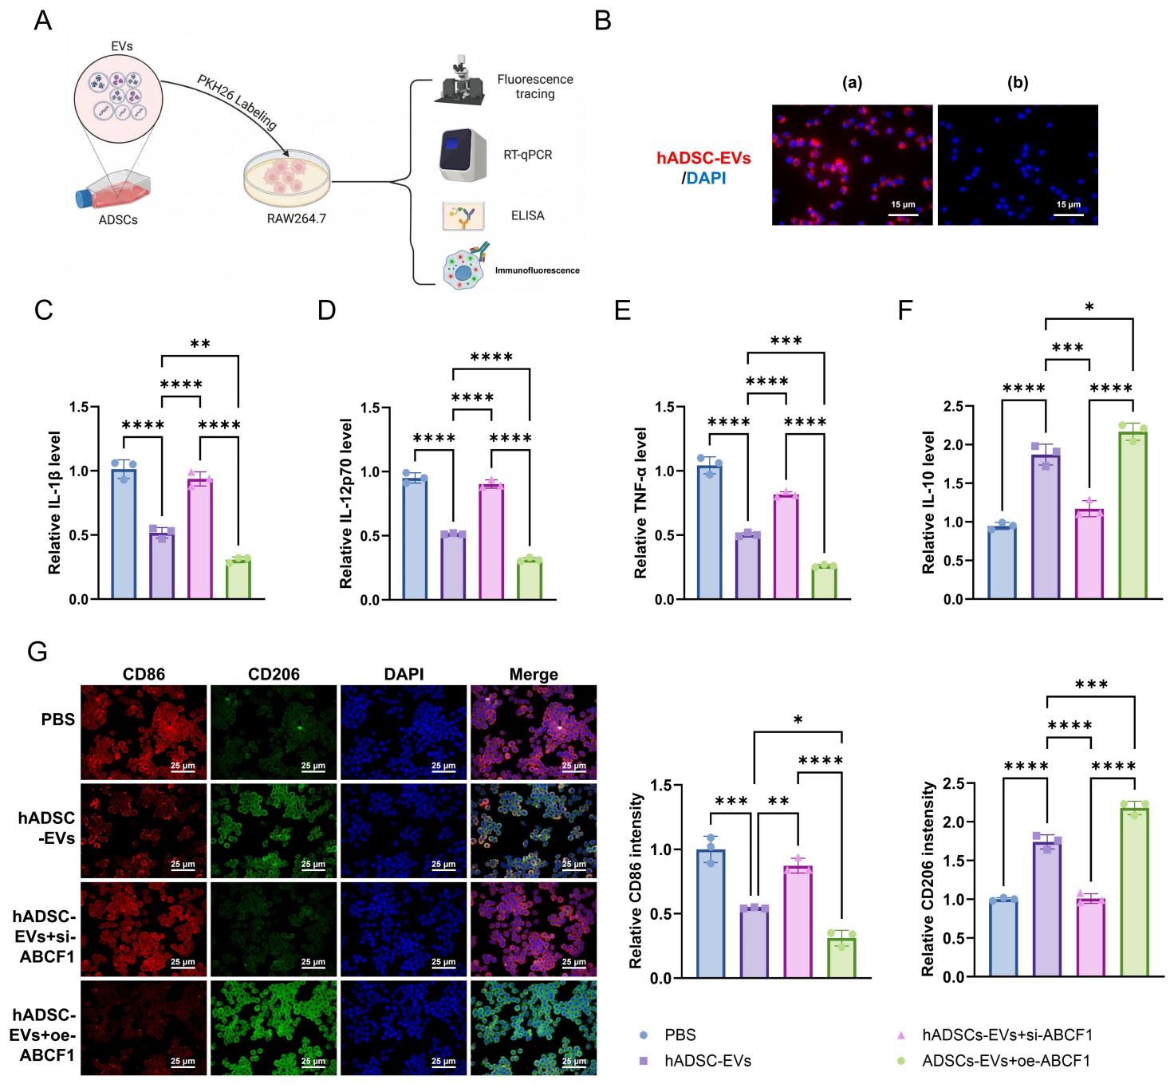
Figure S6. hADSC-EVs Deliver ABCF1 to RAW264.7 Macrophages and Modulate Their Polarization.
Note: (A) Schematic representation of the experimental workflow. EVs were labeled with a fluorescent dye and co-incubated with RAW264.7 macrophages, followed by downstream functional analyses. (B) Representative fluorescence tracking images demonstrating the cellular uptake of hADSC-EVs by RAW264.7 macrophages. Image (a) shows the internalization of labeled EVs (red fluorescence), while (b) represents the unlabeled negative control assessing background autofluorescence. Nuclei were counterstained with DAPI (blue); scale bar = 15 μm. (C–F) ELISA quantification of relative pro-inflammatory cytokines IL-1β (C), IL-12p70 (D), TNF-α (E), and the anti-inflammatory cytokine IL-10 (F) in the culture supernatants of RAW264.7 macrophages following the indicated treatments. Data were normalized to the PBS control group (set as 1). (G) Representative immunofluorescence images and quantitative intensity analysis of CD86 (M1 marker, red) and CD206 (M2 marker, green) in RAW264.7 macrophages. Nuclei were counterstained with DAPI (blue); scale bar = 25 μm. All cell-based assays were performed in triplicate, with data obtained from three independent experiments (n = 3 per group). Data are presented as mean ± SEM. *p < 0.05; **p < 0.01; ***p < 0.001; ****p < 0.0001 (analyzed by one-way ANOVA followed by Tukey’s post hoc test).
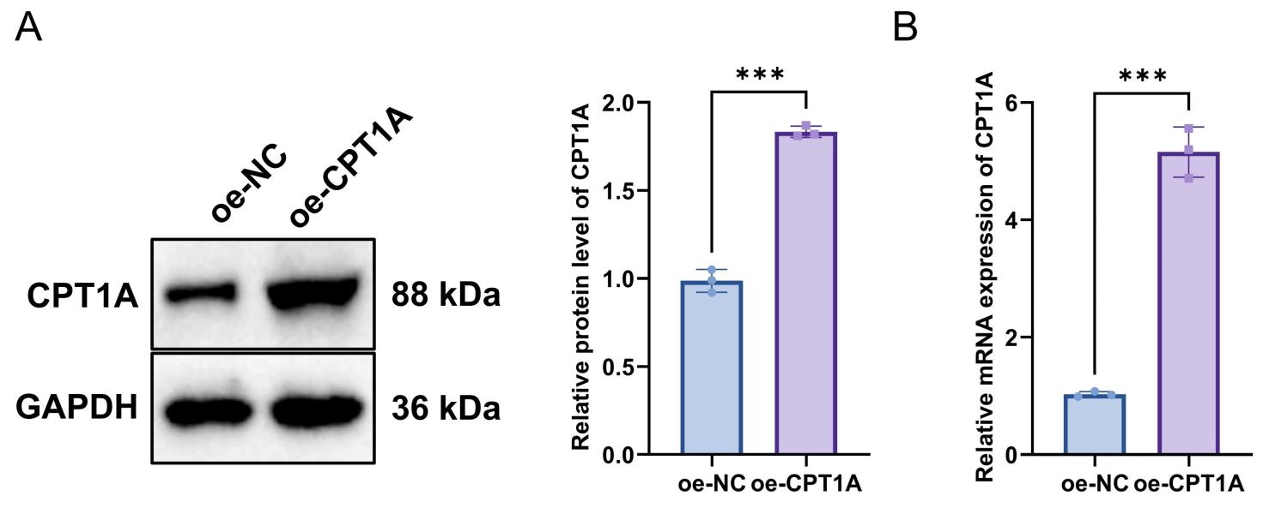
Figure S7. Validation of CPT1A Overexpression.
Note: (A) Representative Western blot images (left) and quantitative analysis (right) of CPT1A protein expression in RAW264.7 macrophages transfected with either an empty vector (oe-NC) or a CPT1A overexpression plasmid (oe-CPT1A). GAPDH was used as the loading control. (B) RT-qPCR quantification of Cpt1a mRNA levels in RAW264.7 macrophages following transfection. Data were normalized to Gapdh as the internal reference gene. For both protein and mRNA analyses, relative expression levels were calculated by setting the oe-NC control group to 1. All cell-based experiments were performed in triplicate, with data obtained from three independent experiments (n = 3 per group). Data are presented as mean ± SEM. ***p < 0.001 (analyzed by unpaired Student’s t-test).
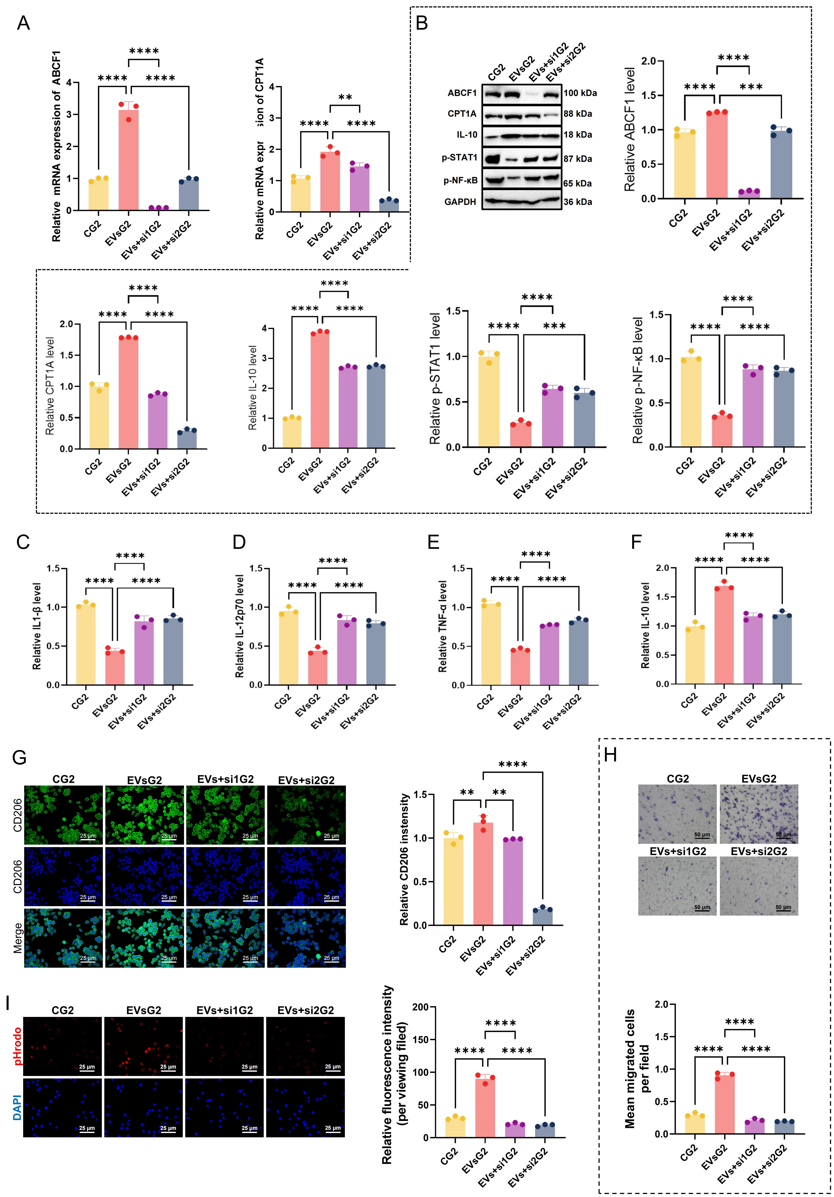
Figure S8. ABCF1 Promotes M2 Polarization via the CPT1A/IL-10 Axis by Suppressing NF-κB/STAT1 Signaling (M2 Induction Model).
Note: RAW264.7 macrophages were cultured under M2-inducing conditions (IL-4) and divided into four groups: Control (CG2), hADSC-EVs treatment (EVsG2), treatment with EVs derived from ABCF1-knockdown ADSCs (EVs+si1G2), and hADSC-EVs treatment combined with direct transfection of Cpt1a siRNA into the macrophages (EVs+si2G2). (A) RT-qPCR analysis of Abcf1 and Cpt1a mRNA expression in M2-polarized RAW264.7 macrophages across the designated treatment groups. Data were normalized to Gapdh, with the CG2 group set to 1. (B) Representative Western blot images and quantitative analysis of ABCF1, CPT1A, IL-10, p-STAT1, and p-NF-κB protein levels. GAPDH served as the loading control. (C-F) ELISA quantification of the relative secretion levels of pro-inflammatory cytokines IL-1β (C), IL-12p70 (D), and TNF-α (E), alongside the anti-inflammatory cytokine IL-10 (F) in the culture supernatants. Relative levels were normalized to the CG2 group. (G) Representative immunofluorescence images and quantitative intensity analysis of the M2 marker CD206 (green) in RAW264.7 macrophages. Nuclei were counterstained with DAPI (blue); scale bar: 25 μm. (H) Transwell migration assay evaluating the relative migratory capacity of M2-polarized RAW264.7 macrophages. Representative images (top) and quantitative analysis (bottom) are shown. Scale bar: 50 μm. (I) Phagocytosis assay using pHrodo Red E. coli BioParticles to measure the engulfment capability of macrophages. Representative images (left) and quantification of relative fluorescence intensity (right) are presented; scale bar: 25 μm. All cell-based experiments were performed in triplicate, with data obtained from three independent experiments (n = 3 per group). Data are presented as mean ± SEM. **p < 0.01, ***p < 0.001, ****p < 0.0001 (analyzed by one-way ANOVA followed by Tukey’s post hoc test).
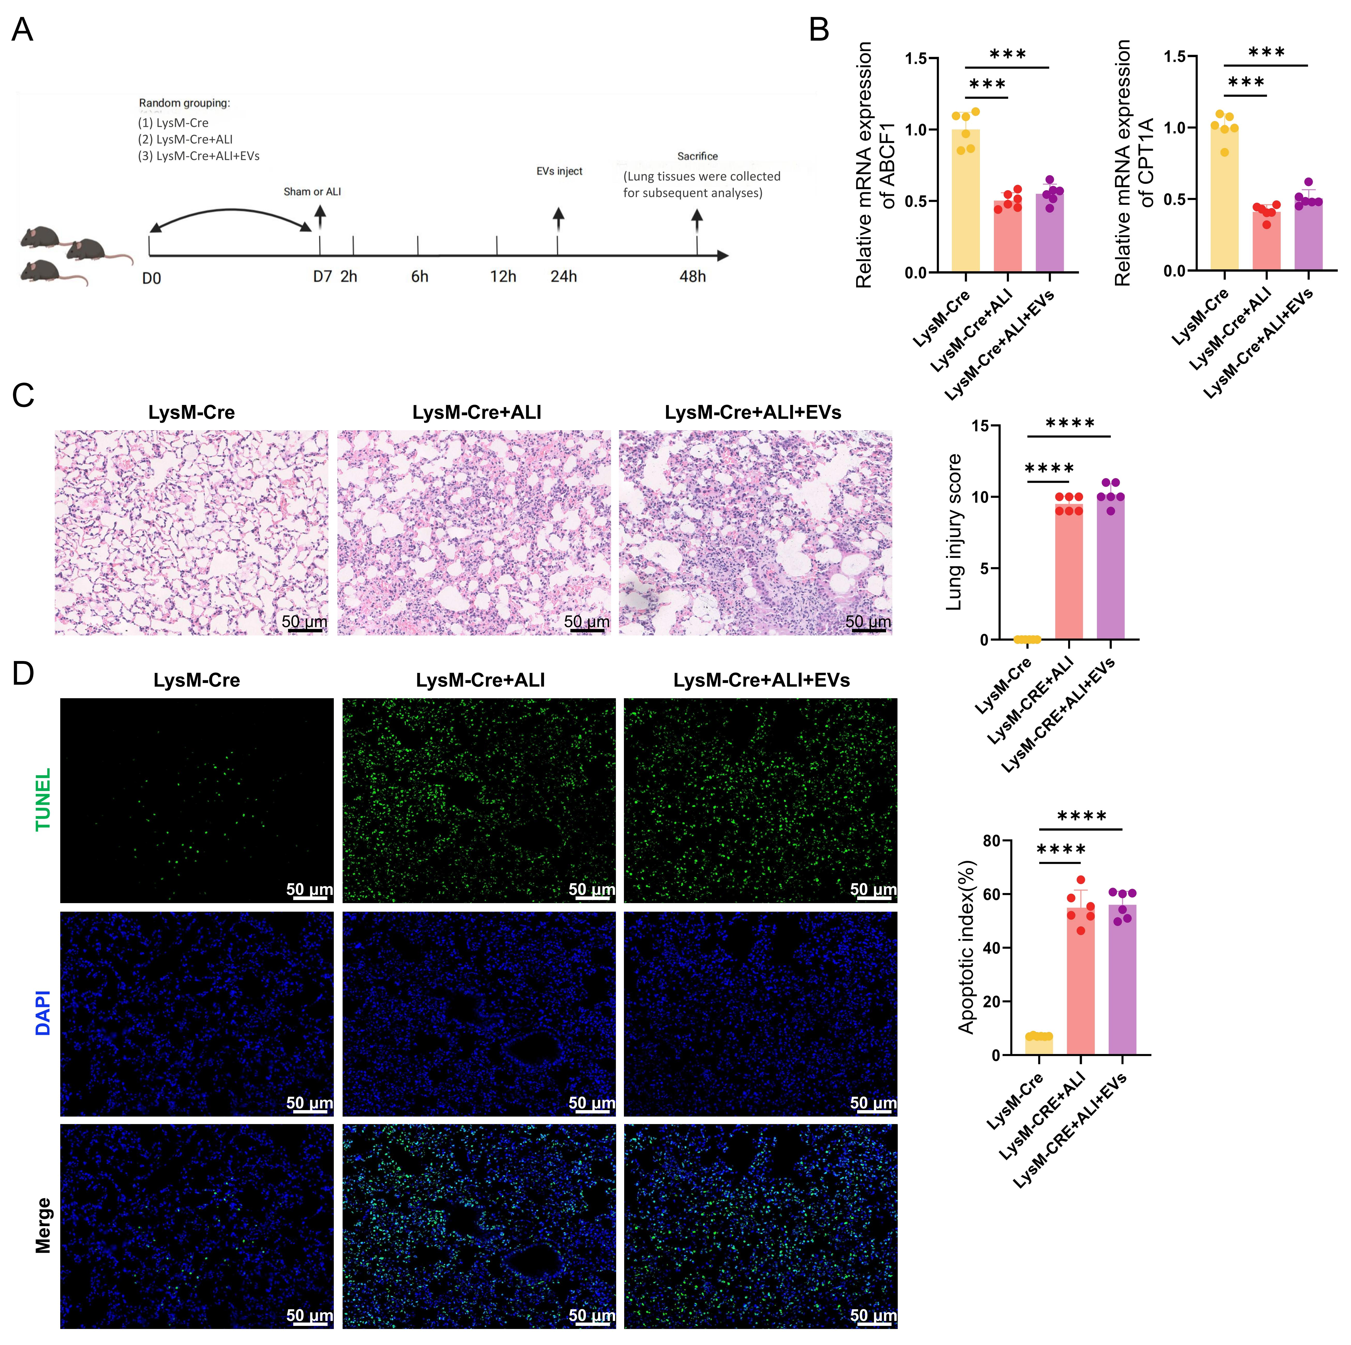
Figure S9. hADSC-derived EVs Attenuate Sepsis-Induced ALI through Macrophage-Dependent Mechanisms.
Note: (A) Schematic illustration of the in vivo experimental timeline. The CLP-induced ALI model and subsequent EV treatments were performed in a macrophage-depletion model utilizing LysM-Cre; iDTR double-transgenic mice treated with diphtheria toxin. (Note: In all panels, the label 'LysM-Cre' represents this macrophage-depleted LysM-Cre; iDTR model). Mice were randomly divided into three groups: LysM-Cre (Sham), LysM-Cre + ALI, and LysM-Cre + ALI + EVs. (B) RT-qPCR analysis of Abcf1 and Cpt1a mRNA expression in lung tissues from the designated groups. Data were normalized to Gapdh as the internal reference gene, with the LysM-Cre control group set to 1. (C) Representative H&E staining images of lung tissues assessing histopathological changes (alveolar structural integrity, inflammatory infiltration, and edema). The corresponding quantitative lung injury scores are presented in the right panel. Scale bar: 50 μm. (D) Representative TUNEL staining images indicating apoptosis of alveolar epithelial cells. The right panel shows the quantified apoptotic index (%). Nuclei were counterstained with DAPI (blue). Scale bar: 50 μm. All data are presented as mean ± SEM (n = 6 mice per group). ***p < 0.001, ****p < 0.0001 (analyzed by one-way ANOVA followed by Tukey’s post hoc test). Note that EV treatment failed to rescue the expression of ABCF1/CPT1A or alleviate lung injury and apoptosis in this myeloid-targeted model.

Table S1 List of Primers Used for qPCR.
Gene | Forward primer | Reverse primer
ABCF1  (Mouse) | AGAAAGCCCGAGTTGTGTTTG | GCCCCCTTGTAGTCGTTGATG
ABCF1  (Human) | CTCCTCAAGCACATTGCCAACC | GCTTCAATCGCTTGGTGTCAGC
CPT1A  (Mouse) | CTCCGCCTGAGCCATGAAG | CACCAGTGATGATGCCATTCT
PGC1β  (Mouse) | TCCTGTAAAAGCCCGGAGTAT | GCTCTGGTAGGGGCAGTGA
CD36  (Mouse) | ATGGGCTGTGATCGGAACTG | GTCTTCCCAATAAGCATGTCTCC
IL-10  (Mouse) | CTTACTGACTGGCATGAGGATCA | GCAGCTCTAGGAGCATGTGG
IL-1β  (Mouse) | GCAACTGTTCCTGAACTCAACT | ATCTTTTGGGGTCCGTCAACT
IL-12p70  (Mouse) | TGGTTTGCCATCGTTTTGCTG | ACAGGTGAGGTTCACTGTTTCT
TNF-α  (Mouse) | CGCCATGAGCACTGAGAGTATGATC | CAGCCACGAGCAGGAAAGAGAAG
GAPDH  (Mouse) | AGGTCGGTGTGAACGGATTTG | TGTAGACCATGTAGTTGAGGTCA
GAPDH  (Human) | GTCTCCTCTGACTTCAACAGCG | ACCACCCTGTTGCTGTAGCCAA

