ESM1-mediated DNMT3A suppresses cervical cancer metastasis through epigenetic regulation of ID3 expression
Chen-Lin Yu, Chia-Liang Lin, Hsiang-Lin Lee, Hui-Ling Chiou, Pei-Ni Chen, Shun-Fa Yang, Yi-Hsien Hsieh

Supplementary Figure S1
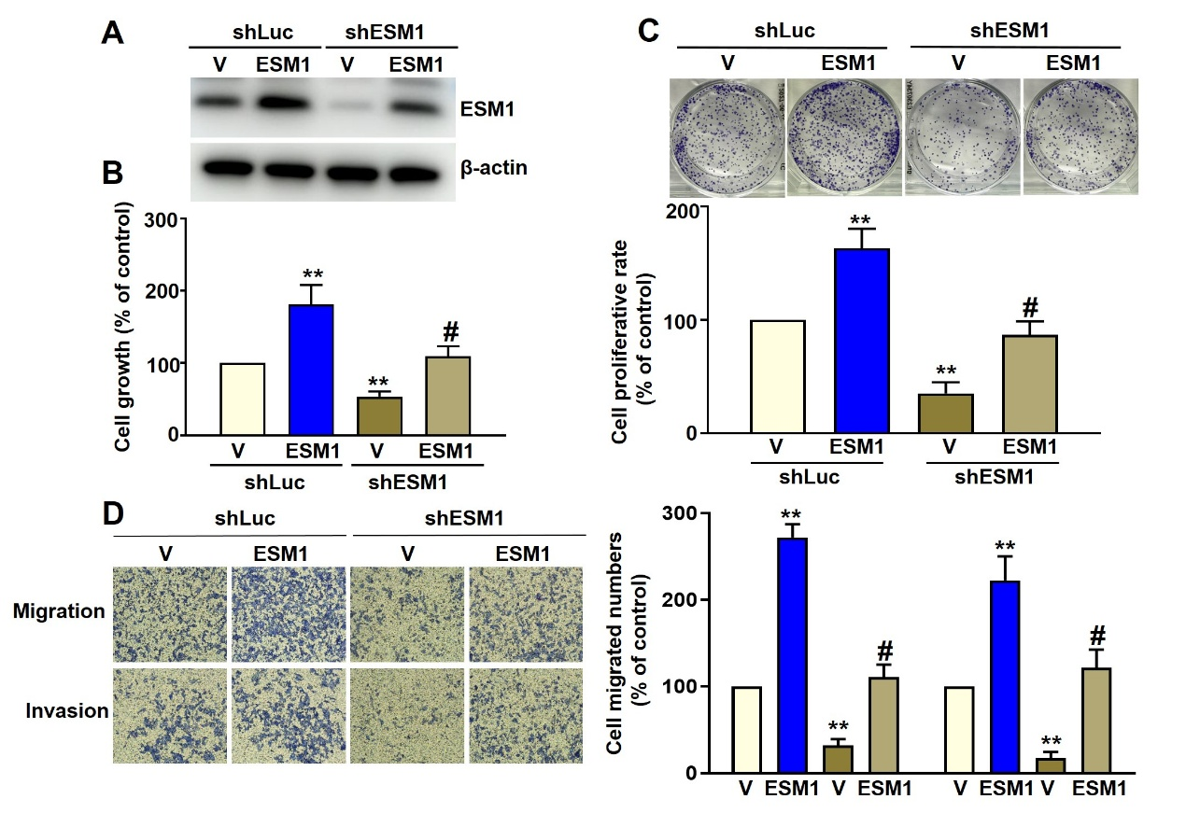

Supplementary Figure S1. ESM1 regulates the malignant properties of human cervical cancer HeLa cells (A) The reintroduction of ESM1 expression by the ESM1-expressing plasmid was confirmed by Western blot. (B) Cell growth was assessed by MTT assay. (C) Cell proliferation was evaluated by colony formation assay. (D) Cell migration and invasion were examined using migration and Matrigel invasion assays. Data are expressed as the mean ± SD of three independent experiments. Each experiment values are relative to the shLuc group. ** p < 0.01 compared with the shLuc control group. # p < 0.05 compared with the stable ESM1 knockdown cells transfected with empty vectors.

