Supplementary material and methods

Immunophenotyping
For immunophenotypic analyses, dead cells were excluded using the LIVE/DEAD Fixable Aqua Dead Cell Stain Kit (Thermo Fisher) added to the antibody mix. The samples were then acquired on CytoFlex cytometer (Beckman Coulter) equipped with three lasers and capable of measuring 15 parameters. Approximately 1.000.000 cells were selected for each sample based on scatter parameters, and the analysis was performed after excluding dead cells and coincident events. Data analysis was carried out using FlowJo v10.6.1 (Becton Dickinson).
In a control cohort of 37 AML samples, molecular data on FLT3 mutational status were correlated with the proportion of CD34⁺/CD123⁺/CD25⁺/CD99⁺ cells. Mononuclear cells were lysed using BD Pharm Lyse (BD Biosciences), resuspended in Stain Buffer with BSA (BD Biosciences), and stained with anti-human antibodies against CD45 V500-C, CD34 APC, CD99R PE (Miltenyi Biotec), CD123 BV605, and CD25 (BD Biosciences). At least 300,000 events within the CD45⁺ leukocyte gate were acquired on a BD FACSLyric flow cytometer (BD Biosciences). Gating strategies included FSC vs. time plots and doublet exclusion to ensure data quality. Data were analyzed using BD FACS Suite software, applying a sequential gating strategy to define leukemic populations based on the co-expression of CD34, CD99, CD123, and CD25 within the leukocyte compartment.

Single-cell (SC) targeted DNA library preparation and sequencing
Single-cell sequencing was performed using Mission Bio Tapestri Platform with Tapestri Single-Cell DNA + Protein Sequencing v3 User Guide (Mission Bio, CA) and Tapestri Myeloid Panel (Tapestri Single-Cell DNA Myeloid Oligo Pool, Mission Bio, Cat. MB03-0036). Vital cells were thawed in RPMI 1640 + 20% FBS medium, pellet was resuspended in Cell Staining Buffer (CSB, BioLegend, Cat. 42020) and diluted in ~ 25.000 cells/µL. Then the cells were incubated with TotalSeq™-D-Heme Oncology Cocktail (BioLegend, Cat. 399906), to which 0.5 µg of TotalSeq™-D0845 anti-human CD99 (BioLegend, Cat. 371325) resuspended in CSB were added. Cells were incubated for 30 minutes in ice, washed, pelleted, filtered (Pre-Separation Filters (30 µm), Miltenyi Biotec, Cat. 130-041-407) and diluted in Cell Buffer at a concentration of ~2,800 – 3,200 cells/µL. After that cells were encapsulated with Lysis Buffer to create cell emulsion, according to manufacturer instructions. Incubations and PCR cycles were performed in the SimpliAmp™ Thermal Cycler (Thermo Fisher Scientific, Cat. A24881). After a digestion, emulsion was combined with Barcoding Mix and Barcoding Beads; so, targeted PCR amplification was performed setting the program for > 300 Amplicon Number (Myeloid Panel has 312 amplicons). After the PCR phase, emulsion was broken and PCR products were cleaned up through an enzymatic way. At this point, AMPure XP Reagent (Beckman Coulter, Cat. A63882) was used to separate DNA library (attached to the beads) and Protein library (in suspension); DNA libraries were purified with AMPure XP beads, while Protein libraries was purified through Biotin Oligos/Streptavidin Beads bonds. P5 and P7 adapter sequences (Illumina) were added to the purified DNA and Protein PCR products for sequencing and, after the PCR, libraries were purified with AMPure XP beads. The libraries obtained in this way, were quantified with Qubit™ dsDNA HS Kit (Thermo Fisher Scientific, Cat. Q32851) and quality was evaluated through Agilent DNA High Sensitivity Kit (Agilent Technologies, Cat. 5067-4626). 1.5 nM of each libraries were pooled together and PhiX Control v3 (Illumina, Cat. 15017666) was added in order to cover 15% of total reads.
The sequencing was performed by the NovaSeq 6000 instrument (Illumina) with the NovaSeq 6000 S2 Reagent Kit v1.5 (300 cycles) (Illumina, Cat. 20028314). FastQ files were uploaded on Tapestri Pipeline online tool and analysed with DNA + Protein / Standard Version 3.6 protocol, from which we obtained a report and “.h5” files; the latter were used for the informatic analysis by Tapestri Mosaic (Version 3.12.2), following Curated Jupyter Notebook for DNA Analysis, CNV Analysis, Protein Analysis and Combined Visualizations plots. Custom codes were used for deeper data investigations.

RNAseq
The concentration and the purity of RNA starting material for RNAseq analysis were measured on a spectrophotometer while RNA Integrity Number (RIN) and DV200 values were evaluated on an Agilent TapeStation 4200 (High Sensitivity RNA ScreenTape Assay kit). RNA stranded libraries were generated starting from 0,5-10 ng total RNA using Takara Bio SMARTer Stranded Total RNA-Seq Kit v2- Pico Input Mammalian protocol.
Libraries were quantified with Qubit™ dsDNA HS Assay Kit, profile checked on an Agilent 4200 TapeStation system (High Sensitivity D1000 Assay kit), and then sequenced on an Illumina HiSeq platform with paired-end reads 150bp long. Fastq reads were quality checked using FastQC (https://www.bioinformatics.babraham.ac.uk/projects/fastqc/) for overall and per-base read quality and presence of adaptor sequences. Paired reads were subsequently aligned to the human reference genome (GRCh38/hg38) using the splice-aware aligner STAR v 2.5.0c (Dobin, Davis et al. 2013) and indexed with Samtools (Li, Handsaker et al. 2009). Per-gene read counts were generated using the STAR quantMode geneCounts option. Raw per-gene read counts were then processed using the Bioconductor package DESeq2 package v. 1.30 (Love, Huber et al. 2014) in order to perform the differential expression analysis. Genes with an adjusted p-value (Benjamini-Hochberg False Discovery Rate - FDR) < 0.05 were considered as differentially expressed. Sorted, indexed bam files were finally used for manual quality check of the alignment profiles.

Supplementary Figure 1

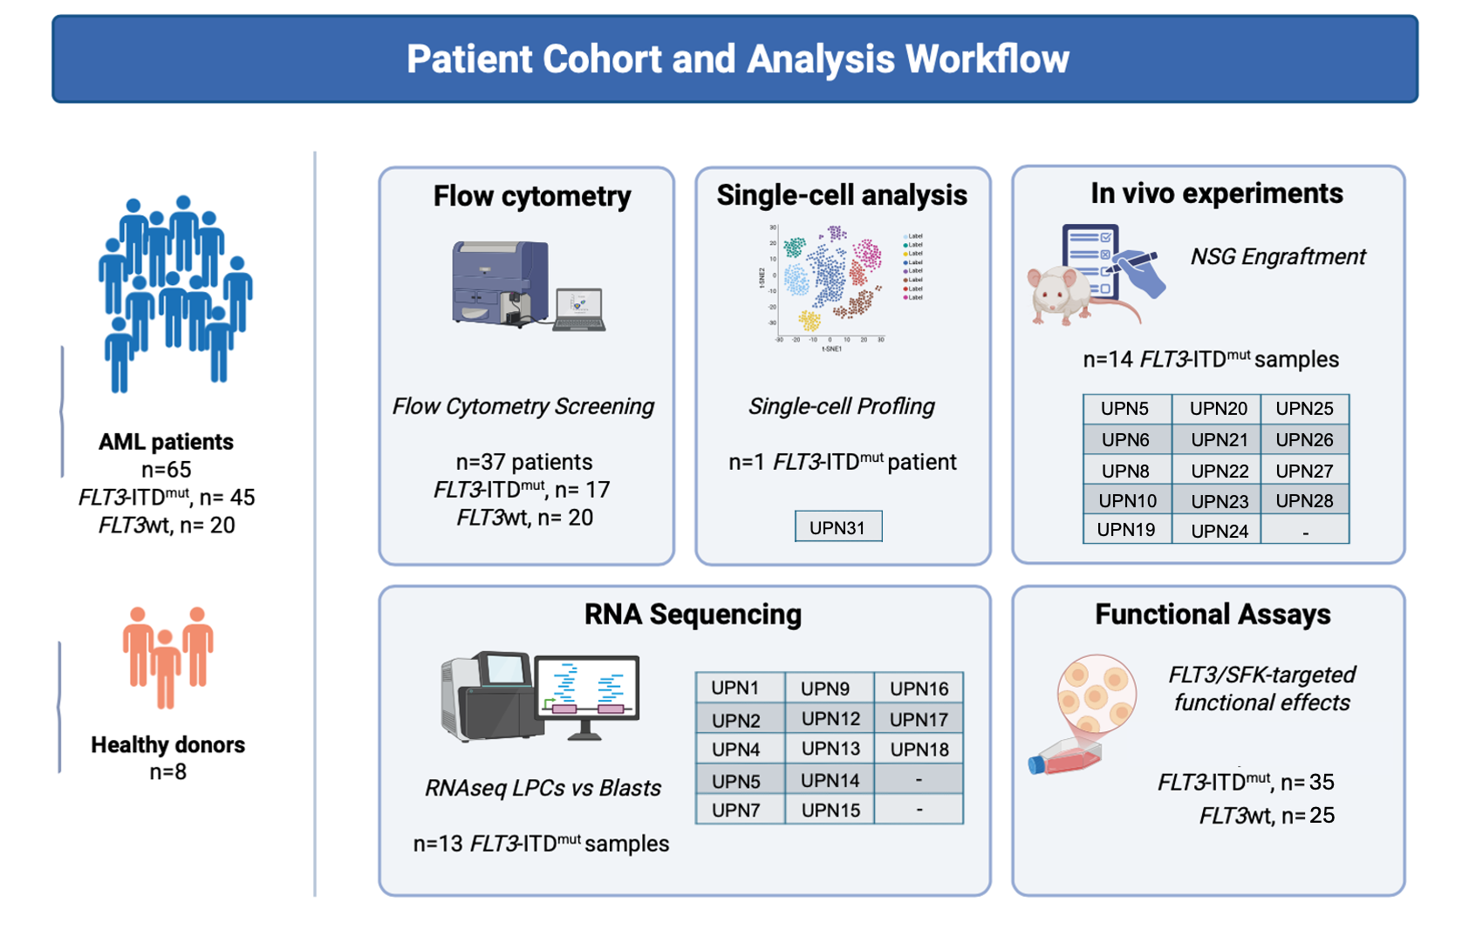

Figure S1. Schematic representation of sample distribution and methodological workflow.

Supplementary Figure 2

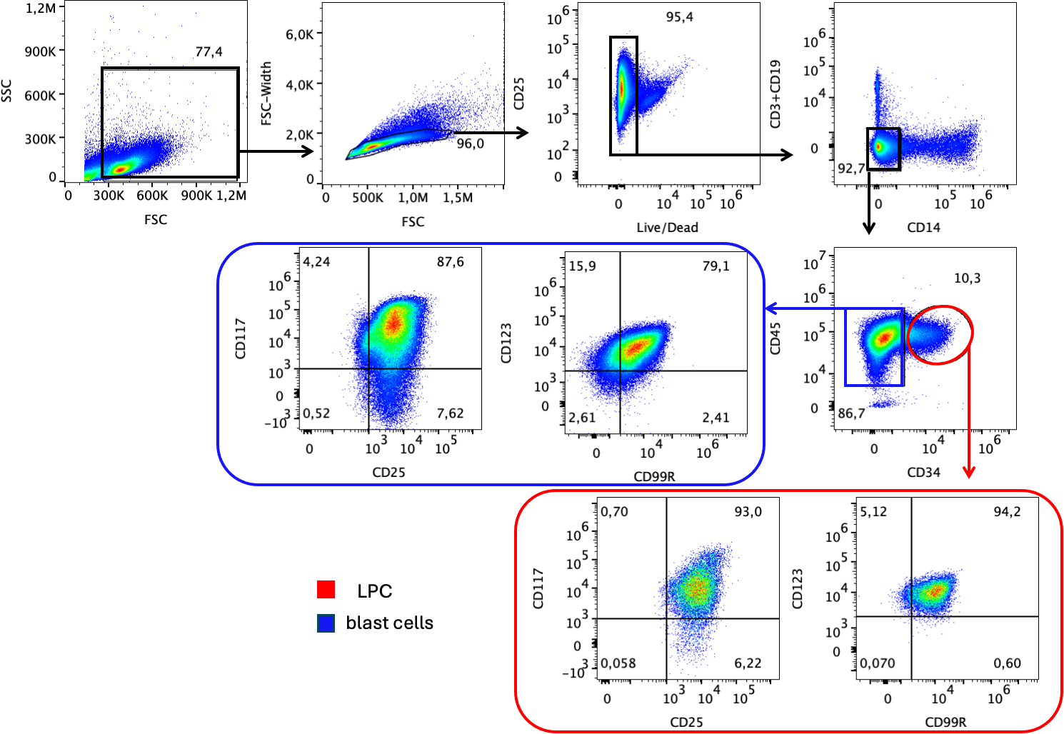

Figure S2. Representative Gating strategy for sorting. Representative flow cytometry analysis of a bone marrow (BM) sample from a patient with FLT3-ITD^{mut} mutated AML (UPN8) showing the gating strategy used to identify and sort the LPC population defined by CD34, CD123, CD25, and CD99R expression. After gating on physical parameters (FSC vs. SSC), cell doublets and non-viable cells were excluded. Cells expressing CD14, CD3, and CD19 were subsequently removed from the analysis. The remaining population was then divided into two subsets: CD34⁺ cells, referred to as LPCs, and CD34⁻ cells, designated as blast cells. The subsequent plots show the expression levels of CD99R, CD123, CD117, and CD25 in both LPCs and blast cells. In the majority of samples, the sorted populations achieved a purity greater than 99%, with contaminating cells accounting for less than 1% (LPC purity).

Supplementary Figure 3
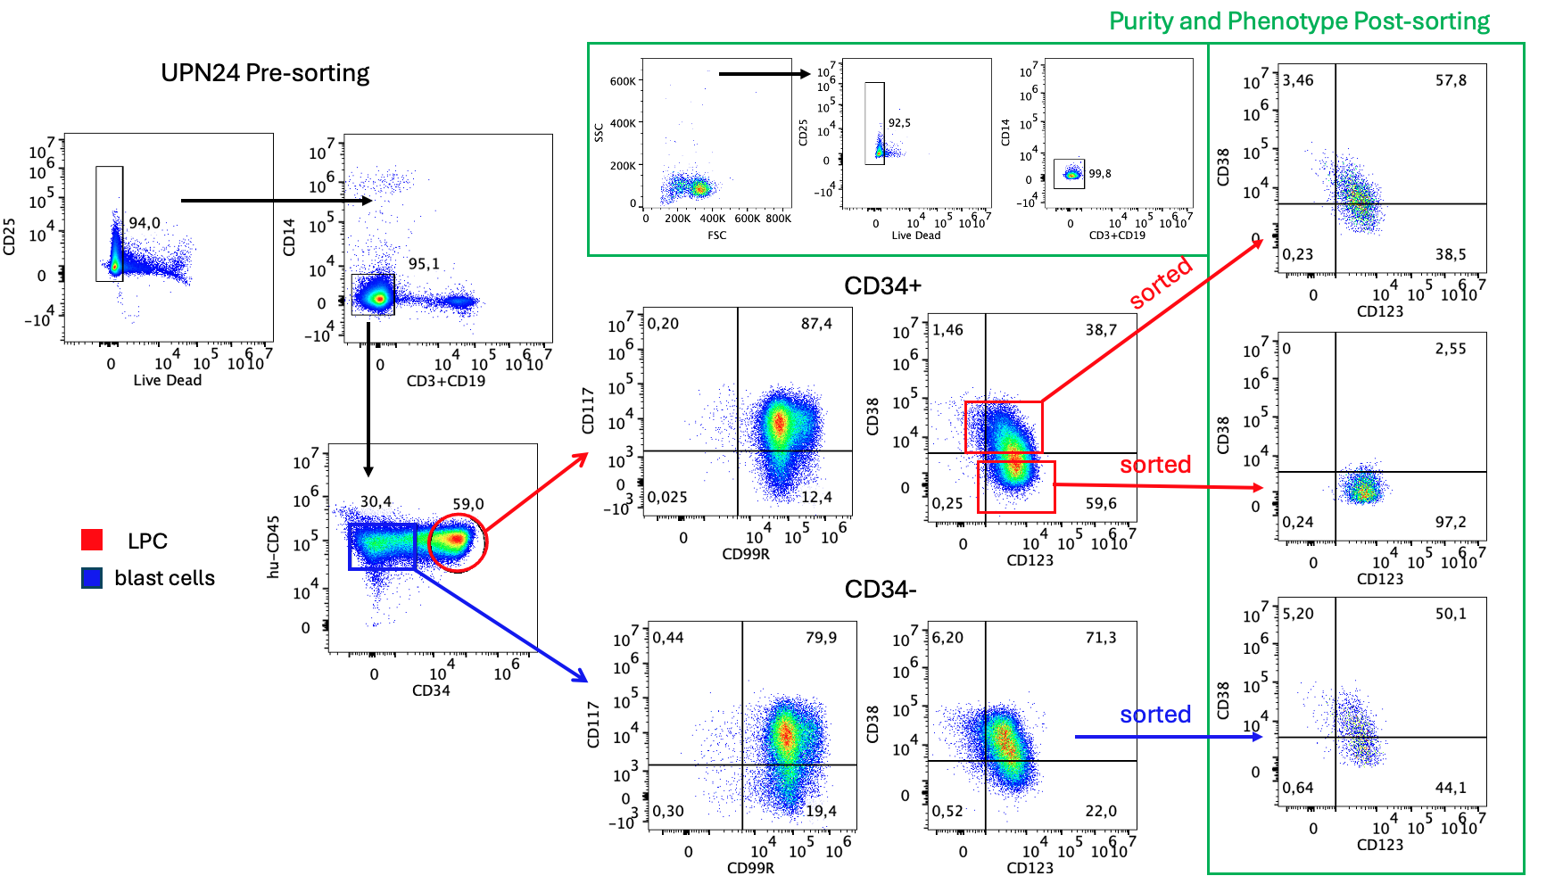

Figure S3. Representative gating strategy and post-sort purity of leukemic progenitor cells (LPCs) and blast cells from an FLT3-ITD^{mut} AML sample. Representative flow cytometry gating strategy used to identify, isolate and sort LPCs and blast cells from the bone marrow of an FLT3-ITD^{mut} AML patient (UPN24). Following the exclusion of dead cells and lineage-positive cells (CD3, CD14 and CD19), two leukemic populations were identified based on CD34 expression. LPCs (red gate) were defined as CD34⁺CD99R⁺CD123⁺CD117⁺ cells and were further subdivided into CD38⁻ and CD38low/+ fractions prior to cell sorting. In parallel, blast cells (blue gate) were sorted as the corresponding CD34⁻ leukemic population sharing the same aberrant immunophenotypic profile (CD99R⁺CD123⁺CD117⁺). The panels outlined in green show the post-sort purity of each isolated population together with the immunophenotypic characterization of the sorted cells, confirming the successful enrichment of the selected leukemic subsets.

Supplementary Figure 4

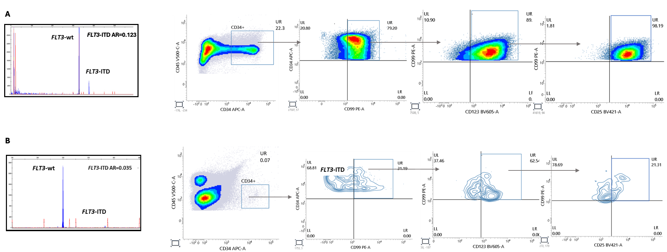

Figure S4. Identification of FLT3-ITD^{mut} clones using combined MPFC gating and capillary electrophoresis. (A) Representative capillary electrophoresis profile showing FLT3-ITD peaks and corresponding allelic ratio (AR) for a primary AML sample, alongside the multiparametric flow cytometry (MPFC) gating strategy used to identify CD34/CD123/CD25/CD99+ leukemic progenitor compartment. (B) Same analysis for a patient harboring a FLT3-ITD^{mut} micro-clone, illustrating that the LAIP-based MPFC strategy can detect small FLT3-ITD^{mut} populations within the overall leukemic fraction.

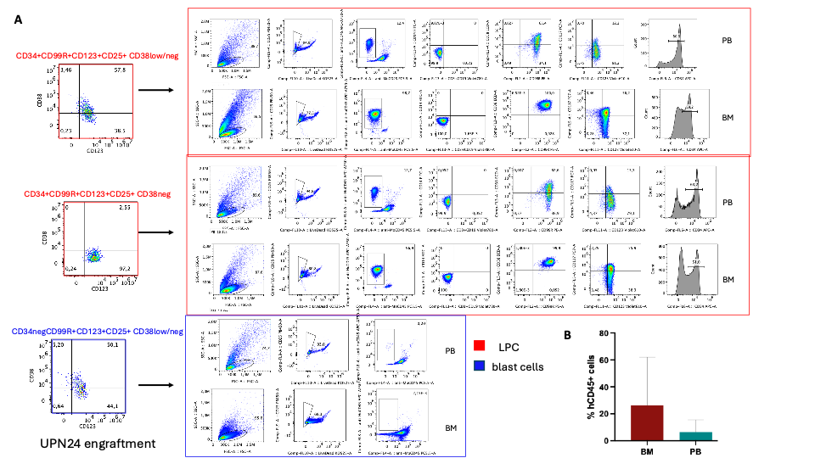
Supplementary Figure 5

Figure S5. Representative xenotransplantation experiments and summary of engraftment efficiency of FLT3-ITD^{mut} LPCs. (A) Representative xenotransplantation experiment performed using the three leukemic populations isolated from the FLT3-ITD^{mut} AML sample UPN24, previously described in Supplementary Figure S3. The CD34⁺CD99R⁺CD123⁺CD25⁺CD38^low/+ and CD34⁺CD99R⁺CD123⁺CD25⁺CD38⁻ LPC subpopulations (red) together with the corresponding CD34⁻CD99R⁺CD123⁺CD25⁺CD38^low/− blast population (blue) were sorted and transplanted independently into recipient mice. Representative flow cytometry plots show the percentage of human CD45⁺ cells detected in peripheral blood (PB) and bone marrow (BM) together with the immunophenotypic characterization of the engrafted human cells. Leukemic engraftment was observed exclusively in mice transplanted with the LPC subpopulations, whereas the corresponding blast population did not generate detectable engraftment. (B) Quantitative summary of all evaluable xenotransplantation experiments. Bar graph showing the percentage of human CD45⁺ cells in BM and PB of all recipient mice that achieved detectable engraftment.

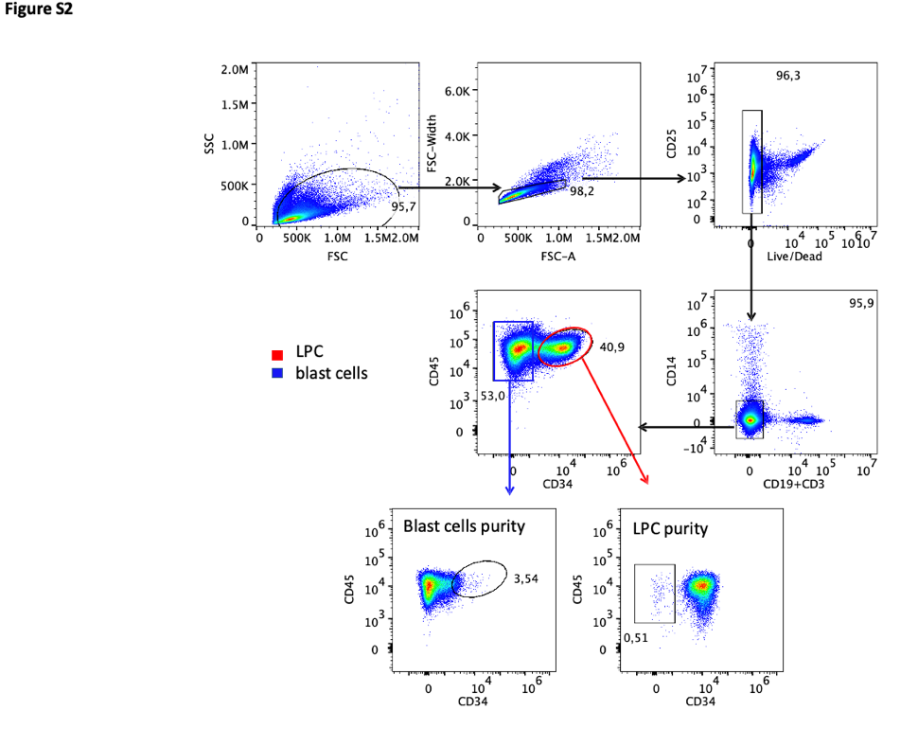
Supplementary Figure 6

Supplementary Figure S6. Representative gating strategy and post-sort purity of leukemic populations isolated from UPN27. Representative flow cytometry gating strategy used to identify and sort LPCs (red) and blast cells (blue) from the bone marrow sample of the FLT3-ITD^{mut} AML patient UPN27. Following the exclusion of dead cells and lineage-positive cells (CD3, CD14 and CD19), the leukemic populations were separated according to CD34 expression and subsequently sorted. Post-sort purity analysis is shown for both sorted populations. The LPC fraction achieved high purity, whereas the blast fraction contained approximately 3.5% contaminating LPCs. Consistent with this finding, transplantation of the sorted blast population resulted in a very low level of human cell engraftment (2.5% in bone marrow and 0.05% in peripheral blood), likely attributable to the presence of residual LPC contamination. The primary and secondary engraftment of the LPC population derived from UPN27 is presented in Figure 3.
Supplementary Figure 7

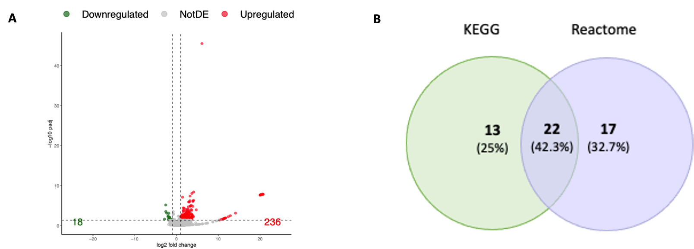

Figure S7. Gene expression profile and shared pathway alterations in FLT3-ITD^{mut} LPCs. (A) Volcano plot showing the comparison of DEGs between LPCs and blasts. Upregulated genes are shown in red, whereas downregulated genes are represented with green dots. Significant cut-offs are indicated dotted lines on the axes (FDR < 0.05 and |log2FC|≥ 1); (B) Venn diagram showing the intersection of the deregulated pathways identified by DAVID.

Supplementary Figure 8

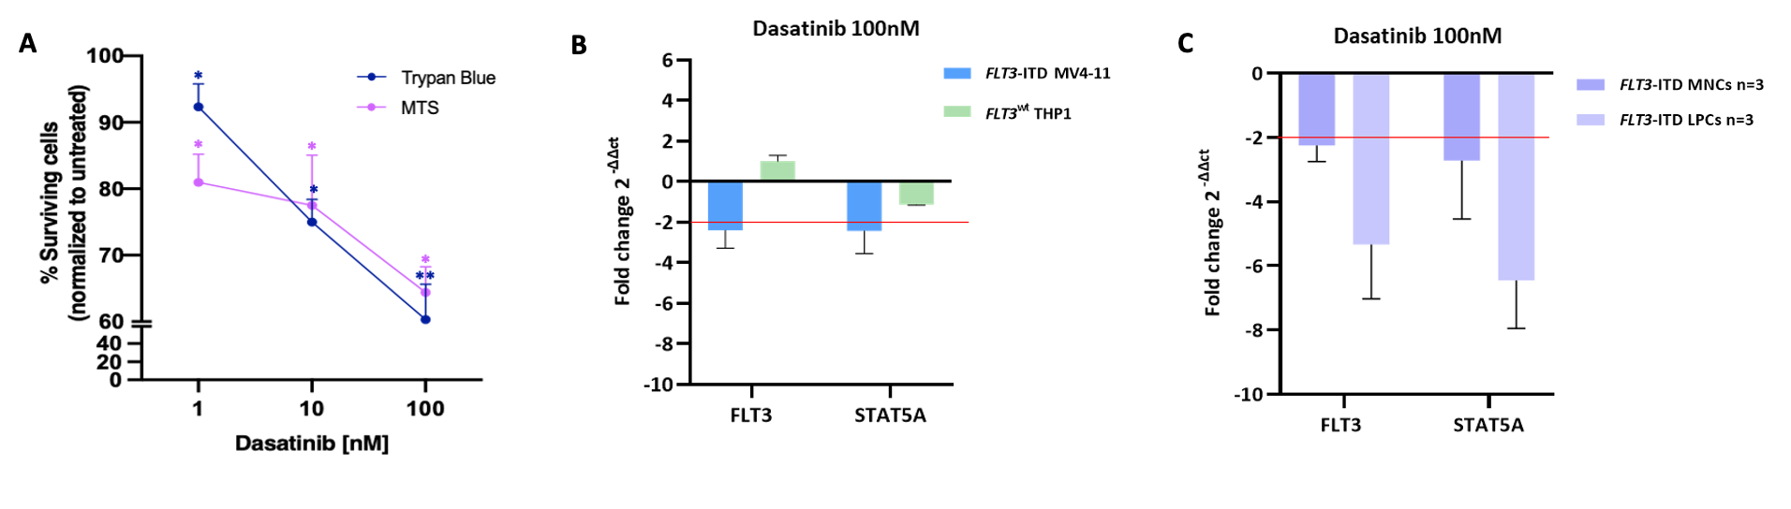
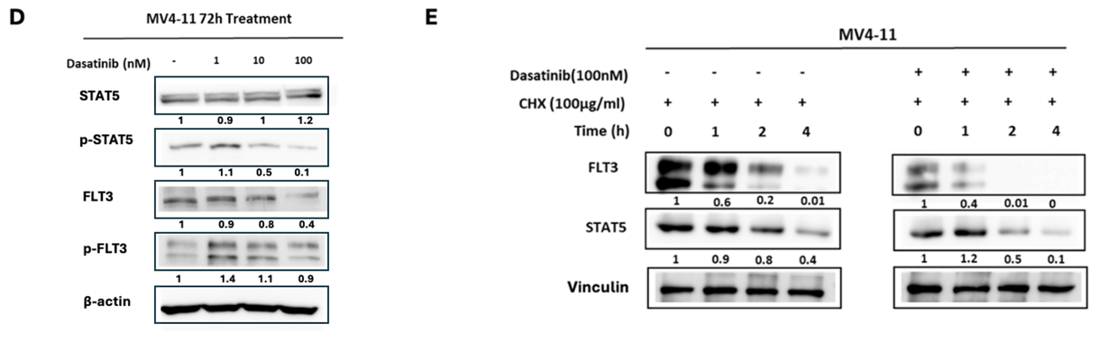

Figure S8. Effects of LCK inhibition on FLT3-ITD^{mut} AML cell survival and FLT3/STAT5 dynamics. (A) Proliferation rate of FLT3-ITD^{mut} MV4-11 cells evaluated after 72h of treatment with dasatinib, at increasing concentration, using Trypan blue and MTS assays; (B) Modulation of FLT3 and STAT5A expression by qRT-PCR in FLT3-ITD^{mut} MV4-11 and in FLT3^{wt} THP1 cells, in response to 72h of treatment with dasatinib. Data are presented as median with range. The significant fold change cut-off is depicted with a red line on the y-axis; (C) Modulation of FLT3 and STAT5A expression by qRT-PCR in paired FLT3-ITD^{mut} MNCs (n=3) and LPCs (n=3), in response to 72h of treatment with dasatinib. Data are presented as median with range. The significant fold change cut-off is depicted with a red line on the y-axis; (D) Expression of FLT3, STAT5A, p-STAT5A, p-FLT3 protein evaluated by Western Blot analysis in MV4-11 cells following 72h of treatment with increasing concentration of dasatinib; (E) Analysis of FLT3 and STAT5A protein stability, evaluated by CHX assay, following treatment with dasatinib for 1,2,4 h.
Supplementary Figure 9

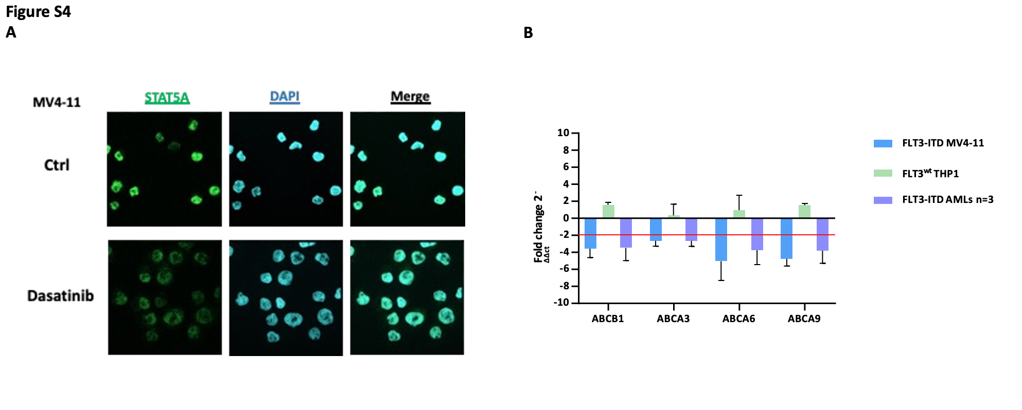

Figure S9. LCK inhibition decreased the expression of STAT5 and several ABC transporters in FLT3-ITD^{mut} MV4-11 cells (A) Reduction of STAT5A expression evaluated by immunofluorescence analysis of FLT3-ITD MV4-11 cells, following 24h of treatment with dasatinib. Cells were stained using anti-STAT5 antibody (green); (B) Modulation of ABCB1, ABCA3, ABCA6 and ABCA9 expression by qRT-PCR in FLT3^{wt} THP1, FLT3-ITD^{mut} MV4-11 and primary AML (n=3) cells, in response to 72h of treatment with dasatinib. Data are presented as median with range.

Supplementary Figure 10

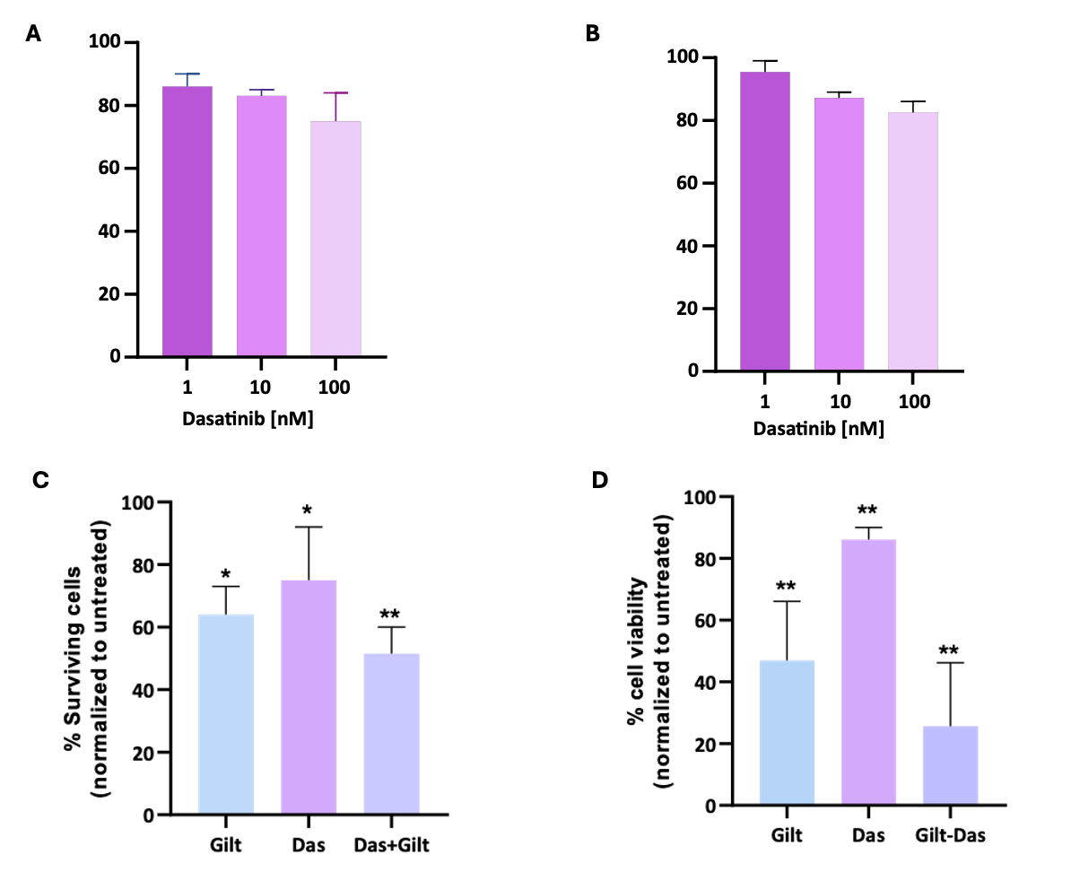

Figure S10. Gilteritinib enhances Dasatinib cytotoxic effect in MV4-11 cell lines through the inhibition of protein kinase activity. MV4-11 cells were exposed to increasing concentration of dasatinib (1, 10, and 100 nM) for 24h; cell proliferation and cytotoxicity were determined by Trypan Blue staining (A) and MTS assay (B). Data are presented as median with range. For combination experiments, MV4-11 cells were exposed to dasatinib (100 nM) and gilteritinib (5 nM) combination for 24h; cell proliferation and cytotoxicity were determined by Trypan Blue staining (C) and MTS assay (D). Data are presented as median with range. Values are normalized to the corresponding untreated control; asterisks indicate statistical significance relative to untreated cells.

Table S1. Primer sequences and PCR conditions used for qRT-PCR
Gene | Forward 5’ 3’ | Reverse 5’ 3’ | Ta (°C)
LCK | AACACTCACGGCTCCTTCCTCA | GTAGAAGCCACCGTTGTCCAGC | 60
STAT5A | CGAGTGCAGTGGTGAGATCC | CTGAGACTCAAACAGGACTGTGAA | 60
FLT3 | GAAACCCAAGCTGGAGAATACCTA | TGGAACGCTCTCAGATATGCAGAC | 60

