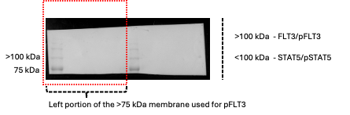
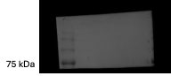
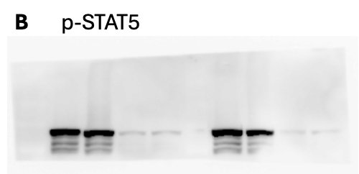

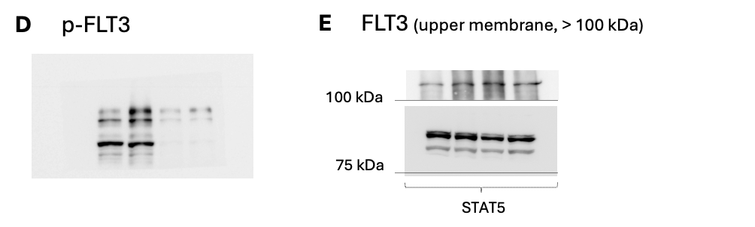
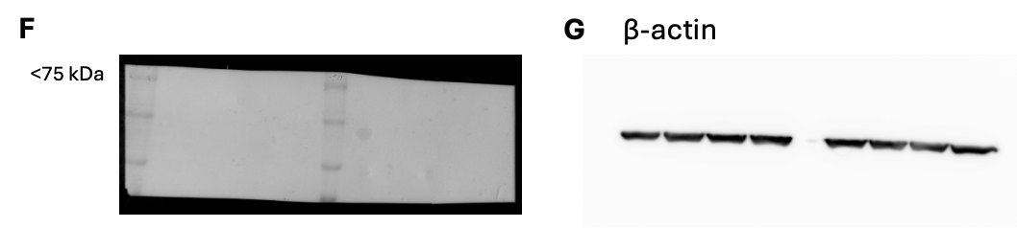
Original data Figure 1



Western-blot membranes and corresponding cropped panels for FLT3, STAT5A, p-STAT5A, p-FLT3 in FLT3-ITDmut primary samples after 6h of treatment with Dasatinib and Gilteritinib, related to Figure 6B. Membranes were cut horizontally according to molecular weight markers prior to antibody incubation. (A) Representative full-length membrane showing molecular weight markers and the region corresponding to the upper portion (>75 kDa), used for the detection of FLT3, p-FLT3, STAT5 and p-STAT5. (B) Membrane probed for p-STAT5. (C) A portion of the same membrane (left side) was separately processed (D) and probed for p-FLT3. (E) This upper membrane (>75 kDa) was further divided at 100 kDa: the upper portion (>100 kDa) was probed for FLT3 to reduce background signal, while the lower portion (< 100 kDa) was probed for STAT5. (F) Representative full-length membrane corresponding to the lower portion (<75 kDa), used for loading control detection. (G) This lower portion of the membrane (<75 kDa) was used for β-actin detection. Representative images from a single membrane are shown. Dashed box indicates the region corresponding to the cropped images shown.
Original data Figure 2

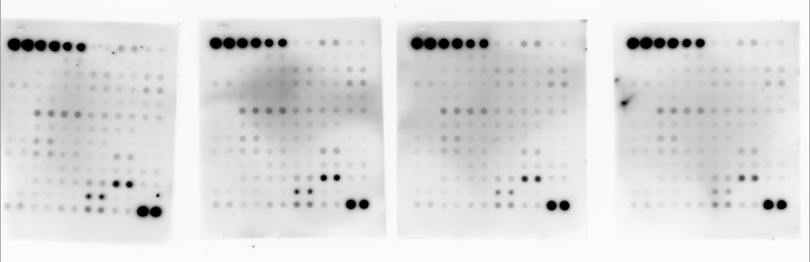

Western-blot membranes from Human Phosphorylation Antibody Array (ab193662) used to assess RTK signaling following treatment with dasatinib and gilteritinib, related to Figure 6C. Full-length membranes from independent experimental conditions are shown. These images represent the original membranes used for the quantification presented in Figure 6C.

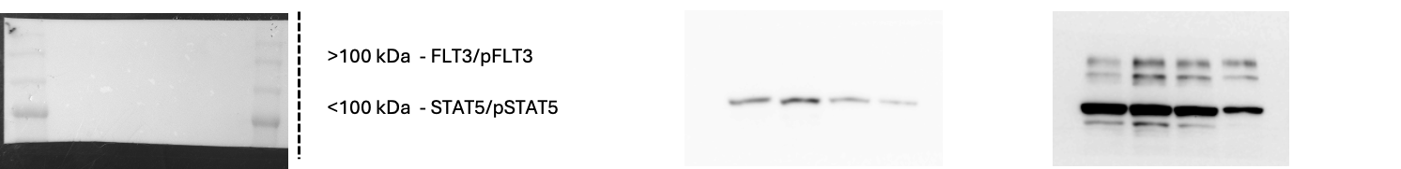
Original data Figure 3
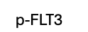
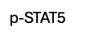








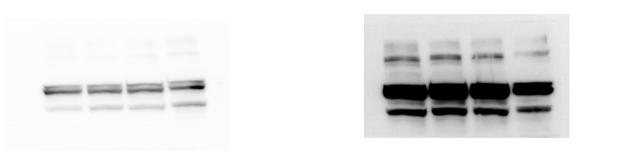

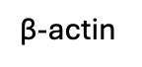


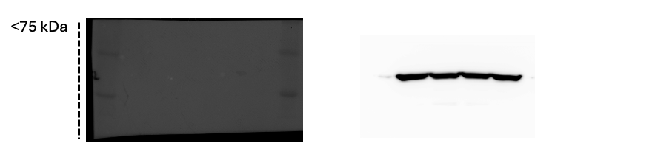

Western blot membranes for FLT3, STAT5, p-STAT5 and p-FLT3 in MV4-11 cells treated with dasatinib, related to Figure S6D. Membranes were cut horizontally according to molecular weight markers prior to antibody incubation. (A) Representative full-length image of the upper portion of the membrane (>75 kDa), showing molecular weight markers. This portion was used for the detection of FLT3, p-FLT3, STAT5 and p-STAT5. (B) Cropped membrane probed for p-STAT5. (C) Cropped membrane probed for p-FLT3. (D) Cropped membrane probed for STAT5. (E) Cropped membrane probed for FLT3. (F) Representative full-length image of the lower portion of the membrane (<75 kDa), used for loading control detection. (G) Cropped membrane probed for β-actin.

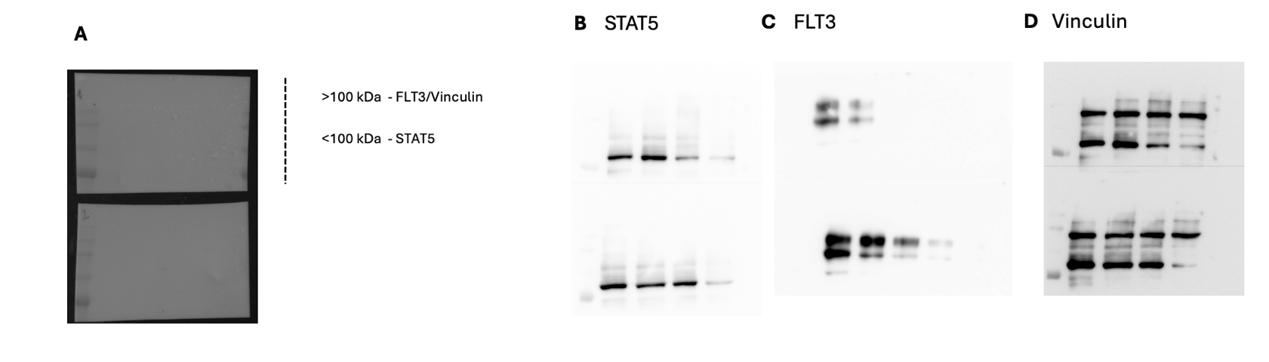
Original data Figure 4

Western blot membrane for STAT5, FLT3 and vinculin in MV4-11 cells, related to Figure S6E. The membrane was cut horizontally according to molecular weight markers prior to antibody incubation. The upper portion of the membrane (>75 kDa) was used for the detection of FLT3, STAT5 and vinculin. Left panel: representative full-length image of the membrane showing molecular weight markers and the regions corresponding to >100 kDa (FLT3 and vinculin) and <100 kDa (STAT5). (A) Cropped membrane probed for STAT5. (B) Cropped membrane probed for FLT3. (C) Cropped membrane probed for vinculin. All cropped images correspond to the same membrane shown on the left.

