ESAM Reduces Sensitivity to Anti-HER2 Therapy in HER2-Positive Breast Cancer by Activating the mTOR Pathway

Supplemental Material (Fig. S1- Fig. S4)
Fig. S1. 3D morphology of HER2-positive breast cancer PDOs treated with or without trastuzumab and pertuzumab. (A) Drug-insensitive PDOs (NS1, NS2) continued to proliferate and maintained their intact 3D structure. (B) Drug-sensitive PDOs (S1, S2) exhibited reduced growth rates and failed to maintain their spherical shape.
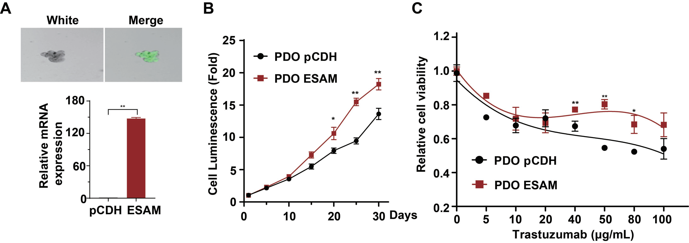
Fig. S2. High ESAM expression promotes the proliferation of HER2-positive breast cancer PDOs and confers trastuzumab insensitivity. (A) qPCR analysis of ESAM expression in PDOs infected with pLenti-ESAM or a pLenti-vector control. (B) PDOs proliferation was assessed using the CellTiter-Glo Luminescent Cell Viability Assay. (C) Cell viability assays demonstrated that ESAM overexpression significantly reduced PDOs sensitivity to trastuzumab. (The quantitative data are presented in the histograms and were assessed with a two-tailed unpaired Student’s t test. Data are presented as the mean ± SD. *P < 0.05, **P < 0.01).
Fig. S3. ESAM expression is positively correlated with the mTORC1 signaling pathway. (A) GSEA of the TCGA database revealed that ESAM expression is positively associated with both the mTORC1 and PI3K/AKT/mTOR pathways, and RNA-seq of ESAM-overexpressing cells confirmed mTORC1 hyperactivation. (B) Western blot and (C) qPCR analyses evaluating correlation between ESAM expression and mTOR pathway proteins (mTOR, p-mTOR and p-S6) in 26 HER2-positive breast cancer surgical specimens obtained from FUSCC (2014). (D, E) Western blot analysis of p-mTOR (Ser2481), p-p70 S6 (Ser371), and p-4EBP1 (Thr37/46) levels in ESAM-overexpressing BT474 cells compared to control cells, following treatment with or without Everolimus or LY294002. (The quantitative data are presented in the histograms and were assessed with a two-tailed unpaired Student’s t test. Data are presented as the mean ± SD. *P < 0.05, **P < 0.01).
Fig. S4. Supplementary characterization of the ESAM–Calnexin axis. (A) Western blot analysis evaluating Calnexin expression in control and ESAM-overexpressing SK-BR-3 cells under basal conditions or following trastuzumab treatment. (B) Silver staining demonstrating the interaction between ESAM and Calnexin. (C, D) Western blot analysis of representative ER-associated degradation components, including HRD1, VCP/p97, and SEL1L, together with the UPR/ER-stress marker CHOP following ESAM overexpression or depletion in BT474 (C) and SK-BR-3 (D) cells. Manipulation of ESAM expression did not markedly alter the abundance of the examined ERAD- or UPR-associated proteins. (E) Kaplan-Meier survival analysis evaluating the association between ESAM expression and clinical outcomes (OS, RFS, DMFS, and PPS) using the publicly available KM-plotter database (http://kmplot.com/analysis/). (*P < 0.05).

Supplemental Material (Table S1- Table S5)
Table S1 Correlation between ESAM expression and clinicopathologic features of HER2 positive patients of FUSCC database (n=95)
Factors | Number of cases | ESAM expression |  | P value
Factors | Number of cases | Low (%) | High (%)
Number of cases | 95 | 47 | 48
Age | 95 |  |  | 0.712
<40 |  | 6(12.8) | 4(8.3)
≥40 |  | 41(87.2) | 44(91.7)
pN | 95 |  |  | 0.762
pN0 |  | 24(51.1) | 26(54.2)
pN1-3 |  | 23(48.9) | 22(45.8)
pT | 94 |  |  | 0.791
Tis |  | 5(10.6) | 5(10.6)
pT1 |  | 13(27.7) | 14(28.8)
pT2-3 |  | 29(61.7) | 28(59.6)
TNM | 85 |  |  | 0.740
Ⅰ-Ⅱ |  | 23(54.8) | 22(51.2)
Ⅲ |  | 19(45.2) | 21(48.8)
Ki67 | 75 |  |  | 0.378
<20% |  | 21(53.8) | 23(63.9)
≥20% |  | 18(46.2) | 13(36.1)
*P < 0.05

Table S2 Pathological and immunohistochemical information of the patients corresponding to the organoids (n=13)
Patient ID | Pathology | Receptor status
Patient ID | Pathology | ER | PR | HER2 | Ki67
001 | IDC | 2% | Negative | 3+ | 40%
002 | IDC | Negative | Negative | 3+ | 30%
003 | IDC | Negative | Negative | 3+ | 60%
004 | IDC | Negative | Negative | 3+ | 60%
005 | IDC | Negative | Negative | 3+ | 60%
006 | IDC | Negative | Negative | 3+ | 80%
007 | IDC | Negative | Negative | 3+ | 30%
008 | IDC | Negative | Negative | 3+ | 40%
009 | IDC | Negative | Negative | 3+ | 40%
010 | IDC | Negative | Negative | 3+ | 60%
011 | IDC | Negative | Negative | 3+ | 40%
012 | IDC | Negative | Negative | 3+ | 60%
013 | IDC | Negative | Negative | 3+ | 40%

Table S3 shRNA sequences targeting human ESAM and Calnexin
siRNA | sequences
ESAM-sh1-AS | AATTCAAAAAGACAAACAAGGCAAATCTACTCGAGTAGATTTGCCTTGTTTGTC
ESAM-sh1-S | CCGGGACAAACAAGGCAAATCTACTCGAGTAGATTTGCCTTGTTTGTCTTTTTG
ESAM-sh2-AS | AATTCAAAAAGATATCAAGGAGGATGCCATTCTCGAGAATGGCATCCTCCTTGATATC
ESAM-sh2-S | CCGGGATATCAAGGAGGATGCCATTCTCGAGAATGGCATCCTCCTTGATATCTTTTTG
Calnexin-sh-AS | CCGGCAAGGTTACTTACAAAGCTCTCGAGAGCTTTGTAAGTAACCTTGTTTTTG
Calnexin-sh-S | AATTCAAAAACAAGGTTACTTACAAAGCTCTCGAGAGCTTTGTAAGTAACCTTG

Table S4 siRNA sequences targeting human mTOR
siRNA | sequences
mTOR-si1-S | GAGCCUUGUUGAUCCUUAATT
mTOR-si1-AS | UUAAGGAUCAACAAGGCUCTT
mTOR-si2-S | GCUGUGAGGUCUGAGUUUATT
mTOR-si2-AS | UAAACUCAGACCUCACAGCTT

Table S5 Primer sequences for qPCR
Primer | sequences（5’-3’）
ESAM | Forward Primer: CGCTGTCCAATACCAGTGGGAT  Reverse Primer: CCTTGCAGACATAGACTCCAGC
β-actin | Forward Primer: CACCATTGGCAATGAGCGGTTC  Reverse Primer: AGGTCTTTGCGGATGTCCACGT
Calnexin | Forward Primer: TCTTGGTTCTGCGGCACG  Reverse Primer: AGCAGTTCCAAGCACCAGTAA

