Supplementary Information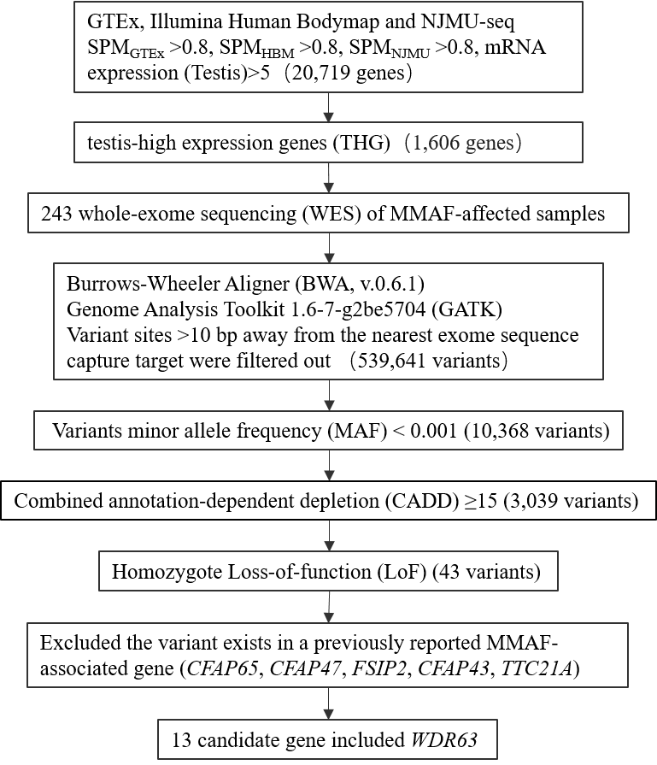
Supplementary Fig. S1: The screening process of harboring variants in WDR63 gene.

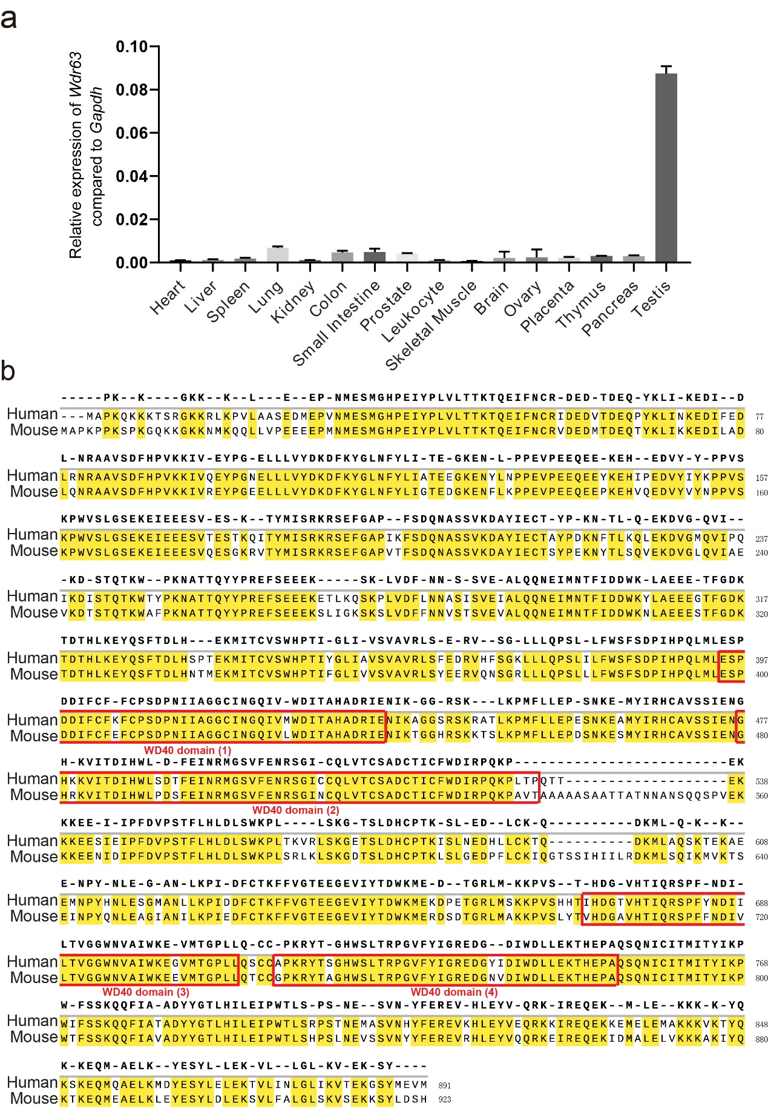

Supplementary Fig. S2: WDR63 was highly expressed in human testes and conserved among different species
a Real-time q-PCR for Wdr63 in various human tissues with Gapdh as a control. Human tissues cDNA come from Human MTC Panel I kit (Cat. #: 636742, Clontech). Error bars, SEM (n = 3). b Amino acid sequence alignment between human and mouse WDR63 protein. The red box indicates WD40 domain of WDR63 in human and mouse.

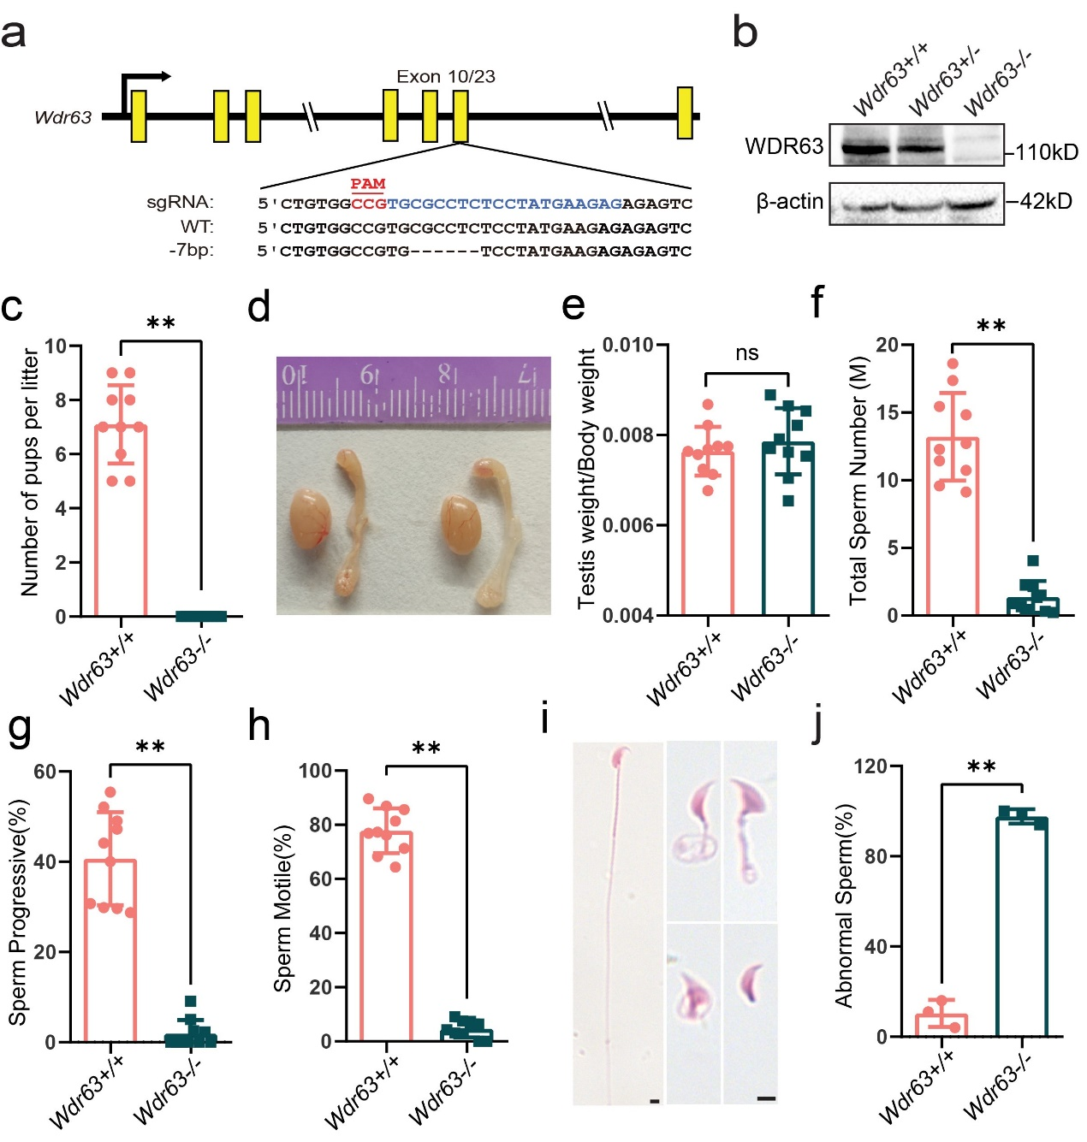

Supplementary Fig. S3: Phenotypes of Wdr63 null male mice with 7-bp frameshift deletion
a Schematic of the Wdr63 knocked out mouse utilized CRISPR/Cas9 system. The sgRNA was designed to target exon 10 of the Wdr63, a 7-bp frameshift deletion was obtained. b Western blot analysis of Wdr63 wild-type (Wdr63−/−), heterozygous mice (Wdr63+/−) and homozygous mice (Wdr63+/+) testes with a mouse polyclonal antibody raised against WDR63. β-actin was used as a loading control. c Breeding results from Wdr63+/+and Wdr63−/−. d-e Testes and epididymis from 8-week-old mice were comparable between Wdr63+/+ and Wdr63−/− male mice. f Total sperm number, g sperm progressive and h sperm motile were analysis by Computer Assisted Sperm Analyzer (CASA) method. i-j HE staining analysis morphology of the spermatozoon from Wdr63+/+ and Wdr63−/− male mice evident under light microscopy. Scale bars: 5 μm. All the phenotypes consistent with Wdr63 null Male Mice with the nonsense mutation (GCG-TGA) plus a 2-bp deletion genotype. Abbreviations: M, million. For c to h, n=10 and the bars represent mean ± SEM. For j, n=3 and the bars represent mean ± SEM. The statistical analysis was carried out using One-way ANOVA test, ** denotes P < 0.01; ns, not significant.

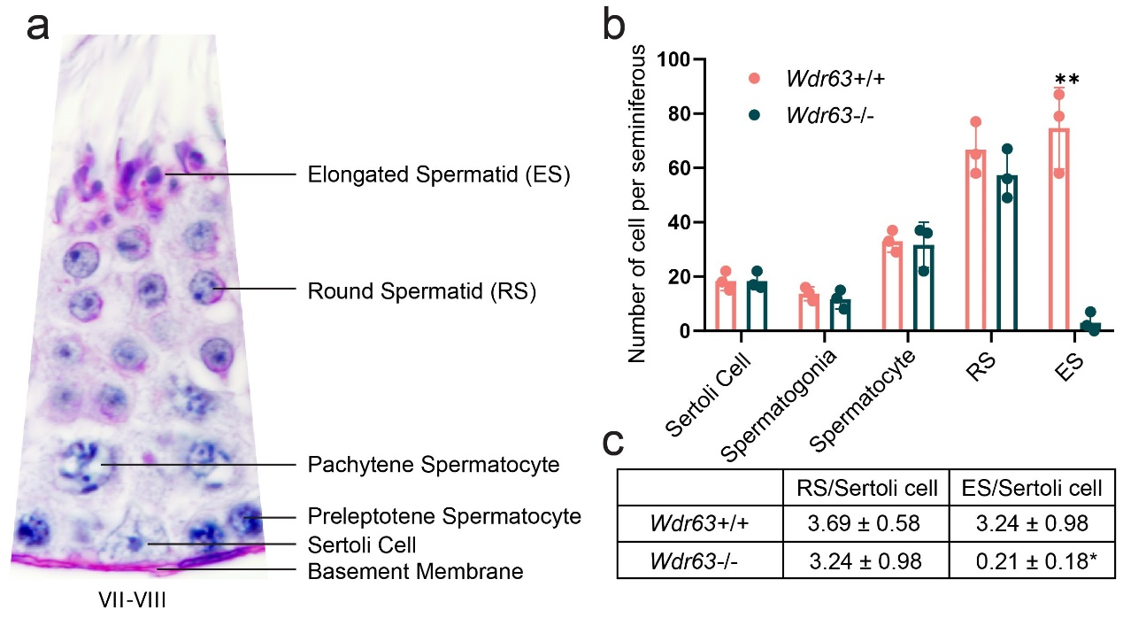
Supplementary Fig. S4: The number of elongated spermatids is significantly reduced in VII–VIII seminiferous tubules.
a Schematic diagram of different spermatogenic and sertoli cells in Periodic acid–Schiff (PAS) staining. b The number of different spermatogenic and sertoli cells per seminiferous. c the ratios of elongated spermatid and Sertoli cells in homozygous and wild-type. For b to c, n=3 and the bars represent mean ± SEM. The statistical analysis was carried out using One-way ANOVA test, * denotes P < 0.05, ** denotes P < 0.01.

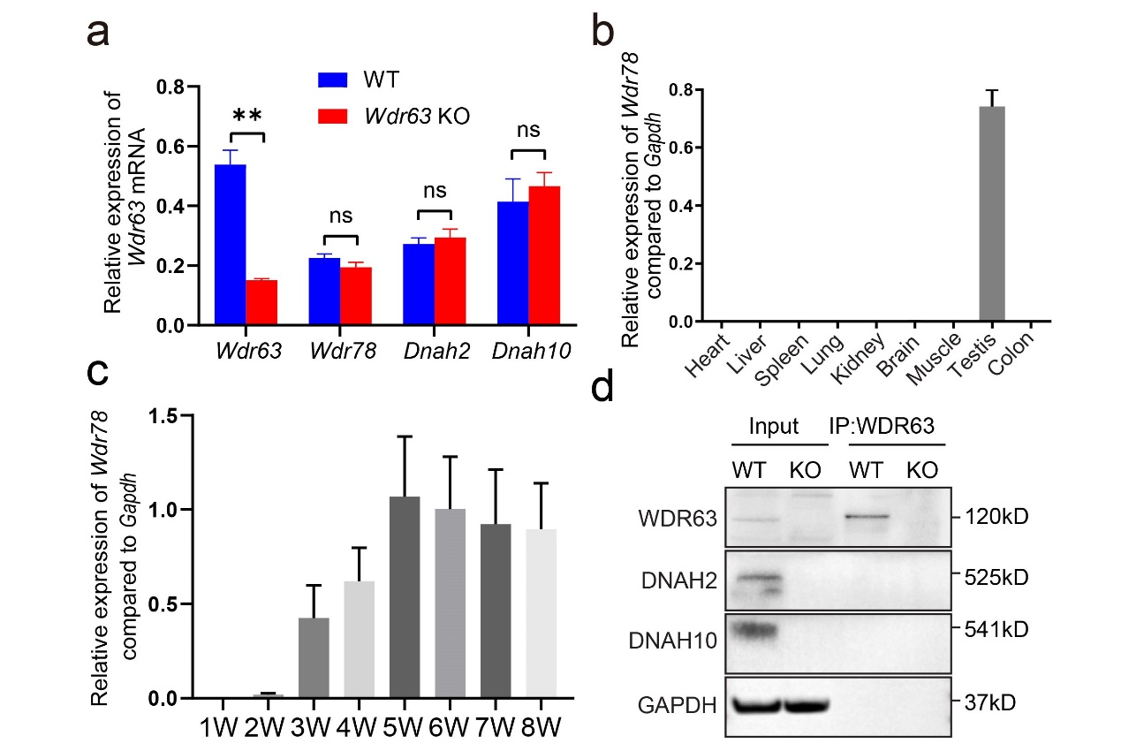

Supplementary Fig. S5: WDR63 only bind to WDR78 but not DNAH2 and DNAH10 in mammals
a mRNA levels of Wdr63, Wdr78, Dnah2 and Dnah10 in wild-type and Wdr63-KO mouse testis. b Real-time q-PCR for Wdr78 transcripts in various mouse tissues, and Gapdh gene is used as a control. Error bars, SEM (n = 3). c mRNA levels of Wdr78 in mouse testis at the indicated time points. Error bars, SEM (n = 3). d Immunoblotting followed by co-IP assays demonstrated that WDR63 did not bind to DNAH2 and DNAH10 in mammals. For a, n=3 and the bars represent mean ± SEM. The statistical analysis was carried out using One-way ANOVA test, ** denotes P < 0.01; ns, not significant.

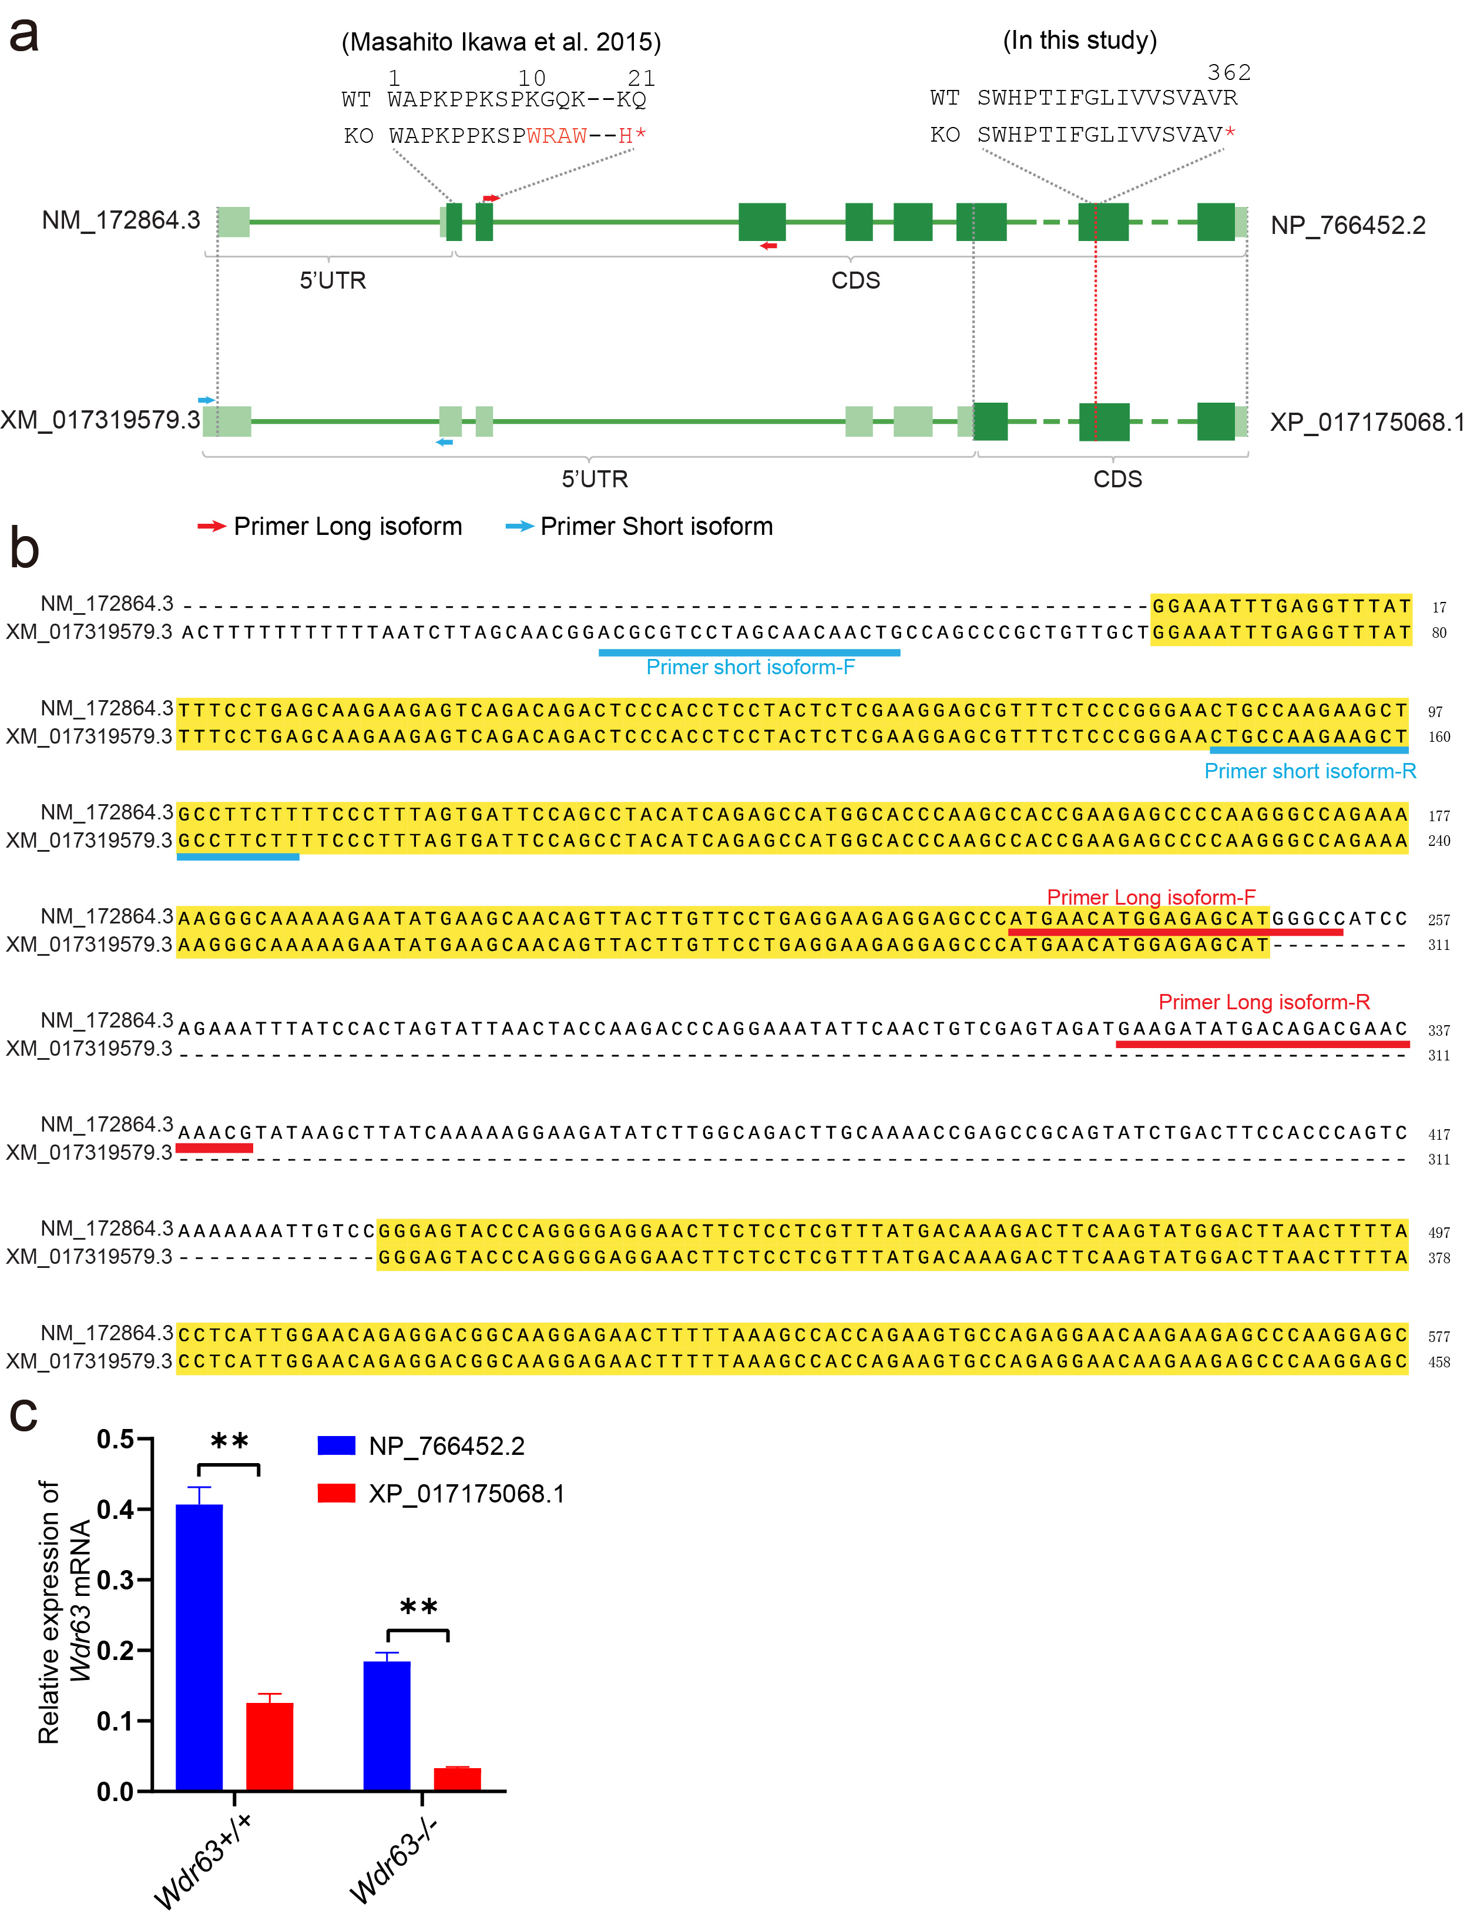

Supplementary Fig. S6: Wdr63 produce two distinct Wdr63 transcripts and both of them expressed in mice testes.
a As show in schematic diagram, Wdr63 produce two distinct Wdr63 mRNA isoforms differing in their transcriptional initiation, named long isoform (NM_172864.3) and short isoform (XM_017319579.3). A previous study reported that Wdr63-KO male mice with a 472bp deletion spanning exon 2 and exon 3 induced a premature stop codon in long isoform but not short isoform. In this study, we engineered a sgRNA target on exon 10 of Wdr63, which located at common regions of two transcripts. Two pairs of primers in non-common regions were used to distinguish long and short transcripts. b Sequencing alignment of non-common regions between long and short transcripts. The underlining indicates the location of primers at two transcripts. c Real-time q-PCR for two transcripts of Wdr63 in wild-type and Wdr63-KO mice testes, and Gapdh gene is used as a control. For c, n=3 and the bars represent mean ± SEM. The statistical analysis was carried out using One-way ANOVA test, ** denotes P < 0.01.

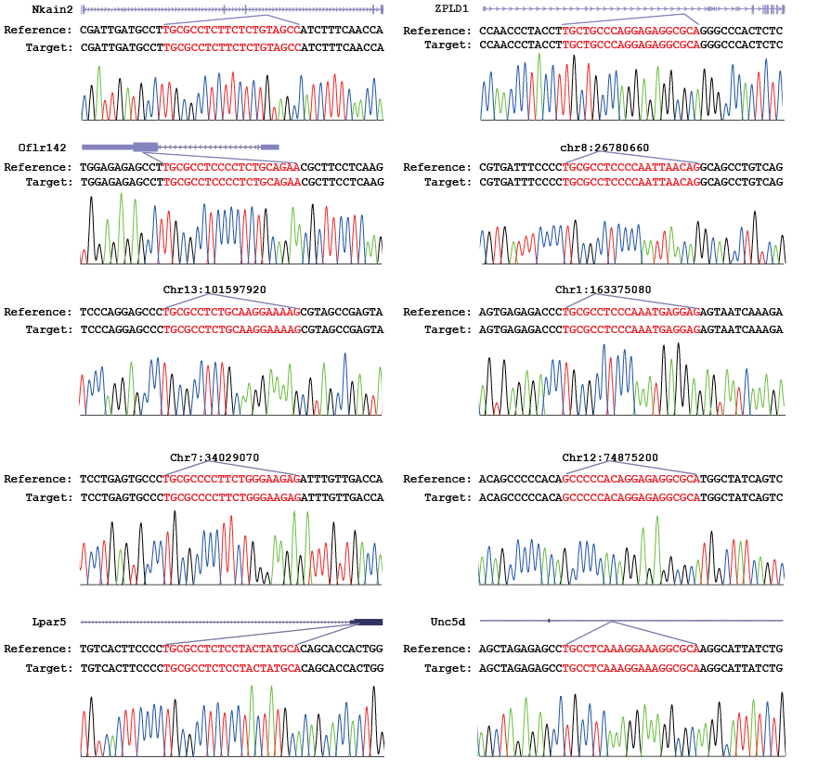
Supplementary Fig. S7: The off-target evaluation of CRISPR-Cas9 in Wdr63-KO mice
The potential off-targets site's genomic locations were identified by Off-Spotter server. Sanger sequencing using to verify the sequence of off-targets sites is mismatch.

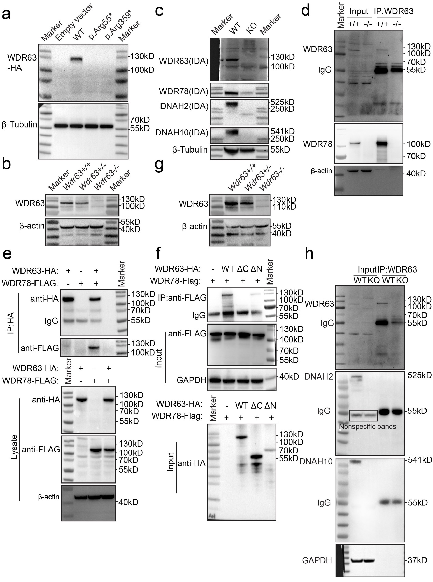
Supplementary Fig. S8: Original Immunoblots for Indicated Figures
a-h relative to Fig. 1d, Fig. 2d, Fig. 5a, Fig. 5b, Fig. 5c, Fig.5f, Supplementary Fig. 3b, Supplementary Fig. 5d, respectively.

Supplementary Tables
Supplementary Table S1: Semen characteristics of men carrying bi-allelic WDR63 variants
 | M1 | M2 | Reference Values
Semen Parameters
Semen volume (mL) | 1.6 | 1.5 | >1.5
Sperm concentration (10⁶/mL) | 7.5* | 0* | >15.0
Total sperm count (10⁶) | 12.0* | 0* | >39.0
Motility (%) | 0* | 0* | >40.0
Progressive motility (%) | 0* | 0* | >32.0
Lower and upper reference limits are shown according to the World Health Organization standards and the distribution ranges of morphologically abnormal spermatozoa observed in fertile individuals.
*Abnormal values.

Supplementary Table S2: Primers used for WDR63 Sanger sequencing.
Primer Name | Primer Sequence (5'-3')
WDR63-exon1-F | AGAGTTGCTGCGGTTTGTG
WDR63-exon1-R | GCCTTTCCCATTCAGAGCTT
WDR63-exon2-F | GCCCAGGGTAAATCTTAGAAAAC
WDR63-exon2-R | AAAAATCCCATTCAATGAAGAAATA
WDR63-exon3-F | TGATTCAAAAATGTAAATTTGACTTCC
WDR63-exon3-R | TCAGTTTGTAGTATTCCTGCTTGC
WDR63-exon4/5-F | AGGACCTGCGCAACAGAG
WDR63-exon4/5-R | ACAAGCAGAAGCTCATTTCCA
WDR63-exon6-F | GCTATAACCTAAACTTGGGCATACA
WDR63-exon6-R | CCCTCAGGAATAAGTGTTGTTCA
WDR63-exon7-F | TCAGGGACTTCATTATGTTACCTTT
WDR63-exon7-R | CATTTTGTCTGAGTGCTTATGTCC
WDR63-exon8-F | TCATGTAGCCTTTGAATAGTGGTC
WDR63-exon8-R | TGCATTGTTAAGAAAATCAACCA
WDR63-exon9/10-F | CTGTGTCTCATGGCATCCAA
WDR63-exon9/10-R | AAAAGAAAGTCGCACGGCTA
WDR63-exon11-F | TCGCCATGATCTTAATCTCTTTT
WDR63-exon11-R | GTCCAAGGAACTGCCAAGTC
WDR63-exon12/13-F | AAGAGCCACACTGAAGGTAAGC
WDR63-exon12/13-R | CATTTTCTATTGAAGAGACTGCACA
WDR63-exon14-F | CGGCCGGTATGTTCTTTTATT
WDR63-exon14-R | GCAACAATCCATAACATTCTTTCA
WDR63-exon15-F | AGGCTGCACCTCTTGTTTGT
WDR63-exon15-R | TGAGCTGCTCTACTTTTAGAGAGTGT
WDR63-exon16-F | TCTTTGCTATATGTTCTCCCAAAA
WDR63-exon16-R | ACCGTGTTAGCCAGGATGAT
WDR63-exon17-F | GCAAGGGGCAGAAAATGTAA
WDR63-exon17-R | TGCAAACAAGCATACTAAAATATGAAA
WDR63-exon18-F | GCACATGAGTGTGAAGTCTTTTG
WDR63-exon18-R | CCTCCCATTAGCAAGACCAG
WDR63-exon19-F | CACTGCAGGAATGCAAACAG
WDR63-exon19-R | AAAAAGTGTCCCAAAGGCACTA
WDR63-exon20-F | GCATGGTGAATTTCCCTCAG
WDR63-exon20-R | TGTTCCCGAGTTACCCAAAA
WDR63-exon21-F | GATGGTTTTCTGTTTGCTGATTT
WDR63-exon21-R | TCCCTTACAGAGCAAAAATGC
WDR63-exon22-F | CCTGTCACCCTCTCATGGAC
WDR63-exon22-R | CCACTGGTGTTCGAGGAAA
WDR63-exon23-F | CCCCCAGAAAACATATCAGAAG
WDR63-exon23-R | AGAGGGAAGAAGTCCCCAAA

Supplementary Table S3: Primers used for Wdr63 KO mouse genotype analysis.
Primer Name | Sequence (5'-3')
WDR63-F | AACCTTCCAAGTACACTGT
WDR63-R | GGTAATTGATGGAGGTTGC

Supplementary Table S4: Primers used for off-target evaluation.
Primer Name | Primer Sequence (5'-3')
chr2:90252087-90252509-F | GGGGTTCAGCATAGGGGTA
chr2:90252087-90252509-R | TAAAGGTGTCAGTGCAGGCA
chr8:26780453-26780875-F | CCTTATGGGTCCGCACAG
chr8:26780453-26780875-R | CTCTCCGTCCCACTCTGC
chr13:101597715-101598137-F | GGGCTGTGGACACTCAAAGT
chr13:101597715-101598137-R | CTTCCCAGAGCCTAATGTTGG
chr1:163374875-163375297-F | AACCCAGTGAGAGGCAGATAGA
chr1:163374875-163375297-R | ACACACATGCACACATGTAAACA
chr7:34028865-34029287-F | CTATGGTGATGGGAGCCACT
chr7:34028865-34029287-R | ACTAGCCCCAAAATGGCTGT
chr12:74874991-74875413-F | CTCGCTGGGTGGTAATTTTC
chr12:74874991-74875413-R | AAACCCATCCAGGGAATTAAA
chr6:125081392-125081814-F | CTGGTATTGGCGACTGGTCT
chr6:125081392-125081814-R | CCAGATGAACATGTACGGCA
chr8:28850810-28851232-F | AGCCACAGAACCCATAGGAA
chr8:28850810-28851232-R | CACACATGCACACCATTCAC
chr3:102027968-102028390-F | CCCACCAGCATTTCTGTACC
chr3:102027968-102028390-R | CTTATACCTCTGGCTGGCTCA
chr6:124893068-124893490-F | CCAGCTACTCCAGGGCCTA
chr6:124893068-124893490-R | TTTAGCACTGGATGCCCTG

Supplementary Table S5: Primers used for RT-qPCR analysis.
Primer Name | Primer Sequence (5'-3')
M-WDR63-F | ACCGAGCCGCAGTATCTGA
M-WDR63-R | GCCGTCCTCTGTTCCAATGAG
H-WDR63-F | GGGCAGATTGTCATGTGGGA
H-WDR63-R | TATGGCCACGTTCCAACCTC
M-DNAH2-F | TGGATGTTAAGAACACCTCTTGG
M-DNAH2-R | GGTTCACCAGGGCTAACTCA
M-DNAH10-F | TGTGCCGAGTCATCAACCTA
M-DNAH10-R | AAAGGTCCTGGCAGATGTTG
NM_172864.3-F | ATGAACATGGAGAGCATGGGCC
NM_172864.3-R | CGTTTGTTCGTCTGTCATATCTTC
XM_017319579.3-F | ACGCGTCCTAGCAACAACTG
XM_017319579.3-R | AAGAAGGCAGCTTCTTGGCAG
M-GAPDH-F | AGGTCGGTGTGAACGGATTTG
M-GAPDH-R | GGGGTCGTTGATGGCAACA
H-GAPDH-F | GGAGCGAGATCCCTCCAAAAT
H-GAPDH-R | GGCTGTTGTCATACTTCTCATGG

Supplementary Movie S1: Sperm Motility in wild-type male mice.
Supplementary Movie S2: Sperm Motility in Wdr63-KO male mice.
Supplementary Data S1: The data of Mass spectrometric analysis.

