Supporting Information
Synaptic devices implemented with two-dimensional layered single crystal chromium thiophosphate (CrPS₄)
Mi Jung Lee,^{1†} Sangik Lee,^{1†} Sungmin Lee,^{2,3} K. Balamurugan,^{2,3} Chansoo Yoon,¹ Jun Tae Jang,⁴ Sung-Hoon Kim,^{5,6} Deok-Hwang Kwon,⁷ Miyoung Kim,⁷ Jae-Pyoung Ahn,⁵ Dae Hwan Kim,⁴ Je-Geun Park,^{2,3} and Bae Ho Park¹*

¹Department of Physics, Konkuk University, Seoul 05029, Korea
²Center for Correlated Electron Systems, Institute for Basic Science, Seoul 08826, Korea
³Department of Physics and Astronomy, Seoul National University, Seoul 08826, Korea
⁴School of Electrical Engineering, Kookmin University, Seoul 02707, Korea
⁵Advanced Analysis Center, Korea Institute of Science and Technology, Seoul 02792, Korea
⁶Department of Materials Science and Engineering, Korea University, Seoul 02841, Korea
⁷Department of Materials Science and Engineering, Seoul National University, Seoul 08826, Korea

†These authors equally contributed to this work.
*Correspondence and requests for materials should be addressed to B. H. P. (email: baehpark@konkuk.ac.kr)

1. Determination of the thickness of CrPS₄ flakes

The 2D layered CrPS₄ single crystal was used as an electrolyte with its thickness controlled using a mechanical exfoliation method. The different thicknesses of the CrPS₄ flakes were estimated based on the contrast between the flake and the substrate in an optical microscope image. An atomic force microscopy (AFM) topography image was further obtained in order to determine the thickness of the layer. Figures S1a and S1b show the AMF line profiles obtained along the dashed lines indicated in the optical images in the insets, which reveal thicknesses of ~115 nm and ~17 nm, respectively.

2. Linear fitting of the I-V curves at LRS

Figures S2a and S2b show the $ln({I) vs. \ln{(V)}}$ curves of the Ag/CrPS₄ (115 nm)/Au and Ag/CrPS₄ (17 nm)/Au devices at LRS, respectively. Both curves clearly exhibit linear relationships with gradients close to 1, indicating that conductive bridges connect the Ag and Au electrodes¹.

3. Temperature dependence of the switching parameters

Figure S3a shows the temperature dependent resistances of the Ag/CrPS₄ (115 nm)/Au device at the LRS and HRS, respectively. At the LRS, the resistance value increases with temperature, which is of good agreement with the metallic behavior and may be attributed to the formation of a conductive bridge. In contrast, at the HRS, the resistance value decreases as the temperature increases, thus corresponding to an insulator-like phenomenon. The HRS current in a CBRAM usually follows a thermally activated conduction mechanism, the temperature dependent resistance of which is expressed using the Arrhenius equation (Eq. 1) as follows:
$\ln\left|R\right|=\ln\left|A\right|+E_{a}\left(\frac{1}{k_{B}T}\right)$ (1)
where $A$is the pre-exponential factor, $E_{a}$ is the activation energy, and $k_{B}$ is the Boltzmann constant². The inset of Figure S3a clearly shows that the HRS resistance of the Ag/CrPS₄ (115 nm)/Au device, which is measured at a 0.15 V read voltage, is well fitted using the Arrhenius equation. From the slope of the fitting line, the $E_{a}$ of the HRS resistance is determined to be 0.24 eV. As shown in Figure S3b, the set and reset voltages of the Ag/CrPS₄ (115 nm)/Au device were measured over a temperature range of 200 K to 400 K. The amplitudes of both the set and reset voltages decrease as the temperature increases, therefore implying that the thermal energy enables the formation and rupture of conductive bridge even under a low electric field^{3,4}.

4. RS characteristics depending on TE material

To further understand the RS characteristics of the Ag/CrPS₄/Au device, various top electrode (TE) materials, such as Cu, Au, and Pt, were substituted for the Ag top electrode. Figure S4a clearly shows bipolar RS characteristics of the Cu/CrPS₄/Au device. Similar to Ag, Cu is an electrochemically active metal and its mobile ions can move to generate a conductive bridge. However, when a noble metal is used as a TE, RS characteristics are not observed (Figures S4b and S4c). Therefore, it is believed that the RS characteristics of the Ag/CrPS₄/Au device are caused by the migration of cations originating from the TE.

5. Change in a conductive bridge synchronized with the RS characteristics of a lateral Ag/CrPS₄/Au device
To directly monitor the change in the conductive bridge accompanied by RS characteristics, a lateral Ag/CrPS₄/Au device was fabricated. Figures S5a and S5b show the SEM images of the device at the pristine state and the LRS, obtained before and after the application of a positive forming voltage, respectively. The formation of a conductive bridge at the LRS can be clearly observed, which may grow through the dissolution of the Ag anode, migration of the oxidized Ag ions, and their reduction at the Au cathode. As shown in Figure S5c, narrow areas of the conductive bridge with RS characteristics, indicated by blue arrows, are induced by successive reset switchings (navy and purple squares), which may lead to its electrical disconnection. In contrast, the set switching (green square) causes widening of the conductive bridge, resulting in a complete connection between the Ag and Au electrodes. These results explicitly support the idea that the bipolar RS characteristics of our vertical Ag/CrPS₄/Au device are mainly induced by the formation and rupture of a conductive bridge resulting from cation migration^{5,6}.

6. Evolution of conducting filament in a vertical Ag/CrPS₄/Au device
In order to thoroughly understand the evolution of conducting filament, in situ I-V/TEM experiments were conducted. These experiments were carried out several times using cross section samples of the vertical Ag/CrPS₄/Au devices. From one of the experimental results in the images shown in Figure S6, which are obtained after applying incremental voltages from 0 V to 8 V, it seems that the number of conducting filaments formed at the Au electrode increases as the applied voltage is increased from 1 V to 8 V. However, the successful demonstration of in situ I-V/TEM experiments is extremely challenging due to the difficulties of sample preparation and the control of mobile Ag ion. As part of future work, we intend to conduct a comprehensive cross-sectional TEM study for vertical Ag/CrPS₄/Au devices at pristine state, LRS, HRS, and breakdown state.

7. Quantitative modeling of the frequency-dependent binary resistive switching
In a previous report, Wong et al. developed and verified a physical model to quantify all stages of the switching process of the CBRAM⁷. Similarly, we could quantitatively model the observed frequency-dependent binary resistive switching in Figure 4c using HSPICE simulation based on Verilog-A code. Figure S7a shows a typically simulated DC sweep I-V characteristic using the parameters listed in Table S1. By simulating frequency-dependent binary resistive switching at fixed SET (1.6 V) and RESET (-1.5 V) voltages, it can be observed that the resistance on/off ratio increases as the frequency of the input pulse decreases from 25 Hz to 8.55 Hz (Figure S7b). It is also found that the frequency-dependent binary resistive switching is induced by frequency-dependent change in the length and width of the conducting filament during resistive switching: the conducting filament is increasingly ruptured by the decreasing frequency of the input pulses.

.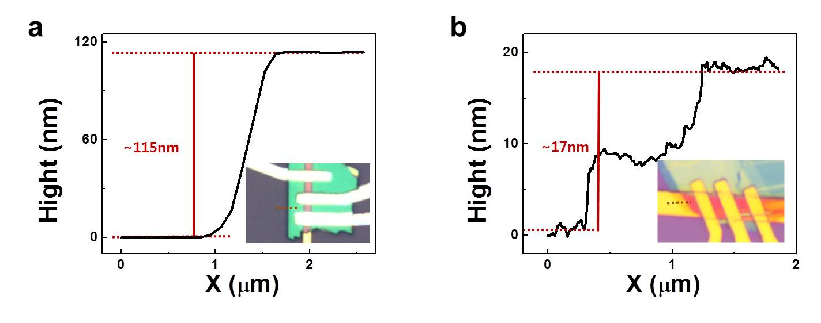
Figure S1. AFM line profiles for CrPS₄ layers with thicknesses of (a) ~115 nm and (b) ~17 nm, which are obtained along the dashed lines indicated in the optical images in the insets.

.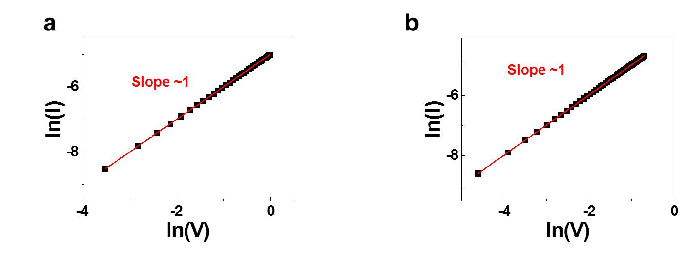
Figure S2. $ln({I) vs. \ln{(V)}}$ curves of the (a) Ag/CrPS₄ (115 nm)/Au and (b) Ag/CrPS₄ (17 nm)/Au capacitors at the LRS.
.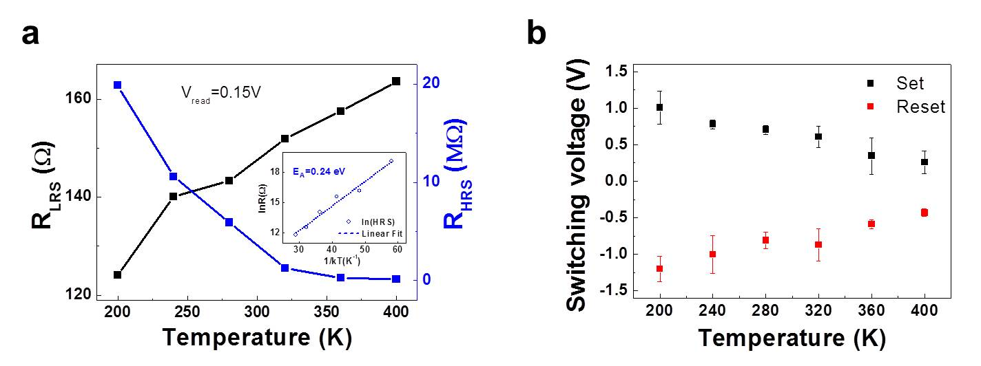
Figure S3. (a) The LRS and HRS resistances, and (b) set and reset voltages of the Ag/CrPS₄ (115 nm)/Au device, which were measured over a temperature range of 200 K to 400 K. The inset of (a) shows the Arrhenius plot of the HRS resistance.

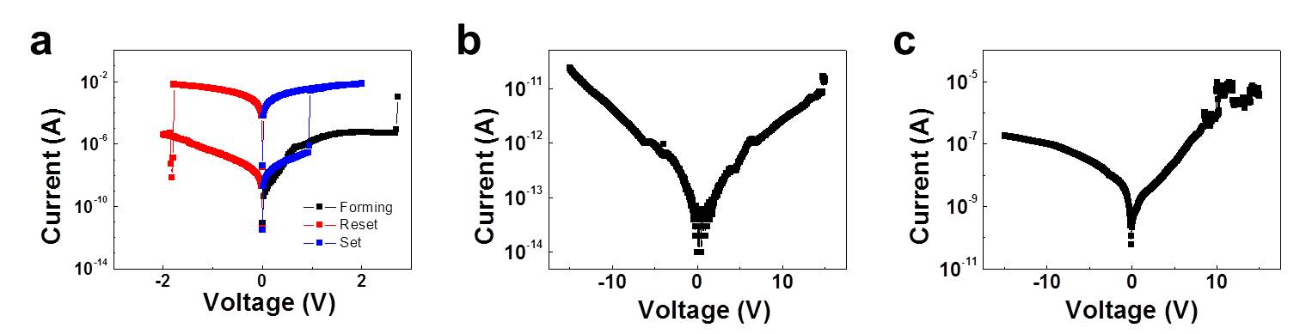
Figure S4. The I-V curves of (a) Cu/CrPS₄/Au, (b) Au/CrPS₄/Au, and (c) Pt/CrPS₄/Au devices.
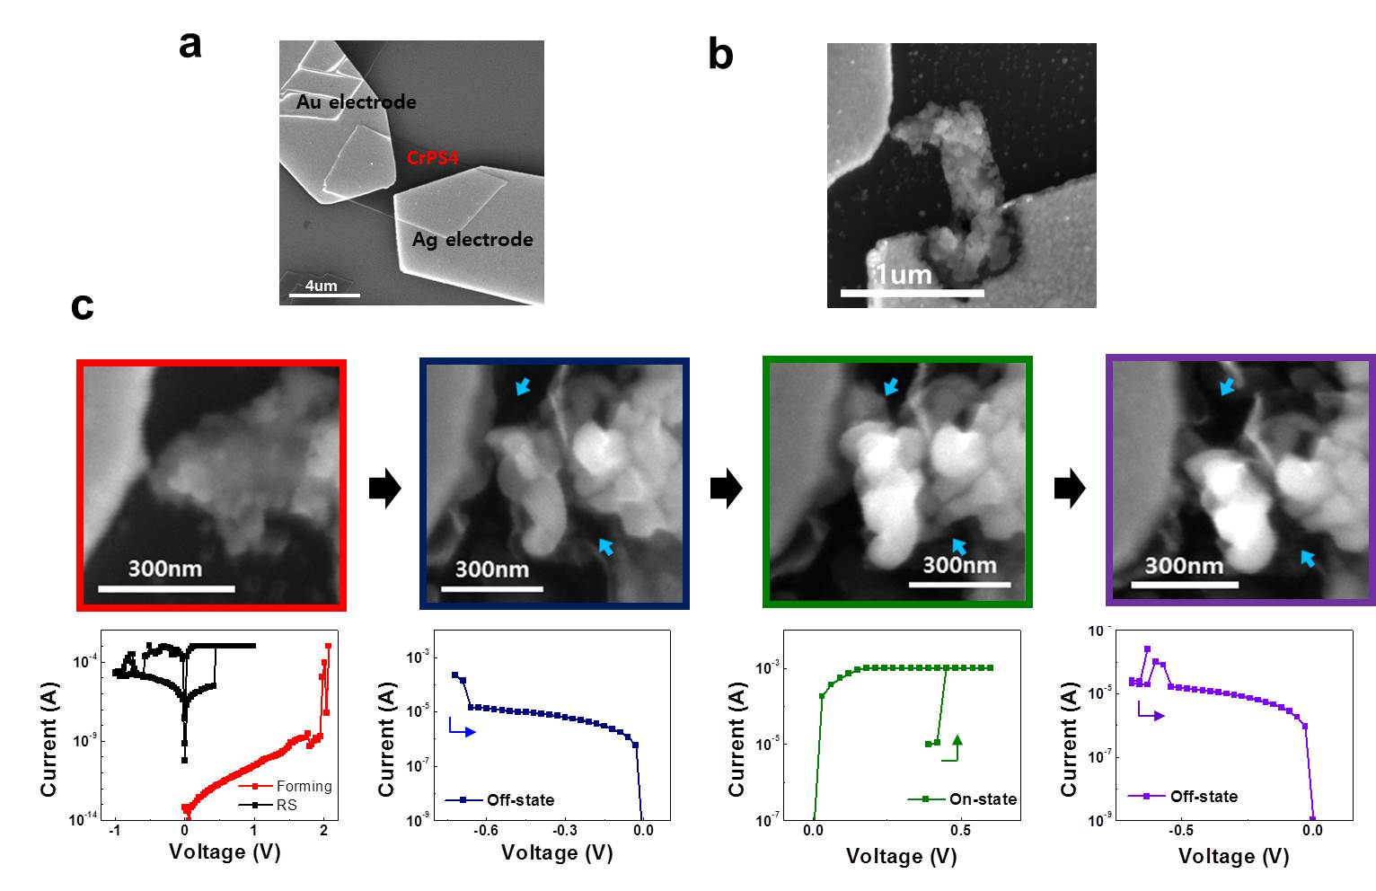
Figure S5. SEM images of a planar Ag/CrPS₄/Au device at (a) the pristine state and (b) the LRS obtained before and after the application of a positive forming voltage, respectively. (c) The change in the SEM images with RS characteristics of the planar Ag/CrPS₄/Au device which are achieved during successive set and reset switchings. The blue arrows denote the narrow areas of a conductive bridge induced by successive reset switchings which may lead to its electrical disconnection.

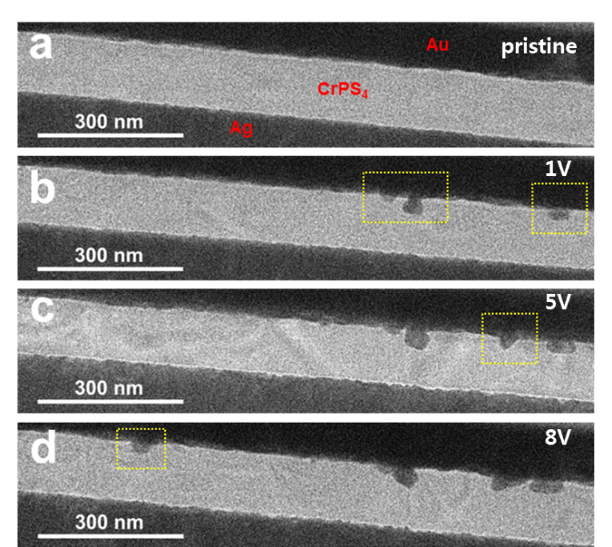
Figure S6. In situ I-V/TEM images of a vertical Ag/CrPS₄/Au device which are obtained (a) at pristine state and under applied voltages of (b) 1 V, (c) 5 V, and (d) 8 V, respectively.

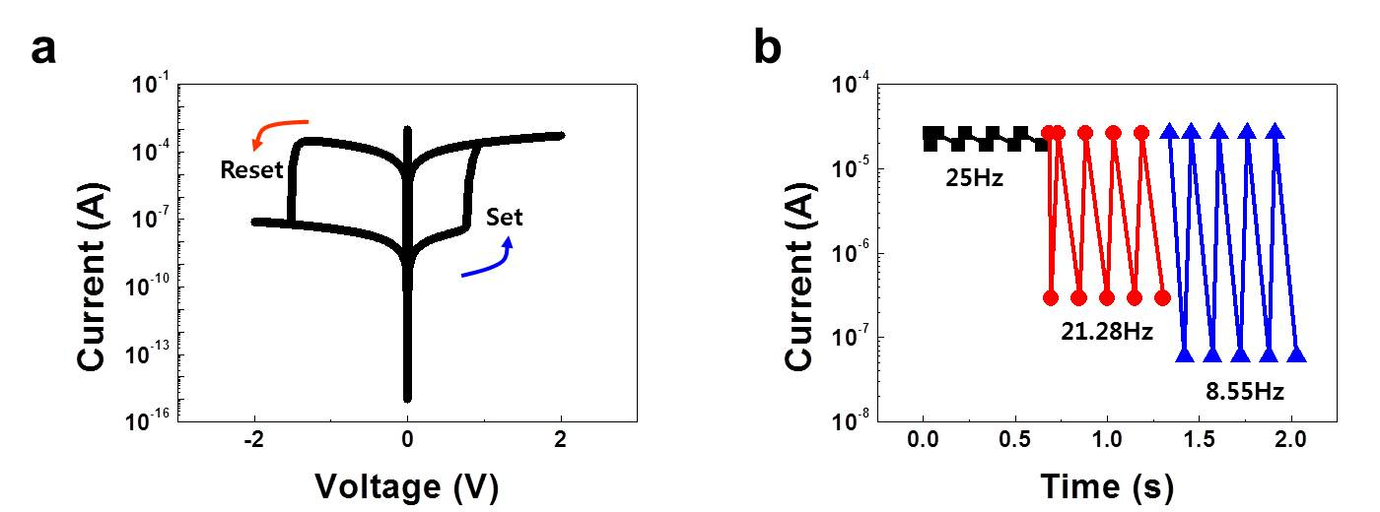

Figure S7. (a) I-V curve and (b) frequency-dependent binary resistive switching which are obtained via HSPICE simulations based on Verilog-A code.

Table S1. Parameters used in the HSPICE simulation. Z is the charge number of cation; v_{h} and v_{r} are the growth velocities of the conducting filament along the vertical and radial directions, respectively; E_{a} is the activation energy; a is the effective hopping distance; ρ_{on} and ρ_{off} are the resistivities of the conducting filament and nonconducting solid-electrolyte, respectively; A is the area of the bottom of the conducting filament, assuming that it is cylindrical before the SET process; L is the film thickness of the solid electrolyte; R_{th} is the equivalent thermal resistance⁷.

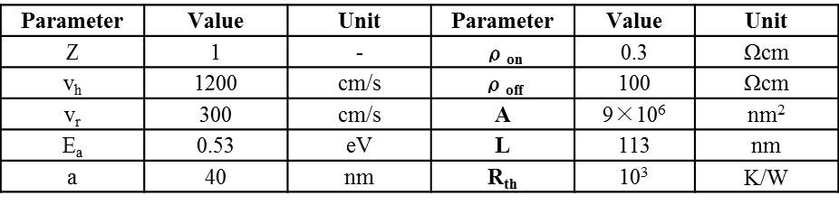

REFERENCES

1. Kwon, K.-C., Song, M.-J., Kwon, K.-H., Jeoung, H.-V., Kim, D.-W., Lee, G.-S., Hong, J.-P. & Park, J.-G. Nanoscale CuO solid-electrolyte-based conductive-bridging-random-access-memory cell operating multi-level-cell and 1selector1resistor. J. Mater. Chem. C 3, 9540–9550 (2015).
2. Bessonov, A. a, Kirikova, M. N., Petukhov, D. I., Allen, M., Ryhänen, T. & Bailey, M. J. a. Layered memristive and memcapacitive switches for printable electronics. Nat. Mater. 14, 199–204 (2015).
3. Tohru Tsuruoka, Kazuya Terabe, T. H. and M. A. Temperature effects on the switching kinetics of a Cu–Ta2O5-based atomic switch. Nanotechnology 22, 254013 (2011).
4. Waser, R., Dittmann, R., Staikov, C. & Szot, K. Redox-based resistive switching memories nanoionic mechanisms, prospects, and challenges. Adv. Mater. 21, 2632–2663 (2009).
5. Yang, Y., Gao, P., Li, L., Pan, X., Tappertzhofen, S., Choi, S., Waser, R., Valov, I. & Lu, W. D. Electrochemical dynamics of nanoscale metallic inclusions in dielectrics. Nat. Commun. 5, 4232 (2014).
6. Yang, Y., Gao, P., Gaba, S., Chang, T., Pan, X. & Lu, W. Observation of conducting filament growth in nanoscale resistive memories. Nat. Commun. 3, 732 (2012).
7. Yu, S. & Wong, H.-S. P. Compact modeling of conducting-bridge random-access memory (CBRAM). IEEE Trans. Electron Devices 58, 1352–1360 (2011).

