Simultaneously enhanced strength and ductility for 3D-printed stainless steel 316L by selective laser melting
Zhongji Sun‡, Xipeng Tan‡,*, Shu Beng Tor, Chee Kai Chua

Singapore Centre for 3D Printing, School of Mechanical & Aerospace Engineering, Nanyang Technological University, 50 Nanyang Avenue, Singapore 639798
* Corresponding author. E-mail: xptan1985@gmail.com & xptan@ntu.edu.sg
‡ These authors contributed equally to this work

All SLM process parameters used in this work are presented in Supplementary Table 1. The energy density was kept ~104 J/mm³ as suggested by previous research¹.The precursor SS316L powder is shown in Supplementary Fig. 1(a). Supplementary Fig. 1(b) illustrates the scanning strategy, a rotation of ~67° between successive layers is employed to prevent accumulation of residual stresses. Archimedes method was adopted to measure relative densities of SLM-built SS316L parts as shown in Supplementary Fig. 1(c). Tensile coupons were machined out from blocks built with enclosed process parameters in Supplementary Fig. 1(c) by EDM method. Supplementary Fig. 1(d) displays the overall dimensions of tensile coupons used in this work.
Supplementary Table 1. Overall SLM process parameters. Layer thickness was kept at 50 μm and energy density was maintained at ~104 J/mm³ for all the fabricated SS316L samples.
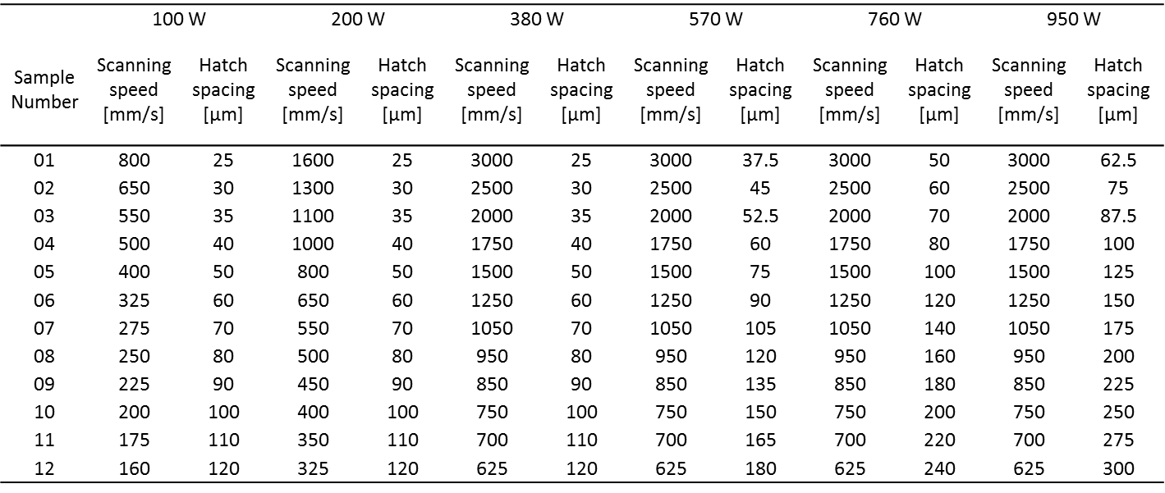

Supplementary Figure 1. (a) SEM micrograph of the precursor SS316L powder. (b) Illustration of coordinate system and scanning strategy in SLM process. Red arrows indicate the actual scanning lines and the angle between two consecutive layers n and n+1 is ~67 º. (c) Density graph obtained from Archimedes measurements for SLM-built SS316L samples with varying process parameters. (d) Overall dimensions of the tensile coupon.

Supplementary Figure 2. (a) Tensile graphs of 380 W and 950 W along the build direction that is perpendicular to the testing direction shown in Figure 2. (b) and (c) Inverse pole figures of 380 W and 950 W samples with respect to tensile direction (build direction).

It is clear that the <011> textured 950 W sample still has a better combination of strength and ductility combination as compared to the <001> textured 380 W sample. Though, the strength values of both samples along build direction are lower compared to the horizontal direction. As shown in the inverse pole figures, due to the presence of cube texture in 380 W sample, majority of the grains have a Taylor factor smaller than 2.6 which is unfavorable for deformation twinning. It should be noted though, that due to the small size of tensile coupon, no extensometer was applied during the testing. However, we still can conclude that 950 W sample has superior mechanical properties on both strength and ductility in comparison to 380 W sample along both horizontal and vertical directions. In addition, it is shown to be slightly weaker along vertical direction as compared to horizontal direction for SLM-built SS316L parts.

Supplementary Figure 3. EBSD IPF coloring maps with respect to build directions for 380 W and 950 W samples in (a) & (c) the as-build state and in (b) & (d) the heat-treated state. Scale bar 200 μm.

Heat treatments at 650 °C were carried out for 950 W and 380 W samples. They were held in vacuum condition for 2 hours followed by furnace cooling². There is little sign of grain growth for both samples. Crystallographic textures of both samples were certainly not affected by the heat treatment process. Thus, the microstructure and properties of the SLM-built SS316L parts in this work are supposed to be thermally stable at 650 °C, that is higher than one third of its melting point.
Melt pool geometries for 380 W and 950 W samples were determined from the outmost top layer of the as-built parts, which were cut perpendicular/parallel to the laser scanning lines before polishing and etching. Supplementary Fig. 4(a) shows the melt pool geometry perpendicular to the laser scanning lines of 380 W sample. Due to the Marangoni effect caused by the small hatch spacing, the melt pool is rather shallow with a melt pool width of ~150 μm and depth of ~50 μm. In contrast, melt pool of 950 W sample perpendicular to scanning lines is continuous and has a height of ~200 μm (Supplementary Fig. 4(b)). Cross sections parallel to scanning lines in Supplementary Fig. 4(c) reveal the melt pool width of ~150 μm and depth of ~300 μm. These geometrical parameters of the melt pool were input for the kinetic Monte Carlo simulations.

Supplementary Figure 4. Melt pool morphologies perpendicular to the laser scanning lines for (a) 380 W and (b) 950 W samples. (c) Melt pool geometry of 950 W sample parallel to the laser scanning lines.
A series of kinetic Monte Carlo simulations were conducted to study the relationship between melt pool geometry and crystallographic texture formation. Supplementary Fig. 5 shows the crystallographic texture transition map from <001> to <011> with the increase of H/W ratio. The map can be sectioned into five different zones with different melt pool geometries. The melt pools with the geometrical features depicted in Zone I will generate the <001> texture while the ones with geometrical features in Zone V will give birth to the <011> texture. Zone II to IV are the transition phases that may cause a mixed type of <001> and <011> textures. It implies that with a fixed width, a long, shallow melt pool promotes the formation of <001> texture; whereas a short, deep melt pool favors the occurrence of <011> texture.

Supplementary Figure 5. Crystallographic texture selection map from varying melt pool geometries by kinetic Monte Carlo simulations.

Amorphous silicate nano-inclusions were observed in both 380 W and 950 W samples (Supplementary Fig. 6(a) and 6(c))^{3,4}. Dense dislocations that were formed into a cellular morphology can be observed from <001> zone axis in Supplementary Fig. 6(b) and 6(d). It is clear that the dislocations entangled within cell boundaries are denser in 950 W sample compared to the 380 W counterpart. It contributes to a higher yield strength and easier initiation of deformation twins in 950 W sample.
Supplementary Figure 6. TEM micrographs showing amorphous nano-inclusions and dislocation cells in the as-SLM-built (a) and (b) 380 W, and (c) and (d) 950 W samples. Scale bars for (a) and (c) are 200 nm, for (b) and (d) are 500 nm.

The contribution of grain refinement towards overall strength enhancement is rather minimal. According to classical Hall-Petch relationship, $σ_{y}=σ_{0}+\frac{k_{y}}{√d}$ whereas $σ_{y}$ is the yield strength, $σ_{0}$, $k_{y}$ are material-specific constants, and d is the average grain diameter. From EBSD graphs in Figure 4, by estimating grains as circles, the average diameter for 380 W and 950 W samples are 13.2 μm and 11.6 μm respectively. For SS316L at room temperature, $k_{y}$ has a value in the range of (~450 to 700 MPa*μm^{1/2})⁵. By substituting in the relevant values, the $\frac{k_{y}}{√d}$ term for 380 W and 950 W samples are ~8.1 MPa and ~12.6 MPa respectively. Thus, the effect of grain refinement towards overall strength increment is negligible.
Supplementary Video 1: Simulation of grain formation within the melt pool of the 380 W sample.

Supplementary Video 2: Simulation of grain formation within the melt pool of the 950 W sample.

References
1. Cherry, J. A, et al. Investigation into the effect of process parameters on microstructural and physical properties of 316L stainless steel parts by selective laser melting. The International Journal of Advanced Manufacturing Technology 76.5-8 (2015: 869-879.
2. Riemer, A., et al. On the fatigue crack growth behavior in 316L stainless steel manufactured by selective laser melting. Engineering Fracture Mechanics 120 (2014): 15-25.
3. Sun, Z, et al. Selective laser melting of stainless steel 316L with low porosity and high build rates. Materials & Design 104 (2016): 197-204.
4. K. Saeidi, et al. Hardened austenite steel with columnar subgrain structure formed by laser melting. Mateirals Science and Engineering: A 625 (2015) 221 – 229.
5. Singh, K.K. et al. Hall-Petch behavior of 316L austenitic stainless steel at room temperature. Materials science and technology 18.2 (2002): 165-172.

