Supporting information

Fractionation of cellulose nanocrystals: enhancing liquid crystal ordering
without promoting gelation
Camila Honorato-Riosª, Claudius Lehrª, Christina Schützª, Roland Sanctuaryª, Mikhail A. Osipov^{b}, Jörg Ballerª, Jan P.F. Lagerwall^{a*}
ªUniversity of Luxembourg, Physics and Materials Science Research Unit, 1511 Luxembourg, Luxembourg
^{b}University of Strathclyde, Mathematics & Statistics, Glasgow, G11XQ, Scotland (UK)

Characterisation of as-received cellulose nanocrystals without sonication

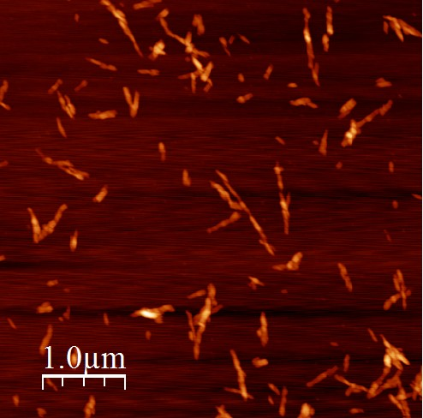
Figure S1. Representative AFM image of as-received cellulose nanocrystals from University of Maine without sonication.

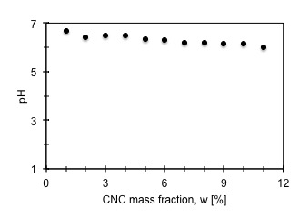
Figure S2. Curve of pH versus mass fraction for as-received CNC without sonication. Each pH value was determined at 20˚C.

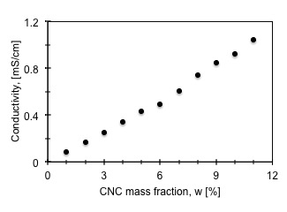
Figure S3. Conductivity of as-received CNC suspensions as a function of mass fraction, without sonication. Each conductivity value was determined at 20˚C.

Purification of cellulose nanocrystals and conductometric titration

Dialysis
The as-received CNC sample was diluted to 2 wt.% and extensively dialysed against ultrapure water during 5 days. Thereafter the suspension was sonicated for 70 s with ultrasonic probe (Dr. Hielscher UP200St equipped with a 7 mm diameter titanium tip), with an energy input of 0.01 kJ/mL CNC suspension (see section 9). Our Na⁺ form CNC suspensions partially retained the Na⁺ counterions after dialysis, with a final pH of 4.3.

Ion-exchange column
H⁺ form resin (DOWEX 50WX8, Sigma Aldrich) was used to remove Na⁺ counterions and other cations and to fully protonate the CNC sulphate half-ester groups¹. The resin was slurried in ultrapure water and poured into a glass column (inner diameter 2.5 cm) with fritted glass disk at the bottom. A resin bed height of 16 cm was obtained with 40 g SAC (Strong Acid Cation) resin. Before feeding the column with CNC, the ion-exchange resin was rinsed with 1 L of ultrapure water until the eluate was colourless, with a pH identical to the wash water. A CNC suspension was fed from the top at a concentration w=0.5 wt.%, yielding a pH after the ion-exchange of 2.7. The CNC concentration after the column was w=0.5 wt.%, confirming no loss of sample.

Determination of sulphur content of the as-received CNC by conductometric titration
The sulphate half-ester content of each CNC batch was determined by the conductometric titration method reported by Beck, et al.¹. We diluted each CNC suspension sample, prepared to contain 150 mg of cellulose with ultrapure water to give a total volume of 200 mL. Aſter the addition of 2 mL of 0.1 M NaCl solution, the suspension was titrated with 10 mM NaOH using a T90 Mettler Toledo titrator system. The NaOH solution was added in 0.1 mL increments over a period of 20 min.

The equivalence point volumes (E_{p}) are indicated in Figure S4 for three titration curves. For all calculations, we use $c_{NaOH}=0.01$ M and the molar mass of sulphur $M_{S}=32$ g/mol.

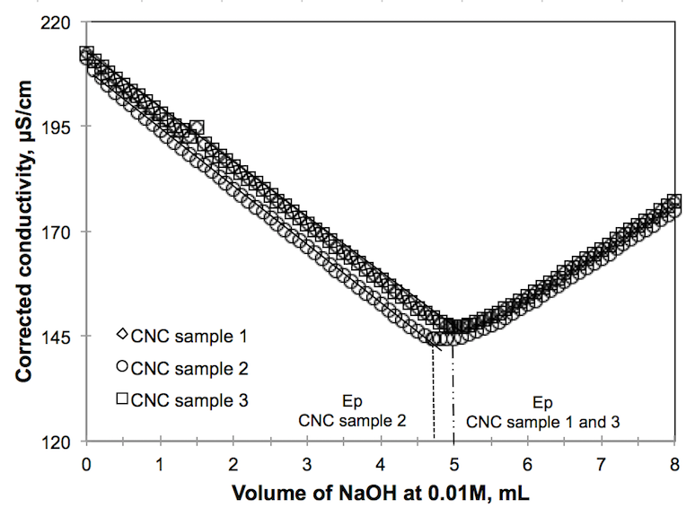
Figure S4. Conductometric titration curves for purified as-received CNC. The equivalence point obtained from the titration curve gives the sulphur content.

We determined the sulphur content of the as-received CNC, according to the expression¹ (m_{S} is the mass of sulphur and m_{CNC} is the mass of CNC):

$${m_{S}}/{m_{CNC}}=\frac{E_{p}c_{NaOH}M_{s}}{m_{CNC}}$$

Sample | m_{CNC} [mg] | Equivalence point, Ep [mL] | $${m_{S}}/{m_{CNC}}$$
CNC 1 | 142 | 5.0 | 0.011
CNC 2 | 153 | 4.8 | 0.010
CNC 3 | 143 | 5.0 | 0.011
Based on these experiments we conclude that the sulphur content in the as-received CNC is, adjusted to the accuracy of $c_{NaOH}$, 1% by mass.

Determination of diameter, length and aspect ratio of cellulose nanocrystals
Atomic force microscopy (AFM) experiments
We deposited 20 µL poly-L-lysine solution (0.01 vol.%) on a freshly cleaved mica surface (NanoAndMore GmbH) and allowed it to react for 3 minutes. Subsequently the mica surface was rinsed with ultrapure water and dried with compressed air. The CNC suspension to be studied was then diluted to w = 0.002 wt.% in order to allow investigation of individual rods, and of this suspension, 20 µL was placed on the treated surface for 3 minutes. The sample was then rinsed with ultrapure water and pre-dried with compressed air, followed by transfer to a vacuum oven at 40°C for complete drying overnight. A Multi-mode V AFM (Digital Instruments Nanoscope Veeco) was used in tapping mode to image the samples and AFM probes from Budget Sensors (Tap300 Al-G, resonance frequency 300 kHz and force constant 40 N/m) were used.

Analysis of AFM data
We performed accurate measurements of diameter d, length L and aspect ratio L/d for our CNC rods by carrying out single profile measurements with the software WSxM. To get a truly representative measure of d, we found that the commonly used method of measuring an AFM height profile perpendicular to each rod at some randomly chosen crossing point was insufficient, due to the considerable height variations along every individual CNC rod. Instead, we measured the height profile along each rod r (inset, Figure S5) and the average value was used as its diameter, d_{r}. For each sample, 300 rods were measured individually and by averaging d_{r} obtained for each of these we thus determined a final representative diameter value d for that particular CNC sample.

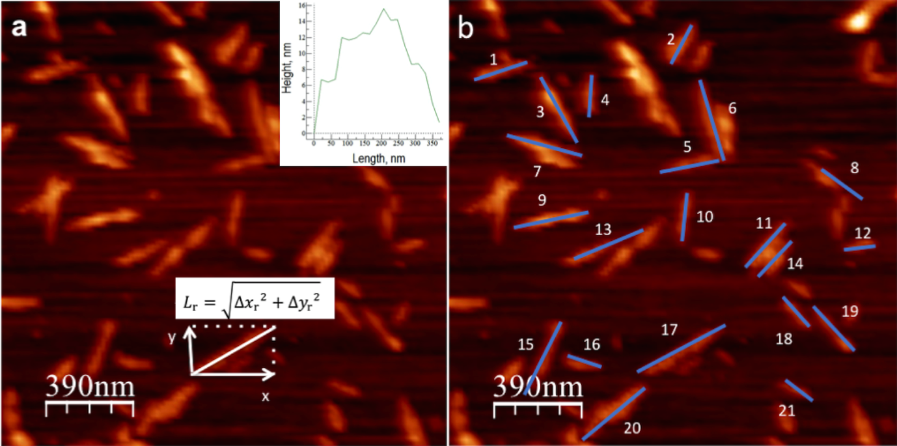
Figure S5. AFM images of a random CNC sample as example of the determination of diameter d, length L and aspect ratio L/d of CNC rods. (a) Original image with an example of the height profile along one rod (inset), showing how d changes along the length of a typical rod (height zero corresponds to the substrate level). (b) 22 rods measured by using the profile tool (an Excel file with all profile data is included as separate Supporting Information file).

To obtain the length L_{r} of each rod r regardless of its orientation in the sample plane, we used the extension of the rod in the lab frame’s x and y directions, ∆x_{r} and ∆y_{r}, which are directly available from the height profile data. We then applied the Pythagorean theorem to calculate the length as $L_{r}=\sqrt{{{∆x}_{r}}^{2}+{{∆y}_{r}}^{2}}$, as indicated in Figure S5. An average length value $\overline{L}$, representing the CNC sample, was again calculated as the average of all L_{r} values established for the 300 rods. Finally, for each rod r we determined the aspect ratio as L_{r}/d_{r}, and the aspect ratio chosen to represent the sample was the average $\overline{L/d}$ of the 300 individual rod aspect ratios. The full statistics for the iii-CNC and aaa-CNC fractions are shown in the main paper, Fig. 2c-e, and for the initial suspension (init-CNC) the corresponding curves are shown in Fig. S6.

If we instead calculate the average aspect ratio $\overline{L/d}$ using the average length $\overline{L}$ and average diameter $\overline{d}$, respectively, of all particles, as shown in Table S1, the average $\overline{L/d}$ calculated in this way decreases from 61 to 53 for aaa-CNC and from 46 to 41 for iii-CNC.

Table S1. Aspect ratios calculated as the average length divided by the average height of 300 rods.
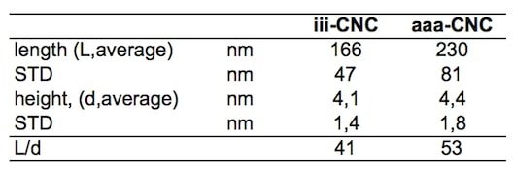
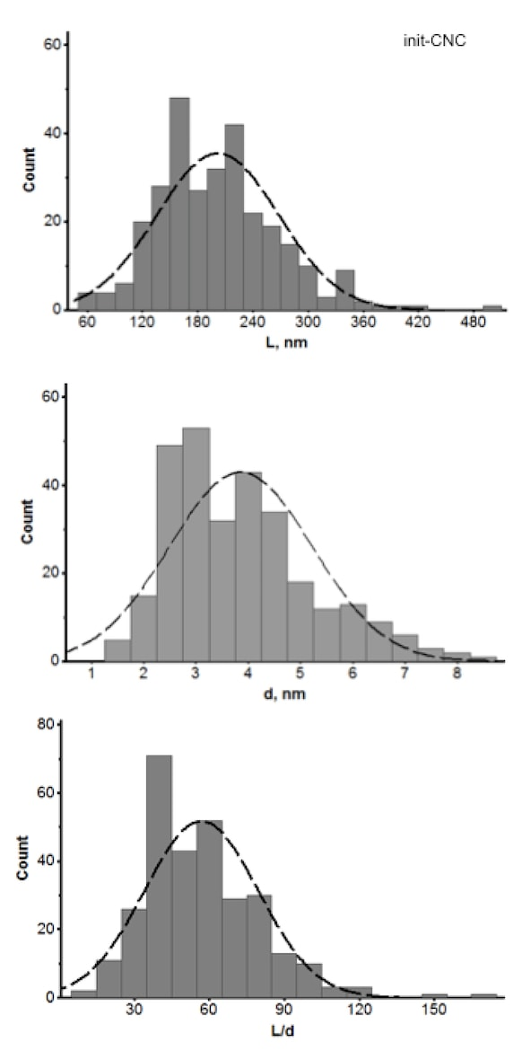
Figure S6. (a) Length L, (b) diameter d (indicated as the ‘height’ in the AFM measurement) and (c) aspect ratio L/d distributions of the initial CNC suspension (init-CNC), as determined using AFM measurements for 300 rods.

Determination of CNC mass fraction in the isotropic and anisotropic fractions, respectively, of suspensions with phase coexistence
To establish the mass fractions w^{i} and wª of CNC in the isotropic and anisotropic fractions, respectively, of a suspension of init-CNC with an overall CNC mass fraction w^{init} in the phase coexistence regime, we determined the CNC dried content of each phase by extracting samples using a pipette, and allowing them to dry in an oven at 100˚C. As it is difficult to avoid any extraction of the unwanted phase, some error is always present, hence the data should be considered approximate. The results are plotted in Fig. S7.

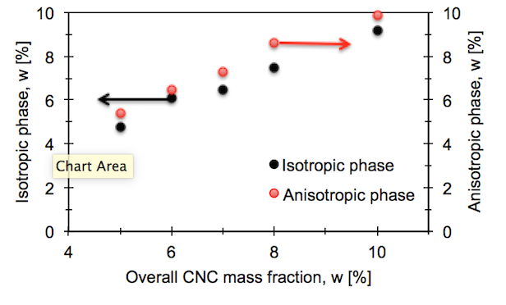
Figure S7. Approximate mass fractions of isotropic phases and anisotropic phases, respectively, versus overall CNC mass fraction. CNC suspensions have been standing in sample vials for 6 months before measurements.

Attempt to fractionate CNCs by centrifugation
As a first attempt to fractionate our CNC, an initial suspension at w = 7 wt.% was centrifuged using different rotation speeds ω and for varying periods of time. AFM images of the samples after centrifugation are shown in Figure S8. They revealed that CNC rods aggregate during the centrifugation, affecting the suspension behavior and the phase diagrams. This happened for all centrifugation settings used in our trials. We thus ruled out the method of speeding up the fractionation by centrifugation, and instead waited until sufficient separation had been achieved by gravity alone.

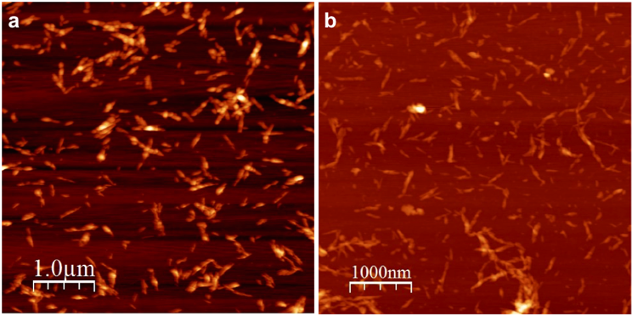
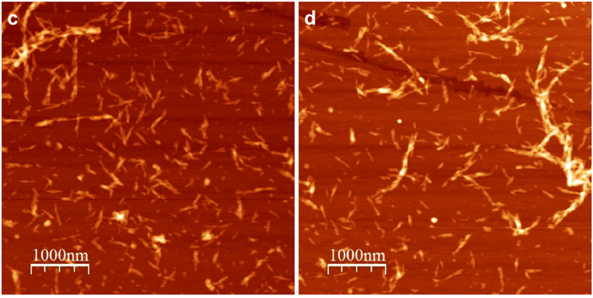
Figure S8. AFM images of centrifuged CNC; (a-b) ω = 8,000 rpm and centrifugation time 30 min and 60 min, respectively; (c-d) ω = 12,000 rpm and centrifugation time 30 and 60 min, respectively.

Curves of pH for iii-CNC and aaa-CNC
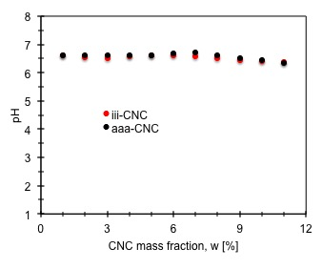
Figure S9. Curves of pH for iii-CNC(black dots) and aaa-CNC (red dots).

Estimation of the counterion concentration required for inducing gelation
Figure S10 shows the three CNC series init-CNC, iii-CNC and aaa-CNC without any salt addition 24 hours after turning each vial upside down. As is easy to see, all samples with CNC mass fraction w < 12 wt.% are still fluid, the content flowing down to the cap of the inverted vials during the experiment. The vials at w ≥ 12 wt.%, in contrast, show no sign of flow after 24 hours, indicating that these samples are in a gel state. These observations hold for all three series, suggesting that only the value of the counterion concentration $c_{{Na}^{+}}$determines whether a sample reaches gelation or not.

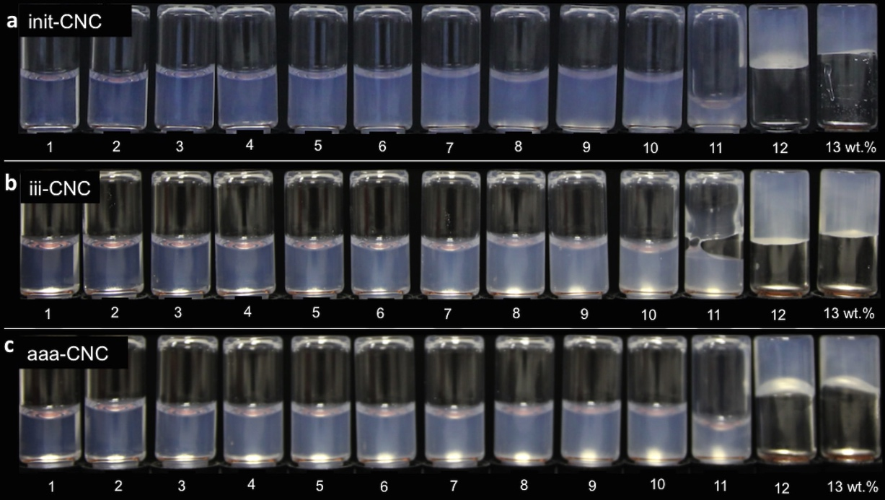
Figure S10. Sample vials of salt-free samples after 24 hours upside down; (a) init-CNC (b) iii-CNC and (c) aaa-CNC. For all the CNC suspensions, the onset of gelation is w ≈ 12 wt.%.

To determine experimentally the threshold value of counterion concentration that triggers gelation, $c_{{Na}^{+}}^{g}$, we attempted to induce gelation also at w < 12 wt.% by adjusting the sodium ion concentration in all suspensions until $c_{{Na}^{+}}=c_{{Na}^{+}}^{g}$ via addition of NaCl solution (1 M). In order to have a starting point of how much NaCl solution to add to each vial, we used the information from the CNC supplier that the particles have a sulphur content of 0.95 wt.% and we assumed that every sulphate group is in its ionic state. This assumption is based on the fact that the CNC was, after the sulphuric acid hydrolysis was completed, neutralized with an excess of NaOH. As is common for commercial samples, the CNC counter ions are thus Na⁺ rather than the H⁺ counter ions present directly after acid hydrolysis. We used w_{g} = 13 wt.% as an initial estimate of the amount of CNC needed for ensuring gelation. This allowed us to estimate the expected counterion concentration required for gelation as:

$c_{{Na}^{+}}^{g}=c_{S}^{g}=\frac{0.95}{100}\frac{{ρw}_{g}}{M_{S}}=\frac{0.95}{100}\frac{0.13 kg/L}{32.065 g/mol}=39 mM$ (1)

where $c_{S}^{g}$ is the sulphur concentration in the sample at gelation without salt addition, and M_{S} is the molar mass of sulphur. For simplicity, we have approximated the density $ρ$ of the suspension as 1 kg/L, thus yielding a sample mass of m = 1 kg per liter of suspension.
Starting from this result, we calculated the required NaCl concentration c_{NaCl} for achieving constant $c_{{Na}^{+}}=c_{{Na}^{+}}^{g}$ for every CNC mass fraction w, corresponding to a sulphur concentration c_{s}, as:
$c_{{Na}^{+}}^{g}=c_{S}+c_{NaCl}=c_{{Na}^{+}}^{g}\frac{w}{w_{g}}+c_{NaCl}=39 mM$. (2)

The first experiment with salt addition prepared according to this formula, for each of the three CNC qualities with w increasing in integer steps from 1% to 11%, yielded the behaviour after 24 hours shown in Figure S11. The amount of NaCl appeared to be insufficient, suggesting that our estimated $c_{{Na}^{+}}^{g}$ was smaller than the real value. A slight discrepancy is not surprising, considering the variability in CNC samples and the simplifications we did leading up to formula (1). For instance, taking a more realistic density value for the gelled CNC suspension of $ρ$ = 1.05 kg/L one obtains $c_{{Na}^{+}}^{g}=40 mM$. We therefore increased the assumed counterion concentration threshold $c_{{Na}^{+}}^{g}$ in (2) first to 43 mM, then to 45 mM, resulting in the behaviour shown in Figures S12 and S13, respectively. While the suspensions in Figure S12 had become very viscous, they still flowed in the gravitational field, but in Figure S13 gelation is seen for all samples with w > 2 wt.%. Based on this experiment we used $c_{{Na}^{+}}^{g}$ = 45 mM in the following experiments. We note, however, that gelation may be a slow process in the very vicinity of $c_{{Na}^{+}}=c_{{Na}^{+}}^{g}$ (see reference 30 in the main paper), hence it may be that the 24 hour waiting time in our experiments was insufficient, and the real $c_{{Na}^{+}}^{g}$ is in fact somewhat lower than 45 mM.

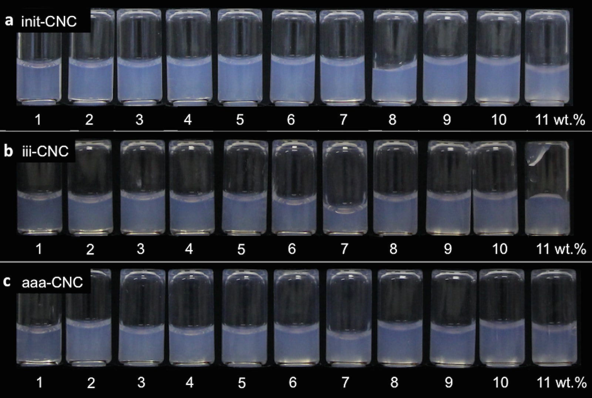
Figure S11. Sample vials with w ≤ 11 wt.% standing upside down during 24 hours after addition of salt assuming a gelation threshold counterion concentration of $c_{{Na}^{+}}^{g}$ = 39 mM. (a) init-CNC (b) iii-CNC and (c) aaa-CNC. The amount of salt added to each vial is given as c_{NaCl} in (2) and is plotted in Figure S14, orange series. No CNC suspension reached gelation within 24 hours after the addition of salt, hence $c_{{Na}^{+}}^{g}$was estimated too low.

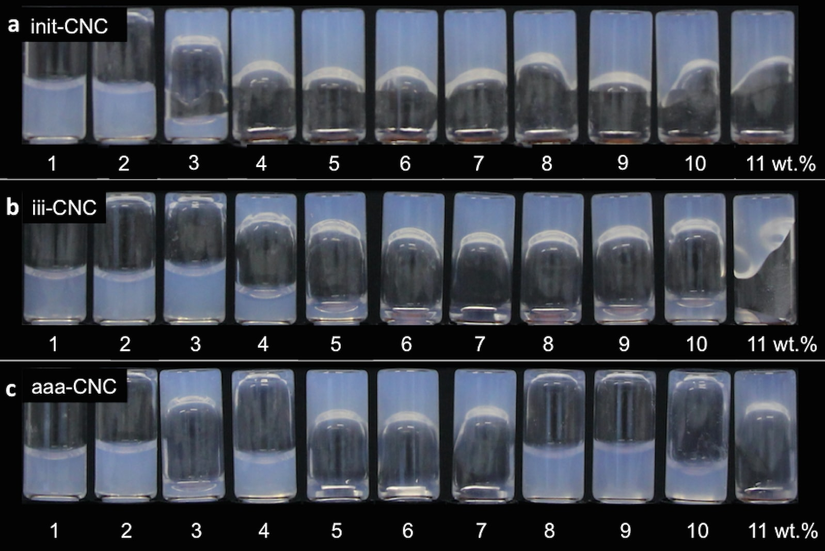
Figure S12. Sample vials with w ≤ 11 wt.% standing upside down during 24 hours after addition of salt assuming a gelation threshold counterion concentration of $c_{{Na}^{+}}^{g}$ = 43 mM. (a) init-CNC (b) iii-CNC and (c) aaa-CNC. The amount of salt added to each vial is given as c_{NaCl} in (2) and is plotted in Figure S14, black series. Some of the CNC suspensions remained at the inverted bottom of the vial. Nevertheless, most suspensions flow over time, hence we assumed that we had still underestimated $c_{{Na}^{+}}^{g}$.

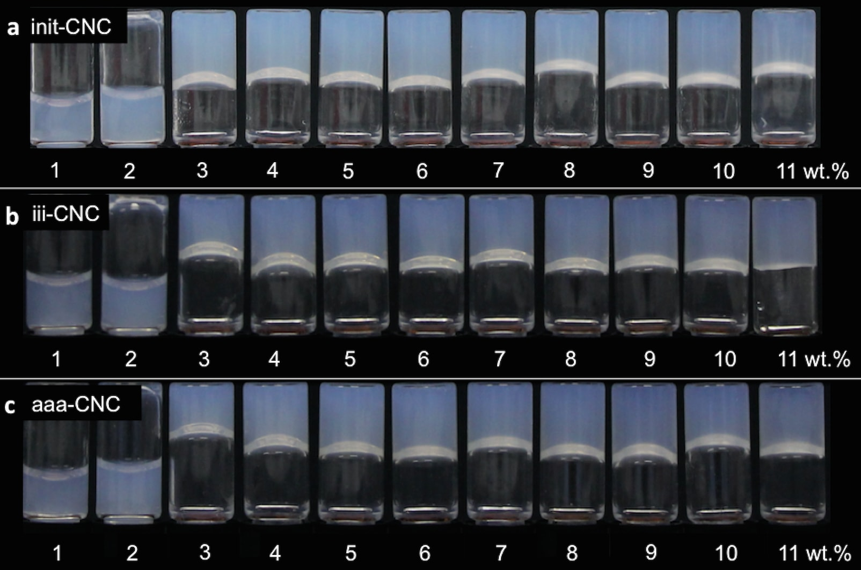
Figure S13. Sample vials with w ≤ 11 wt.% standing upside down during 24 hours after addition of salt assuming a gelation threshold counterion concentration of $c_{{Na}^{+}}^{g}$ = 45 mM. (a) init-CNC (b) iii-CNC and (c) aaa-CNC. The amount of salt added to each vial is given as c_{NaCl} in (2) and is plotted in Figure S14, red series. Except for w < 3 wt.%, all the CNC suspensions remained at the inverted bottom of the vial, indicating that gelation is reached, i.e. we concluded that $c_{{Na}^{+}}^{g}$ ≈ 45 mM.

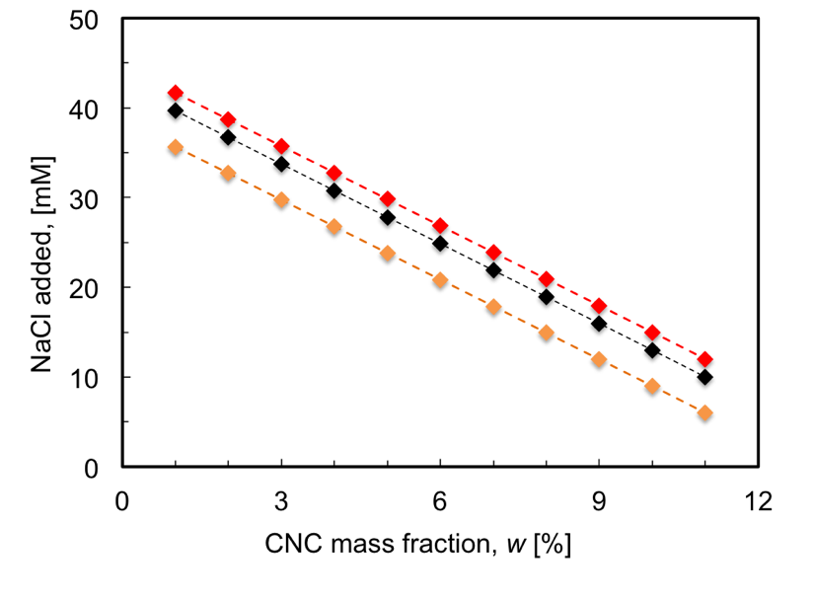
Figure S14. Three series of NaCl addition for assumed gelation threshold of counterion concentration $c_{{Na}^{+}}^{g}$ = 39 mM (orange), 43 mM (black) and 45 mM (red), respectively, targeting constant counterion concentration independent of CNC content. Gelation was reached with $c_{{Na}^{+}}^{g}$ = 45 mM. Corresponding pictures of the macroscopic sample vials are shown in Figures S11-S13. The connecting lines are guides for the eye.

Rheological investigations
Rheological measurements were performed with an Anton Paar rheometer MCR 302. All measurements were done using parallel-plate configuration (diameter 50 mm, gap size 1 mm). To avoid evaporation of water, measurements at 25±1°C were started directly after insertion of the samples into the rheometer. Moreover, sponges soaked with water were placed within the measurement cell in order to ensure an atmosphere saturated in water. For each sample, the following measurement protocol was used: Amplitude sweeps to determine the linear viscoelastic region (Fig. S15) are followed by frequency sweeps (max shear strain: 5%) and finally measurements with increasing shear rate are done to record flow curves.

Figure S15. Amplitude sweeps to determine the linear viscoelastic region.

Estimation of energy transferred to the CNC suspension during tip sonication
The energy introduced by the sonication was estimated according to the calculation procedure at http://www.sonicator.com/literature/faq.shtml. The delivered power under continuous (c) operation, as measured by the device, was indicated to be P_{w}^{c} = 37 W with the tip immersed in 50 mL water (w), under the same conditions as during CNC sonication. With the tip in air (a), the corresponding reading was P_{a}^{c} = 4 W. From this we calculate that the continuous power to the sample (s) would be P_{s}^{c} = 33 W. However, the CNC suspensions were sonicated using a χ = 30% pulse setting, and the total sonication time was t = 70 s. Hence, the total energy delivered to the suspension (containing 6 wt.% CNC) can be calculated as $E_{s}=P_{s}^{c}χt=33∙0.3∙70=690$ J. With a suspension volume of 50 mL this yields an energy of 14 J/mL suspension, or 0.01 kJ/mL adjusted for the accuracy in the power measurement.

Confirmation of chiral nematic (cholesteric) phase development by polarising microscopy
While the chiral nature of the nematic phase does not play a central role in this study, we nevertheless wanted to confirm that the CNC suspensions formed a chiral nematic (cholesteric) phase, as expected. This was confirmed by the characteristic fingerprint textures when a non-gelled liquid crystalline sample was filled into a flat glass capillary and studied in a polarising microscope, while samples near or beyond the gelation threshold developed no or only irregular fingerprint lines, see Figure S16.
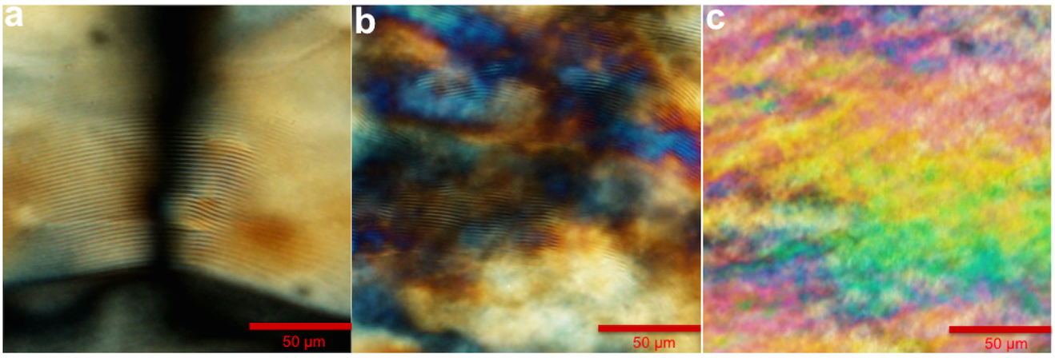
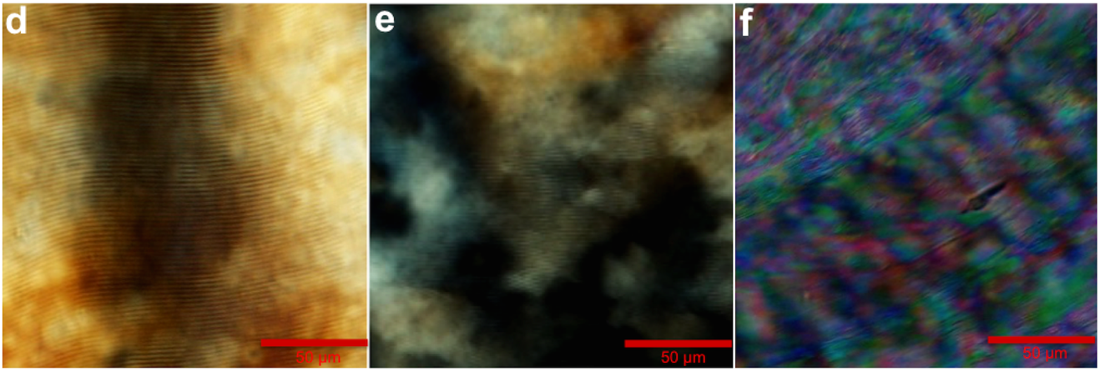
Figure S16. Fingerprint textures (a,b,c) iii-CNC at 11 wt.%, 12 wt.% and 13 wt.%, (d,e,f) aaa-CNC at 11 wt.%, 12 wt.% and 13 wt.%.

Comparison of the as-received CNC from FPL versus the purified-form CNC (Na-CNC)
As mentioned in the main manuscript, commercial CNC from FPL is used as the starting material for our fractionation study, without any additional purification. It is well known that small amounts of extra ions might influence the CNC behavior e.g. phase diagram, onset of gelation and chiral nematic pitch². For this reason, we wanted to compare the as-received CNC to purified CNC. Therefore we purified the as-received CNC as indicated in Section 2, Supplementary Information, followed by the addition of NaOH until pH 7. This way we ensure that only sodium ions (Na⁺) are present as counterions.

Figure S17 shows that the volume fraction of liquid crystal phase at 5 wt.% CNC is slightly higher for the as-received CNC (left) compared to the purified-form CNC (right), but the difference is small. Moreover, gelation is reached at the same concentration for both samples (not shown here). We also determined the chiral nematic pitch for both CNC samples at 5 wt.%, obtaining values of 6.6 μm ± 0.3 μm and 6.4 μm ± 0.3 μm for the as-received CNC and purified-form CNC respectively. These results indicate that the behavior of both CNC types is similar, justifying the use of as-received CNC without any further purification treatment.

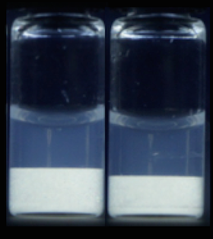
Figure S17. Comparison of as-received CNC from FPL (left) versus purified-form CNC (right), both at 5 wt.%. Sample vials have been standing vertically for 2 months.

1. Beck, S., Méthot, M. & Bouchard, J. General procedure for determining cellulose nanocrystal sulfate half-ester content by conductometric titration. Cellulose 22, 101–116 (2015).
2. Honorato-Rios, C. et al. Equilibrium Liquid Crystal Phase Diagrams and Detection of Kinetic Arrest in Cellulose Nanocrystal Suspensions. Front. Mater. 3, 1–13 (2016).

CNC particles typically have a somewhat irregular shape, possibly with a cross section that is more rectangular than circular, but for simplicity we approximate them as cylinders.

