Supplementary Information

Effect of Donor–Acceptor Molecular Orientations on Charge Photogeneration in Organic Solar Cells

Hansol Lee,¹ Dongki Lee,¹ Dong Hun Sin,¹ Sang Woo Kim,² Mun Seok Jeong,² and Kilwon Cho*¹

¹ Department of Chemical Engineering, Pohang University of Science and Technology, Pohang 37673, Korea.
² Department of Energy Science, Sungkyunkwan University, Suwon 16419, Korea
* Corresponding author (E-mail: kwcho@postech.ac.kr)

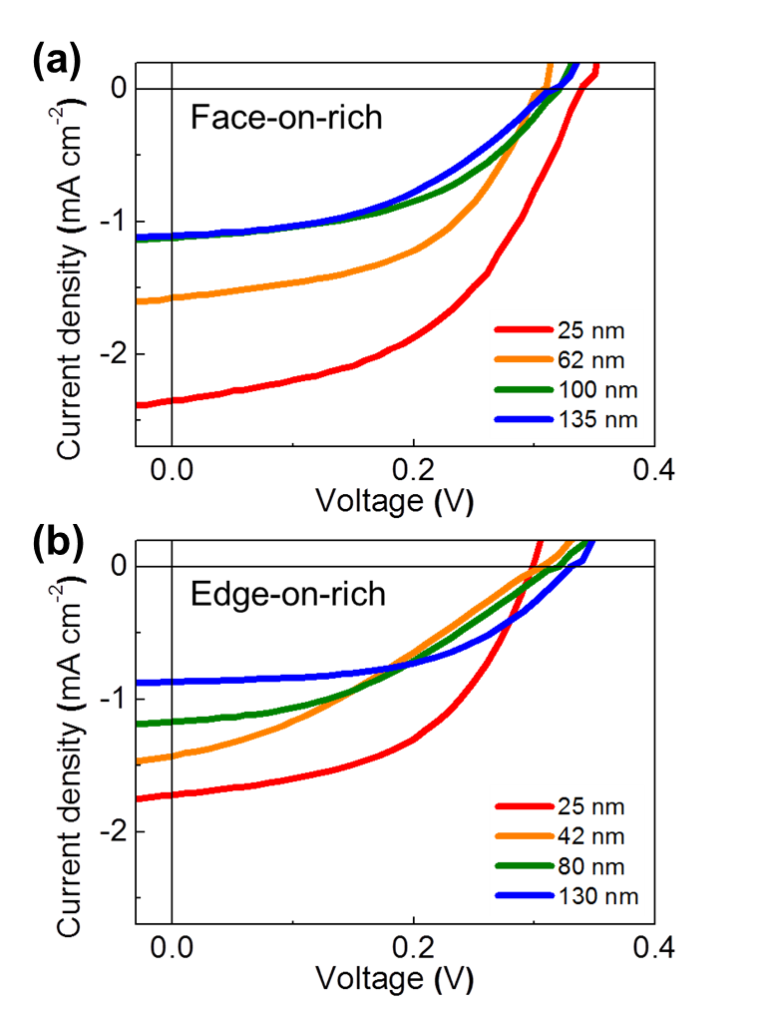
Figure S1. J-V characteristics of orientation-controlled P3HT/PCBM bilayer devices with various P3HT thicknesses. (a) Devices with face-on-rich P3HT layers. (b) Devices with edge-on-rich P3HT layers.
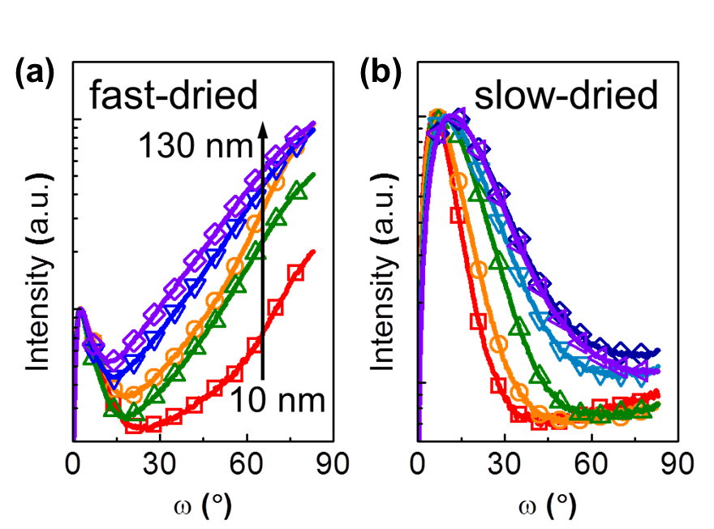
Figure S2. Pole figures of orientation-controlled P3HT films of various thicknesses. (a) Fast-dried films. (b) Slow-dried films. Thicknesses were varied from 10 nm to 130 nm.

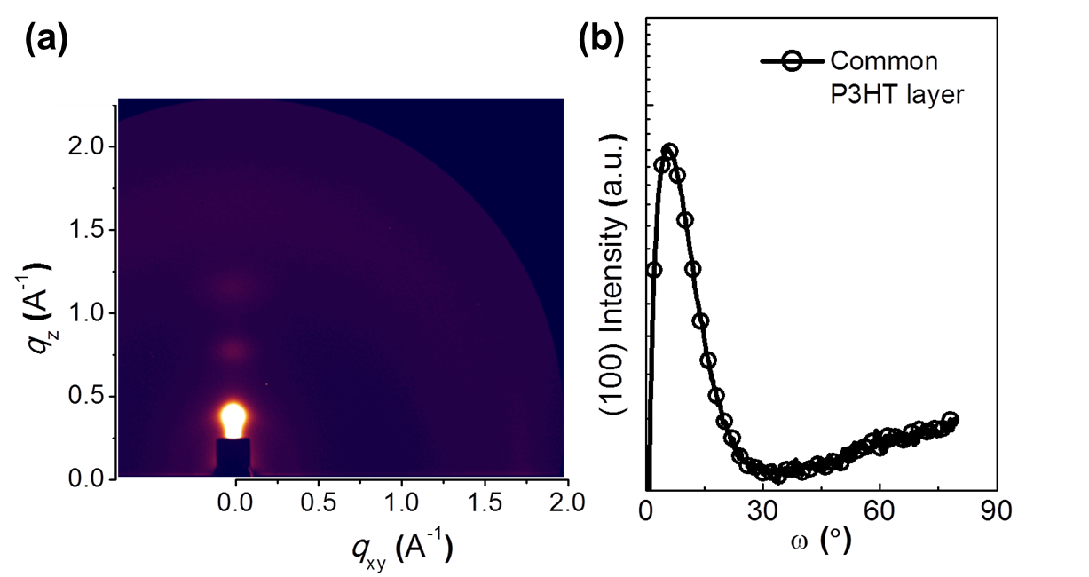
Figure S3. GIWAXS results of the P3HT film used as a common interfacial layer. (a) 2D image of the P3HT film. (b) Corresponding pole figure of the P3HT (100) peak.

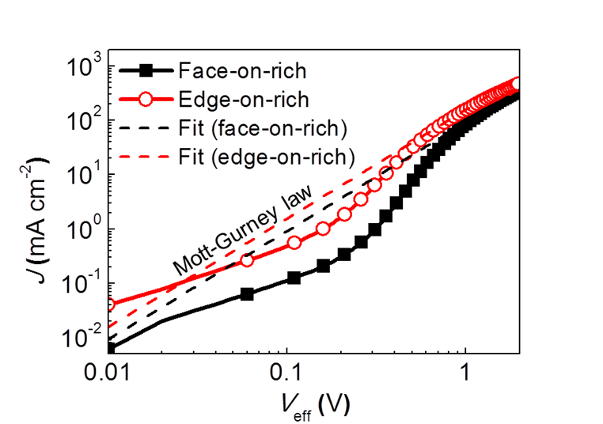
Figure S4. J-V characteristics of SCLC measurements. Hole-only devices were fabricated with a single layer of P3HT film (either face-on-rich or edge-on-rich). Symbols: experimental data; dashed lines: line fitted using Mott-Gurney’s law. Carrier mobilities were calculated as described elsewhere.

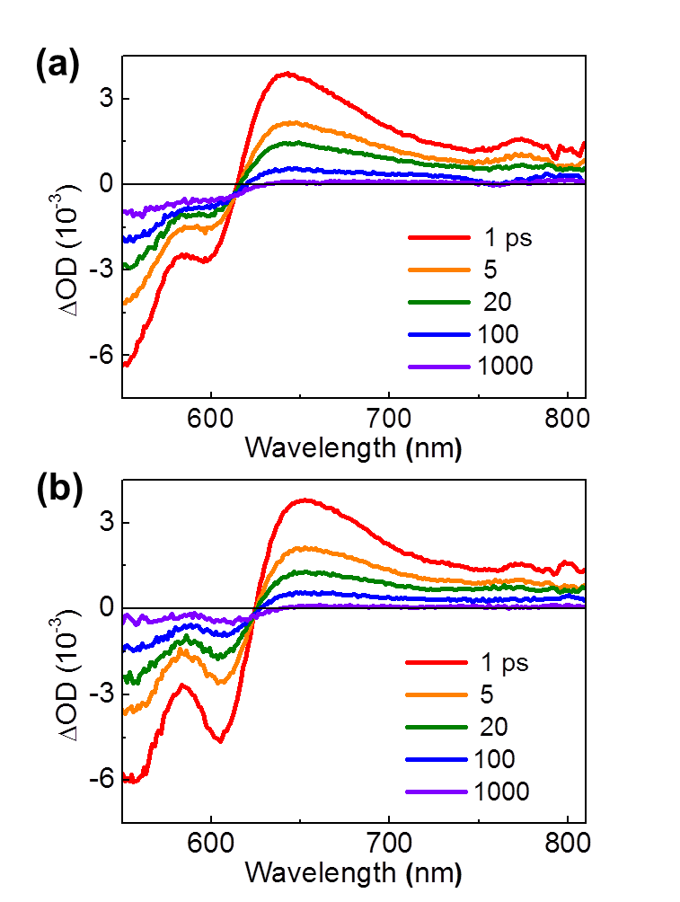
Figure S5. TA spectra of P3HT single layer samples with controlled P3HT orientation. (a): sample with the face-on-rich P3HT film; (b): sample with the edge-on-rich P3HT film.

Table S1. Photovoltaic parameters of orientation-controlled P3HT/PCBM bilayer devices with various P3HT thicknesses.
 | P3HT thickness  [nm] | PCE  [%] | J_{sc}  [mA cm⁻²] | V_{oc}  [V] | FF
P3HT(face-on-rich)/PCBM | 25 | 0.385 | 2.35 | 0.34 | 0.482
 | 62 | 0.245 | 1.58 | 0.31 | 0.501
 | 100 | 0.172 | 1.12 | 0.32 | 0.477
 | 135 | 0.156 | 1.11 | 0.32 | 0.439
P3HT(edge-on-rich)/PCBM | 25 | 0.259 | 1.72 | 0.30 | 0.502
 | 42 | 0.140 | 1.43 | 0.31 | 0.316
 | 80 | 0.145 | 1.17 | 0.32 | 0.388
 | 130 | 0.149 | 0.871 | 0.33 | 0.519

Table S2. SCLC hole mobilities [cm² V⁻¹ s⁻¹] of orientation-controlled P3HT films.
 | P3HT  (face-on-rich) | P3HT  (edge-on-rich)
µ_{h, SCLC} | 4.42 x 10⁻⁶ | 5.58 x 10⁻⁶

