Supplementary Materials
Extracellular vesicles (EVs)-polyphenol nanoaggregates for microRNA-based cancer diagnosis
Minjeong Jang¹, Giwoong Choi², Yoon Young Choi³, Jae Eun Lee³, Jik-Han Jung¹, Seung Won Oh¹, Dai Hoon Han⁴, Haeshin Lee⁵, Ji-Ho Park¹, Jae-Ho Cheong³, Pilnam Kim^{1,6*}
¹Department of Bio and Brain Engineering, Korea Advanced Institute of Science and Technology (KAIST), Daejeon 34141, South Korea
²Department of mechanical engineering, Korea Advanced Institute of Science and Technology (KAIST), Daejeon 34141, South Korea
³Department of Surgery, Yonsei University College of Medicine, Severance Hospital, Seoul 03722, South Korea
⁴Department of Hepatobiliary and Pancreatic Surgery, Yonsei University College of Medicine, Severance Hospital, Seoul 03722, South Korea
⁵Department of Chemistry, Korea Advanced Institute of Science and Technology (KAIST), Daejeon 34141, South Korea
⁶ KAIST Institute for Health Science and Technology, Daejeon 34141, South Korea Daejeon, Republic of Korea
* Corresponding Author: Pilnam Kim, Department of Bio and Brain Engineering, Korea Advanced Institute of Science and Technology, Daejeon 34141, Korea. Phone: +82-42-350-4332; E-mail: pkim@kaist.ac.kr
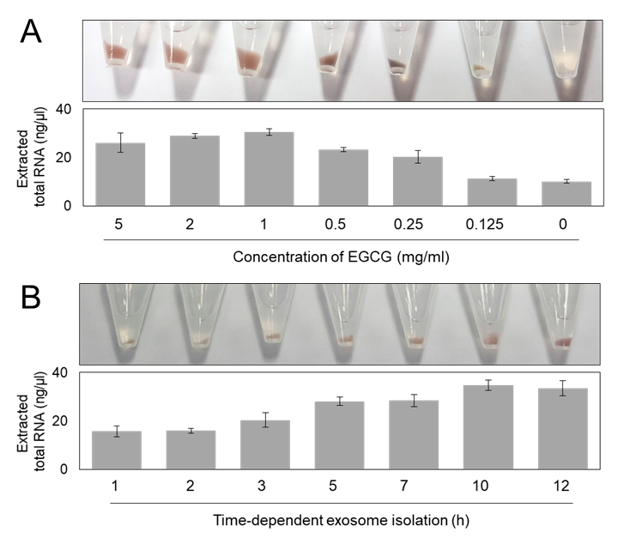
Supplementary Fig. S1. Optimization of polyphenol-assisted EVs isolation (A,B) Optimization depending on EGCG concentration (mg/ml) and processing times (hours). Measurement of the concentration of extracted total RNA indicated that treatment of 1 mg/ml of EGCG over 10 – 12 hours has high efficiency.

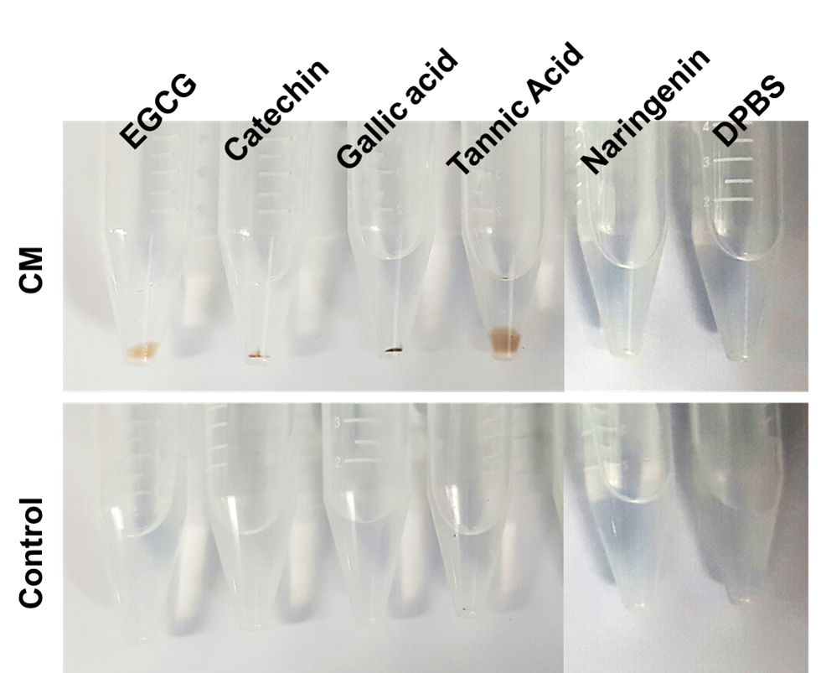
Supplementary Fig. S2. Precipitation of EVs by various polyphenolic molecules, including EGCG, catechin, gallic acid (GA), tannic acid (TA), naringenin. DPBS is negative control.

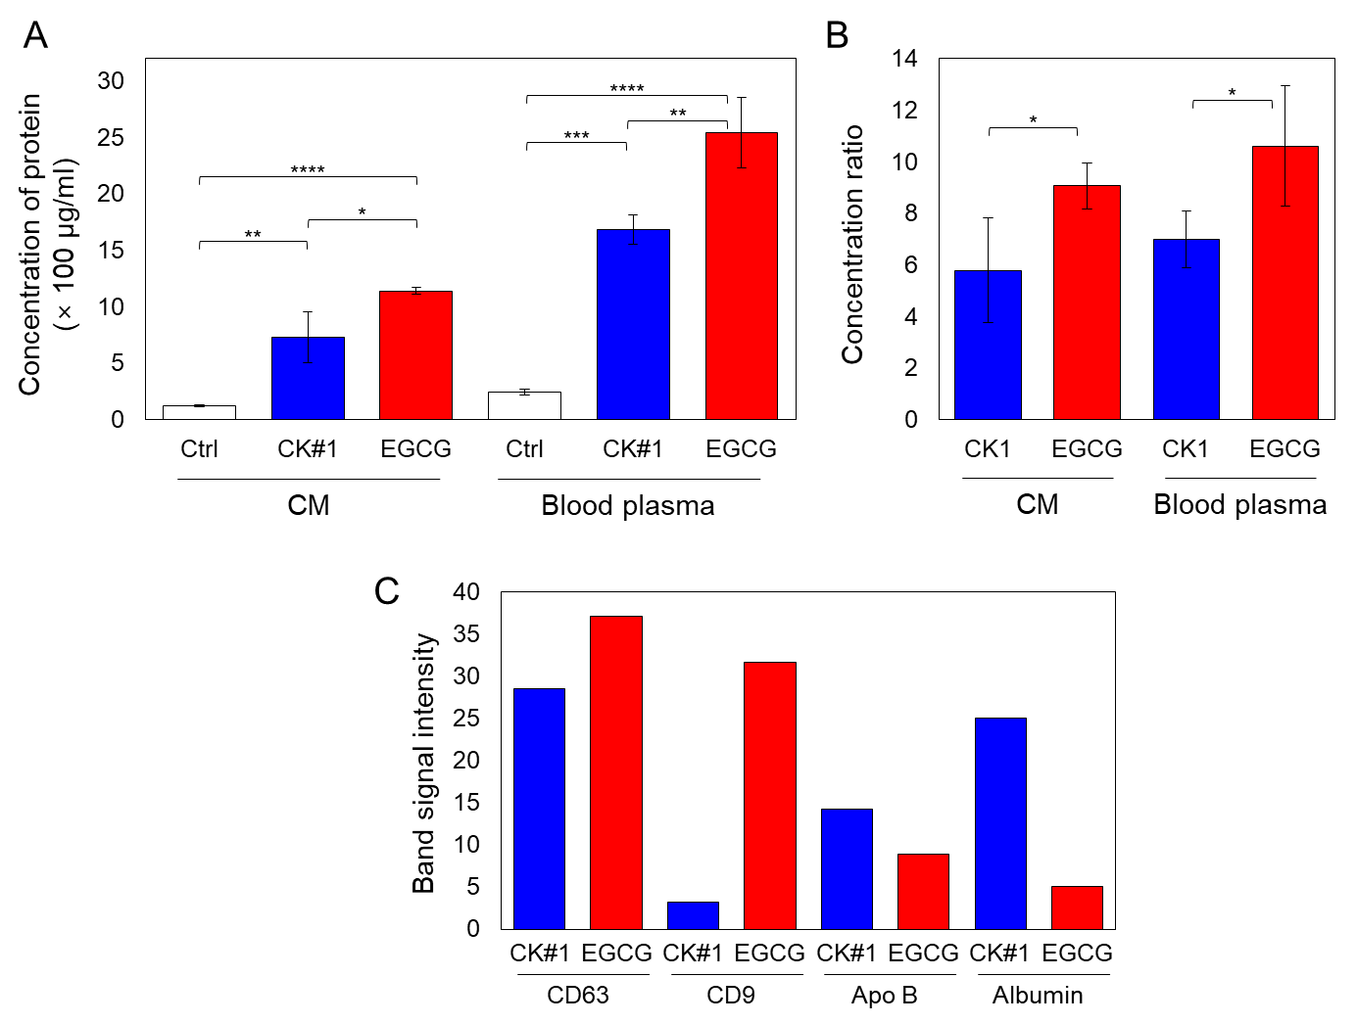
Supplementary Fig. S3. Comparison of concentration ability of CK#1 (ExoQuick) and EGCG from conditioned medium (CM) and blood plasma. (A) The concentration of extracted total proteins from CM and blood plasma by using CK#1 and EGCG. A negative control is the same volume of CM or diluted blood plasma. *:p<0.05, **:p<0.01, ***:p<0.001, ****:p<0.0001 (B) Concentration ratio (concentrated proteins by CK#1 or EGCG / negative control) of CK#1 and EGCG from CM and blood plasma. *:p<0.05 (C) Band signal intensity of CD63, CD9, Apo B and Albumin in isolated EVs from blood plasma by using CK#1 and EGCG.

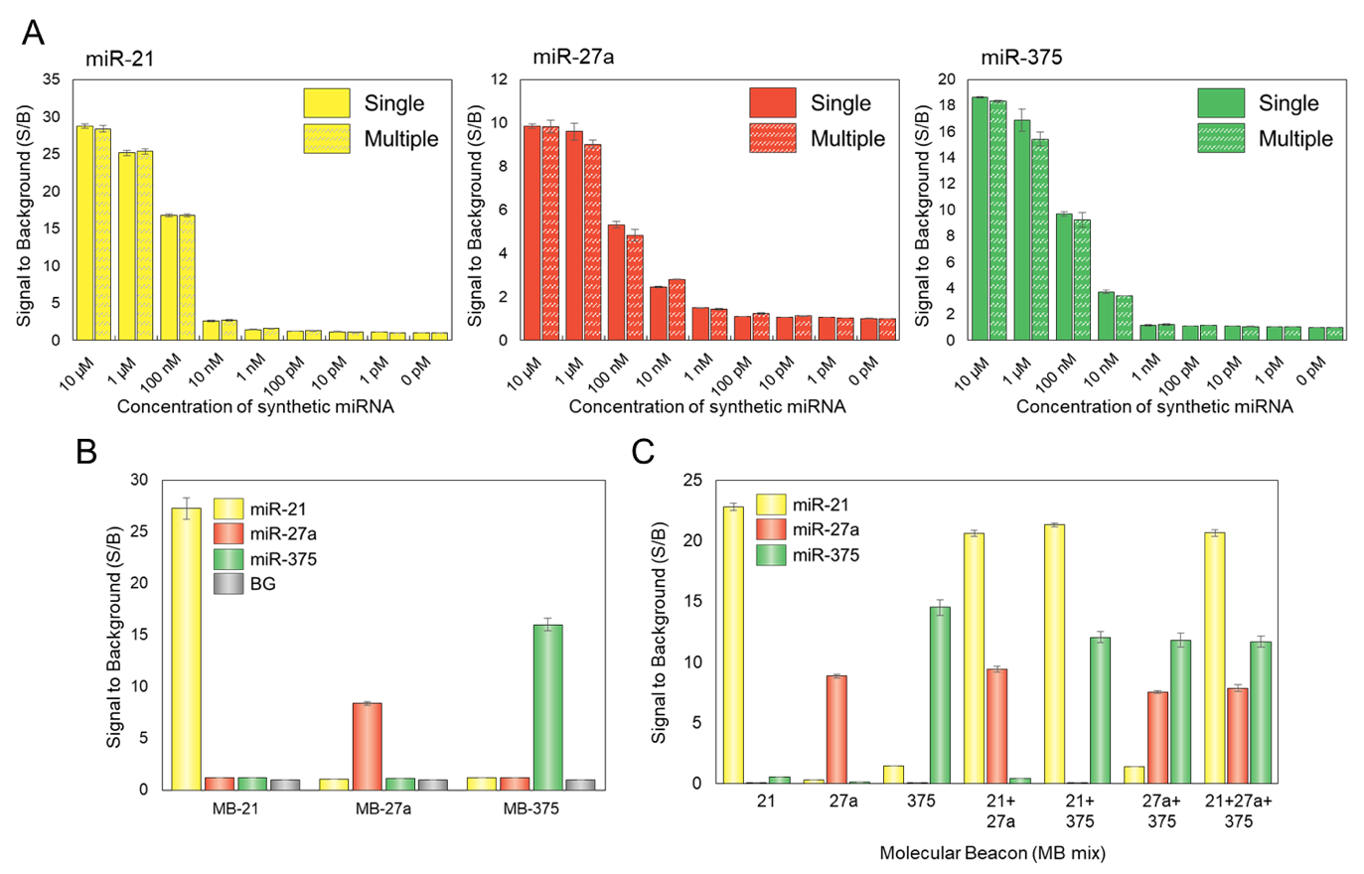
Supplementary Fig. S4. Synthetic miRNA analysis. (A) The limit of detection (LOD) of target synthetic miRNA (miR-21, -27a and -375). (B) The cross-reactivity between MBs and synthetic miRNA. (C) The multiplexed detection of synthetic miRNAs.

To test the limit of detection (LOD) of target miRNA, we incubated MB with synthetic target miRNAs in a concentration-dependent manner and measured S/B ratio (Fig. S4A). As expected, the S/B ratio increased in the presence of the target miRNA, increased concentrations of target miRNAs have higher S/B ratio. For the Cy3-labeled MB21, the S/B ratio increased up to 25.1 ± 0.3 by incubation with 1 μM of target miR-21. Likewise, the S/B ratio increased up to 9.6 ± 0.4 and 16.9 ± 0.8 by incubation 10 μM of target miR-27a and miR-375 with MB27a and MB375, respectively. To test the detection efficiency by multiplexed MB mix, 200nM of MB21, MB27a, and MB375 mixtures were co-incubated together with 1 μM of miR-21, miR-27a, and miR-375. The S/B ratio with multiplexed MBs of miR-21, -27a, -375 was almost the same as that with the single MB. To check the cross-reactivity, MBs were incubated to complementary or non-complementary miRNAs (Fig. S4B). 200 nM of Cy3-labeled MB21, Cy5-labeled MB27a, and FAM-labeled MB375 were incubated with 1 μM of miR-21, miR-27a, and miR-375 for 30 min, and measured its (S/B) ratio after the hybridization. Fluorescence signals were measured with Ex/Em of 535/575, 640/680, and 480/520 wavelength for Cy3, Cy5, and FAM, respectively. When the MBs interacted with non-complementary synthetic miRNA, the fluorescence signal was almost similar to the background. This means that the possibility of cross-reactivity is very low, and MB has high specific hybridization to their target miRNA. We found multiplexed detection of synthetic miRNAs performed successfully using their specific MBs. For the multiplexed detection of synthetic miRNAs, a combination of MB21, MB27a, and MB375 mixture co-incubated together with isolated EVs (Fig. S4C). The S/B ratio in the triple (21+27a+375) detection of synthetic miR-21 using MB21 was about 9.6 % decrease compared to that in the single (21) detection. And, the S/B ratio in the triple detection of synthetic miR-27a using MB27a was about 11.2 % decrease compared to that in the single (27a) detection. Likewise, the S/B ratio in the triple detection of synthetic miR-375 using MB375 was about 11.2 % decrease compared to that in the single (375) detection. Thus, multiplexed detection of synthetic miRNAs successfully carried out using their specific MBs.

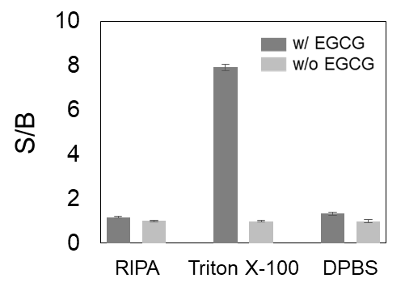

Supplementary Fig. S5. Optimization of buffer solutions for one-step EVs lysis and MBs hybridization. Target buffer is RIPA and 1% Triton X-100 in DPBS, and DPBS is negative control.

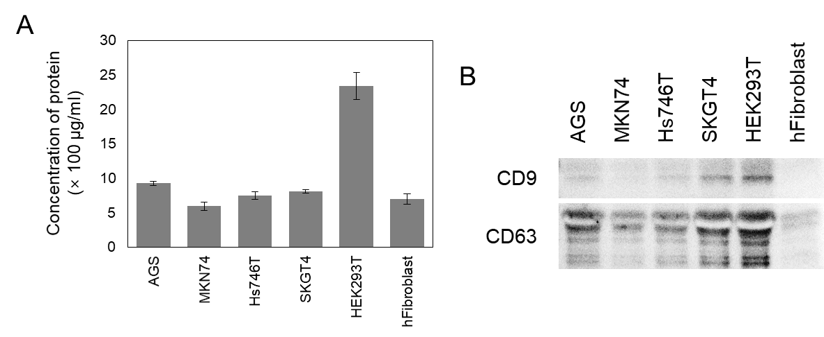
Supplementary Fig. S6. Comparison of protein expression in EVs precipitation depending on cell lines. (A) The concentration of extracted total proteins depending on cell types by analyzing Bradford assay. (B) Expression of exosome surface markers, CD9 and CD63, depending on cell lines.

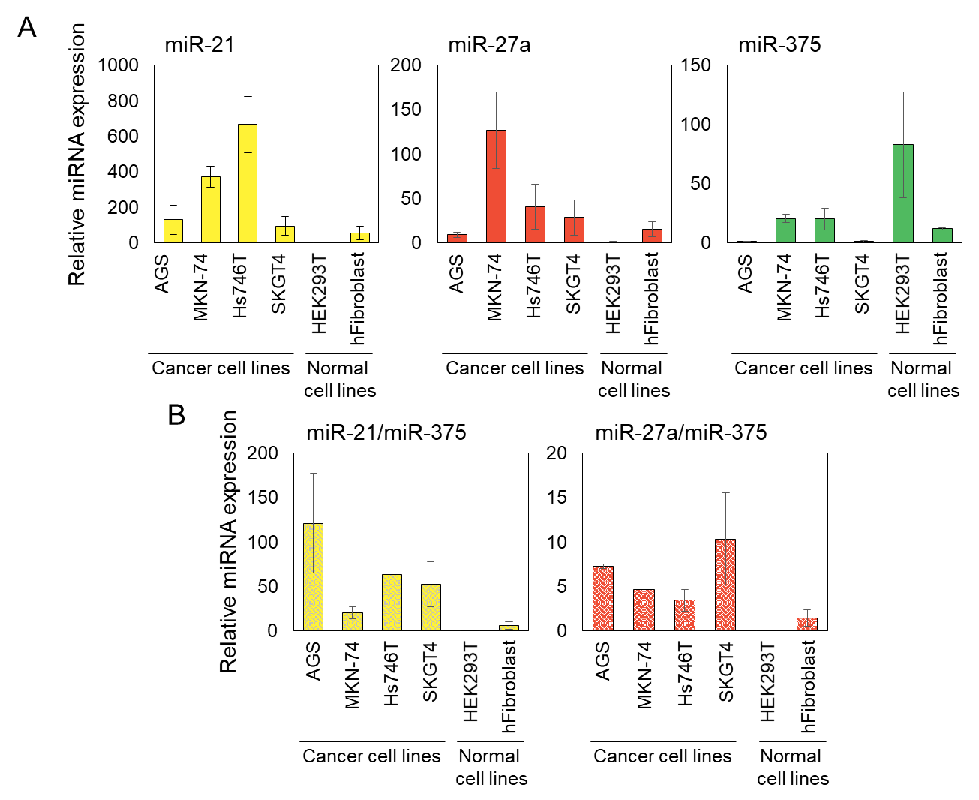

Supplementary Fig. S7. Cell type-dependent quantitative miRNA analysis by using RT-qPCR (n=3). (A) Expression of miR-21, -27a, and -375 in various cell lines analyzed by RT-qPCR. (B) miR-21/miR-375 and miR-27a/miR-375 ratios for different cell types.

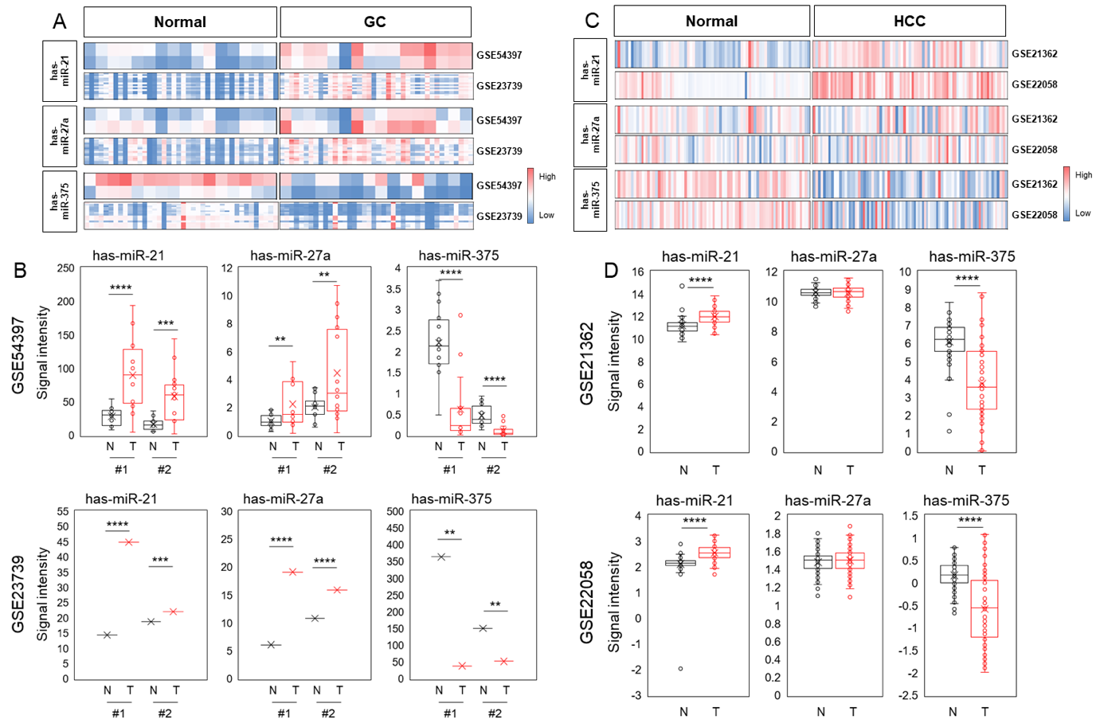
Supplementary Fig. S8. Expression of miR-21, -27a and -375 in (A) GC a nd (B) HCC based on GEO database. (B,C) Heatmap of miR-21, -27a, and -375 expression patterns in GC (B) and HCC (C) compared to normal cells. Red indicates upregulation; blue indicates downregulation. **:p<0.01, ***:p<0.001, ****:p<0.0001

