Supplementary Information for

“Strong spin orientation dependent spin current diffusion and inverse spin Hall effect in a ferromagnetic metal”

Table of Contents:
A. Experimental errors in the testing setup
B. Anisotropic magnetoresistance in the metallic exchange bias structure
C. Calculation of the shunting factor for Py in the spin-valve heterostructure
D. ANE-Like signals in GGG/Cu/Py/IrMn

A. Experimental errors in the testing setup
To reveal the experimental errors in our test, we have fabricated the structure of YIG(100 nm)/Pt(3 nm) with the same radial pattern shown in Fig. 1(d). The $V_{th}-H$ curves of different strips (numbered by the angle) are measured under the same condition, where the directions of the thermal voltage, temperature gradient and external field are mutually orthogonal. The results are shown in Fig. S1(a) and the corresponding LSSE voltages ($\frac{1}{2}\left|V_{th}\left(H_{+}\right)-V_{th}\left(H_{-}\right)\right|$) in different strips are depicted in Fig. S1(b). There exists voltage fluctuation for different Pt strips, but the variation is less than 5% of the average amplitude. We attribute the deviation to the inconsistent electrode distances due to the location error of the bonding points on the strip terminals in different measurements. In fact, for the same channel (i.e. at a certain $θ$), the measurements repeated up to 10 times with careful wire-bonding for each time give tiny different thermal voltage magnitude at different time, usually below 5%.
Since the studied samples are radially patterned with eight strip (0.3 mm$×$5.6 mm) channels and the relative alignment angle is 22.5$°$, the center part of the pattern becomes a circular area with a diameter of about 1.5 mm. To clarify whether there is any recognizable effect caused by the central part, we have also compared the LSSE voltages of the radial pattern YIG(100 nm)/Pt(3 nm) with the one that is patterned into a single 0.3 mm × 5.6 mm strip. Fig. S1(c) shows the LSSE loops of the 2 samples and the LSSE voltages of the single strip pattern (denoted as $V_{1}$) and 8 strips pattern (denoted as $V_{8}$). $V_{1}$ is 1.82 $μV$, slightly smaller than $V_{8}=$ 1.91 $μV$. The difference between them is within the experimental error (5%). Therefore, the effect caused by the central circular part is unimportant for the present experiment, each strip of the radial pattern can be treated as a single narrow rectangular strip for the thermal voltage result analysis.

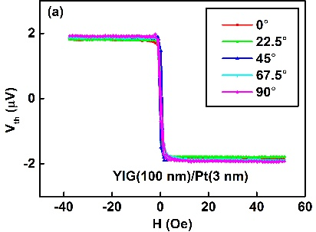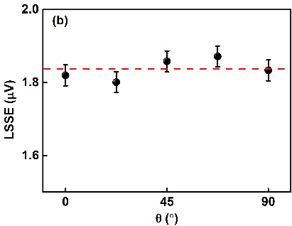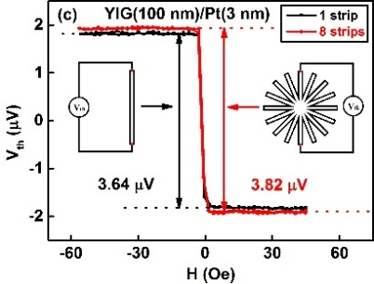
Figure S1. LSSE voltage of YIG(100 nm)/Pt(3 nm) with different $θ$ and different patterns. (a) Raw data of the magnetic-field dependent thermal voltage in YIG/Pt(3 nm) with different strips (numbered by the angle). (b) $θ$ dependent LSSE voltages ($\frac{1}{2}\left|V_{th}\left(H_{+}\right)-V_{th}\left(H_{-}\right)\right|$) in YIG/Pt(3 nm). Red dash line correspond to the average amplitude and the error bars represent the 68% confidence level ($± SD$). (c) LSSE measurement of the single strip pattern (black line and symbol) and eight strip pattern (red line and symbol).

B. Anisotropic magnetoresistance in the metallic exchange bias structure
The anisotropic magnetoresistance (AMR) in the metallic exchange bias structure (Cu/Py/IrMn) is discussed in this section. Because of the AMR in Py, the resistance of the Cu/Py/IrMn strips at different $θ$ should be different during the YIG reversal process with Py pinned at different directions, which will accordingly alter the corresponding measured thermal voltage. We have measured the AMR of the samples YIG/Cu(3.5 nm)/Py(5-10 nm)/IrMn(8 nm)/SiO₂(5 nm). The AMR is about 0.1−0.3% for them. As an example, Fig. S2(b) displays the angular dependent resistance (left panel) at the external field of 3400 Oe for YIG/Cu/Py(7 nm)/IrMn/SiO₂ and the corresponding $R-H$ curves (right panel) of the strips at $θ=0$ and 90°. The field of 3400 Oe is more than ten times of the exchange bias field (∼250 Oe) in this structure, it will align the Py magnetization along the external field direction. The AMR of the sample is determined to be about 0.2$\%$ from either $R-θ$ or $R-H$. Such a tiny variation of the film resistance at different $θ$ brings negligible correction for the spin orientation dependent ISHE voltage, where $\frac{\left|V_{ISHE}\left(0°\right)-V_{ISHE}\left(90°\right)\right|}{V_{ISHE}\left(90°\right)}$ reaches 47% in the YIG(100 nm)/Cu(3.5 nm)/Py(7 nm)/IrMn(8 nm)/SiO₂(5 nm).

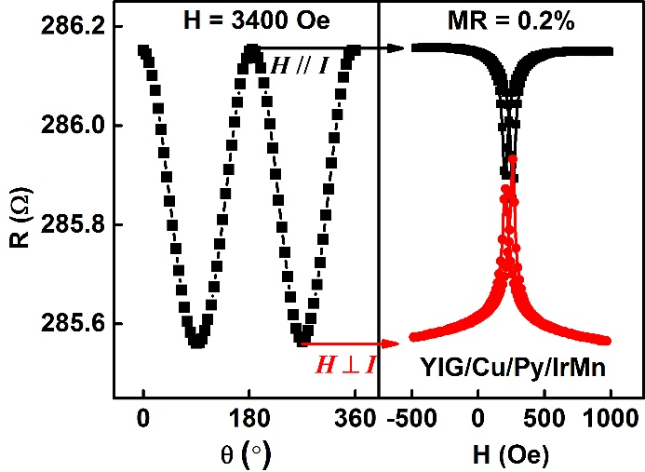
Figure S2. Anisotropic magnetoresistance (AMR) of the YIG(100 nm)/Cu(3.5 nm)/Py(7 nm)/IrMn(8 nm)/SiO₂(5 nm) structure. Left panel shows the angular dependent magnetoresistance curve, the external field is fixed in 3400 Oe and $θ$ means the angle between external field and current direction (in plane). Right panel exhibits the $R-H$ curves at $θ=0$ and 90°. The saturation field in the $R-H$ measurement displays discrepancy for different $θ$ due to the shape anisotropy of the strips.

C. Calculation of the shunting factor for Py in the spin-valve heterostructure
To determine $λ_{sf}$ and $θ_{SH}$ at different $θ$, the ISHE voltage ($V_{ISHE}^{Py}$) generated in Py is calculated by $V_{ISHE}^{Py}= {ξV}_{ISHE}$, where $ξ$ is the shunting factor, obtained from the conventional Hall Bar patterned multilayer samples of YIG(100 nm)/Cu(3.5 nm)/Py(t nm)/IrMn(8 nm)/SiO₂(5 nm) ($t$ = 3$-$12 nm) using four-probe technique. The Py thickness dependence of conductance is shown in Fig. S3. The data shows good linear dependence, and the resistivity of Py ($ρ_{Py}$) and the resistance irrelevant to Py ($R_{other}$) can be obtained according to the linear fits: $G_{total}= \frac{1}{R_{other}}+ α\frac{t_{Py}}{ρ_{Py}}$, in which $α=\frac{width}{length}$ is the shape factor of the Hall bar. The resistance of Py ($R_{Py}$) and $ξ=1+\frac{R_{Py}}{R_{other}}$ for each Py thickness can be obtained in the further calculation. Fig. S3 gives the $ρ_{Py}$ = 23.2$μΩ∙cm$ and $R_{other}$ = 840 $Ω$.

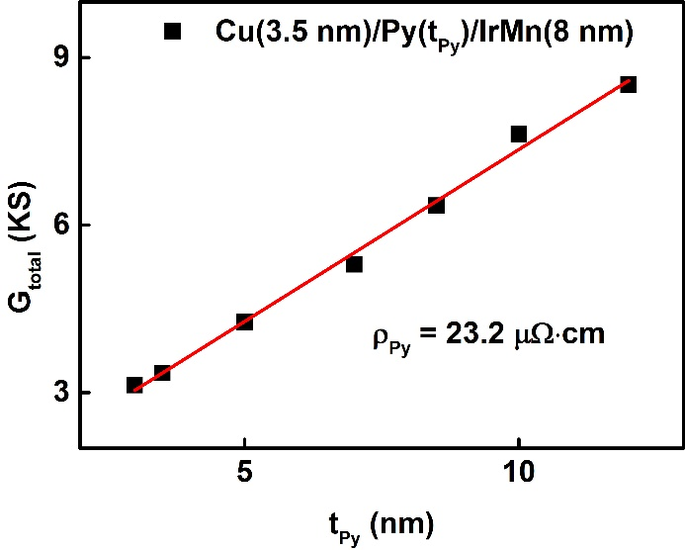
Figure S3. Py thickness dependence of the total conductance in YIG(100 nm)/Cu(3.5 nm)/Py(t nm)/IrMn(8 nm)/ SiO₂(5 nm) structure. Red line represents the best linear fitting result, from which the Py resistivity is evaluated.

D. ANE-Like signals in GGG/Cu/Py/IrMn
To better understand the spin current modulated ANE-Like phenomenon observed in the spin-valve heterostructure, we would like to point out that the thermal voltages resulting from ANE-Like in our structure are different from their ordinary counterpart that can be defined by Eqs. (1)$-$(3). Take the calculation of $V_{ANE-Like}$in the situation of $θ=$0$°$ and 90$°$ in the YIG/Cu/Py/IrMn structure as examples. At $θ=$0$°$,
2$V_{ANE-Like}^{θ=0°}=V_{ANE-Like}\left(↓_{Py}↓_{YIG}\right)-V_{ANE-Like}\left(↑_{Py}↓_{YIG}\right)+V_{ANE-Like}\left(↑_{Py}↑_{YIG}\right)-V_{ANE-Like}\left(↑_{Py}↑_{YIG}\right)$;
whereas at$θ=$90$°$,
2$V_{ANE-Like}^{θ=90°}=V_{ANE-Like}\left(↓_{Py}↓_{YIG}\right)-V_{ANE-Like}\left(→_{Py}↓_{YIG}\right)+V_{ANE-Like}\left(→_{Py}↑_{YIG}\right)-V_{ANE-Like}\left(↑_{Py}↑_{YIG}\right)$,
where the arrows mean the directions of Py and YIG magnetization. The same terms $V_{ANE-Like}\left(↓_{Py}↓_{YIG}\right)-V_{ANE-Like}\left(↑_{Py}↑_{YIG}\right)$ in both equations represent the saturated thermal voltage arising from the ANE (and ARLE as well as ISHE of IrMn due to the spin current from Py) when ${\vec{M}}_{YIG}$ and ${\vec{M}}_{Py}$ are parallel to each other, which is identical in different$θ$measurements. The observed anisotropic ANE-Like signal is due to the difference between $V_{ANE-Like}\left(↑_{Py}↑_{YIG}\right)-V_{ANE-Like}\left(↑_{Py}↓_{YIG}\right)$ and $V_{ANE-Like}\left(→_{Py}↑_{YIG}\right)-V_{ANE-Like}\left(→_{Py}↓_{YIG}\right)$. In principle, the difference of these two expressions should be equal to 0 if $V_{ANE-Like}$ is solely decided by${\vec{M}}_{Py}$according to Eqs. (1)$-$(3). The introduction of pure spin current in the Py layer seems to cause an additional contribution to the ANE-Like signal, and this contribution strongly depends on the polarization direction of the pure spin current (${\vec{M}}_{YIG}$) with respect to ${\vec{M}}_{Py}$, although ${\vec{M}}_{Py}$ itself is unvaried from the magnetostatic point of view. The interplay between spin current and the local moment of Py, namely the spin-transfer torque and the resultant magnetic precession, may take responsibility of the modified $V_{ANE-Like}$. It is the introduction of spin current resulting from${\vec{M}}_{YIG}$at different direction with respect to the ${\vec{M}}_{Py}$ that modifies the $V_{ANE-Like}$.
As an important control trial, the thermal voltage loop of the radial pattern sample GGG/Cu(3.5 nm)/Py(10 nm)/ IrMn(8 nm)/SiO₂(5 nm) at different $θ$ is shown in Figs. S4(a)$-$(e). $θ$ denotes the angle between the external field $\vec{H}$ and exchange-bias direction (${\vec{H}}_{EB}$). Although the magnetization reversal process of the Py strips differs for different $θ$ because of the exchange bias and shape anisotropy, the saturated thermal voltage $V_{ANE-Like}=\frac{1}{2}\left|V_{th}\left(H_{+}\right)-V_{th}\left(H_{-}\right)\right|$ is nearly invariant with respect to $θ$, which is summarized in Fig. S4(f). The fluctuation of ANE$-$Like voltage is less than 3% of the average amplitude for this GGG based sample, far smaller than the change of the ANE-Like voltage in YIG/Cu(3.5 nm)/Py(10 nm)/IrMn(8 nm)/SiO₂(5 nm) structure, where $Ra\left(V_{ANE-Like}\right)=\frac{ΔV_{ANE-Like}}{V_{ANE-Like}\left(90°\right)}=\frac{\left|V_{ANE-Like}^{N}\left(0°\right)-V_{ANE-Like}^{N}\left(90°\right)\right|}{V_{ANE-Like}^{N}\left(90°\right)}=$15%. Above result proves that the spin current injected from YIG can evidently influence the ANE-Like signal in Py.

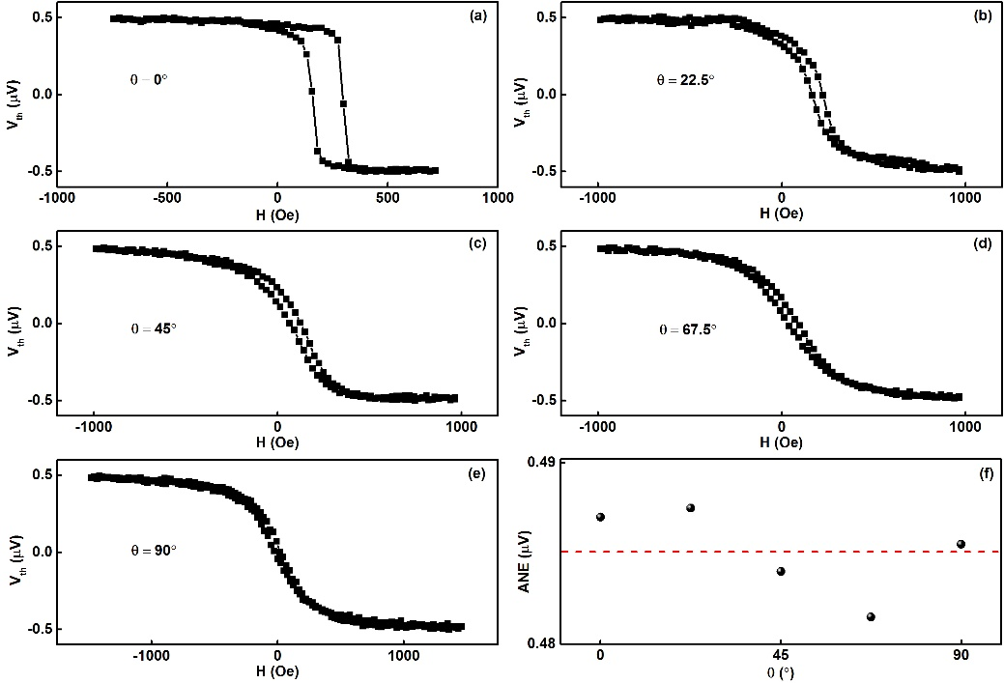
Figure S4. Thermal voltage of GGG/Cu(3.5 nm)/Py(10 nm)/IrMn(8 nm)/SiO₂(5 nm). (a)$-$(e) show the thermal voltage loop at different $θ$, where $θ$ denotes the angle between the external field $\vec{H}$ and exchange-bias direction (${\vec{H}}_{EB}$). (f) $θ$ dependence ANE voltages ($\frac{1}{2}\left|V_{th}\left(H_{+}\right)-V_{th}\left(H_{-}\right)\right|$). Red dash line correspond to the average amplitude.

