SUPPLEMENTARY INFORMATION
Flexible Transparent Heteroepitaxial Conducting Oxide with Mobility Exceeding 100 cm² V⁻¹ s⁻¹ at Room Temperature

Chun-Hao Ma¹, En-Liang Chen¹, Yu-Hong Lai¹, Yi-Cheng Chen¹, Li Chang¹, and Ying-Hao Chu^{1,2*}

¹ Department of Materials Science and Engineering, National Chiao Tung University, Hsinchu 30010, Taiwan
² Center for Emergent Functional Matter Science, National Chiao Tung University, Hsinchu 30010, Taiwan

*email: yhc@nctu.edu.tw
Figure S1 XPS measurement of IMO/AZO/mica.
Typical XPS spectrum is obtained from the surface of IMO/AZO/mica heterostructure as well as high-resolution spectra of In 3d and Mo 3d core levels.
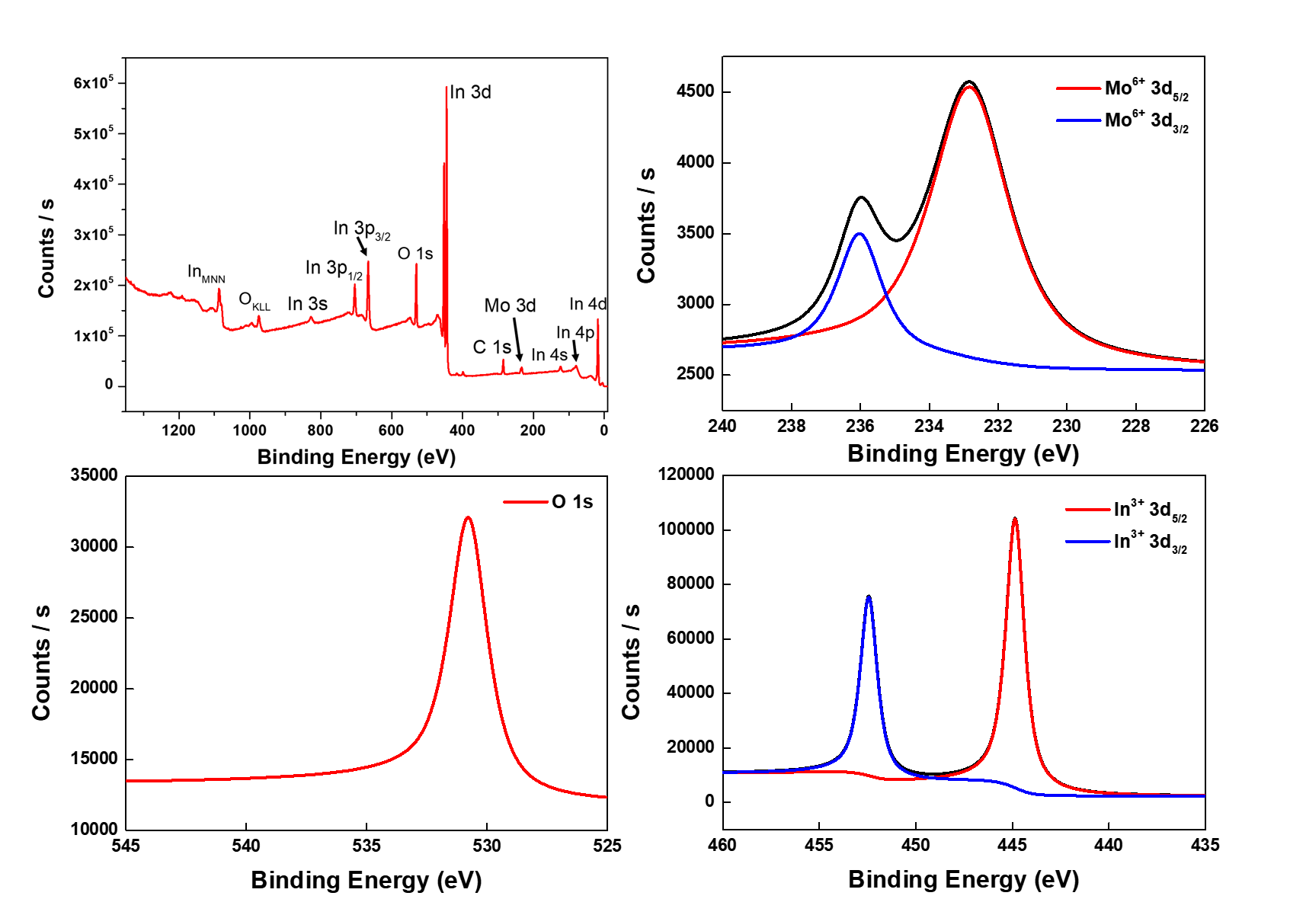

Figure S2 The controllable behavior.
The transport behavior can be simply controlled between insulating and metallic by annealing the samples in different oxygen atmosphere. The heteroepitaxy, annealed in high oxygen pressure, exhibits an insulator behavior.
